The Density Webquest

Name: __________________________ Period: _______

Key Concepts:
- To understand the properties of density
- To calculate volume, mass and density
- To understand what percent deviation is
- To calculate percent deviation

Part A: Volume

- What is the definition of volume?

  - What do you think is the key word in that definition (one word)?

- What happens to the volume of an object if it is heated?

Finding the Volume of a regular shaped object
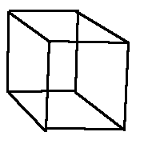

- What is the formula for volume (scroll to bottom of site)?

  - What is the volume of this object (show your work)? Measure it with a ruler in centimeters.

  - How should the units be?

Finding the Volume of an irregular shaped object
- An object that can not be measured by a ruler

- Briefly describe the steps to calculate volume of an irregular shaped object (the water displacement method):

- Practice:
  - What is the volume of the water in this picture?
  - What is the volume of water after the object is placed in it in this picture?
  - What is the volume of the object (volume before object – volume after object was placed in)

Part B: Mass

- What is the definition of mass?

    - What do you think the key word is in the definition?

- How do you calculate the mass of an object? Pay close attention to the units that are used, too.

    - Practice calculating mass (scroll about half way down)?

Part C: Density

- What is the definition of density?

- What is the formula for density (write all of them)? Remember the triangle method! It helps!

- Practice Problems (show work):
    - What is the density of a 75 g block of wood measuring 12 cm x 8 cm x 9 cm?
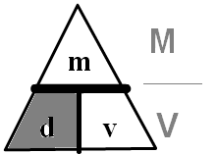
      - What’s the mass:

      - What’s the volume:

      - What’s the density (calculate it)

    - What is the mass of a 49 cm³ object with a density of 63 g/cm³?
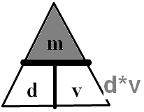
      - What’s the volume?

      - What’s the density?

3. What’s the mass (calculate it)?

    - What is the volume of a 17 kg solid with a density of 0.05 kg/cm³?
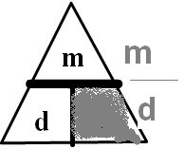
      - What’s the mass?

      - What’s the density?

3. What’s the volume (calculate it)?

- Here are the answers! And explanations.

