Photo Page
Insured: Byron-Bergen CSD
Location: Bergen, NY (Crisis Drill)

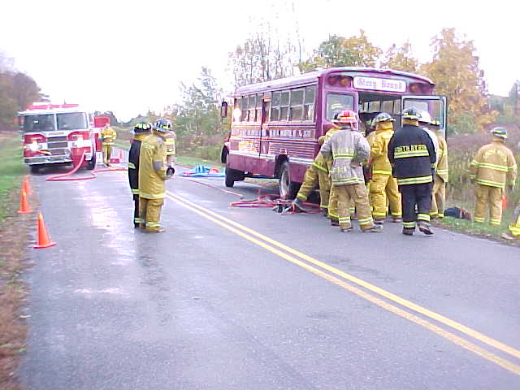 |  | 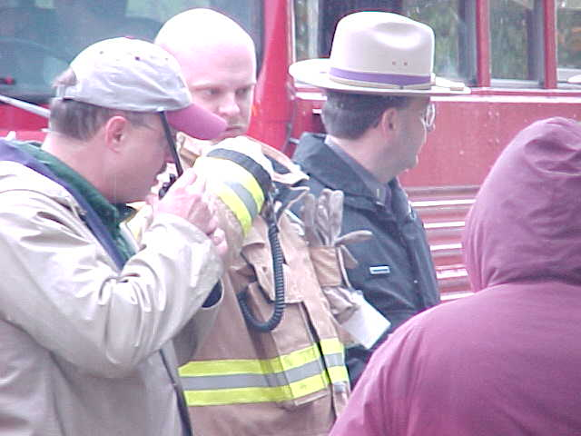
Photo 1 - |  | Photo 2 –
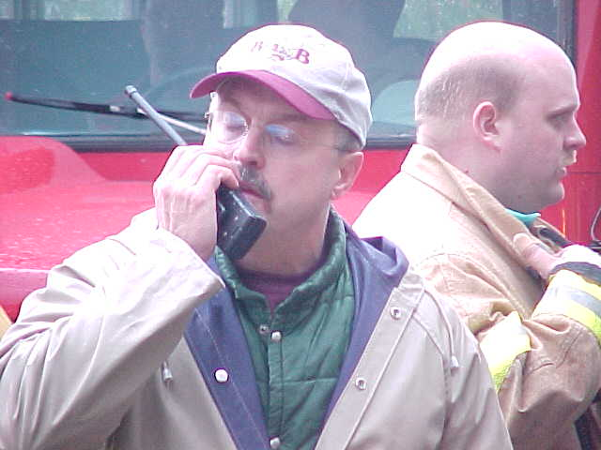 |  | 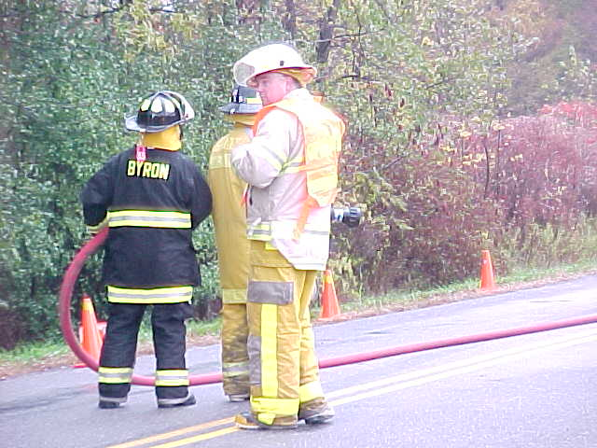
Photo 3 - |  | Photo 4 -
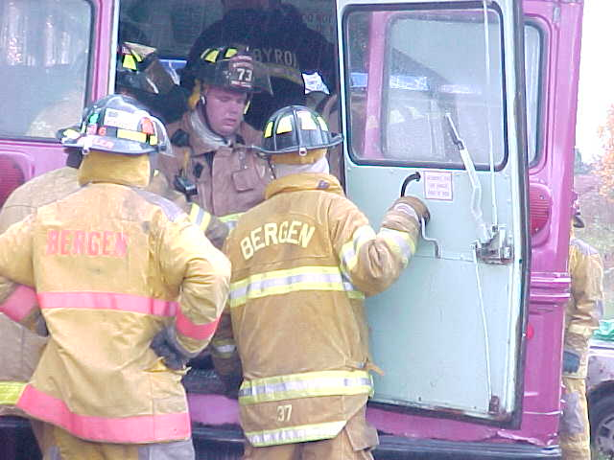 |  | 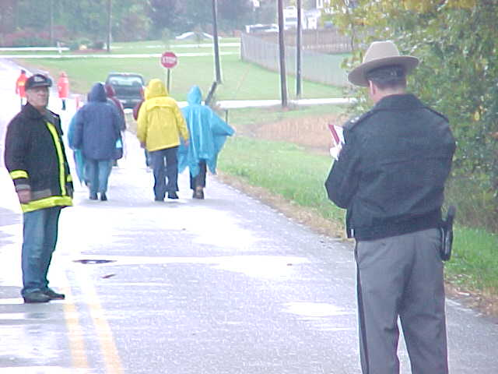
Photo 5 - |  | Photo 6 -

