Payroll Manager Made Simple
This document contains instructions for adding a new employee in Payroll Manager. Follow the steps below for the successful completion of entering employee demographic and salary information into Payroll Manager.
- Open the Employee Information window by selecting the Employee Information Maintenance icon .
- Click the Information folder on the left-hand side of the window to add employee demographic data or press the F8 key to navigate to the Employee Information window.
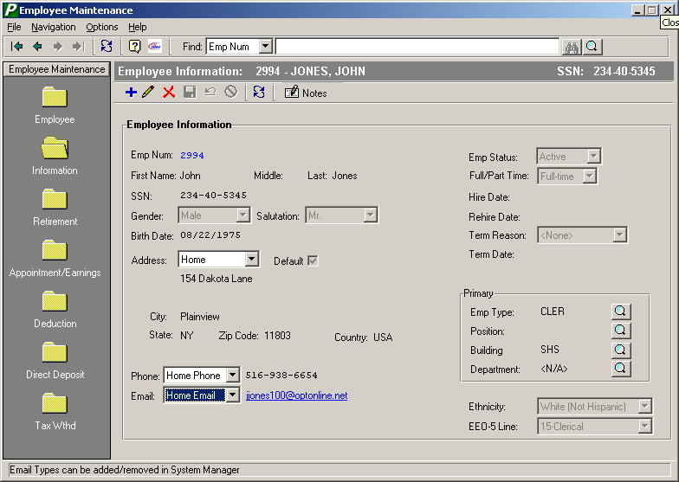
A) Enter the employee name in each individual field to denote the first name, middle initial, and last name.
B) The system allows you to specify multiple different addresses for each employee. Use the drop-down arrow to select the appropriate address type as defined in the Address Type Setup File. Example, you may indicate a home address and a summer address for one employee. Label one of the addresses as the employee’s default address by placing a check in the Default checkbox. This indicates the employee’s main address for the majority of the fiscal year.
C) The system allows you to record both a home phone number and a business phone number. Use the drop-down arrow to specify the phone number type that you wish to record – i.e., home number or work number. These phone types are defined by the district in the Contact Type Setup File in System Manager. In the following field, enter the telephone number, including the area code, for the employee. (999-999-9999 format)
D) The system allows you to record both a home email address and a business email address. Use the drop-down arrow to specify the email type that you wish to record – i.e., home email or work email. These email types are defined by the district in the Contact Type Setup File in System Manager. In the following field, enter the email address for the employee.
- Click the Retirement folder on the left-hand side of the window to update employee retirement data or press the F8 key to navigate to the Retirement window.
- Click the Appointment/Earnings folder on the left-hand side of the window to add appointment, earnings, and account distribution information or press the F8 key to navigate to the Appointment window.
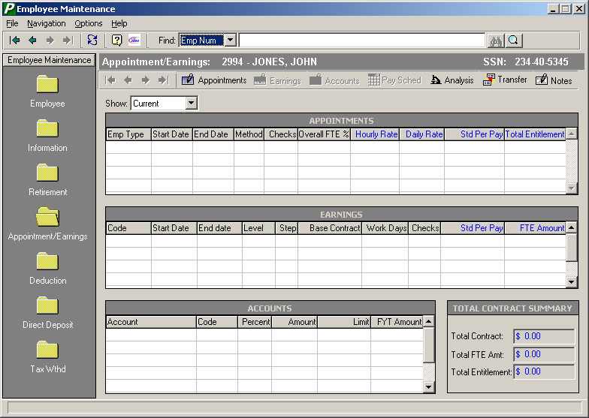
The maintenance options are displayed horizontally across the window above the appointment browser.
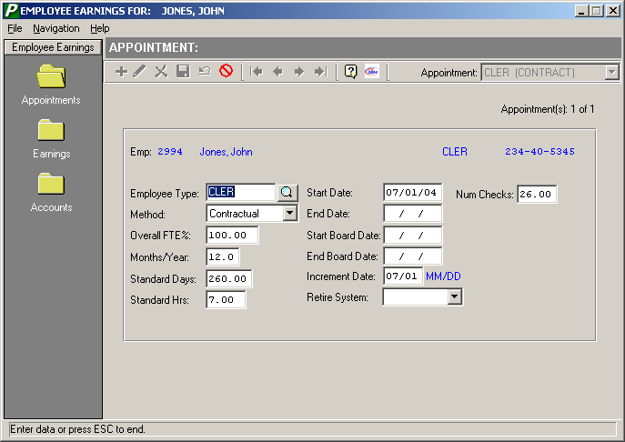
Make sure the standard number of days for this appointment is entered, as the system uses this amount to calculate the Daily Rate. The Daily Rate is equal to the FTE Amount divided by the number of Appointment Standard Days. The Daily Rate is then used to determine the Hourly Rate amount.

- Click the Earnings folder on the left-hand side of the window to add earnings information or press the F8 key to navigate to the Earnings window. Specify the type of earnings that you wish to add.
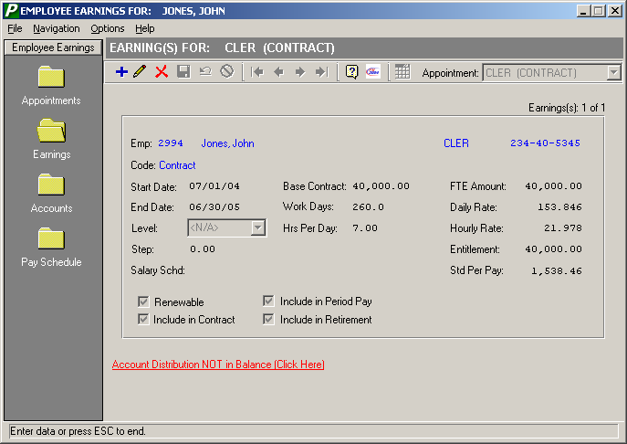
The Salary Schd field is a display-only field that denotes the current schedule linked to the employee type and bargaining unit based on the specified level, step, and starting/ending date range.
- Click the Accounts folder on the left-hand side of the window to add account distribution information, or click on the Account Distribution NOT in Balance link shown in red lettering on the bottom of the Earnings window, or press the F8 key to navigate to the Accounts window.
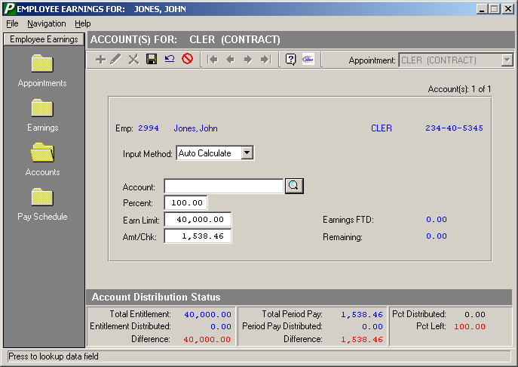
Use the Input Method field to specify how you wish to input data on this window. Choose Auto Calculate if you want the system to automatically calculate the Earn Limit and Amt/Check upon entry of the percentage. Choose Manual Override if you want to override the system-defaulted Percent, Earn Limit, and Amt/Check and enter your own values. Finance Manager will check to ensure that the complete entitlement amount is distributed.
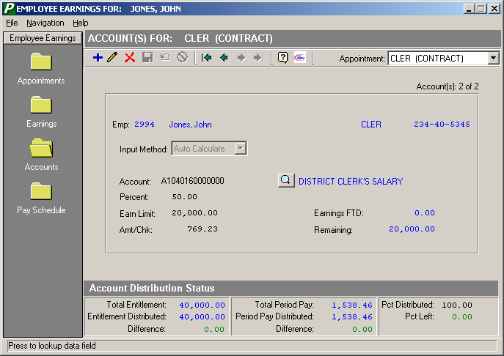
The Account Distribution Status tracks your entries to make sure that you distribute the proper entitlement amount. The system tallies the total entitlement and total entitlement distributed; the difference between the two must be zero in order to be in balance. The system also tallies the total period pay amount and total period pay amount distributed; the difference between the two must be zero in order to be in balance. In addition, the system tallies the percent distributed; the percent left must be zero in order to be in balance.
If the selected employee has more than one distribution record, the upper right-hand side of the window displays Account(s) 1 of 2, Account(s) 2 of 2, etc. Use the First, Previous, Next, and Last buttons in the Navigational toolbar to switch to another distribution record.
If the selected employee has more than one appointment record, use the drop-down arrow in the Appointment field at the top right-hand side of the window to switch to another appointment and distribution record.
- Click the Pay Schedule folder on the left-hand side of the window to look at the employees check schedule or press the F8 key to navigate to the Pay Schedule window.
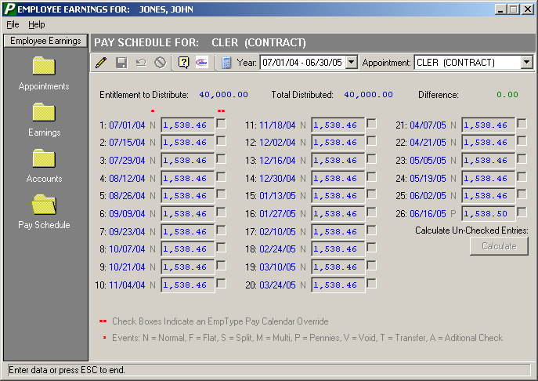
The Pay Schedule window provides a summarized look at the employee’s check schedule for the entire fiscal year. This window is only active if a pay schedule has been established for the employee type through the Set Payroll Calendar routine. The Pay Schedule window displays the gross dollar amount of each paycheck based on the entitlement and the number of checks in the fiscal year. You may override the pay schedule amount any time it becomes necessary. You may have a different pay schedule for each appointment that the employee has.
The window displays the amount of the entitlement to distribute, the amount already distributed by the pay schedule, and the difference between the distributed and not distributed amount. Each schedule consists of multiple entries containing the check date, pay event (Normal, Flat, Split, Multiple, Pennies, Void, Transfer, Additional Check), check amount, and pay calendar override flag.
Event Flags
The event flags represent the following:
N (Normal) – The employee is getting or was paid the normal period pay amount.
F (Flat) – The employee is getting or was paid a flat amount. Example: Some districts pay their teachers a flat dollar amount at the start of the fiscal year.
S (Split) – The employee is getting or was paid for only 5 out of the 10 days in the payroll period and you wish to pay that employee 50% of the normal pay period amount.
M (Multi) – The employee is getting or was paid multiple checks in the same payroll period.
P (Pennies) – The employee is getting or was paid extra pennies to complete payment of the full entitlement.
V (Void) – The employee’s check was voided.
T (Transfer) – The earnings from the employee’s check was transferred to a different account or earning code.
A (Additional Check) – The employee was paid additional monies outside of the original scheduled check dates.
Typing over a period pay entry flags the ** field with a checkmark, indicating an override to the original pay calendar entry. If you made changes to any of the original pay schedule entries, press the Calculate button. The system will recalculate any unchecked entries based on the changes that you made and the amount of the entitlement distributed. Press the Save button to save any changes made.
The Payroll Generation routine will check to see if a payroll schedule of payments exists for employees. If a pay schedule is being used, the generation process generates the amount of the scheduled payment. If a pay schedule is not being used, the system uses the period pay amount from the employee appointment earnings distribution window.
NOTE: If an employee has already been paid in the fiscal year, the pay schedule line for the check date displays the actual amount paid to the employee after the check was posted. The amount for any pay date for which the check has been posted may not be modified. So, if you had generated the employee’s pay and then entered additional earnings through the Display/Modify routine, the posting process updates the amount paid for that pay date on the Pay Schedule window. At that point, the distribution will be out of balance and the user would have to calculate the Pay Schedule entries.
The system will not automatically recalculate the schedule amounts as it is uncommon for the remaining to divide out evenly. The user may instead generate a report to verify pay schedules. The report would display a listing of employee records that are out of balance and then go to that employee’s screen and balance the schedule.
Below is the completed payroll Appointment/Earnings record.
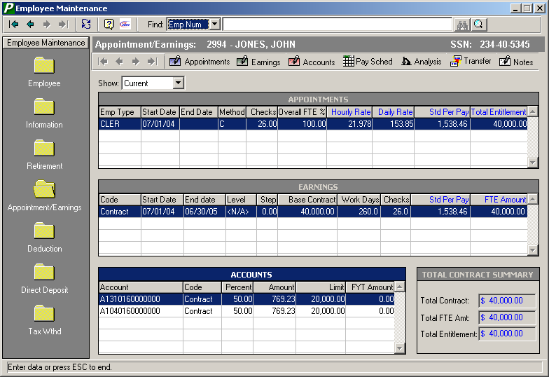

- Click the Deductions folder on the left-hand side of the window to add the employee’s voluntary deduction data or press the F8 key to navigate to the Deduction window.
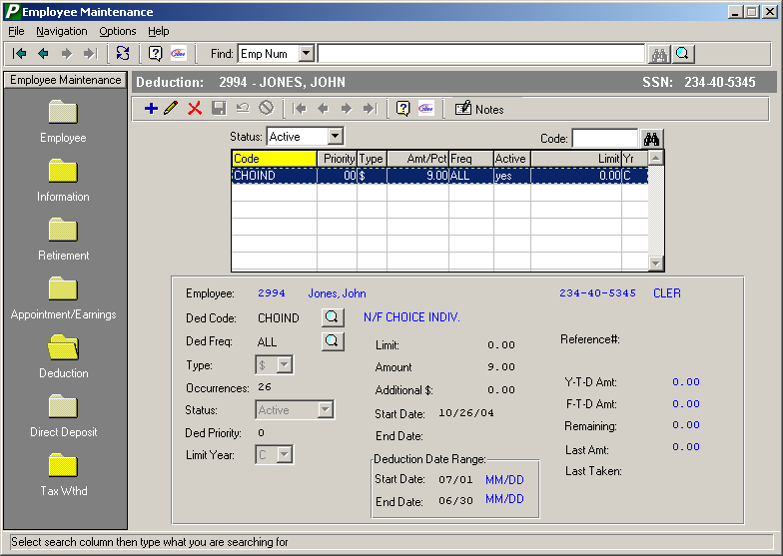
The Ded Priority field allows you to assign a number to each deduction record for the purpose of prioritizing the deductions. The Payroll Calculation process will look at the priority to determine which deduction to take first.
The Additional $ field allows you to enter a ONE-TIME adjustment that will be added to the normal deduction amount.
- Click the Direct Deposit folder on the left-hand side of the window to add the employee’s direct deposit data or press the F8 key to navigate to the Direct Deposit window.
- Click the Tax Wthd folder on the left-hand side of the window to add the employee’s tax withholding data or press the F8 key to navigate to the Tax Withholding window.

