Monday, October 2, 2000

This Week!

This week we will continue with our weekly spelling tests. The children did a great job last week. Helping them to review during the week and not waiting until Thursday night also helps to give the children confidence.
We will be only be focusing on one story this week. The story is about a little leopard that is adopted by another family. The little leopard feels that he does not belong and tries to find a family that is more like him. Read the story with your son/daughter and enjoy the great ending. Don’t forget to return the reading/flashcard slips.

Bird Feeder
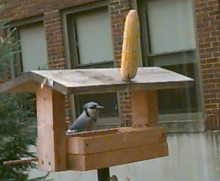
Thank you so much to those that sent in birdseed. The children really enjoy seeing them come for their daily meals. If you did not have the opportunity of sending in seed, we will gladly take contributions, throughout the year.

Show and Tell

We will continue to give the children the opportunity of having “Show and Tell Time” each Friday. It gives the children confidence in sharing in front of the class, thus preparing them for oral presentations as they grow older.

Fire Prevention Week

This week is set aside each year as “Fire Prevention Week”. During this week we will focus on how to prevent fires within the home and what to do and what not to do in the event of a fire. This is done not to scare the children, but instead to help them think safety. Twelve fire drills are conducted each year to ensure the safety of the children here at school. During the week (weather permitting) we will try a window escape, since we are on the first level. I have enclosed a form for you to actually write down two ways to escape from your home in the event of a fire. I am encouraging the children to return the form to school upon completion. One family I know, actually rehearses the drill in their home annually.

Harvest Fest

Our Harvest Fest will be held on Tuesday, October 31st. The Harvest Fest will be centered around The Wizard of Oz. The children will also have the opportunity of participating in the annual Halloween Parade that will be held at the end of the school day.

Science Fair

Our annual Science Fair will be held on Wednesday, October 18th. Projects are to be brought to school on the 17th and can be picked up at the end of the fair at 7:30 or the following morning. An additional form is attached to the newsletter today.

