Creating a Bookmark / Favorite

Why?
When we want to save an analysis view for later use

Steps
- When you’ve found a view that you’d like to save, click the Prepare a Bookmark button in the toolbar
Click the Prepare a bookmark button in the toolbar

- Follow the steps for your browser to create a bookmark or favorite

For Microsoft Internet Explorer:
- Click Add to Favorites from the Favorites menu

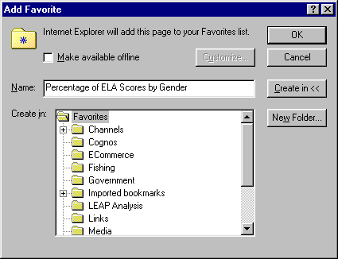
Note, name of the bookmark we’d like to create

- Type the name of the bookmark in the Name: box. In this example, we’re looking at Percentage of ELA Scores by Gender.
- Click the folder in which you’d like to create the bookmark. In this example, we’ll place the bookmark in the LEAP Analysis folder. Note that the folder appears “open” after selecting it.
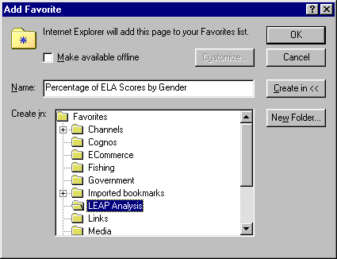
Note, folder appears “open”
- Click OK to save the bookmark.

For Netscape Communicator
- Click Bookmarks from the Communicator menu
- Click Add Bookmark
- The bookmark is placed in bookmarks list but, not in a specific folder
- To move the bookmark to a different folder, click Bookmarks from the Communicator menu then click Edit Bookmarks. You can then drag the bookmark into an existing folder or create a new folder for the bookmark.

