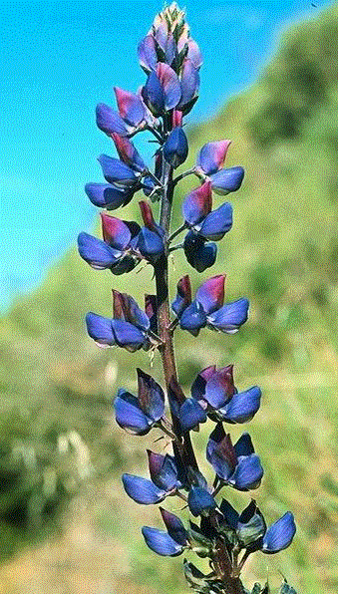

Monday, October 30, 2000

This Week!

This week we will be introducing a great story entitled Miss Rumphius. In this story Miss Rumphius is a very mature lady. In the story Little Alice looks at the life of Miss Rumphius and begins to set goals for herself. It is a great story about how one person can make the world a little better because of the choices he/she makes. Enjoy! Do you know what a lupine is?

Halloween/Harvest Fest

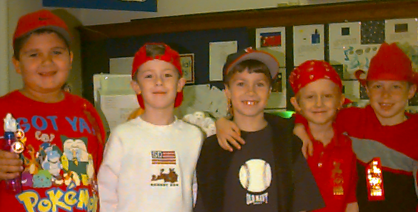
As a “Brunch Activity” we are planning on making and serving doughnuts at around 8:30am. The children seem to always really enjoy the awesome smell as the doughnuts fry, not to mention the great taste of the warm doughnut they await. The children will have the privilege of attending the Harvest Fest from 12:20 – 12:50 in the little gym. The Harvest Fest this year will be centered around the Wizard of Oz theme. The Halloween Parade will follow at the end of the day at 1:30. We will be dressing for the parade at approximately at 1:15. Please have your son/daughter bring his/her costume to school in a labeled bag. If your son/daughter is wearing make-up to school, please use it sparingly, since it has a tendency to smear and run within a few hours.

Parent -Teacher Conferences

Parent-Teacher Conferences are scheduled for Tuesday, November 7th from 11:00am - 8:00pm and Wednesday, November 15th from 8:00am – 3:00pm. Conference slips were sent home today. I have tried to give you the time you requested or as close to the time. Please complete the bottom portion of the slip, to confirm that this time will work out with your schedule and return with your son/daughter.

Reading Incentive

Thank you for helping your son/daughter prepare the “character pumpkin” for the Great Pumpkin Reading Program. Pumpkins will be on display tomorrow, October 31st in the auditorium.
Red Ribbon Week – Revisited

Great discussions were held as we wrote slogans on why we should remain drug free. Thank you for assisting your son/daughter in wearing red on Tuesday and Thursday. I know it must have been difficult to find all those red items. Below is a group photo of the children wearing red from head to toe.

Science Fair – Revisited

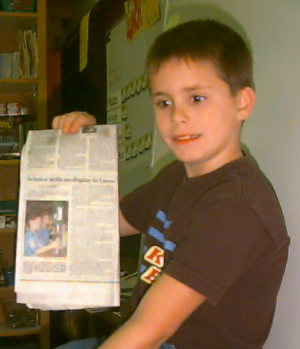
Thank you to all parents who assisted their son/daughter in participating in the Science Fair. Brandon thoroughly enjoyed sharing with the class his experiment, as well as the article that was placed in the Finger Lakes Times.

