Monday, October 16, 2000

This Week!

We will only be focusing on one story this week. The story is entitled Could Be Worse. In this story the children wonder if Grandpa’s life is boring, since things are always the same at his house and he keeps saying “could be worse”. Grandpa has however, a fantastic adventurous dream and this is where the story begins. Enjoy as you read it with your son/daughter. We will also begin a great story entitled The Pumpkin Patch. This is a non-fiction book all about pumpkins, from planting time all the way through harvest. This story will continue through next Tuesday.

Fire Prevention Week-Revisited
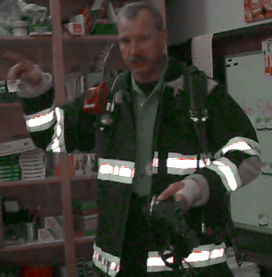
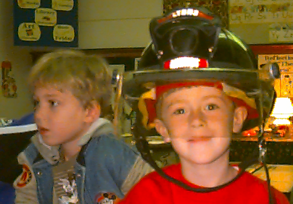
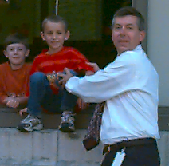
Mr. Aunkst came to school to show us the gear that firemen wear and the equipment they use. He also talked about the many ways to prevent fires and what to do in the event of a fire. We even did a drill by exiting through the window to prepare us for a fire that might develop in the hallway. The children were so excited. I think they will remember it a long time.

Harvest Fest

The Halloween Parade will be held this year on Tuesday, October 31st. Please note we are encouraging the children to wear costumes of a “gentle nature”. No spears, swords, guns or sharp objects, that could cause injury. Fun loving - not gory! Please keep these ideas in mind as you plan
with you son/daughter. Our Harvest Fest will also be held on Tuesday, October 31st. The Harvest Fest will be centered around the Wizard of Oz theme.

Science Fair

Our annual Science Fair will be held this Wednesday, October 18th. Children that are planning on participating, should plan to bring their projects to school on the 17^{th.} The projects can be picked up at the end of the fair at 7:30 or the following morning.

Parent -Teacher Conferences

Attached to the newsletter this week you will find the sign-up slip for Parent-Teacher 8:00pm and Wednesday, November 15th from 8:00am – 3:00pm. Please return the sign-up slip at your earliest convenience.

