Subject Area____Information Literacy K-6_______________Grade Level ___2____

Mission Statement: It is the mission of the Elba Central School District to actualize the phrase “Elba Equals Educational Excellence for Everyone.” We are committed to providing both quality and equity. Every student will have the opportunity to develop to the best of his/her ability.

Elba Standards: In addition to the knowledge and basic skills they need in order to participate in society, graduates of Elba Central School will develop:
- Empowering skills: decision making, goal setting, creative thinking and problem solving abilities;
- Communication and social interaction skills;
- Technological literacy;
- Total wellness (social, physical, emotional health and self-esteem);
- The values necessary to participate in society.
As a result of achieving these outcomes, our students will embrace lifelong learning.

National Standards:
Information Literacy
Standard 1: The student who is information literate accesses information efficiently and effectively.
Standard 2: The student who is information literate evaluates information critically and competently.
Standard 3: The student who is information literate uses information accurately and creatively.
Independent Learning
Standard 4: The student who is an independent learner is information literate and pursues information related to personal interests.
Standard 5: The student who is an independent learner is information literate and appreciates literature and other creative expressions of information.
Standard 6: The student who is an independent learner is information literate and strives for excellence in information seeking and knowledge generation.
Social Responsibility
Standard 7: The student who contributes positively to the learning community and to society is information literate and recognizes the importance of information to a democratic society.
Standard 8: The student who contributes positively to the learning community and to society is information literate and practices ethical behavior in regard to information and information technology.
Standard 9: The student who contributes positively to the learning community and to society is information literate and participates effectively in groups to pursue and generate information.
Performance Indicators:
Students will:
1-Media Center Responsibilities
- understand what a library is
- demonstrate good citizenship in the library by following rules and procedures
- utilize the librarian as a teacher and resource person
- demonstrate proper care of a book and other materials in the library
- follow circulation procedures
2- Collection Organization/Location
- have the ability to locate easy fiction, non-fiction, easy-to-read books and other relevant materials
- select materials for themselves
- understand that each item has a specific place on the library shelves
- understand the arrangement of fiction and non-fiction books
- have an awareness of the location and use of the catalog (OPAC)
3- Literature Appreciation
- recognize the variety of books available in the library
- have the ability to identify a variety of authors and genres (nursery rhymes, fairy tales, concept books, fantasy, non-fiction, poetry)
- develop an appreciation for his/her favorite books and authors
- recognize that books are for enjoyment as well as for information
- have an understanding of the Caldecott Medal
- develop an understanding of story elements (character, and plot)
4- Listening and Interactive Skills
- listen and comprehend stories read aloud (sequencing, prediction, retelling)
- recognize that quiet listening is necessary for group attention and enjoyment
- respond appropriately to what is seen and heard
- ability to differentiate between factual and non-factual information
5- Reference Skills
- understand ABC order
- understanding of how to use the encyclopedia
- participate in collaborated classroom/library supported research projects
6- Vocabulary
- use and understand the following terms:
  - borrow, return, renew, overdue
  - author, title, illustrator
  - spine, spine label, cover, barcode, paperback, hardcover, pages

Assessment: | Acceptable Performance Level
Conversations, questions, observations | Students will respond and participate in activities to support performance indicators.
Circulation statistics | All students will participate in book exchange. Circulation statistics will increase each year.
Surveys of knowledge and interests | 90% of students will answer questions on survey correctly.
Small group questioning | Students will actively participate in group discussions.

Scope: Second grade students will begin to develop an understanding of information literacy.

Sequence:

Month | Concept |  | Supporting Activities | Performance Indicator | Achieved Peformance Level
ON  GOING | Listening Skills |  | Use of props at the beginning of each story session, questions and conversations recalling information from stories- retelling of stories through skits and props. Ie:Get Well, Good Knight by Shelley Moore (reader’s theater)  Songs from HI Ho Librario! Judy Freeman and other artists. | 3, 4 | Reinforced
ON  GOING | Collection organization-Locate easy books |  | Orientation at beginning of year-Book exchange,  Questionnaire | 2 | Reinforced
ON  GOING | Collection organization-Locate fiction, non-fiction and easy to read books |  | Orientation review at beginning of year-  Book exchange-  Questionaire  Dewey Decimal system  Look for 398.2 (Hi ho librario!);folklore, | 2 | Introduced
ON  GOING | Literature appreciation-  Story elements |  | Discussion after stories of characters and plot- worksheet to reinforce (Activities for any Literature Unit)-  Retelling of stories using characters and plot-draw pictures using story elements-  Story elements poster | 3 | Introduce
SEPT | Proper handling of books |  | Mr. Wiggles poster; practice with books on tables; create bookmarks to mark page; | 1 | Reinforced
SEPT | Circulation procedures |  | Book exchange,  Questionnaire | 1, 2, 6 | Reinforced
OCT |  | Vocabulary | Parts of a book worksheet (Explore the Library A-B) | 6 | Introduced/Reinforced
OCT |  | Literature appreciation- Historical Fiction | Mailing May (Tunnell); Eleanor and Amelia Go For a Ride; Prairie Train (Chall); The Girl on the High-Diving Horse (High); Homespun Sarah (Kay); Henry Climbs a Mountain (Johnson); Prairie Friends (Levinson); Up the Learning Tree (Vaughan); | 3 | Introduce
NOV |  | Reference Skills-ABC Order | www.littlefingers.com (shelving books); Between the Lions Website: ABCow  Green Eggs and Ham game  Questionaire | 5 | Reinforced
JAN |  | Literature appreciation- Fantasy | Gather multiple copies of fantasy books; divide students into groups and give each group one fantasy book, a red pen and a blue pen; Instruct each group to draw on notepaper three columns labeled Characher, Plot, and Setting; As group members read their book, have them fill in each column, writing the realistic elements in blue, and the fantastical elements in red. Compare findings. | 3 | Reinforced
JAN |  | How to use the OPAC | Students look up subject, title or author on the OPAC; answer questions about the information and locate the book on the shelf. | 2
FEB |  | Literature appreciation-  Fairy tales & Folktales | Flannel Board Storytelling, puppets, puppet theater,  SLS CCB- Folktales, Fairy Tales and Nursery Rhymes. Comparison of versions of fairy tales- Venn Diagram-  Fairy and Folktale Tic-Tac-Toe (Reaching Every Reader)  Spoonerisms | 3 | Reinforced
APRIL |  | Literature appreciation-Poetry | Announce at the end of each class “Poetry Break!” and read a poem as a signal to students that class is almost over.  Alligator Pie (Hi Ho Librario!); Jack Prelutsky; Shel Silverstein (cd);  Alligators All Around; Chicken Soup With Rice; Pierre; | 3
MAY |  | Reference Skills- encyclopedia |  | 5 | Introduce

Methodology: Best practices, 6+1 Writing, storytelling, puppetry, RAC, Information Power

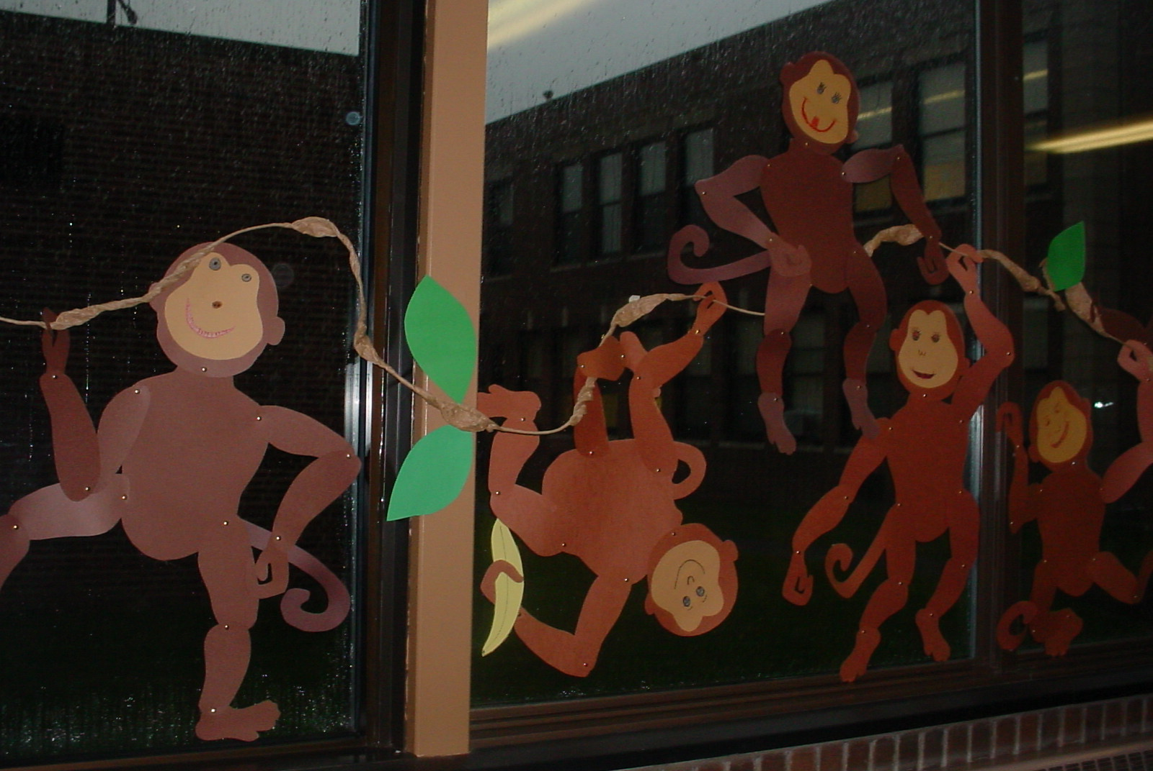
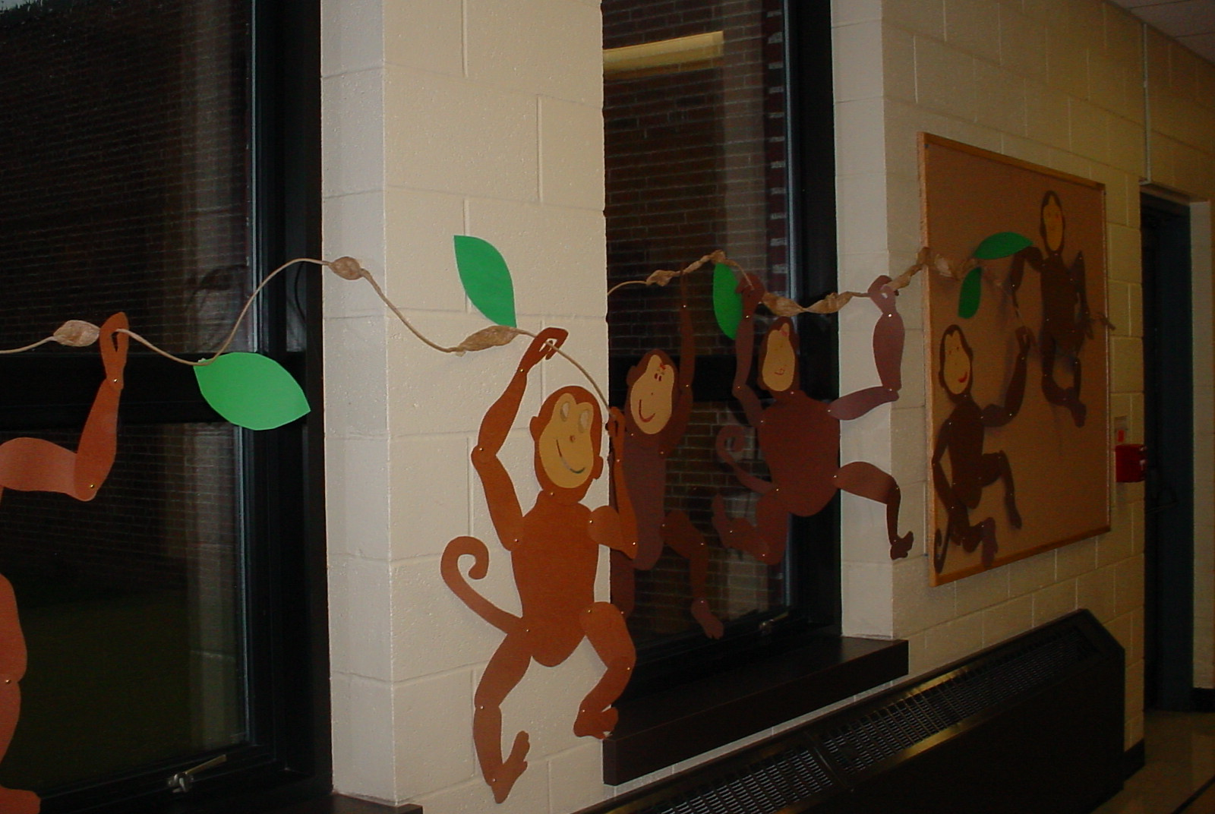

Monkeys made by 2nd graders for Jim Aylesworth author visit.

Bibliography:

Bannister, Barbara Farley. Elementary School Librarian’s Survival Guide. 1993.

The Best of Mailbox Magazine: Authors: Grades 1-3, 1999.

Carey, Patsy.Activities for any Literature Unit, 1995.

Davis, Robin Works. An Alphabet of Books, 1995.

Davis, Robin Works. An Alphabet of Authors, 1996.

Dingwall, Cindy. Library Celebrations, 1999.

Freeman, Judy. What’s New in Children’s Literature and Strategies for Using It in Your Program, 2003.

Miller, Pat. Reaching Every Reader: Promotional Strategies for the Elementary School Library Media Specialist, 2001.
Preller, James. The Big Book of Picture-Book Authors and Illustrators, 2001.

Rhodes, Immacula A. Teaching With Favorite Kevin Hawkes Books, 2002.

Ritter, Darlene. Literature-Based Art Activities, 1991.

Spencer, Gwynne. What’s Cooking in Children’s Literature, 2001.

SAMPLE

2nd Grade Questionaire

Date: ____________
Class:____________
Names: ___________________________________________

1. What do you like best about coming to library?
Responses:

2. Is there a book that we have read together that is your favorite?
Responses:

3. What letter is this? (Hold up several letters, have individuals answer) Responses:

4. What does the author do? What does the illustrator do?

5.Where in the library can you find easy/picture books?

Nonfiction?

6. Which of the following activities would be your favorite?
Play with playdough, look at a book or watch TV

7. Name something that you like to do for fun or something that you are interested in.

8. Will you tell me five ways to handle books that will keep the books looking nice?

SAMPLE

2nd Grade Vocabulary Survey

Date: ______________
Class:______________

Name of Student | author | title | illustrator | spine | spine label | cover | barcode | paperback | hardcover | pages

