Photo Page
Insured: Byron-Bergen CSD
Location: 6917 West Bergen Rd. Bergen, NY

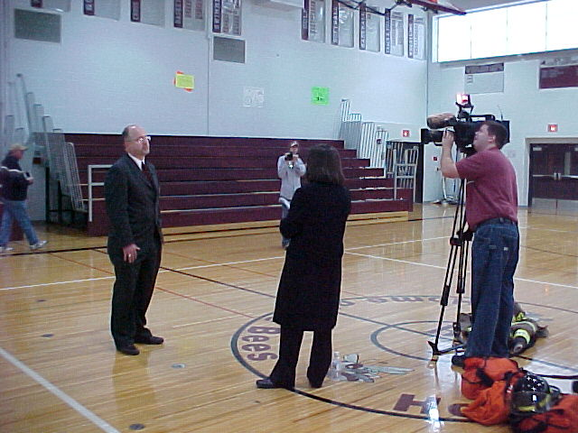 |  | 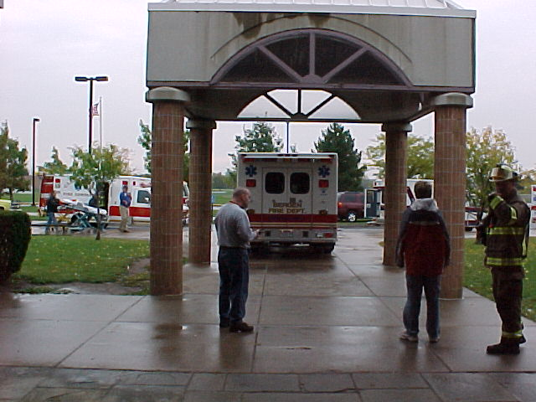
Photo 1 – Mr. Greg Geer (School Supt.) being interviewed by Rochester TV news station |  | Photo 2 – Emergency vehicles transporting injured students.
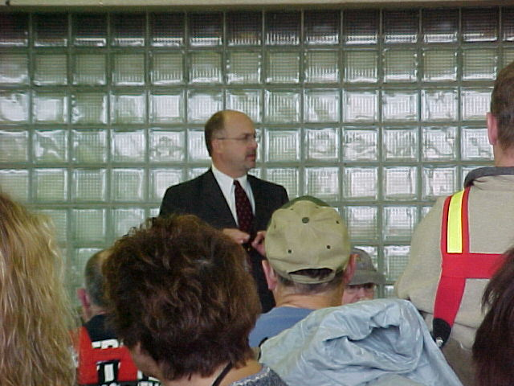 |  | 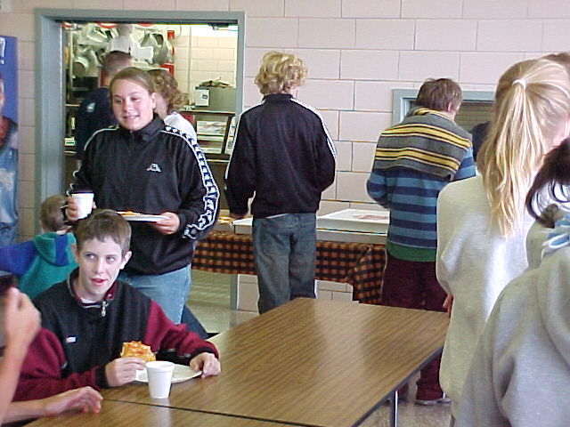
Photo 3 – Mr. Geer commenting as part of a debrief after crisis drill. |  | Photo 4 - Food and refreshments for drill participants.
Photo 5 - |  | Photo 6 -

