Photo Page
Insured: Byron-Bergen CSD
Location: 6917 West Bergen Rd. Bergen, NY

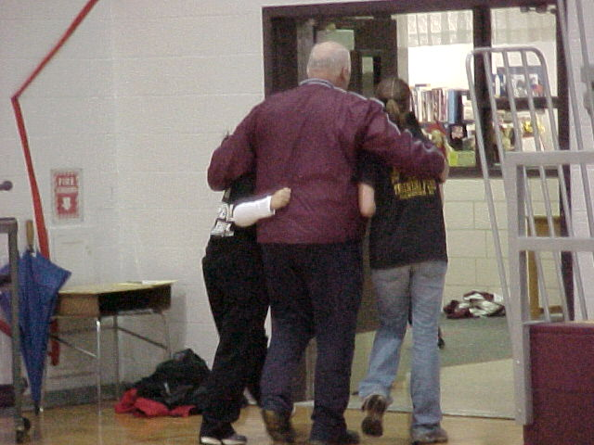 |  | 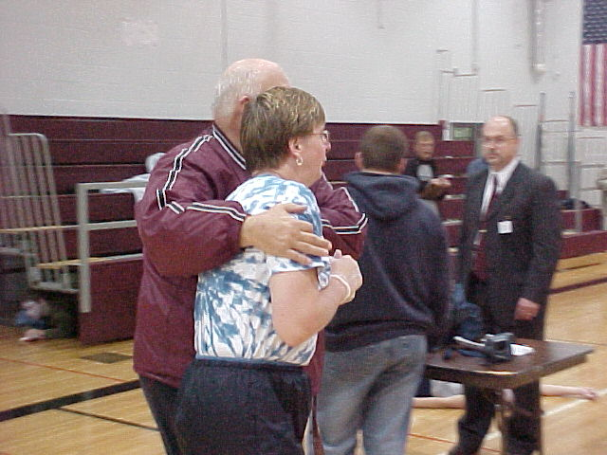
Photo 1 – Administrator consoling students |  | Photo 2 – Administrator consoling parent
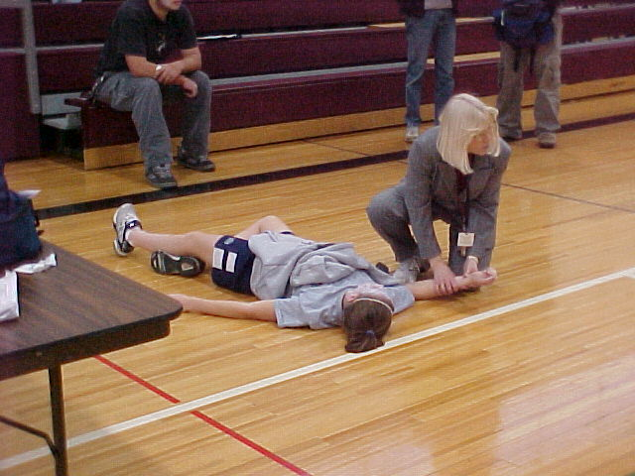 |  | 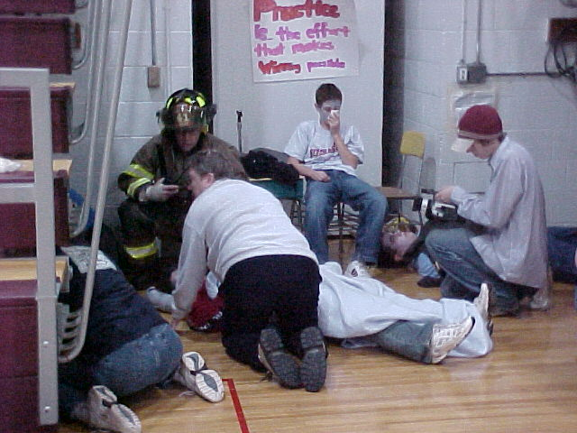
Photo 3 - Injured Student Being Attended To |  | Photo 4 - Injured Student Being Attended To
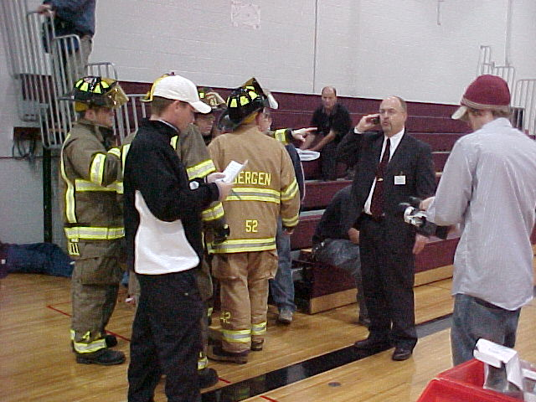 |  | 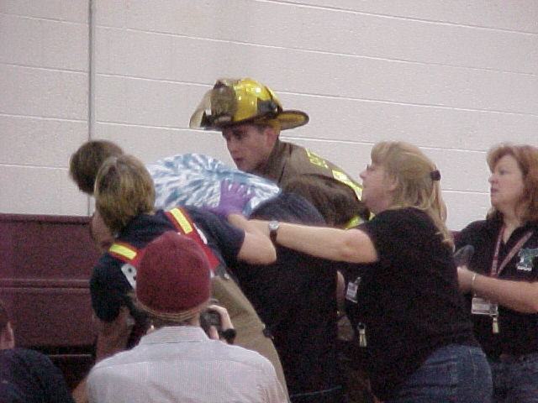
Photo 5 – Emergency responders and Mr. Geer (School Supt.) assessing scene. |  | Photo 6 – Emergency responders and other personnel handling a distraught parent.

