Photo Page
Insured: Byron-Bergen CSD
Location: 6917 West Bergen Rd. Bergen, NY

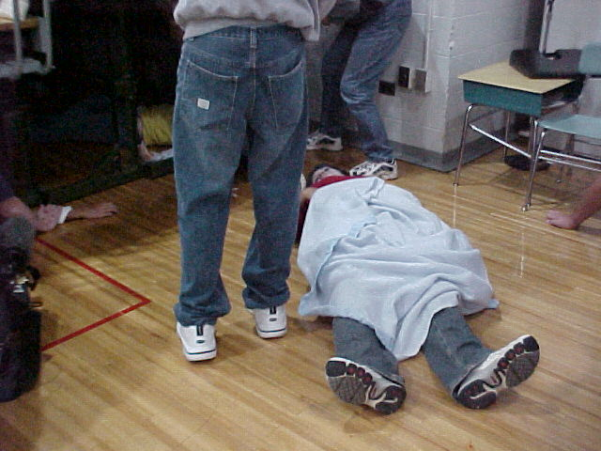 |  | 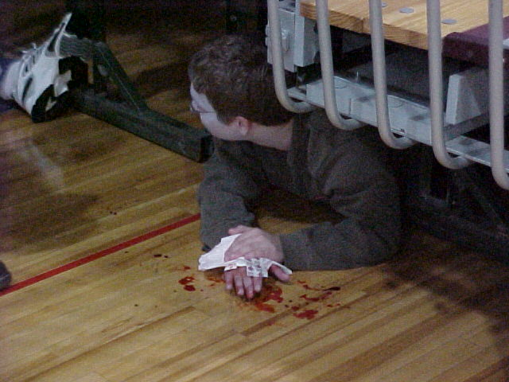
Photo 1 -Injured Student |  | Photo 2 – Injured Student
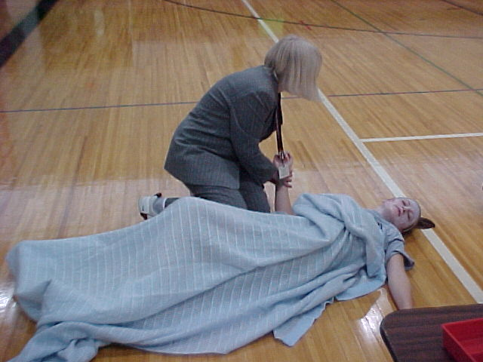 |  | 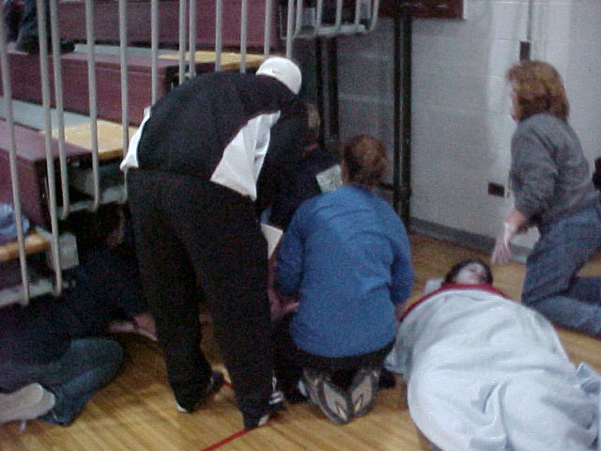
Photo 3 - Injured Student Being Attended To |  | Photo 4 - Injured Student Being Attended To
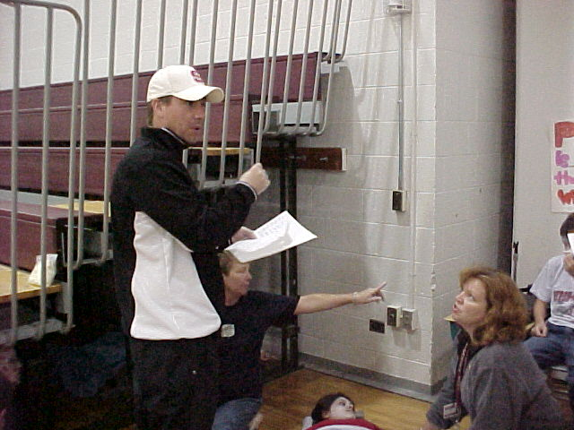 |  | 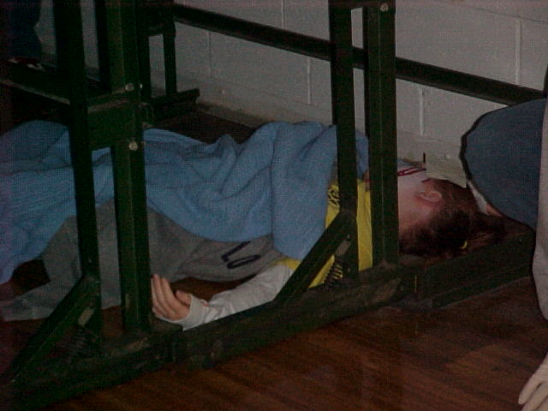
Photo 5 – Coach accounting for Injured Students |  | Photo 6 - Injured Student

