Photo Page
Insured: Byron-Bergen CSD
Location: 6917 West Bergen Rd. Bergen, NY

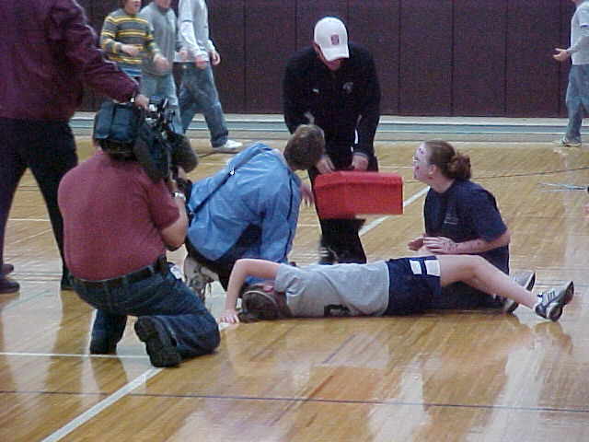 |  | 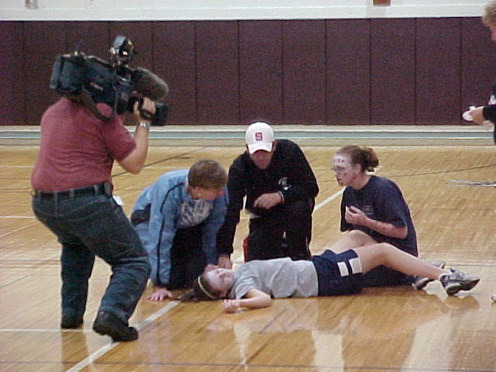
Photo 1 -Injured Student Being Assisted. Also, camera man from local TV News |  | Photo 2 – Injured Student Being Assisted. Also, camera man from local TV News
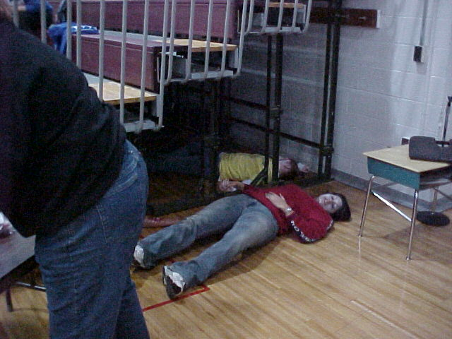 |  | 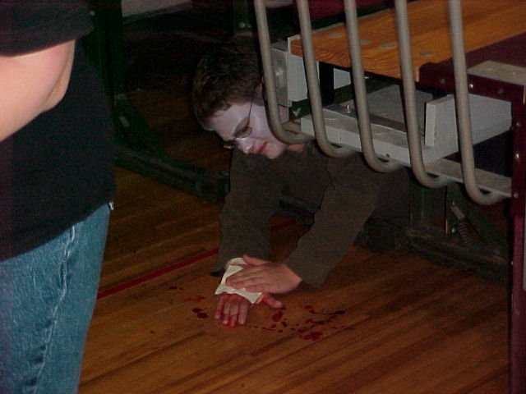
Photo 3 – Injured Student |  | Photo 4 - Injured Student
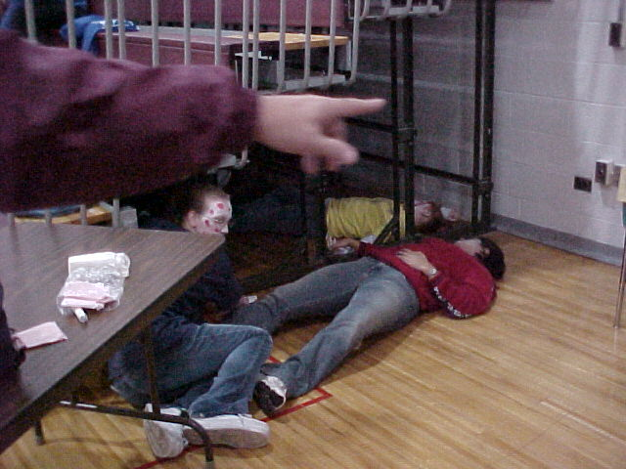 |  | 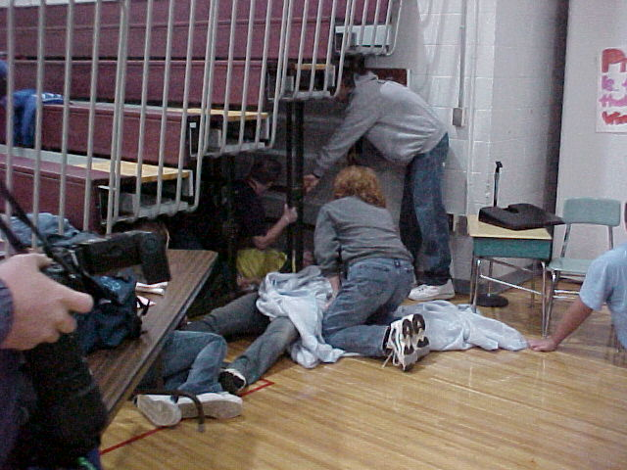
Photo 5 - Injured Students |  | Photo 6 - Injured Students Being Assisted

