Photo Page
Insured: Byron-Bergen CSD
Location: 6917 West Bergen Rd. Bergen, NY

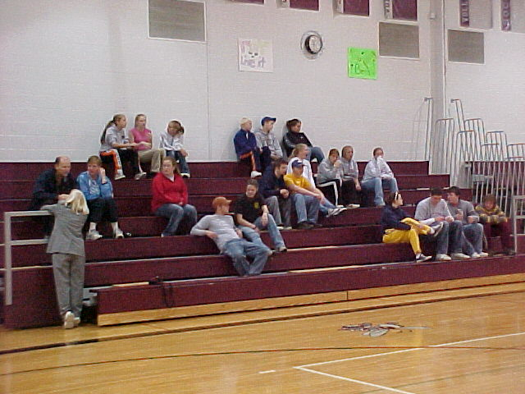 |  | 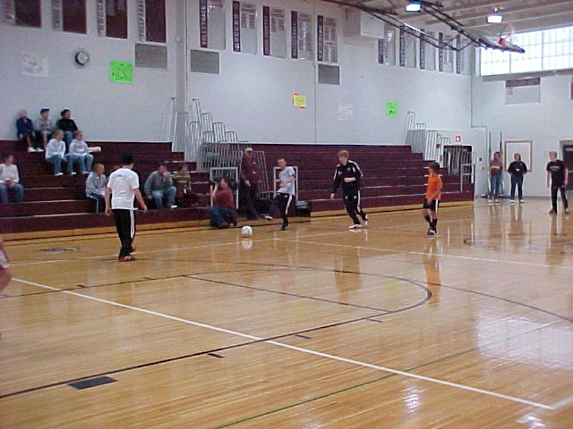
Photo 1 – Spectators Watching Fake Soccer Game |  | Photo 2 – Soccer Game
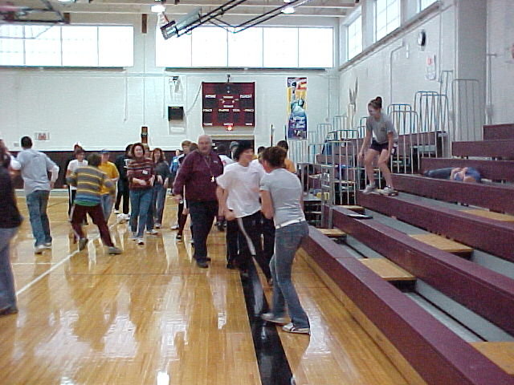 |  | 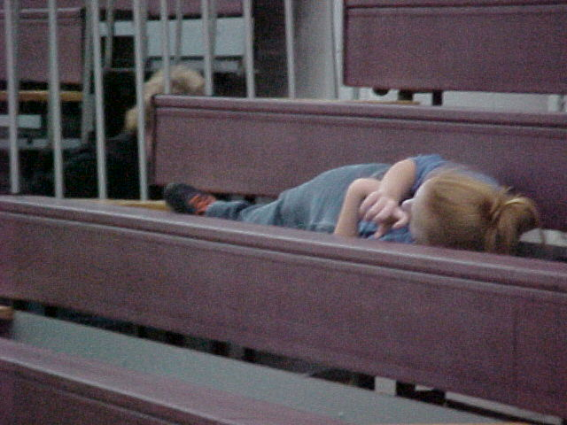
Photo 3 – Shortly After Bleacher Collapse |  | Photo 4 - Injured Student
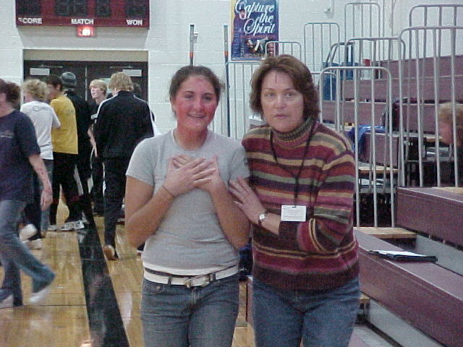 |  | 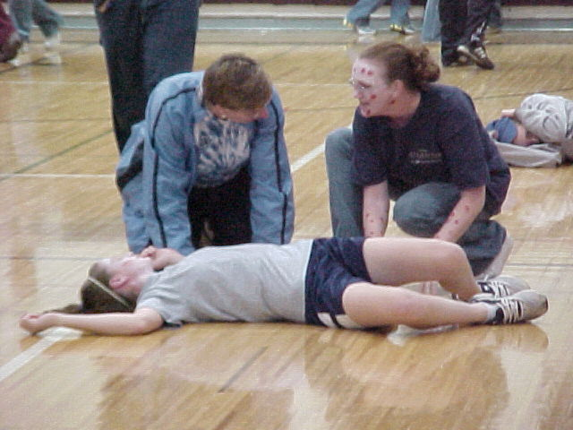
Photo 5 - Injured Student Being Assisted |  | Photo 6 - Injured Student Being Assisted

