Subject Area____Information Literacy K-6_______________Grade Level ___1____

Mission Statement: It is the mission of the Elba Central School District to actualize the phrase “Elba Equals Educational Excellence for Everyone.” We are committed to providing both quality and equity. Every student will have the opportunity to develop to the best of his/her ability.

Elba Standards: In addition to the knowledge and basic skills they need in order to participate in society, graduates of Elba Central School will develop:
- Empowering skills: decision making, goal setting, creative thinking and problem solving abilities;
- Communication and social interaction skills;
- Technological literacy;
- Total wellness (social, physical, emotional health and self-esteem);
- The values necessary to participate in society.
As a result of achieving these outcomes, our students will embrace lifelong learning.

National Standards:
Information Literacy
Standard 1: The student who is information literate accesses information efficiently and effectively.
Standard 2: The student who is information literate evaluates information critically and competently.
Standard 3: The student who is information literate uses information accurately and creatively.
Independent Learning
Standard 4: The student who is an independent learner is information literate and pursues information related to personal interests.
Standard 5: The student who is an independent learner is information literate and appreciates literature and other creative expressions of information.
Standard 6: The student who is an independent learner is information literate and strives for excellence in information seeking and knowledge generation.
Social Responsibility
Standard 7: The student who contributes positively to the learning community and to society is information literate and recognizes the importance of information to a democratic society.
Standard 8: The student who contributes positively to the learning community and to society is information literate and practices ethical behavior in regard to information and information technology.
Standard 9: The student who contributes positively to the learning community and to society is information literate and participates effectively in groups to pursue and generate information.
Performance Indicators:
Students will:
1-Media Center Responsibilities
- understand what a library is
- demonstrate good citizenship in the library by following rules and procedures
- utilize the librarian as a teacher and resource person
- demonstrate proper care of a book and other materials in the library
- follow circulation procedures
2- Collection Organization/Location
- display the ability to locate easy fiction, non-fiction, easy-to-read books and other relevant materials
- select materials for themselves
- understand that each item has a specific place on the library shelves
3- Literature Appreciation
- recognize the variety of books available in the library
- have the ability to identify a variety of authors and genres (nursery rhymes, fairy tales, concept books, fantasy, non-fiction, poetry)
- develop an appreciation for his/her favorite books and authors
- recognize that books are for enjoyment as well as for information
- have an understanding of the Caldecott Medal
- develop an understanding of story elements (character, and plot)
4- Listening and Interactive Skills
- listen and comprehend stories read aloud (sequencing, prediction, retelling)
- recognize that quiet listening is necessary for group attention and enjoyment
- respond appropriately to what is seen and heard
- ability to differentiate between factual and non-factual information
5- Reference Skills
- understand ABC order
6- Vocabulary
- use and understand the following terms:
  - borrow, return, renew, overdue
  - author, title, illustrator
  - spine, spine label, cover, barcode, paperback, hardcover, pages

Assessment: | Acceptable Performance Level
Conversations, questions, observations | Students will respond and participate in activities to support performance indicators.
Circulation statistics | All students will participate in book exchange. Circulation statistics will increase each year.
Surveys of knowledge and interests | 90% of students will answer questions on survey correctly.
Small group questioning | Students will actively participate in group discussions.

Scope: First grade students will begin to develop an understanding of information literacy.

Sequence:

Month |  |  | Concept | Supporting Activities | Performance Indicator | Achieved Peformance Level
Ongoing |  |  | Circulation procedures | Participate in book exchange  Survey and questionaire | 1, 2, 3, 6 | Reinforced
Ongoing |  |  | Listening Skills | Use of props at the beginning of each story session, questions and conversations recalling information from stories- retelling of stories through skits and props. The Mitten by Jan Brett- each student wears the mask of an animal from the story and acts out the part www.janbrett.com  Songs from HI Ho Librario! Judy Freeman and other artists. | 4 | Reinforced
Ongoing |  |  | Literature appreciation-Author and illustrator appreciation | Marc Brown, Leo Lionni, Norman Bridwell, Eric Carle, Kevin Henkes, Dr. Seuss, Beatrix Potter, Robert Munsch, Audrey Wood, Jan Brett, etc  Surveys and questionaire  Author visit  Concentration game using characters from books-Curious George  Brief intro to Caldecott Medal  Mem Fox author study  http://www.memfox.net/  Laura Numeroff author study (Moose puppet)  author reads stories. | 3 | Introduced and reinforced
Ongoing |  |  | Collection organization-Locate easy books | Orientation at beginning of year-Book exchange,  Questionnaire | 2 | Reinforced
Ongoing |  |  | Literature appreciation-Picture Books, Concept Books, Fantasy, Non-fiction | activities to reinforce sequencing, retelling, and prediction. Activities For Any Literature Unit (Primary)-real vs. make-believe- puzzle time—  Fantasy genre- gather many fantasy picture books with illustrations; have students trace real illustrations and make believe illustrations on two separate pieces of paper.  Comparison between fiction and non-fiction books—  (Halloween) Hattie the Backstage Bat (Freeman) puppet; Stella Luna; B-B-B-Bats; Beautiful Bats  (Thanksgiving)ie: Squanto’s Journey by Joseph Bruchac & Thanksgiving at the Toppleton’s by Eileen Spinelli to compare fiction vs. non-fiction at Thanksgiving-- various fiction and non-fiction books on tables for students to look at and compare—point out differences, photos, facts, not a make believe story.  A Weekend With Wendell by Kevin Henkes- When did it happen? Sequencing worksheet (p. 34)  Lily’s Purple Plastic Purse by Kevin Henkes- Movie-star glasses (p.54)  (Christmas) Christmas Trolls (Brett); Wait Until Christmas, Walter! (Christelow); How the Grinch Stole Christmas; The Berenstain Bears Save Christmas;  (Easter) It’s Perfectly True (Andersen); The Most Wonderful Egg in the World (Heine); Chicken Little (Kellogg); Peeping Beauty (Auch); Eggs Mark the Spot (Auch);  The Easter Egg Farm (Auch); Zinnia and Dot (Ernst); Oh I Had a Little Chicken/I Went to Cincinnati (Hi Ho Librario!);  (Spring) The Very Hungry Caterpillar; The Caterpillar Fight (McBratney)puppet; From Caterpillar to Butterfly (Heiligman) If At First You Do Not See (Brown); Cecil Was a Caterpillar (Hi Ho Librario!);  (Food) A Nice Walk in the Jungle (Bodsworth); Mother, Mother, I Feel Sick, Send for the Doctor, Quick, Quick, Quick. (Charlip); Henry My Son (Hi Ho Librario!); Gregory the Terrible Eater- book + Reading Rainbow movie- problem and solution; The Hungry Thing (Slepian); How to Make an Apple Pie and See the World; The Robbery at the Diamond Dog Diner; Pete’s a Pizza; Little Nino’s Pizzeria;  (Snakes) Hide and Snake (Baker); The Singing Snake (Czernecki); How Snake Got His Hiss: An Original Tale (Davol); Verdi (Cannon); The Day Jimmy’s Boa Ate the Wash (Noble)-books and video- have class supply sound effects during story- ; Jimmy’s Boa Bounces Back (Noble)puppet- draw a picture of a further adventure of Jimmy’s boa;  (Sickness) Who’s Sick Today? (Cherry); Rachel Fister’s Blister (MacDonald); The Adventures of Isabel (Nash);  (Wordless books) Deep in the Forest; Good Night, Gorilla; Do You Want to Be My Friend; Anno’s Alphabet; Rosie’s Walk; Tuesday; My Friend Rabbit;-see attached article;  (Groundhog day) Gregory’s Shadow (puppet) | 3, 4 | Reinforced
Sept |  |  | Media Center responsibilities-What is a library? | Read aloud concept books about libraries; The Library (Stewart); Book! Book! Book! (Bruss); Check It Out (Gibbons); | 1 | Reinforced
Sept/Oct | Proper handling of books |  |  | Mr. Wiggles poster; practice with books on tables; create bookmarks to mark page; questionaire | 1 | Reinforced
Oct | Vocabulary |  |  | parts of a book color and label worksheet,  reinforcement of parts of book during storytime.  Individual surveys and questionnaires | 6 | Reinforced
Nov | Reference Skills-ABC Order |  |  | ABC concept books; Chicka, Chicka, Boom, Boom (book and software); www.littlefingers.com (shelving books); Between the Lions Website: ABCow; Jan Brett flash cards;  Questionnaire  Play Green Eggs and Ham game | 2, 5 | Reinforced
Dec | Vocabulary-author, title, illustrator |  |  | The Tale of Thomas Mead (Hutchins); Somewhere in Africa (Mennen); Hi Ho Librario! | 6 | Reinforced
Jan | Collection organization-each item has a specific location |  |  | Look for 398.2 (Hi ho librario!); The Dragon’s Pearl (Lawson); Puss in Boots; Papa Gatto: An Italian Fairy Tale (Sanderson); From Sea to Shining Sea: A Treasury of American Folklore and Folk Songs;  Strega Nona; Clever Tom and the Leprechaun (Shute, Linda); A Tale of Two Tengu: A Japanese Folktale (McCoy, Karen Kawamoto)  Other countries:Australia- The Singing Snake (Czernecki); South America- Moon Rope: Un Lazo a la Luna: A Peruvian Folktale (Ehlert);  Joseph Had a Little Overcoat- | 2 | Reinforced
Feb | Literature appreciation-Nursery Rhymes, Fairy Tales |  |  | Throw it Out the Window (Hi Ho Librario!) The Comic Adventures of Old Mother Hubbard and Her Dog (DePaola); Dear Peter Rabbit (Ada); The Mother Goose Songbook (Glazer); The Hole by the Apple Tree: An A-Z Discovery Tale (Polette)(also alphabet memorization);  Jane Yolen’s Mother Goose Songbook;  There Was an Old Lady Who Swallowed a Fly; Hoimie the Woim (Hi Ho Librario!); The Greedy Old Fat Man: An American Folktale (Galdone);  Mother Goose, Wee-Sing Nursery Rhymes cassette tape, Mother Goose on the Internet  http://www.ipl.org/div/kidspace/storyhour/goose/  StorytellingGlove, Flannel Board Storytelling, puppets, puppet theater,  Five little monkeys story board;  Halloween story board; Gingerbread man story board; Little Red Hen story board;  SLS CCB-Folktales, Fairy Tales and Nursery Rhymes.  Comparison of versions of fairy tales, ie: Goldilocks and the Three Bears vs. Goldilocks and the Three Hares | 3, 4 | Reinforced
Dec & Mar | Literature appreciation-  Story elements |  |  | Discussion after stories of characters and plot- worksheet to reinforce (Activities for any Literature Unit)-  Retelling of stories using characters and plot-draw pictures using story elements- | 3 | Introduce
April |  | Literature appreciation-Poetry |  | Announce at the end of each class “Poetry Break!” and read a poem as a signal to students that class is almost over. Down By the Bay (Raffi); Gifts (Bogart)(song: My Aunt Came Back); Spider on the Floor (Raffi); The Lady With the Alligator Purse (Westcott); Alligator Pie (Hi Ho Librario!); Alligators All Around; Chicken Soup With Rice; Jack Prelutsky; Shel Silverstein (cd); Munching: Poems About Eating (Hopkins); Do Not Feed the Table (Lillegard); Just Dessert (Powell); | 3 | Reinforced

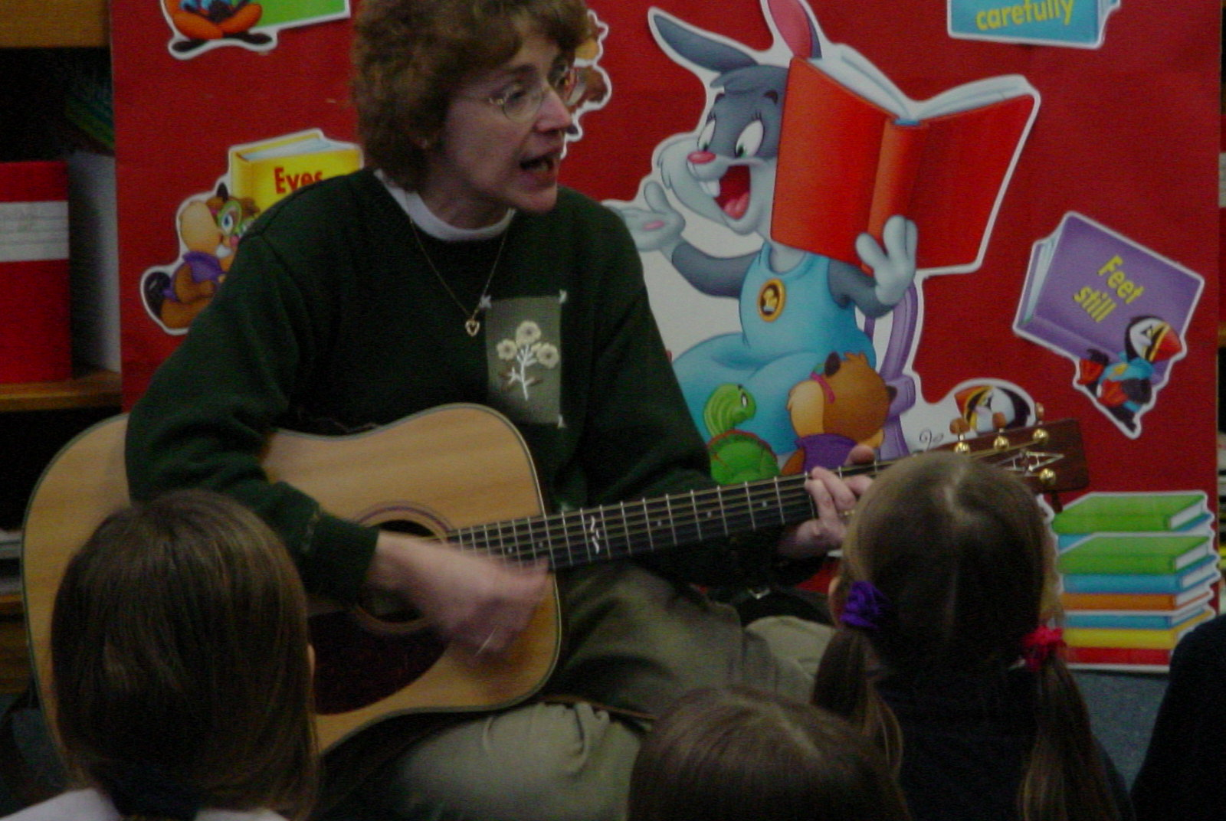
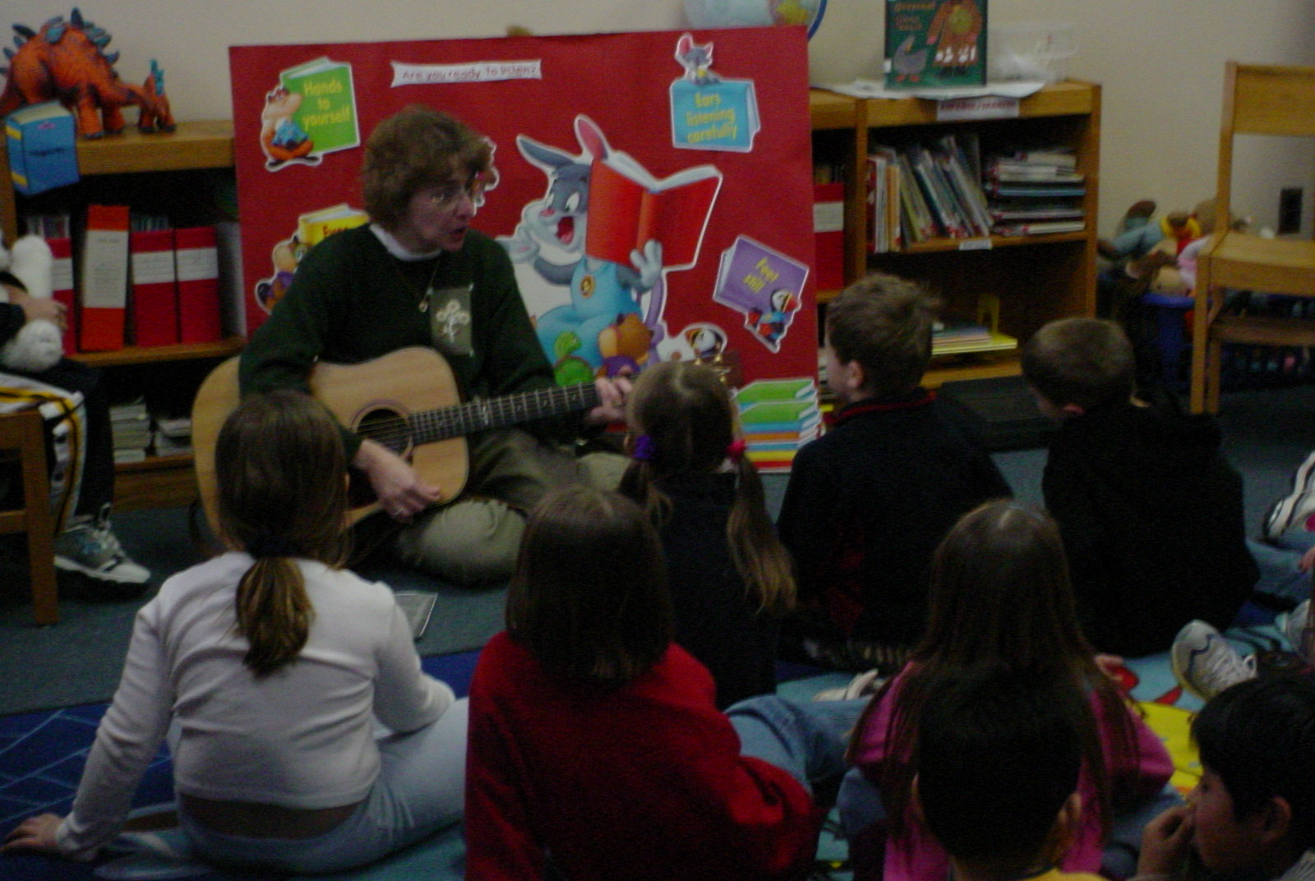

Guest (Joyce Pcionek) playing guitar and singing the folk song “Joseph Had a Little Overcoat” with 1st grade classes.

Methodology: Best Practices, 6+1 Writing, Storytelling, puppetry, RAC, Information Power

Bibliography:

Bannister, Barbara Farley. Elementary School Librarian’s Survival Guide. 1993.

The Best of Mailbox Magazine: Authors: Grades 1-3, 1999.

Carey, Patsy.Activities for any Literature Unit, 1995.

Davis, Robin Works. An Alphabet of Books, 1995.

Davis, Robin Works. An Alphabet of Authors, 1996.

Dingwall, Cindy. Library Celebrations, 1999.

Freeman, Judy. What’s New in Children’s Literature and Strategies for Using It in Your Program, 2003.

Miller, Pat. Reaching Every Reader: Promotional Strategies for the Elementary School Library Media Specialist, 2001.
Preller, James. The Big Book of Picture-Book Authors and Illustrators, 2001.

Ritter, Darlene. Literature-Based Art Activities, 1991.

Spencer, Gwynne. What’s Cooking in Children’s Literature, 2001.

SAMPLE

1st Grade Questionaire

Date: ____________
Class:____________
Names: ___________________________________________

1. What do you like best about coming to library?
Responses:

2. Is there a book that we have read together that is your favorite?
Responses:

3. What letter is this? (Hold up several letters, have individuals answer) Responses:

4. What does the author do? What does the illustrator do?

5.Where in the library can you find easy/picture books?

Nonfiction?

6. Which of the following activities would be your favorite?
Play with playdough, look at a book or watch TV

7. Name something that you like to do for fun or something that you are interested in.

8. Will you tell me five ways to handle books that will keep the books looking nice?

SAMPLE

1st Grade Vocabulary Survey

Date: ______________
Class:______________

Name of Student | author | title | illustrator | spine | spine label | cover | barcode | paperback | hardcover | pages

