Contents

Section 1PowerPlay Web Skills
1

Changing Measures…………………………………………………………... | 2
Drilling Down…………………………………………………………………... | 4
Replacing a Dimension with Another Dimension………………………….. | 6
Filtering…………………………………………………………………………. | 8
Nesting a Subcategory……………………………………………………….. | 9
Removing a Nesting………………………………………………………….. | 11
Using Measures as a Dimension……………………………………………. | 13
Swapping Rows and Columns………………………………………………. | 15
Nesting Another Dimesion…………………………………………………… | 17
Swapping Nested Dimensions………………………………………………. | 19
Changing between Percentage of Rows and Columns…………………… | 21
Changing between Percentage of Row/Column Subtotals……………….. | 22
Suppressing Zeros……………………………………………………………. | 24

Section 2Workshops
25

A. | Show the percent of students at each performance level on the ELA 4 for each income group………………………………………………… | 26
B. | Show the percentage distribution of results for the 1999 Grade 4 Math test for your school district and compare it to the regionally summarized scores………………………………………………………. | 29
C. | Show a multi-year comparison of the PEP 5 writing data as well as an analysis of the performance of the different groups of students based on their program services……………………………………….. | 32

Section 3Appendices
35

Definition of Terms……………………………………………………………. | 36
Tips and Tricks………………………………………………………………... | 38
Cognos Web Access Screen Diagram……………………………………... | 39
Dimension Viewer Diagram………………………………………………….. | 40
Results Display Diagram…………………………………………………….. | 41
Toolbar…………………………………………………………………………. | 42
Database and Cube Comparison…………………………………………… | 43
1998-1999 LEAP Record Layout……………………………………………. | 44

Section 1PowerPlay Web Skills

Changing Measures………………………………………….…. | 2
Drilling Down……………………………………………..……... | 4
Replacing a Dimension with Another Dimension……………. | 6
Filtering…………………………………………..………………. | 8
Nesting a Subcategory………………………...……………….. | 9
Removing a Nesting……………………………...…………….. | 11
Using Measures as a Dimension…………...…………………. | 13
Swapping Rows and Columns………...………………………. | 15
Nesting Another Dimesion……...……………………………… | 17
Swapping Nested Dimensions…...……………………………. | 19
Changing between Percentage of Rows and Columns..…… | 21
Changing between Percentage of Row/Column Subtotals.... | 22
Suppressing Zeros……………………………………………… | 24

Changing Measures

Why?
When we want to view a different measure (Number of Assessments or Average Score)

Example
- We’re viewing the number of assessments for all LEAP Subject Areas
- We’d like to see the number of assessments for the individual measures in the ELA Subject area only
- We need to drill down on the ELA Subject area

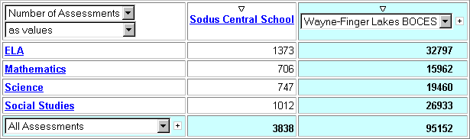
Number of Assessments by Subject Area
Note, we’re viewing number of Assessments

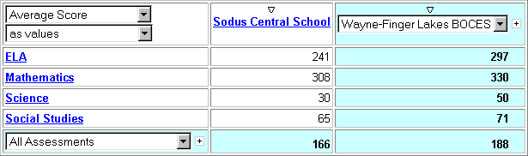
Average Score of Assessments by Subject Area
Now, we’re viewing the Average Score

Drilling Down

Why?
When we want to view more detailed results for a category by showing its sub-category instead

Example
- We’re viewing the number of assessments for all LEAP Subject Areas
- We’d like to see the number of assessments for the individual measures in the ELA Subject area only
- We need to drill down on the ELA Subject area

Number of Assessments by Subject Area for Each Year

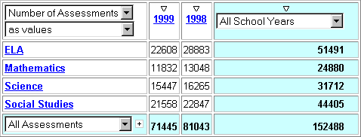

Click ELA to show the individual ELA measures

Drilling Down (cont.)
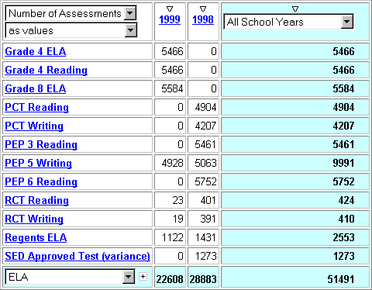
Now, we’re viewing only ELA Assessments

Number of ELA Assessments by Measure for Each Year

Replacing a Dimension with another Dimension

Why?
When we want to view results for another dimension (row or column), we need to replace that dimension

Example
- We’re viewing the percentage of assessments against the different populations of students for each year
- We now want to view the percentage of assessments by ethnicity for each year
- We need to replace a dimension

Percentage of Assessments by Population for Each Year

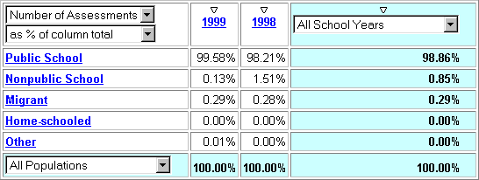
Note, we’re viewing Populations

Replacing a Dimension with another Dimension (cont.)
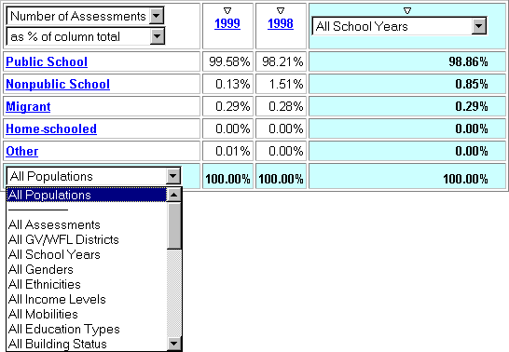
Click All Ethnicities

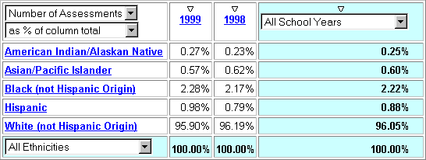
Percentage of Assessments by Ethnicity for Each Year
Now, we’re viewing Ethnicities

Why?
Filtering
To view only data for an individual category of a Dimension

Example
- We’re viewing the average score of each student in each Subject area by Income Level for all Integration Levels
- We now want to only view the scores for students who are out of Regular Education classes 0-20% of the time
- We need to filter the Integration Level dimension
Average Score by Subject Area and Income Level

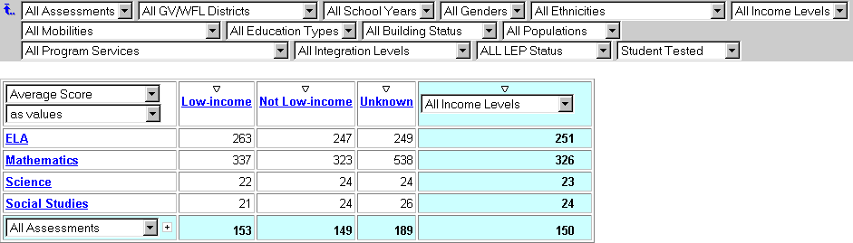
Note, only students tested !!

Click Outside Regular Ed 0-20%
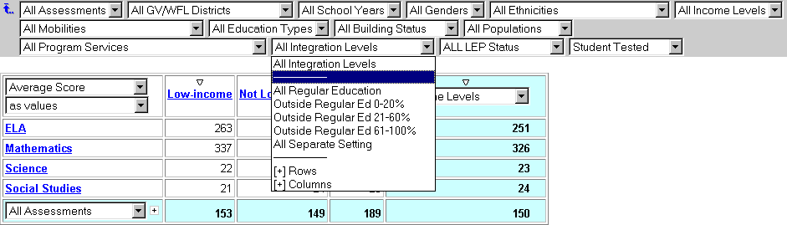
Now, Only that Integration Level shows
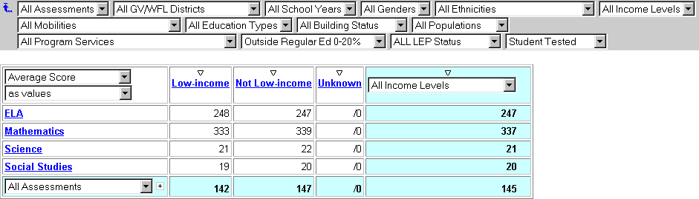

Why?
Nesting a Subcategory
When we want to view more detailed results for all categories shown by also showing their subcategories

Example
- We’re viewing the number of assessments for all LEAP Subject Areas by year
- We’d like to see the number of assessments for the individual measures in all of the Subject Areas
- We need to nest the Subject Areas
Number of Assessments by Subject Area for Each Year

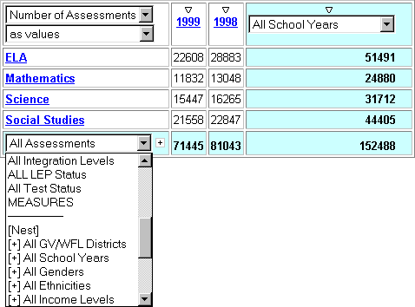
Click [Nest] or the Plus Sign +

Number of Assessments by Test within Each Test Area for Each Year
Nesting a Subcategory (cont.)

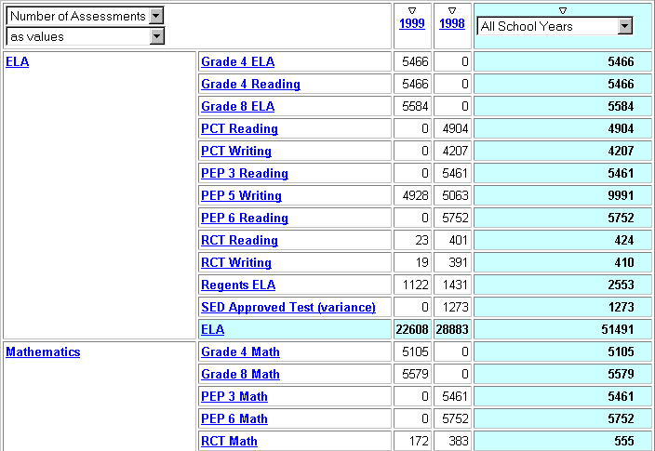
Number of Assessments by Measure within each Subject Area for Each Year
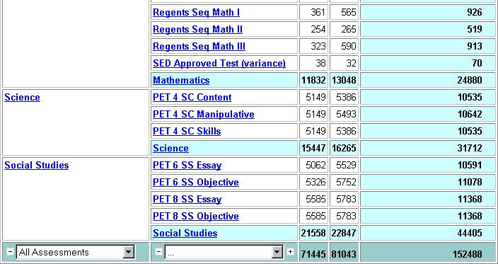

Now, we’re viewing measures within each subject area

Why?
Removing a Nesting
When we’re done viewing the results at the nested level

Example
- We’re viewing the number of assessments for all measures in each LEAP Subject Area by year
- We’d like to see only the LEAP Subject Areas by year
- We need to remove a nesting
Number of Assessments by Measure within each Subject Area for Each Year

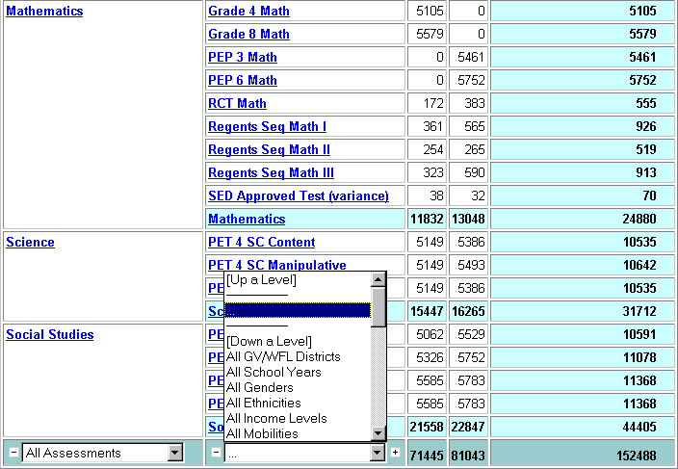
Click [Up a Level] or the minus sign -

Removing a Nesting (cont.)

Number of Assessments by Subject Area for Each Year

Now, we’ve removed the individual measure column

Using Measures as a Dimension

Why?
When we want to view multiple Measures at once. For instance we want to view the number of assessments and the average score.

Example
- We’re viewing number of assessments grouped by subject area and then by education type
- We’d like to view the number of assessments and the average score at the same time for these same categories
- We need to nest the measures
Number of Assessments by Subject Area and Education Type

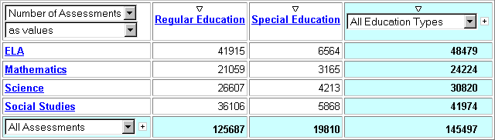

Note we’re only viewing number of assessments

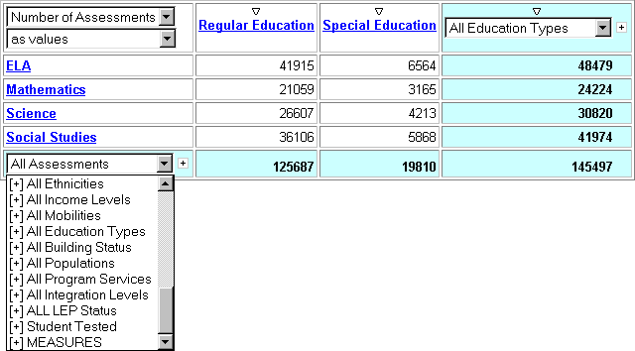
Click [+] MEASURES from the row pulldown

Using Measures as a Dimension (cont.)
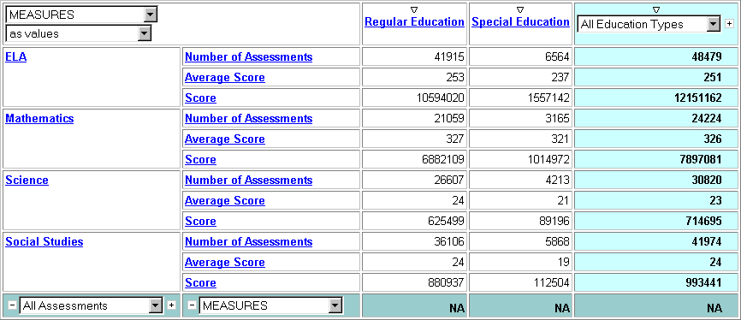
Note we’re now viewing all of the measures
Number of Assessments and Average Score by Subject Area and Education Type

Why?
Swapping Rows and Columns
When we’d like to switch the rows with the columns to make analysis easier

Example
- We’re viewing the average score of the Assessments by Education type and Program Services
- We’d like to see more of the results on one page so we don’t have to scroll to the right to see the remainder of the view
- We need to Swap Rows and Columns

Average score of the Assessments by Education type and Program Services

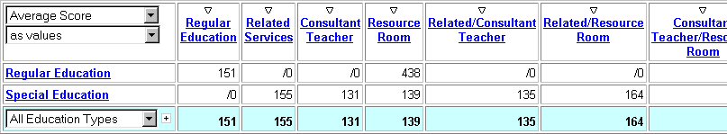
Note there are more columns

Click the Swap Rows and Columns Button in the Toolbar
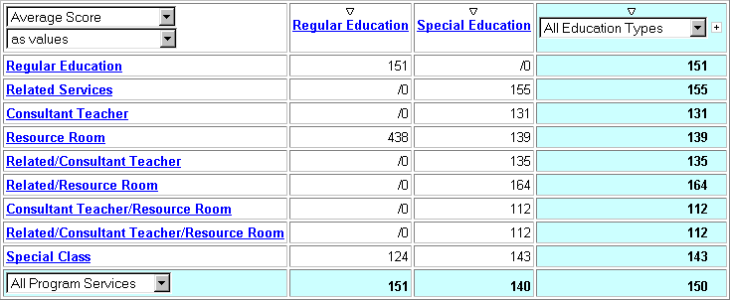
Now the rows and columns are switched
Average score of the Assessments by Program Services and Education Type
Swapping Rows and Columns (cont.)

Why?
Nesting Another Dimension
When we want to view more detailed results for all categories shown by detailing results by children for another dimension

Example
- We’re viewing the number of assessments for all LEAP Subject Areas by year
- We’d like to see the number of assessments for the individual measures in all of the Subject Areas
- We need to nest the Subject Areas
Number of Assessments by Subject Area for Each Year

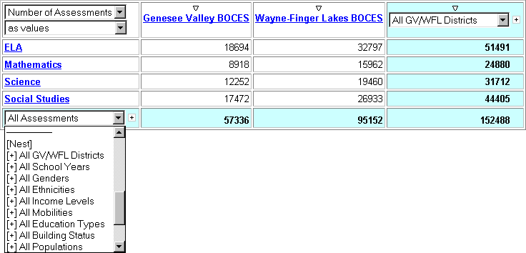
Click [+] All Income Levels

Nesting Another Dimension (cont.)
Number of Assessments by Subject Area and Income Level for Each Year

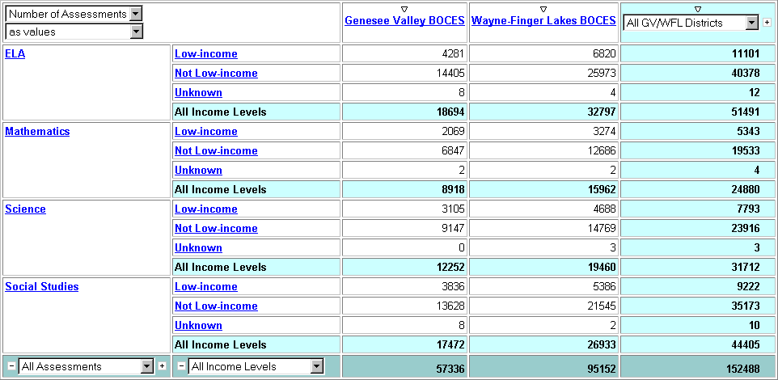
Now, we’ve nested the Income Level Dimension

Why?
Swapping Nested Dimensions
When we want to change the grouping order in a set of nested dimensions

Example
- We’re viewing percentages of assessments grouped by Subject area and then by LEP status
- We’d like to see the percentages grouped by LEP status and then Subject area
- We need to swap the nested dimensions
Percentages of Assessments Grouped by Subject Area and then by LEP Status

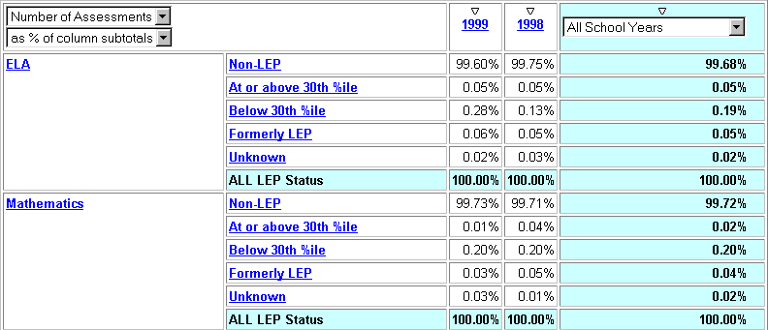

Click [Swap Left] in the innermost dimension

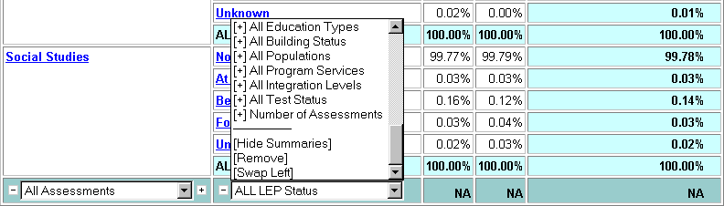

Swapping Nested Dimensions (cont.)
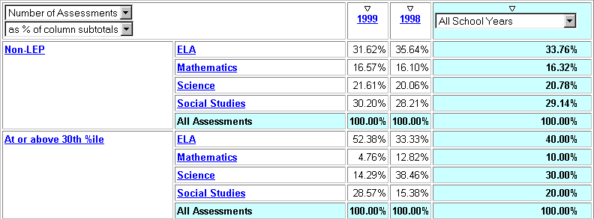
Now, the two dimensions are reversed
Percentages of Assessments Grouped by LEP Status and then by Subject Area

Changing Between % of Rows and Columns

Why?
When we want to view the percentage of the measure of its column total or of its row total.

Example
- We’re viewing percentages of assessments by gender grouped by gender and then by education type
- We’d like to see the percentages of assessments by education type grouped by gender and then by education type
- We need to change the measure display type to % of column total
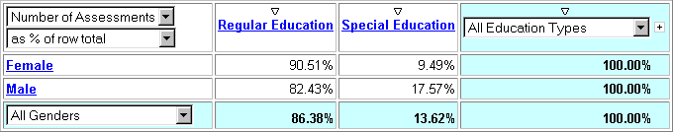
Percentage of Regular Ed. And Special Ed. Assessments by Gender
Note this is the average for the column (Education Type)

Note figures are percentages of the row total (Gender)

Percentage of Male and Female Assessments by Education Type

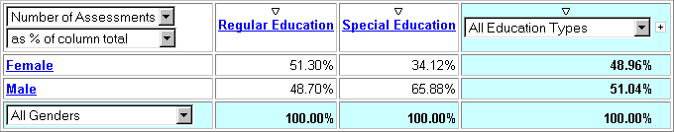
Now figures are percentages of the column total (Education Type)

Now this is the average for the row (Gender)

Changing between % of Row/Column Subtotals

Why?
When we want to view the percentage of the measure of its column subtotal or of its row subtotal.

Example
- We’re viewing percentages of assessments grouped by test area and then by LEP status
- We’d like to see the percentages grouped by LEP status and then Test area
- We need to swap the nested dimensions

Note figures are percentages of Gender/Income Level by Education type

Note these rows are the percentage of females and males by Education Type

Percentage of Regular Ed. And Special Ed. Assessments by Gender and Income Level

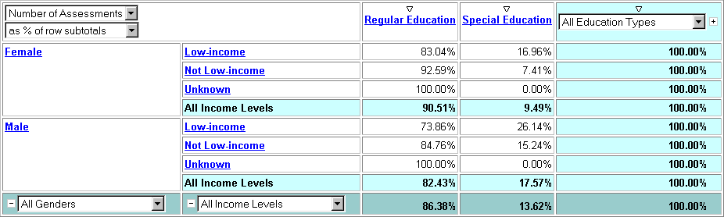

Note this row is the percentage of assessments by Education Type

Changing between % of Row/Column Subtotals (cont.)

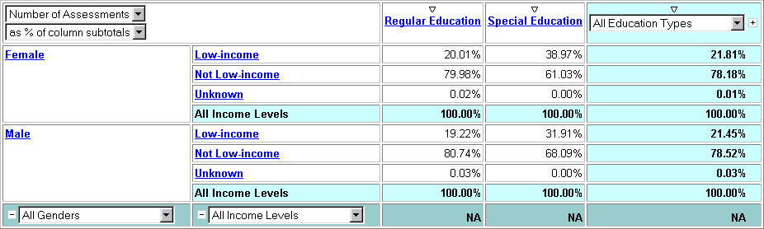
Percentage of Regular Ed. And Special Ed. Assessments by Gender and Income Level
Now figures are the percentage of Gender/ Education type by Income Level
Now this column is the % of males or females by income level for all Education Types

Suppressing Zeros

Why?
To eliminate categories whose measurements are all zero

Example
- We’re viewing the average score of each student in each Subject area by Income Level for students who are out of Regular Education Classes 0-20% of the time and we have a column with all
- We’d like to remove that column
Average Score by Subject Area and Income Level for Outside Regular Ed. 0-20%

Click the Zero Suppression button in the toolbar
Now, the “Unknown” column is gone
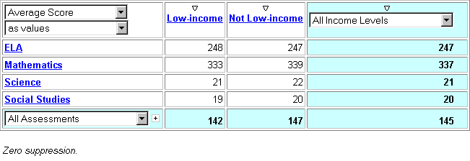
Note, indication that Zero Suppression is on

A. | Show the percent of students at each performance level on the ELA 4 for each income group……………...……… | 26
B. | Show the percentage distribution of results for the 1999 Grade 4 Math test for your school district and compare it to the regionally summarized scores……………………... | 29
C. | Show a multi-year comparison of the PEP 5 writing data as well as an analysis of the performance of the different groups of students based on their program services………………………………………………………. | 32

Section 2Workshops
Percentages of Assessments Grouped by Test Area and then by LEP Status

Show the percent of students at each performance level on the ELA 4 for each income group.
Workshop A

Your results should look like the following (note: your columns will be determined by your access level):
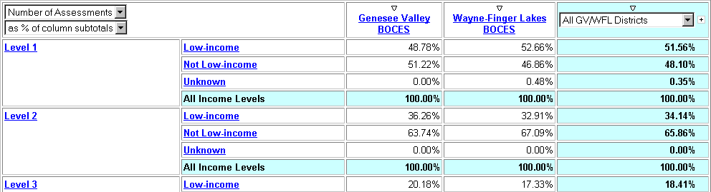
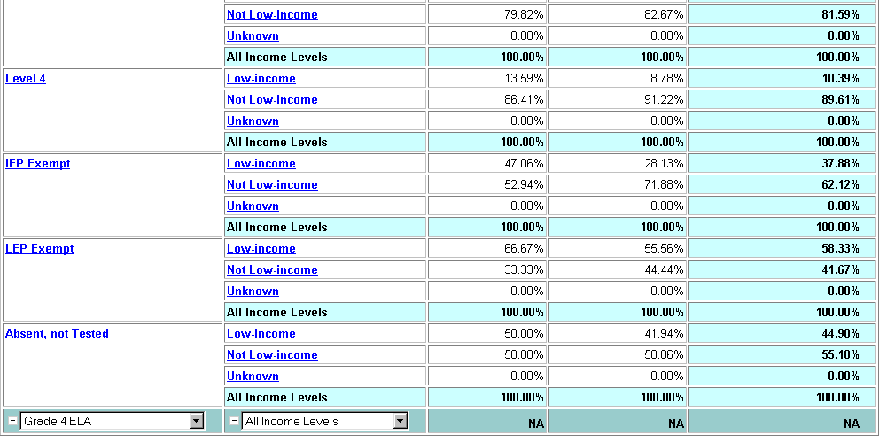
View next page for solutions

Questions
Of all of the Level 1 Assessments, what percent was from students noted as low-income?
At what level of assessment was the greatest percentage difference between each income level?

Going Further
What percentage of assessments from Low Income students attained a Level 3?

Tasks

Tasks

- Start with the Default View
- Drill down on ELA
- Drill down on ELA 4
- Nest the Income Level as rows
- Change the Measure Display Type to % of Column subtotal

Going Further Tasks

- Swap the nested Row dimension
Workshop A – Tasks to Perform

Workshop 1 – Step by Step

Step by Step Instructions

Step by Step Instructions

- Start with the Default View
- Start with Subject Areas as the Rows and your district(s) data as the columns

- Drill down on ELA
- Click the ELA row in the Results View

- Drill down on ELA 4
- Click the Grade 4 ELA row in the Results View

- Nest the Income Level as rows
- Click the [+] All Income Levels from the Row Dimension pulldown

- Change the Measure Display Type to % of Column subtotal
- Click the As % of Column total from the Measure Display Type pulldown

Going Further Step by Step Instructions

- Swap the nested Row dimension
Workshop A – Step by Step Instructions
- Click the Swap Left from the nested, Income Level row’s Row Dimension pulldown

Show the percentage distribution of results for the 1999 Grade 4 Math test for your school district and compare it to the regionally summarized scores.
Workshop B

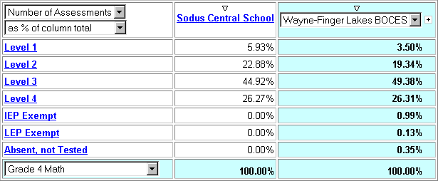
Your results should look similar to the following:

View next page for solutions

Questions
In which levels did students at your school perform better than the regional average?
In which levels did students at your school perform worse than the regional average?

Going Further
Show the percentage distribution for each of the measures in the mathematics subject area in one display.

Or

Show the percentage distribution for the Grade 4 Math results as a clustered bar graph.

Workshop B – Tasks to Perform

Tasks

- Start with the Default View
- Drill down on Mathematics
- Drill down on Grade 4 Math
- Filter year 1999
- Change to show measures as a % of Column Total

Going Further Tasks

- Show all of the Mathematics measures as the outside row
- Nest the Mathematics sub-categories (results levels)

Or

- Select clustered bar graph as the display

Workshop B – Step by Step Instructions

Step by Step Instructions

Step by Step Instructions

- Start with the Default View
- Start with Subject Areas as the Rows and your district(s) data as the columns

- Drill down on Mathematics
- Click the Mathematics row in the Results View

- Drill down on Grade 4 Math
- Click the Grade 4 Math row in the Results View

- Filter year 1999
- Select 1999 as from the All Years pulldown in the dimension line

- Change to show measures as a % of Column Total
- Select As % of Column total from the Measures Display type pulldown

Going Further Step by Step Instructions

Going Further Step by Step Instructions

- Show all of the Mathematics measures as the outside row
- Drill down on Mathematics by clicking the Mathematics row in the Results View

- Nest the Mathematics sub-categories (results levels)
- Click the [Nest] from the Mathematics row’s Row Dimension pulldown

Or

- Click the clustered bar graph button in the toolbar

Show a multi-year comparison of the PEP 5 writing data as well as an analysis of the performance of different groups of students based on their program services.
Workshop C

Your results should look like the following:
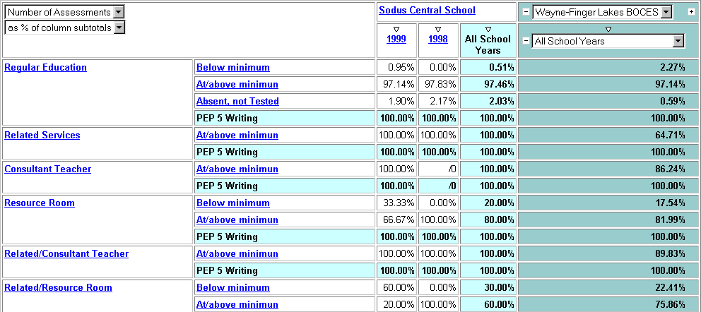
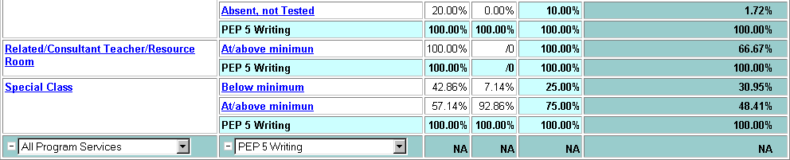

View next page for solutions

Questions
Of all of the PEP 5 Writing Assessments for students who were in the resource room for part of the day, what percent scored above the minimum?
Students participating in what program service realized the greatest decrease in performance on the PEP 5 writing measure?

Going Further
Show a stacked bar graph of the percentage of students, for each year, using each program service grouped by whether the students met the minimum score. The graph should show how each program service contributed to the number of students who scored at each level.

Tasks

- Start with the Default View
- Drill down on ELA
- Drill down on PEP 5 Writing
- Nest the Years dimension as columns
- Nest the Program Services dimension as Rows
- Change the Measure Display Type to % of Column Subtotal
- Swap the nested row dimension
- Eliminate the rows that have zeros in all columns

Going Further Tasks

- Swap the nested Row dimension again
Workshop C – Tasks to Perform

- Change the display to a Stacked Bar Graph

Workshop 1 – Step by Step

Step by Step Instructions

- Start with the Default View
- Start with Subject Areas as the Rows and your district(s) data as the columns

- Drill down on ELA
- Click the ELA row in the Results View

- Drill down on PEP 5 Writing
- Click the PEP 5 Writing row in the Results View

- Nest the Years dimension as columns
- Click the [+] All Years from the Row Dimension pulldown

- Nest the Program Services dimension as Rows
- Click the [+] All Program Services from the Row Dimension pulldown

- Change the Measure Display Type to % of Column Subtotal
- Select As % of Column total from the Measures Display type pulldown

- Swap the nested row dimension
- Click the Swap Left from the nested, Program Services row’s Row Dimension pulldown

- Eliminate the rows that have zeros in all columns
- Click the Zero Suppression button on the toolbar

Going Further Step by Step Instructions

- Swap the nested Row dimension again
Workshop C – Step by Step Instructions
- Click the Swap Left from the nested, Score level row’s Row Dimension pulldown

- Change the display to a Stacked Bar Graph
- Click the Stacked Bar Display button on the toolbar

Section 3Appendices

Definition of Terms………………………………………..……. | 36
Tips and Tricks……………………………………………..…... | 38
Cognos Web Access Screen Diagram…………………..…... | 39
Dimension Viewer Diagram………………………………..….. | 40
Results Display Diagram…………………………….……..….. | 41
Toolbar…………………………………………………….….…. | 42
Database and Cube Comparison……………………...……… | 43
1998-1999 LEAP Record Layout……………………..………. | 44

Definition of Terms

Data Analysis
- make informed decisions by analyzing your school’s data
- explore data from different angles and gain new insights
- find faster answers to Education-delivery questions

Cube: A collection of related data on which you can perform analysis. The LEAP data resides in a cube

Dimension: a grouping of data that defines something you’re analyzing
Examples:
- LEP
- Building
- Regular or Special Ed.
- Mobility
- Gender

Measure: performance indicators of the data that you’re analyzing
Examples:
- Score on a test
- Number of days absent
- Number of students exempted from a test
- Amount of budget spent on each program
- Percentage of students requiring special services

Multidimensional Analysis: analyzing school performance across different dimensions
Examples:
- Percentage of students at each performance level on the ELA-4 for each income group
- Percentage of Special Ed. students at each Performance level of the ELA by level of integration
- Percentage of students by integration level exempted from each ELA test

Definition of Terms (cont.)

Levels and Categories:
- Data is organized into dimensions and stored in a hierarchy of levels
- A category is a data item that exists in a level

Categories
ELA
Science
Mathematics
Social Studies
Objective Content

Manipulative Skills
Objective Skills
Level = Subject Area
Level = Individual Measure
…
…
…
…
LEAP Data Subject Area Dimension

Tips and Tricks

- When viewing Average Scores, make sure you filter for “Students Tested” from the “All Test Status” dimension.
- When viewing Number of Assessments, use the “All Test Status” dimension to select whether your analysis will include: only students tested, only students not tested, or both.
- All tasks that can be performed for rows (filtering, nesting, swapping, etc.) can also be performed for columns, and vice versa.
- You only have access to the data appropriate to you. For district personnel, only your school is available for analysis. For BOCES personnel, only your BOCES (at an aggregate level) is available for analysis.
- The “Score” measure is of little use
- PowerPlay Web is best viewed at a monitor resolution of at least 800 by 600.
- No student-level data is available in this cube.
- Use bookmarks to get back to your favorite reports.
- Use Excel to perform further data manipulation, if needed. Save your results to a .CSV (comma separated values) formatted file and import it into Excel.
- “/0” (division by zero) usually means that the value is zero.
- Use your browser’s Back button to go back to a previous view.
- To nest rows (or columns), you can use the [+] Rows (or [+] Columns) from the dimension in the dimension line or you can choose [+] DimensionName from the Row (or Column) Dimension pulldown
Cognos Web Access Screen Diagram

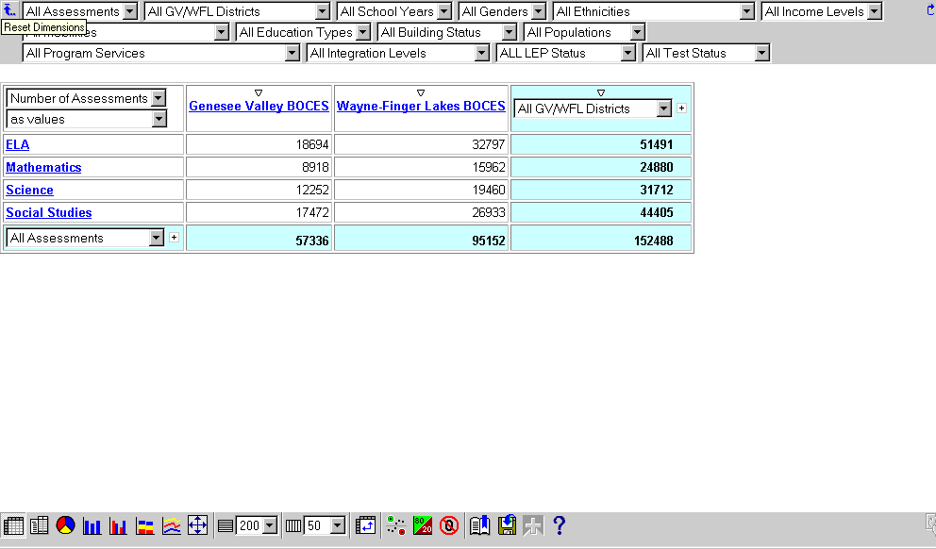
Dimension Viewer

Results Display

Toolbar

Dimensions

Toggles wrapping of the Dimension Row

Resets Dimensions to Defaults

1st Dimension = Default Rows

2nd Dimension = Default Columns

Dimension Viewer
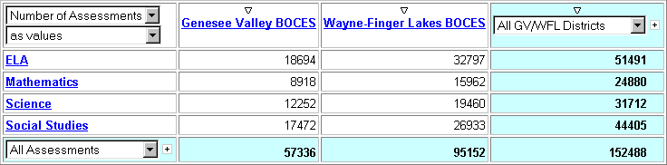
Current Measure / Click for Others
Results Display
Current Measure Display Type / Click for Others

Columns

Sort Ascending / Descending

Category
Current Column Dimension / Click for Column Modifications

Rows

Current Row Dimension / Click for Row Modifications

Category
Nest this Level’s Children

Row Total

Grand Total

Column Total

Values

Nest this dimension’s next level

Toolbar

1
2
3
4
5
6
7
8
9
10
11
12
13
14
15
16
17
18

1 Crosstab display (default) 10 Limits # of Columns per page

2 Indented Crosstab display 11 Swaps Rows and Columns

3 Pie Chart 12 Applies Exception highlighting

4 Bar Chart 13 Applies 80/20 suppression

5 Clustered Bar Chart 14 Applies Zero suppresion

6 Stacked Bar Chart 15 Prepares a bookmark

7 Multiline Chart 16 Saves to .CSV format

8 Fit chart displays to page 17 Drills through to another report

9 Limits # of Rows per page 18 Opens the Help window

Operational Database(s)
Database and Cube Comparison
Operational Report(s)
Reports on day-to-day, operational data

Examples:
Attendance
Grade summaries
Budget reports
Class schedules
Etc.

PowerPlay Cubes
Holds summarized, static data for analysis purposes. Typically, trend analysis.

Examples:
LEAP cube
Regents cube
Financial cube
Item analysis cube
Etc.

Operational Databases

PowerPlay Cube

Cognos PowerPlay Analysis

Operational Reports

Operational Database(s)
Holds operational data, has frequent updates, very detailed

Examples:

Schoolmaster
SASI
Part 200
CP
CCC
Jostens
Spreadsheets
Access Databases
Etc.

PowerPlay Analysis
- Reporting with high-level, strategic analysis goal in mind
- OLAP tool (On-Line Analytical Processing)
- Analyze data without awaiting a “report” to be created and run
- Enables you to easily find new ways to analyze data

Positions 1 – 30
1998 – 1999 LEAP Record Layout
BEDS Building Code  (Use ‘0999’ as last four digits for students serviced out-of-district; use 0888 as last four digits for home-schooled students.) |  |  |  |  |  |  |  |  |  |  |  | Year |  |  |  | Bldg. Status | Funding |  |  |  | Student ID Number

Positions 31 – 54 |  |  |  |  |  |  |  |  |  |  |  |  |  |  |  |  |  |  |  |  |  |  |  |  | 55 – 56
Date of Birth  Y Y Y Y M M D D |  |  |  |  |  |  |  | Grade  Level |  | Gender | Ethnicity | Poverty | Population | Mobility | Disability | Program Services | Level of Integration | Service Provider  Complete for students placed out-of-district |  |  |  |  |  |  | LEP Status | Yrs enrolled in  BE or ESL pgm

Subject  - 25 - | Measure | Assmt  Language | Date of Administration | Score | Standard Met
Subject  - 25 - | Measure | Assmt  Language | Y Y Y Y M M | Score | Standard Met

1st Assessment 57 – 73
2nd Assessment 74 – 90
3rd Assessment 91 – 107
4th Assessment 108 – 124
5th Assessment 125 – 141
6th Assessment 142 – 158
7th Assessment 159 – 174
8th Assessment 175 – 191
9th Assessment 192 – 208

