Cognos Web Access Screen

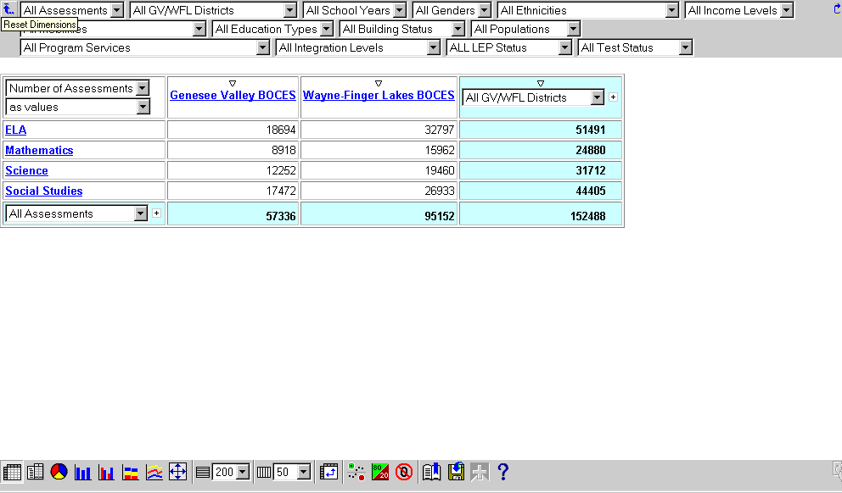
Dimension Viewer

Results Display

Toolbar

Dimensions

Toggles wrapping of the Dimension Row

Resets Dimensions to Defaults

1st Dimension = Default Rows

2nd Dimension = Default Columns

Dimension Viewer
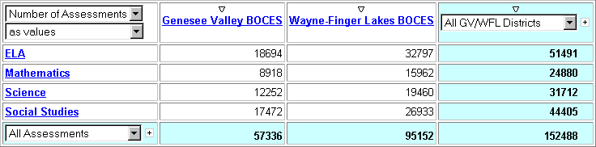
Current Measure / Click for Others
Results Display
Current Measure Display Type / Click for Others

Columns

Sort Ascending / Descending

Category
Current Column Dimension / Click for Column Modifications

Rows

Current Row Dimension / Click for Row Modifications

Category
Nest this Level’s Children

Row Total

Grand Total

Column Total

Values

Nest this dimension’s next level

Toolbar

1
2
3
4
5
6
7
8
9
10
11
12
13
14
15
16
17
18

Crosstab display (default) 10 Limits # of Columns per page

Indented Crosstab display 11 Swaps Rows and Columns

Pie Chart 12 Applies Exception highlighting

Bar Chart 13 Applies 80/20 suppression

Clustered Bar Chart 14 Applies Zero suppresion

Stacked Bar Chart 15 Prepares a bookmark

Multiline Chart 16 Saves to .CSV format

Fit chart displays to page 17 Drills through to another report

Limits # of Rows per page 18 Opens the Help window

