Monday, October 23, 2000

This Week!

This week we will be completing the great story entitled The Pumpkin Patch. This story is great in that it brings us through the entire growing season and stages of the pumpkin. We will begin our second story entitled Shortcut by Donald Crews on Wednesday. This is a story about a group of children that decide to take a shortcut home. They however, did not think about the dangers that could present themselves. This book is perfect in opening opportunities to discuss wise and poor choices.

Harvest Fest

To help make Halloween Day extra enjoyable we are going to making doughnuts in the Science Lab. As a “Brunch Activity” we are planning on making/serving doughnuts at around 8:30am. The children seem to really enjoy the awesome smell as the doughnuts fry, not to mention the great taste of the warm doughnut they await. I wanted to let you know in advance of what we are planning for treats. The Halloween Parade will be held this year on Tuesday, October 31st. Please note we are encouraging the children to wear costumes of a “gentle nature”. Fun loving - not gory! The Harvest Fest will be centered around the Wizard of Oz theme.

Red Ribbon Week

This week we will be directing our thoughts at an early age, to “saying no” to drugs. Hopefully

with early education we will be able to correct this ever-growing problem in our nation. An activity is planned for each day.

Monday: We will be distributing red ribbons to the children to remind them of the promise they are making to say “No to Drugs”. We will also be decorating our classroom door with a drug free theme. Please encourage your son/daughter to wear their ribbon each day.

Tuesday: “Drug Free from Head to Toe” We will be combining these two themes. We will be encouraging the children to wear something red on their head. (hats, bandanas, barrettes, head bands, etc.) Let’s see how many children come to school with red on their head and feet!

Wednesday: “Born To Be Free” Children will be encouraged to bring in a baby picture to add to the classroom collage. Please place your son’s/daughter’s name on the back of the picture so it can be returned safely.

Thursday: “Wear Red Day” We will be encouraging the children to wear as much red as possible.

Parent -Teacher Conferences

If you have not returned your Parent/Teacher Conference sign-up slip, please return it with your son/daughter at your earliest convenience. Parent-Teacher Conferences are scheduled for Tuesday, November 7th from 11:00am - 8:00pm and Wednesday, November 15th from 8:00am – 3:00pm.

Presidential Election

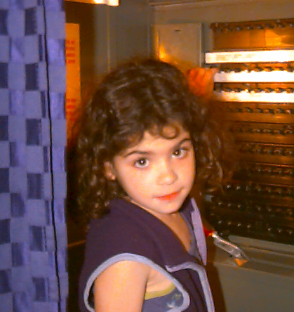
On Tuesday, the children (whole school) had the opportunity of going into a real voting booth and voting for the Presidential Candidate of his/her choice. We will be discussing Presidential Elections more as election time approaches. According to the children at Lyons Elementary School Mr. George W. Bush won the election.

Circus Time
.
Billy Martin’s Cole All Star Circus will be coming to the High School Gym on Saturday, October 28th. If you are planning on purchasing advanced tickets, you need to send in the order form and enclose the payment by Thursday, October 26th. Tickets will be sent home with the children on Thursday, October 26th.

Reading Incentive

The Reading Incentive Committee will be encouraging the children to get involved in the Great Pumpkin Reading Program. Attached in the newsletter today you will find a form to fill out listing your son’s/daughter’s favorite character from a book, including the title and author. They are then to pick out a pumpkin, keeping the size in mind, since it needs to be manageable to bring to school. They will then be asked to decorate the pumpkin to look like the character they have chosen. Please remind them not to cut the pumpkin, since they deteriorate so rapidly. Please remember that this project is optional.

Conference Day

Please note that there will be no school for children this Friday, October 27th. Teachers will be participating in an all day Superintendent’s Conference Day.

