Subject Area____Information Literacy K-6_______________Grade Level ___K____

Mission Statement: It is the mission of the Elba Central School District to actualize the phrase “Elba Equals Educational Excellence for Everyone.” We are committed to providing both quality and equity. Every student will have the opportunity to develop to the best of his/her ability.

Elba Standards: In addition to the knowledge and basic skills they need in order to participate in society, graduates of Elba Central School will develop:
- Empowering skills: decision making, goal setting, creative thinking and problem solving abilities;
- Communication and social interaction skills;
- Technological literacy;
- Total wellness (social, physical, emotional health and self-esteem);
- The values necessary to participate in society.
As a result of achieving these outcomes, our students will embrace lifelong learning.

National Standards:
Information Literacy
Standard 1: The student who is information literate accesses information efficiently and effectively.
Standard 2: The student who is information literate evaluates information critically and competently.
Standard 3: The student who is information literate uses information accurately and creatively.
Independent Learning
Standard 4: The student who is an independent learner is information literate and pursues information related to personal interests.
Standard 5: The student who is an independent learner is information literate and appreciates literature and other creative expressions of information.
Standard 6: The student who is an independent learner is information literate and strives for excellence in information seeking and knowledge generation.
Social Responsibility
Standard 7: The student who contributes positively to the learning community and to society is information literate and recognizes the importance of information to a democratic society.
Standard 8: The student who contributes positively to the learning community and to society is information literate and practices ethical behavior in regard to information and information technology.
Standard 9: The student who contributes positively to the learning community and to society is information literate and participates effectively in groups to pursue and generate information.
Performance Indicators:
Students will:
1-Media Center Responsibilities
- understand what a library is
- demonstrate good citizenship in the library by following rules and procedures
- utilize the librarian as a teacher and resource person
- Demonstrate proper care of a book and other materials in the library
- Follow circulation procedures
2- Collection Organization/Location
- display the ability to locate easy books
- select materials for themselves
- understand that each item has a specific place on the library shelves
3- Literature Appreciation
- recognize the variety of books available in the library
- have the ability to identify a variety of authors and genres (nursery rhymes, fairy tales, concept books, non-fiction, poetry)
- develop an appreciation for his/her favorite books and authors
- recognize that books are for enjoyment as well as for information
4- Listening and Interactive Skills
- listen and comprehend stories read aloud (sequencing, prediction, retelling)
- recognize that quiet listening is necessary for group attention and enjoyment
- respond appropriately to what is seen and heard
5- Reference Skills
- understand ABC order
6- Vocabulary
- use and understand the following terms:
  - borrow, return, renew
  - author, title, illustrator
  - spine, spine label, cover, barcode, paperback, hardcover, pages

Assessment: | Acceptable Performance Level
Conversations, questions, observations | Students will respond and participate in activities to support performance indicators.
Circulation statistics | All students will participate in book exchange. Circulation statistics will increase each year.
Surveys of knowledge and interests | 90% of students will answer questions on survey correctly.
Small group questioning | Students will actively participate in group discussions.

Scope: Kindergarten students will begin to build a general understanding of information literacy.

Sequence:

Month | Concept |  | Supporting Activities | Performance Indicator | Achieved Peformance Level
SEPT | Media Center responsibilities-What is a library? |  | Read aloud concept books about libraries; The Library (Stewart); At the Library (Loomis) | 1, 4 | Introduced
SEPT & JAN | Proper handling of books |  | The Monster Who Loved Books; Mr. Wiggles poster; practice with books on tables; create bookmarks to mark page;  What Happened to Marion’s Book;  Stella Louella’s Runaway Book;  Library lessons booklet- Marion’s coloring page, bookmark patterns | 1 | Introduced
ON  GOING | Circulation procedures |  | choose a book from a designated selection of fiction and nonfiction | 1, 2, 6 | Introduced
ON  GOING | Listening Skills |  | Use of props at the beginning of each story session, questions and conversations recalling information from stories- retelling of stories through skits and props. The Mitten by Jan Brett- each student wears the mask of an animal from the story and acts out the part www.janbrett.com  Songs from HI Ho Librario! Judy Freeman and other artists. | 4 | Introduced
ON  GOING | Literature appreciation-Author and illustrator appreciation |  | Marc Brown, Leo Lionni, Norman Bridwell, Eric Carle, Kevin Henkes, Dr. Seuss, Beatrix Potter, Robert Munsch, Audrey Wood, Jan Brett, Laura Numeroff, Robin Pulver, Jim Aylesworth, etc  Surveys and questionaire  Author visit  Concentration game using characters from books-“Curious George”, Jan Brett characters; | 3, 6 | Introduced
ON  GOING | Reference Skills- ABC Order |  | ABC concept books; Chicka, Chicka, Boom, Boom (book and software); www.littlefingers.com (shelving books); Between the Lions Website: ABCow;  Jan Brett flash cards;  Jan Brett alphabet flags- have students line up alphabetically;  Sing alphabet songs- http://www.preschooleducation.com/sletter.shtml  questionnaire | 2, 5 | Introduced
SEPT | Collection organization-Locate easy books |  | Orientation at beginning of year-Book exchange,  Questionnaire | 2 | Introduced
FEB |  | Collection organization-each item has a specific location | Look for 398.2 (Hi ho librario!)  Strega Nona; Clever Tom and the Leprechaun (Shute, Linda); A Tale of Two Tengu: A Japanese Folktale (McCoy, Karen Kawamoto)  Other countries:Australia- The Singing Snake (Czernecki); South America- Moon Rope: Un Lazo a la Luna: A Peruvian Folktale (Ehlert); | 2 | Introduced
FEB |  | Literature appreciation-Nursery Rhymes, Fairy Tales | Throw it Out the Window (Hi Ho Librario!) The Comic Adventures of Old Mother Hubbard and Her Dog (DePaola); Dear Peter Rabbit (Ada); The Mother Goose Songbook (Glazer); The Hole by the Apple Tree: An A-Z Discovery Tale (Polette)(also alphabet memorization);  Jane Yolen’s Mother Goose Songbook;  There Was an Old Lady Who Swallowed a Fly; Hoimie the Woim (Hi Ho Librario!); The Greedy Old Fat Man: An American Folktale (Galdone);  Mother Goose, Wee-Sing Nursery Rhymes cassette tape, Mother Goose on the Internet  http://www.ipl.org/div/kidspace/storyhour/goose/  StorytellingGlove, Flannel Board Storytelling, puppets, puppet theater;  Five little monkeys story board;  Halloween story board; Gingerbread man story board; Little Red Hen story board;  SLS CCB-Folktales, Fairy Tales and Nursery Rhymes. | 3 | Introduced
ON  GOING |  | Literature appreciation-Picture Books, Concept Books, Non-fiction | Various titles throughout year, linking Kindergarten letter of the week whenever possible, activities to reinforce sequencing, retelling, and prediction. Activities For Any Literature Unit (Primary)-real vs. make-believe- puzzle time—  Comparison between fiction and non-fiction books-- various fiction and non-fiction books on tables for students to look at and compare—point out differences, photos, facts, not a make believe story.  (Name & Self Recognition)There Once Was a Man Named Michael Finnegan; Chrysanthemum (Henkes);  Sheila Rae the Brave (Henkes) On the way with Sheila Rae (p. 39)(binder for CD-Rom)  (Halloween)Go Away Big Green Monster- create own monsters on construction paper (see pictures) Big Pumpkin (Silverman); Nothing at All (Cazet)  (Thanksgiving) Thanksgiving at the Tappletons (Spinelli); The Night Before Thanksgiving; Turkey Pox (Anderson); Clifford’s Thanksgiving; Arthur’s Thanksgiving; I Never Say I’m Thankful, But I Am (Moncure);  (Christmas) If You Take a Mouse to the Movies; Twas the Night Before Christmas; Merry Christmas, Big Hungry Bear (Wood); Dream Snow (Carle); Little Miss Spider: A Christmas Wish; Lucy and Tom’s Christmas (Hughes); Who’s That Knocking on Christmas Eve? (Brett)  (Snow) The Snowy Day (Keats) tape; Emmett’s Snowball (Miller); Snow (Shulevitz) Katy and the Big Snow (Burton) Snowballs (Ehlert); Axle Annie (Pulver); The Snowman (Briggs); All You Need for a Snowman (Schertle)Stranger in the Woods;  (Easter) The Most Wonderful Egg in the World (Heine); Chicken Little (Kellogg); Peeping Beauty (Auch); Eggs Mark the Spot (Auch);  The Easter Egg Farm (Auch); Zinnia and Dot (Ernst); Oh I Had a Little Chicken/I Went to Cincinnati (Hi Ho Librario!);  (Spring) The Very Hungry Caterpillar; The Caterpillar Fight (McBratney)puppet; From Caterpillar to Butterfly (Heiligman) If At First You Do Not See (Brown); Cecil Was a Caterpillar (Hi Ho Librario!);  (Food) A Nice Walk in the Jungle (Bodsworth); Mother, Mother, I Feel Sick, Send for the Doctor, Quick, Quick, Quick. (Charlip); Henry My Son (Hi Ho Librario!) ; Eating the Alphabet (Ehlert)  (Snakes) Hide and Snake (Baker); The Singing Snake (Czernecki); How Snake Got His Hiss: An Original Tale (Davol);  (Sickness) Who’s Sick Today? (Cherry); Rachel Fister’s Blister (MacDonald); The Adventures of Isabel (Nash);  (Wordless books) Deep in the Forest; Good Night, Gorilla; Do You Want to Be My Friend; Anno’s Alphabet; Rosie’s Walk; Tuesday; My Friend Rabbit; -see attached article; | 3, 4 | Introduced
APRIL |  | Literature appreciation-Poetry | Announce at the end of each class “Poetry break” and read a poem as a signal to students to quiet down and prepare to leave; Down By the Bay (Raffi); Gifts (Bogart)(song: My Aunt Came Back); Spider on the Floor (Raffi); The Lady With the Alligator Purse (Westcott); Alligator Pie (Hi Ho Librario!); Alligators All Around; Jack Prelutsky; Shel Silverstein (cd); Munching: Poems About Eating (Hopkins); Do Not Feed the Table (Lillegard); Just Dessert (Powell); | 3 | Introduced
NOV |  | Vocabulary- author, title, illustrator | Petunia; Hi Ho Librario! | 6 | Introduced
OCT/  JAN |  | Vocabulary-spine, spine label, cover, barcode, paperback, hardcover, pages | parts of a book color and label worksheet,  reinforcement of parts of book during storytime.  Individual surveys and questionnaires | 6 | Introduced

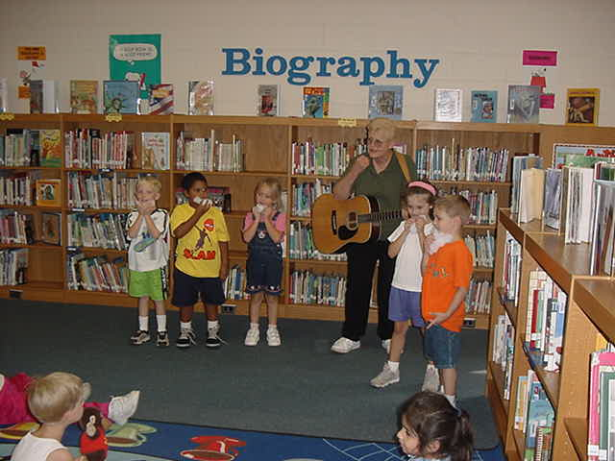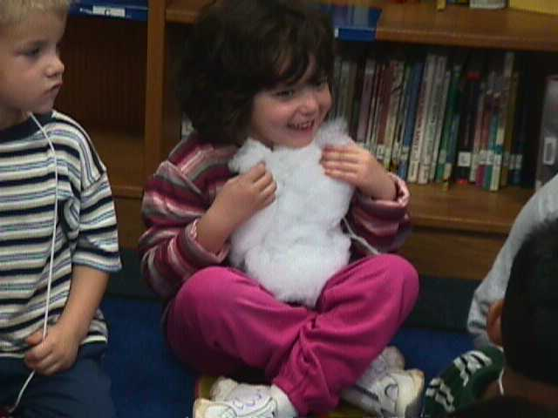

Kindergarten students act out “Michael Finnegan”.

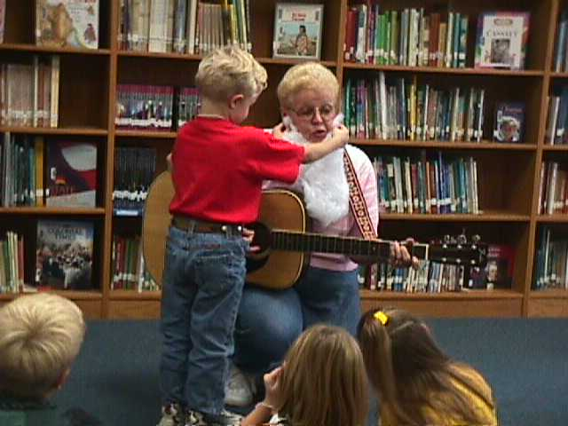

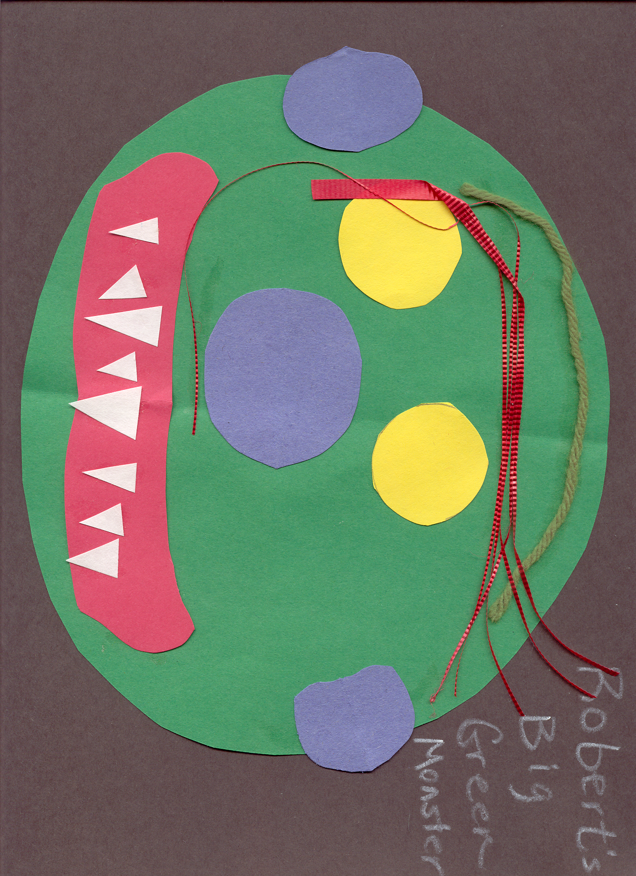
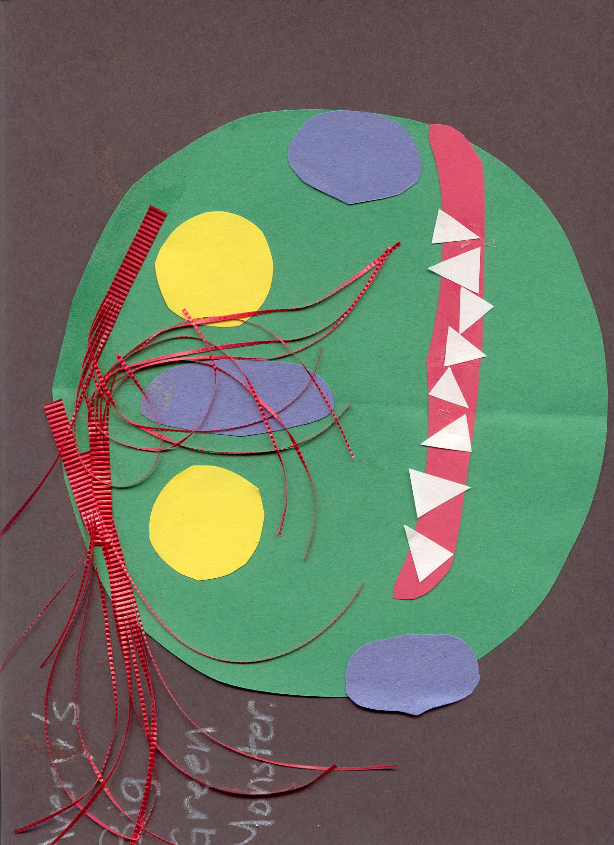
Big Green Monster Activity

Methodology: Best Practices, 6+1 Writing, RAC, Information Power

Bibliography:

Bannister, Barbara Farley. Elementary School Librarian’s Survival Guide. 1993.

The Best of Mailbox Magazine: Authors: Preschool/Kindergarten, 1999.

Carey, Patsy.Activities for any Literature Unit, 1995.

Davis, Robin Works. An Alphabet of Books, 1995.

Davis, Robin Works. An Alphabet of Authors, 1996.

Dingwall, Cindy. Library Celebrations, 1999.

Freeman, Judy. What’s New in Children’s Literature and Strategies for Using It in Your Program, 2003.

Freeman, Judy. Hi Ho Librario!, 1997.

Miller, Pat. Reaching Every Reader: Promotional Strategies for the Elementary School Library Media Specialist, 2001.

Ritter, Darlene. Literature-Based Art Activities, 1991.

Spencer, Gwynne. What’s Cooking in Children’s Literature, 2001.

SAMPLE

Kindergarten Questionaire

Date: ____________
Class:____________
Names: ___________________________________________

1. What do you like best about coming to library?
Responses:

2. Is there a book that we have read together that is your favorite?
Responses:

3. What letter is this? (Hold up several letters, have individuals answer) Responses:

4. What does the author do? What does the illustrator do?

5.Where in the library can you find easy/picture books?

6. Which of the following activities would be your favorite?
Play with playdough, look at a book or watch TV

7. Name something that you like to do for fun or something that you are interested in.

8. Will you tell me five ways to handle books that will keep the books looking nice?

SAMPLE

Kindergarten Vocabulary Survey

Date: ______________
Class:______________

Name of Student | author | title | illustrator | spine | spine label | cover | barcode | paperback | hardcover | pages

