WAYNE CENTRAL SCHOOL DISTRICT
BOARD OF EDUCATION MEETING AGENDA


DATE: April 7, 2004
TIME: 6:30 p.m.
PLACE: High School Auditorium

6:30 Call to Order /Pledge of Allegiance
6:30 Executive Session
7:30 Approval of Agenda/Approval of MINUTES Att. 1
7:35 Public Comment
7:40 Board Member Comments
7:45 Board President’s Comments

7:50 Action Item Report

7:55 Superintendent’s Report
- Recognition Presentations
- School Report Card
- Performance Contract Decision
- Budget Adoption Att. 2
- Student Questions

8:30 Items for Board Action:
1. Personnel Action Att. 3
2. CSE/CPSE Action Att. 4
3. Consensus Agenda: Att. 5
- Treasurer’s Report - February
- Approve Health Contract
- Approve Bid
- Approve Budget Transfer

8:35 Policy

8:40 Public Comment/Board Comments
8:45 Adjournment

Next Meeting: Three Boards Meeting Walworth Town Hall

District Mission Statement

Based on the belief that all students can learn, the staff of the Wayne Central School District accepts the responsibility to teach all students, regardless of differences, the fundamental skills. We further accept the responsibility to challenge all students to attain higher levels of achievement. Wayne Central will provide the opportunity, environment, and encouragement to meet this goal while developing the whole child, physically, socially, emotionally, and culturally.

WAYNE CENTRAL SCHOOL DISTRICT
Ontario Center, New York 14520

BOARD OF EDUCATION MINUTES UNOFFICIAL UNTIL APPROVED

DATE: Wednesday, March 24, 2004 TIME: 7:30 p.m.
TYPE: Regular Business Meeting PLACE: High School Cafeteria

PRESENT: Trustees Brunner, Diller, Griswold, Johnson, Lyke, Ratcliffe, Robusto, Triou, Wyse; District Clerk Switzer; Administrators Havens, Pirozzolo, Shaffer, Siracuse, Saxby, Woodard, Atseff, Spring, Callahan, Blankenberg, Davis

ABSENT: Trustee Ratcliffe

GUESTS: Visitor’s Roster filed in clerk’s agenda file, this meeting

I. CALL TO ORDER: 7:30 p.m. by Richard A. Johnson, School Board President

Prior to the meeting, members of the Board of Education and school officials participated in a visit and tour of the co-generation and windmill power facility at Harbec Manufacturing Company at 369 Route 104 in Ontario to provide background knowledge for the presentation on energy performance contract during the business meeting.

II. PLEDGE OF ALLEGIANCE

III. APPROVAL OF AGENDA & MINUTES (March 10, 2004)

Mr. Johnson noted that the intent for an executive session would shift from prior to the business agenda to prior to adjournment at the end of the meeting. Mr. Wyse offered a MOTION to approve the agenda for this evening’s meeting, as revised, and the minutes of the meeting of March 10, 2004, as presented. 7 Ayes, 0 Nays, 1 Absent (Mr. Ratcliffe), 1 Abstention (Mr. Griswold), Carried.

IV. PUBLIC COMMENT – None

V. BOARD MEMBER COMMENTS

- Mrs. Brunner stated that she attended the district-wide instrumental program, dubbed “bandomania,” as part of observance of Music In Our Schools Month and extended compliments to the student musicians and their instructors for the performances.

- Mrs. Brunner stated that she attended the district-wide art show and exhibit and extended compliments to the students for their excellent work and to staff for efforts in presenting the event.

- Mr. Robusto stated that he attended the recent donkey basketball game and complimented the students on their excellent behavior; the event was thoroughly enjoyed by everyone in attendance.

- Mr. Wyse stated that he attended the district-wide vocal music program as part of observance of Music In Our Schools Month and extended compliments to the student musicians and their instructors for the performances.

VI. BOARD PRESIDENT’S COMMENTS

- Mr. Johnson extended thanks to Mr. Robert Bechtold, owner of Harbec Plastics Company, for hosting the visit by trustees and school officials prior to the business meeting this evening and for the background information he provided about windmill power.

- Mr. Johnson welcomed students, parents, staff and others present for the Science Olympiad presentation scheduled for this evening’s business agenda. He added that the Board of Education is very proud of the achievement by local students.

VII. REPORT ON ACTION ITEMS BY THE SUPERINTENDENT OF SCHOOLS - None

VIII. REPORTS OF THE SUPERINTENDENT OF SCHOOLS

PRESENTATION BY SCIENCE OLYMPIAD TEAM • MIDDLE SCHOOL

Mr. Havens noted that students on Science Olympiad teams placed first and fifth in regional competition and continued a tradition of top performance in that event. He introduced Edward Currier, middle school science teacher/department chairperson, and Mrs. Paulette Bodak, parent volunteer, who served as coaches for the two teams, to introduce their team members.

Each of the students narrated portions of a PowerPoint presentation on the varied topics and science concepts and skills included in the Olympiad competition (e.g erosion, weight, flight, sound, biology, physics, weight) The Endeavor team earned first place and the Discovery team earned fifth place, four (4) points behind the fourth place team.

Mr. Havens and Mr. Currier presented certificates to the students, parent advisors, school advisors and other adults who assisted and supported the teams in their competition efforts (copy of list of participants filed in clerk’s agenda file, this meeting). Again this year, T-shirts for team members were provided by the Walworth-Ontario Rotary Club.

Parents, visitors and school officials present extended a hearty round of applause to the students on their achievements. On behalf of the students and others involved, Mr. Currier thanked everyone for their support and encouragement.

During the recess, students hosted and explained displays of their varied competition events to persons present.

Mr. Johnson extended thanks to parents of the students for their support that is essential for the success the children achieve.

IX. RECESS: 8:00 p.m.

X. RECONVENE: 8:15 p.m.

- REPORTS OF THE SUPERINTENDENT OF SCHOOLS (continued)

PRESENTATION ON ENERGY PERFORMANCE CONTRACT PROPOSAL

Mr. Havens introduced Mr. Robert Grant and Mr. Paul Darby from Atlantic Energy Services, Inc., to present information about an energy use audit of school facilities they conducted to determine potential economies in energy usage. They have also explored the used of co-generating mini-turbines and a windmill similar to that viewed and visited by the Board of Education prior to this evening’s meeting.

Mr. Grant shared information about the scope and intent of energy performance contracts to obtain long-term energy and cost savings for public agencies (copy filed in clerk’s agenda file, this meeting). The projects are handled as capital projects by the NYS Education Department but do not require prior voter approval since the funding is derived from state building aid and re-allocation of savings achieved by the performance contract. Design plans and specifications require review and approval by the State Education Department.

Mr. Grant stated that the preliminary evaluation of district facilities estimates annual savings of nearly $200,000 in energy costs. He also identified some upgrades to windows and boilers that would provide additional energy conservation and shared examples of projects conducted and economies realized by the several school districts with which his firm has worked on energy performance contracts.

Mr. Havens asked what options are available to the school district if the energy savings projected by a performance contract do not occur. Mr. Grant stated that the “savings clause” included in the performance contract insures reimbursement to the school district.

Mr. Robusto asked if the savings clause is guaranteed by the energy performance contractor or by a performance bond. Mr. Grant stated the guarantee is in the form of a performance bond. Mr. Darby stated that a copy of the guarantee is required by the NYS Education Department.

Mrs. Lyke asked if the proposal included costs for a windmill and if windmills are in place in any other school districts. Mr. Grant stated he is exploring those costs and that no other districts have them in place.

Mr. Havens asked how the size of a windmill for school use would compare to the one viewed this evening at Harbec Manufacturing Company. Mr. Grant stated that the size of a windmill to meet the energy needs of the facilities on the Ontario Center campus, (600 KW), is approximately twice the 250 KW now in place at the Harbec site. He added that the school campus would have a centralized energy generation site that would also generate savings in energy charges.

Mr. Havens asked if some school districts have micro-generators in place; Mr. Grant noted some examples (e.g. Marion, Penfield Greece, Corning-Painted Post, Keshequa).

Mr. Johnson asked about any limitations of local zoning regulations for installation of a windmill on school property. Mr. Grant noted that school districts are exempt from local zoning regulations; permits are issued by the NYS Education Department. Cooperative efforts with local communities are, however, incorporated into such plans.

Mr. Havens noted that the proposal for wind-powered co-generation has many opportunities for instructional programs. Mr. Currier noted that the middle school presently has a photovoltaic system in place as part of the science program and noted the many links to math-science and technology classes that this proposal would have for local students.

Mr. Wyse asked about the use of boilers and asked what percentage of the school district’s energy use the proposed project would cover; Mr. Grant stated appx. 95%.

A student present in the audience asked if a windmill would have any impact on athletic fields. Mr. Grant stated that a proposed site was located on the perimeter of the Ontario Center campus southeast of the Ontario Primary School.

Mr. Havens noted that the presentation this evening is for informational purposes and he will seek direction from the Board of Education on whether or not to pursue a comprehensive energy audit at the April meeting.

Mrs. Lyke asked what time frame would occur subsequent to authorization for an energy performance audit by the Board of Education. Mr. Grant reviewed the necessary steps, extending over some six (6) months, for preparing specifications, seeking proposals, and obtaining state approvals.

Mr. Havens asked what happens if an energy audit shows no advantages to the school district. Mr. Grant stated such a study is normally not pursued if potential energy savings are not projected; his preliminary audit of school facilities indicates a potential for such savings.

Mr. Robusto asked if any web-based sources are available for further research on energy performance contracts. Mr. Grant provided details.

Mr. Wyse suggested consideration as chillers to address existing concerns about cooling facilities and the possibility of incorporating it into the 2002 Capital Improvement Project.

Mr. Griswold asked if the state aid for an energy performance contact is greater if it is linked to an instructional use. Mr. Havens provided details.

Mrs. Lyke asked how long Mr. Grant’s firm has worked on energy performance contracts; Mr. Grant provided details.

Mr. Havens will seek information from neighboring districts on their uses of co-generation facilities. Mr. Triou would like the opportunity to discuss those projects with officials at those school districts.

Additional discussion followed and is generally summarized as follows:

• Similar proposals in prior years were not pursued based on insufficient energy savings and absence of state aid or savings clauses in performance contracts that are now available
• Schools that have shifted to co-generation approaches have found them of value
• Project costs would equate to 65% from building aid and 35% from energy savings
• Consideration of additional maintenance and training costs is also necessary
• Heat generated by co-generation could be used
• Approval by the NYS Education Department is not granted if energy savings are not shown
• Additional information on the system in place at Harbec Manufacturing was requested
• In place of public approval, a resolution of the Board of Education is required to begin the energy performance contract process
• A windmill site should consider location of watershed retention ponds included in the 2002 Capital Improvement Project
• Compensation of the energy contractor is incorporated in overall project cost
• State regulations do not allow addition of air cooling facilities to a project if they are not already in place
• The firm selected to conduct the energy audit works closely with the school architect

Mr. Johnson thanked Mr. Grant and Mr. Darby for their presentation and participation this evening and invited trustees to forward any additional questions they may have to Mr. Havens.

UPDATE ON 2002 CAPITAL IMPROVEMENT PROJECT

Mr. Havens asked Mr. Atseff to provide an update on state approval of the 2002 Capital Improvement Project.

Mr. Atseff stated that the NYS Education Department has issued approval of architectural drawings and their approval of mechanical, electrical and plumbing specifications is expected soon. Following that review, state officials may pose additional questions or may issue final approvals.

Upon receipt of state approval, final work on specifications is estimated at ten (10) days, followed by four to six weeks to advertise and obtain bids. At this date, award of bids is projected for late May or early June and work at the high school would begin in the summer of 2005.

DISCUSSION OF PROPOSED 2004-2005 BUDGET

Mr. Havens asked Mr. Atseff to provide information on final estimates of the projected 2004-2005-school budget.

Mr. Atseff noted that the agenda enclosure reflects items discussed by the Board of Education through the March 10th meeting. This draft reflects a proposed budget-to-budget increase of 7.3% and a projected tax rate increase between 3.9% and 4.9%. About 1.7% of the budget increase is due to introduction of the full day kindergarten program and inclusion of modified football and volleyball and completion phase one of the model school’s program for 2004-2005.

Mr. Havens noted that the projected tax rate increase is the lowest in the last five (5) years and that the school district is in the best financial position of the same time period while providing for the full day kindergarten program, modified football and volleyball and completion phase one of model schools for 2004-2005.

Discussion followed on the present and future taxable assessed valuation of the nuclear power station and its impact on school finances.

Mr. Griswold asked what tax rates area school districts are projecting for next year. Mr. Havens stated that projections presently range from 3% to 9%.

Mr. Griswold asked if there are any items or areas the district might need which are not included. Mr. Havens stated that he does not favor incorporating additional items until revisions in the district’s taxable assessed value are finalized with the sale and assessment of the nuclear power station. He added that the local share of costs for full day kindergarten after the first year of transition aid and start of payments for the debt associated with the 2002 Capital Improvement Project are also factors to consider as part of budget planning for the 2005-2006 school year.

Mr. Johnson noted that the proposed 2004-2005 budget represents the first time in five (5) years that the Board of Education has not had to agonize over revisions and reductions and it represents commitments made to issues such as full-day kindergarten, additional modified level athletic teams, and model school’s programs. He believes the community will support this proposed budget.

Mr. Triou noted that the Board of Education is committed to communicating with the community on school issues and asked Mr. Havens what issues may have surfaced. Mr. Havens noted that the property re-valuation in local communities is the primary topic of discussion at this time.

Mrs. Brunner asked if the allocation for refund of taxes is sufficient to meet any changes in assessed value after the school levy is determined. Mr. Havens and Mr. Atseff provided details.

Mr. Triou asked when the project ed tax rate increase of 3.9% to 4.9% would be refined. Mr. Havens stated final data is expected when the proposed budget is presented to voters for consideration at the annual school election on May 18^{th.}

STUDENT QUESTIONS

Crystal Loren, 2685 Ridge Road, Ontario, asked if and when the school district would open the fitness center at the high school for community use. Mr. Havens noted plans to allow community use of the fitness center by senior citizens, beginning April 1st, and in future joint programs through the town recreation and parks department.

Tim Russell, 6874 Fisher Road, Ontario, asked what precautions were planned to prevent disruptions to the June exam schedule by the capital improvement project. Mr. Havens provided details.

XII. RECESS 9:11 p.m.

XIII. RECONVNE 9:15 p.m.

XIV. ITEMS FOR BOARD OF EDUCATION ACTION

A. ADOPT SESSION DAY CALENDAR • 2004-2005 SCHOOL YEAR

Mr. Havens presented the proposed session day calendar for the 2004-2005 school year for review and consideration by the Board of Education:

Mrs. Brunner offered a MOTION to approve the proposed session day calendar for the 2004-2005 school year as recommended by the superintendent of schools.

Mr. Griswold asked about the number of half-day sessions planned for next year. Mr. Havens stated that half-days for staff training are now provided as full days every other month.

Mr. Triou noted that the proposed calendar includes 188 days and asked how many days neighboring districts have in their calendars. Mr. Havens stated that we have the greatest number of days. Mr. Wyse noted that the number of days is determined by the collective bargaining agreement with the teachers’ association.

Mrs. Diller asked what happens if all of the emergency days are not used. Mr. Havens stated any available days would be used for instructional purposes.

On the question, the vote was 8 Ayes, 0 Nays, 1 Absent (Mr. Ratcliffe), Carried.

B. ADOPT RESOLUTION TO PARTICIPATE IN FINANCIAL ASSISTANCE
(Shared Costs Re: Assessment Challenge of Nuclear Power Plant, Town of Ontario)

Mr. Havens presented the proposed resolution to participate in shared costs for negotiation and litigation costs with the Town of Ontario & County of Wayne relative to challenge of real property tax assessments of the nuclear power station for review and consideration by the Board of Education.

Mrs. Brunner offered a MOTION, seconded by Mr. Wyse, to adopt a RESOLUTION to participate in financial assistance in conjunction with the Town of Ontario & County of Wayne re: challenge of real property tax assessments, TO WIT:

RESOLUTION TO PARTICIPATE IN FINANCIAL ASSISTANCE
FOR COSTS OF NEGOTIATIONS AND LITIGATION
INVOLVING CHALLENGES TO REAL PROPERTY ASSESSMENTS
(Town of Ontario)

WHEREAS, the County of Wayne, by Resolution No. 444-95 in August, 1995, adopted a resolution that the County of Wayne may participate in providing financial assistance for litigation challenges to real property assessments in cases where the assessed value is more than $200,000 provided the town and the school district wherein the challenge to the real property assessment is made agree to share the cost of litigation equally with the County of Wayne, and

WHEREAS, the Wayne Central School District is desirous to have the County of Wayne share equally with the Wayne Central School District and the Town of Ontario wherein the property lies in the costs of negotiations and any litigation to challenges to real property assessments in excess of $200,000.00, and

WHEREAS, in connection therewith in acquiescence to said resolution by the Board of Supervisors of the County of Wayne, the Wayne Central School District agrees to share the cost of negotiations and litigation equally with the County of Wayne provided the Town of Ontario also agrees to share said costs of negotiations and litigation equally with the Wayne Central School District and the County of Wayne.

NOW, THEREFORE, it is

RESOLVED, that the Wayne Central School District, in compliance and satisfaction with the County of Wayne Board of Supervisors Resolution 444-95, wherein the Board of Supervisors of the County of Wayne authorized the County of Wayne to participate in financial assistance for litigation challenges to real property assessments in excess of $200,000.00, agrees to share the cost of negotiations, litigation and legal fees equally with the County of Wayne provided the Town of Ontario, assessing taxes on properties within the Town of Ontario, agrees to share the cost of negotiations and litigation equally with the County of Wayne and the Wayne Central School District.

DATED: Ontario Center, New York, March 24, 2004

On the question, the RESOLUTION was adopted by a vote of 8 Ayes, 0 Nays, 1 Absent (Mr. Ratcliffe).

XV. ADDITIONAL PUBLIC COMMENT - None

VVI. ADDITIONAL BOARD MEMBER COMMENTS

  - Mr. Griswold noted the excellent information obtain during the visit and tour this evening at Harbec Manufacturing Company and suggestion written thanks from the Board of Education to Mr. Bechtold.

  - Mr. Robusto stated that the presentation on performance contracting was very informative and offers exciting opportunities for the school district.

  - Mr. Robusto commended Mr. Havens for his efforts to reach a conclusion on the nuclear power plant value issue as reflected by the resolution adopted this evening.

  - Mrs. Lyke shared information she received while seeking signatures on her trustee-nominating petition about home energy audits that are related to the tour, visit and presentation this evening.

  - Mr. Havens extended congratulations to Mr. Blankenberg, director of athletics and physical education, on his selection as Athletic Director of the Year by Section V.

XVII. EXECUTIVE SESSION (Personnel)

Mr. Wyse offered a MOTION to adjourn the meeting, at 9:15 p.m., for an executive session on matters relating to specific personnel. 8 Ayes, 0 Nays, 1 Absent (Mr. Ratcliffe), Carried.

XVIII. RECONVENE: 9:56 p.m.

XIX. ADJOURNMENT

Mr. Triou offered a MOTION to adjourn the meeting at 9:57 p.m. 8 Ayes, 0 Nays, 1 Absent (Mr. Ratcliffe), Carried.

Respectfully submitted,

JAMES E. SWITZER
School District Clerk

APPROVAL OF MINUTES
APPROVAL OF MINUTES

The foregoing minutes of the Board of
Education were submitted for review
& (approved as presented)(corrected
as noted) at the meeting of

April 7, 2004

---------------------------
School District Clerk

JES/jes:wp

Att. 2

TO: Michael Havens
Superintendent of Schools
FROM: Gregory Atseff
Assistant Superintendent for Business
DATE: April 10, 2004
RE: 2004/2005 Budget

Attached is the proposed 2004/2005 budget for board adoption. The proposed 2004/2005 budget includes the following additions to the instructional program.

- Full Day Kindergarten
- Modified Football
- Model Schools – completion of Phase I
- Modified Volleyball

The estimated tax rate increase for the 2004/2005 budget is 3.9%

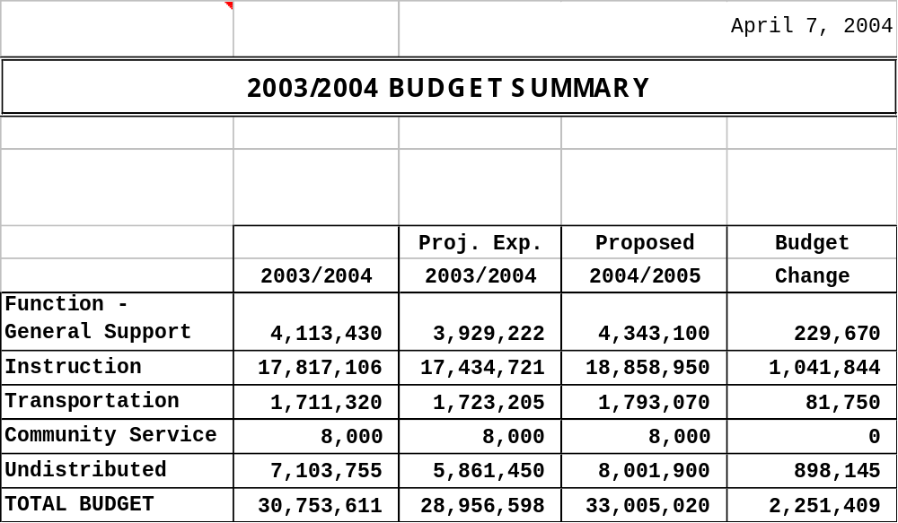

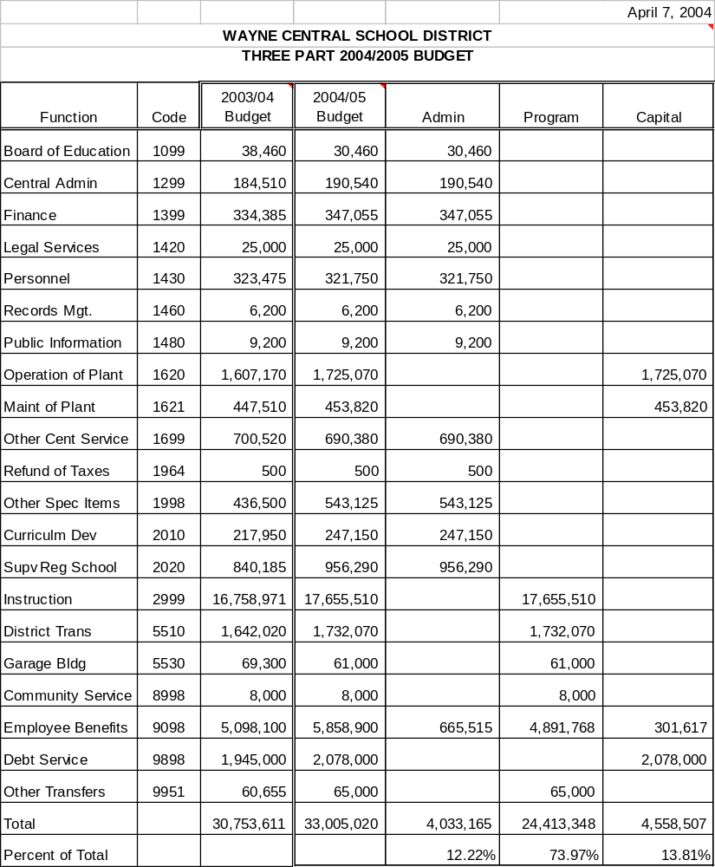

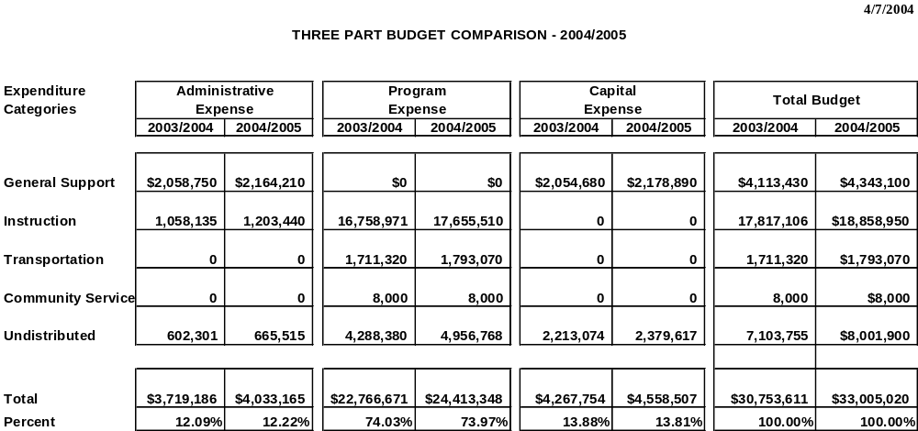

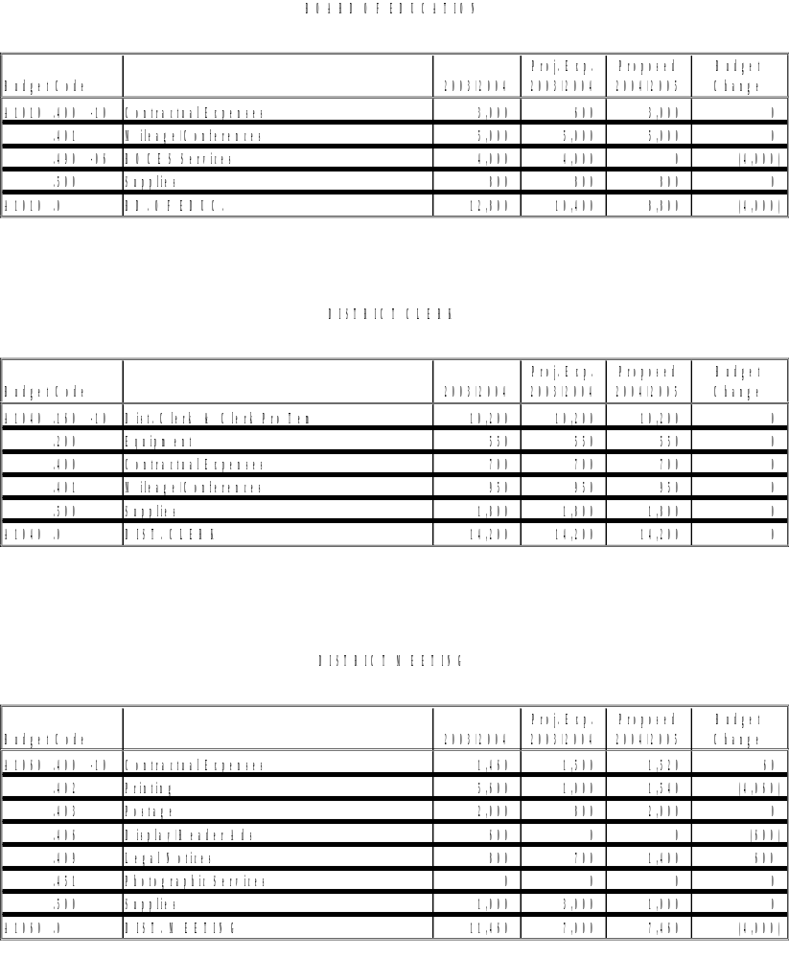

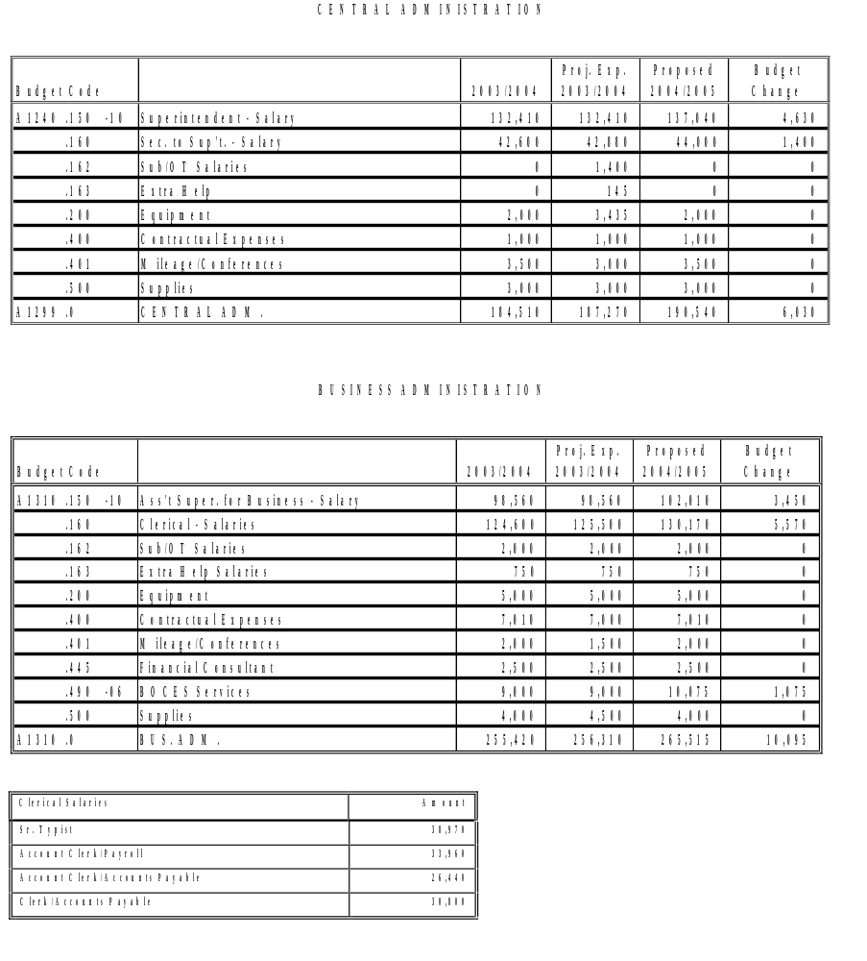

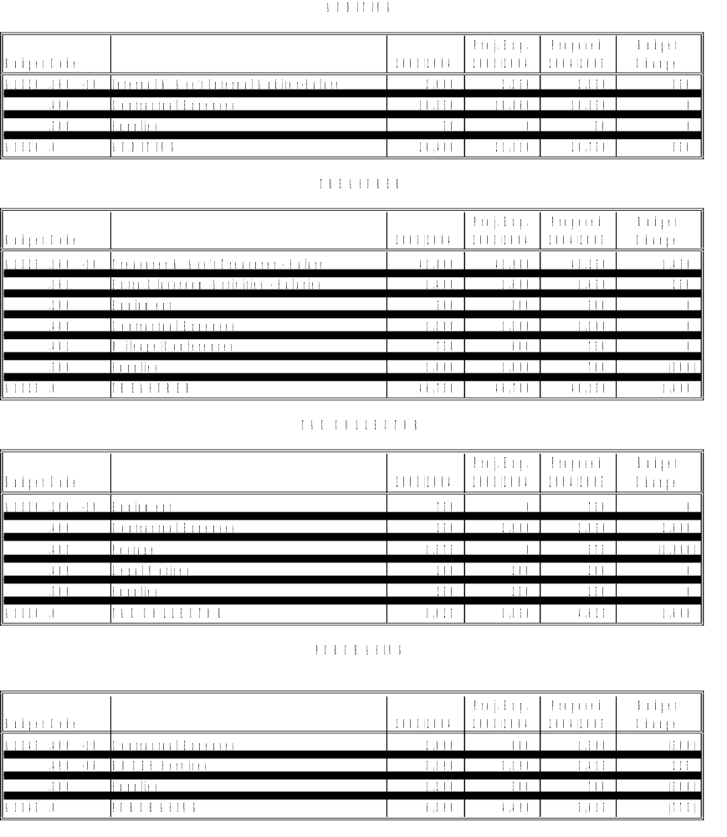

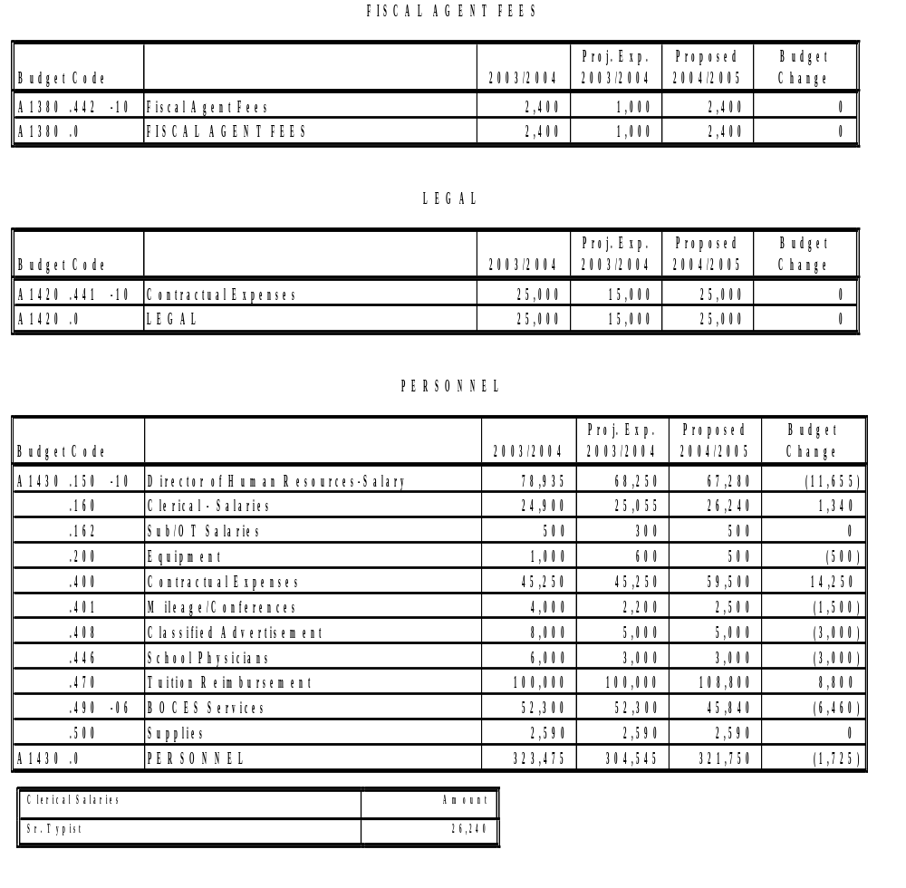

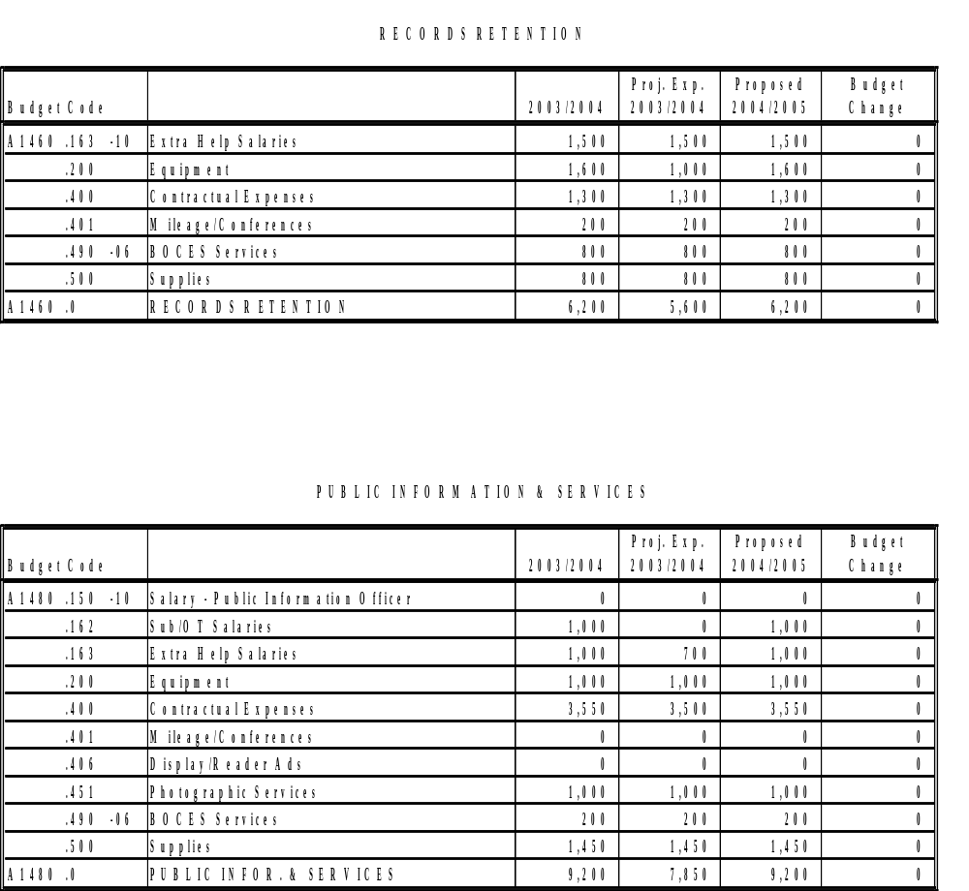

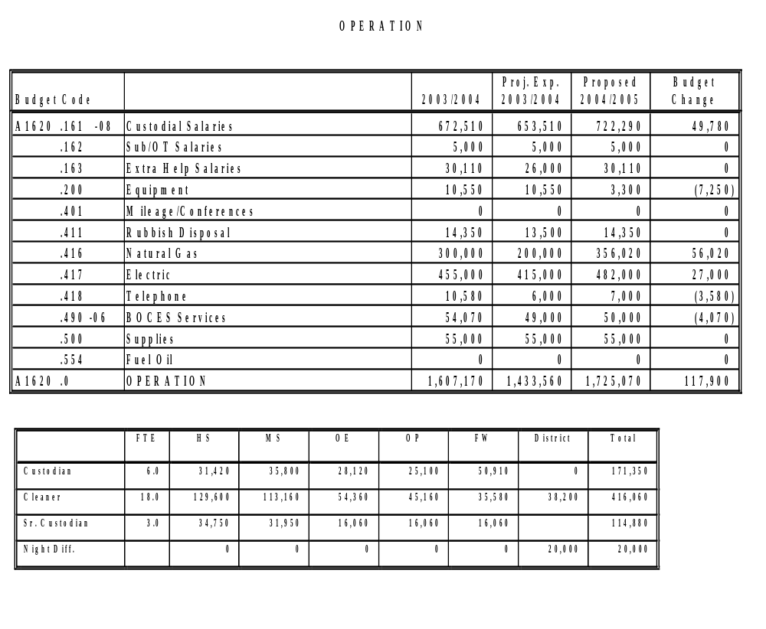

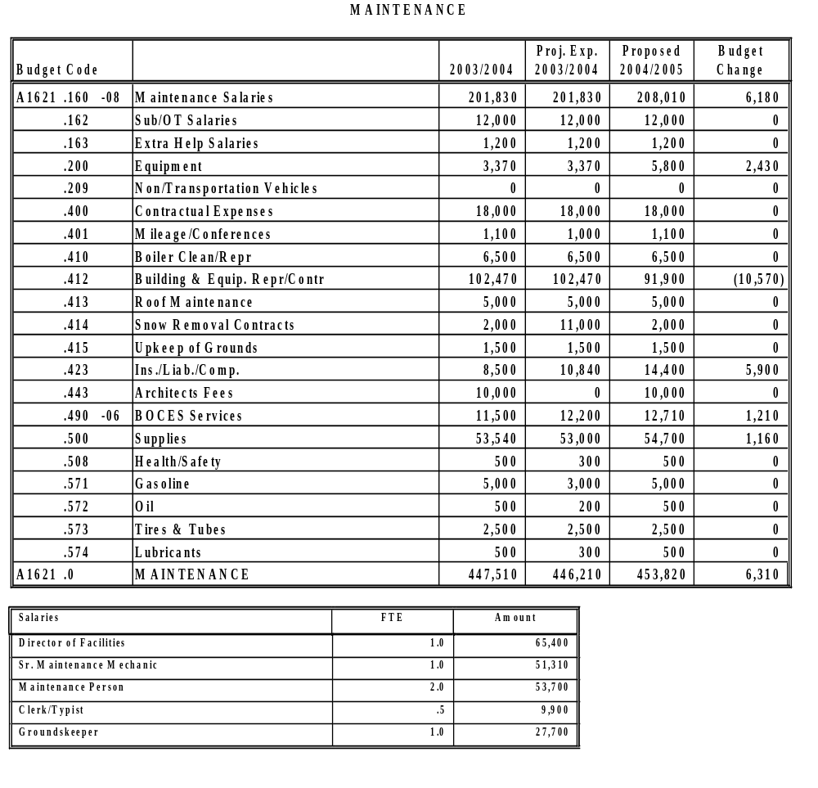

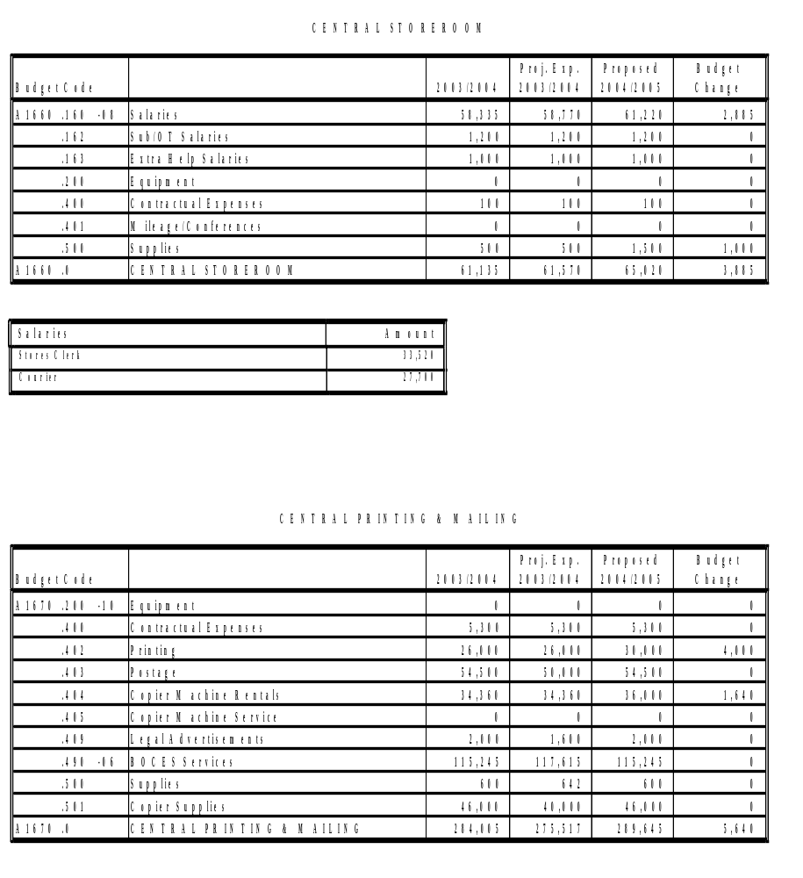

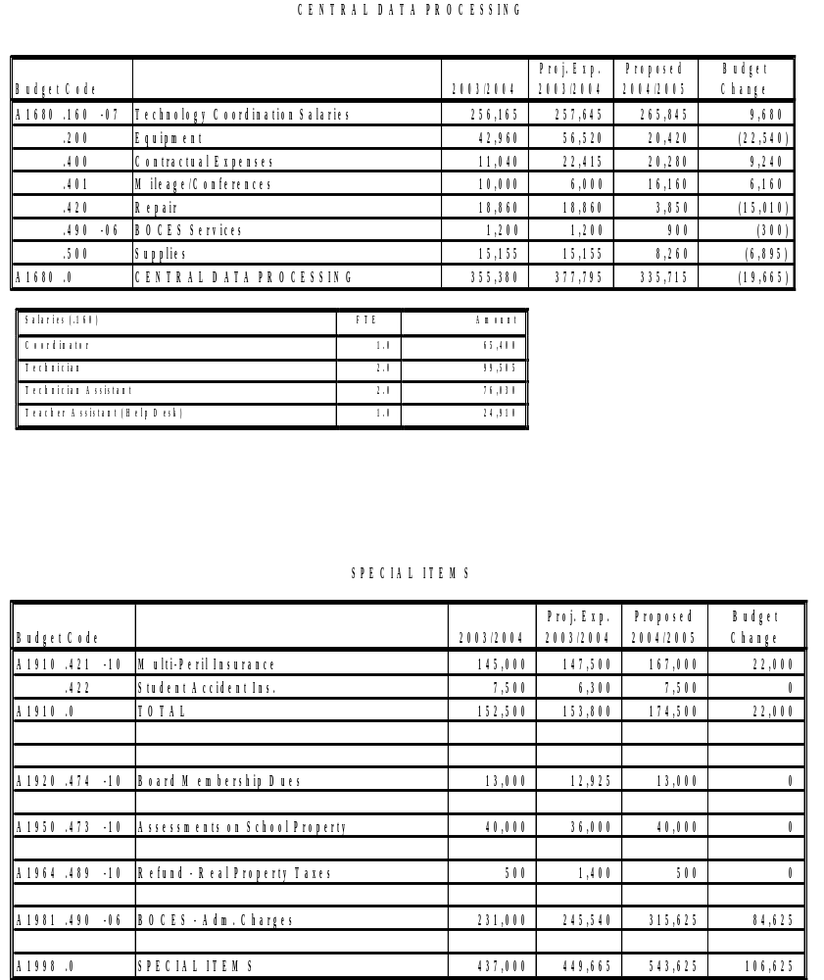

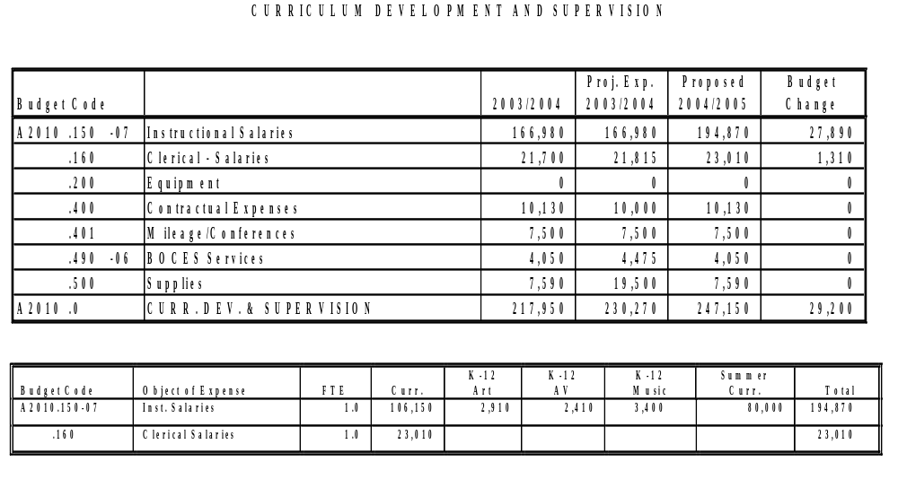

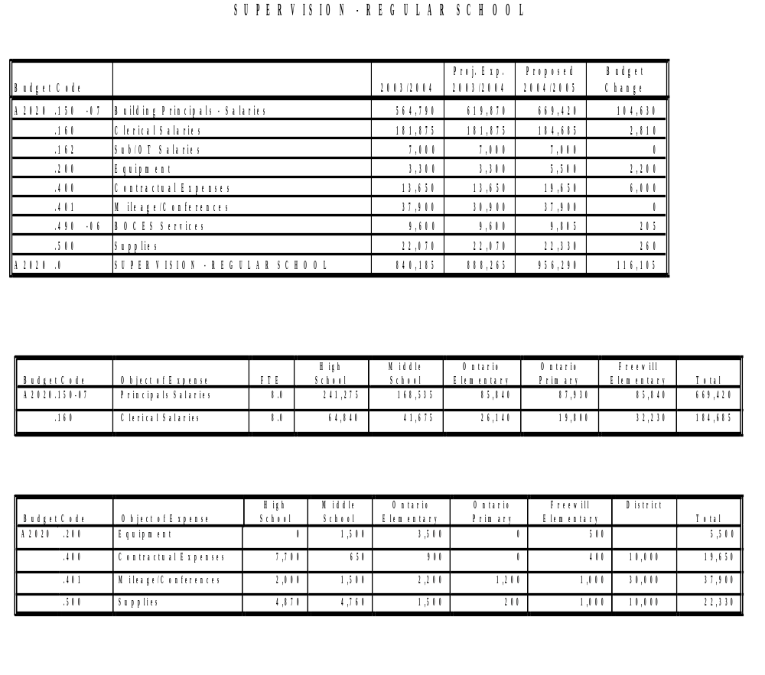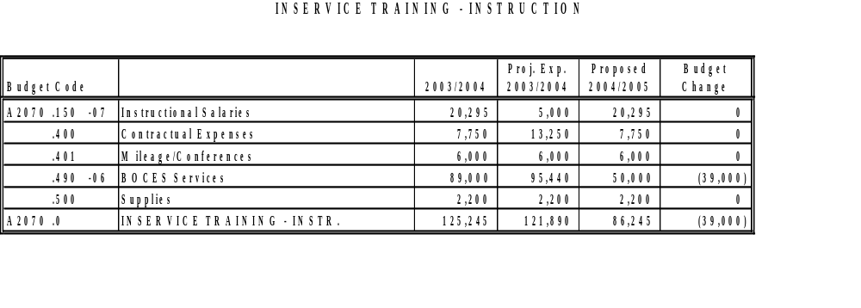

TEACHING - REGULAR SCHOOL

Error! Not a valid link.Error! Not a valid link.

Budget Code | Object of Expense | FTE | HS | MS | OE | OP |  | FW |  | District | Total
A2110.100 | Early Start Salaries |  |  |  |  |  |  |  |  |  | 0
.120 | K-2 Salaries | 26.8 |  |  |  | 1,245,300 |  |  |  |  | 1,245,300
.120 | K-5 Salaries | 29.0 |  |  |  |  |  | 1,411,900 |  |  | 1,411,900
.120-07 | K-Full Day | 4.0 |  |  |  | 140,000 |  | 20,000 |  |  | 160,000
.120-07 | K-6 Salaries/PCEN | 1.0 |  |  |  |  |  | 44,535 |  |  | 44,535
.120-07 | Enrichment Coord. | 1.0 |  |  |  |  |  |  |  | 46,320 | 46,320
.120 | 3-5 Salaries | 25.0 |  |  | 1,251,820 |  |  |  |  |  | 1,251,820
.120 | 6-Salaries | 9.0 |  | 439,500 |  |  |  |  |  |  | 439,500
.130 | 7-8 Salaries | 38.8 |  | 1,752,700 |  |  |  |  |  |  | 1,752,700
.130-07 | Teacher Mentor |  |  |  |  |  |  |  |  | 35,000 | 35,000
.130 | 9-12 Salaries | 54.0 | 2,596,200 |  |  |  |  |  |  |  | 2,596,200
.168 | Tchr. Aides/Ass’t Salaries | 33.0 | 90,300 | 65,000 | 130,000 | 104,000 |  | 160,000 |  | 31,000 | 580,300
.168-07 | Tchr. Aides/ K-Full Day | 3.0 |  |  |  | 30,000 |  | 15,000 |  |  | 45,000
.200 | Equipment |  | 3,165 | 4,225 | 8,925 | 3,600 |  | 1,850 |  | 1,300 | 23,065
.200 | Equipment (K-Full Day) |  |  |  |  |  | 30,000 |  | 15,000 |  | 45,000
.400 | Contractual Expenses |  | 21,725 | 4,720 | 950 | 860 |  | 2,575 |  | 23,925 | 54,755
.401 | Mileage/Conferece |  | 6,070 | 5,350 | 0 | 3,600 |  | 4,000 |  | 1,825 | 20,845
.480 | Textbooks |  | 43,515 | 42,740 | 22,695 | 21,720 |  | 23,380 |  |  | 154,050
.500 | Supplies |  | 52,520 | 47,600 | 17,850 | 22,290 |  | 23,475 |  | 15,430 | 179,165
.500 | Supplies (K-Full Day) |  |  |  |  | 20,000 |  | 10,000 |  |  | 30,000

BREAK-DOWN OF DISTRICT BUDGET REQUESTS:

Budget Code | Object of Expense | Art | Enrichment | Music | P/E | PCEN | Bi-Lingual | Reading Buddies | District | Total
.120-07 | Salaries |  | 46,320 |  |  |  |  |  |  | 46,320
.200-07 | Equipment | 300 | 0 | 0 | 1,000 | 0 | 0 |  |  | 1,300
.400-07 | Contractual Expenses | 75 | 6,580 | 1,970 | 1,000 | 0 | 0 | 14,300 |  | 23,925
.401-07 | Mileage/Conferences | 825 | 0 | 500 | 500 | 0 | 0 |  |  | 1,825
.500 | Supplies | 1,300 | 10,600 | 30 | 0 | 3,300 | 200 |  |  | 15,430

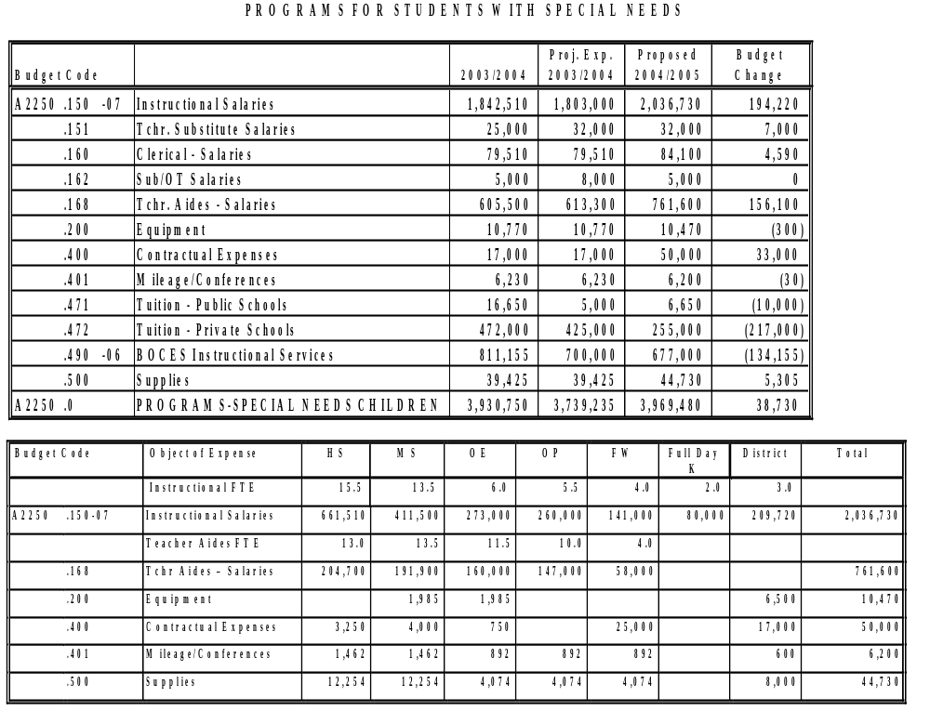

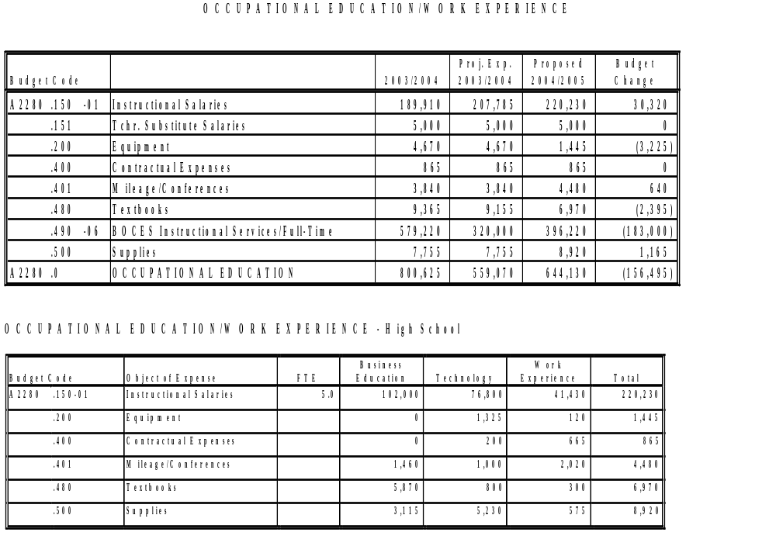
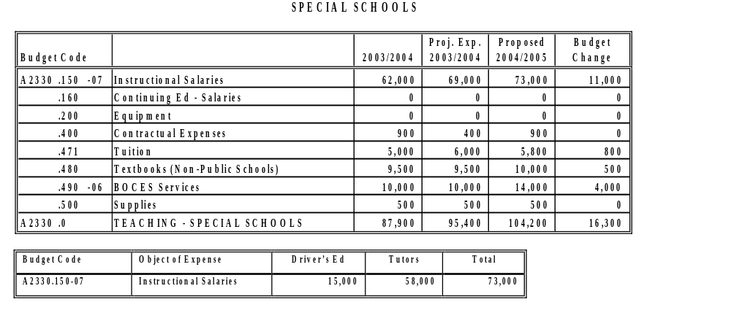

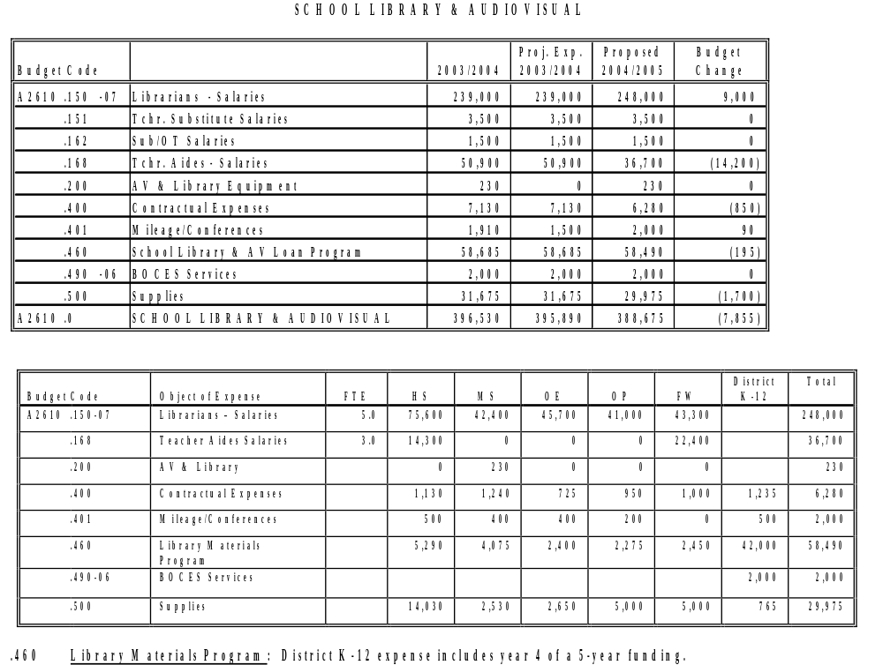

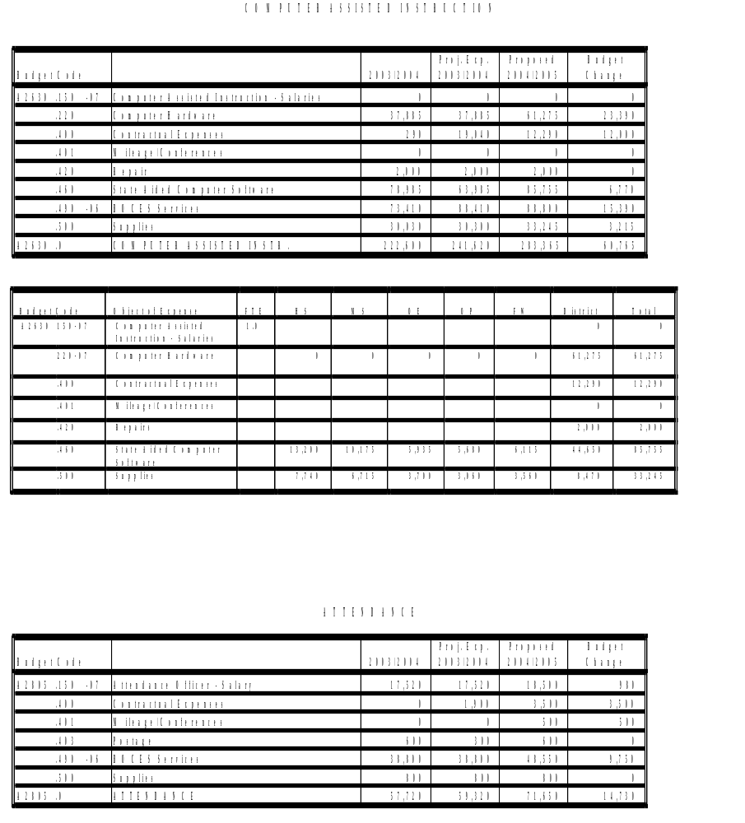

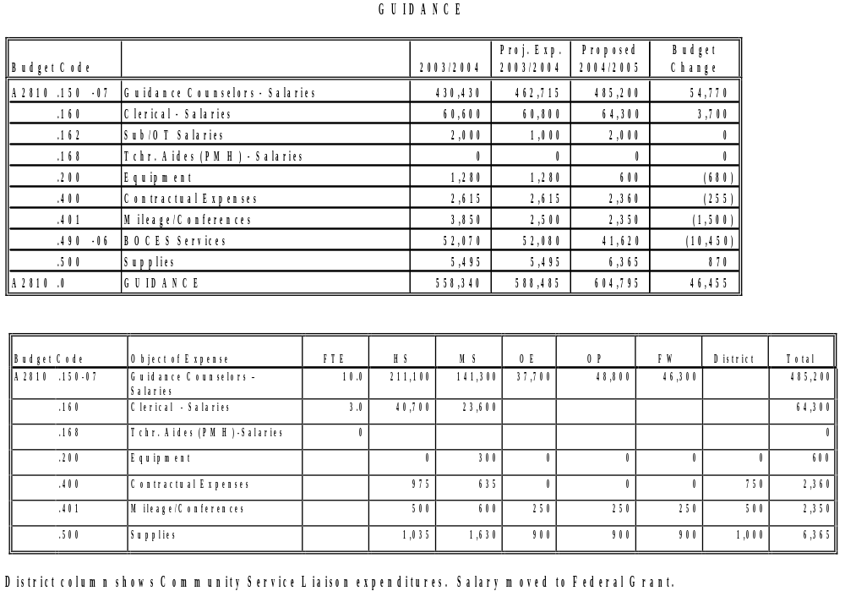
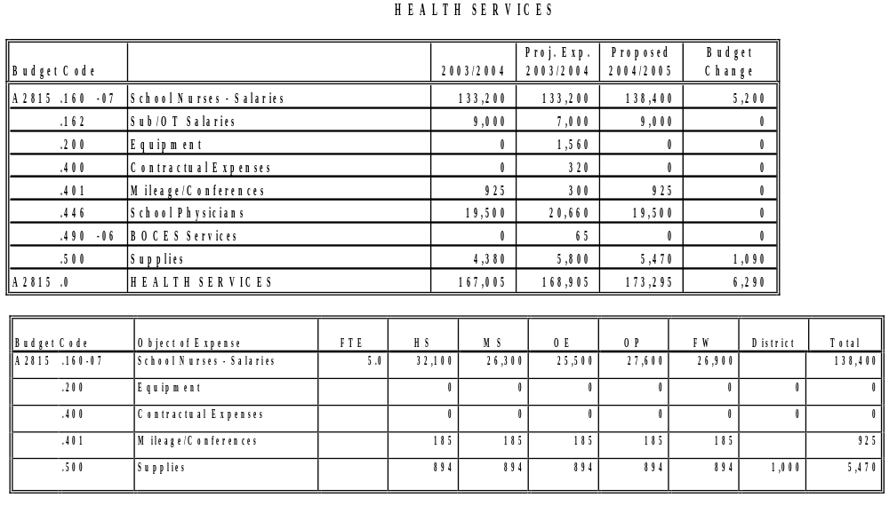
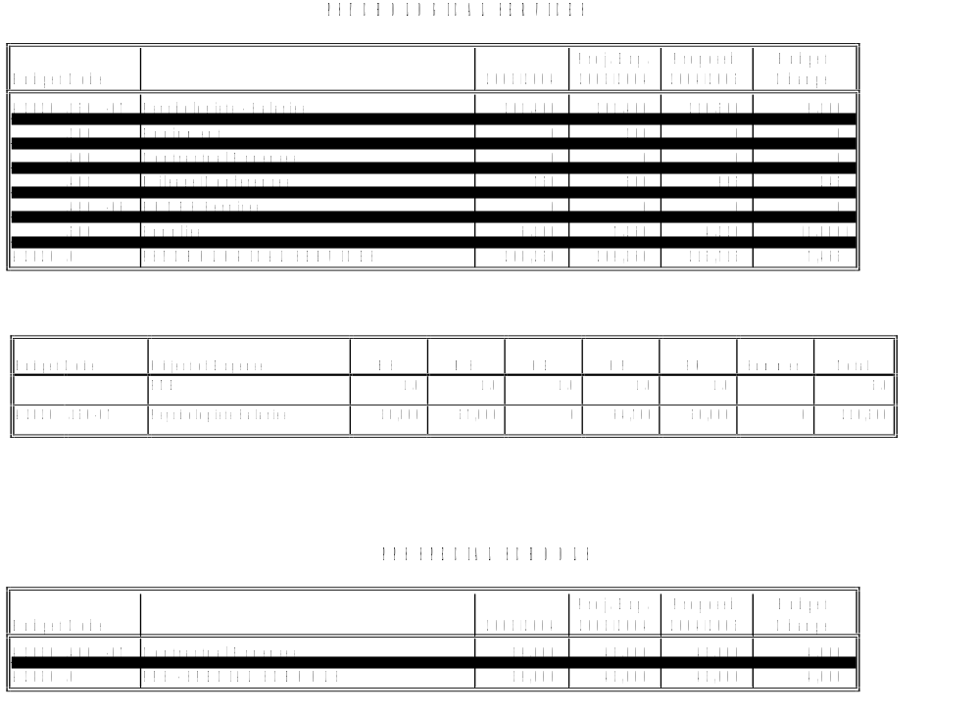

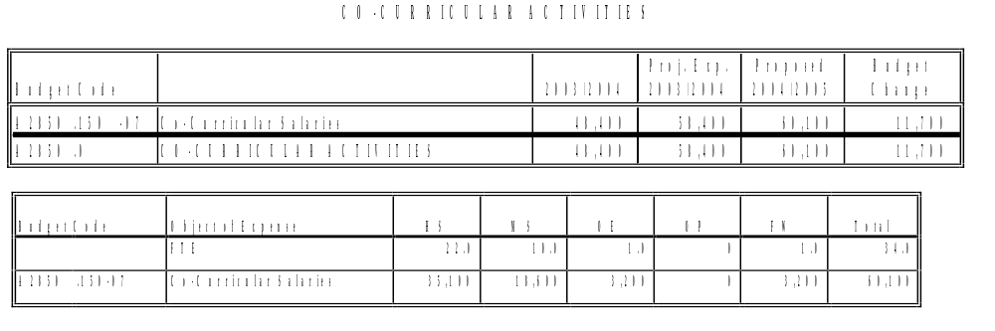

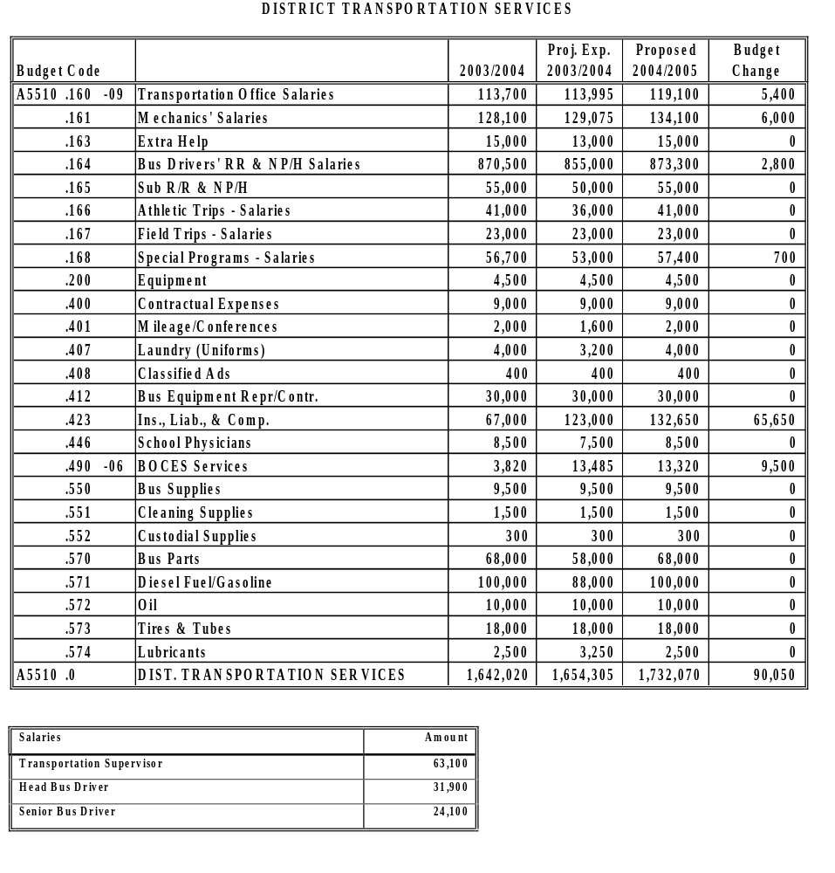
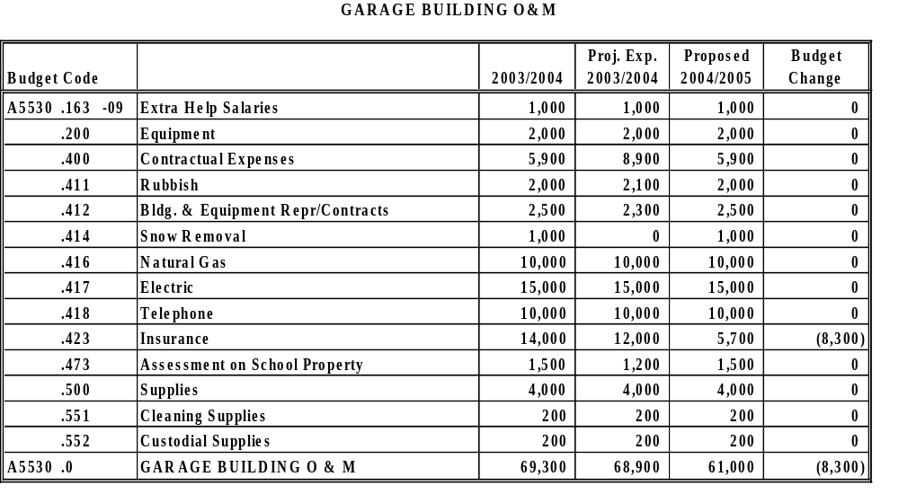

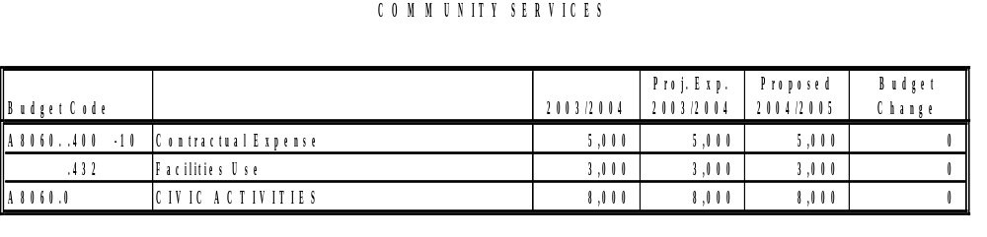
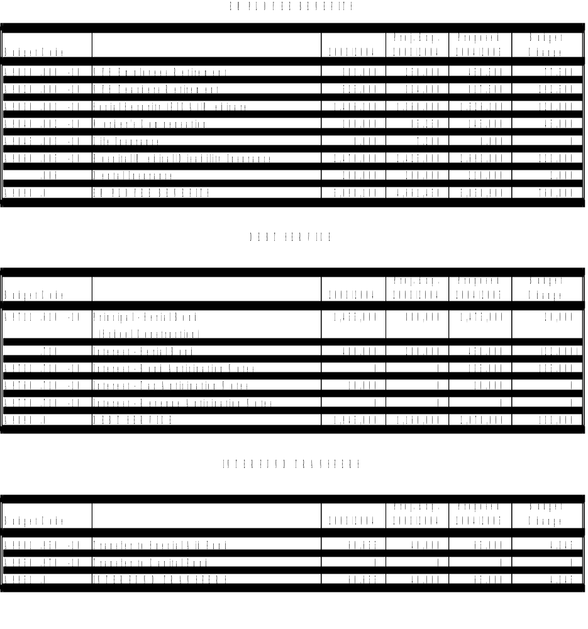

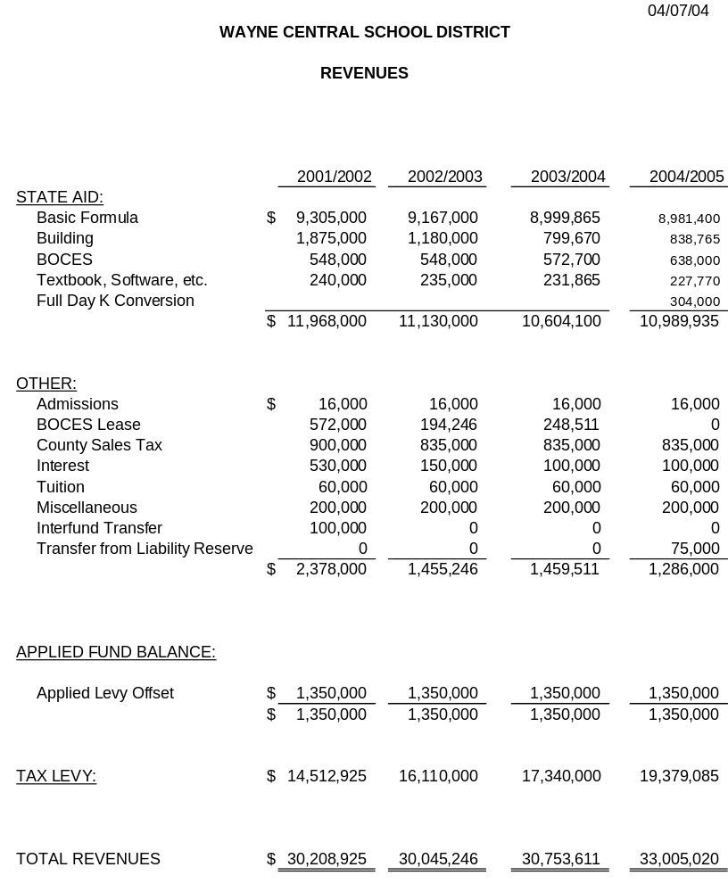

Att. 3

WAYNE CENTRAL SCHOOL DISTRICT

To: Michael Havens, Superintendent of Schools
From: Mark D. Callahan, Director of Human Resources
Re: Personnel Action
Date: April 7, 2004

The following is submitted for your review and approval.

ADMINISTRATIVE STAFF

- Resolution to Create Position:

Create position of 1.0 FTE Assistant Director of Student Services assigned to the District Office effective July 1, 2004.

- Appointments:

Michelle Scheik, Assistant Director of Student Services, assigned to the District Office, a three year probationary appointment effective July 1, 2004 through June 30, 2007, at $68,000 annually. Michelle has served as the Assistant to the Director of Student Services while being a teacher on special assignment.

INSTRUCTIONAL STAFF

- Tenure Recommendation:

The following teachers are being recommended by the Superintendent for appointment to tenure according to the tenure area and date listed:

Name Tenure Area Date_____________________
Stephanie Collins Speech and Hearing August 31, 2004
Phillip Corleto School Counselor August 31, 2004
Tiffany Cotsonas Elementary Education August 31, 2004
Jayson Gauthier Technology August 31, 2004
Jennifer Klehr Social Studies August 31, 2004
Debra Knox Elementary Education August 31, 2004
Mary Rosdahl Special Education August 31, 2004
Joshua Schlageter Elementary Education August 31, 2004
Carrie St. Pierre Elementary Education August 31, 2004
Andrew Struzik Social Studies August 31, 2004
Amy Sullivan Elementary Education August 31, 2004
Amy Tobin Reading August 31, 2004
Name Tenure Area Date_____________________
Kathleen Walker Reading August 31, 2004
Elizabeth Waring Special Education August 31, 2004
Jennifer Wing Social Studies August 31, 2004

- Resignations:

JoAnn Harder, Elementary Teacher, assigned to the Ontario Primary School effective June 30, 2004. For the purpose of retirement.

JoAnne Hurley, Math Teacher, assigned to the Thomas C. Armstrong Middle School effective October 25, 2004. For the purpose of retirement.

Ellen Miller, Vocal Music Teacher, assigned to the Freewill Elementary School effective September 2, 2004. For the purpose of retirement.

Patricia Morton, Elementary Teacher, assigned to the Ontario Primary School effective June 30,
2004. For the purpose of retirement.

Michelle Scheik, Special Education Teacher, assigned to District Office as a teacher on special assignment, effective July 1, 2004. Michelle will be re-assigned to the Administrative role of Assistant Director of Student Services.

Megan Stuart, Elementary Teacher, assigned to the Ontario Elementary School, effective June 30, 2004. For personal reasons.

- Leave of Absence: None

- Appointments

Kelly Grover, School Counselor, assigned to the Thomas C. Armstrong Middle School, a three month temporary appointment effective March 29, 2004 through June 30, 2004 at $34,750 pro-rated. Temporary replacement for Joan Prevost (childrearing leave).

Nancy Jordan, Reading Teacher, assigned to the Thomas C. Armstrong Middle School, a four month temporary appointment effective March 8, 2004 through June 30, 2004 at $34,750 pro-rated. Temporary replacement for Jennifer Borowiak (childrearing leave).

Renee Saba, Elementary Teacher, assigned to the Ontario Primary School, a four month temporary appointment anticipated from April 8, 2004 through June 30, 2004 at $34,750 pro-rated. Temporary replacement for Rebecca Grof f (childrearing leave).

Rosa Visconte-Goebel, Elementary Teacher, assigned to the Ontario Elementary School, a four month temporary appointment effective March 22, 2004 through June 30, 2004 at $34,750 pro-rated. Temporary replacement for Stephanie Mordaci (childrearing leave).

ADDENDUM TO ANNUAL APPOINTMENT OF SUBSTITUTE TEACHERS
FOR 2003-04

Last Name | First Name
Benwell | David
Brol | Bonnie
Cheetham | Lisa
Connelly | Craig
Deverell | Lee
Herden | Mark
Kent | Amanda
Lambert | Courtney
Martin | Scott
Munding | Kimberly
Sandefer | Corrie
Schlegel | Lisa
Sollame | Becky
Stead | Janis

SUPPORT STAFF

- Resignations:

Barbara Boyce, Teacher Aide, assigned to the Ontario Elementary School effective June 25, 2004. For the purpose of retirement.

- Appointments

Lynne Howard, 1:1 Teacher Aide (1.0 FTE) assigned to the Thomas C. Armstrong Middle School, a three month temporary Civil Service appointment effective March 15, 2004 through June 30, 2004, at $7.65/hr. Position required to support new student.

John Leone, Cleaner (.5 FTE) assigned to the Thomas C. Armstrong Middle School and James A. Beneway High School, a three month temporary Civil Service appointment effective March 31, 2004 through June 30, 2004, at $8.10/hr. Temporary replacement for Susan Anseeuw (Workers’ Compensation LOA).

Lisa Mercurio, 1:1 Teacher Aide (1.0 FTE) assigned to the Ontario Elementray School, a four month temporary Civil Service appointment effective February 23, 2004 through June 30, 2004, at $7.65/hr. Position required to support new student.

The Superintendent recommends the following annual appointments of Advisors, and Athletic Coaches for 2003-2004. These appointments will be effective September 1, 2003 through June 30, 2004, at contractual rates.

MUSICAL ADVISOR APPOINTMENTS (AMENDED)

Appointments:

Name Activity Bldg. Rate
Joe Stamonine Sound HS $410
George Bauerschmidt Accompanist HS $546

- ADVISOR (AMENDED)

Name Activity Bldg. Rate
Sandra Karpp Ecology Club OE $530

- COACHING APPOINTMENT (AMENDED)

Spring 2004

Name Team Step WCS Years Level Incentive Salary
Jared Drexler Asst. Girls’ 1 1 E No $2374
Varsity Track

Att. 5

WAYNE CENTRAL SCHOOL DISTRICT
Ontario Center, New York

TO: Board of Education
FROM: Michael Havens

RE: Consensus Agenda
DATE: April 1, 2004

The following items are recommended for approval as presented in a Consensus Agenda:

- Accept February Treasurer’s Report

- Approve Health Contract with West Irondequoit Central School District

- Award Operation & Maintenance Cleaning Supplies Bid

- Approve Budget Transfer

Consensus Agenda #2

TO: Michael Havens
Superintendent of Schools
FROM: Gregory J. Atseff
Assistant Superintendent for Business
DATE: April 7, 2004
RE: Health Service Contract - West Irondequoit

Attached is the contract for health services for Wayne students attending a private or parochial school in the West Irondequoit School District for the 2003-2004 school year.

The cost of the contract is:

(1) student @ $347.44 = $347.44

The attendance officer has verified the students listed on the health service contract.

RESOLUTION

Be it resolved, that the Board of Education of the Wayne Central School District hereby approves the contract for health services with the West Irondequoit School District for the 2003-2004 school year, and hereby authorizes the Superintendent of Schools, Board President, and District Clerk to execute the contract.

/db

Attachment

Consensus Agenda #3

TO: Michael Havens
Superintendent of Schools
FROM: Gregory J. Atseff
Assistant Superintendent for Business
DATE: April 7, 2004
RE: Operation & Maintenance Cleaning Supplies

In accordance with Section 103A, Article 5-A, of the New York State General Municipal Law, a legal notice was advertised in the official school newspapers inviting the submission of sealed bids for Operation and Maintenance Cleaning Supplies and Equipment.

Sealed bids were received and opened publicly on Thursday, March 11, 2004, at 1:00 p.m. at the district administrative offices.

Bids were advertised to be evaluated on either an item-by-item basis or total basis, whichever best suited the district. Prices submitted are to be f.o.b. Wayne Central School District. Where indicated, the vendor responded to a request for a discount for non-bid items purchased during the school year.

The lowest responsible bidders are identified as follows:

 | Vendor | Bid Total | Discount
 | Corr Distributors, Inc..  33 Chandler Street  Buffalo, NY 14207 | $3,139.57
 | Economy Paper  1174 E. Main Street  PO Box 90420  Rochester, NY 14609 | 6,108.75 | 1%
 | Gabriel First Corp.  233 West Commercial St.  East Rochester, NY 14445 | 10,780.29
 | Hillyard Chemical Co  159 Lagrange Ave.  Rochester, NY 14613-1511 | 2,527.84 | 15%
 | L.J.C. Distributors  1626 Cedar Ave.  Scranton, PA 18505 | 1,800.00
 | Palmer Distributing  100 Hoffman St.  Newark, NY 14513 | 974.52 | State Cont.
 | Total | $25,330.97
Attached is a copy of the vendor bid list for your reference.

/db

Attachment
OPERATION & MAINTENANCE
CLEANING BID
3/11/04

All American Poly
Bid Department
40 Turner Rd.
Piscataway, NJ 08854

Brulin Corp.
Mr. Andrew Chadwick
PO Box 17227
Rochester, NY 14617-0227

Central Poly Corp.
Mr. Andrew Hoffer
18 Donaldson Place
Linden, NJ 07036

Chase Commercial Source
401 Pixley Rd.
Rochester, NY 14624

Chemsearch
Mr. Hank Sciarabba
21 Lost Mountain Trl
Rochester, NY 14625-2423

Cook Iron Store
Mr. Matt Kurtz
PO Box 31237
Rochester, NY 14603

Corr Distributors, Inc.
Mr. Will Slocombe
33 Chandler Street
Buffalo, NY 14207

Drummond American
Mr. Don Kolpuski
47 Fox Ct.
Rochester, NY 14624

Ecolab Inc.
Ms. Dianne Hardy
370 Wabasha St.
St. Paul, MN 55102

Economy Paper Company
Mr. Ed Shova
1175 E. Main Street,
PO Box 90420
Rochester, NY 14609

Gabriel First Corp.
233 West Commercial St.
East Rochester, NY 14445

Green Oaks Janitor Supply
465 Blossom Rd
Rochester NY 14610

Hillyard Chemical Co.
159 Lagrange Ave.
Rochester, NY 14613-1511

Jamestown Soap & Solvent, Inc.
Mr. Randy Anderson
1279 Hunt Road
Ashville, NY 14710

L.J.C. Distributors
1626 Cedar Ave.
Scranton, PA 18505

Leggette Enterprises
Mr. Scott Legette
3781 Union Street, PO Box 278
Marion, NY 14505

Mat Works
Ms. Danielle Griffith
11900 Old Baltimore Pike
Beltsville, MD 20705

Metco Supply Inc.
81 Kiski Avenue
Leechburg, PA 15656

Neutron Industries
Mr. Donald Lutter
7107 North Black Canyon Highway
Phoenix, AZ 85021

Palmer Distributing
Mr. Todd Palmer
100 Hoffman St.
Newark, NY 14513

Ravan Environmental Inc.
Mr. Mike Loene
7 Sunleaf Drive
Penfield, NY 14526

Reliable Products
Mr. Jerry Garski
3474 Woodlands Circle
Macedon, NY 14502

W.W. Grainger
Mr. John Crowley
430 W. Metro Park
Rochester, NY 14623

Consensus Agenda #4

TO: Michael Havens
Superintendent of Schools
FROM: Gregory J. Atseff
Assistant Superintendent for Business
DATE: April 7, 2004
RE: Budget Transfers

In accordance with Policy #5330, please present the attached list of budget transfers to the Board of Education for their approval at their meeting on April 7, 2004.

The transfers are necessary to cover increased insurance costs for the district fleet, to transfer money from a payroll code to a contractual code to pay non-employees for the production of the high school musical, and to cover an increased number of students receiving ESL services.

GJA/db
Attachment


