Subject Area: Art K-6 Grade Level: 5

Mission Statement: It is the mission of the Elba Central School District to actualize the phrase “Elba Equals Educational Excellence for Everyone.” We are committed to providing both quality and equity. Every student will have the opportunity to develop to the best of his/her ability.

Elba Standards: In addition to the knowledge and basic skills they need in order to participate in society, graduates of Elba Central School will develop:
- Empowering skills: decision making, goal setting, creative thinking and problem solving abilities;
- Communication and social interaction skills;
- Technological literacy;
- Total wellness (social, physical, emotional health and self-esteem);
- The values necessary to participate in society.
As a result of achieving these outcomes, our students will embrace lifelong
learning

New York State Standards: 1) Creating, Performing and Participating in the Arts. 2) Knowing and using Art Materials and Resources. 3) Responding to and Analyzing Works of Art. 4) Understanding the Cultural Contributions of the Arts.
National Standards:

National Standards: 2)Using knowledge of structures and functions. 3)Choosing and evaluating a range of subject matter, symbols and ideas. 5)Reflecting upon and assessing the characteristics and merits of their work and the work of others.

Performance Indicators:
1-A use the elements and principles of art to communicate specific meanings to others in their art work.
1-B know and use as variety of sources for developing and conveying ideas, images, themes, symbols, and events in their creation of art.
1-C use the elements and principles of art to communicate specific meanings to others in their artwork.
1-D during the creative process, reflect on the effectiveness of selected mediums or techniques to convey intended meanings
1-E identify and use in individual and group experience, some of the roles and means for designing, producing and exhibiting art works and discuss ways to improve them.
2-A develop skills in a variety of art materials and competence in at least one medium.
2-B use the computer and other electronic media as designing tools to communicate visual ideas.
2-C take advantage of community opportunities and cultural institutions to learn from professional artists, look at original art and increase their understanding of art.
2-D understand the variety of careers related to the visual arts and the skills necessary to pursue some of them
3-A discuss and write their analyses and interpretations of their own works of art and the art of others using appropriate critical language
3-B identify, analyze and interpret the visual and sensory characteristics that they discover in natural and human-made forms.
3-C compare the ways ideas and concepts are communicated through visual art with the various ways that those ideas and concepts are manifested in other art forms
3-D compare the ways ideas, themes , and concepts are communicated through the visual arts in other disciplines, and various ways that those ideas, themes and concepts are manifested within the discipline.
4-A Demonstrate how art works and artifacts from diverse cultures reflect aspects of those cultures
4-B Demonstrate the ways in which some particular art works and artifacts reflect important aspects of the diverse cultures of the United States
4-C Create art works that reflect a particular historical period of the culture
Assessment: | Acceptable Performance Level
Completed art projects | 3 or 4 on completed work
2 pieces of artwork in Art show/May | 3 or 4 on Report Cards 20/40 weeks

Scope: Fifth Grade art students will explore 20th century Art/Artists/Styles/Techniques and movements as they reflect changes in a modern culture.

CONTENT SEQUENCE  *Skill appears in bold print | PERFORMANCE INDICATORS (INTERMEDIATE) | INTEGRATED CONTENT STANDARD/P.I. | METHOD OF ASSESSMENT | ACHIEVED PERFORMANCE LEVELS
20TH CENTURY STUDY OF ART/ARTISTS Fauvism: Self Portraits Henri Matisse | 1C  1D, 4C | SS  2.1C II&IV  I | Rubric | Developing  Awareness
Art Deco: Cool Cats | 3A, 3C, 3D, 4A, 4B 4C | SS  2.1C II&IV  I | Rubric | Awareness  Developing
Cubism “My Bedroom” Picasso (Guernica) | 1A, 1B, 1C, 4C, 4A, 4B | SS  2.1C II&IV  I | Rubric | Developing  Awareness
Animation Walt Disney  Internet use | 2A, 2C, 2D, 3C, 3D  2B | SS  2.1C II&IV  I | Rubric | Awareness  Developing
Animation Walt Disney  Internet use | 2A, 2C, 2D, 3C, 3D  2B | MST  5.3B  E | Rubric | Awareness  Developing
Holiday Fine Arts Festival | 1E, 2C, 3C |  | Report Card Gr. | Awareness
Abstract Expressionism: Jackson Pollock / Piet Mondrian Kid Pix Deluxe 3. Comparative Writing:” 6 Traits”  Ideas & Organization | 1C, 2B, 4C  1E, 3C, 3D, 4B | 6 + 1  I,O | Rubric | Developing  Awareness
 | 1C, 2B, 4C  1E, 3C, 3D, 4B | ELA  S&W  1.2A,C,D  I | Rubric | Developing  Awareness
Surrealism: Magazine Collage Henri Magritte / Salvador Dali | 1C, 4C | SS  2.1C II&IV  I | Rubric | Developing
MCEscher OPArt or Jasper Johns “Flags” | 1C, 4C  1E | SS  2.1C II&IV  I | Rubric | Developing  Awareness
Pop Art: “Soup Can” Name Alliterations Andy Warhol | 1A, 1B, 1C, 4C | SS  2.1C II&IV  I | Rubric | Developing
Acrostics of Artists 20th century. School Arts January 2003 | 3A  4C | SS  2.1C II&IV  I | Rubric | Awareness Developing
Spring Fine Arts Festival | 1E, 2C, 3C | SS  2.1C II&IV  I | Report Card Gr. | Awareness
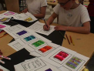 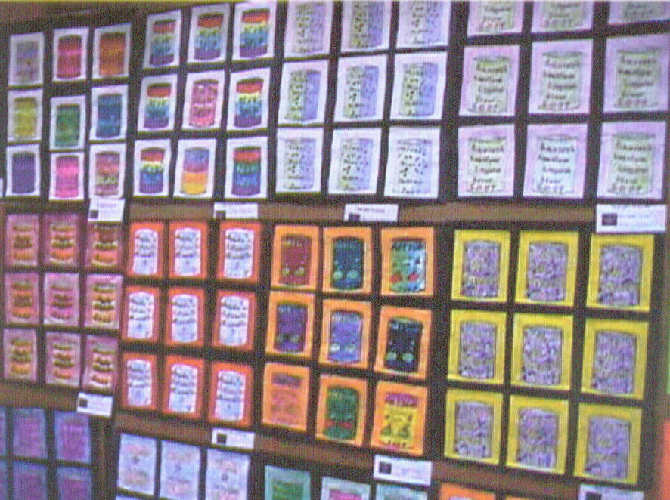 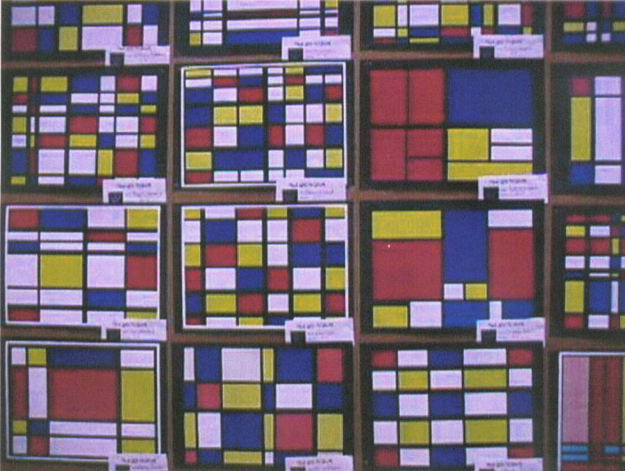 “Soup Cans” Pop Art P.I. 1A, 1B, 1C, 4C Integrated SS 2.1D II I Abstract Mondrian-Kid Pix
Integrated w/ MST 5.3B &SS 2.1D II I
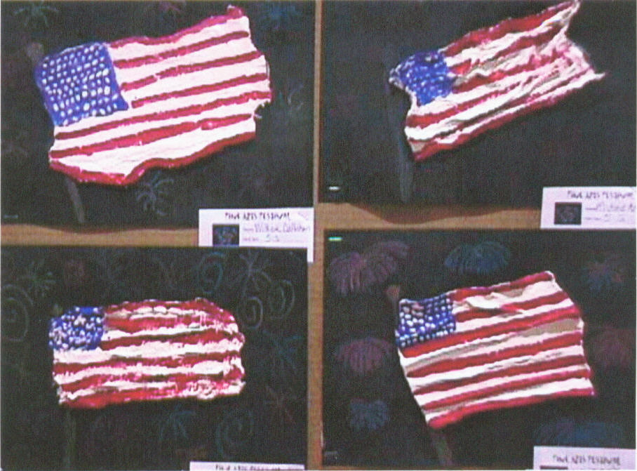
Jasper Johns “Flag” P.I. 1C,E ,4C,
Integrated W/ SS 2.1D II I

Methodology: 20th Century Designs Jackie Gaff, 6- Traits, Kid Pix Deluxe 3,
Arts & Activities, School Arts January ‘03

