Subject Area: Art K-6 Grade Level: 4

Mission Statement: It is the mission of the Elba Central School District to actualize the phrase “Elba Equals Educational Excellence for Everyone.” We are committed to providing both quality and equity. Every student will have the opportunity to develop to the best of his/her ability.

Elba Standards: In addition to the knowledge and basic skills they need in order to participate in society, graduates of Elba Central School will develop:
- Empowering skills: decision making, goal setting, creative thinking and problem solving abilities;
- Communication and social interaction skills;
- Technological literacy;
- Total wellness (social, physical, emotional health and self-esteem);
- The values necessary to participate in society.
As a result of achieving these outcomes, our students will embrace lifelong learning.

New York State Standards: 1) Creating, performing and participating in the arts.
2) Knowing and using art materials and resources. 3) Responding to and analyzing works of art 4) Understanding the cultural contributions of the arts

National Standards: 2) Using knowledge of structures and functions.
4) Understanding the visual arts in relation to history and culture. 5) Reflecting upon and assessing the characteristics and merits of their work and the work of others.

Performance Indicators:
1-A, produce a collection of works, in a variety of mediums, based on a range of individual and collective experiences.
1-B, know and use a variety of sources for developing and conveying ideas, images, themes, symbols, and events in their creation of art
1-C, use the elements and principles of art to communicate specific meanings to others in their art work.
1-D, during the creative process, reflect on the effectiveness of selected mediums or techniques to convey intended meanings.
1-E, identify and use, in individual and group experiences, some of the roles and means for designing, producing, and exhibiting art works and discuss ways to improve them.
2-A, develop skills with a variety of art materials and competence in at least one medium.
2-B, use the computer and other electronic media as designing tools and to communicate visual ideas.
2-C, take advantage of community opportunities and cultural institutions to learn from professional artists, look at original art and increase their understanding of art.
2-D, understand the variety of careers related to the visual arts and the skills necessary
to pursue some of them.
3-A, discuss and write their analyses and interpretations of their own works of art and the art of others, using appropriate critical language.
3-B, identify, analyze and interpret the visual and sensory characteristics that they discover in natural and human-made forms.
4-A, demonstrate how art works and artifacts from diverse world cultures reflect aspects of those cultures.
4-B, demonstrate the ways in which some particular art works and artifacts reflect important aspects of the diverse cultures of the United States.

Assessment: | Acceptable Performance Level
Completed projects | 3-4 on completed projects,  progress assessment on all major projects
2 pieces of art work in the art show/May | 3-4 on report cards 20/40 weeks

Scope: Fourth Grade art students will create a body of work with emphasis on local architecture and it’s historical significance both general and specific
.

CONTENT SEQUENCE  *Skill appears in bold print | PERFORMANCE INDICATORS  (INTERMEDIATE) | INTEGRATED CONTENT AREA STANDARD AND P.I. | ASSESSMENT | ACHIEVED PERFORMANCE LEVELS
Visiting Architect | 2C, 2D | CDOS  2.1A  E | Rubric | Proficient
Introduction to (4) basic styles of arch. Federal, Greek Revival, Gothic Revival, Italianate Arch. Vocab. | 3B, 4A, 4B | SS  1i.1A  E | Rubric | Proficient
Block Methods of printing | 1A, 1B, 1C,  1D, 1E |  | Rubric | Awareness – I  Proficient
Computer Generated Arch. Façade Drawing | 2A  2B | MST  5.3A  E | Rubric | Proficient Awareness - I
Written description of local arch.  6 Traits “Ideas and Organization” | 3A | 6 + 1  I,O | Rubric | Proficient
Architectural Façade Relief | 1A  1D, 1E, 2A, 2C, 4B |  | Rubric | Awareness - I  Proficient
Holiday Fine Arts Festival | 1E, 2C, 3C |  | Report Card Gr. | Proficient

Rhythm Instruments, clay hand bells (slab Construction) to be used in Musical presentation (March-Music in our schools month) | 3C, 4A | Arts  M  2.2B  E | Rubric | Proficient
Architectural Pencil Drawing | 1A, 1C  2A |  | Rubric | Awareness – I  Proficient
Fiber Weaving | 2D, 3B, 4A, 4B | CDOS  2.1A  E | Rubric | Proficient
Spring Fine Arts Festival | 1E, 2C, 3C |  | Report Card Gr. | Proficient

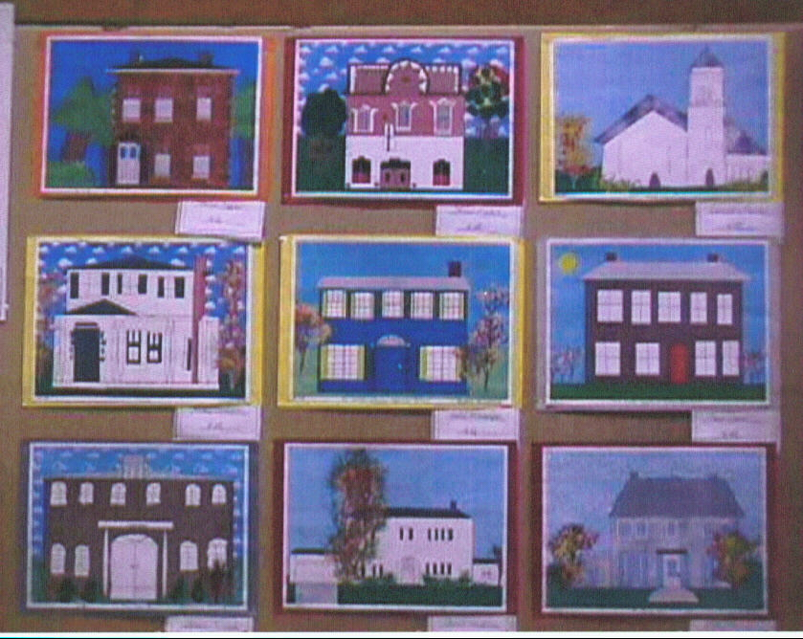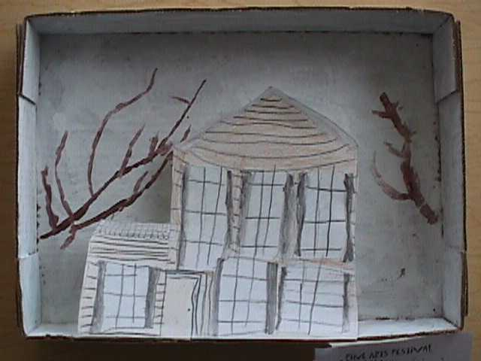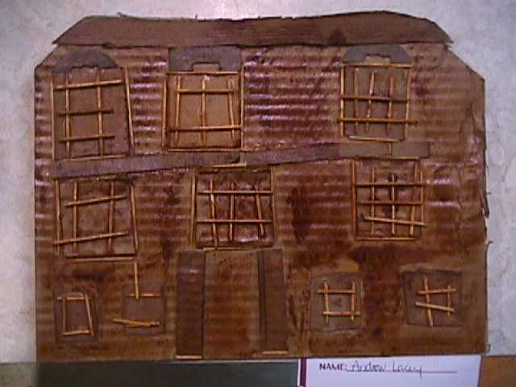
Arch. Drawing w/ Kid Pix Arch. Diorama P.I. 1A Arch. Façade Relief
P.I. 2A, 2B Integrated w/ MST 5.3B Integrated w/SS 1i.1A 1A,1D,1E, 2A, 2C, 4B

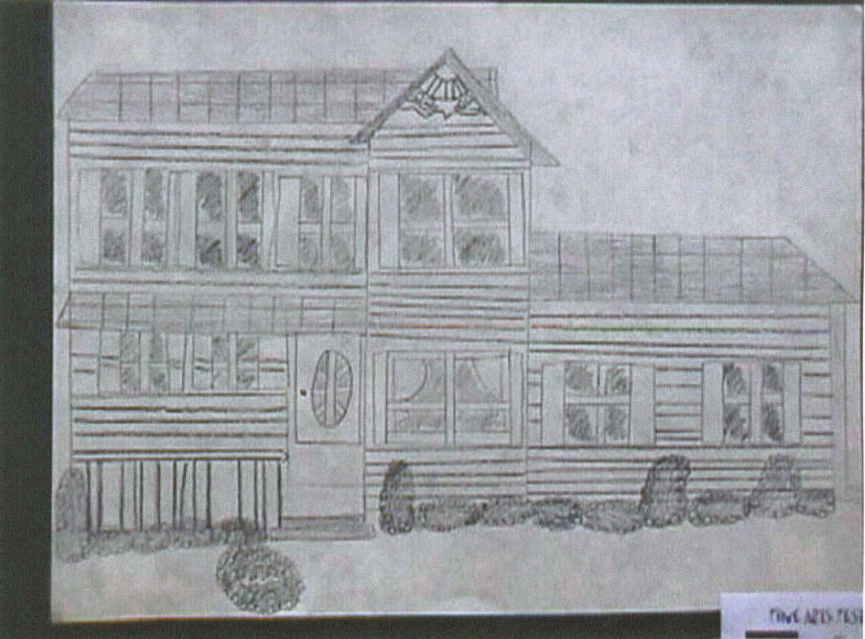
Arch Pencil Drawing 1A,C, 2A

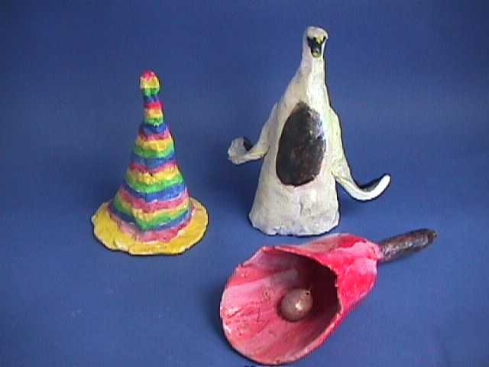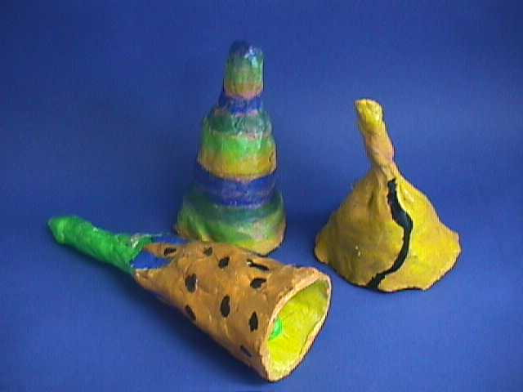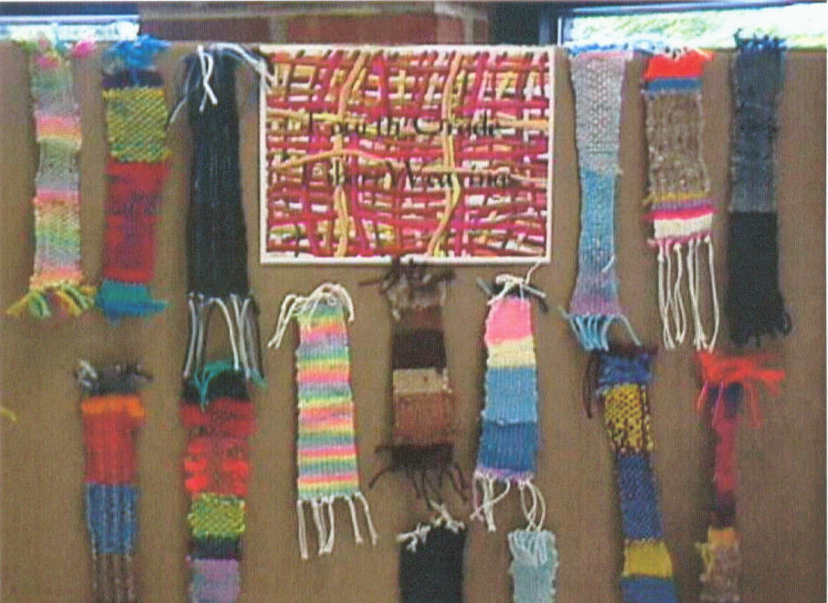
Clay Slab Constructed Hand Bells 3C, 4A Fiber Weaving w/ Hand Loom
Integrated with Arts M2.2B P.I.2D,3B,4A,B
Integrated w/ CDOS 2.1A

Methodology: Kid Pix Deluxe 3, Architectural Heritage of Genesee County, Contacts with Landmark Society, Guest speakers in field of Architecture, School Arts, 6 Traits.

