Subject Area: Art K-6 Grade Level: 1

Mission Statement: It is the mission of the Elba Central School District to actualize the phrase “Elba Equals Educational Excellence for Everyone.” We are committed to providing both quality and equity. Every student will have the opportunity to develop to the best of his/her ability.

Elba Standards: In addition to the knowledge and basic skills they need in order to participate in society, graduates of Elba Central School will develop:
- Empowering skills: decision making, goal setting, creative thinking and problem solving abilities;
- Communication and social interaction skills;
- Technological literacy;
- Total wellness (social, physical, emotional health and self-esteem);
- The values necessary to participate in society.
As a result of achieving these outcomes, our students will embrace lifelong learning.

New York State Standards: 1) Creating, performing and participating in the arts. 2) Knowing and using art materials and resources. 3) Responding to and analyzing works of art. 4) Understanding the cultural dimensions and contributions of the arts.

National Standards: 1) Understanding and applying media, techniques, and processes. 6) Making connections between visual arts and other disciplines.

Performance Indicators:
1A experiment and create art works in a variety of mediums (drawing, painting, sculpture, printmaking, video and computer graphics), based on a range of individual and collective experiences.
1-B develop their own ideas and images through the exploration and creation of art works based on themes symbols and events.
1-C understand and use the elements and principles of art(line, color, texture, shape) in order to communicate their ideas.
2-A understand the characteristics of various mediums (two-dimensional, three dimensional, electronic images in order to select those that are appropriate for their purpose and intent.
2-B develop skills with electronic media as a means of expressing visual ideas.
2-C know about some cultural institutions (museums and galleries) and community opportunities (art festivals) for looking at original art and talking to visiting artists, to increase their understanding of art
2-D give examples of adults who make their living in the arts professions.
3-A explain their reflections about the meanings, purposes, and sources of works of art; describe their responses to the works and the reasons for those responses
3-B explain the visual and other sensory qualities (surfaces, colors, textures, shapes, sizes, volumes) found in a variety of works
3-D how ideas, themes, or concepts in the visual arts are expressed in other disciplines (e.g., mathematics, science, literature, social studies, etc.)
4-A look at and discuss a variety of art works and artifacts from world cultures to discover some important ideas, issues and events of those cultures

Assessment: | Acceptable Performance Level
Completed projects | 2-3 or (4) on completed work
2 pieces of art work in art show/May | 2-3 or (4) on report cards 20/40 weeks

Scope: First Grade art students will build a knowledge and understanding of the elements and principles of art.

CONTENT SEQUENCE  *Skill appears in bold print | PERFORMANCE INDICATORS  (ELEMENTARY) | INTEGRATED  CONTENT  STANDARD/P.I. | METHOD OF ASSESSMENT | ACHIEVED PERFORMANCE LEVELS
2-D drawings Paintings and collages w/ a variety of art media and techniques and | 1A, 1B, 1C |  | Rubric | Awareness
Pinch & Coil Pots, Fired and painted Form | 2A, 2C, 2D | CDOS  2.1A  E | Rubric | Awareness
Piñatas w/ Paper Mache  Christmas Around the World | 1A, 1B, 1C, 2D, 3A, 4A, 4B | SS  2.1C  E | Rubric | Awareness
Piñatas w/ Paper Mache  Christmas Around the World | 1A, 1B, 1C, 2D, 3A, 4A, 4B | ELA  L&R  2.1A  E | Rubric | Awareness
Holiday Fine Arts Festival | 1E, 2C, 3C |  | Report Card Gr. | Awareness
Vincent Van Gogh (World’s Greatest Artists) Mike Venezia; Use of Kid Pix 3 to create their interpretation of “The Starry Night” | 1A, 1B, 1C, 2A, 2B, 3A, 4A | MST  T  5.3B  E | Rubric | Awareness
 | 1A, 1B, 1C, 2A, 2B, 3A, 4A | ELA  L&R  2.1A  E | Rubric | Awareness

Review of Van Gogh with an interpretation of “Sunflower” painting using a Texture collage technique and a of variety of media choices | 1A, 1B, 1C  3B, |  |  | Developing  Awareness
Look at examples of Rhythm instruments from other cultures, create “Guiros” to be used in Music class to create Rhythm | 3C, 4A | Arts  M  2.2B  E  Perform @ Assembly |  | Awareness
Chinese New Year; create Dragon | 3D, 4A, 4C | SS  2.1C  E |  | Awareness
Action Figure Sculptures | 2A  2D, 3A, 3B | CDOS  2.1A  E |  | Developing  Awareness
Origami-Japanese Paper Folding | 3B, 3D, 4C, 4A | SS  2.1C |  | Awareness
Spring Fine Arts Festival | 1E, 2C, 3C |  | Report Card Gr. | Awareness
Animals in art (1st gr. Zoo Field Trip) | 1A, 1B, 1C, 2A  3B, 3D |  |  | Developing  Awareness

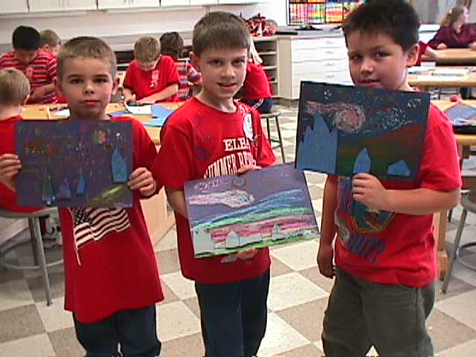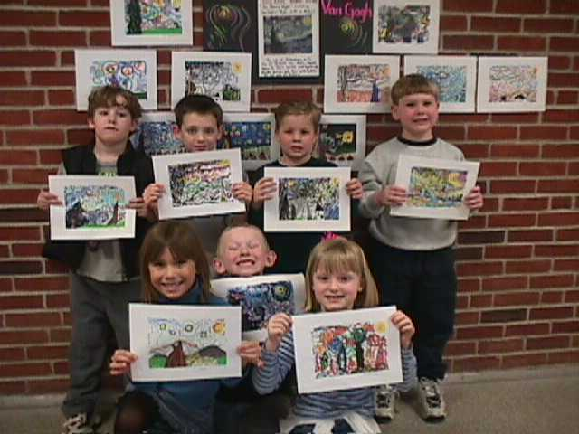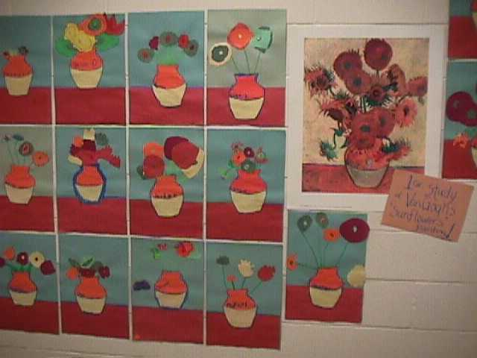
Van Gogh 2-D w/ relief cut outs Van Gogh w/Kid Pix Van Gogh “Sunflowers”
P.I. 1A,1B computer program P.I. 2A, 2B 1A, 1B, 1C, 2D, 3B
Integration w/ ELA L&R 2.1A Integration w/MST 5.3B
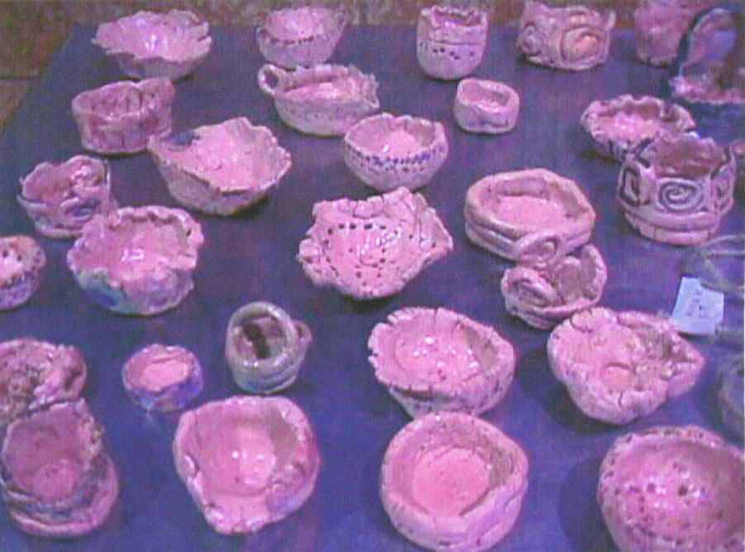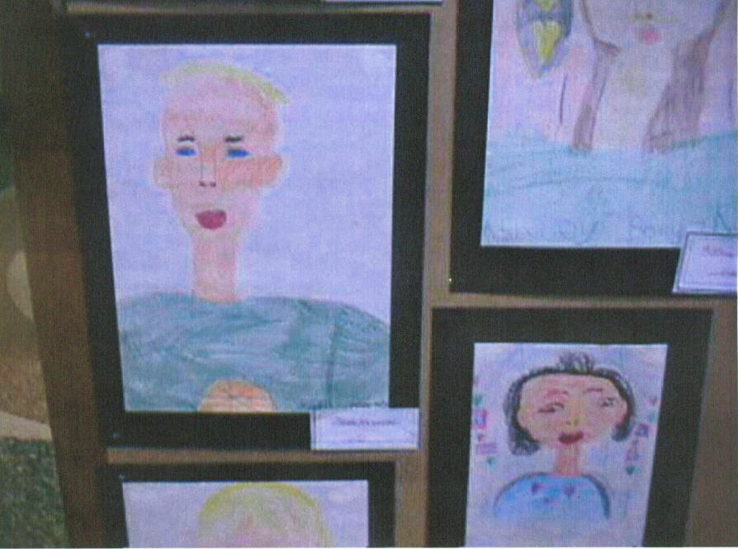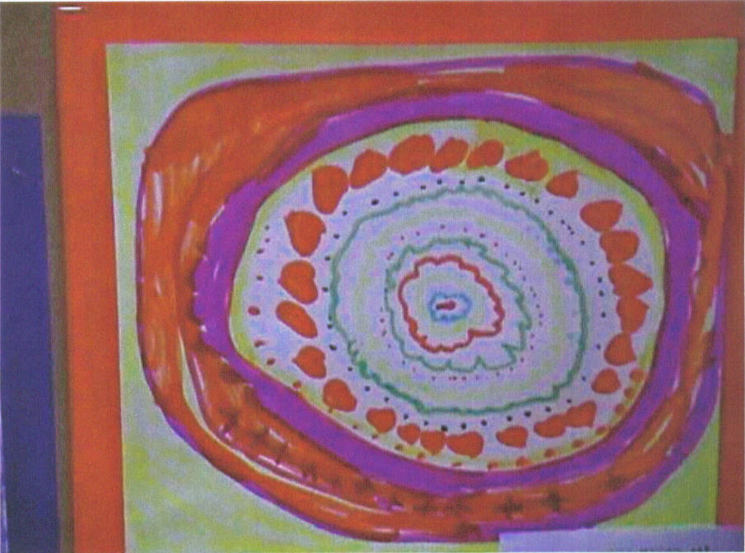
Coil &Pinch Pots 2A, D Self Portrait Drawing 1A-C Radial Balance Drawing
Integration w/ CDOS2.1A 1A-C
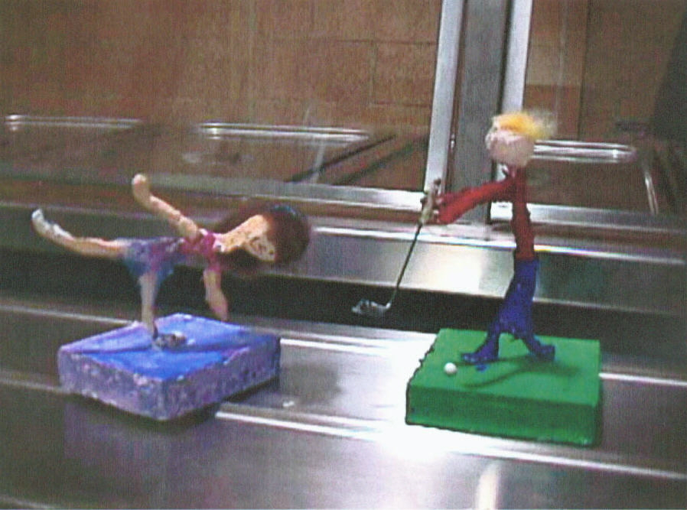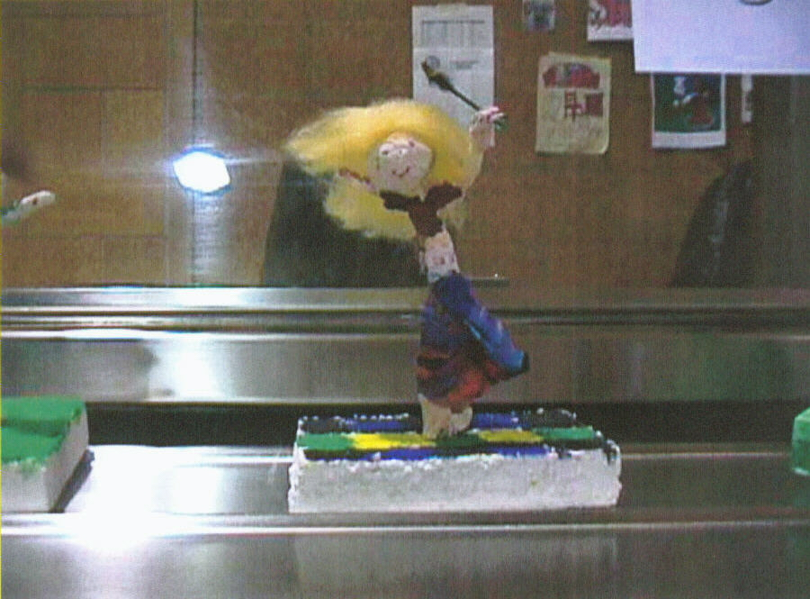
Action Sculpture P.I. 2A, D, 3A, B Integrated w/ CDOS 2.1A

Methodology: Kid Pix Deluxe 3 Program, Getting to know the Artist Series (Mike Venezia), use of Librarian to help us create children’s picture book, integration with Grade 1 units and themes when possible.

