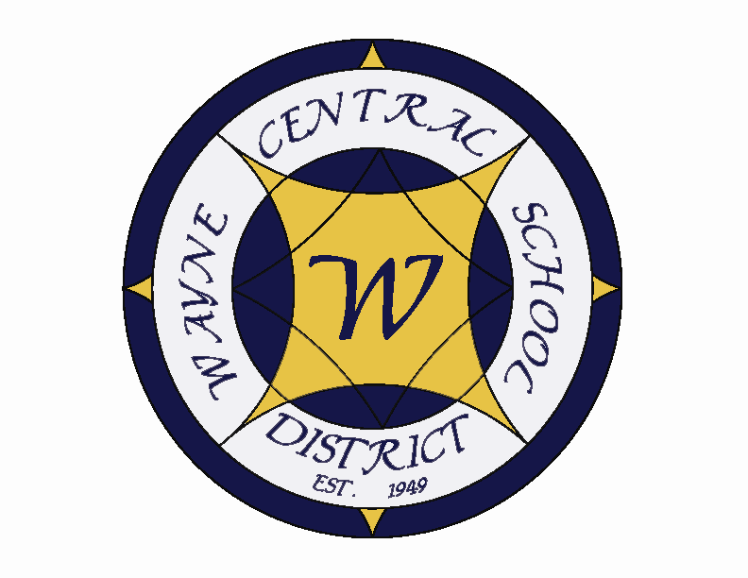
Letter to the Board

Michael Havens
Superintendent of Schools
Phone: 315-524-1001 Fax: 315-524-1049 mhavens@wayne.k12.ny.us

July 22, 2009

“"To conquer fear is the beginning of wisdom."

--Bertrand Russell,
Nobel laureate in literature

1. Administrative Retreat: I will be at the administrative retreat on Thursday and Friday so I won’t be able to do my Friday letter. This shortened version is in its place

2. Gullace: The trial on the Gullace trailer park has been completed. Each side now needs to submit their briefs to the Judge. While our attorney believes our side did a good job because even our professional assessment was less than the assessor’s there will be some refund coming due to Gullace. If the judge sides with us Greg estimates the refund for all years will be $46,904.10. If the judge sides with Gullace Greg estimates it will be 251,589.74. Most likely it will be somewhere in between. We have a reserve account designed for this purpose.

3. Ginna: We are in the final stages of concluding the assessment dispute with Ginna. The settlement will include a minimum and maximum that Ginna will pay in taxes for the duration of the agreement (8.6-8.9 million). For us the Town and the County it means that we each will each be getting more money than we would have under the current set up. In addition to their regular tax obligation in September we will get a portion of the underage in January. For this school year Greg estimates it means we will be getting $169,062.23 more than we budgeted for. So I guess we win some and we lose some.

4. Consultant visit: Don’t forget that you will be interviewing Phil Martin on July 28 and Vince Coppola on July 30th to select a search consultant. We have received a packet of material from Vince which I have attached. If we get anything from Phil I will send it along.

5. Upcoming Events:
7/28 – Search Consultant Meeting – DO Conference Room
7/30 – Search Consultant Meeting – DO Conference Room
7/27 – 7/31 – Administrative Block Out Week – No meetings Scheduled
8/3-8/7 – Administrative Block Out Week – No Meetings Scheduled
8/10 – Fall Sports Begin
8/13 – Board of Education Meeting – 7:00 p.m.
8/20 – MS Orientation & Ice Cream Social

6. Attachments:
a) Coppola materials
