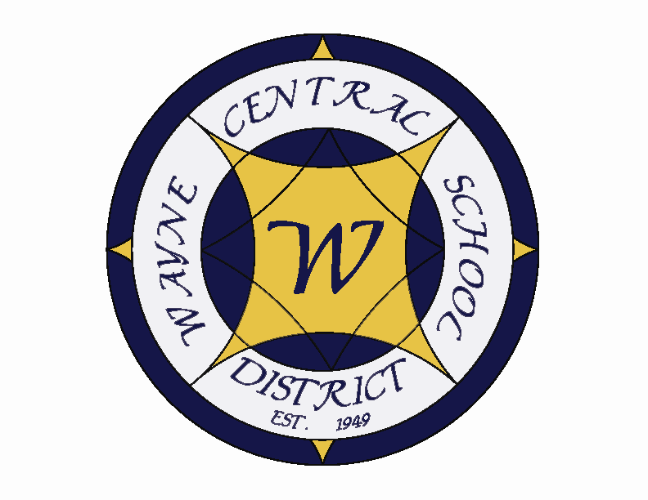
Letter to the Board

Michael Havens
Superintendent of Schools
Phone: 315-524-1001 Fax: 315-524-1049 mhavens@wayne.k12.ny.us

July 17, 2009

“Wisdom lies in taking everything with good humor and a grain of salt.”
- George Santayana, Spanish-American Philosopher & Author

Board Letter:

1. Facilities Meeting: On Thursday Greg, Bob Miller and I met with our architect and construction manager regarding the one campus facilities project. We told them we needed to complete as much of the original list as possible and to create a single campus elementary school. The cost for the entire project had to be at no additional tax rate to the public and we need to be able to keep the $1,000,000 staffing savings. This means the entire project has to be in the $47,000,000 range. We will meet with them in two weeks to see what they have. This would be a good time for the Board representatives to sit with us as we begin plans. I believe this is Tom, Joyce and Jeff though I am not sure. Please let me know if you are on the committee and we will arrange an appropriate time.

2. 4th Quarter Report: Attached is the 4th quarter academic standings. Once again, our highest achieving class remains the Freshman class. It will be interesting to track them next year to see if this is an academically successful group, or if the Freshman Academy seems to remain the success factor. Overall, the honor roll numbers slipped a bit from the third quarter, but that is to be expected with the finals and regents factored in. Still, all things considered, I believe having half our students achieving overall grades of 85 or better is an accomplishment. I recall when these numbers were in the 30% range.

3. Administrative Retreat: Next Thursday and Friday I will be at the administrative retreat so you won’t be getting a letter. We will be developing our plans for next year’s goals, including the elementary Foreign Language Program.

4. Superintendent Brochures: I have had Amy begin collecting brochures on superintendent openings so we can see what the competition looks like and to make sure ours is the most appealing.

5. NYSSBA Workshops: There are several NYSSBA workshops coming up. Please let Lori know if you are interested in attending any of them. They are:
2009 Board Officers Academy: “Navigating Your School Board through Tomorrow’s Challenges”
“The Board’s Role in Attracting & Developing High-Quality Teachers”
“Reach New Heights – Policy & the Effective School Board Meeting”
2009 Annual School Board Convention (NYC) – October 15-18

6. Upcoming Events:
7/23 & 24 – Administrative Retreat – Walworth Lodge - 8:00 – 5:00
8/13 – Board of Education Meeting – 7:00 p.m.

7. Attachments:
A) 4th Quarter Results
