WAYNE CENTRAL SCHOOL DISTRICT
BOARD OF EDUCATION

ORGANIZATIONAL MEETING AGENDA

DATE: July 9, 2009 TIME: 6:00 p.m. PLACE: District Office Conference Room

1. Call to Order: Mr. Frank Robusto, President of the Board, 2008-09

2. Pledge of Allegiance/Approval of Agenda

3. District Clerk administers Oath to Newly Seated Board Members: Mr. Scott Griswold
Mrs. Susan Newman
Mr. John Triou

4. Election of Board of Education Officers for 2009-2010

(a) President of the Board of Education
(b) Vice-President of the Board of Education
(District Clerk administers Oath of Office to Officers)

5. Appointment of District Officers for 2009-2010

(a) District Clerk: James Switzer
(b) District Clerk Pro Tem: Greg Atseff
(c) District Treasurer: Leora Stramonine
(e) Internal Claims Auditor: Russell Harris
(f) School Tax Collector: Helen Jensen
(g) Records Management/Access Officer James Switzer

6. Appointment of District Officials for 2009-2010

(a) School Attorney Wayne VanderByl, Attorney at Law
- School Physician: Cynthia Devore, M.D.
- School Census Enumerator: James Switzer
(e) Purchasing Agent: Gregory Atseff
(f) Attendance Officer: James Switzer
(g) School District Independent Auditor: Raymond F. Wager, CPA, P.C.
(h) Extra-Classroom Activity Account Treasurers:
Leora Stramonine, Wayne Middle School

Kim Muir, Wayne High School
(i) Title IX Compliance Officer Kim Cox
(j) Civil Service Appointing Officer: Mark Callahan
(k) School Architect: Clark-Patterson-Lee, P.C.
(l) Asbestos Compliance Designee Robert Miller
(m) Section 504 Compliance Officer Michelle Scheik
(n) American Disabilities Act Coordinator Michelle Scheik
(o) Liaison for Homeless Youth Kim Cox
(p) Chemical Hygiene Officer Patricia Brennan
(q) School District Internal Auditing Freed, Maxick and Battaglia

- Designations for 2009-2010

(a) Official Depositories: J.P. Morgan Chase, Fleet/Bank of America, Key Bank,
Lyons National
(b) Official Newspapers:
WAYNE COUNTY MAIL (Ontario) & THE TIMES (Walworth-Macedon)

8. Authorizations for Chief School Officer for 2009-2010

(a) Certification of payrolls
(b) Approval of attendance at conferences, workshops, conventions
(c) Approval of budget transfers per board policy
(d) Approval to borrow funds up to $25,000, for short term cash flow needs, without prior Board of Education approval.
- Designation to handle student residency determinations on behalf of the Board of
Education as provided by part 100.2(y) of the Regulations of the Commissioner of
Education.
(g) Approval to invest funds of the general, construction, school lunch, federal & capital
fund accounts

9. Bonding of Personnel: Authorize purchase of blanket bond for each of the following school district officers at the amounts specified:

(a) School District Treasurer ($1,000,000)
(b) School Tax Collector ($1,000,000)
(c) All other employees ($100,000)

10. Additional Designations and Authorizations for 2009-2010:

(a) Authorized signatures on Extra Classroom Activity Accounts:
Middle School: Robert Armocida, Leora Stramonine or Gregory Atseff

High School: Joseph Siracuse, Kim Muir or Leora Stramonine

(b) Authorized signature on all district checks:
District Treasurer's signature, using check-signing machine, and in her absence;
Assistant Superintendent for Business’s signature, using check signing machine.

(c) Mileage reimbursement rate for 2009-2010: .55 cents/mile
Copy fee - Freedom of Information Act: .25 cents per page

(d) Establishment of Petty Cash Funds for 2009-2010:
District Office (Gregory Atseff & Leora Stramonine) $50.00

- Establish substitute and building use rates for 2009-2010:

- Custodial rates for building use $25.64
- Food Service rates for building use $22.82
(c) Substitute teacher rates $85/day; $95/day after 15 consecutive days, retroactive
$110/day retired certified teachers
$75/day non-certified teacher

- Appointment of District-Wide Safety Team for 2009-2010:

Co-Chairperson: Robert Miller
Co-Chairperson: Chris Shaffer
K-5 Teacher Representative: Pam Davison
School Safety Representative: Fred Prince
School Resource Officer: Trooper Chapman
Human Resources Representative: Mark Callahan
Custodial Staff Representative: Thomas Lucieer
6-12 Teacher Representative: Maureen Doyle
SCRIP Team Representative: Lori Sensenbach
Board Liaison: Jacqueline Brunner
Parent Representative: Patricia Griswold
Student Representative: TBD

13. Adopt Continuing Resolutions:

- BOCES Cooperative Bid Joint Purchasing Resolution Att. 1

(b) Revenue Anticipation Note Resolution Att. 2

14. Adopt 2009-2010 Board of Education meeting schedule Att. 3

15. Additional Board Member Appointments for 2009-2010

1. Wayne-Finger Lakes BOCES Board of Education
- District Representative
- Alternate

- Four County School Boards:
- Board of Directors
- Legislative Committee
- Program Planning Committee

- Appointment to 2009-2010 Board Committees
- Policy Committee
- Audit Committee
- Voter Turnout Committee
- Board Protocol Committee

5. Liaison to the Wayne County Educational Coalition

6. Liaison to Long-Range Planning Committee

7. Liaison to PTA and Parent Groups:
High School
Middle School
Freewill Elementary
Ontario Primary-Elementary

BREAK

16. Regular Business Meeting

- Approve Agenda/Board Minutes Att. 4

- Comments from the Public

- Comments from the Board Members

- Comments from the Board President

- Superintendent’s Report
- Board Retreat Agenda Att. 5
- Discussion on Walworth’s 55+ Community

- Items for Board Action
- Personnel Action Att. 6
- CSE Action Att. 7
- Consensus Agenda: Att. 8
  - Approve Treasurer’s Reports
  - Accept Gift to District
  - Appoint Fire Inspector
  - Adopt Project Lead the Way Resolution
  - Approve Budget Transfers
  - Approve Health Contract

VII. Comments from the Public

VIII. Comments from the Board

IX. Comments from the Board President

X. Adjournment

Next Meeting Date: August 13, 2009 District Office Conference Room 7:00 p.m.

District Mission Statement
Based on the belief that all students can learn, the staff of the Wayne Central School District accepts the responsibility to teach all students, regardless of differences, the fundamental skills. We further accept the responsibility to challenge all students to attain higher levels of achievement. Wayne Central will provide the opportunity, environment, and encouragement to meet this goal while developing the whole child, physically, socially, emotionally, and culturally.

Att. 1
CONTINUING RESOLUTION FOR PARTICIPATION IN
PURCHASE OF VARIOUS COMMODITIES AND/OR SERVICES
THROUGH COOPERATIVE BIDS OF WAYNE-FINGER LAKES B.O.C.E.S

WHEREAS, The Board of Education of Wayne Central School District of New York State desires to participate in a cooperative bidding program conducted by the Board of Cooperative Educational Services of Ontario, Seneca, Wayne, and Yates Counties from year to year, or until this resolution is rescinded, for the purchase of various commodities and/or services, and

WHEREAS, The Board of Education of Wayne Central School District of New York State is desirous of participating with the Board of Cooperative Educational Services of Ontario, Seneca, Wayne, and Yates Counties in the joint bid of the commodities and/or services mentioned below as authorized by General Municipal Law, § 119-o, and

WHEREAS, the Board of Education of Wayne Central School District of New York State has appointed the Board of Cooperative Educational Services of Ontario, Seneca, Wayne, and Yates Counties as its representative to assume the responsibility for drafting of specifications, advertising for bids, accepting and opening bids, tabulating bids, reporting the results to the Board of Education of Wayne Central School District of New York State and making recommendations thereon, NOW, THEREFORE:

BE IT RESOLVED, that the Board of Education of the Wayne Central School District of New York State does hereby make, and the Board of Cooperative Educational Services of Ontario, Seneca, Wayne, and Yates Counties hereby accepts, the appointment of the Board of Cooperative Educational Services of Ontario, Seneca, Wayne, and Yates Counties to represent it in all matters related above, and

BE IT FURTHER RESOLVED, that the Board of Education of the Wayne Central School District of New York State authorizes the above-mentioned Board of Cooperative Educational Services of Ontario, Seneca, Wayne, and Yates Counties to represent it in all matters regarding the entering into contract for the purchase of the various commodities and/or services, and

BE IT FURTHER RESOLVED, that the Board of Education of the Wayne Central School District of New York State agrees to assume its equitable share of the costs incurred as a result of the cooperative bidding,

NOW, THEREFORE, BE IT RESOLVED, that the purchasing agent, on behalf of the Board of Education of the Wayne Central School District of New York State, is hereby authorized to participate in cooperative bidding conducted by the Board of Cooperative Educational Services of Ontario, Seneca, Wayne, and Yates Counties for various commodities and/or services and, if requested, to furnish the Board of Cooperative Educational Services of Ontario, Seneca, Wayne, and Yates Counties an estimated minimum number of units that will be bid by the Board of Cooperative Educational Services of Ontario, Seneca, Wayne, and Yates Counties. The Board of Cooperative Educational Services of Ontario, Seneca, Wayne, and Yates Counties is hereby authorized to award cooperative bids to the bidder(s) deemed to be the lowest responsive and responsible bidders meeting the bid specifications and otherwise complying with Article 5-A of the General Municipal Law of the State of New York relating to public bids and contracts.

Att. 2

REVENUE ANTICIPATION NOTE RESOLUTION
DATED MARCH 12, 2003
DELEGATING POWER TO THE PRESIDENT OF THE BOARD OF EDUCATION
TO AUTHORIZE, FROM TIME TO TIME AND YEAR TO YEAR,
THE ISSUANCE AND SALE OF REVENUE ANTICIPATION NOTES
OF THE WAYNE CENTRAL SCHOOL DISTRICT, NEW YORK, IN
ANTICIPATION OF THE COLLECTION OF REVENUES AS STATE AID

To better provide for the accomplishment of the purposes and goals of the Wayne Central School District,

BE IT RESOLVED by the Board of Education of the Wayne Central School District, New York, as follows:

Section 1. The power to authorize, from time to time and year to year, the issuance and sale of revenue anticipation notes of the Wayne Central School District, New York, including renewals thereof, in anticipation of the collection of revenues to be received by the school district as state aid from the State of New York, is hereby delegated to the President of the Board of Education, the chief fiscal officer. Such notes shall be of such terms, and of such form and content, as may be determined by said President of the Board of Education in accordance with the Local Finance Law of the State of New York.

Section 2. It is hereby determined that any notes which may be issued by the school district pursuant to this resolution in anticipation of the collection of such revenues to be received by the school district from the State of New York for any given fiscal year shall be issued during such fiscal year or during the two weeks prior to the commencement of such fiscal year and otherwise in accordance with §25.00 of the Local Finance Law of the State of New York.

Section 3. The Vice President of the Board of Education or the District Clerk may execute such notes in place of the President of the Board of Education if s/he shall so designate.

Section 4. It is hereby determined and declared that it is the intent of this Board of Education that this resolution remains in full force and effect in perpetuity for the issuance of the aforesaid notes from year to year, until this resolution is modified, amended, rescinded, revoked or repealed by this Board of Education.

Section 5. This resolution shall take effect immediately upon its adoption.
Att. 3

WAYNE CENTRAL SCHOOL DISTRICT
BOARD OF EDUCATION MEETING SCHEDULE
2009-10

July 9 District Office 7:00 p.m.
(Reorganizational Meeting)
August 13 District Office Conference Room 7:00 p.m.
September 10 District Office 7:00 p.m.
September 24 District Office (Tour Trans, Maint, Athletics) 7:00 p.m.
October 8 Ontario Primary School 7:00 p.m.
October 19 (Monday) Ontario Town Hall
(Three Boards Meeting hosted by Ontario) 7:00 p.m
November 12 Freewill Elementary School 7:00 p.m.
December 10 District Office (tour high school) 7:00 p.m.
January 14 Ontario Elementary School 7:00 p.m.
January 28 Middle School 7:00 p.m.
February 11 District Office 7:00 p.m.
February 25 High School 7:00 p.m.
March 4 District Office 7:00 p.m.
March 18 District Office 7:00 p.m.
(Three Boards Meeting hosted by Walworth) 7:00 p.m.
April 8 District Office 7:00 p.m.
April 28 District Office 7:00 p.m.
(Wednesday) (BOCES Vote Date)
May 6 High School Performing Arts Center 7:00 p.m.
(Budget Hearing)
May 18 High School Gymnasium Lobby 9:00 a.m. - 9:00 p.m.
(Tuesday) (Budget Vote and Board Election)
May 27 District Office 7:00 p.m.
June 10 District Office 7:00 p.m.
June 24 District Office 7:00 p.m.
July 8 District Office 7:00 p.m.
(Reorganizational Meeting)

Adopted: July 9, 2009
Board of Education
Att. 4

WAYNE CENTRAL SCHOOL DISTRICT
Ontario Center, New York 14520

BOARD OF EDUCATION MINUTES UNOFFICIAL UNTIL APPROVED

DATE: Thursday, June 25, 2009 TIME: 6:15 p.m.
TYPE: Regular Business Meeting PLACE: District Office

PRESENT: Members Brunner (left @ 6:50 p.m.), Griswold, Lyke, Newman (left @ 6:50 p.m.), Nicholson, Paz, Robusto & Schultz; District Clerk Switzer; Administrators Havens, Siracuse, La Ruche, Schiek, Cox & Callahan

ABSENT: Mr. Triou

GUESTS: Visitor’s Roster filed in clerk’s agenda file, this meeting

I. CALL TO ORDER: 6:15 p.m. by Frank Robusto, Jr., School Board President

II. EXECUTIVE SESSION (Personnel Matters, Property Sale/Acquisition)

Mr. Nicholson offered a MOTION, seconded by Mrs. Newman, to adjourn the meeting, at 6:16 p.m., for an executive session on sale or acquisition of real property and for discussion of matters pertaining to the appointment, employment, promotion, demotion, discipline, suspension, dismissal or removal of specific persons and matters related 8 Ayes, 0 Nays, 1 Absent (Mr. Triou), Carried.

(Mrs. Brunner & Mrs. Newman left the meeting @ 6:50 p.m.)

III. RECONVENE: 7:00 p.m.

IV. PLEDGE OF ALLEGIANCE

V. APPROVAL OF AGENDA & MINUTES (June 11, 2009)

Mr. Griswold offered a MOTION seconded by Mr. Paz, to approve the agenda for this evening’s meeting and the minutes of the meeting of June 11, 2009, each as presented. 6 Ayes, 0 Nays, 3 Absent (Mrs. Brunner, Mrs. Newman, Mr. Triou), Carried.

VI. PUBLIC COMMENT

Mr. Robusto stated that the Board of Education values public comment and that, under NYS Open Meetings Law, school board meetings are open to the public, not public meetings. Two opportunities are provided for public comment and time limits are placed on each speaker. While immediate responses are not always possible, follow-up will occur if needed. He asked speakers to identify themselves, their address, any organization they may represent and to provide copies of any documentation to the school district clerk.

- Susan Brown, 7518 Knickerbocker Road, Ontario, thanked staff members at Ontario Primary and Ontario Elementary Schools for their essential support of the two-day “Donuts for Dad” event which drew over 800 persons.

- Mrs. Brown, supra, stated that the letter she received today dated June 15th from Mr. Havens in response to her comments at the prior meeting did not address her questions whether American Sign Language was considered as a foreign language to reinforce skills for visual learners.

VII. BOARD MEMBER COMMENTS

- Mrs. Lyke extended compliments to everyone involved with the “Donuts for Dad” event.

- Mrs. Lyke reported on her recent visit to Albany to serve as a math exam reviewer and noted she was very impressed by the process.

VIII. BOARD PRESIDENT’S COMMENTS

A. Mr. Robusto extended condolences to the family of Herbert Reiss, a retired banker who served as internal claims auditor for the Board of Education while working in a second career as a senior custodian at the high school in the 1990’s.

IX. REPORT ON ACTION ITEMS BY THE SUPERINTENDENT OF SCHOOLS - None

X. REPORTS OF THE SUPERINTENDENT OF SCHOOLS

- SPECIAL MEETING ● WORKSHOP ● GOALS & OBJECTIVES ● 2009-2010 SCHOOL YEAR

Mr. Havens reminder board members of the special meeting on Monday, July 13th at Casey Park from 5:00 to 8:00 p.m. for a workshop session to review student achievements (2008-2009) and discuss district goals (2009-2010).

- REVIEW OF PROGRAMS & ACTIVITIES ● SUMMER RECESS 2009

Mr. Havens presented an overview of programs and activities for students and staff members during summer recess for review and information of the Board of Education.

Using a Power Point presentation, he noted that nearly 750 students are expected to participate in instructional programs such as literacy, special education, driver education and remedial, advanced and enhanced programs.

With an additional 400 or more students involved in summer athletic camps and events, he noted that the traditional image of a “summer break” is closer to a “year round school year.” (copy filed in clerk’s agenda file, this meeting) Summer curriculum workshops and training sessions and the instructional programs will draw over 500 staff members.

- UPDATE ON UNIVERSAL PRE-KINDERGATEN PROGRAM

Mr. Havens introduced Mrs. Kim Cox, assistant superintendent for instruction, and Robert La Ruche, principal of Ontario Primary School, to provide an update on the universal pre-kindergarten program (U.P.K.) for the Board of Education.

Mrs. Cox outlined a Power Point report on the role that the U.P.K. programs, now in their second year, play in future student success, early intervention for learning needs and in building positive social, language, math, reading and fine motor skills. Five (5) local pre-school agencies had contracts to provide services this past school year for nearly 80 children through the grant-funded programs. (copy filed in clerk’s agenda file, this meeting)

Mr. Schultz asked what percentage of eligible students were not selected in the lottery for the the program. Mrs. Cox stated that each of the children who were eligible did participate. She added that appx. 80% of our kindergarten students had some kind of pre-school program and 70% of them had participated in the universal pre-kindergarten program.

She also outlined the pre- and post-assessment efforts required by the state grant and the growth and development of the children illustrated by the results. Mr. La Ruche shared details of visits to U.P.K. sites, events for smooth transition to kindergarten programs and the value of the programs observed in the math, reading, behavior and social skills.

Mrs. Lyke asked how many pre-school children are not receiving any pre-kindergarten programs or services. Mrs. Cox provided details. Mrs. Lyke asked if absence of transportation to and from the program is a major factor. Mrs. Cox noted that while transportation is an issue for some parents & guardians, the number of days per week and reluctance of parents to have children away from home before kindergarten are also contributing factors.

Mr. Havens stated that there is a common concern that those children with greatest need for pre-kindergarten programs are often those who do not participate and noted the numerous efforts the school district makes to reach them and their parents.

Mrs. Lyke noted that she has observed the lack of social and readiness skills in families and children who re-locate to our community and did not have option or access to pre-kindergarten programs.

Mr. Paz asked what additional efforts the Board of Education could make to help enrich the U.P.K. program. Mrs. Cox noted that the school board’s support for the program and of efforts to reach more students is very important. She also reviewed speech and language screening programs offered each year to parents and guardians of three and four year olds recorded on school census rolls.

Mr. Havens thanked Mrs. Cox and Mr. La Ruche for their presentation and information.

- STUDENT REPRESENTATIVE

Emily Stein, student representative, was unable to attend the meeting as planned.

XI. LIAISON & COMMITTEE REPORTS

- FOUR COUNTY SCHOOL BOARDS ASSOCIATION

Mrs. Lyke noted a meeting of the program planning committee on June 29th in Geneva.

XII. ADDITIONAL PUBLIC COMMENT

- Mrs. Brown, supra, asked what effect class time and attendance rate have on student success in universal pre-kindergarten programs.

- Mrs. Brown, supra, suggested that the Board of Education consider collaboration with local public libraries in child-parent programs for pre-school aged and universal pre-kindergarten children.

XIII. ADDITIONAL BOARD MEMBER COMMENTS

- Mr. Robusto relayed a telephone conversation with Walworth Town Supervisor Robert Plant on potential of tax incentives for residential communities restricted to persons over age 55 with no school-age children which is under review by town officials and a home developer. He noted that this concept generates a fixed, lower annual revenue in property taxes for school purposes and is in place in other states.

Discussion on pros and cons of the concept are generally summarized as follows:

- Mr. Nicholson asked if the vote on school matters by persons in such communities counts as a full vote and how the incentive would work.

- Mr. Robusto stated that we presently offer tax incentives for business development and expansion.

- Mr. Schultz asked what the current average cost per pupil is; Mr. Havens stated appx. $14,000 per student this past year and $16,000 for next year,

- Mr. Schultz commented that non-student households presently subsidize school-age households for overall school expenses which tax incentives for non-student homes would impact.

- Mr. Paz asked about the long-term impact on the school budget and if any models of the proposal are available for review; Mr. Robusto stated some are in place in Arizona

- Mr. Paz asked how areas/zones for these neighborhoods are marketed and if only new residents are eligible; Mr. Robusto shared details.

- Mr. Griswold asked what happens if business owners object to over-55 reduced school levies

- Mr. Paz asked if the proposal could occur as a pilot project in New York State

- Mrs. Lyke asked if the proposed incentive would replace or eliminate Basic or Advanced STAR exemptions.

- Mr. Nicholson noted a development in Broome County that included some retail and service-related agencies in a planned community. Mr. Robusto stated that 84 homes are included in the area proposed in Walworth.

- Mr. Paz asked if the proposed community is similar to St. Ann’s Community in Webster; Mr. Robusto explained it is similar to single-family patio homes with deed restrictions that are no costs to the school district to create but would yield varied revenues for school purposes

- Mr. Robusto noted that he served on an ad hoc committee formed by Mr. Switzer while Ontario Town Supervisor which studied the impact of housing and growth on student enrollment and the community tax base.

- Mr. Nicholson asked what values the homes in the proposed community would have; Mr. Robusto stated a range of $180,000 to $225,000

- Mr. Havens asked what level of tax abatement is contemplated; Mr. Robusto stated that the developer in Walworth is considering a range of 25% to 50%.

- Mr. Nicholson asked if Walworth Town Officials favor the concept; Mr. Robusto stated they do

- Mrs. Lyke noted that Mr. Evans, the developer, did present the topic to the Board of Education at a prior meeting.

- Mr. Paz stated that the proposal sounds visionary; he would like to review specific financial details as they relate to the school district

Mr. Robusto suggested additional review and discussion of the topic at a future school board meeting.

XIV. ADJOURNMENT

Mr. Paz offered a MOTION, seconded by Mr. Schultz, to adjourn the meeting at 7:55 p.m. 6 Ayes, 0 Nays, 3 Absent (Mrs. Brunner, Mrs. Newman, Mr. Triou), Carried.

Respectfully submitted,

JAMES E. SWITZER
School District Clerk

APPROVAL OF MINUTES

The foregoing minutes of the Board of Education were submitted for review
& (approved as presented) (corrected as noted) at the meeting of

July 9, 2009

---------------------------
School District Clerk
JES/jes:wp

Att. 5

Board Administrative Workshop Agenda
(Original )
1. Welcome 5:00—5:05

2. Annual Report 5:05—5:30

3. Dinner 5:30—6:00

4. Elementary Second Language 6:00—6:45

5. Annual Goals Group Work 6:45—7:30
A. Elementary/Middle
B. High School
C. Facilities & Finance

6. Reporting out 7:30—7:45

7. Approving Goals 7:45—8:00
Board Administrative Workshop Agenda
(Alternate)
1. Welcome 5:00—5:05

2. Annual Report 5:05—5:30

3. Dinner 5:30—6:00

4. Elementary Second Language 6:00—6:45

5. Discussion of Single Campus Concept 6:45—7:45

A. Financial Costs/Savings
B. Architects Conceptual Drawings
C. Political and Educational Issues
D. Other Considerations

6. Next Steps/Meetings 7:45—8:00

Att. 6

WAYNE CENTRAL SCHOOL DISTRICT

To: Board of Education

From: Michael Havens, Superintendent of Schools
(Prepared by Mark D. Callahan, Director of Human Resources)

Re: Personnel Action

Date: July 9, 2009

The following is submitted for your review and approval.

INSTRUCTIONAL STAFF

RESIGNATION:

Meghan Francis, Special Education Teacher, assigned to Freewill Elementary School, effective June 30, 2009. For personal reasons.

Martha Herbik, German Teacher, assigned to James Beneway High/Thomas C. Armstrong Middle School, effective June 30, 2009. For personal reasons.

Ken Lumb, School Counselor, assigned to James Beneway High School, effective June 30, 2009. For personal reasons.

Jon Lundberg, Earth Science Teacher, assigned to James Beneway High School, effective
June 30, 2009. For personal reasons.

Amy McGinn, Special Education Teacher, assigned to Thomas C. Armstrong Middle School, effective June 30, 2009. For personal reasons.

Colleen Pudup, Special Education Teacher, assigned to Ontario Elementary School, effective June 30, 2009. For personal reasons.

Brandy Stewart, Special Education Teacher, assigned to Freewill Elementary School, effective June 30, 2009. For personal reasons.

Leslie Weber, English Teacher, assigned to James A. Beneway High School, effective
June 30, 2009. For personal reasons.

LEAVE OF ABSENCE:

Cheryl Fry, Elementary Teacher, assigned to the Freewill Elementary School, a FMLA leave of absence effective May12, 2009 to June 30, 2009. FMLA LOA

APPOINTMENTS:

Michael Fox, English Teacher, NYS Control No. 163245071 (Initial valid through 8/31/2012) assigned to the James A. Beneway High School, a probationary appointment effective September 1, 2009 through August 31, 2012 at $41,135. (Base + MS) Replacement for Leslie Weber (resignation).

Catherine Contino, Elementary Teacher, assigned to the Freewill Elementary School, temporary appointment effective May 13, 2009 through June 30, 2009 at $38,650 prorated. (Replacement for Cheryl Fry).
2009 SUMMER SPECIAL EDUCATION PROGRAM APPOINTMENTS:

Teachers ($5,250 stipend): Pam Buddendeck, Cassie Denniston, Kathy Lamana , Kristina Stiles, Nicole Denniston, David Tinnes, Sharon Doran, Jennifer Daly, Sarah Homer.

2009 SUMMER TRANSITION PROGRAM:

Julie Green, Teacher, new and Remedial Health course assigned to James A. Beneway High School at a stipend of $2,875.00

Jackie Leszyk, Teacher, Remedial Health course assigned to James A. Beneway High School at stipend of $1,250.

SUPPORT STAFF

RESIGNATIONS:

Barbara Stalker, Teaching Assistant, assigned to Freewill Elementary School, resignation effective June 30, 2009. For the purpose of retirement.

Lori Thomas, Food Service Helper, assigned to Freewill Elementary School, resignation effective June 30, 2009 For personal reasons.

LEAVE OF ABSENCE:

Richard G. Swarthout, bus driver, assigned to transportation, a formal leave of absence effective: September 1, 2009 through June 30, 2010. For personal reasons.

APPOINTMENTS:

Sandra Adolf, 1:1 Teacher Aide assigned to the Thomas C. Armstrong Middle School, a temporary Civil Service appointment effective September 1, 2009 through June 30, 2010 at $10.85 per hour.

Kristen Bauerschmidt, 1:1 Teacher Aide (.5 FTE), assigned to James A. Beneway High School, a temporary Civil Service appointment effective September 1, 2009 through June 30, 2010 at $11.30 per hour.

Jacqueline Boerschlein, 1:1 Teacher Aide assigned to the Freewill Elementary School, a temporary Civil Service appointment effective September 1, 2009 through June 30, 2010 at $11.30 per hour.

Dawn Brogan, 1:1 Teacher Aide assigned to the Thomas C. Armstrong Middle School, a temporary Civil Service appointment effective September 1, 2009 through June 30, 2010 at $10.84 per hour.

Myra Jane Cotsonas, 1:1 Teacher Aide (0.5 FTE), assigned to the James A. Beneway High School, a temporary Civil Service appointment effective September 1, 2009 through June 30, 2010, at $12.70 per hour.

Mary DeWolf, 1:1 Teacher Aide assigned to the Thomas C. Armstrong Middle School, a temporary Civil Service appointment effective September 1, 2009 through June 30, 2010, at $11.30 per hour.

Kay Drechsler, 1:1 Teacher Aide (0.5 FTE) assigned to the James A. Beneway High School, a temporary Civil Service appointment effective September 1, 2009 through June 30, 2010 at $10.85 per hour.

Ellen Ebert, 1:1 Teacher Aide (0.5 FTE) assigned to the James A. Beneway High School, a temporary Civil Service appointment effective September 1, 2009 through June 30, 2010, at $14.10 per hour.

Rachel Ford, 1:1 Teacher Aide assigned to the Thomas C. Armstrong Middle School, a temporary Civil Service appointment effective September 1, 2009 through June 30, 2010, at $12.70 per hour.

Rhonda Graham, 1:1 Teacher Aide assigned to the James A. Beneway High School, a temporary Civil Service appointment effective September 1, 2009 through June 30, 2010 at $10.41 per hour.

Suzanne Gresens, 1:1 Teacher Aide assigned to the Thomas C. Armstrong Middle School, a temporary Civil Service appointment effective September 1, 2009 through June 30, 2010 at $10.41 per hour.

Denise Kolb, Teacher Aide assigned to the Thomas C. Armstrong Middle School, a six month probationary appointment effective September 1, 2009 through February 28, 2010 at $13.35 per hour.

Christine LoDestro, 1:1 Teacher Aide assigned to the Ontario Primary School, a temporary Civil Service appointment effective September 1, 2009 through June 30, 2010 at $9.54 per hour.

MaryPat MacAdam, 1:1 Teacher Aide ,(.5 FTE) assigned to James A. Beneway High School, a temporary Civil Service appointment effective September 1, 2009 through June 30, 2010 at $15.40 per hour.

Laura Marchegiano, 1:1 Teacher Aide assigned to the Ontario Elementary School, a temporary Civil Service appointment effective September 1, 2009 through June 30, 2010 at $12.20 per hour.

Debra Pecoraro, 1:1 Teacher Aide assigned to the Thomas C. Armstrong Middle School, a temporary Civil Service appointment effective September 1, 2009 through June 30, 2010, at $13.45 per hour.

Karin Pickard, 1:1 Teacher Aide assigned to the James A. Beneway High School, a temporary Civil Service appointment effective September 1, 2009 through June 30, 2010, at $14.10 per hour.

Jayne VerSchage, 1:1 Teacher Aide assigned to the James A. Beneway High School, a temporary Civil Service appointment effective September 1, 2009 through June 30, 2010 at $13.35 per hour.

MISC. APPOINTMENTS:

2008 SUMMER SCHOOL SPECIAL EDUCATION APPOINTMENTS:

Teacher Aides (at current contractual rate): Barrie Gurnett, Lynn Byrne, Alison Palmer, Julie Schueler, Anne Bulman, Patricia Gommenginger, Jeanne DeMinck, Tricia Ramsey, Kimberly Hynes, Mary Pat McAdams, Nancy Vogt, Laura Marchegiano, Laurie Bernard, Chelsea Griswold, Theresa Morris, Tracey LaPlaca, Jackie Boerschlein, Patty Genesky, Jessica Warner, Lisa Mercurio.

Nurse: Joyce Catalano (at current contractual rate):
Speech Therapists: Stephanie Collins and Annie Fradenburg at a rate of $35.00 per hour.
Occupational Therapist: Diane Hartley at a rate of $35.00 per hour
Physical Therapist: Marcy Smith (at current contractual rate)
Counselor: Jennifer Spina at a stipend rate of $25.00 per hour
Reading: Sharon Doran, Julie Diffenderfer at a rate of $25.00 per hour
Math: Shari Hurny at a rate of $25.00 per hour

Technology Summer Help: (7 hrs/day, 39 days)

Christopher Miller $ 8.40 per hour
Paul Whitmire $ 7.25 per hour

Sectionals Competition Payment
Name | Team | Stipend
Andy Struzik | Varsity Baseball | $404.00
Ryan VanAllen | JV Baseball | $162.00
Bob Taylor | Varsity Softball | $404.00
Amanda Kent | JV Softball | $162.00
Charlie Roods | B. Varsity Track | $404.00
Colin Roods | B. Varsity Track Asst. | $162.00
Riley Wheaton | G. Varsity Track | $404.00
Tim Burlee | G. Varsity Track Asst. | $162.00

State Qualifier Payment
Name | Team | Stipend
Charlie Roods | B. Varsity Track | $404.00
Colin Roods | B. Varsity Track Asst. | $162.00
Riley Wheaton | G. Varsity Track | $404.00
Tim Burlee | G. Varsity Track Asst. | $162.00

2009-10 Stipend Position Appointments (with contractual rates)
 | ❖ Financial Positions
 |  |  | Name |  | Function | Bldg. | Amount
 |  |  | Russ Harris |  | Internal Auditor | District Office | $3,215
 |  |  | Lee Stramonine |  | Central Treasurer | MS | $1,075
 |  |  | Kim Muir |  | Central Treasurer | HS | $1,340
 | ❖ Department Chairpersons: rate - $2,129 plus $202 per supervised teacher
 |  |  | Name |  | Department | Bldg. | #Tchr | Amount
 |  |  | Kelly Gallup |  | Counseling | District Wide | 9 | $3,947
 |  |  | Charlie Roods |  | English | HS | 10 | $4,149
 |  |  | Rick Vair |  | Mathematics | HS | 7 | $3,543
 |  |  | Pat Brennan |  | Science | HS | 11 | $4,351
 |  |  | Mark MacMillian |  | Social Studies | HS | 9.5 | $4,048
 |  |  | Georgia Locicero |  | Special Education | HS | 16 | $5,361
 |  |  | Susan VanAcker |  | Technology/ Occ Ed | MS/HS | 8 | $3,745
 |  |  | Jackie Senecal |  | Foreign Language | HS/MS | 5 | $3,139
 |  |  | Diane Wolcott |  | English | MS | 7 | $3,543
 |  |  | Brad LaBarge |  | Mathematics | MS | 7 | $3,543
 |  |  | Molly VanOrman |  | Science | MS | 5.5 | $3,240
 |  |  | Mark Binsack |  | Social Studies | MS | 5.5 | $3,240
 |  |  | Kathy LaManna |  | Special Education | MS | 10.5 | $4,250
 | ❖ K-12 Advisors: rate - $2129 plus $202 per supervised teacher
 |  |  | Name |  | Department | Bldg. | #Tchr | Amount
 |  |  | Tami Scheuer |  | Art | District Wide | 7 | $3,543
 |  |  | Debra Maier |  | Media | District Wide | 4 | $2,937
 |  |  | Mike Lester |  | Music | District Wide | 10 | $4,149
 | ❖ Elementary Assistant Principals: rate - $2,129
 |  |  | Name |  | School | Amount
 |  |  | Elizabeth Hennessy |  | OP | $2,129
 |  |  | Jim Herendeen |  | OE | $2,129
 |  |  | Michael Walker |  | FE | $2,129
 | ❖ Advisors: rate – varies per activity
 |  |  | Name |  | Activity | Bldg. | Rate
 |  |  | Alan Eagle |  | Detention | HS | $3,286
 |  | Brittney Pulcini |  |  | Freshman Class | HS | $1,020
 |  | Julie Schwartz |  |  | Honor Society (.5) | HS | $510
 |  |  | Kelly Gallup |  | Honor Society (.5) | HS | $510
 |  | Tracy DonVito |  |  | Junior Class (.5) | HS | $680
 |  |  | Jay Marino |  | Junior Class (.5) | HS | $680
 |  | Dave Tinnes |  |  | Key Club | HS | $680
 |  | Becky Walzer |  |  | Masterminds | HS | $1,360
 |  | Matt Angell |  |  | Math Team (.5) | HS | $1,643
 |  |  | Lisa Twitchell |  | Math Team (.5) | HS | $1,643
 |  | Kathy Perconti |  |  | Musical Drama Director | HS | $3,286
 |  | Mike Lester |  |  | Musical Inst. Director | HS | $1,360
 |  | Steve Powers |  |  | Musical Producer | HS | $3,286
 |  | Kathy Perconti |  |  | Musical Vocal Director | HS | $1,699
 |  | TBD |  |  | Accompaniest | HS | $680
 |  |  | Kathy Perconti |  | Choreographer | HS | $1,020
 |  | Lisa Marlowe |  |  | Senior Class | HS | $3,286
 |  | Tom Gentile |  |  | Ski Club | HS | $1,020
 |  |  | Jackie Senecal |  | Student Senate (.5) | HS | $510
 |  |  | Lisa Marlowe |  | Student Senate (.5) | HS | $510
 |  | Gwen Hoffman |  |  | Sophmore Class | HS | $1,020
 |  | Nolan Flores |  |  | Varsity Club | HS | $680
 |  |  | Amy Gebhardt |  | Yearbook | HS | $3,286
 |  |  | Jay Gauthier |  | Detention (.5) | MS | $1,643
 |  |  | John Pilato |  | Detention (.5) | MS | $1,643
 |  |  | Erin O'Brien |  | Government (.5) | MS | $510
 |  |  | Josh Harris |  | Government (.5) | MS | $510
 |  |  | TBD |  | History Club | MS | $680
 |  |  | TBD |  | Honor Society | MS | $680
 |  |  | Kathy Walker |  | Newspaper | MS | $680
 |  |  | TBD |  | Science Olympiad | MS | $1,699
 |  |  | Kevin Shoemaker |  | Ski Club | MS | $1,020
 |  |  | Rae Jagoda |  | Yearbook (.5) | MS | $680
 |  |  | Jennifer Laux |  | Yearbook (.5) | MS | $680
 |  |  | Amy Sullivan |  | Intramurals | FE | $32/day
 |  |  | Tiffany Cotsonas |  | Intramurals | FE | $32/day
 |  |  | Nicole Denniston |  | Intramurals | FE | $32/day
 |  |  | Darlene Martino |  | Intramurals | FE | $32/day
 |  |  | Martha Hanely |  | Intramurals | FE | $32/day
 |  |  | Lisa Simpson |  | Intramurals | OE | $32/day
 |  |  | Wendy Freida |  | Intramurals | OE | $32/day
 |  |  | Lisa Mercurio |  | Intramurals | OE | $32/day
 |  |  | Nicki Welch |  | Intramurals | OE | $32/day
 |  |  | Dave Leone |  | Intramurals | MS | $32/day
 |  |  | Scott Freischlag |  | Intramurals | MS | $32/day
 |  |  | Maureen Doyle |  | Intramurals | MS | $32/day
 |  |  | Dave Marean |  | Intramurals | HS | $32/day
 |  |  | John Cotsonas |  | Intramurals | HS | $32/day
 |  |  | Jessica Quick |  | Intramurals | HS | $32/day
 |  |  | Kim Baker |  | Intramurals | HS | $32/day
 | ❖ Team Leaders: rate - $2,129 plus $108 per supervised teacher
 |  |  | Name |  | Grade Level | Bldg. | #Tchr | Amount
 |  |  | Lori Gilbert |  | Kindergarten | FE | 3 | $2,453
 |  |  | Kim Adamson |  | Grade One | FE | 2 | $2,345
 |  |  | Darlene Martino |  | Grade Two | FE | 2 | $2,345
 |  |  | Dan Kielon |  | Grade Three | FE | 2 | $2,345
 |  |  | Tracy LaBarge |  | Grade Four | FE | 2 | $2,345
 |  |  | Andrea Dysert |  | Grade Five | FE | 2 | $2,345
 |  |  | Jennifer Laux |  | Grade 6 Neptune (.5) | MS | 3 | $1,227
 |  |  | Lisa Clemons |  | Grade 6 Neptune (.5) | MS | 3 | $1,227
 |  |  | Deb Bussard |  | Grade 6 Pluto | MS | 3 | $2,453
 |  |  | Gale McAndrew |  | Grade 6 Venus (.5) | MS | 3 | $1,227
 |  |  | Wendy Herrick |  | Grade 6 Venus (.5) | MS | 3 | $1,227
 |  |  | Erin O'Brien |  | Grade 7 Jupiter | MS | 4 | $2,561
 |  |  | Heather Estabrook |  | Grade 7 Saturn | MS | 3 | $2,453
 |  |  | Jennifer Cotton |  | Grade 8 Mars | MS | 4 | $2,561
 |  |  | Jenny Wing |  | Grade 8 Mercury | MS | 4 | $2,561
 |  |  | Shari Hurny |  | Grade Three | OE | 4 | $2,561
 |  |  | Julie Wells |  | Grade Four | OE | 5 | $2,669
 |  |  | Shari Sohn |  | Grade Five | OE | 5 | $2,669
 |  |  | Colleen Meagher |  | Kindergarten | OP | 5 | $2,669
 |  |  | Erica Wagner |  | Grade One | OP | 7 | $2,885
 |  |  | Catherine Grisley |  | Grade Two | OP | 7 | $2,885
 | ❖ Model School Club Advisors -
 |  |  | Name |  | Activity | Bldg. | Amount
 |  |  | Beth Peters |  | Homework Helpers (.5) | FE | $340
 |  |  | Mary Ann Krittell |  | Homework Helpers (.5) | FE | $340
 |  |  | Martha Hanley |  | KICKS Club (.5) | FE | $340
 |  |  | Megan Zipperich |  | KICKS Club (.5) | FE | $340
 |  |  | Wendy Riley |  | Art | HS | $680
 |  |  | April Roods |  | Book Club | HS | $680
 |  |  | April Roods |  | Drama Club | HS | $680
 |  |  | Gail Streeter |  | FBLA | HS | $680
 |  |  | Elizabeth Adams |  | German Club | HS | $680
 |  |  | Mike Lester |  | Jazz Band | HS | $680
 |  |  | Russ Harris |  | Media Club | HS | $680
 |  |  | Susan VanAcker |  | Natural Helpers | HS | $680
 |  |  | Mike Fox |  | Newspaper | HS | $680
 |  |  | Clare Morgan |  | Science Olympiad | HS | $680
 |  |  | Kathy Perconti |  | Select Chorus | HS | $680
 |  |  | Janiece Jackman |  | Spanish Club | HS | $680
 |  |  | Mike Elliott |  | Technology Student Assoc | HS | $1,699
 |  |  | Derek DeMass |  | Technology Student Assoc | MS or HS | $1,699
 |  |  | Jay Gautheir |  | Skateboard Club | MS | $1,020
 |  |  | Jay Gautheir |  | Technology Student Assoc | MS | $1,699
 |  |  | Sandy Karpp |  | Ecology Club | OE | $680
 |  |  | Kathy Uerz |  | Academic Club | OE | $680
 |  |  | Catherine Grisley |  | Science Club | OP | $680
Att. 7

Committee on Special Education Recommendations for Board of Education Review
(July 9, 2009 meeting)

Meeting | Alt. ID# | Age | Committee | Grade | Reason | Decision | Disability | Rec.  School | Rec.  Program
5/28/2009 | 101301 | 12:4 | CSE | 07 | Initial Eligibility Determination Mtg. | Classified | Emotional Disability | Wayne Central Middle School | Special Class  Counseling  Special Class (ESY)
Att. 8


WAYNE CENTRAL SCHOOL DISTRICT
Consensus Agenda

TO: Board of Education

FROM: Michael Havens

RE: Consensus Agenda

DATE: July 9, 2009

The following items are being recommended for approval in a consensus agenda:

Item #1 Accept Treasurer’s Report – May

Item #2 Award Scoreboard bid

Item #3 Award Tire & Tube Bid to Tallmadge Tire Service

Item #4 Award Bid Extension for Transport Gas Contract

Item #5 Award BOCES Cooperative Bid for GM Parts & Supplies

Item #6 Award Propane Gas Bid

Item #7 Appoint Annual Fire Inspector

Item #8 Adopt Resolution to Participate in BOCES Coop Bid for Project Lead the Way

Item #9 Approve Budget Transfers

Item #10 Approve Health Contract with Canandaigua City School District

Consensus Agenda #1
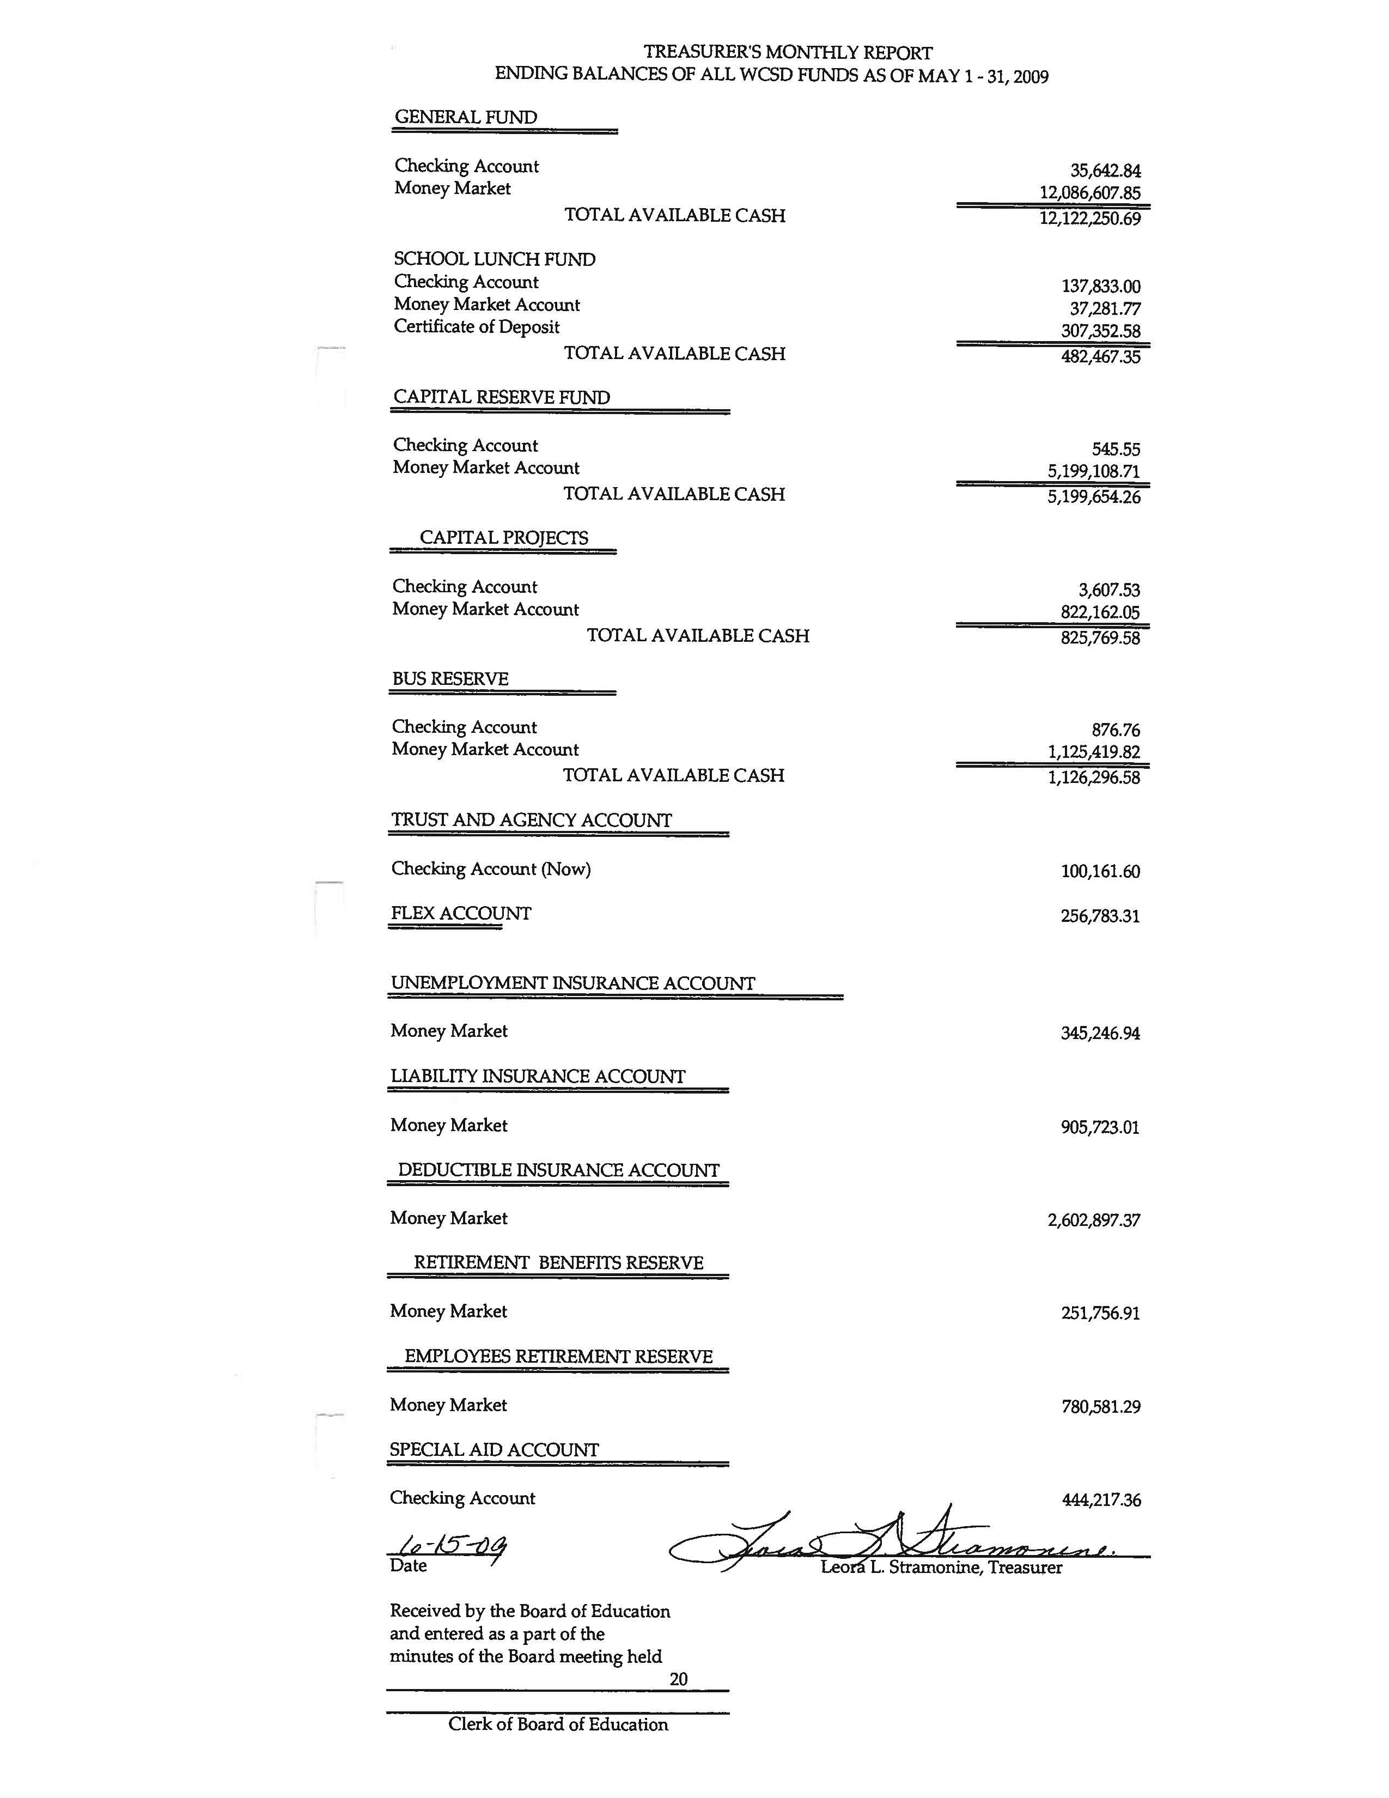
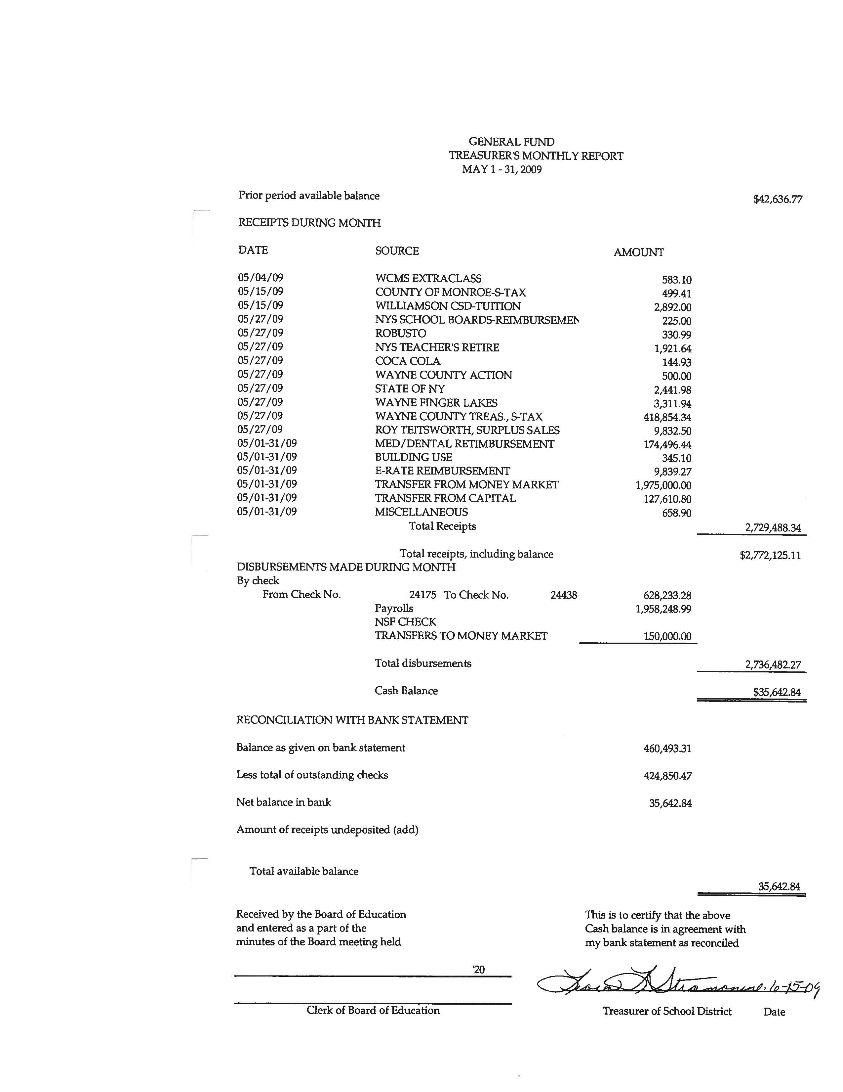

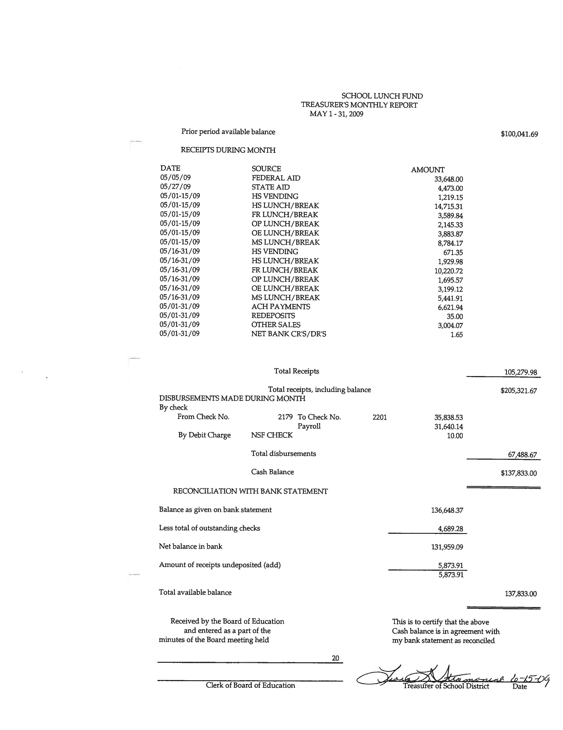

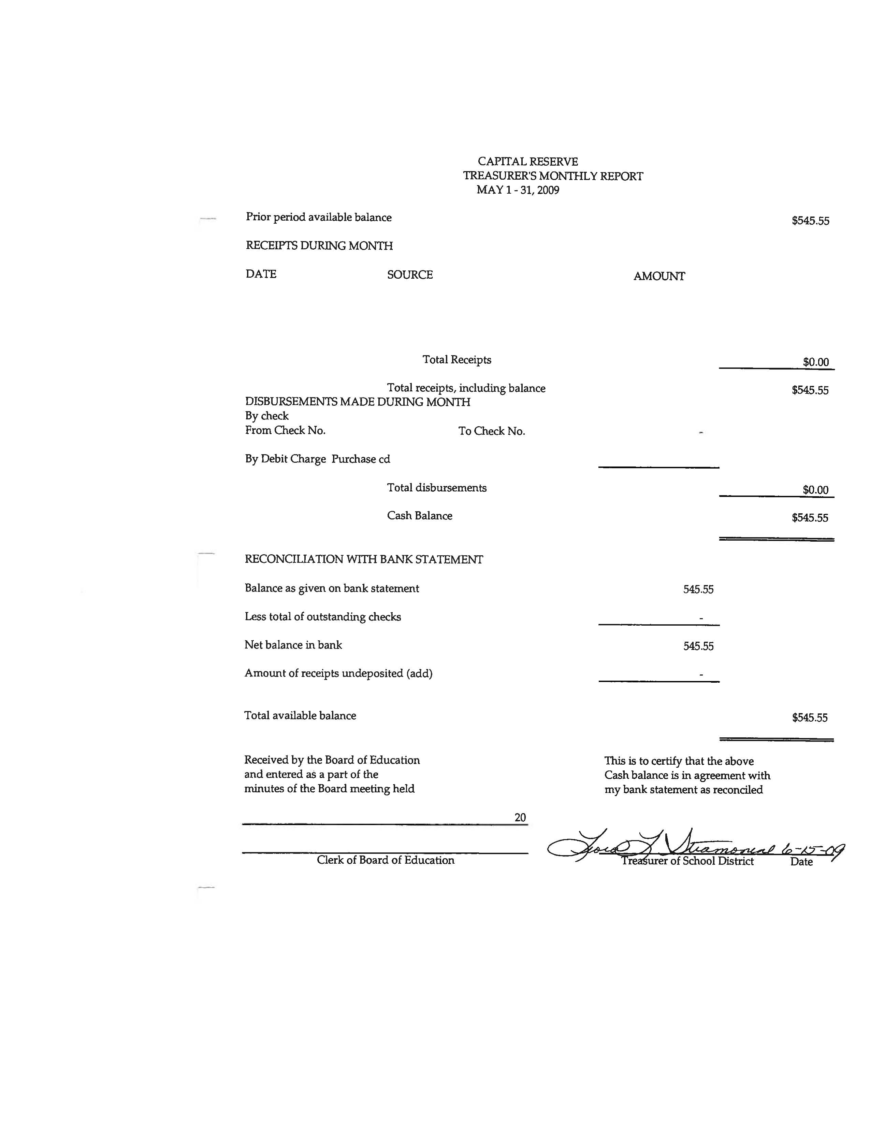
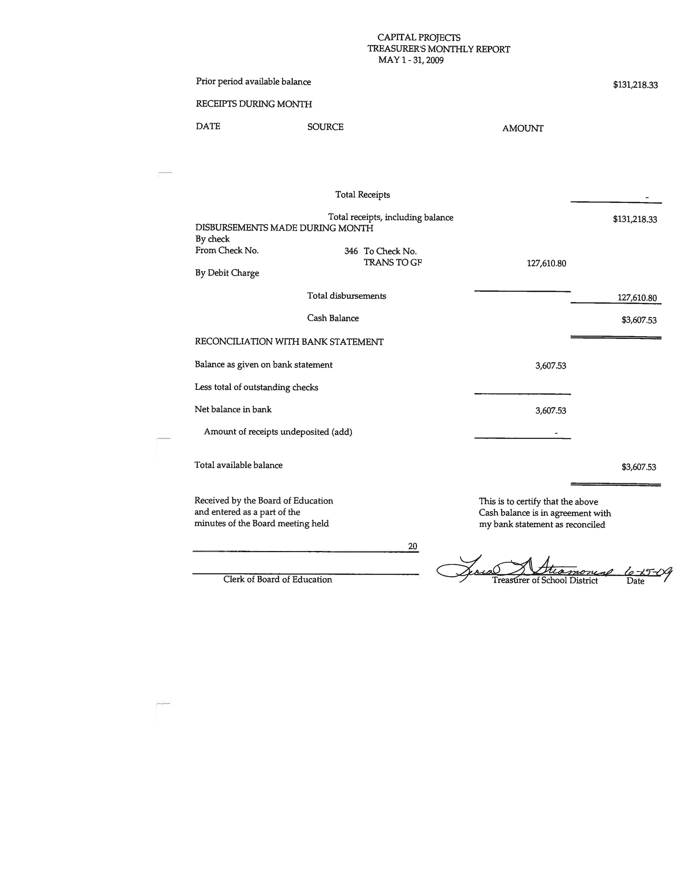
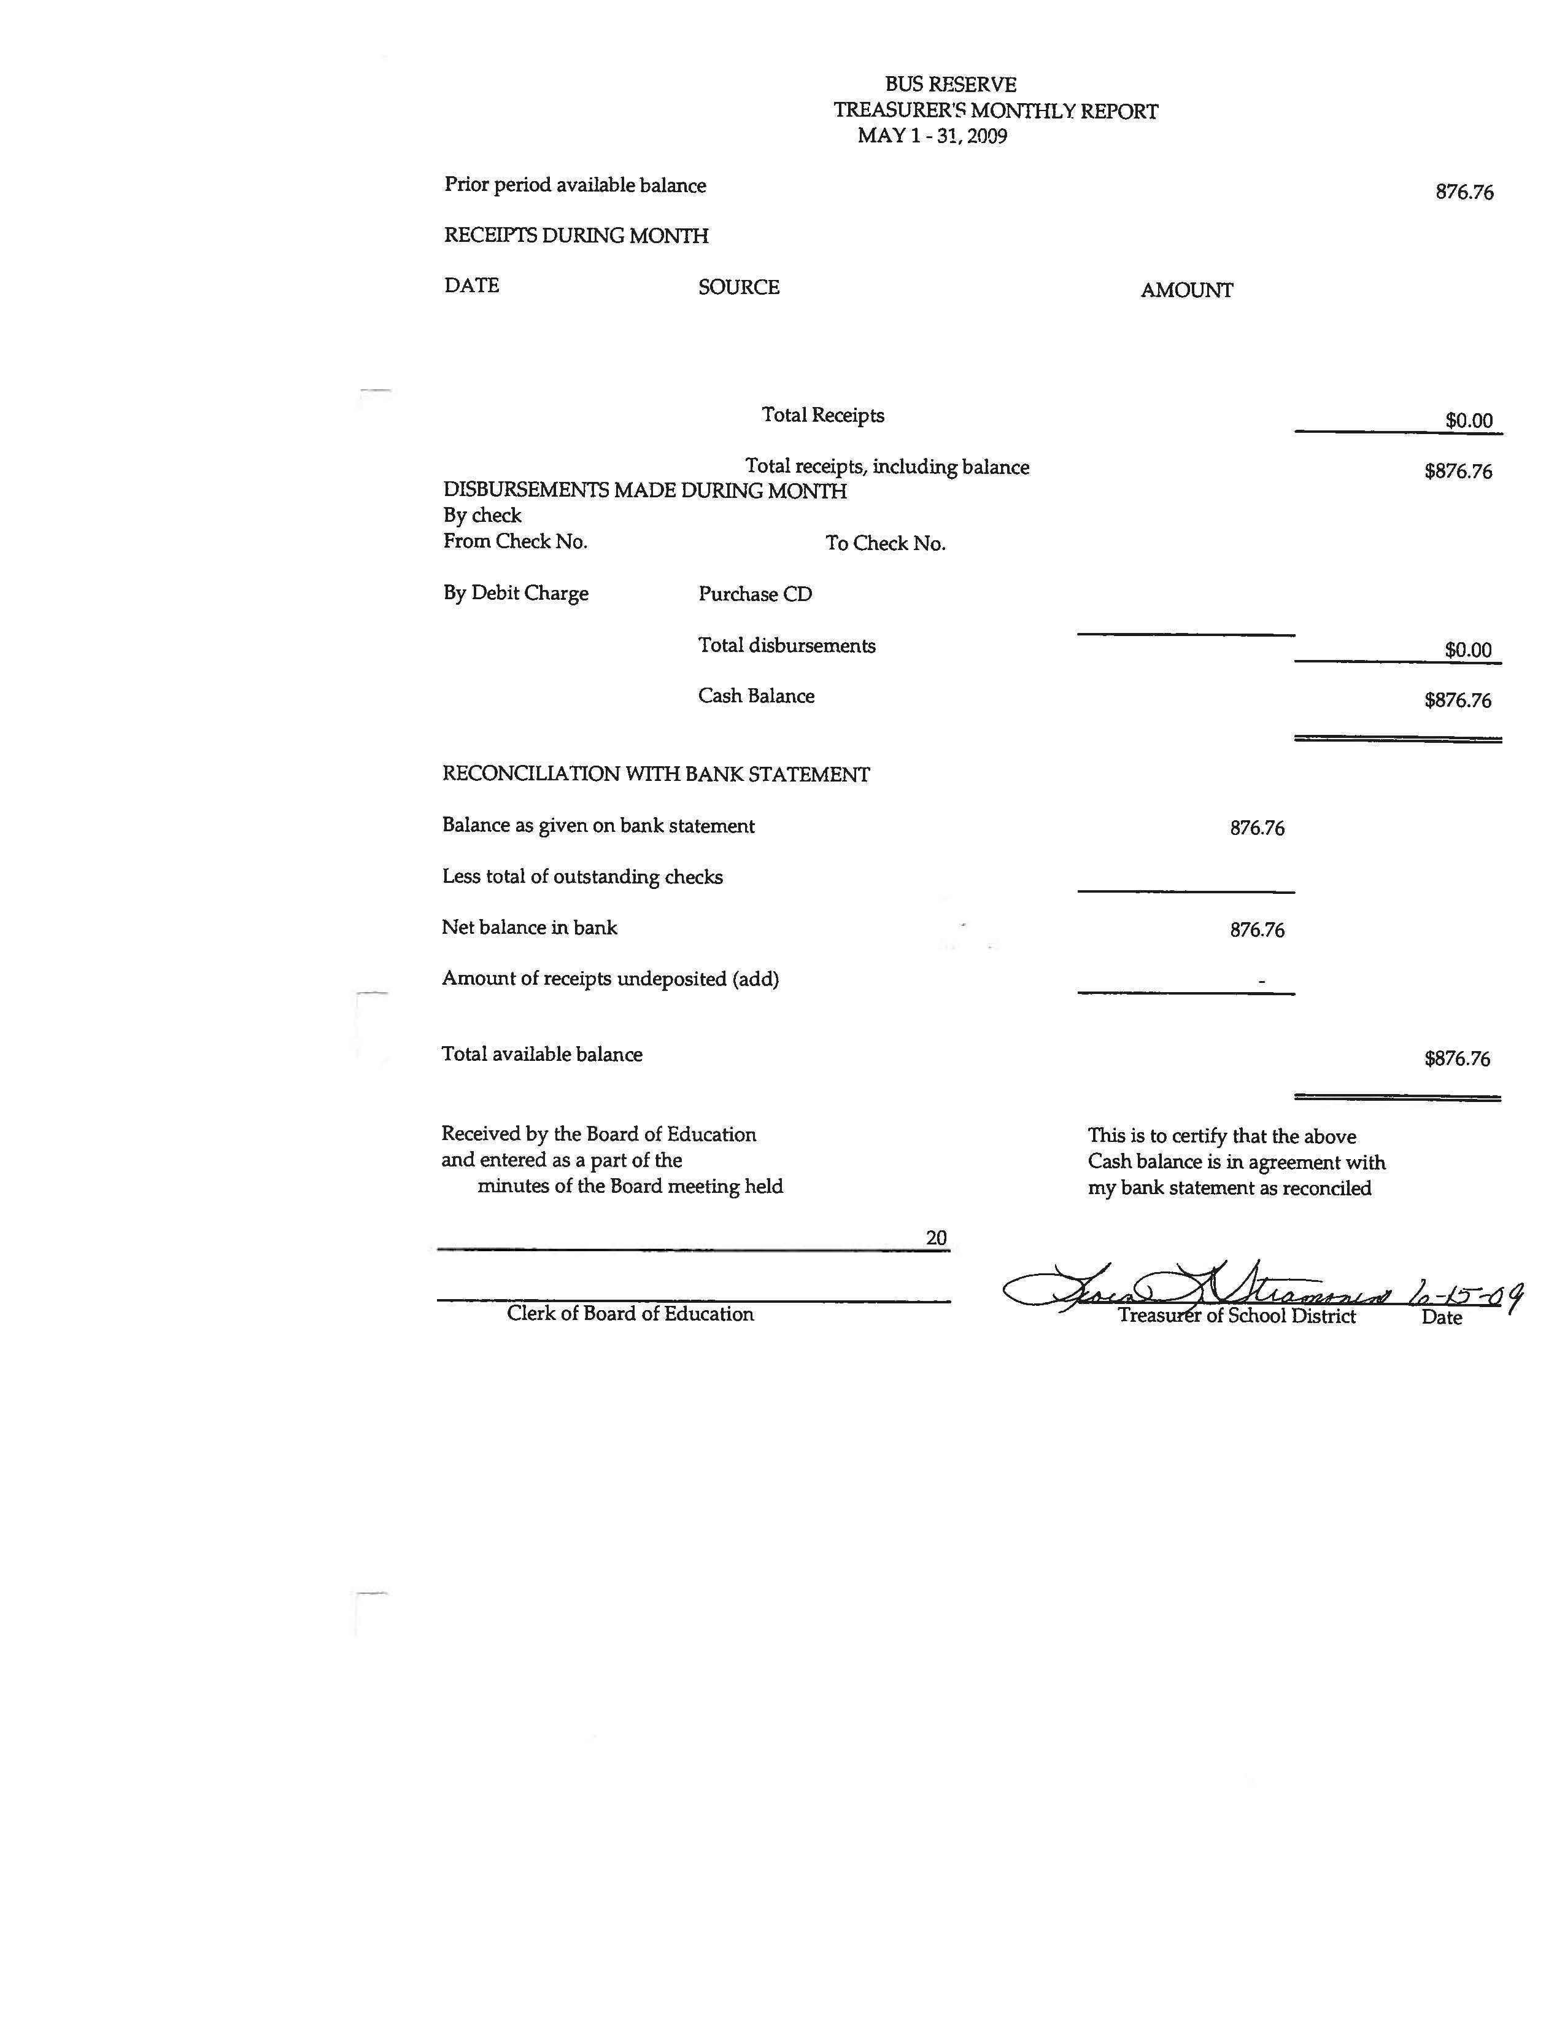
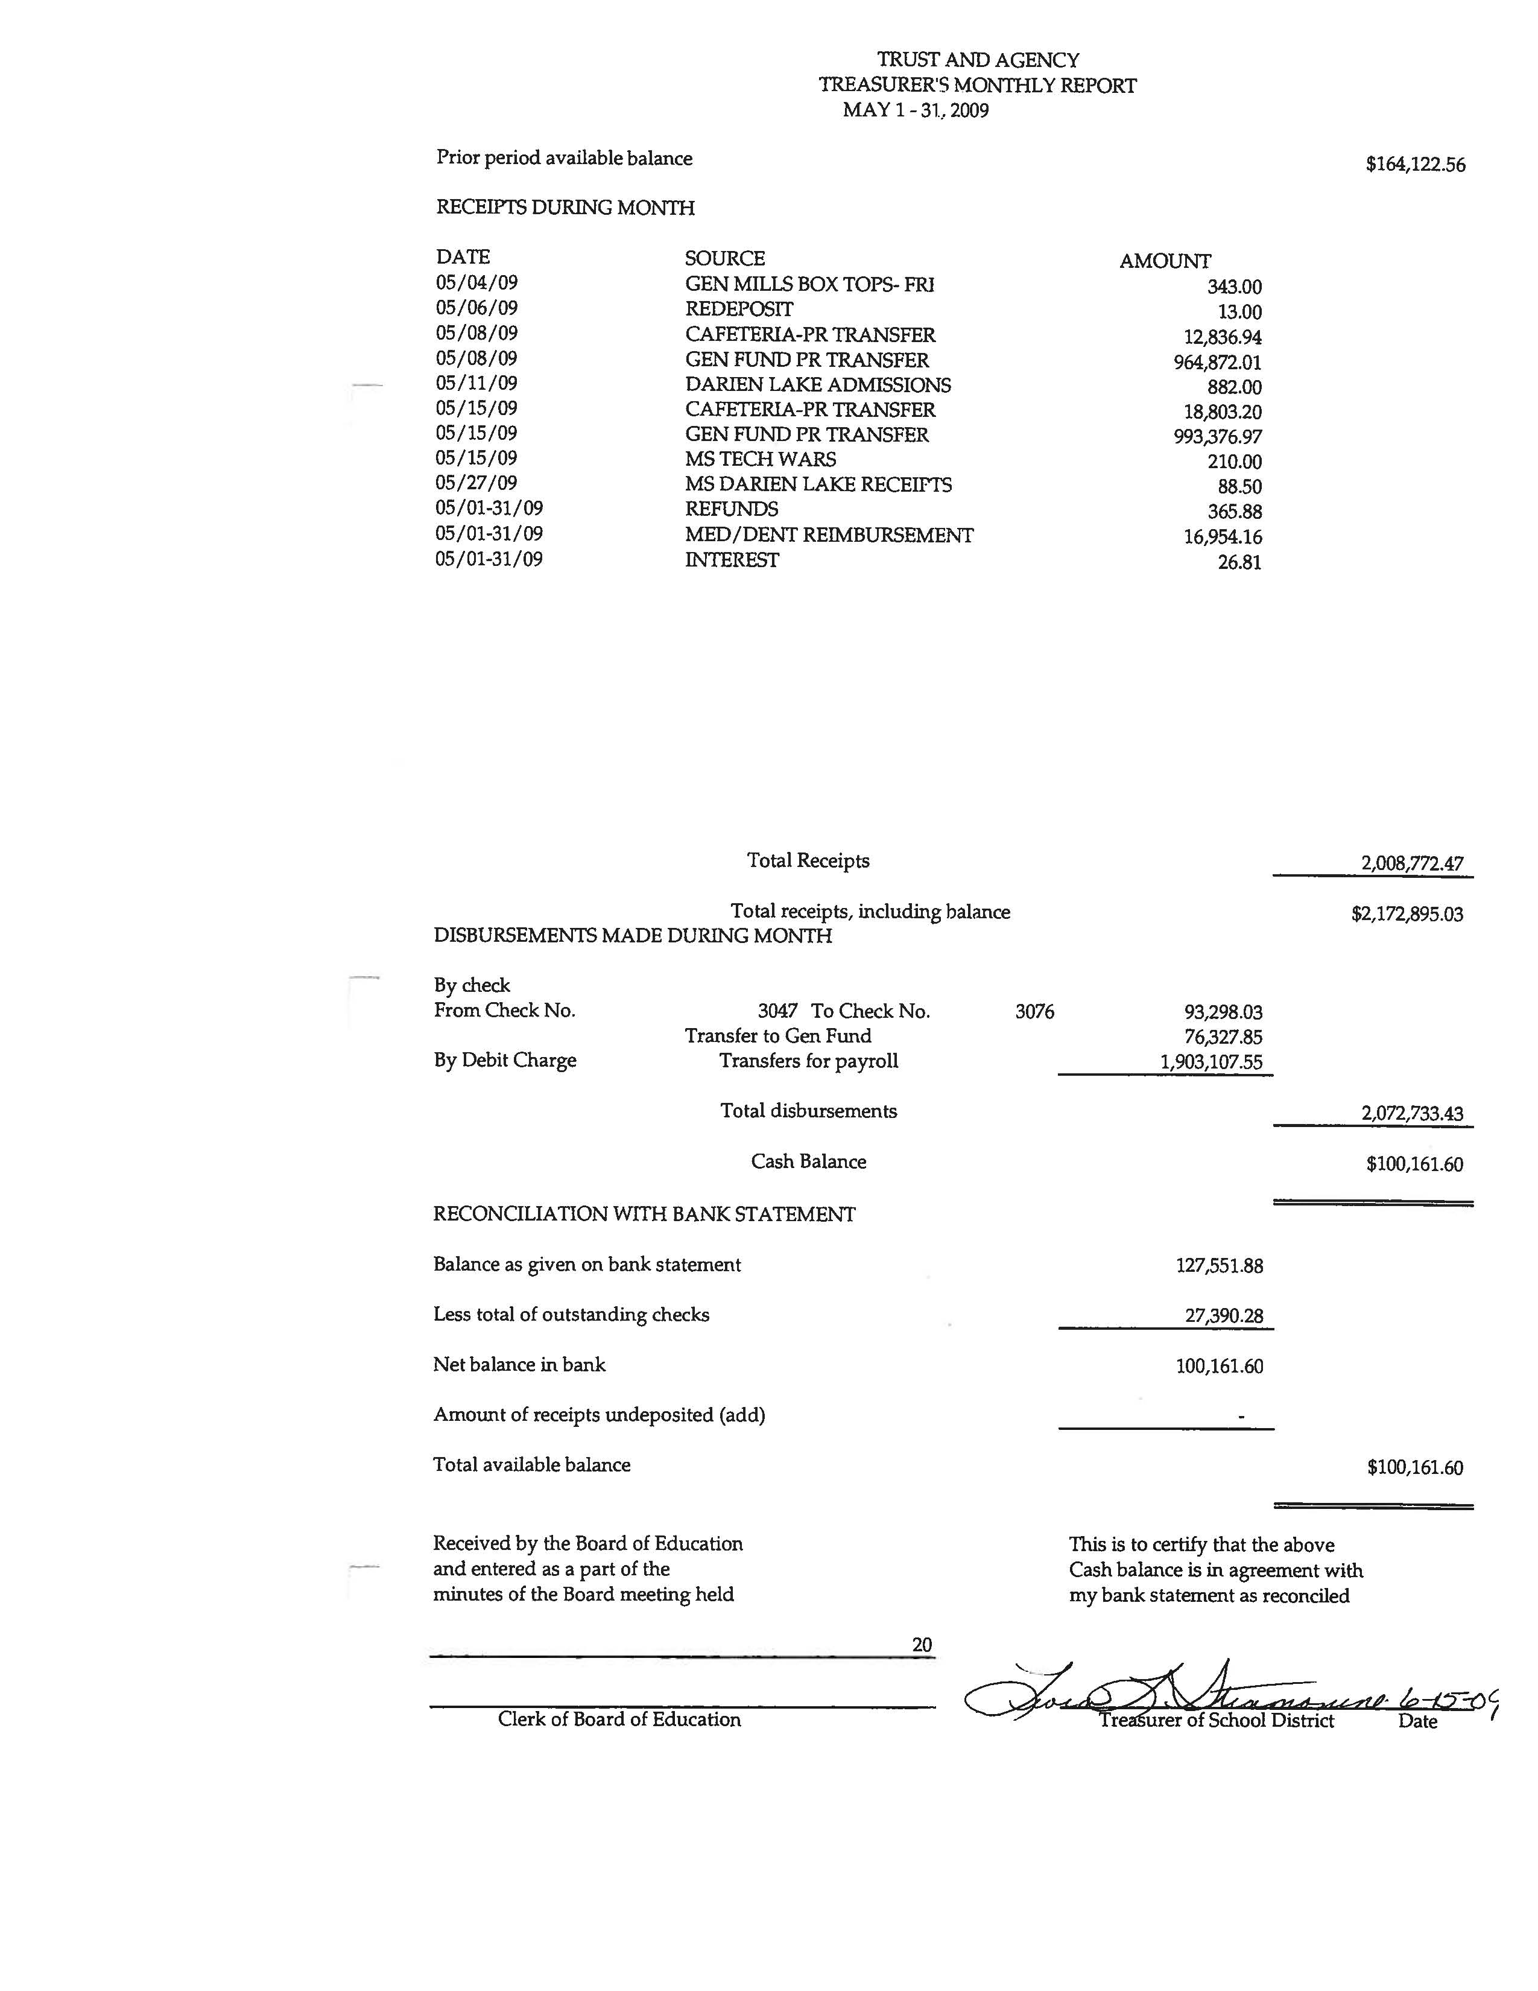
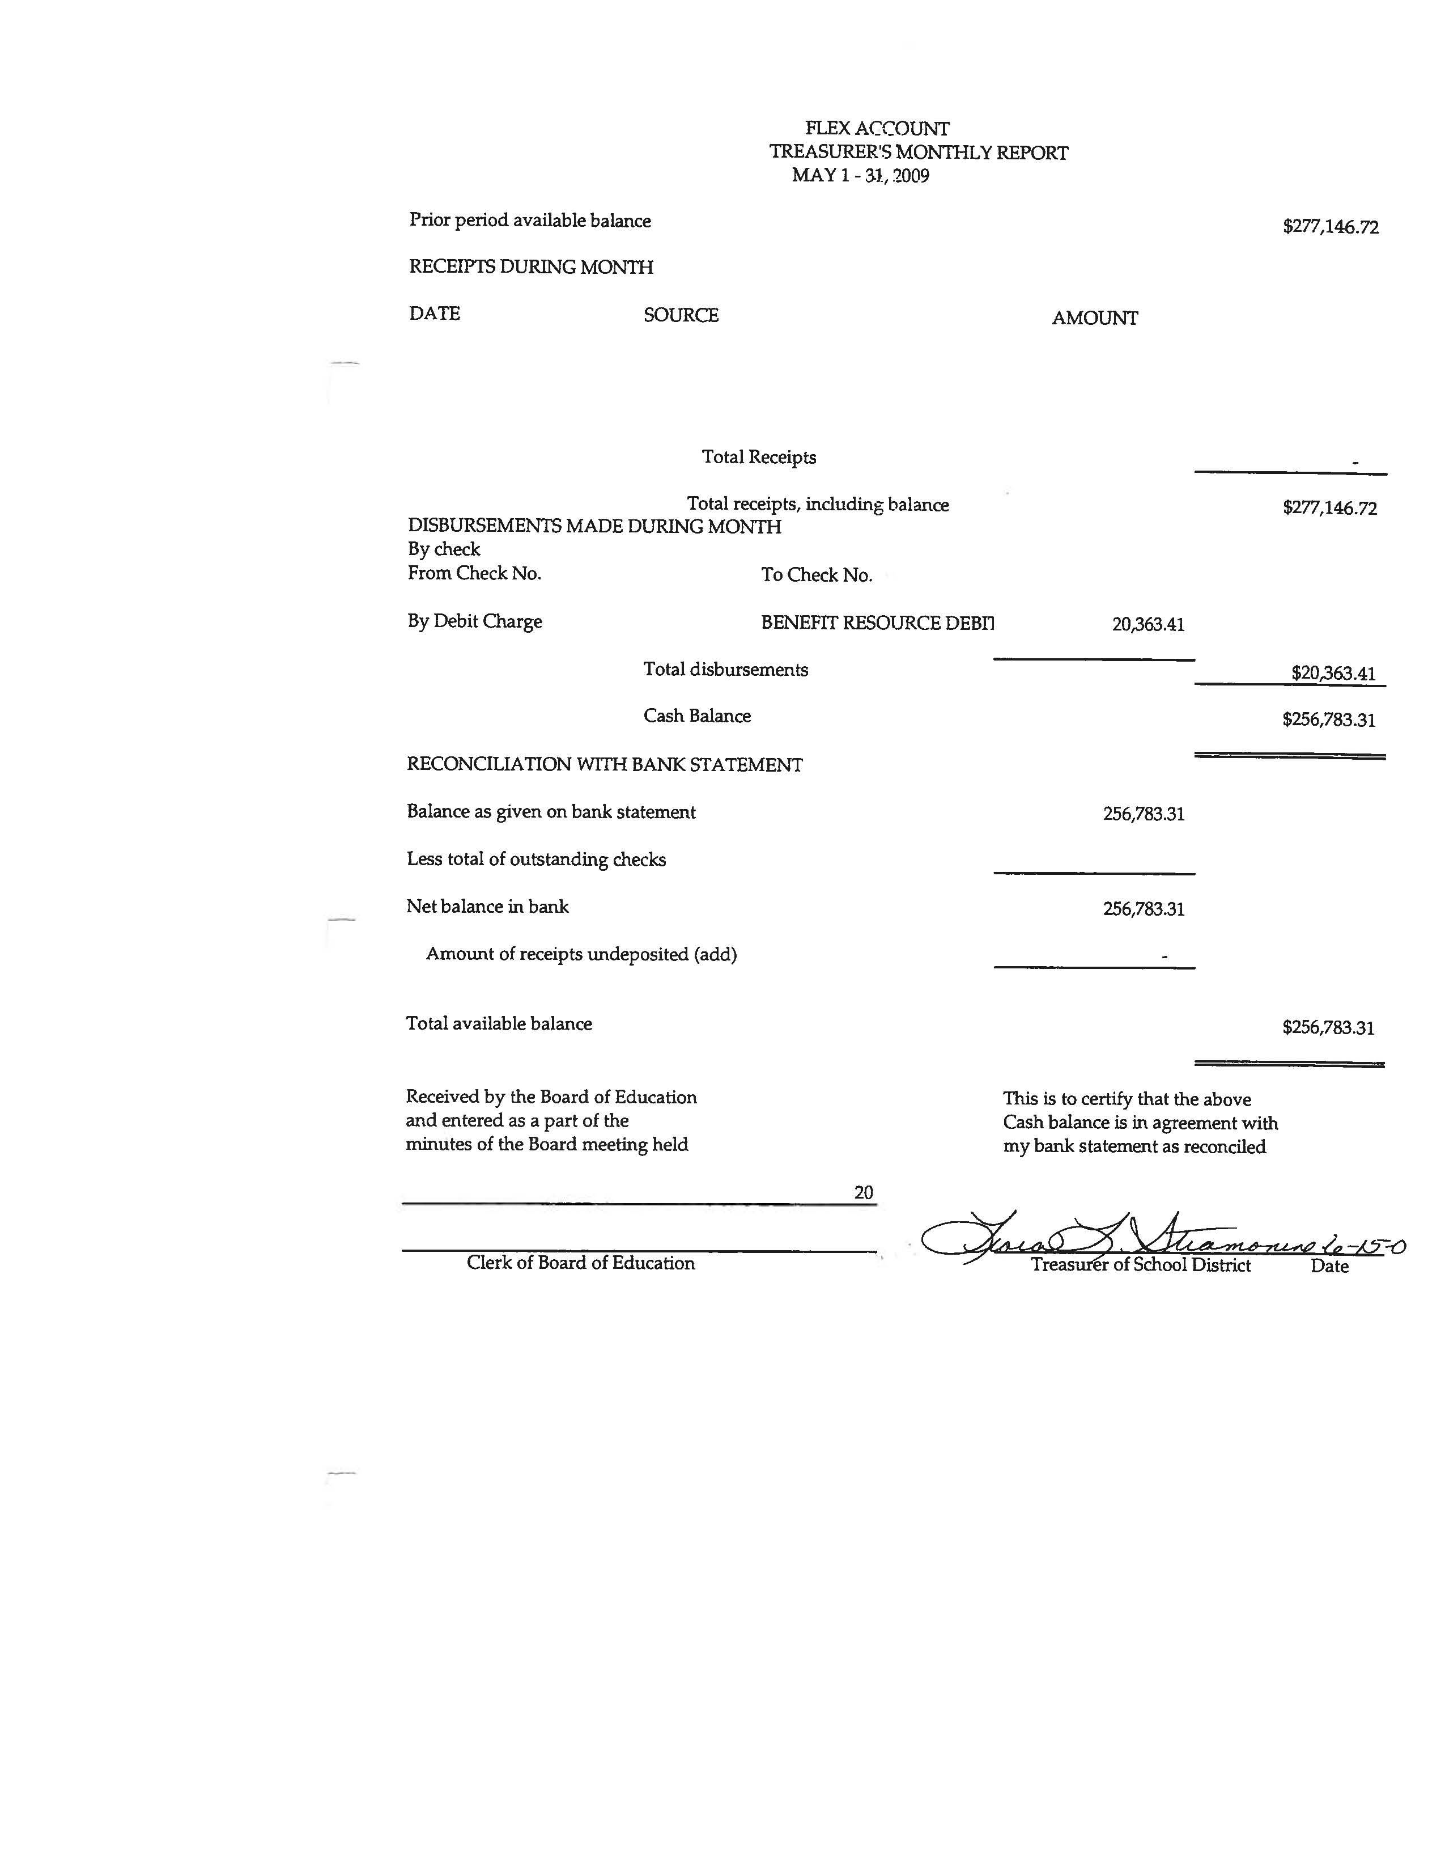
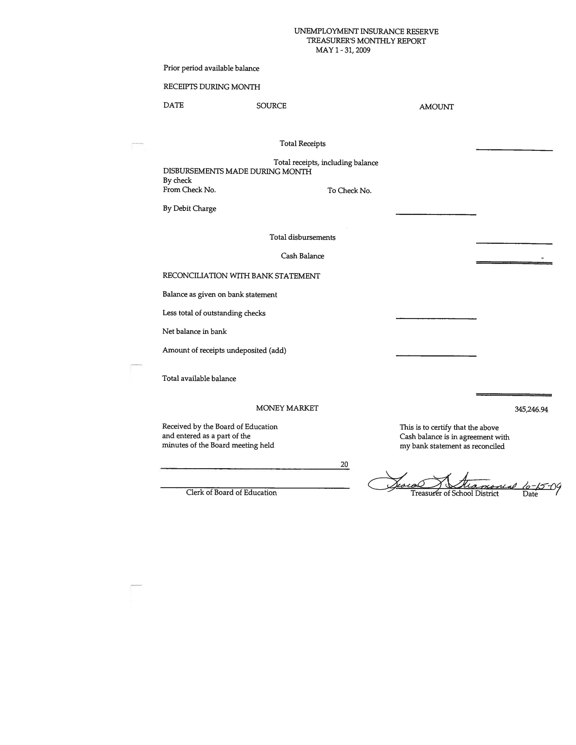
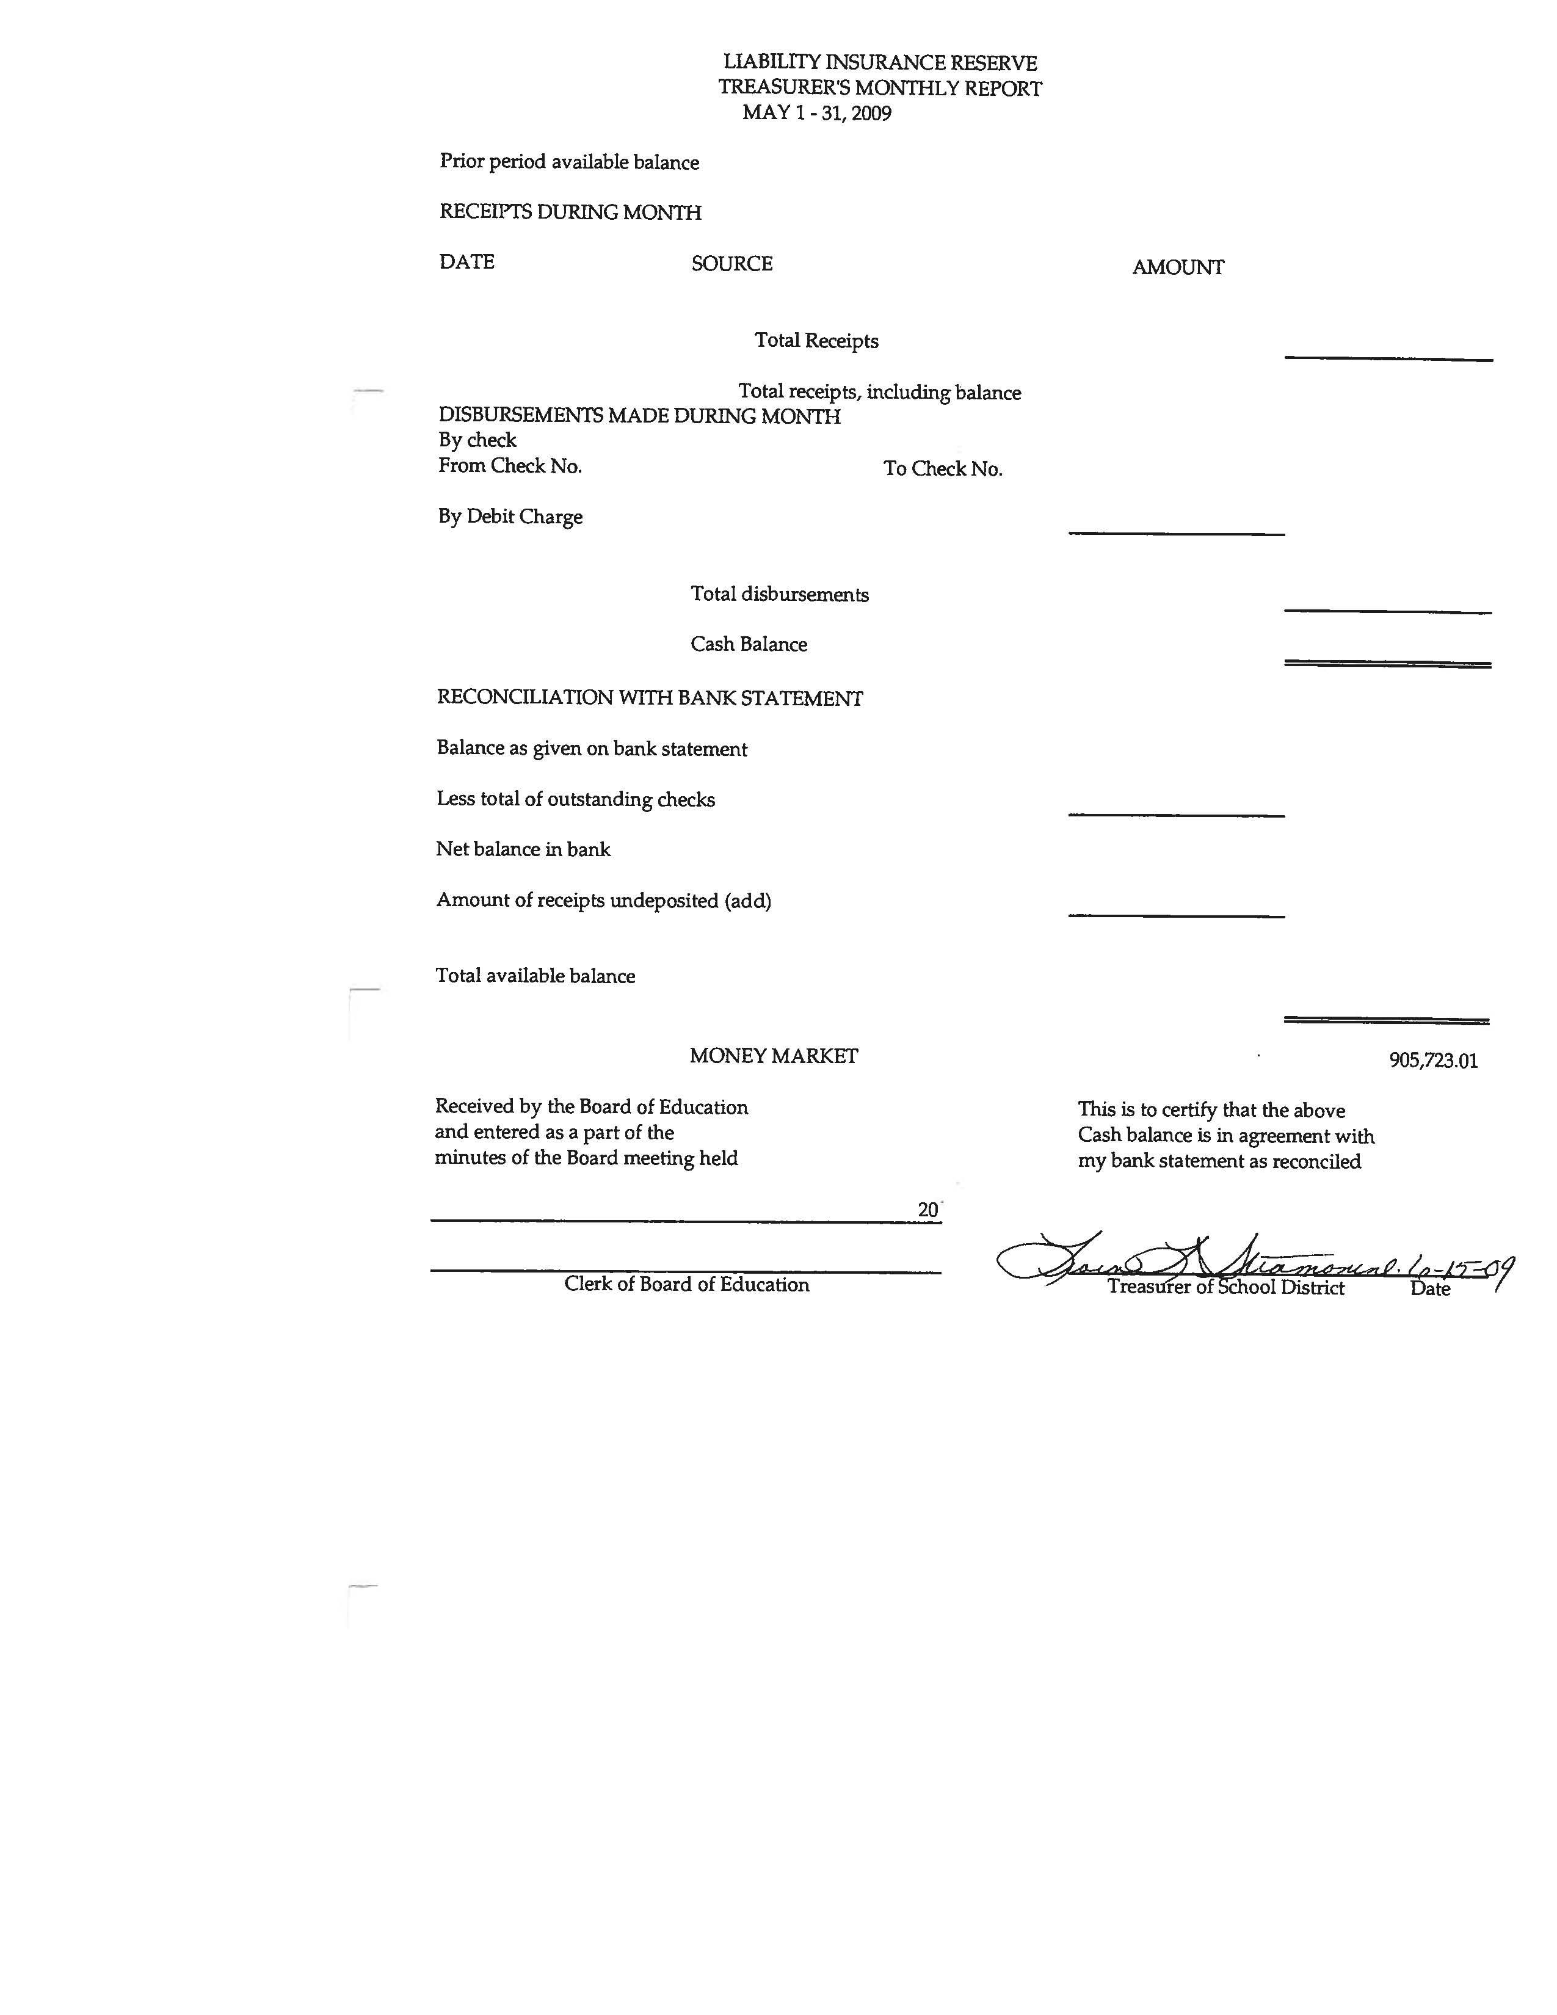
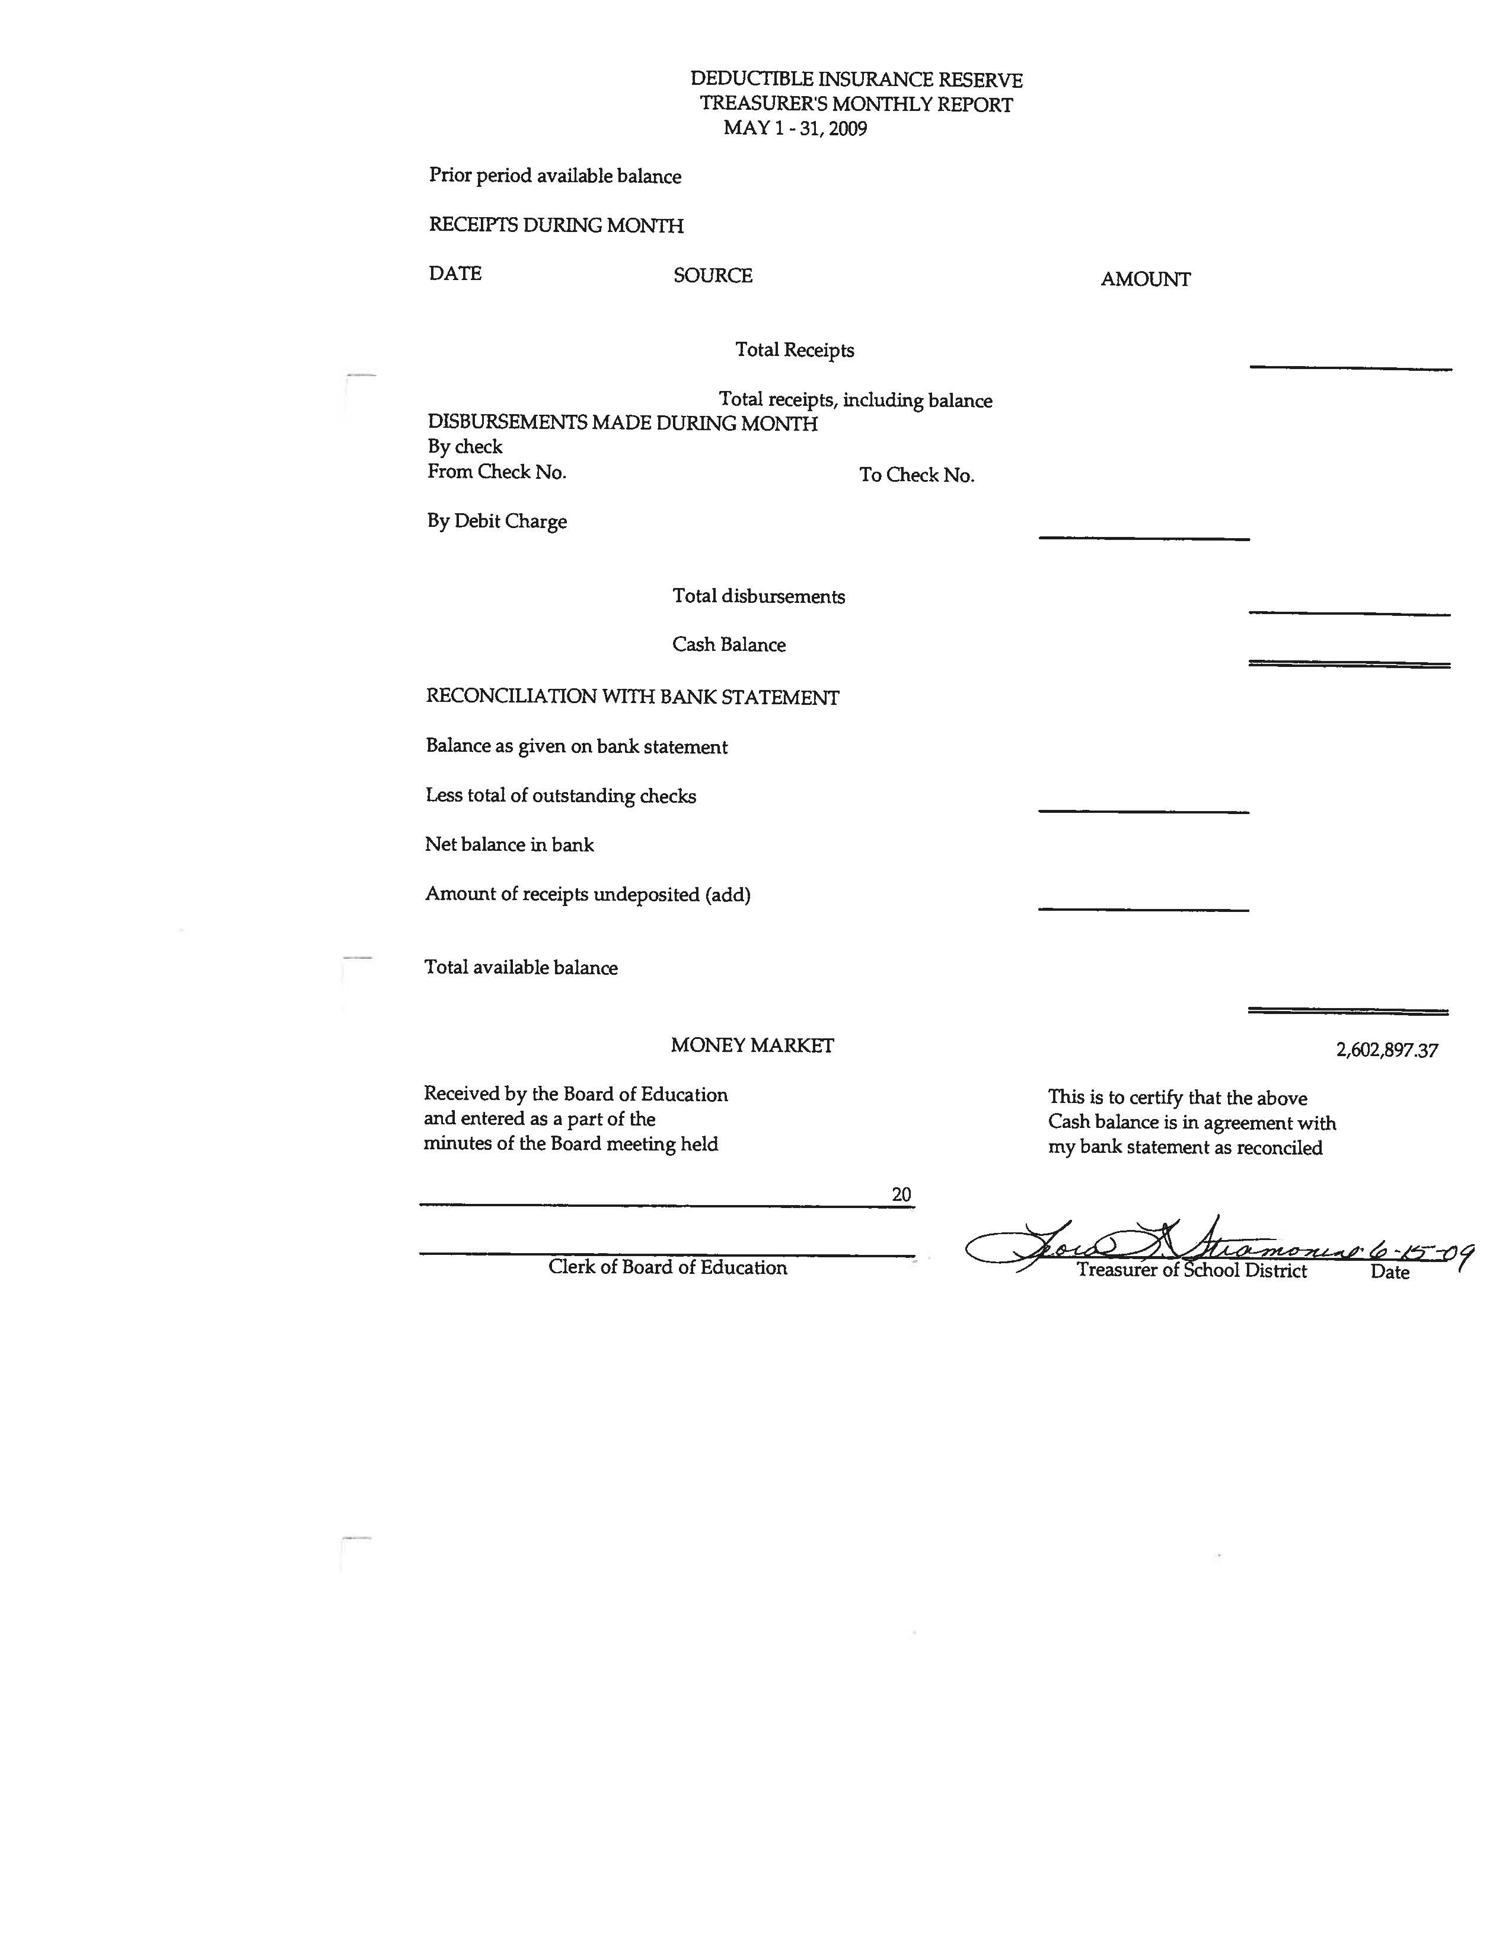
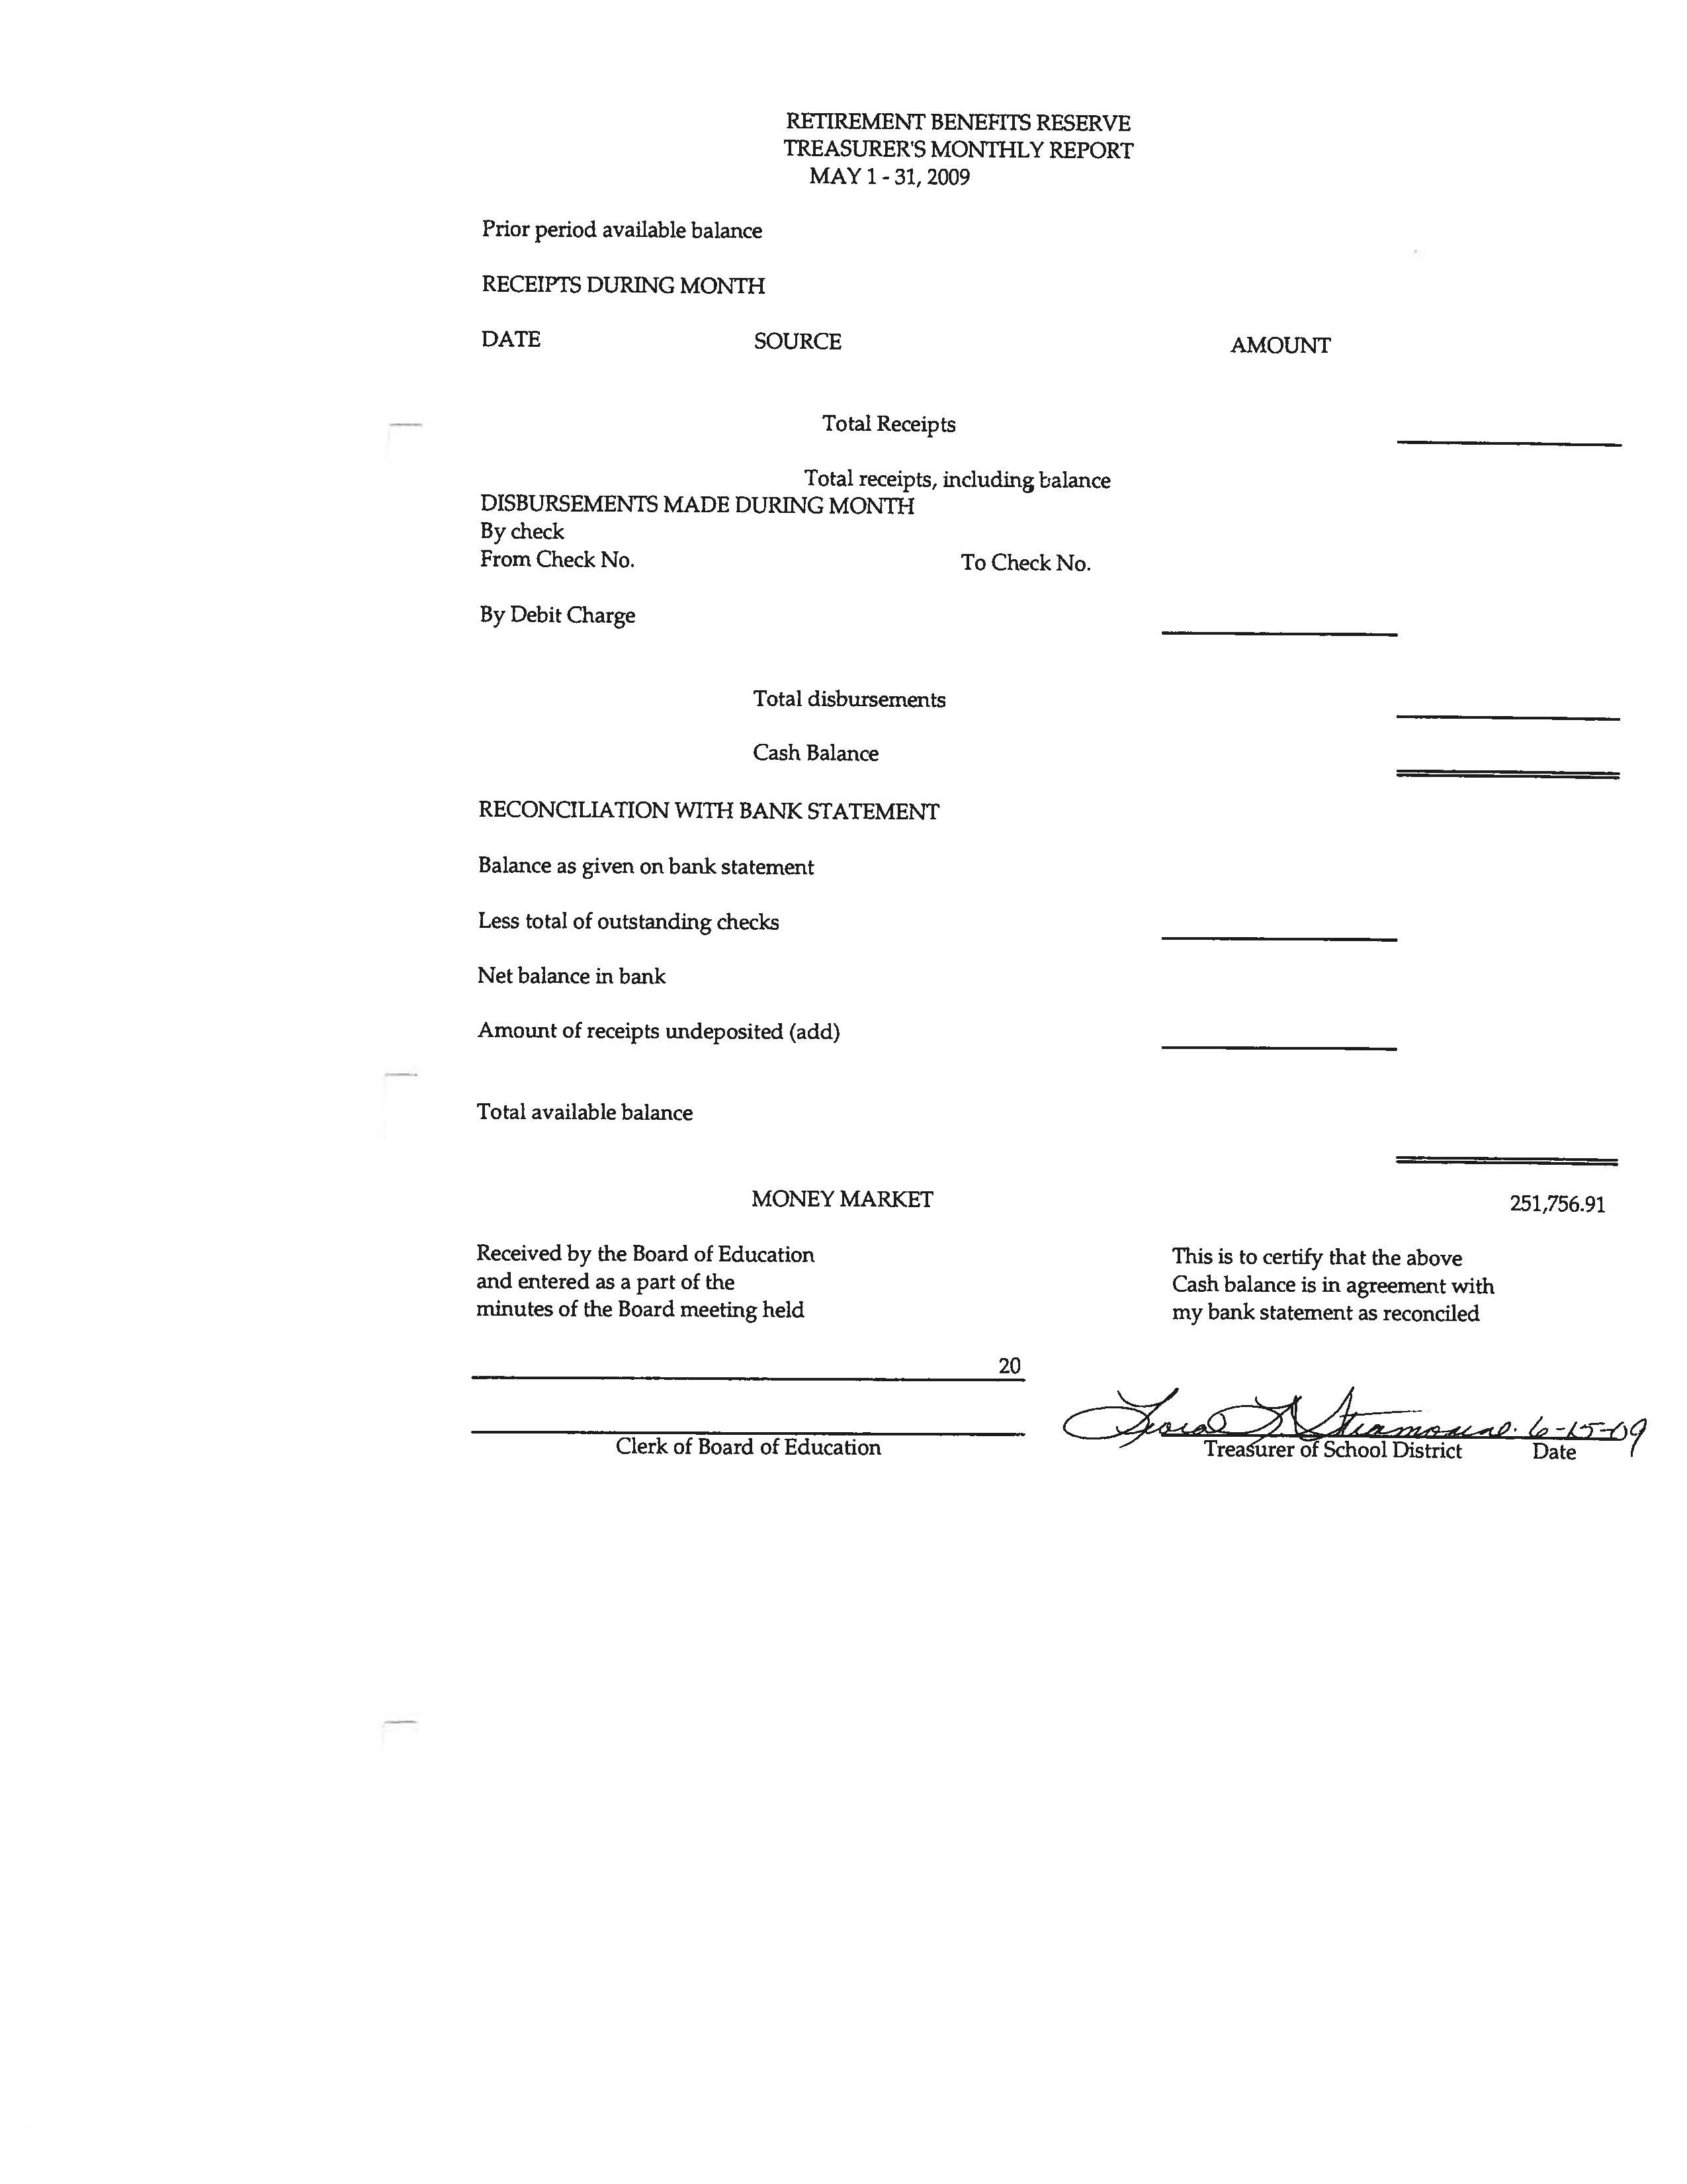
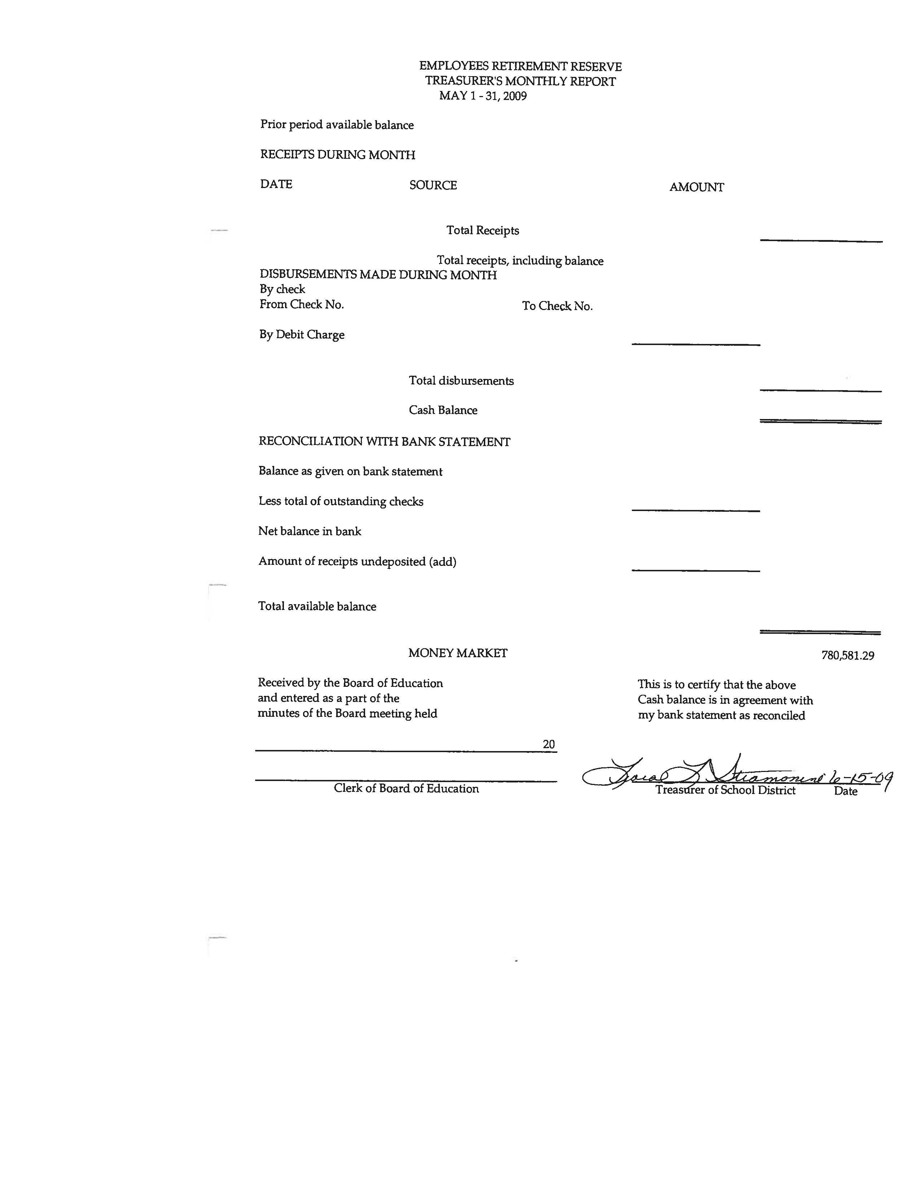
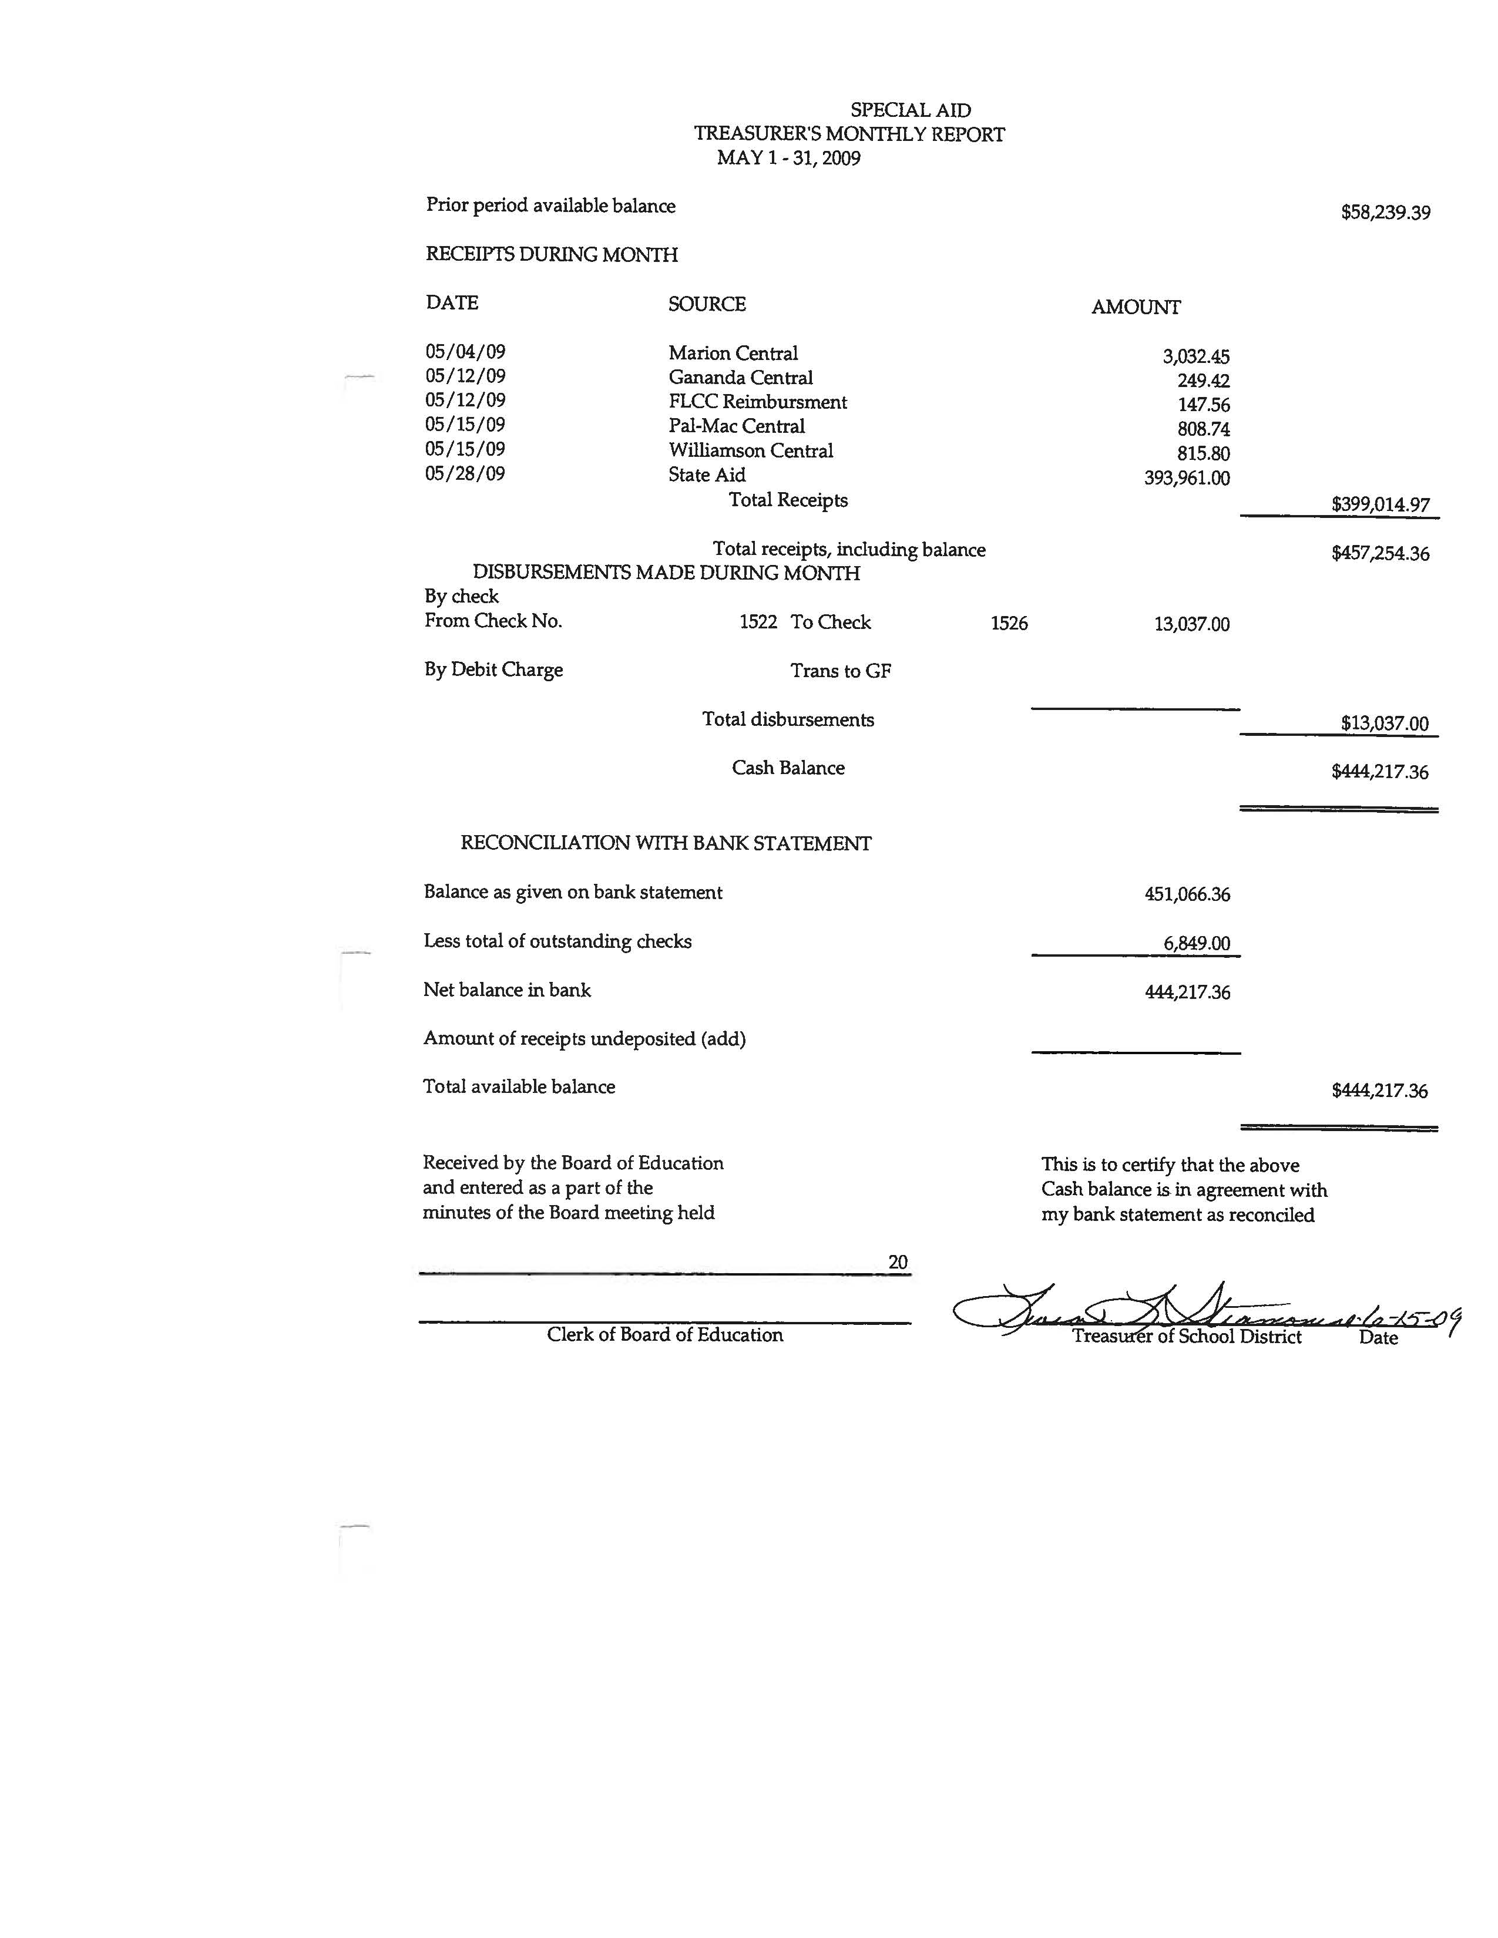
Consensus Agenda #2

TO: Michael Havens
Superintendent of Schools
FROM: Gregory J. Atseff
Assistant Superintendent for Business
DATE: July 9, 2009
RE: Matching Scoreboards for Baseball & Softball Bid

In accordance with Section 103A, Article 5-A, of the New York State General Municipal Law, a legal notice was advertised in the official school newspapers inviting the submission of sealed bids for Outdoor Matching Scoreboards.

Sealed bids were received and opened publicly on Thursday, June 18, 2009, at 2:00 p.m. at the district administrative offices.

Bids were advertised to be evaluated on either an item-by-item basis or total basis, whichever best suited the district. Prices submitted are to be f.o.b. Wayne Central School District.

Recommend that the Board of Education award the bid for the scoreboards to Toth’s Sporting, 71 Victor Heights Parkway, Victor, NY 14564, the only bidder at a total bid price of $14,900.

Attached is a copy of the vendor bid list for your reference.

/db

Attachment

SCOREBOARD BID VENDORS
JUNE 19, 2009 – 2:00 P.M.

Toth's Sporting
71 Victor Heights parkway
Victor, NY 14564

Varsity Scoreboards
106 Max Hurt Drive
Murray, Kentucky 42071

Fair-Play Scoreboards
1700 Delaware Ave.
Des Moines, IA 50317

Eversan Inc.
34 Main St.
Whitesboro, NY 13492

Consensus Agenda #3

TO: Michael Havens
Superintendent of Schools
FROM: Gregory J. Atseff
Assistant Superintendent for Business
DATE: July 9, 2009
RE: Tire & Tube Bid

In accordance with Section 103A, Article 5-A, of the New York State General Municipal Law, a legal notice was advertised in the official school newspapers inviting the submission of sealed bids for Tires and Tubes for use on school owned vehicles for the 2009/2010 school year.

Sealed bids were received and opened publicly on Thursday, June 18, 2009, at 1:00 p.m. at the district administrative offices.

Bids were advertised to be evaluated on a total basis with estimated quantities. Prices submitted are to be f.o.b. Wayne Central School District.

Recommend that the Board of Education award the bid for Tires & Tubes to Tallmadge Tire Service the lowest responsible bidder meeting bid specifications with a bid price of $30,230.00 which was based on estimated quantities.

Bid Summary:

Vendor Bid Price

- Lewis General Tire $34,492.76
3870 W. Henrietta Rd.
Rochester, NY 14623

- Tallmadge Tire Service $30,230.00
1285 Route 318
Waterloo, NY 13165

Attached is a copy of the vendor bid list for your reference.

/db

Attachment

Tire & Tube Vendors
2009

Lewis General Tire, Inc.
Mr. John Russell
3870 W. Henrietta Rd.
Rochester, NY 14623

Main Tire Exchange, Inc.
Mr. Rick Guy
40 Mushroom Blvd.
Rochester, NY 14623

Parmenter, Inc.
Mr. Ashton Bond
1800 Route 14N
Geneva, NY 14456

Tallmadge Tire Auto & Truck
Mr. Peter Ufholz
1285 Route 318
Waterloo, NY 13165

Consensus Agenda #4

TO: Michael Havens
Superintendent of Schools
FROM: Gregory J. Atseff
Assistant Superintendent for Business
DATE: July 9, 2009
RE: BOCES Cooperative Bid Extension for Transport Gas Contract

Wayne Central School District originally participated in a cooperative bid for Natural Gas with the schools in the Wayne-Finger Lakes BOCES area. Wayne Finger Lakes BOCES has received notification that the current pricing awarded for the period of October 1, 2008 through September 30, 2009 will be extended through September 30, 2010.

Empire Natural Gas was the lowest responsible bidder for supply of the gas with RG&E providing transport of the gas. The price structure is SC-3 $1.207 & balancing.

Consensus Agenda #5

TO: Michael Havens
Superintendent of Schools
FROM: Gregory J. Atseff
Assistant Superintendent for Business
DATE: July 9, 2009
RE: GM Parts Bid

In accordance with Section 103A, Article 5-A, of the New York State General Municipal Law, a legal notice was advertised in the official school newspapers inviting the submission of sealed bids for GM Parts for use on school owned vehicles for the 2009/2010 school year.

Sealed bids were received and opened publicly on Thursday, June 18, 2009 at 1:15 p.m. at the district administrative offices.

Bids were advertised to be evaluated on a discount off list price. Prices submitted are to be f.o.b. Wayne Central School District.

Recommend that the bid be awarded to Hoselton Chevrolet for GM Parts as the lowest responsible bidder meeting bid specifications.

Bid summary:

Vendor Bid Price

Cavellaro-Neubauer 25% off list
3740 Route 104
Williamson, NY 14589

Hoselton Chevrolet 30% off list
909 Fairport Rd.
East Rochester, NY 14445

Attached is a copy of the vendor bid list for your reference.

/db

Attachment

GM PARTS VENDORS
2009

Cavallaro Neubauer
Mr. Bardley Peterson
3740 Route 104
Williamson, NY 14589

Doyle Chevrolet
740 Ridge Road
Webster, NY 14580

Hoselton Chevrolet
Mr. Michael Frazer
909 Fairport Rd.
East Rochester, NY 14445

Consensus Agenda #6

TO: Michael Havens
Superintendent of Schools
FROM: Gregory J. Atseff
Assistant Superintendent for Business
DATE: July 9, 2009
RE: Propane Gas Bid

In accordance with Section 103A, Article 5-A, of the New York State General Municipal Law, a legal notice was advertised in the official school newspapers inviting the submission of sealed bids for Propane Gas for use on school owned vehicles for a three year period beginning July 1, 2009 and ending June 30, 2012.

Sealed bids were received and opened publicly on Thursday, June 18, 2009, at 1:30 p.m. at the district administrative offices.

Prices submitted are to be f.o.b. Wayne Central School District.

Recommend that the Board of Education award the bid for Propane Gas to Suburban Propane, L.P., 84 York Street, Auburn, NY 13021, the lowest responsible bidder meeting bid specifications with a bid price of $.763/LP gal. over the published Selkirk NY price. Bid price also includes an LP Gas Fueling System.

Suburban Propane was the only company submitting a bid.

Attached is a copy of the vendor bid list for your reference.

/db

Attachment

PROPANE GAS BID
JUNE 19, 2009 – 1:30 P.M.

Griffith Energy
Mr. John Jehlen
3849 Route 31
Palmyra, New York 14522

DiSanto Propane
Jonah
11098 Clyde-Savannah Rd.
Clyce, NY 14433

Phelps Sungas, Inc.
Ron
224 Cross Rd.
Geneva, NY 14456

Suburban Propane
Debbie
84 York St.
Auburn, NY 13021

Townsend Propane
Steve
PO Box 148
Leroy, NY 14482

Consensus Agenda #7

TO: Michael Havens
Superintendent of Schools
FROM: Gregory J. Atseff
Assistant Superintendent for Business
DATE: July 9, 2009
RE: Annual Fire Safety Report

The Wayne Central School District is required to conduct an annual fire safety inspection of all buildings owned, used, or leased by the district. The school district must file a Fire Safety Report with the New York State Department of Education. The fire inspection must be conducted between the dates of July 15 and August 31, 2009. The Fire Safety Report must be received by SED on or before September 1st. A Certificate of Occupancy will be issued within thirty days of the end of the district's inspection period if the report was not filed late and if a plan for correcting violations, if any, has been filed.

Recommend that the board of education at the regular meeting to be held on July 9, 2009, approve the following:

1. Appointment of Fire Inspector

Recommend that the specialist provided by BOCES Health & Safety, Kelly Wasson, be appointed as the Fire Inspector for the Wayne Central School District. BOCES will provide a certified fire inspector. The cost of the service is covered under our agreement with Wayne-Finger Lakes BOCES.

- Recommend that the board of education appoint Mr. Robert Miller, Director of Facilities, as the building designee. He will accompany the fire inspector during the inspection of school facilities and will be involved in the development of any district plans necessary to correct violations.

c: Mr. Joe Siracuse, Wayne High School Principal
Mr. Robert Armocida, Wayne Middle School Principal
Mr. Robert LaRuche, Ontario Primary Principal
Mr. Mike Pullen, Ontario Elementary Principal
Mr. Jona Wright, Freewill Elementary Principal
Mr. Robert Miller, Director of Facilities
Mr. Fred Prince, Transportation Manager

Consensus Agenda #8

TO: Michael Havens
Superintendent of Schools
FROM: Gregory J. Atseff
Assistant Superintendent for Business
DATE: July 9, 2009
RE: Resolution to participate in BOCES Cooperative Bid for Engineering, Biomedical Equipment and Supplies

Recommend that the Board of Education at the regular meeting scheduled on July 9, 2009, approve the following resolution for participation in Monroe 2-Orleans BOCES cooperative bid for purchase of Engineering, Biomedical Equipment and Supplies. Attached is the Cooperative Bid Procedures for your reference.

WHEREAS, it is the plan of a number of PUBLIC SCHOOL DISTRICTS, other BOCES organizations, and the Monroe 2-Orleans BOCES (the “BOCES”) during the 2009-2010 school year to bid jointly for the purchase of various types of computers and technology commodities (the “Commodities”); and

WHEREAS, the Wayne Central School District (“the School District”) is desirous of participating in the joint bidding of the Commodities, as authorized by General Municipal Law, Article 5-G; and

WHEREAS, this Board of Education has received and reviewed the Cooperative Bid Procedures
(“the Procedures”) governing its rights and responsibilities should it elect to participate in the joint bidding of the Commodities; and

BE IT RESOLVED, that the Board of Education hereby appoints the superintendent or designee to represent it in all matters related above; and

BE IT FURTHER RESOLVED, that in accordance with Cooperative Bid Procedures the Board of Education agrees to award bid item purchases according to the recommendations of the BOCES if such award is in the best interest of the school district.

/db

Attachment
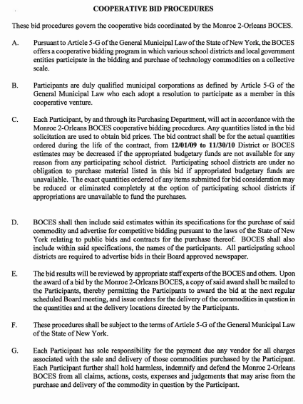
Consensus Agenda #9

TO: Michael Havens
Superintendent of Schools
FROM: Gregory J. Atseff
Assistant Superintendent for Business
DATE: July 9, 2009
RE: Budget Transfers

In accordance with Policy #5330, please present the attached list of budget transfers to the Board of Education for their approval at their meeting on July 9, 2009.

GJA/db

c: Helen Jensen, Clerk

Attachment

Consensus Agenda #10

TO: Michael Havens
Superintendent of Schools
FROM: Gregory J. Atseff
Assistant Superintendent for Business
DATE: July 9, 2009
RE: Health Service Contract - Canandaigua City School District

Attached is the contract for health services for Wayne students attending a private or parochial school in the Canandaigua City School District for the 2008-2009 school year.

The cost of the contract is:

3 | Students @ | $472.92 | = | $1,418.76

The students listed on the health service contract have been verified by the attendance office.

RESOLUTION

Be it resolved, that the Board of Education of the Wayne Central School District hereby approves the contract for health services with the Canandaigua City School District for the 2008-2009 school year, and hereby authorizes the Board President, Superintendent, and District Clerk to execute the contract.

/db

Attachment

