
Letter to the Board

Michael Havens
Superintendent of Schools
Phone: 315-524-1001 Fax: 315-524-1049 mhavens@wayne.k12.ny.us

June 19, 2009

“Laughter is an instant vacation.” - - Milton Berle, Comedian & Actor

Board Agenda:

1. Executive Session: You will hold an executive session at 6:00 to begin discussion on the process for the selection of a new superintendent. You should bring a copy of the search information that was passed out at the last meeting.

2. Reorganizational Meeting Business: I want to point out the few items that represent the changes/adjustments.
- Under appointment of District Officials: Riley Wheaton is replaced by Patricia Brennan. This is because Pat is our new department chair for science and the position is held by the department chair.
- The mileage reimbursement rate has been reduced from 58.5 to 55 cents/mile. This is based on the new IRS rate.
- The custodial rate fee for building use was increased from $24.65 to $25.64/hour. This has increased due to the contractual raises.
- The food service rate for building use was decreased from $23.78 to $22.82/hour. This is also due to the contract but because we have more new people the salary is less.
- District Wide Safety Team – Desirae Saiers will no longer serve (graduated). A student rep will need to be appointed. This generally occurs after school resumes.

3. Cooperative Purchasing Resolution: Each year we adopt this resolution which allows us to participate in cooperative purchasing with WFL BOCES for various products and services. I recommend we continue to do so.

4. Revenue Anticipation Notes: Each year we adopt this resolution which allows us to borrow money, should there be a revenue shortfall due to unforeseen circumstances (like the state budget not being adopted on time). Most likely we would have enough reserves to see us through but this protects the financial integrity of the district. I recommend we continue to do so.

5. Board Meeting Calendar: The Board meeting calendar is attached for approval. This is as presented, with the only exception being the August meeting date being moved to August 13 (to coincide with the current calendar’s tentative date and prevent a conflict with the middle school).

6. Board Administrative Retreat: I have attached two agendas for our retreat. One is the same as what you saw at the last meeting and generally follows the previous few years’ format. The second provides time to discuss the building project and leaves less time for goals. We obviously do know two of our major goals already, which are “develop the implementation plan for an elementary foreign language program” and “select a new superintendent to lead us for the next ten years”. I’ll ask you to decide which agenda to use.

7. Superintendent’s Report: We will discuss the Walworth over 55 community. Mr. Robusto began this discussion at the last meeting and there have been many interesting follow up emails.

8. Business Items: We have minutes, personnel action and CSE action for board review and approval. We also have a large consensus agenda including the May Treasurer’s Report, several bid awards, the appointment of the fire inspector, a resolution to participate in the Project Lead the Way Bid, budget transfers and the health contract with Canandaigua City School District. I recommend approval of all items as submitted.

Board Letter:

1. Summer Calendar: I am attaching a calendar of summer activities at the school. You have received much of this information in an overview of the activities that are occurring, but I thought a written copy might be helpful. You will note that there are two weeks that are blocked out so that the administration might have an opportunity to take vacation and unwind. Gone are the days when summer meant a slow down time in education.

2. Docushare Accounts: Lori has updated everyone’s accounts. Please let her know if you need to revisit your access information.

3. Four County: The website is down for restructuring until further notice.

4. Disclosure Statement: I have attached the disclosure statement if anyone still needs to submit this form to Jim.

5. Upcoming Events:
7/9 – Reorganizational Meeting @ District Office Conference Room
7/13 – Board Retreat @ Casey Park – 5:00 p.m.
8/13 – Board of Education meeting – 7:00 p.m.

6. Attachments:
a) Summer Activities Calendar
b) CSEA Newsletter - June
c) Disclosure Document
d) Ontario Town Board Meeting Minutes – 6/22
e) WTA Newsletter – June

Summer Activities - 2009

High School

Summer School (Wayne Finger Lakes) – July 6th – August14th (7:00 –12:00)
Monday - Thursday
-Will be using most of D wing classrooms (D14– D29 & 2E, 4E, 4H, cafe and Library

Transition Program – July 6th – August 11th (7:30 – 11:30) Monday - Thursday
- 4 classrooms in A wing including computer room

Special Ed Summer School – July 7th – August 16th (8:00 – 2:00)
Monday - Thursday
Ronnie Steele’s room

Summer Driver Ed – July 1 – August 14 (7:00 – 4:00) Monday - Friday
M/W Schedule or Tu/Th Schedule and every other Friday
Classroom is Chorus Room Ext - 1605

Ontario Elementary School

Reading Camp – July 6th – August 6th (8:00 – 12:00) Monday - Thursday
- Rooms 106-112, 118-122, 106 and Library

Summer Explore Institute – July 13th–23rd (8:30-11:30) Monday - Thursday
– Rooms 113, old gym,128,129,201,202,207, 208 and 209

Special Ed Summer School – July 6th – August 14th (8:00 – 2:00) Monday - Friday
- Rooms 123, 124,125 and 126.
- Room 116 for OT & PT – 2 days per week
- Room 124 for speech - Tue, Wed and Thurs.

Middle School

Summer Explore Institute – July 13th – 23rd (8:30-11:30) Monday-Thursday. 4A, 8A, 13A, 15A and 15G

Summer Bridge Program – July 6th – August 6th (7:45 – 11:20) Monday - Thursday
- B wing classrooms (7)

Special Ed Summer School – July 6th – August 14th (8:00 – 2:00) Monday - Friday
- Kathy LaManna’s classroom and small gym.
- Room 4B

District Wide Staff Activities

New Teacher Orientation – August 24th, 25th and 26th (7:30 – 2:30)
Held in High School
- August 24th – Music, Chorus, Café and PAC
- August – 25th and 26th - Café, C wing and computer Lab

Curriculum Writing – June (8:00 –2:30)
Held in High School
6/ 29 – DO Conf, PE Office, 8H, 22D, 2E, 1G, 3D, 6D, 9G, 2E
6/30- PE Office, 15D, 8H, 19D, 2E, 22D, 2E , 1G, 3D, 9A, Lib, 6D, 9G
7/1 – 4e, PE office, 15D, 2E, 8H, 2E, 22D, 1G, 7A, 3D, Lib, 7A 16D, 18D, 6D, 9G
7/2 – 4E, PE office, 2E, 8H, 2E, 22D, 7A, 9A, LIB, 7A, 16D, 18D, 6D, 9G
7/3 – 13D
7/6 – 5F, 9A, 2E, LIB,7A
7/7/ - 5F, 9A, 2E, LIB, 7A
7/8 – 5F
7/9 – 5F
7/10 5F
7/17 – 2E
7/20, 21, 22 – 9A
7/24 – 2E
7/27, 28, 29, 30 – 2E

Administration

- Block Out Weeks: (no meetings, activities, events of any kind to be scheduled for admin.)
July 27 – July 31
August 3 - 7

Administrative Council Meetings: July 7 – 8:00 a.m. – District Office Conference Room
August 18 – 8:00 a.m. – District Office Conference Room

Administrative Retreat: July 23 & 24 – Walworth Lodge – Walworth Town Park

District Wide

- Teachers back on September 1st

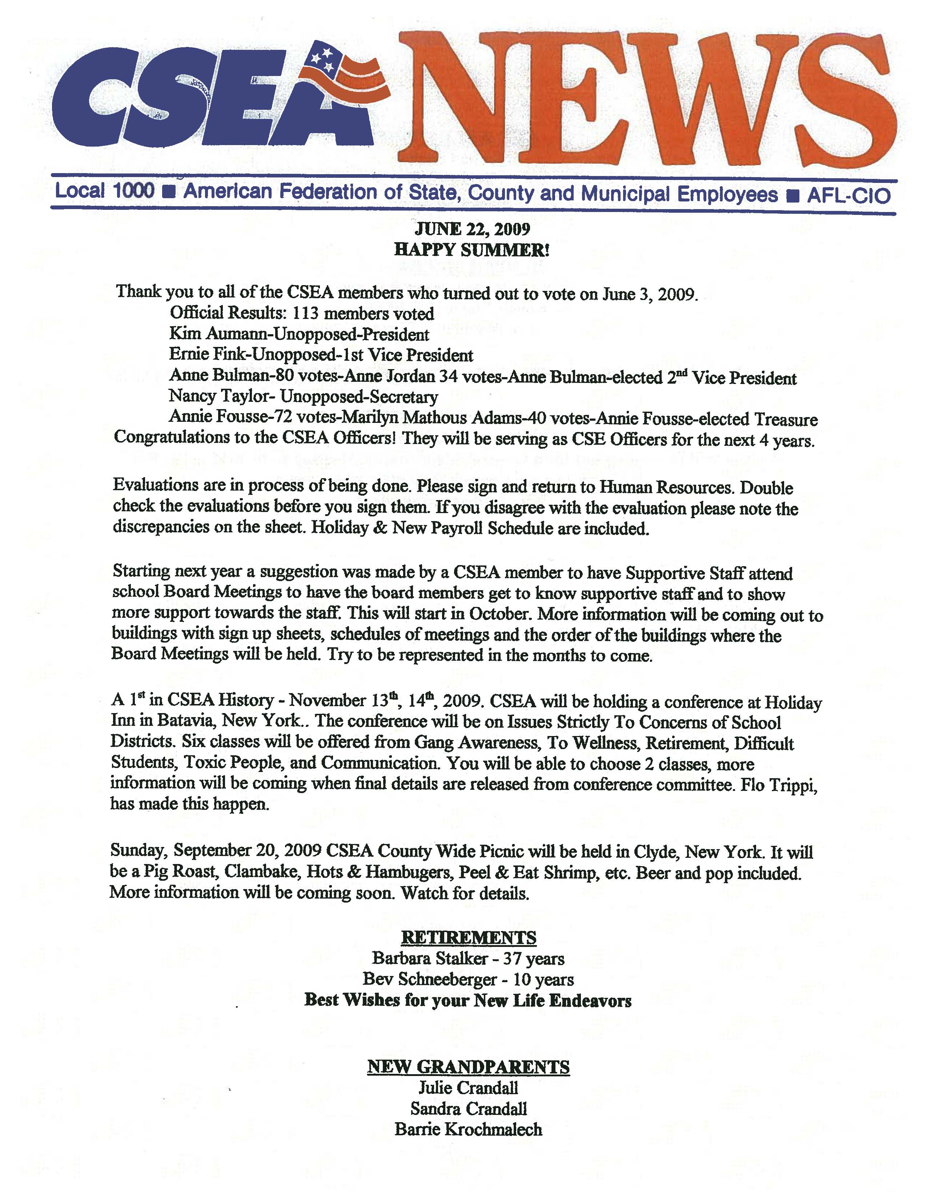
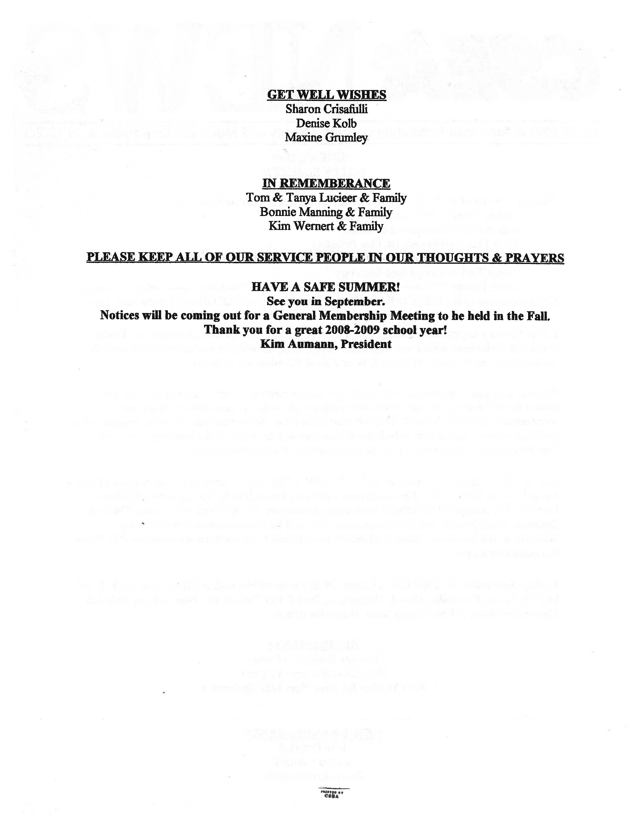
PERSONNEL 6100-E
EXHIBIT Page 1 of 2
WAYNE CENTRAL SCHOOL DISTRICT
Ontario Center, New York 14520-0155

DISCLOSURE OF SIGNIFICANT FINANCIAL INTERESTS & OBLIGATIONS

Conflict of Interest Form

PART I – DECLARATION & CERTIFICATION

Pursuant to §§800-805 of the General Municipal Law of the State of New York, members of a Board of Education are required to complete and file this disclosure of any conflict of interest with their official duties.

NAME:……………………………………………………… Title…………………………………………………….

NAME of VENDOR or SUBCONTRACTOR:………………………………………………………………………

Do you, your spouse or dependent child (ren) hold a position of management (e.g. board member, director, officer, partner, trustee, employee, consultant) with a vendor or a (sub) contractor which does business with the school district?

YES NO

Do you, your spouse or dependent child(ren) have a significant financial interest* with a vendor or (sub) contractor which does business with the school district?
YES N0

Is it reasonable to anticipate that you would benefit financially from any decision you would make on any contract, purchase, lease, sale or agreement with the school district with a vendor or (sub) contractor in which you, your spouse or dependent child(ren) have a significant financial interest * for whom you have the responsibility to negotiate, prepare, authorize, approve or audit ?
YES N0

(*) Stock, stock options and/or any other ownership interest in a single entity valued at more than $10,000 or 5% ownership

If you answered NO to each of the questions above, please sign and date below.

If you answered YES to any of the questions above, please complete Part II (over) for each vendor or (sub) contractor with which you have relationships noted above.

CERTIFICATION

I certify that the answers to the questions noted above are accurate and truthful to the best of my knowledge. I agree to file a new or updated disclosure form if the answer to any of the questions noted above changes.

Signature …………………………………………………….. Date ……………………………….
When completed, this form is filed with the school district clerk to file in the official records of the Board of Education.

(continued, over)

EXHIBIT APPROVED: January 22, 2009

Policy Regulations Handbook • Wayne Central School District

PERSONNEL 6100-E
EXHIBIT Page 2 of 2

NUMBER of Part II Forms Submitted is…….. of which this is Form Number …..

WAYNE CENTRAL SCHOOL DISTRICT
Ontario Center, New York 14520-0155

DISCLOSURE OF SIGNIFICANT FINANCIAL INTERESTS & OBLIGATIONS

Conflict of Interest Form

PART II – DISCLOSURE OF FINANCIAL INTEREST OR OBLIGATIONS

Instructions:

If you answered YES to any of the questions in Part I, please complete this form. Please complete and attach a separate form for each vendor or sub-contractor with which you have indicated a relationship in Part I.

NAME:………………………………………………Title………………………………………………….

NAME of VENDOR or SUB-CONTRACTOR:……………………………………………………………

FINANCIAL RELATIONSHIP(S) WITH THE SCHOOL DISTRICT DECLARED IN PART I
(Please Check All That Apply)
….. Consultant
….. Employee
….. Equity Interest
….. Recipient of Honoraria
….. Recipient of Royalties
….. Other: (Please Describe)

NATURE OF FINANCIAL RELATIONSHIP(S) WITH THE SCHOOL DISTRICT DECLARED IN PART I (Please Check All That Apply)
….. Self
….. Spouse
….. Dependent Child (ren)

PAYMENTS OR ROYALTIES

In the last twelve (12) months, have you received payments for salary, director’s fees, consultant fees, honoraria, royalties or any other payment(s) that, when combined with similar payments by the school district to your spouse or dependent child (ren), will exceed $10,000 ?
YES NO

In the next twelve (12) months, do you anticipate receipt of payments for salary, director’s fees, consultant fees, honoraria, royalties or any other payment(s) that, when combined with similar payments by the school district to your spouse or dependent child(ren), have a fair market value exceeding $10,000 or represent an ownership interest of more than 5%?

YES NO
CERTIFICATION

I certify that the answers to the questions noted above are accurate and truthful to the best of my knowledge. I agree to file a new or updated disclosure form if the answer to any of the questions noted above changes.

Signature ……………………………………………………………………….. Date ……………………………………
When completed, this form is filed with the school district clerk to file in the official records of the Board of Education.

EXHIBIT APPROVED: January 22, 2009

Policy Regulations Handbook • Wayne Central School District

JUNE 22, 2009

ONTARIO TOWN BOARD MEETING

A regular meeting of the Ontario Town Board was called to order by Supervisor Robert Kelsch at 7:00 p.m. in the Ontario Town Hall. Present were Supervisor Robert Kelsch, Council members: Jason Ruffell, Lori Eaton-Smith, James Switzer, Stephen Tobin, Superintendent of Highways Jerry Santangelo, Water Utilities Distribution Crew Chief Rodney Peets, Sole Assessor Christine Luteyn, Attorney for the Town Alan Knauf (entered at 7:36 pm) and Town Clerk Debra DeMinck.

10 residents and visitors were present at portions of the meeting.

Mr. Tobin led the Pledge of Allegiance.

Revisions to the Agenda - A motion was made by Mr. Switzer, seconded by Mr. Ruffell, to approve the agenda with the following addition: under appointments – add appointment for Superintendent of Water Utilities. 5 Ayes 0 Nays MOTION CARRIED

Comments From the Public – None

Approval of Minutes – Mr. Kelsch asked for approval of the minutes of the June 8, 2009 Town Board meeting. A motion was made by Mr. Switzer, seconded by Mr. Ruffell, to approve the minutes as presented. 5 Ayes
0 Nays MOTION CARRIED

Correspondence – The Town Clerk received official notification from The Brookwoods Country Club, 2101 Country Club Lane, Ontario that they are renewing their alcoholic beverage license. A motion was made by Mr. Switzer, seconded by Mr. Ruffell, to accept and file the correspondence. 5 Ayes 0 Nays MOTION CARRIED

New Business - A motion was made by Mr. Ruffell, seconded by Mr. Tobin, to authorize the Town Clerk to post and publish a Legal Notice of Public Hearing to be held on July 13, 2009, at 7:00 p.m. at the Ontario Town Hall, 1850 Ridge Road, Ontario, to consider enactment of proposed Local Law #2 of 2009 to amend Chapter 150 (Zoning) of the Town Code. 5 Ayes 0 Nays MOTION CARRIED

A motion was made by Mr. Switzer, seconded by Mr. Ruffell, to accept a Municipal Grant in the amount of $9,600.00 from Wayne County for the public right of way improvement project between 2001 and 2003 Ridge Road and to award engineering for the project to MRB Group, 2480 Browncroft Blvd., Rochester, 14625, the lowest quote, in the amount of $1,900 and to authorize the supervisor to sign the contract.
5 Ayes 0 Nays MOTION CARRIED

A motion was made by Mr. Switzer, seconded by Mr. Ruffell, to re-submit a request to reduce the established 45 MPH speed limit to 30 MPH on Ridge Road, a County highway, from 1400 Ridge Road to the intersection of Slocum Road and authorize the Town Clerk to sign and send NYDMV form TE-9 to the Wayne County Highway Department. (See Town Board minutes of September 13, 2004 for additional details.) 5 Ayes 0 Nays MOTION CARRIED

A motion was made by Mr. Ruffell, seconded by Mr. Tobin, to authorize the Supervisor to seek bids for material for the Landfill Closure project and to direct the Town Clerk to post and publish the legal notice to bidders pending review of the specifications by the Attorney for the Town and the Superintendents of Highway and Water Utilities. 5 Ayes 0 Nays MOTION CARRIED

A motion was made by Mr. Switzer, seconded by Mr. Tobin, to authorize the Superintendent of Highways and the Superintendent of Water Utilities to seek bids for a John Deere 550J bulldozer or equivalent and to authorize the Town Clerk to post and publish a legal notice to bid. 5 Ayes 0 Nays MOTION CARRIED

Budget Transfers/Adjustments – A motion was made by Mr. Switzer, seconded by Mr. Ruffell, to approve the following budget transfer/adjustments:
General Fund transfer $500.00 from A1010.4 to A8751.4
General Fund transfer $2,620.00 from A5410.4 to H78-104-8510.202
General Fund transfer $5,200.00 from A1990.4 to H78-104-8510.203
General Fund transfer $4,300.00 from A1990.4 to H78-104-8510.205
General Fund transfer $9,700.00 from A9901.900 to H78-104-8510.202
General Fund transfer $5,230.00 from A6989.4 to H78-104-8510.202
5 Ayes 0 Nays MOTION CARRIED

Appointments/Resignations – A motion was made by Mr. Switzer, seconded by Mrs. Smith, to appoint Rodney Peets to the full time Civil Service position of Superintendent of Water Utilities for the Town of Ontario. This position includes Superintendent of Water & Wastewater, Superintendent of Water Utilities –Watershed, Laboratory Director for Water & Wastewater and Stormwater Management Officer. This provisional appointment carries a mandatory probationary period of 12 weeks, an annual salary of $84,767.00, prorated and is effective Thursday, June 25, 2009. 5 Ayes 0 Nays MOTION CARRIED

Reports by Town Board Members – Mr. Kelsch reported there is one confirmed case of H1N1 virus (Swine Flu) in Wayne County according to the Wayne County Public Health Department.
The Ontario Town Board workshop scheduled for July 6, 2009 has been cancelled. The next workshop will be July 20, 2009 at 7:00 p.m. in the Ontario Town Hall meeting room.

Approval of Claims – A motion was made by Mr. Switzer, seconded by Mrs. Smith, to approve the abstract of claims for June 22, 2009 including vouchers #1452 through #1578 with a grand total of $192,132.40 and to authorize the Supervisor to issue payments for same. 5 Ayes 0 Nays MOTION CARRIED

Comments from the Public – None

(Attorney for the Town entered 7:36 p.m.)

There was a discussion on the timeframe given to the Department of Environmental Conservation (DEC) regarding the final dates to close the landfill. The DEC wants the landfill closure project completed by the end of 2010.

A motion was made by Mr. Switzer, seconded by Mr. Ruffell to adopt a

RESOLUTION FOR FINAL CLOSURE OF ONTARIO LANDFILL
WHEREAS, the Town of Ontario (the “Town”) operated a Landfill (the “Landfill”) on Ontario Center Road in the Town; and
WHEAREAS, the New York State Department of Environmental Conservation (“DEC”) has claimed that the Landfill was operated without a permit, and not properly closed, all in violation of DEC regulations set forth at 6 N.Y.C.R.R. Part 360; and
WHEREAS, when the permit (the “Permit”) for the Landfill expired in 1981, the Town reportedly stopped accepting garbage and closed the Landfill; and
WHEREAS, some solid waste was reportedly accepted at the Landfill after that time, and there are areas of the Landfill that do not presently have two feet of cover that was required to close in compliance with the Permit; and
WHEREAS, revisions to the DEC Part 360 regulations effective since 1989 would require a much more costly closure, but the Town has claimed those requirements do not apply; and
WHEREAS, the Town desires to resolve this issue and settle any dispute with DEC without further legal costs or the risk of large fines, undertake closure of the Landfill in a manner satisfactory to DEC that will protect health and the environment, and allow the Landfill to be available for trails for recreational use; and
WHEREAS, DEC has approved the Engineering Report for the Closure-Post Closure Plan for the Town of Ontario Landfill (the “Closure Plan”) prepared by MRB Group, the Town’s Engineers; and
WHEREAS, DEC has prepared a draft Consent Order, which requires payment of a fine in the amount of $1,000, closure of the Landfill in accordance with the Closure Plan, and a suspended penalty in the amount of $30,000, payable if the Town does not meet its obligations under the Consent Order; and
WHEREAS, the Attorney for the Town has suggested changes to the Consent Order, including extending the deadline for closure of the Landfill until late in 2010; and
WHEREAS, while original estimates for the costs of closure of the Landfill were in excess of $6 million, the Plan negotiated by the Town is projected to cost far less than $2 million, using Town forces;
NOW, THEREFORE, BE IT RESOLVED that the Town Supervisor is authorized and directed to execute the Consent Order in a form reasonably acceptable to the Town Supervisor and the Attorney for the Town.
5 Ayes 0 Nays MOTION CARRIED

Executive Session - A motion was made by Mr. Switzer, seconded by Mr. Ruffell, to move into an executive session at 8:05 p.m. for collective bargaining. 5 Ayes 0 Nays MOTION CARRIED

A motion was made by Mr. Tobin, seconded by Mr. Ruffell, to adopt the Memorandum of Agreement between the Town of Ontario and Civil Service Employees Association, Inc. Local 1000, AFSCME, AFL-CIO Local 859 Town of Ontario Clerical Unit. The contract term is January 1, 2009 – December 31, 2015. 5 Ayes 0 Nays MOTION CARRIED

A motion was made by Mr. Tobin, seconded by Mr. Ruffell to move into an executive session at 8:15 p.m. to discuss several tax certiorari cases with the Attorney for the Town and the Sole Assessor. 5 Ayes 0 Nays MOTION CARRIED

Adjourn – A motion was made by Mr. Tobin, seconded by Mr. Ruffell, to adjourn at 9:27 p.m. 5 Ayes 0 Nays MOTION CARRIED

Respectfully submitted,

Debra DeMinck
Ontario Town Clerk

The above minutes will become official upon approval of the town board.
