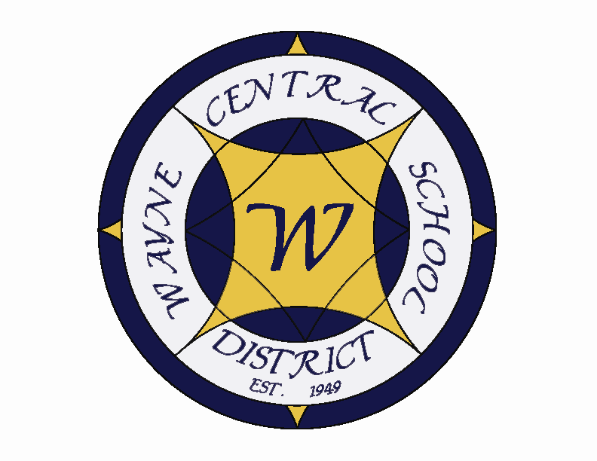
Letter to the Board

Michael Havens
Superintendent of Schools
Phone: 315-524-1001 Fax: 315-524-1049 mhavens@wayne.k12.ny.us

May 29, 2009

“All the art of living lies in a fine mingling of letting go and holding on.” - - Henry Ellis

Board Letter

1. Math Results: Math results are in. Our students have done the best ever by far. Results are as follows: Grade 3-98% Grade 4-90%
Grade 5-95% Grade 6-91%
Grade 7-97% Grade 8-92%
Overall 94%
At last year’s Board administrative retreat, we set a goal of 75% success rate for our students with disabilities. It appears that our children reached that goal at every grade level. This is terrific academic news. This information is embargoed so it cannot be shared publically yet but I knew you would want to know.

2. Freewill: This morning we met with representatives of the Town of Walworth to discuss the possibility of a long term lease of the building. They understand that we have not yet committed ourselves to one campus, but they might be interested in the facility should we move to the Ontario Campus. We have agreed to provide them with drawings of the school along with utility usage. We are meeting again in June to continue discussions.

3. Superintendent’s Hearing: I believe you will be getting an appeal of a superintendent’s hearing that was held this week. I explained that they would need to put their appeal in writing to you. When there is an appeal, each party presents a letter to you explaining their reasoning for either wanting the decision changed or maintained. You have the option of upholding the decision, throwing out the decision or modifying the decision. If the parents are still unsatisfied they have the right to appeal to the commissioner. The parents may not follow through but I didn’t want you surprised.

4. Investigator Larkin: Investigator Larkin from SED met with two students and some staff members regarding the Middle School teacher. She still has a high school student to interview. I don’t expect to have any additional information for a couple months.

5. Musical Awards: Tuesday night Wayne Central took home several awards for Thoroughly Modern Millie at the Elenbes in Newark. Please congratulate the cast and crew for an outstanding year. This year's recipients were:

Breanna Melino – Outstanding Leading Actress

Nate DelleFave– Outstanding Leading Actor runner up

Audrey Cooper – Outstanding Supporting Actress runner up

Outstanding Dance Ensemble
You can vote for Breanna to win the Stars of Tomorrow by going to http://www.tinyurl.com/voteforbre.

6. Docushare: The Board Agenda’s and Letters have been added to docushare. If you need your passwords again, please contact Lori and she will let you know.

7. Graduation: Mrs. Marlowe would like to know if all the board is planning on attending graduation and if so, she needs to know your height. Graduation is on Friday evening, June 26, 7:00 p.m. (you need to be there by about 6:40 p.m.) at the CMAC at FLCC. Please forward your information to Lori, who will compile a list and forward to Lisa.

8. Upcoming Events:
6/2 & 3 – Grade 8 NYS Social Studies Exam
6/5 – FE 5th Grade Banquet
6/5 – Ed Currier Awards @ MS

