
Letter to the Board

Michael Havens
Superintendent of Schools
Phone: 315-524-1001 Fax: 315-524-1049 mhavens@wayne.k12.ny.us

May 15, 2009

"Don't be afraid of opposition. Remember, a kite rises against, not with the wind."
--Hamilton Wright Mabie, American writer

Board Letter

1. Budget: I have completed all but one of the budget presentations. They have all gone well but the atmosphere is very quiet. It may be that with a tax decrease it is a “no-brainer”. I worry about the “no” votes that will come out every year. We just have to make sure we get enough “yes” vote in what may be a small turn out. See you Tuesday night to hear the results.

2. Wrestling Questions: A Board member has asked a few additional questions regarding our wrestling program. I have given those answers below and have attached a memo from Mr. Blankenberg regarding one of the issues that I explained in an earlier memo. I have also reiterated the district’s position that we do not encourage nor condone having a coach give a portion of his stipend to someone who volunteers to help out with the program.
1. Was Ron Gross a certified wrestling coach in 2007-2008?
Mr. Gross was a certified coach in 2007-08
2. Was Ron Gross being paid by the district in 2007-08?
Mr. Gross was paid $3,385 as an assistant coach
3. Why wasn’t the position that Ron Gross held posted?
The coaching positions were posted (see attached). It is possible that the position should have
been posted again.
4. Was Ron Gross appointed by the Board in 2007-08?
Mr. Gross was appointed by the Board on December 6, 2007
5. Explain why Gary Schojan is being given money by Marc Blankenberg for his coaching duties for 2008-09 instead of by the district.
See attached memo from Mr. Blankenberg
6. Is it true that Mr. Blankenberg approved a plan by which Ron Gross paid Mike Patterson 50% of Ron Gross’s pay?
Mr. Blankenberg states he approved no such plan. He does know that Mr. Gross did give Mike Patterson some money out of his own pocket for helping out. Mr. Blankenberg does not know how much. During this time the head coach (Mr. Gross) and the assistant (Mr. Hargarther) were struggling to work together. Mr. Blankenberg assured me that the coaches’ practice of giving a volunteer some money will stop.
7. Is it true that Mike Patterson has no coaching certification?
Mike Patterson has begun his certification but is not a certified coach
8. Was the WTA contract violated by any of the above action?
Not that we are aware of

3. Reserve Funds: I have attached an article from the D&C about the State Comptroller’s criticism of school districts for having too much money in reserve funds. You will recall that we were questioned about our reserves by the auditor. She let it go when we explained we would be using our reserves for the next building project. (the article is not complete…but there is enough of the article to get the idea)

4. Stimulus Money and Smart Boards: As a way of using the stimulus money and increasing our use of technology, we are offering a class in the proper instructional uses of Smart Boards in the classroom. Upon completion of the class (actually before) the teacher will have a Smart Board installed in their classroom. My estimate of 30 interested staff was way off. We have 81 teachers signed up. This is a wonderful problem to solve and luckily we have enough stimulus money to afford it.

5. Flags at Half Staff: Flags on State government buildings be flown at half-staff on Tuesday, May 19, in honor of Elmira, resident Army Private Justin P. Hartford, who died Friday, May 8, in a non-combat related incident at Joint Base Balad, Iraq. Flags are also being flown at half staff today, Friday, May 15 in recognition of Peace Officers’ Memorial Day (by decree of the Governor).

6. Kim Cox & Joe Siracuse: Both Joe & Kim will miss the next three Board of Education meetings (May 28, June 11 and June 25) because they are taking a course at the U of R. Of course, they are still available to answer any questions you may have about anything on the agenda, or anything else for that matter. They both can be reached by phone or email as usual.

6. Upcoming Events:
5/11 – HS PTSO Budget Presentation - HS Faculty Room – 7:00 p.m.
5/18 – FE Parent Group Budget Presentation – FE Cafeteria – 6:45 p.m.
5/19 – School Budget Vote & Election – HS Gym – 9:00 am – 9:00 p.m.
5/19 – FE Band & Chorus Concert @ PAC – 7:00 p.m.
5/19 – OP/OE PTA Meeting @ OE Cafeteria – 3:45 p.m.

Athletic Events:
5/15 – Boys’ JV Baseball vs. Mynderse – 4:15
5/15 – Girls’ JV Softball vs. Mynderse – 4:15
5/16 – Wayne Girls’ Diamond Tournament – JV - 11:00 & 1:00
5/16 – Wayne Girls’ Diamond Tournament – V – 3:00, 5:00 & 7:00
5/19 – Boys’ JV Baseball vs. Pal-Mac – 4:15
5/19 – Girls’ Softball vs. Pal-Mac – 4:15 p.m.
5/19 – Girls’ Softball vs. Pal-Mac – 7:00 p.m.
5/21 – Boys’ JV Baseball vs. Canandaigua – 4:15 p.m.
5/21 – Girls’ V Softball vs. Canandaigua – 7:00 p.m.

- Attachments:
a) Wrestling Memo
b) Coaching Posting info
c) Revised 09-10 school calendar
d) Calendar Revisions Memo
e) Audit Article
f) Kathy Green Retirement Party Invitation
g) Saba letter to parents

LO

Wayne Central School District

Office of the Director of Athletics

Memorandum


To: Mr. Havens
From: Marc Blankenberg
Date: 3-4-09
Re: Modified Wrestling Coaches

During the 2007-08 school year Gary Schojan was the Modified Wrestling Coach. Scott Freischlag applied for the Modified Wrestling Position for 2008-09 school year and was appointed. During fall and prior to the start of the season Scott was not sure if he was going to comment to the position. If Scott changed his mind about coaching the team I would have recommended Gary for the position. Scott and Gary did some wrestling intramurals together before the season started. Just prior to the start of the season Scott had indicated to me that he was going to coach. Ron Gross had indicated to me that Scott and Gary were going to work together. I assumed that they were going to share Scott’s salary. Scott and Gary were under the assumption that because of the good recruiting they had done through the intramural program and the increased number of team members that they were both going to be paid and have two coaches for the team.

In the last 7 years the Modified Wrestling Squad size has ranged from 13-20 students participating. This season there are 26 students on the team. With this increase in number of students and the structure of practices and meets there is justification for a second coach. However, with the economic climate I did not ask for the second position and I should have.

I did not realize there was an issue until Gary questioned where his paycheck was.
I have explained the situation to Gary and told him that situation is my fault because I assumed that they were sharing a salary. I told Gary that I would find a way to compensate him for his time.
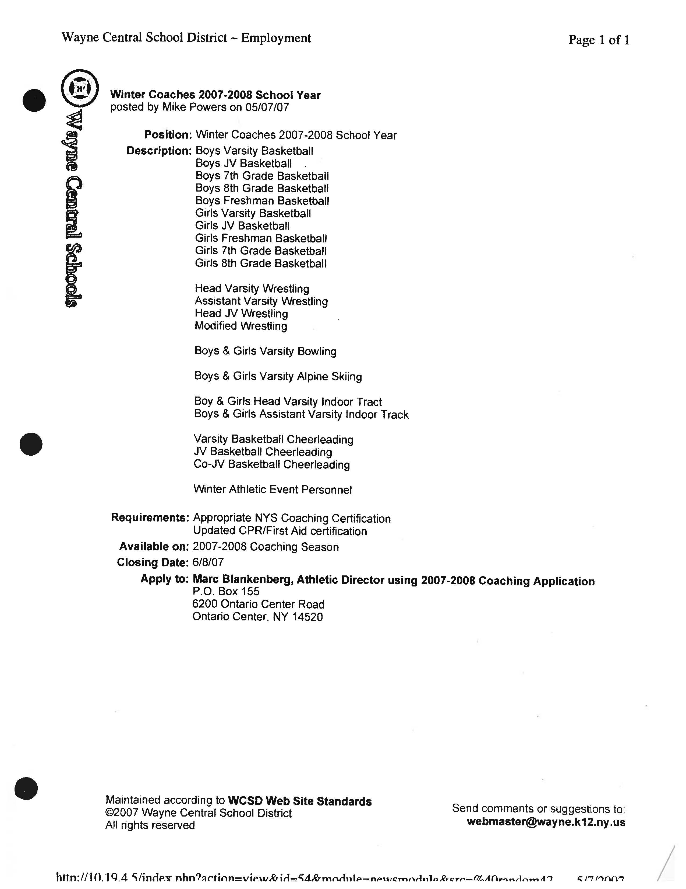

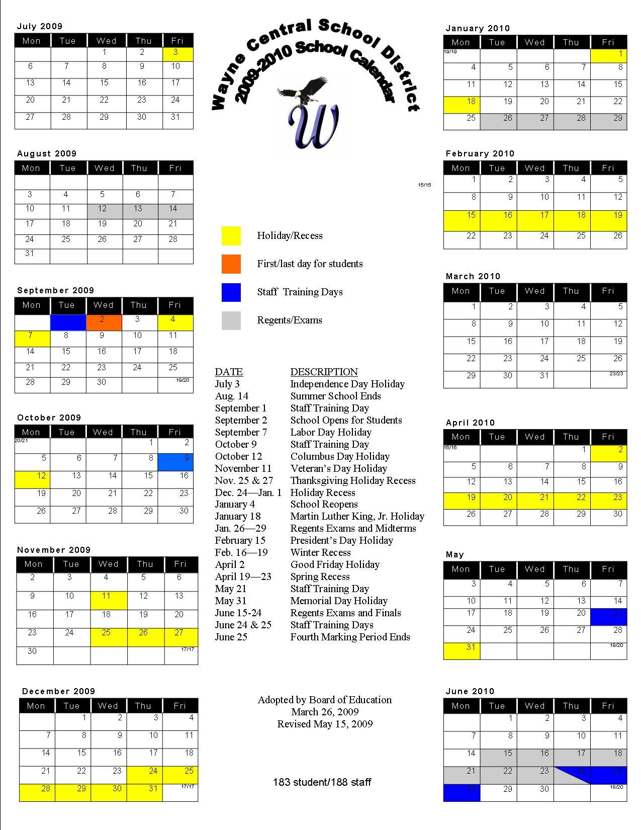

WAYNE CENTRAL
SCHOOL CALENDAR
UPDATES

CURRENT CALENDAR – JUNE 2009

Tuesday – June 23 – Half day for students
- This is a change from prior schedule where students were attending a full day

ELEMENTARY (K-5)
Monday (June 22) – full day staff & students
Tuesday (June 23) – half day students/ full day staff
Wednesday (June 24) – no students/full day staff

MIDDLE SCHOOL (6-8)
Monday (June 22) – half day students/ full day staff
Tuesday (June 23) – half day students/ full day staff
Wednesday (June 24) – no students/full day staff
HIGH SCHOOL (9-12)
Monday (June 22) – testing schedule students/ full day staff
Tuesday (June 23) – testing schedule students/full day staff
Wednesday (June 24) – testing schedule students/full day staff

2009-2010 CALENDAR – NEXT SCHOOL YEAR

Friday, September 4 – No School – Staff & Students

June 28 added for staff

An adjusted 09-10 calendar is attached.
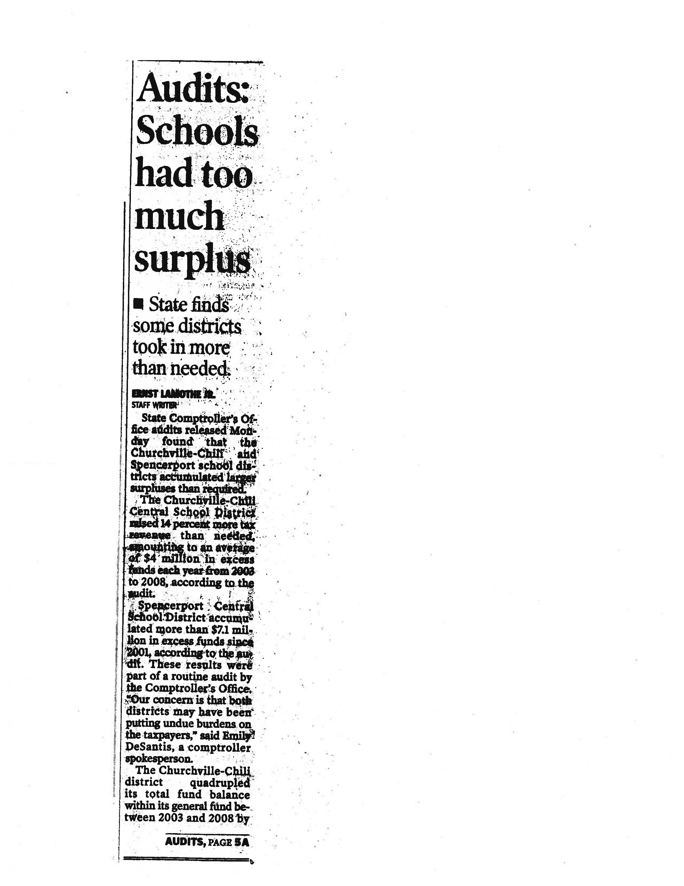


WAYNE CENTRAL SCHOOL DISTRICT
______________________________

ONTARIO PRIMARY SCHOOL
1730 Ridge Road - P.O. Box 155 - Ontario Center, NY 14520
Telephone (315) 524-1150 Fax (315) 524-1169
www.wayne.k12.ny.us

Michael L. Havens
Superintendent of Schools

Robert C. La Ruche
Ontario Primary Principal

Dear Parents/Guardians:

We are writing this letter to inform you of an incident that occurred in our classroom this morning.
As many of you are aware, we are trying to hatch fertilized eggs in our classroom. The heat lamp that we
have to keep the chicks warm accidently tipped over onto the cardboard box in our room. The box
began to smoke, nothing actually caught fire. Since the children’s safety is of the utmost importance we
evacuated the building and the fire dept. arrived to clear the building. Everyone, including the chicks
is fine. We just wanted you to be aware in case your children should have any questions. We are in the
process of purchasing metal boxes to insure that this does not happen again. It was a learning experience
for all of us.

If you have any questions or concerns, please do not hesitate to contact me at school.

Renee Saba
Robert C. La Ruche, Principal

