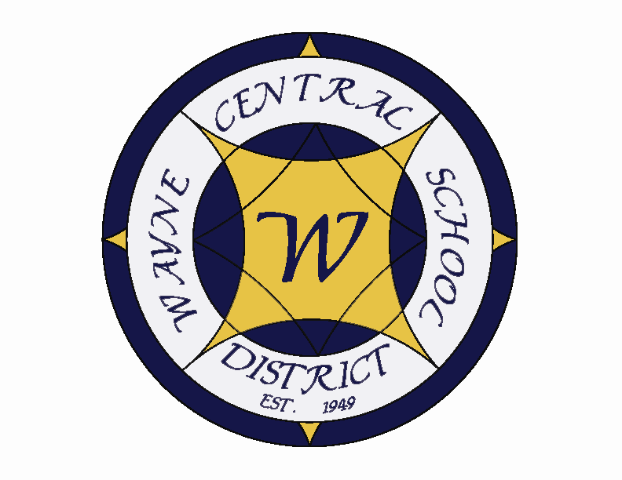
Letter to the Board

Michael Havens
Superintendent of Schools
Phone: 315-524-1001 Fax: 315-524-1049 mhavens@wayne.k12.ny.us

May 1, 2009

"Obstacles are those frightful things you see when you take your eyes off your goal."
--Henry Ford, Founder of Ford Motor Co.

Board Agenda:

- Executive Session: We have three items to discuss in executive session. Mrs. Cox and Mr. Pullen are up for tenure. I will be discussing their progress and heartily recommending them for tenure. We have also received a grievance from the WTA about having school the Friday before Labor. We will be reviewing the specifics of their claim and probable process for settlement. The ironic part of this is that we had developed an alternative calendar that would eliminate the need for students to come in before Labor Day and would give teachers the Thursday and Friday before Labor Day off. I’ll explain more at the meeting.

- Budget Hearing: Greg and I will be presenting the proposed budget to the public at 7:00 in the Performing Arts Center.

- Swine Flu Update: This is a fast moving target. Any news I give you today will be outdated tonight. I can tell you that as of right now there are no confirmed cases in Wayne County, however of the 90+ nationwide cases, 51 of them are in NYS. We had a number of students come down sick during the trip to Disney, however to date all have been Type A flu. There have been many conflicting directions regarding what to do when we begin to get confirmed cases. The most recent directive is to close for seven days. This may well change by the time we meet on Thursday. As per our Pandemic Plan, Michelle Scheik, Director of Student Services, is our point person for this. Michelle and Bob Miller went for training today (Friday). We will meet Monday morning to make sure we are up to date on everything. I will in turn, try to keep you up to date. Friday update: All “suspected”cases in Wayne County are confirmed Negative.

- Internships: As a continued part of our “grow your own” administrative initiative, we will be presenting internships for Donna Rizzo and Barb Heald for your consideration. Both proposals are attached. Administrative council has approved both proposals.

- Financial Report: Greg will present his annual financial report. We continue to look in excellent shape.

- Business Items: We have personnel items and CSE/CPSE as usual. Also under the consent agenda we have the March Treasurer’s Report, health contracts from East Irondequoit, Pittsford, and Penfield, award the local bid for the PE/Interscholastic/Health supplies and the BOCES cooperative bid for the same, accept a gift to the district from the MS PTO for funding of the annual MS end of year trip to Darien Lake, approve budget transfers, and appoint the school election officials for the school budget vote in May. I recommend approval of all items as submitted.

- Policy: Our only policy item is the second reading of 3410 –Code of Conduct policy.

- Student Representative: The student representative for this meeting is Megan Payne. She is a freshman is a class officer. She participated in ski/snowboard club, is a member of chorus. She is interested in pursuing a career in chemistry or possibly become a pharmacist.

Board Letter

- Wrestling Stipend: I have been asked a couple questions about the payment of an assistant wrestling coach. Each sport has a certain number of coaches, based on the type of sport and number of participants. This year Mr. Blankenberg made a mistake with the wrestling coaches. Actually I believe it to be a miscommunication between him and the head coach. As a result there were more people who expected to be paid for their positions than the district was authorized to compensate. Mr. Blankenberg met with me about it, explained the situation, explained that it was his error and that he was going to make it right. He has or is paying this person from his own pocket. Some people say Marc messed up, but I think he has stepped up to the plate to make it right himself and I’ve got to say I am proud of him for wanting to do this.

- Smart Boards: We are using part of the Federal stimulus money to provide additional Smart Boards to classrooms. Each teacher who completes the training program through our teacher center will have a Smart Board installed in their classroom. We expect to be able to purchase up to an additional 40 Smart Boards.

- Regional High School Study: We just received word that Wayne County Schools have been awarded the High Priority Regional High School Grant in the amount of $45,000. Below is the excerpt from the grant regarding our region.

“The third grant to the region is for $45,000 and went to the Wayne-Finger Lakes BOCES and the 11 School Districts within Wayne County to explore the concept of Regional High Schools in Wayne County. The study and planning will examine the potential savings, management improvements, and benefits to the community in developing regional high schools. A regional high school is defined as two or more school districts combining their high school programs and retaining separate elementary and middle school programs, or K-8 programs.”
We will begin to outline our study process at our next County meeting.
- Superintendent Out Of Town: I will be in Cleveland this weekend at the District Rotary conference. I can be reached by cell phone if you need me (315-576-0228). Michelle we be keeping me updated about the Swine Flu progress.

- Swine Flu Letters: I have attached the letter that was sent home to parents. Essentially the same letter was sent to staff. The sample letter was sent to us from the State Education Department/NYS Department of Health and we made very minor modifications.

- MS Musical: The middle school musical “Beauty and the Beast, Jr.” is being presented this weekend by Mike Allen and the middle school students. As always, the middle school has worked hard on this performance, and it is sure to be a wonderful show. Beauty and the Beast is a great family show that can be enjoyed by all ages. I hope you will be able to come out and see the fine young talents of our middle school performers.

- HS 3rd Quarter Honor Roll: The overall percentages for the high school honor roll breaks down as follows: Overall, 56.83% of the high school student body placed either on the merit roll, the honor roll, or the high honor roll. 6.94% made the high honor roll; 26.5% made the honor roll and 23.38% made the merit roll. Each grade has over 50% of its class on the honor roll, in other words earning an overall combined gpa of 85% or higher for this quarter. And once again, the Freshman class – the Freshman Academy continues to notably excel. I am attaching the breakdown for your review.

- Upcoming Events:
5/1 & 2 – MS Musical “Beauty & the Beast” @ PAC - 7:00 p.m.
5/5 & 7 – Driver Improvement Class – HS Room 13D – 6:00 pm.
5/5 – MS PTO Budget Presentation – MS Media Center – 6:30 p.m.
5/6- HS Band Concert @ PAC – 7:00 p.m.
5/6 – NYS Grade 8 Science Written Exam
5/7 – Board of Education Meeting @ PAC – 6:30 p.m.
5/7 – National School Nurse’s Day!
5/11 – HS PTSO Budget Presentation - HS Faculty Room – 7:00 p.m.
5/18 – FE Parent Group Budget Presentation – FE Cafeteria – 6:45 p.m.
5/19 – School Budget Vote & Election – HS Gym – 9:00 am – 9:00 p.m.
5/19 – FE Band & Chorus Concert @ PAC – 7:00 p.m.
5/19 – OP/OE PTA Meeting @ OE Cafeteria – 3:45 p.m.

- Attachments:
a) Safety Committee Meeting Minutes
b) Swine Flu Letter to Parents
c) Swine Flu Letter to Staff
d) Ontario Town Board Meeting Minutes

TO: Safety Committee Members:
Chris Shaffer - Committee Co-Chairperson (MS Asst. Principal)
Fred Prince - Transportation
Maureen Doyle – MS PE
Tom Lucieer – OE Maintenance
Mark Callahan - DO Administration
Lori Sensenbach – OP SCRIP
Beth Peters– FE Instructional
Rob Chapman – SRO
Jackie Brunner - School Board Rep.
Pat Griswold – OE Nurse
Riley Wheaton – HS Science

FROM: Bob Miller – Committee Co-Chairperson (Dir. of Facilities)
RE: Meeting Minutes
DATE: April 21, 2009

Old Business

I updated the group on the insurance recommendations from the December audit:

1) We have installed the “playground rules” signs on all playgrounds
2) A memo was sent to all staff regarding the use of wedges being used to prop classroom doors open was a fire code violation.
3) There was discussion about items being brought in from home that are not fire
rated. Carpets, curtains and furniture must have a ‘Class A’ rating if they are being used in schools. Anything purchased through School Specialty will have this rating. If a non-rated item is brought in by a staff member it would be their responsibility to treated it with a flame retardant product, but there must be documentation of this treatment on file.
4) The policy committee is doing a second reading of the “appliances in the classroom”
recommendation.

New Business

There had been meetings with SCRIPT teams from OE and OP in preparation for lockdown drills. The teams were given both “lockdown guidelines” for training and “drill feedback” forms to be used in evaluating each drill. Copies of these were handed out to committee members by Lori Senesenbach at the safety meeting.

We had our first lockdown drill at Ontario Primary on April 3rd. This was a training drill and it went very smoothly. Safety Committee members Rob Chapman, Tom Lucieer and Pat Griswold helped evaluate and gave feed back for the drill.

The Safety Committee proposes that the district adopt the lockdown and lockout procedures outlined in the New York School Safety Guide for our Homeland Security Booklet. This guide is the most up to date recommendation from both the New York State Education Department and the Office of Homeland Security.

There was also a proposal for a key individual, preferably an administrator in each building, to be trained in the National Incident Command Management System (NICMS). This is a system to coordinate emergency preparedness and incident management among various federal, state and local agencies. This training also establishes a clear chain of command and defines roles and responsibilities in the event of a disaster.

Next meeting: May 26th @ 8am.

LO
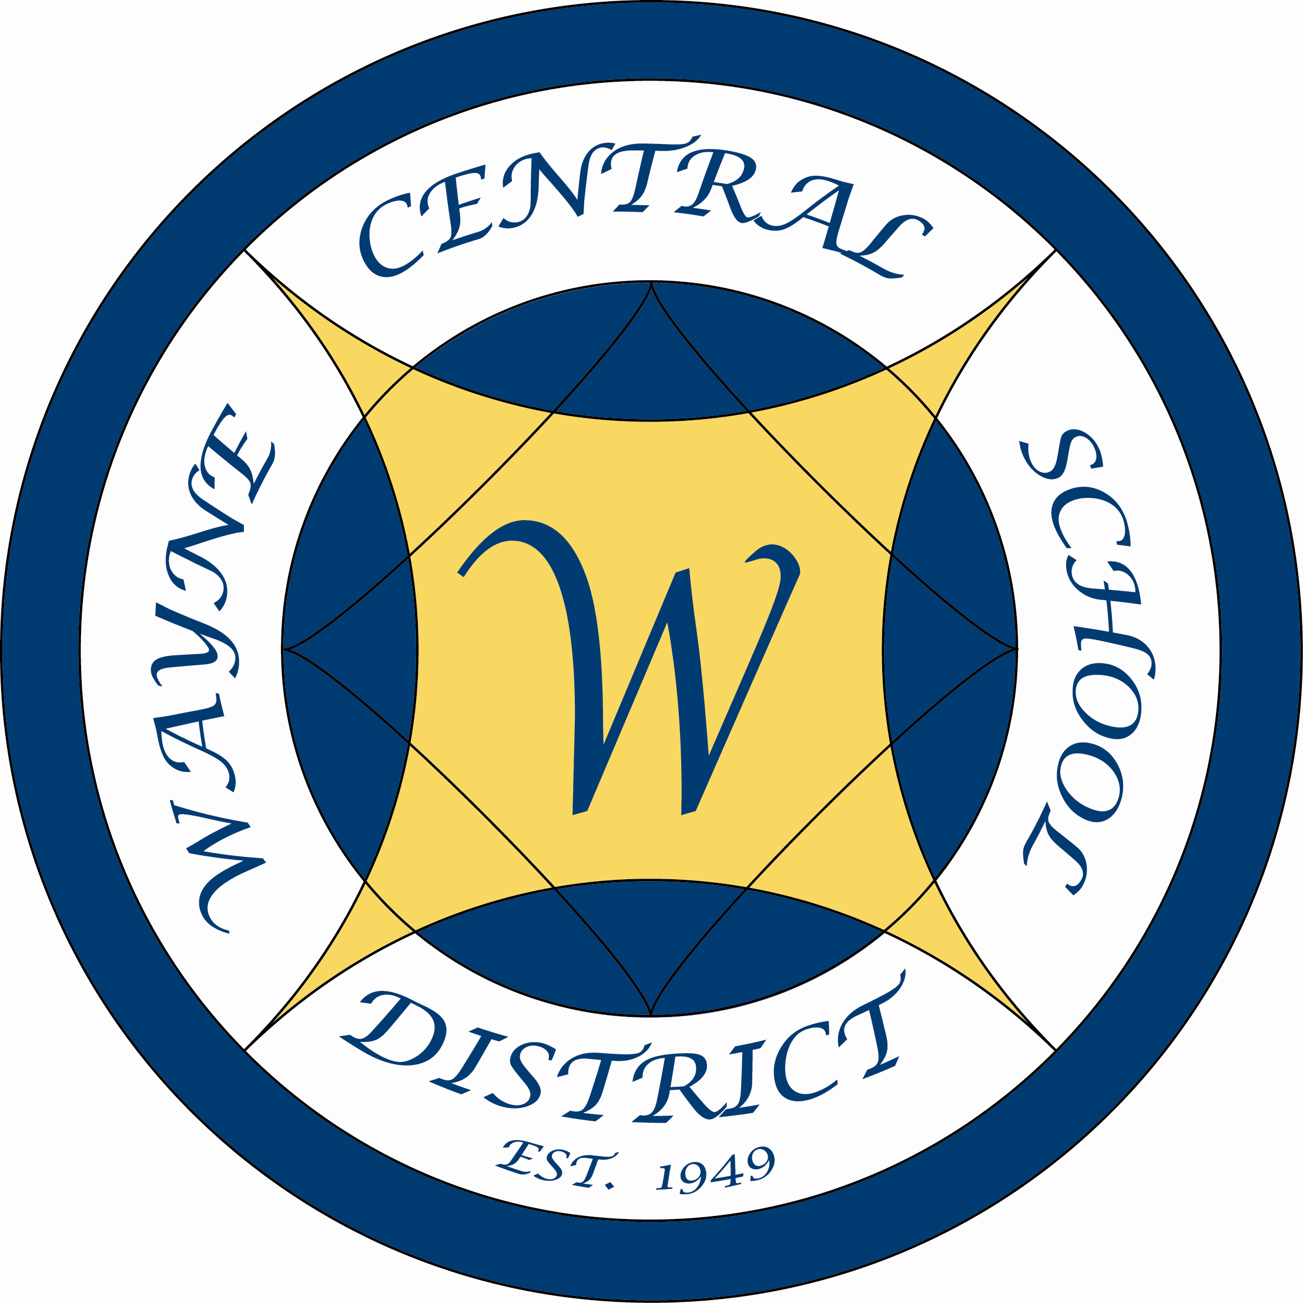

Wayne Central School District

Office of the Superintendent of Schools

P.O. Box 155
6200 Ontario Center Road
Ontario Center, NY 14520
315-524-1001

April 28, 2009

Dear Parents,

This letter is to inform you that the State of New York has entered a heightened surveillance stage resulting from the presence of a swine flu virus that is making people sick in several states, including New York State, and also in Mexico. Although, to date, only mild illness has occurred in the United States, we realize that many people are worried and we hope this letter will help address your concerns. Despite confirmed cases of swine flu in a private school in Queens, New York, we believe students can safely attend classes and schools will remain open at this time (with the exception of the school in Queens at which confirmed cases were discovered).

At this time, the state and local health departments have advised us that students can continue to come to school, as long as they are not sick and do not think they have flu symptoms. Flu-like symptoms include: fever (over 100 degrees F.), feverishness, cough, sore throat, runny nose, or stuffy nose. Additional symptoms may be experienced with swine flu, including muscle pain, fatigue, and sometimes vomiting or diarrhea.

Flu spreads easily. If you suspect your child is getting the flu, it is important that he/she does not attend school or go anywhere else—such as group childcare, the mall, or sporting events—where other people would be exposed to flu germs. It is also important to teach your children how to reduce their risk of getting the flu and protect others from infection.

- Teach your children to wash their hands often. Washing with soap and hot water for at least 20 seconds is ideal (that’s about as long as it takes to sing the “Happy Birthday” song twice).

- Teach your children the proper use of hand sanitizer. Gels, rubs, and hand wipes all work well, as long as they contain at least 60% alcohol. Hand wipes must be disposed of properly. Always read and follow label instructions when using hand sanitizer.

- Teach your children to keep their hands away from their face and avoid touching their mouth, nose, or eyes.

- Teach your children to cover coughs and sneezes with tissues or by coughing into the inside of their elbow. Cough or sneeze into your sleeve—not your hands!

- Help your children to learn these healthy habits by setting a good example and always doing them yourself.

If we all practice good hygiene, health officials believe we can limit the spread of swine flu in our school at this time. We are consulting with local health officials regarding best cleaning practices for infection control in our buildings.

While the current situation does not warrant school closure, if swine flu continues to spread and more students become ill, it may become necessary to close schools for a period of time. We are working with our School Medical Director and County Health officials to monitor the situation here and will make all decisions in consultation with them and state officials. We will inform parents immediately if the situation changes and it becomes necessary to close schools.

While it is unlikely that our schools will close, if they do, please do not make arrangements—such as sending children to a friend’s home or group childcare—that will put them in close contact with other children. It is important to plan ahead. Have a family discussion now to consider options in advance of the event of a school closing.

Please stay informed by paying attention to media reports. You may also get information at www.cdc.gov, www.nyhealth.gov, www.schoolhealthservicesny.com, or the 24 hour toll-free hotline that New Yorkers across the State can use to get answers to their questions. The hotline is 1-800-808-1987.

Thank you for your cooperation in keeping our children and our schools healthy.

Sincerely,

Michael Havens

Michael Havens
Superintendent of Schools

/SED-DOH
xc: Board of Education

LO

Wayne Central School District

Office of Student Services

P.O. Box 155
6200 Ontario Center Road
Ontario Center, NY 14520
315-524-1023

April 30, 2009

Dear Staff,

This letter is to inform you that the State of New York has entered a heightened surveillance stage resulting from the presence of a swine flu virus that is making people sick in several states, including New York State. To date, only mild illness has occurred in the United States. However, we realize that many people are worried and we hope this letter will help address your concerns. Despite confirmed cases of swine flu in a private school in Queens, New York; we believe students can safely attend classes and schools will remain open at this time (with the exception of the school in Queens at which confirmed cases were discovered).

Currently, the state and local health departments have advised us that students can continue to come to school as long as they are not sick and do not think they have flu-like symptoms. Flu-like symptoms include: fever (over 100 degrees Fahrenheit), feverishness, cough, sore throat, runny nose, or stuffy nose. Additional symptoms may be experienced with swine flu including muscle pain, fatigue, and sometimes vomiting or diarrhea.

The flu virus spreads easily. In an effort to prevent the spread of the flu virus, it is important to teach your students how to reduce their risk of getting the flu and to protect others from infection.

- Teach your students to wash their hands often. Washing with soap and hot water for at least 20 seconds is ideal (that’s about as long as it takes to sing the “Happy Birthday” song twice).

- Teach your students the proper use of hand sanitizer. Gels, rubs, and hand wipes all work well, as long as they contain at least 60% alcohol. Hand wipes must be disposed of properly. Always read and follow label instructions when using hand sanitizer.

- Teach your students to keep their hands away from their face and avoid touching their mouth, nose, or eyes.

- Teach your students to cover coughs and sneezes with tissues or by coughing into the inside of their elbow. Cough or sneeze into your sleeve—not your hands!

- Help your students to learn these healthy habits by setting a good example by practicing them yourself.

If we all observe good hygiene, health officials believe we can limit the spread of swine flu in our school. We are consulting with local health officials regarding best cleaning practices for infection control in our buildings.

While the current situation does not warrant school closure, if swine flu continues to spread and more students become ill, it may become necessary to close schools for a period of time. We are working with our School Medical Director and County Health officials to monitor the situation here, and will make all decisions in consultation with these individuals in addition to our state officials. We will inform parents and staff immediately if the situation changes and it becomes necessary to close schools.

The district continues to use care in the cleaning and maintenance of our buildings including special attention to shared bathrooms, common areas (including doorknobs, handles, railings), and health offices. Government approved disinfectants are used as indicated.

Health office staff receives daily interim guidance through our district physician on proper management of swine flu based on information provided by the Centers for Disease Control (CDC) and the New York State Departments of Health (NYSDOH) and Education (NYSED). Our school nurses are using personal protective devices, such as N-95 facemasks and gloves, along with scrupulous hand hygiene between patients.

District officials are currently in contact with federal, state, and local advisory agencies to guide us through this difficult period. The district has a detailed pandemic emergency plan in place that addresses school closure in the event of a pandemic or high risk for a pandemic. Our district physician is directly involved in the guidance of our health staff and administrators during this uncertain time.

What You Can Do to Help

The district asks you to understand this is an evolving situation that is frequently changing. We may not always have immediate answers to all your questions, but we will investigate concerns expressed whenever feasible. The district may not exclude anyone from school based on speculation, rumor, innuendo, or fear. We are trying to operate cautiously to maintain the safety and integrity of our school community while preserving the privacy, dignity, and rights of each individual and family. Accordingly, we will not share any personal information about any family or child with the public, and we will not exclude any child needlessly. Therefore, please refrain from asking questions that may breach the confidentiality of a student and his/her family. Remain calm and trust that the CDC, NYSDOH, NYSED, the local public health officials, and the district as a whole are monitoring and managing swine flu cautiously and with the best interest of the public in mind.

Thank you for your cooperation in keeping our children and our schools healthy.

Sincerely,

Michelle Scheik

Michelle Scheik
Director of Student Services
“Students First – Excellence For All”
“Students First – Excellence For All”
APRIL 27, 2009

ONTARIO TOWN BOARD MEETING

A regular meeting of the Ontario Town Board was called to order by Supervisor Robert Kelsch at 7:00 p.m. in the Ontario Town Hall. Present were Supervisor Robert Kelsch, Council members: Jason Ruffell, Lori Eaton-Smith, James Switzer, Stephen Tobin, Director of Parks and Recreation William Riddell and Town Clerk Debra DeMinck.

10 residents and visitors were present at portions of the meeting.

Mr. Switzer led the Pledge of Allegiance.

Constellation Energy, represented by David Joslin, Mary Burgess and Mary Ellen Dangler, presented a check for $10,000 to the Friends of the Park for a trail system.

Revisions to the Agenda - A motion was made by Mr. Ruffell, seconded by Mr. Switzer, to approve the agenda with the following addition: under new business – add surplus a tractor from the Parks and Recreation Department. 5 Ayes 0 Nays MOTION CARRIED

Comments From the Public – None

Approval of Minutes – Mr. Kelsch asked for approval of the minutes of the April 13, 2009 Town Board meeting. A motion was made by Mr. Switzer, seconded by Mr. Tobin, to approve the minutes as presented. 5 Ayes 0 Nays MOTION CARRIED
A motion was made by Mr. Switzer, seconded by Mrs. Smith, to approve the minutes of the April 16, 2009 Town Board meeting. 3 Ayes 0 Nays 2 Abstentions (Ruffell, Tobin) MOTION CARRIED

Correspondence – The Town Clerk received official notification from Déjà Vu Tavern, 2569 Route 104, Ontario that they are renewing their liquor license. A motion was made by Mr. Switzer, seconded by Mr. Tobin, to accept and file the correspondence. 5 Ayes 0 Nays MOTION CARRIED

New Business - A motion was made by Mr. Switzer, seconded by Mr. Tobin, to accept the Supervisor’s fiscal report for the month of March 2009 as presented. 5 Ayes 0 Nays MOTION CARRIED

A motion was made by Mr. Tobin, seconded by Mr. Switzer, to amend the mileage reimbursement rate from .55 cents to .50 cents effective May 1, 2009. The Town Board acknowledges the hard work of the Supervisor’s intern, Brendon Johansson. 5 Ayes 0 Nays MOTION CARRIED

A motion was made by Mr. Ruffell, seconded by Mr. Tobin, to declare surplus a 1990 John Deere Compact Tractor, serial number CH4048D004029, as requested by the Director of Parks and Recreation in memo #PR10-2009. 5 Ayes 0 Nays MOTION CARRIED

Policy Items – A motion was made by Mr. Switzer, seconded by Mr. Ruffell, to re-adopt the 2009 Policy Handbook and to adopt the following new polices: 4430P – Computer System Use Policy, 4440P – E-mail Use, 4450AR – Computer Security Password, 4450P – Computer Security Password, 4460AR – Disclosure of Wrongful Conduct (Whistle Blower), 4470P – Violence in the Workplace Policy. 5 Ayes
0 Nays MOTION CARRIED

Budget Transfers/Adjustments – A motion was made by Mr. Switzer, seconded by Mr. Tobin, to approve the following budget transfer: Highway transfer $30,936.17 from DA 5112.4 to DA 5112.2 5 Ayes 0 Nays MOTION CARRIED

Reports by Town Board Members – Mr. Kelsch spoke to the Department of Environmental Conservation
(DEC) and they are in the process of reviewing the plan the Town submitted. The Town was rated by Moody’s Investment Service and our bond rating remains 1A.

Mr. Switzer stated the Town’s equalization rate is 100%. Condolences to the Hetu family on the passing of Josephine Hetu, a native of Ontario. Mr. Switzer encourages everyone to dress casually for the Workshop on Monday, May 4th. The board will be touring the wastewater treatment and compost facilities.

Mrs. Smith stated that at the three boards meeting the request for the tax increase for the Walworth Library has been withdrawn. The tax rate will remain flat.

Mr. Ruffell stated the new code updates from General Code have been received and they did a great job.

Approval of Claims – A motion was made by Mr. Switzer, seconded by Mr. Tobin, to approve the abstract of claims for April 27, 2009 including vouchers #958 through #1096 with a grand total of $225,919.56 and to authorize the Supervisor to issue payments for same. 5 Ayes 0 Nays MOTION CARRIED

Comments from the Public – Joan Stark asked the Town Board if there was an emergency disaster plan in place should the swine flu epidemic reach Ontario.

Executive Session - A motion was made by Mr. Switzer, seconded by Mr. Tobin, to move into an executive session at 7:35 p.m. on a personnel matter pertaining to specific persons. 5 Ayes 0 Nays MOTION CARRIED

Reconvene – 8:05 p.m.

A motion was made by Mr. Ruffell, seconded by Mr. Switzer, to appoint Scott M. Erdeli to the Civil Service position of Accountant for the Town of Ontario. This provisional appointment carries a probationary period of 26 weeks at $47,000 annually, pro-rated, effective Monday, May 4, 2009. 5 Ayes 0 Nays MOTION CARRIED

Adjourn – A motion was made by Mr. Switzer, seconded by Mr. Ruffell, to adjourn at 8:06 p.m. 5 Ayes
0 Nays MOTION CARRIED

Respectfully submitted,

Debra DeMinck
Ontario Town Clerk

The above minutes will become official upon approval of the town board.

