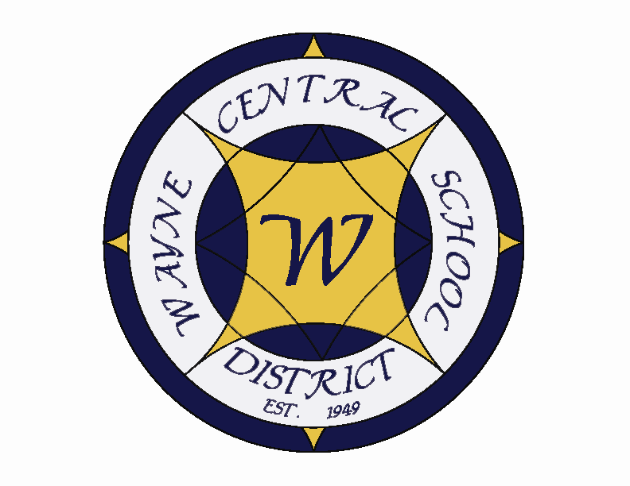
Letter to the Board

Michael Havens
Superintendent of Schools
Phone: 315-524-1001 Fax: 315-524-1049 mhavens@wayne.k12.ny.us

April 3, 2009

Board Agenda:

- This is the Three Boards Meeting. We will be meeting at the Ontario Elementary School old gym for a change of pace.

- Budget Presentation: We will provide the Wayne Central School District 2009-2010 proposed budget presentation. It will not be a full PowerPoint but an overview of the highlights (Jackie, this is where you can tell Walworth that they are crazy for raising the library taxes this year ☺)

- Wind Energy Project Update: We will provide an update on the wind energy project

- Tax Reform Summit: Mr. Switzer of the Ontario Town Board has placed an update on the Tax Reform Summit on the agenda

- Cooperative Services: Mr. Switzer of the Ontario Town Board has requested this discussion.

Board Letter

- Budget Presentations: I am attaching a schedule of budget presentations. Please let me know if any board members are interested in making any budget presentations with me.

- Senior Trip: You can go to the Wayne Web page, then go to the High School page and click on the Trips link – then select NYC to see the kids on their senior trip. I also found that you can see pictures of the Costa Rica trip there as well.

- Audit Report Meeting: The state auditor presented her exit report on Tuesday. As expected there were no negative written findings. This speaks well of the women in our business department. There were five oral comments. These are not big concerns but areas she feels she should mention. Those were 1. Board disclosure forms: We did not have Board disclosure forms on file. These were the forms you signed in November stating there were no conflicts of interest. We have added this to our July annual meeting to make sure it always gets completed. 2) Test Disaster Recovery Program: She recommends we test our program which is designed to recover data if there is a computer meltdown. 3) Receiving goods only through Central Receiving: Some of our salesmen have been bringing our orders directly to our AD. While a good salesmanship practice, it violated our procedures which require that all products first come to Central Receiving. 4) Ray Wager Contract: She believes the contract we have with our auditor Ray Wager is really an “offer of services” not a contract. Greg and Ray don’t agree but are correcting it (the comptroller’s auditor always trumps over our local auditor). 5. Reserves: She believes our reserves are becoming too large. While she accepts our explanation that we are saving for our next building project, so the tax payers won’t see a tax increase, she let us know that some districts are being scrutinized for this. She believes we will have the final report before our budget goes out for a vote.

- Congressman Maffei: Below are the dates and times of Congressman Maffei's upcoming town hall meetings:

April 7 from 6pm-7pm
Newark Village Hall
100 East Miller Street
Newark, NY

April 9 from 6pm-7:30pm
Irondequoit Town Hall
1280 Titus Avenue
Rochester, NY

- CPR Training: Just for clarification, the training Barb Heald is offering is for already certified staff. Marc Blankenberg offers training for staff that have not already received their certification. (I apologize, I thought it was the same one). He is setting something up. I will forward the information on Marc’s training when he has it.

- SED Report: I know the letter that was sent was disheartening to all of you (as it was us). Based on some union meetings that Bob Armocida has had with his building reps about the topic, we believe it to be a Middle School Staff member. I don’t expect we will ever determine who and we aren’t going to waste any time trying to discover who. Mrs. Armitage is calling the parents today so that they and their daughter can be prepared if/when it hits the news. I also asked Mark to contact Melanie so she can be prepared. The sad part of this letter is that if it is successful in bringing the news into this, it will give a black eye to every Middle School teacher, hurt a student who is about to go off to college and a wife who use to be a middle school teacher.

- Dansville Audit: Attached is the news article on the controllers audit for Dansville School District. This is the kind of publicity you get when you don’t do things right.

- Upcoming Events:
4/6 TCA Friends of Music Meeting @ MS Conference Room – 6:45
4/7 – HS Art Show @ AP art wing - 7:00 – 9:00 p.m.
4/7 – OP/OE PTA Meeting (Budget Presentation) @ OE Café – 7:00 p.m.
4/8 – NYS Grade 4 Science Exam
4/9 – Three Boards Meeting @ OE Old Gym – 7:00 p.m.
4/10 – All Schools and offices closed – Good Friday Holiday
4/13 – 17 – Spring Recess – Schools Closed
4/22 – WEDNESDAY - Board of Education meeting @ DO – 7:00 p.m.
4/24 – Junior Prom @ Harro East Ballroom – 6:00 – 11:00 p.m.
4/24 – ½ day parent teacher conferences - K-12

- Attachments:
  - Budget Presentation Schedule
  - HS PTSO Flower Sale Order Form
  - Dansville Audit Article

