
Letter to the Board

Michael Havens
Superintendent of Schools
Phone: 315-524-1001 Fax: 315-524-1049 mhavens@wayne.k12.ny.us

March 20, 2009

“Example, whether it be good or bad, has a powerful influence.”
- - George Washington, 1st President of the United States

Board Agenda:

- Executive Session: We will have an executive session at 6:30 to discuss the teacher who resigned this Friday afternoon.

- 2009-2010 Proposed Budget: The complete 2009-2010 proposed budget is attached for your review. You have been presented the budget in all its parts (administrative, capital, and program) and now you have the revenue side. Neither the tax rate nor the levy is expected to increase. Mr. Atseff’s cover letter outlines the increases and reductions in the budget. The annual budget adoption is the one time when we have presented the last portion (revenues) and adopted at the same meeting. We will want to continue this since the next meeting is a three board and the next after that (April 22) would be too late. We will happy to answer any questions either ahead of time or at the Board meeting.

- Teacher Mentor Program: Mrs. Cox will present an overview of some modifications we’ve made in our teacher mentoring program at Wayne.

- Student Representative: Our student representative for this meeting is Adrienne Heckle. Adrienne is a member of National Honor Society and Varsity soccer.

- 2009-2010 School Calendar: This calendar was discussed at the March 12 Board meeting and is being submitted, without changes, for your adoption at this meeting

Board Letter

- Hackett Update: Mrs. Hackett has requested that the Office of Civil Rights suspend its investigation and has indicated she would be willing to engage in mediation instead. This is very good news especially in light of an additional error Jordan’s teacher made last Friday. I will give you a brief update in executive session.

- April 7 Art Show: The High School is hosting its annual art show on Tuesday, April 7 from 7:00 – 9:00 p.m. featuring the AP art students work. This is one event I really recommend you take the time to attend. It is amazing the quality of these students work. You may see the gallery for two days on April 7 & 8 during school hours. I have attached the invitation.

- Three Boards Meeting: Our next board meeting is on April 9, here at Wayne and it is the joint meeting on the Wayne Central School Board, the Walworth Town Board, and the Ontario Town Board. Please be thinking of what items you wish to have on the agenda for that meeting. I understand the Ontario Town Board will be proposing a visit by the Assistant Attorney General to speak to the boards about issues facing our area and our state at large. Please let Lori know any items you would like to discuss.

- Tot Spot: The Tot Spot is hosting an open house on March 26 at 6:30 p.m. at their Ontario Elementary site. Please feel free to stop in.

- Summer School: We have completed our paperwork to host the consortium for summer school for this coming summer. We are also working on plans to have our middle school summer program be BOCES aide able.

- Upcoming Events:
3/20 – FE Family Night
3/23 – Music In Our Schools Chorus Concert @ PAC – 7:00 p.m.
3/24 – Music In Our Schools Chorus Concert @ PAC – 7:00 p.m.
3/26 – OE Open House – 6:30 p.m.
3/31 – 4/3 – Senior Trip to New York City

- Attachments:
  - Safety Committee Meeting Minutes – 3/10
  - Wayne’s World - March
  - Walworth Town Board Meeting Minutes - 2/19
  - Ontario Town Board Meeting Minutes - 3/9
  - Art Show Invitation

TO: Safety Committee Members:
Chris Shaffer - Committee Co-Chairperson (MS Asst. Principal)
Fred Prince - Transportation
Maureen Doyle – MS PE
Tom Lucieer – OE Maintenance
Mark Callahan - DO Administration
Lori Sensenbach – OP SCRIP
Beth Peters– FE Instructional
Rob Chapman – SRO
Jacquie Brunner - School Board Rep.
Pat Griswold – OE Nurse
Riley Wheaton – HS Science

FROM: Bob Miller – Committee Co-Chairperson (Dir. of Facilities)
RE: Meeting Minutes
DATE: March 10, 2009

Old Business

Rob Chapman (SRO) has the Threat Assessment Team in place at the high school. They have already met once and will be meeting again next week.

I hadn’t received any requests, before the February 13th deadline, from committee members, for information regarding the loss control audit performed in December. Greg and I met with the loss control representative on March 6th to have him clarify some concerns that we had with the audit.

There was some discussion around two recommendations that were also fire code violations. Some of the carpeting, domestic furniture and drapes in student occupied areas did not have a “class A” fire rating. The items that were noted on the report weren’t purchased through School Specialties but were brought in from home. The second recommendation discussed was the use of wedges to hold open classroom doors that lead into the corridors. I will be sending a memo to all staff regarding these two issues.
There was also a recommendation, concerning household appliances in student occupied areas, which will be reviewed by the policy committee.

Next meeting will be on Tuesday April 21, 2009 @ 8:00 AM in the Maintenance building.

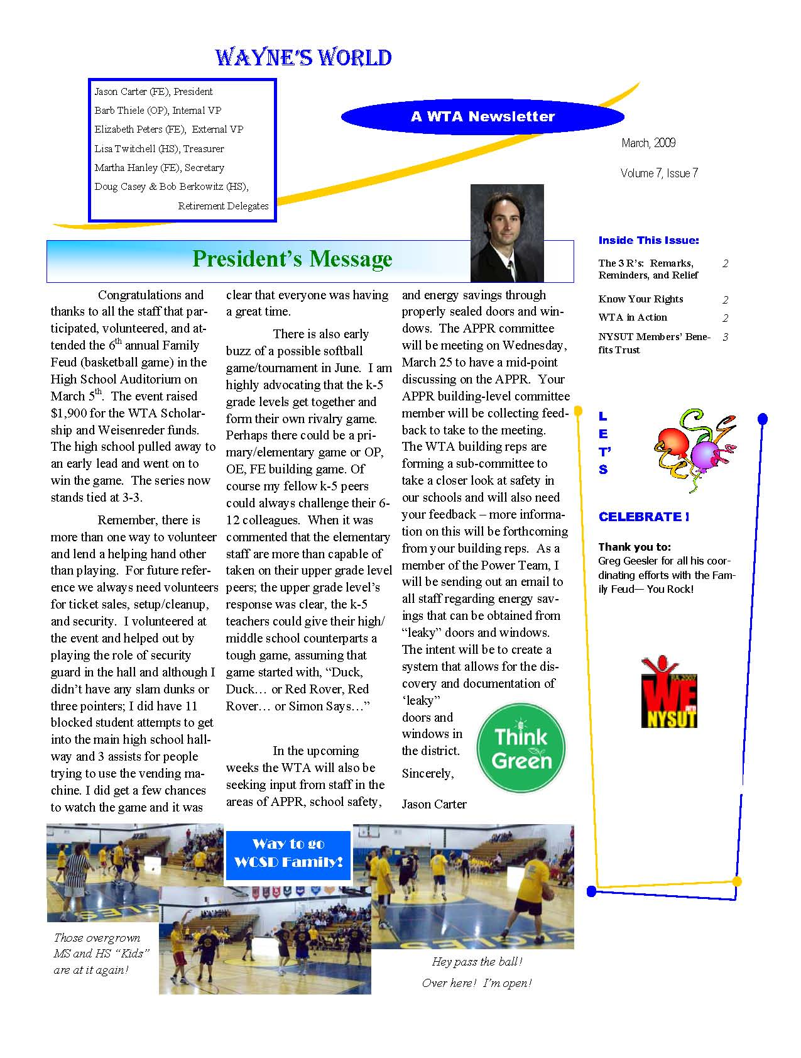
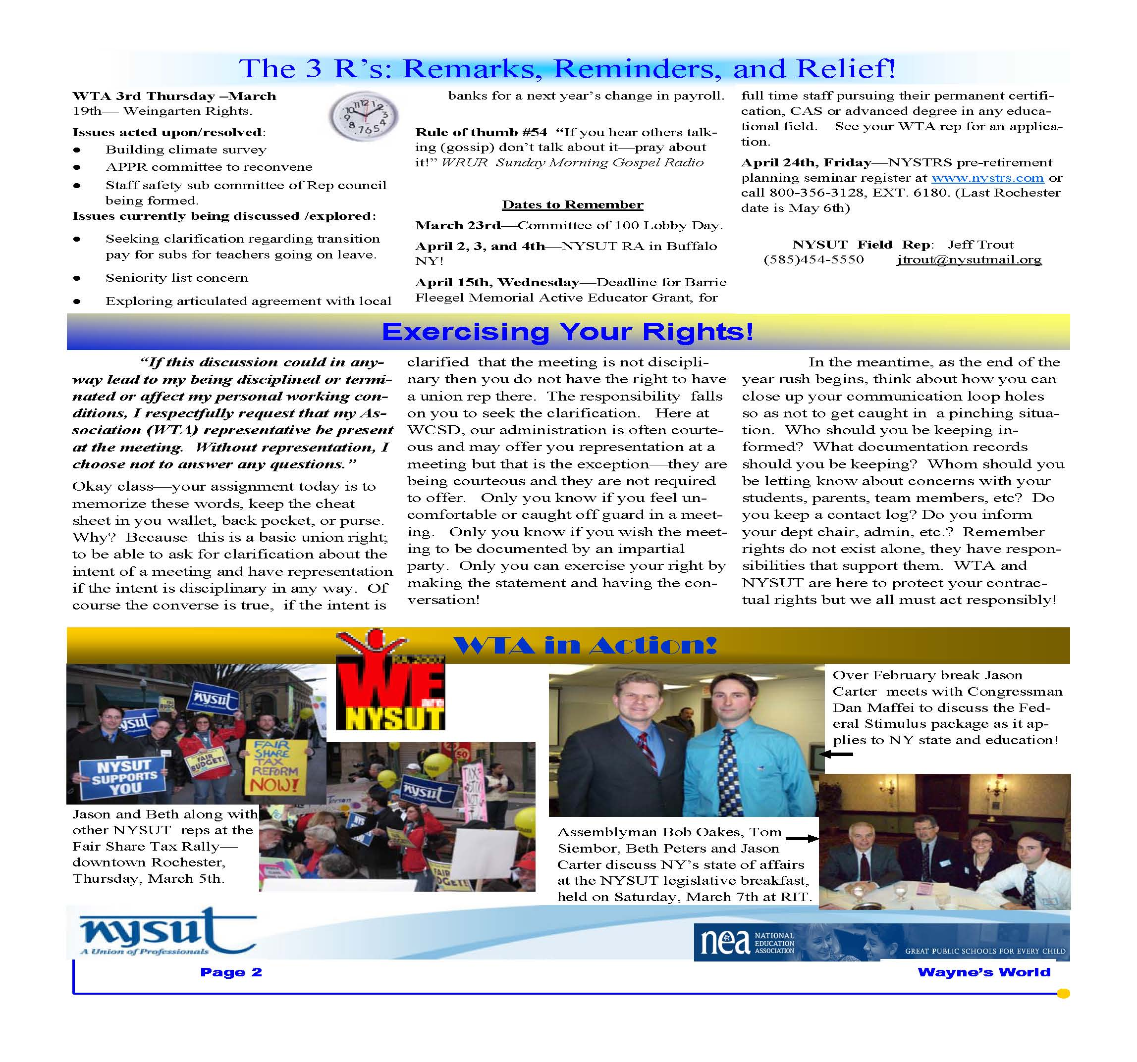

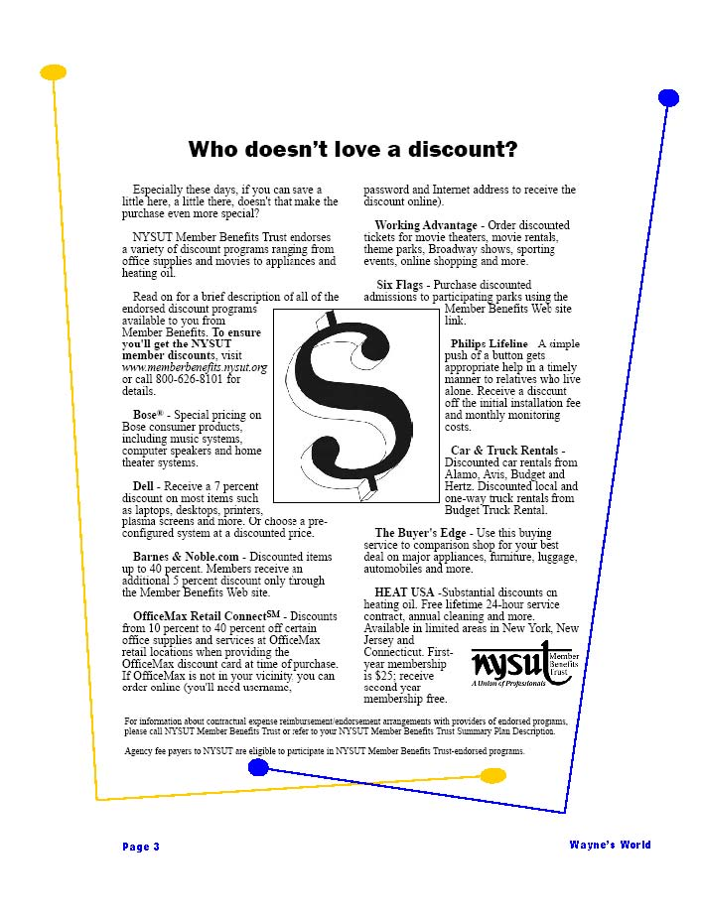

WALWORTH TOWN BOARD – REGULAR MEETING

19 FEBRUARY 2009

Presiding Supervisor Plant called the regularly scheduled Town Board meeting, held at the Walworth Town Hall, 3600 Lorraine Drive, to order at 7:30 PM.

Present: Thomas Yale Councilman
Patricia Marini Councilwoman
Frank Maciuska Councilman
Suzi Hawkins-Mance Councilwoman
Susie Jacobs Town Clerk
Mike Frederes Highway Superintendent
Rob Burns Sewer Superintendent
Jacqueline Van Lare Recreation Director
Karen Ambroz Assessor
Ed Parrone Engineer for the Town

CATCH-A-BUSINESS AWARD:
Supervisor Plant presented a “Catch-a-Business Award” to Mark’s Garage, who was “caught” demonstrating exceptional technical skills during a vehicle repair and went the extra mile with customer service.

CATCH-A-KID AWARD:
Supervisor Plant presented a “Catch-a-Kid Award” to Mikayla Marini for donating her birthday gifts to Golisano’s Children’s Hospital.

PAYCHEX – HEALTH CARE PRESENTATION:
Scott VanAlst, Health Consultant with Paychex, presented Council members with the proposed outline data sheets for MVP-Preferred Plan and Guardian Dental for their review and consideration. Discussion ensued.
Supervisor Plant explained that the Board needed to make a decision on this tonight in order to adhere to the deadline. Councilman Maciuska stated that it was the Health Care recommendation that was needed. Councilwoman Marini commented that the Health Care Committee recommended for the Town to provide Town employees with 80% paid by the Town and 20% paid by the employee - to keep consistent coverage towards health care costs. The Town currently pays 100% for all employees on the single plan, and 80%-20% for double and/or family plans. It was also stated that for part-time employees the Town would pay half of what the Town would pay for a full-time employee – across the board. Discussion ensued. Supervisor Plant suggested that the current policies regarding health care coverage remain in effect for current employees under a grandfather clause, and changes would be effective for new hires hired on or after March 1, 2009. This would still keep the Town below the budgeted amount. Councilman Maciuska agreed “that we want to do what is right” for our employees for all the hard work that they do, and the employees had no idea of the potential increase. Councilman Yale agreed only on the proviso that this would be effective for this year - next year it would have to be reevaluated. He stated that the concept of any benefits being guaranteed for the life of employment is no longer a reality, and the employees have to understand that. “I believe we are now offering a good quality, very competitive price package, and we may see some changes in enrollment may take place because of it.” He would support it for the entry year and reevaluate at budget for 2010. The Dependent Rider discussion ensued; the Health Care Committee’s recommendation was that to the age of 26 would be available on the family plan. Employee question and answer forums regarding the new coverage will be held
on Monday, March 2, from 12:00 Noon until 3:00 PM, and Tuesday, March 3, from 6:30 to 7:30 PM, at the Town Hall; spouses are welcome to attend.

Motion by Councilman Yale that the Town go with the Guardian Plan - Preferred Care as outlined and the Town agrees to pay 80%-20% basis, with single existing plans employees remaining at 100%, new employees hired after March 1, 2009, and further direct that a breakdown chart including everything and all employees benefits be laid out in writing in a very simple format and submitted for review to the Town Board via email.
Seconded by Councilwoman Marini.

Discussion:
Councilman Yale stated that this was a very convoluted thing and he would like to see what the employees were going to see before it was available to them; he further stated that the breakdown chart did not have to come before the Town Board for approval. Councilman Maciuska commented that the Health Care Committee had done a very good job - it’s taken a long time to go through all the policies, look at all the different riders and all the different instruments available, in order to provide this benefit to the employees, and a very good package to the employees. Council members commended the Health Care Committee, Jean Johnson and Kevin Switzer for their time, hard work and noted that Jean made their job much easier.

Roll call vote: Councilman Maciuska Aye
Councilwoman Marini Aye
Councilwoman Hawkins-Mance Aye
Councilman Yale Aye
Supervisor Plant Aye
Motion carried.

RECESS - AUDIT TOWN BOOKS:
Time: 8:02 PM.

RECONVENED:
Time: 9:15 PM.

RESOLUTION 22-09 JUSTICE COURT AUDITED RECORDS:
Councilman Maciuska offered the following Resolution 22-09 and moved its adoption. Seconded by Councilwoman Marini to wit:

WHEREAS, the Town Council of the Town of Walworth has duly audited the Walworth Town Justice Court books at a regular Town Board meeting on February 19, 2009; and

WHEREAS, the Walworth Town Justice Court filed with the Walworth Town Clerk the summary report on February 19, 2009; and

BE IT RESOLVED, that the Town Council of the Town of Walworth adopts Resolution 22-09.

Adopted this19th day of February, 2009, at the meeting of the Town Council.
Roll call vote: Councilman Maciuska Aye
Councilwoman Marini Aye
Councilwoman Hawkins-Mance Aye
Councilman Yale Aye
Supervisor Plant Aye
Resolution carried.
AUDIT OF TOWN BOOKS - RECOMMENDATIONS:
Councilman Maciuska stated that the Town Board had duly audited the records and made the following recommendations:
Supervisor’s Office - there were inconsistencies on how the Town Books were being balanced on a monthly basis; it was a lot more work than necessary. There did not seem to be any errors; however, there was difficulty following things - the Board recommended that the Supervisor’s Office follow common accounting principles and balance to the end of the month - not real time - so that when you went back and looked at the register and saw the statement, this had been discussed with the department. The Town Clerk’s office - we found some inconsistencies again. Last year the Town Board asked that the reconciliation be made to the Bank Statement. He further stated that the Town Board would give clearer guidance to the Town Clerk on how the Board would like that done and the Board’s expectations and that they would like to review the books again in two (2) months to see that everything had been corrected. It did not look like there was anything out of order, but it was difficult to follow through to see how the money was balancing out and we would like that rectified. Receiver of Taxes’ Office - there were no issues.

MINUTES:
Motion by Councilwoman Hawkins-Mance to approve the Minutes of February 5, 2009, as presented Seconded by Councilman Yale.

Discussion: Councilwoman Marini requested a correction on the DRAFT Minutes, Page 24, PUBLIC PARTICIPATION, typographical error on the word “couldn’t.”
Councilwoman Hawkins-Mance amended her Motion. Councilman Yale amended the Second.
Adopted: Vote Ayes 5 Nays 0

CORRESPONDENCE:
Susie Jacobs, Town Clerk, had nothing to enter into record.

SUPERVISOR’S REPORT:
Motion by Councilwoman Marini to approve and file the Supervisor’s Monthly Report for January, 2009, as presented. Seconded by Councilwoman Hawkins-Mance.
Adopted: Vote Ayes 5 Nays 0

RESOLUTION 16-09 – AUDIT OF CLAIMS:
Councilwoman Hawkins-Mance offered the following Resolution 16-09 and moved its adoption. Seconded by Councilman Yale to wit:

WHEREAS, the following claims submitted at the scheduled Town Board Meeting of February 19, 2009, have been audited and approved by the appropriate Council Members.

BE IT RESOLVED that the claims be paid on Abstract #2, numbered 68 through 256, in the following amounts:

GENERAL FUND | $ 73,139.13
HIGHWAY FUND | $ 95,365.52
WALWORTH SEWER DISTRICT #1 | $ 74,168.14
PARK PAVILION CAPITAL FUND | $ 19,448.89
WALWORTH LIGHT DISTRICT  HARVEST HILL LIGHT DISTRICT | $ 1,610.68  $ 750.60
BROOKSIDE LIGHT DISTRICT  ORCHARD VIEW LIGHT DISTRICT  GANANDA LIGHT DISTRICT | $ 14.35  $ 140.40  $ 943.63
WALWORTH CONDOLIDATED DRAINAGE  LINCOLN FIRE PROTECTION  WEST WALWORTH FIRE PROTECTION | $ 2,282.57  $ 120,575.00  $ 149,019.00
BE IT FURTHER RESOLVED that the claims be paid on Abstract #2, numbered 12 through 35, in the following amounts:

TRUST & AGENCY | $ 428,339.05

NOW THEREFORE BE IT RESOLVED that the Town Council of the Town of Walworth adopts resolution 16-09.

Adopted this 8th day of January, 2009, at the meeting of the Town Council.

Roll call vote: Councilman Maciuska Aye
Councilwoman Marini Nay
Councilwoman Hawkins-Mance Aye
Councilman Yale Aye
Supervisor Plant Aye
Resolution carried.

DEPARTMENT HEAD REPORTS:

HIGHWAY – PURCHASE OF SIX-WHEELTRUCK AND PLOW EQUIPMENT
Mike Frederes, Highway Superintendent, requested permission to order one (1) 2010 International 7600 SFA 4 x 2 Six-Wheel Dump Truck with Tenco Plow Equipment, Plow, Wing, Beau-Roc Dump Body and Hoist off New York State Contract #PC62176. Contract delivered price is $158,855.03. He stated that this was a Budgeted item in the 2009 Budget under lines DA5130.21 - $120,000.00, and DA5130.22R - $50,000.00. Monies to be expended from these lines, of which there will be a balance left to easily cover incidentals which they will do in house, such as Lettering, Two-Way Radio, Trailer Hitch, etc.

Motion by Councilman Yale authorizing the purchase of the Six-Wheel Truck and Plow Equipment under State Contract #PC62176.
Seconded by Councilwoman Hawkins-Mance.

Roll call vote: Councilman Maciuska Aye
Councilwoman Marini Aye
Councilwoman Hawkins-Mance Aye
Councilman Yale Aye
Supervisor Plant Aye
Motion carried.

HIGHWAY- SHARED SERVICES GRANT UPDATE
Mike Frederes reported that the Shared Services Grant with the Town of Palmyra, The Village of Palmyra and the Town of Macedon for a Street/Catch Basin Cleaner and an Aerial Lift Truck are both expected to be delivered next week.

Mike Frederes stated the Town is good on salt – we are good for the “week”!

SEWER - FILTER CLOTHS
Rob Burns, Sewer Superintendent, presented the following proposal:

Attached is information pertaining to the Filter Cloth’s used at the Walworth Waste Water Treatment Facility, which is a vital part of the treatment process. The filter cloth’s are in need of being changed. A letter from Aqua-Aerobic Systems, Inc. is included in your packet, stating that under normal operating conditions, filter cloth’s have a service life of four (4) to five (5) years. The Filter Cloth’s at the facility are now into the ninth (9th) year.

I have provided you with details regarding an updated cloth that is available, which would allow the elimination of the high pressure backwash system being used. This would result in savings of both electricity and potable water.

A “Sole Source Supplier” letter as well as a quote, valid for thirty (30) days, from Aqua-Aerobic Systems, Inc. in the amount of $19,164.00 (total job price) for seventy-two (72) Replacement Filter Cloth’s; OptiFiber type PES13A polyester pile, recommended for regular chlorine use - Aqua part number 2963923 has been provided.

This money would be expended from the Sewer Equipment Reserve Savings, current balance of $38,427.27. Based on the information provided by the “Office of the State Comptroller Financial Management Guide”, which states “expenditure from fund is subject to permissive referendum only if the period of probable usefulness of the capital improvement or equipment is more than five (5) years,” this expenditure would not be subject to a referendum.

Motion by Councilman Maciuska authorizing the purchase of the Filter Cloths from Aqua-Aerobic Systems, Inc., in the amount of $19,164.00; note that this a “sole source bid” as proposed.
Seconded by Councilwoman Marini.

Discussion: Councilman Maciuska commented that even though the Town had gotten nine (9) years out of the current Filter Cloths, it probably was not the right thing to do; one of the things that we were seeing was that our efficiency had gone down. One of the directions that the Committee had given the Sewer Superintendent was to get on a more realistic replacement plan.

Roll call vote: Councilman Maciuska Aye
Councilwoman Marini Aye
Councilwoman Hawkins-Mance Aye
Councilman Yale Aye
Supervisor Plant Aye
Motion carried.

SEWER - PUMP STATIONS PURCHASE
Rob Burns, Sewer Superintendent, presented the following:

Please see below a brief overview of the lift pump stations for the Waste Water Treatment Facility throughout the Town of Walworth.

LOCATION QUANTITY MAKE YEAR

Park Pump Station 1 Davis/EMU Pump 1985
(Penfield Road #1) 1 Flyght Pump 2006

Walworth Ontario Road 1 Davis/EMU Pump 1985
1 Flyght Pump 2004

Walworth Palmyra Road 1 Davis/EMU Pump 1985
1 Flyght Pump 2003

Stalker Road 1 Davis/EMU Pump 1985
1 Flyght Pump 2005

Penfield Road #2 2 Flyght Pumps 1990

Everwild 2 Flyght Pumps 1999

Dewberry Lane 2 Flyght Pumps 1999

Pheasant Run 2 Smith/Loveless Pumps 2007

Following is a list of the inventory we have on hand for these pump stations.

- One (1) rebuilt pump which is interchangeable with four (4) of the pump stations; Park (Penfield Road #1), Walworth Ontario Road, Walworth Palmyra Road and Stalker Road.

- One (1) new pump, provided by the contractor, for Everwild.

- Assorted parts, o-rings/impellers for Pheasant Run, provided by the contractor.

- We do not have a spare for the two (2) stations at Dewberry Lane, which receives all of the flow from the western side of town.

With the inclusion of the Pump Replacement/Repair Program for the 2009 budget, I would like to propose the purchase of one (1) Flyght Model CP-3152.181 4” volute Submersible pump for the Dewberry lift station. A quoted price of $8,000.00 was received in 2008; the updated quote for 2009 is now $9,528.80. I would like to expend $8,000.00 from budgeted line SS8130.21, Pump Replacement and the remaining $1,528.80 from budgeted line SS8130.409, Maintenance.

Motion by Councilman Maciuska to authorize the purchase of Replacement Spare Pump as presented. Seconded by Councilwoman Marini.

Roll call vote: Councilman Maciuska Aye
Councilwoman Marini Aye
Councilwoman Hawkins-Mance Aye
Councilman Yale Aye
Supervisor Plant Aye
Motion carried.

RECREATION – GANANDA YOUTH LACROSSE AUTHORIZATION TO USE DOLOMITE PARK
Motion by Councilwoman Marini authorizing Gananda Youth Lacrosse (GYL) to use Dolomite Park for practices on Monday, Wednesday and for games on Saturdays beginning March 16, 2009, until the end of June, 2009. Seconded by Councilwoman Hawkins-Mance.
Adopted: Vote Ayes 5 Nays 0

RECREATION – USE OF ALCOHOL IN PARK PERMIT FOR RICK SMITH – GINEGAW PARK PAVILION
Jacqueline Van Lare presented an alcohol use permit for Saturday, July 11, 2009, for Rick Smith, for beer and wine for all day at Ginegaw Park Pavilion. The group size would be 50 people.

Motion by Councilwoman Marini authorizing an alcohol use permit for Rick Smith on Saturday, July 11, 2009, all day at the open air Ginegaw Park Pavilion.
Seconded by Councilman Yale.
Adopted: Vote Ayes 5 Nays 0

RECREATION – USE OF ALCOHOL IN PARK PERMIT FOR DEBORAH WOLF – GINEGAW PARK PAVILION (LODGE)
Jacqueline Van Lare presented an alcohol use permit for Friday, July 3, 2009, for Deborah Wolf, for beer and champagne, for 8:00 AM to 10:00 PM, at Ginegaw Park Pavilion (Lodge). The group size would be 30 people.

Motion by Councilwoman Marini authorizing an alcohol use permit for Deborah Wolf on Friday, July 3, 2009, all day at the Ginegaw Park Pavilion (Lodge).
Seconded by Councilwoman Hawkins-Mance.
Adopted: Vote Ayes 5 Nays 0

RECREATION – USE OF ALCOHOL IN PARK PERMIT FOR WENDY ROSS – GINEGAW PARK PAVILION (LODGE)
Jacqueline VanLare presented an alcohol use permit for Sunday, August 2, 2009, for Wendy Ross, for beer for all day at Ginegaw Park Pavilion (Lodge). The group size would be 60 people.

Motion by Councilwoman Marini authorizing an alcohol use permit for Wendy Ross on Sunday, August 2, 2009, all day at the Ginegaw Park Pavilion (Lodge). Seconded by Councilwoman Hawkins-Mance. Adopted: Vote Ayes 5 Nays 0

ASSESSOR – ASSESSMENT FILING DEADLINE
Karen Ambroz, Assessor, stated that March 1 is fast approaching for assessments to be filed.

ENGINEER – MS4 COALITION PROGRAM UPDATE
Ed Parrone, Engineer for the Town, stated that next week, Norm, Carl, Suzi and he would be getting together to review 2008 activities as well as some of the bigger discussion items needed to address the following: 1. We will need to address more of the public works facilities, 2). As it relates to how we deal to adjacent MS4 communities (i.e. Macedon, Gananda storm water facilities). Those items need to be addressed at the meeting next week.

ENGINEER – DESIGN CRITERIA
Ed Parrone gave his apologies to the Board on this immediately. He noted that he received comment that there were some problems with the Design Criteria. He stated that some members of the Board had concerns that some of the corrections did not get in there. Mr. Parrone commented that one of the things that they had to add to the Design Criteria was the Sanitary Sewer because the Wayne County Sewer and Water Authority did not have specifications for sewer----- they did for water, it was part of the Design Criteria. He was hopeful that the Town would be in a position to adopt the Design Criteria on March 5. Discussion ensued. Councilman Maciuska requested that markups (track changes) be shown indicating the changes had been made where the Town Board had requested them, and the Board also requested coinciding page numbers. Discussion ensued. Mr. Parrone agreed with these recommendations.

ENGINEER - LAND APPLICATION FOR SLUDGE UPDATE
Mr. Parrone informed the Board that once Mr. Gibbs provided the Land Application for Sludge and if there were a possibility for more, Mr. Parrone stated that they were prepared to evaluate other lands throughout the town where there was a possibility for other land Application for Sludge.

ENGINEER – WALWORTH SEWER TREATMENT PLANT UPDATE
Mr. Parrone stated that we need to prepare a proposal for the Board relative to some upgrades particular to the filter system for the Walworth Sewer Treatment Plant. Rob Burns and he have been working on developing a “Master Plan” in particular to the upgrading of the Sewer Plant. He commended Rob for his tremendous effort he has put in getting quotes for the Town in the last 9-10 months to get the Plant under control and more efficient. He has done an excellent job!

ENGINEER – SANITARY SEWER MASTER PLAN
Mr. Parrone gave Town Board members an update on the need for having this in place in order to receive any potential funding from the Economic Stimulus Package. Supervisor Plant commented that he was working on this and he would contact him with regards to it.

TOWN CLERK – DEPUTY TOWN CLERK DISCUSSION
Susie Jacobs, Town Clerk, presented Council members with an updated proposal including population census numbers and Clerks of the neighboring Towns. She noted that Councilman Yale had requested a proposal from her that would include an itemized breakdown of the individual Deputy Clerk I, Deputy Clerk II and Town Clerk responsibilities/duties, broken down into weekly and hourly increments. She also commented that the proposal included the schedule for the Town Clerk’s Office, in which the Office was open to the public 41.5 office hours and additional hours for Decals, Appointments, and special events. Susie Jacobs told Town Board members that the shortage of manpower and the demands of the workload were extremely difficult on the current staff since December, 2008, and asked what the matrix was that the Town Board was using in considering returning the funds to the Budget Line so that she might establish a person in the position of Deputy Clerk I to service the public as soon as possible. She asked if the Town Board had any questions.

Councilwoman Marini inquired about on the proposal, the Town Clerk had the Deputy Clerk I starting pay rate of $11.46 per hour, which really wasn’t consistent with our starting rate for the Wage and Salary Schedule for an individual unless they had unique circumstances for this type of position. Susie Jacobs stated that she was looking at this particular dollar amount because she was finding that for the demands of the job and the skills required that it would be a fair starting pay. Councilwoman Marini asked what amount was budgeted originally for the Deputy Clerk I for 2009; Councilman Maciuska verified and stated for full-time Deputy Clerk I $22,776.00, and for part-time Deputy Clerk II $17,180.00. Councilman Yale stated that he did not have any questions at this time; he appreciated the added work in breaking down the Town Clerk’s Office. Councilman Yale stated that he shared with the Town Clerk that the comparison of what other towns had did not mean anything to him in itself; just because a Town had 4 clerks or 8 clerks did not mean it was the right number - what we needed to know was how many hours in terms of the expectations of the Town of Walworth’s needs, which had now been supplied. Council members explained they would need further time to review the proposal.

TOWN CLERK – NYS TOWN CLERK’S ASSOCIATION CONFERENCE:
Motion by Councilman Maciuska authorizing Susie Jacobs, Town Clerk, to attend the New York State Town Clerks Association conference in Rochester from April 26, 2009, through April 29, 2009, for a cost not to exceed $75.00, from budgeted line A1410.41.
Seconded by Councilwoman Hawkins-Mance.

Adopted: Vote Ayes 5 Nays 0

PUBLIC PARTICIPATION:
No one present offered any comments.

COMMITTEE REPORTS:
Councilman Maciuska reported that he was getting ready to send out the Windmill Alternative Energy-Draft II for review and comments; if no comments were received, then it would be ready to be acted upon.

Councilman Maciuska would like to commend Sewer Staff. They are very creative and think outside the box; for example, they picked up an old school bus which had a good engine and good tires for $900.00, and they are converting the engine in that to fix one of the engines that we had to replace. And we will have a brand new truck for about $2,000.00 - that was all done by Town forces (Highway has helped out) - that’s creative stuff. We have been able to keep the Sewer Plant running very well and on a very limited budget; it is starting to catch up with us now. We are going to have to start expanding funds to make sure we can make it for the next 20 years.

Councilman Maciuska noted that he wanted to correct the Engineer for the Town - the Town of Walworth does have a Sewer Master Plan. The Town just has to update it to current conditions; therefore, it should not take that long to do. We have talked about the possibilities of getting some of the stimulus funds…yes, there is money available for sewer and water treatment; but we are a big state, and there are towns that are in a lot worse shape than we are - and one of things that we historically have going against us is our income level. We have to be ready, but we have to realistic - we may not get anything, but we still have to do the repairs that we have to make and we have to figure out how to do that. Councilman Maciuska commented that we are also going to take a look at the sludge in addition to land spreading because DEC is moving away from land spreading and nobody wants to buy it. So maybe there are some creative things that we could do with local landfills, and we will take a look at it and work through it. Supervisor Plant commented that Supervisor Hammond of the Town of Macedon requested that a meeting be held with the Sewer Department, Supervisor Hammond and him, to discuss the fact that he was totally unaware of the issue on Route 350. Supervisor Plant will schedule and advise those involved.

LIBRARY COMMITTEE
Councilman Maciuska reported that the Library was being used quite a bit, with people using it as resource to write resumes and find jobs; and when entertainment is the first thing to go on a fixed income, we are a pretty cheap source. Our patronage has increased over 5% from last year.

PARKS AND RECREATION MASTER PLAN
Councilwoman Marini reported that the first meeting of the Parks and Recreation Master Plan would be March 11, 2009, at 7:30 PM, in the Recreation Department – Lower Level. Councilwoman Marini will be sending out Agendas and current copies of the Master Plan to Committee members so that they will have an opportunity to review prior to the meeting.

ECONOMIC COMMITTEE
Councilman Yale reported that the Economic Committee would be holding their first meeting toward the end of March, and then the Comprehensive Plan Committee would be in tandem a few weeks later. He mentioned that we could still use a few more members on each of the committees.

ANIMAL CONTROL
Councilwoman Hawkins-Mance mentioned that she would be meeting with the Officers next week for the annual review of procedures and to get input from them on issues.

TOWN COMPLEX PHASE II
Councilwoman Hawkins-Mance stated that on March 11, 2009, the Committee would meet with the four (4) architectural firm finalists; after that meeting it could be narrowed to one (1) firm.

FINGERLAKES CONSTRUCTION PAYMENT AUTHORIZATION:
Supervisor Plant commented that we have another bill that was not in the Claims, it did have a claim number, but we held it. It was for Fingerlakes Construction for 40% completion - we were waiting to make sure that they got there, and they are way beyond 40%. He would request approval for $29,032.80.

Motion by Councilman Yale authorizing payment to Fingerlakes Construction for an amount not to exceed $29,032.80. Seconded by Councilman Maciuska.
Roll call vote: Councilman Maciuska Aye
Councilwoman Marini Aye
Councilwoman Hawkins-Mance Aye
Councilman Yale Aye
Supervisor Plant Aye
Motion carried.

DAVEY TREE CONTRACT RENEWAL:
Motion by Councilwoman Hawkins-Mance authorizing the Supervisor to sign the contract with Davey Tree for an Annual Plant Health Care Program. Seconded by Councilwoman Marini. Adopted: Vote Ayes 5 Nays 0

RESOLUTION 17-09 PROPOSED LOCAL LAW NO. 1 OF THE YEAR 2009 SCHEDULING PUBLIC HEARING: Councilwoman Marini offered the following Resolution 17-09 and moved its adoption. Seconded by Councilwoman Hawkins-Mance to wit.

WHEREAS a local law, that being proposed Local Law No.1, a copy of which is attached hereto, was introduced at this meeting by a member of the Town Board of the Town of Walworth; and

WHEREAS the Town Board of the Town of Walworth desires to hold a public hearing with respect to the adoption of said proposed Local Law;

NOW, THEREFORE BE IT RESOLVED that a public hearing be held by the Town Board of the Town of Walworth with respect to the adoption of the aforesaid proposed Local Law at 7:45 o’clock PM on Thursday, March 5, 2009 at the Walworth Town Hall, 3600 Lorraine Drive, Walworth, New York 14568; and it is further

RESOLVED that the Town Clerk is hereby authorized and directed to cause public notice of said hearing to be given as provided by law.
Adopted this 19th day of February, 2009, at the meeting of the Town Council.

Roll call vote: Councilman Maciuska Aye
Councilwoman Marini Aye
Councilwoman Hawkins-Mance Aye
Councilman Yale Aye
Supervisor Plant Aye
Resolution carried.

TOWN BOARD RE-APPOINTMENTS:
Motion by Councilman Yale to re-appoint the following:
Recreation Committee Aimee Phillips term expires 12/31/2013
Engineer for the Town Parrone Engineering term expires 12/31/2009
Seconded by Councilwoman Marini.

Discussion: Councilwoman Hawkins-Mance did not understand why Parrone Engineering had to sign an Oath of Office with the Town. Discussion ensued.

Adopted: Vote Ayes 5 Nays 0

RESOLUTION 18-09 FINANCIAL TRANSACTIONS:
Councilman Yale offered the following Resolution 18-09 and moved its adoption. Seconded by Councilwoman Marini to wit.

BE IT RESOLVED that the Senior Account Clerk be authorized to modify budget as follows:

$611.20 from Park Pavilion Capital Fund Site Construction HP8310.43 to
HP8310.42 Park Pavilion Capital Fund Engineering Fees. To cover Parrone Engineering Invoices.
Roll call vote: Councilman Maciuska Aye
Councilwoman Marini Aye
Councilwoman Hawkins-Mance Aye
Councilman Yale Aye
Supervisor Plant Aye
Motion carried.

EXECUTIVE SESSION:
Motion by Councilwoman Marini to enter into executive session to discuss the employment history of a particular person or corporation, or matters leading to the appointment, employment, promotion, demotion, discipline, suspension, dismissal or removal of a particular person or corporation. Seconded by Councilman Maciuska. Adopted: Vote Ayes 5 Nays 0
Time: 9:55 PM.

RECONVENE:
Supervisor Plant reconvened the regularly scheduled meeting.
Time: 10:32 PM.

EMPLOYEE VACATION REINSTATED AUTHORIZATION:
Motion by Councilman Maciuska that a non-supervisory position employee, who had vacation carried over that was lost because of work conditions, have vacation reinstated.
Seconded by Councilwoman Hawkins-Mance.
Adopted: Vote Ayes 5 Nays 0

INSURANCE POLICIES UPDATE:
Councilman Maciuska stated that the Town Board would like to have an update on the research for Insurance Policies at the next meeting. He stated that this information was needed so the Town could continue with the litigation in process. Susie Jacobs commented that she had just begun working on this project.

MEDIATION CENTER AUTHORIZATION:
Motion by Councilwoman Marini for Supervisor Plant to sign a contract with the Mediation for EPA consistent with the Employee Hand Book, to be expended from line A1420.42.
Seconded by Councilman Yale.
Adopted: Vote Ayes 4 Nays 1

POLICY FOR MEALS AND REFRESHMENTS ADOPTION:
Motion by Councilwoman Marini authorizing that the following policy be adopted as a Town Policy:

MEALS AND REFRESHMENTS POLICY
The Walworth Town Board recognizes that from time to time it may be appropriate to provide meals and/or refreshments at meetings and/or events which are being held at the Town Hall. Any expenditure made on such meals and/or refreshments must be reasonable, itemized and should be appropriately documented with a receipt, and submitted to the Town Board for the purposes of audit and possible reimbursement.

Examples of authorized categories of expenditures include but not limited to refreshments for recognition for recognition events, Tri-board meetings, community meetings, employee trainings and other meetings at which Town business may be conducted.

All expenditures under this policy must be pre-approved by the Town Board and/or the Supervisor.
Seconded by Councilman Yale.

Discussion: Councilman Maciuska noted that the Meals and Refreshment Policy does state that the expenditure must be pre-approved by the Town Board and/or the Town Supervisor.

Roll call vote: Councilman Maciuska Aye
Councilwoman Marini Aye
Councilwoman Hawkins-Mance Aye
Councilman Yale Aye
Supervisor Plant Aye
Motion carried.

POLICY FOR PRE-EMPLOYMENT DRUG AND ALCOHOL TESTING:
Motion by Councilwoman Marini that effective March 1, 2009, all new Town of Walworth employees be subject to a pre-employment drug and alcohol test.

For the purpose of pre-employment drug and alcohol testing, employees will be considered those people who receive Town benefits and are permanent part-time or full-time employees.
Seconded by Councilman Maciuska.
Roll call vote: Councilman Maciuska Aye
Councilwoman Marini Aye
Councilwoman Hawkins-Mance Aye
Councilman Yale Aye
Supervisor Plant Aye Motion carried.
POLICY FOR LEGAL NOTICES:
Motion by Councilman Maciuska that all legal notices that are required by law will come out of General line A1670.41. All other discretionary notices for individual departments will come out of that department’s budget, unless otherwise authorized by the Town Board.
Seconded by Councilwoman Marini.
Roll call vote: Councilman Maciuska Aye
Councilwoman Marini Aye
Councilwoman Hawkins-Mance Aye
Councilman Yale Aye
Supervisor Plant Aye
Motion carried.

ADJOURNMENT:
Motion by Councilwoman Hawkins-Mance to adjourn. Seconded by Councilman Maciuska and unanimously carried.
Time: 10:38 PM.

Respectfully Submitted,

Susie C. Jacobs
Town Clerk
MARCH 9, 2009

ONTARIO TOWN BOARD MEETING AND PUBLIC HEARING

A regular meeting of the Ontario Town Board was called to order by Supervisor Kelsch at 7:00 PM in the Ontario Town Hall. Present were Supervisor Robert Kelsch, Council members: Jason Ruffell, Lori Eaton-Smith, James Switzer and Stephen Tobin, Superintendent of Highways Jerry Santangelo, Building Inspector/Code Enforcement Officer Edward Collins, Water Utilities Distribution Crew Chief Rodney Peets, Accounting Supervisor Lois Buckalew, Sole Assessor Christine Luteyn, Associate Attorney for the Town Amy Reichhart and Deputy Town Clerk Carol Luety.

Absent: Director of Recreation & Parks William Riddell, Library Director Sandra Hylen, and Dog Control Officer Mark Plyter

7 residents and visitors were present at portions of the meeting.

Mr. Ruffell led the Pledge of Allegiance.

The Legal Notice of Public Hearing to consider proposed Local Law No. 1 of 2009 of the Town of Ontario which would amend Chapter 150 Zoning of the Town Code was posted on the Town Clerk’s bulletin board and published in the Wayne County Mail on February 26, 2009.

Mr. Kelsch opened the public hearing at 7:03 p.m.

Mr. Ruffell gave a brief presentation on the proposed changes being considered to Chapter 150 Zoning including changes with respect to wind energy conversion systems, accessory structures, certain allowable uses and bulk area regulations.

Mr. Ruffell asked for public comments.

Mr. Roger Legg asked how many wind energy collectors would be allowed on 5 acres. Mr. Ruffell will get back to him.

A motion was made by Mr. Switzer, seconded by Mr. Tobin, to close the public hearing at 7:17 p.m. 5 Ayes 0 Nays MOTION CARRIED

Revisions to the Agenda – A motion was made by Mr. Switzer, seconded by Mr. Tobin to approve the agenda with the following revisions: under new business - add to #3 for a second motion to accept electronic images in lieu of paper copies of cancelled checks, add #5 - a motion to purchase the rolled rubber material from Premier Specialty Flooring, add #6 - a resolution of intent for the town to act as lead agency for dredging at Bear Creek Harbor Park. 5 Ayes 0 Nays MOTION CARRIED

Comments from the Public – none

Approval of Minutes - Mr. Kelsch asked for approval of the minutes of the February 23, 2009 Town Board meeting. A motion was made by Mr. Switzer, seconded by Mr. Tobin, to approve the minutes as presented. 5 Ayes 0 Nays MOTION CARRIED

Correspondence – none

Attorney for the Town Report – The DKR tax certiorari case is moving forward and will continue as planned.
Department Head Reports -
Superintendent of Water Utilities – A motion was made by Mr. Switzer, seconded by Mr. Tobin, to accept the February 2009 report as presented. 5 Ayes 0 Nays MOTION CARRIED

Superintendent of Highways – A motion was made by Mr. Kelsch, seconded by Mr. Tobin, to accept the February 2009 report as presented. 5 Ayes 0 Nays MOTION CARRIED

Building Inspector/Code Enforcement Officer – A motion was made by Mr. Ruffell, seconded by Mr. Switzer, to accept the February 2009 report as presented. 5 Ayes 0 Nays MOTION CARRIED

Director of Recreation & Parks – A motion was made by Mrs. Smith, seconded by Mr. Tobin, to accept the February 2009 report as presented. 5 Ayes 0 Nays MOTION CARRIED

Sole Assessor – A motion was made by Mr. Switzer, seconded by Mr. Tobin, to accept the February 2009 report as presented. 5 Ayes 0 Nays MOTION CARRIED

Ontario Public Library - A motion was made by Mrs. Smith, seconded by Mr. Tobin, to accept the February 2009 report as presented. 5 Ayes 0 Nays MOTION CARRIED

Ontario Town Court – A motion was made by Mr. Tobin, seconded by Mrs. Smith, to receive the February 2009 report as presented. 5 Ayes 0 Nays MOTION CARRIED

Dog Control Officer – A motion was made by Mrs. Smith, seconded by Mr. Switzer, to accept the February 2009 report as presented. 5 Ayes 0 Nays MOTION CARRIED

Economic Development Department - A motion was made by Mr. Kelsch, seconded by Mr. Switzer,
to accept the February 2009 report as presented. 5 Ayes 0 Nays MOTION CARRIED

New Business – A motion was made by Mr. Switzer, seconded by Mrs. Smith, to designate William Riddell and Pamela Grundman as official signers for the Community Center petty cash fund. 5 Ayes 0 Nays MOTION CARRIED

A motion was made by Mr. Tobin, seconded by Mrs. Smith, to purchase one HP Computer workstation for the town clerk’s office at state bid contract for an amount not to exceed $796.00 as requested in a memo from Debra DeMinck, Town Clerk. 5 Ayes 0 Nays MOTION CARRIED

A motion was made by Mr. Switzer, seconded by Mr. Ruffell, to accept a notice from Citizen’s Bank that they are no longer going to return cancelled paper checks but send electronic images online or on compact disk. 5 Ayes 0 Nays MOTION CARRIED

A motion was made by Mr. Switzer, seconded by Mr. Ruffell, to authorize the supervisor and accounting supervisor to accept electronic images in lieu of paper copy cancelled checks as required by regulations from the New York State Comptroller. 5 Ayes 0 Nays MOTION CARRIED

A motion was made by Mr. Ruffell, seconded by Mr. Switzer, to adopt a

RESOLUTION MAKING NEGATIVE DECLARATION
AND ENACTING LOCAL LAW #1 of 2009

WHEREAS, Proposed Local Law No. 1 of 2009 (the “Local Law”) would amend the Zoning Law (the “Zoning Law”) of the Town of Ontario (the “Town”), being Chapter 150 of the Town Code, to make various changes, including changes with respect to wind energy conversion systems, accessory structures, certain allowable uses, and bulk area regulations; and

WHEREAS, the Local Law has been on the desks of all Town Board members since February 25, 2009; and

WHEREAS, an Environmental Assessment Form (“EAF”) was prepared for the Local Law, which the Town Board has reviewed; and

WHEREAS, a full statement of the Local Law, including the EAF, was referred to the Wayne County Planning Board, pursuant to General Municipal Law §239-m, and at its February 25, 2009 meeting, it recommended approval of the Local Law; and

WHEREAS, Notice of a Public Hearing on the Local Law was published in the Wayne County Mail on February 26, 2009, and the Town Clerk also caused a copy of that Notice to be posted on the sign board of the Town maintained pursuant to Town Law §30(6) on February 26, 2009; and

WHEREAS, a public hearing was duly held on the Local Law on March 9, 2009 at 7:00 PM before the Town Board at the Ontario Town Hall, and all persons desiring to speak were heard; and

NOW THEREFORE IT IS RESOLVED THAT the Town Board has considered the Local Law and its potential for environmental impacts; reviewed and considered the EAF, the criteria contained in 6 N.Y.C.R.R. §617.7(c), and other supporting information to identify the relevant areas of environmental concern; and thoroughly analyzed the identified relevant areas of environmental concern to determine if the Local Law may have a significant adverse impact on the environment, and finds that the Local Law would not have a significant impact on the environment, because:
- The amendments will regulate wind energy collectors (formerly referred to in the Zoning Law as “windmills”) so that they will not impact neighboring properties, setting a maximum height restriction of 100 feet and a “fall-zone” radius of 1.5 times the proposed total height, and requiring a detailed site plan.
- The regulations for wind energy collectors, and various other minor adjustments to the Zoning Law included in the Local Law will not result in adverse impacts but rather would generally have a positive impact on aesthetics.
- While the definition of “Utility Sheds” is eliminated, sheds will still be regulated like other accessory structures.
- The amendments clarify that cantilevers may extend into front, rear and side yards by no more than 2 feet, which is de minimis.
- Certain private recreational uses are restricted by generally eliminating private clubs as an allowed use (but adding back in fraternal organizations as an allowed use), and eliminating golf courses as an allowed use in Business (B) and Business Transitional (BT) districts.
- The Local Law will not result in any identified negative environmental impacts, and is consistent with the Comprehensive Plan.

IT IS FURTHER RESOLVED THAT pursuant to the State Environmental Quality Review Act, the Town Board finds that enactment of the Local Law will not have a significant impact on the environment, so that a Negative Declaration shall be made and duly filed, and an environmental impact statement need not be prepared; and

IT IS FURTHER RESOLVED THAT pursuant to the Municipal Home Rule Law, Proposed Local Law No. 1 of 2009 is hereby enacted, and shall be filed with the Secretary of State. 5 Ayes 0 Nays RESOLUTION ADOPTED

A motion was made by Mrs. Smith, seconded by Mr. Tobin, to award the quote for the rolled rubber material needed for the indoor walking track at the Community Center to Premier Specialty Flooring, PO Box 153, East Satauket, NY 11733 the, the lowest responsible quote, as recommended by the Director of Parks & Recreation in memo PR04-2009. 5 Ayes 0 Nays MOTION CARRIED

A motion was made by Mr. Switzer, seconded by Mrs. Smith, to adopt a

RESOLUTION OF INTENT TO ACT AS LEAD AGENCY

WHEREAS, the C.P. Ward, Inc. (the “Contractor”) has proposed a project (the “Action”) to dredge about 585 cubic yards of materials from Bear Creek Harbor in Lake Ontario in the Town of Ontario, adjacent to a concrete boat ramp and sea wall in Bear Creek Harbor Park at 2205 Lake Road in the Town, in order to facilitate the delivery by barge in about June 2009 of 10 prefabricated containment structures that would be delivered to the Ginna Nuclear Power Plant located 1.6 miles to the west; and

WHEREAS, as part of the Action, the Contractor would truck the dredged materials to the Town of Ontario Wastewater Treatment Plant at 2200 Lake Road in the Town, and used to construct a berm on about .6 acres to serve as a noise buffer from that plant for nearby residents; and

WHEREAS, in accordance with the New York State Environmental Quality Review Act (“SEQRA”), and regulations adopted to implement SEQRA, the Town must undertake an environmental review of the Action; and

WHEREAS, the Town Board has reviewed a short environmental assessment form (“EAF”) for the Action prepared by the Contractor to evaluate the significance of potential environmental impacts of the Action;

NOW, THEREFORE, IT IS RESOLVED the Town Board has determined that the proposed Action is an unlisted action, as defined by SEQRA, pursuant to 6 N.Y.C.R.R. §617.2(ak); and it is further

RESOLVED, that the Town Board accepts the EAF; and it is further

RESOLVED, that the Town intends to undertake coordinated review, and act as lead agency for the SEQRA review of the Action, pursuant to 6 N.Y.C.R.R. §617.6(b)(3); and it is further

RESOLVED, that the Town shall furnish all other involved agencies with a copy of the EAF and notified by the Town of its intent to be designated as lead agency for the SEQRA review of the Action, and be given thirty (30) calendar days to consent to or object to that designation. 5 Ayes 0 Nays RESOLUTION ADOPTED

Appointments/Resignations –A motion was made by Mr. Switzer, seconded by Mr. Tobin, to accept Shannon Macartney’s resignation from the position of part time clerk in the town clerk’s office effective March 9, 2009 as presented in a memo dated March 9, 2009 and to authorize the Town Clerk to post and advertise the part time clerk position. 5 Ayes 0 Nays MOTION CARRIED

Reports by Town Board Members – Mrs. Smith announced that Mrs. Lois Mooney is resigning from the Library Board of Trustees and on behalf of the town, thanked her for her service to the town. She also announced that the grand opening for the community center will be April 4, 2009 with details to follow.

Mr. Kelsch reported that the policy handbook update is almost complete. Every department will have a copy of the book and the official copy will be on file in the Town Clerk’s office.

Mr. Switzer announced that the Residential Assessment Ratio for the Town of Ontario is 100% and thanked the assessing department for their hard work to achieve it.

Approval of Claims - A motion was made by Mr. Switzer, seconded by Mr. Tobin, to approve the abstract of claims for March 9, 2009, including vouchers #524 through #656 for a grand total of $837,474.25, and to authorize the Supervisor to issue payments for same. 5 Ayes 0 Nays MOTION CARRIED

Comments from the Public – none

Adjourn - A motion was made by Mr. Switzer, seconded by Mr. Tobin, to adjourn at 8:20 p.m. 5 Ayes 0 Nays MOTION CARRIED

Respectfully submitted,

Carol L. Luety
Deputy Ontario Town Clerk

The above minutes will become official upon approval of the town board.


