
Letter to the Board

Michael Havens
Superintendent of Schools
Phone: 315-524-1001 Fax: 315-524-1049 mhavens@wayne.k12.ny.us

March 13, 2009

“To work for the common good is the greatest creed.” Woodrow Wilson, 28th President of the United States

Board Letter

- HS Musical: “Thoroughly Modern Milly” is this weekend with one performance this evening (Friday) and two performances on Saturday (2:00 and 7:00). It is a great show, and as always, our young performers do an outstanding job entertaining. Don’t miss this opportunity to see the quality of our theatre arts program.

- Middle School Commended Breakfasts: The middle school just celebrated their annual Commended Student Breakfast honoring their High Honor, Honor Roll and Merit Roll with a total of 126 6th graders (66%), 136 7th graders (64%), and 105 8th graders (50%). They had a special guest speaker each morning (Meaghan Backus from News 8 and Fox News, Doug Miller of the Rochester Rhino’s, and Chuck Hinkel is a Wayne Central Alumni who is the Red Wings Director of Media Relations and works for the NFL on CBS and is a statistician for ESPN.

- Web Site: For any of you interested, there is a web site www.projectsunlight.org hosted by Attorney General Cuomo which tracks many NYS items, and one item of interest are the member items that are being considered. It is interesting to see how much money is going downstate.

- Spring Sports/Lacrosse: Spring sports have begun tryouts this week. I would like to note that modified lacrosse has now officially arrived at Wayne Central. We talked about it for years, and it is now beginning in the spring of 2009 with modified combined 7th and 8th grade lacrosse teams at both the boys and girls levels. We are looking forward to entering into this new sport for our district. I believe this comes at a very important time for our young athletes, since this past fall, the finger lakes league voted to disallow our dual soccer teams at the modified level. While these teams do not play at the same time, it provides more opportunities for our students. The coach for the girls team will be Lisa Simpson who is a PE teacher at OE and for the boys coach we will have Jeff Ugine who is a science teacher at the HS.

- HS College Fair: 153 members of our Junior class attended a college fair. This is about 65% of the class, which is a fairly good representation considering a fair number are unavailable due to scheduling conflicts, absenteeism, and the fact that it is a single day event.

- Special Olympics League: Our HS students had an opportunity to participate in a volleyball event on Thursday at the Pal-Mac High School. Last month a bowling event was hosted at Newark that had over 200 participants.

- Upcoming Events:
3/13 – HS Musical “Thoroughly Modern Milly” @ PAC – 7:00 p.m.
3/14 – HS Musical “Thoroughly Modern Milly” @ PAC – 2:00 & 7:00 p.m.
3/17 – Music In Our Schools District Band Concert @ PAC – 7:00 p.m.
3/17 – St. Patrick’s Day
3/18 – OE Science Night – 6 – 8:00 p.m.
3/20 – FE Family Night
3/23 – Music In Our Schools Chorus Concert @ PAC – 7:00 p.m.
3/24 – Music In Our Schools Chorus Concert @ PAC – 7:00 p.m.
3/26 – OE Open House – 6:30 p.m.
3/31 – 4/3 – Senior Trip to New York City

- Attachments:

Salvation Army Thank You letter
  - Ontario Town Board Meeting Minutes -3/9

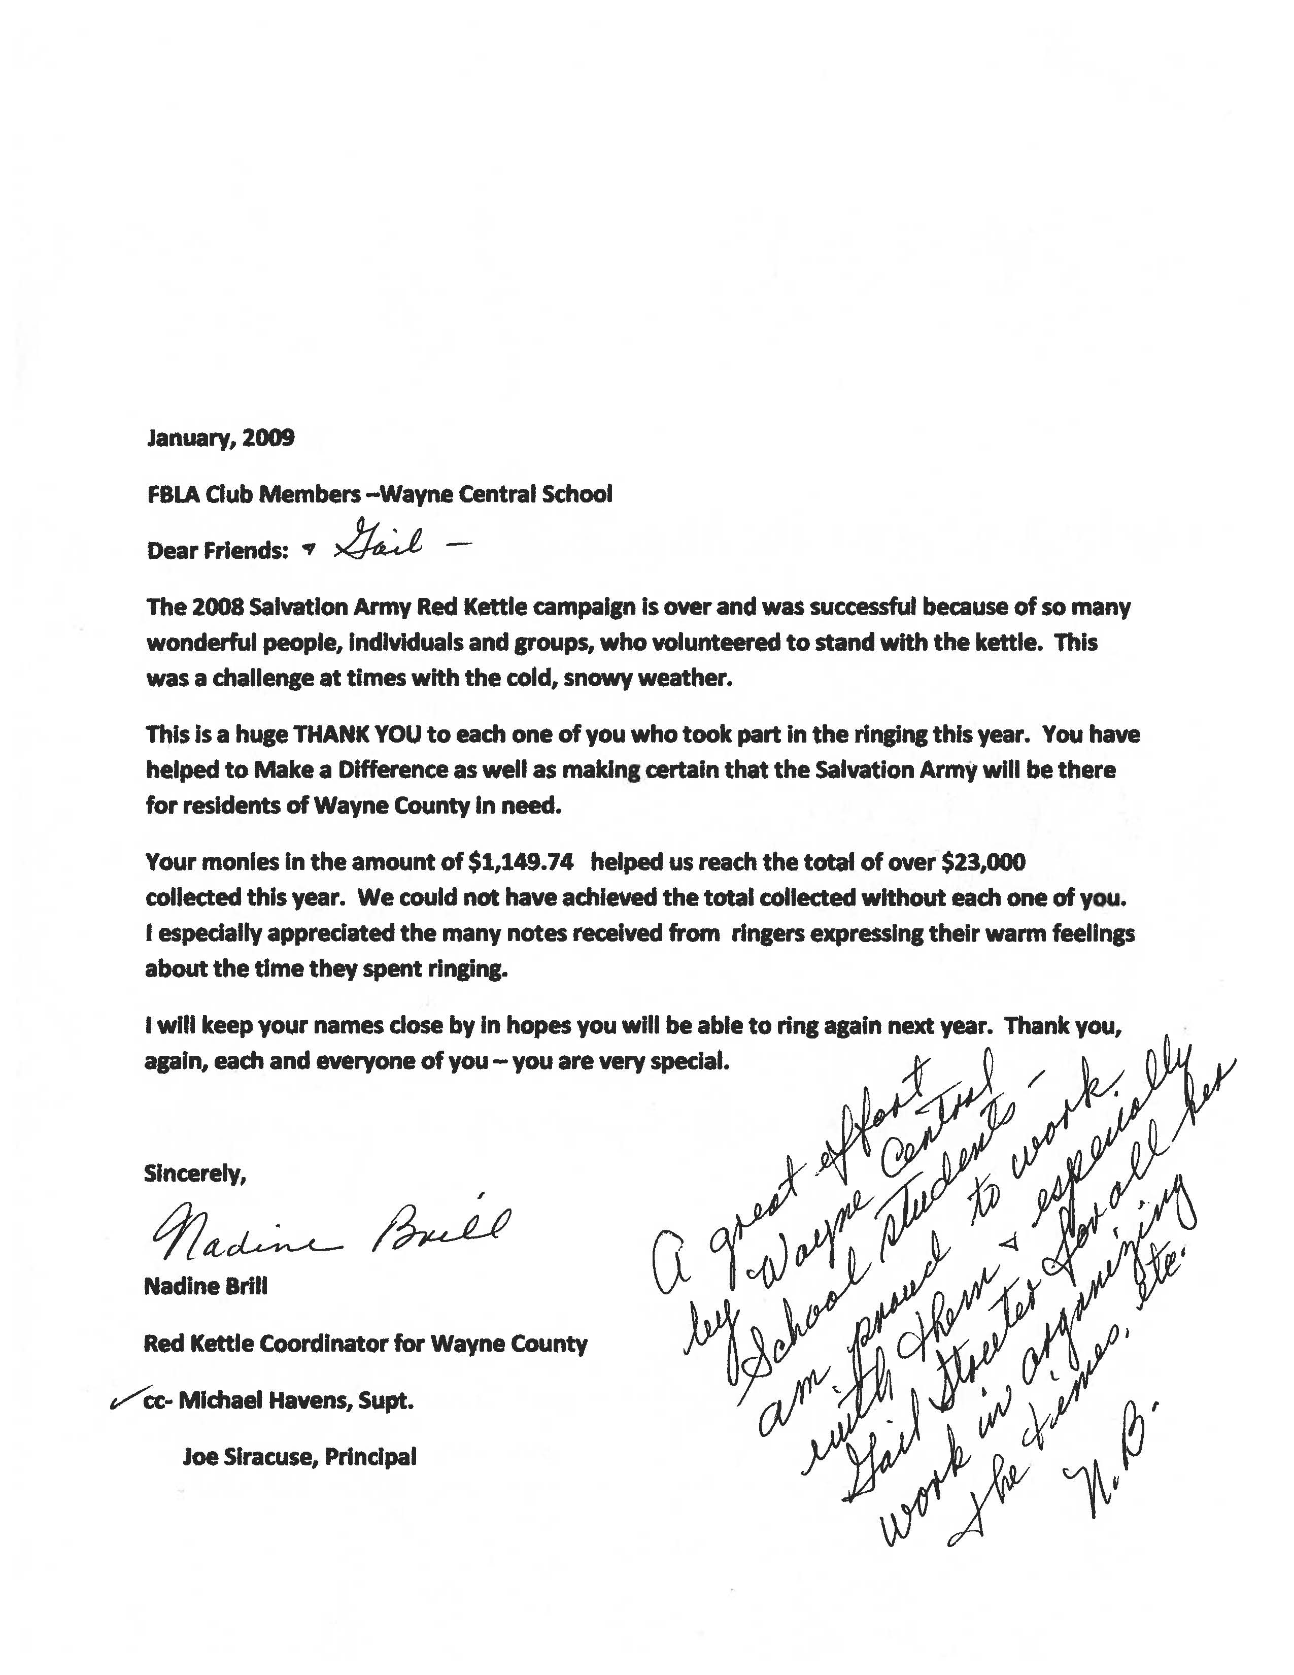
MARCH 9, 2009

ONTARIO TOWN BOARD MEETING AND PUBLIC HEARING

A regular meeting of the Ontario Town Board was called to order by Supervisor Kelsch at 7:00 PM in the Ontario Town Hall. Present were Supervisor Robert Kelsch, Council members: Jason Ruffell, Lori Eaton-Smith, James Switzer and Stephen Tobin, Superintendent of Highways Jerry Santangelo, Building Inspector/Code Enforcement Officer Edward Collins, Water Utilities Distribution Crew Chief Rodney Peets, Accounting Supervisor Lois Buckalew, Sole Assessor Christine Luteyn, Associate Attorney for the Town Amy Reichhart and Deputy Town Clerk Carol Luety.

Absent: Director of Recreation & Parks William Riddell, Library Director Sandra Hylen, and Dog Control Officer Mark Plyter

7 residents and visitors were present at portions of the meeting.

Mr. Ruffell led the Pledge of Allegiance.

The Legal Notice of Public Hearing to consider proposed Local Law No. 1 of 2009 of the Town of Ontario, which would amend Chapter 150 Zoning of the Town Code, was posted on the Town Clerk’s bulletin board and published in the Wayne County Mail on February 26, 2009.

Mr. Kelsch opened a public hearing at 7:03 p.m. to consider proposed Local Law No. 1 of 2009 of the Town of Ontario which would amend Chapter 150 Zoning of the Town Code.

Jason Ruffell gave a brief presentation on the proposed changes being considered to Chapter 150 Zoning including changes with respect to wind energy conversion systems, accessory structures, certain allowable uses and bulk area regulations.

Mr. Ruffell asked for public comments.

Mr. Roger Legg asked how many wind energy collectors would be allowed on 5 acres. Mr. Ruffell will get back to him.

A motion was made by Mr. Switzer, seconded by Mr. Tobin, to close the public hearing at 7:17 p.m. 5 Ayes
0 Nays MOTION CARRIED

Revisions to the Agenda – A motion was made by Mr. Switzer, seconded by Mr. Tobin to approve the agenda with the following revisions- under new business add to #3 a second motion to accept electronic images in lieu of paper copies of cancelled checks, add #5 - a motion to purchase the rolled rubber material from Premier Specialty Flooring, add #6 - a resolution of intent for the town to act as lead agency at Bear Creek Harbor Park. 5 Ayes 0 Nays MOTION CARRIED

Comments from the Public – none

Approval of Minutes - Mr. Kelsch asked for approval of the minutes of the February 23, 2009 Town Board meeting. A motion was made by Mr. Switzer, seconded by Mr. Tobin, to approve the minutes as presented.
5 Ayes 0 Nays MOTION CARRIED

Correspondence – none

Attorney for the Town Report – The DKR tax certiorari case is moving forward and will continue as planned.

Department Head Reports -
Superintendent of Water Utilities – A motion was made by Mr. Switzer, seconded by Mr. Tobin, to accept the February 2009 report as presented. 5 Ayes 0 Nays MOTION CARRIED

Superintendent of Highways – A motion was made by Mr. Kelsch, seconded by Mr. Tobin, to accept the February 2009 report as presented. 5 Ayes 0 Nays MOTION CARRIED

Building Inspector/Code Enforcement Officer – A motion was made by Mr. Ruffell, seconded by Mr. Switzer, to accept the February 2009 report as presented. 5 Ayes 0 Nays MOTION CARRIED

Director of Recreation & Parks – A motion was made by Mrs. Smith, seconded by Mr. Tobin, to accept the February 2009 report as presented. 5 Ayes 0 Nays MOTION CARRIED

Sole Assessor – A motion was made by Mr. Switzer, seconded by Mr. Tobin, to accept the February 2009 report as presented. 5 Ayes 0 Nays MOTION CARRIED

Ontario Public Library - A motion was made by Mrs. Smith, seconded by Mr. Tobin, to accept the February 2009 Library report as presented. 5 Ayes 0 Nays MOTION CARRIED

Ontario Town Court – A motion was made by Mr. Tobin, seconded by Mrs. Smith, to receive the February 2009 report as presented. 5 Ayes 0 Nays MOTION CARRIED

Dog Control Officer – A motion was made by Mrs. Smith, seconded by Mr. Switzer, to accept the February 2009 report as presented. 5 Ayes 0 Nays MOTION CARRIED

Economic Development Department - A motion was made by Mr. Kelsch, seconded by Mr. Switzer,
to accept the February 2009 report as presented. 5 Ayes 0 Nays MOTION CARRIED

New Business – A motion was made by Mr. Switzer, seconded by Mrs. Smith, to authorize William Riddell and Pamela Grundman as official signers for the Community Center petty cash fund. 5 Ayes 0 Nays MOTION CARRIED

A motion was made by Mr. Tobin, seconded by Mrs. Smith, to purchase one HP Computer workstation for the town clerk’s office at state bid contract for an amount not to exceed $796.00 as requested in a memo from Debra DeMinck, Town Clerk. 5 Ayes 0 Nays MOTION CARRIED

A motion was made by Mr. Switzer, seconded by Mr. Ruffell, to accept a notice from Citizen’s Bank that they are no longer going to return cancelled paper checks but send electronic images online or on cd.
5 Ayes 0 Nays MOTION CARRIED

A motion was made by Mr. Switzer, seconded by Mr. Ruffell, to authorize the supervisor and accounting supervisor to accept electronic images in lieu of paper copy cancelled checks as required by regulations from the New York State Comptroller. 5 Ayes 0 Nays MOTION CARRIED

A motion was made by Mr. Ruffell, seconded by Mr. Switzer, to adopt a

RESOLUTION MAKING NEGATIVE DECLARATION
AND ENACTING LOCAL LAW #1 of 2009

WHEREAS, Proposed Local Law No. 1 of 2009 (the “Local Law”) would amend the Zoning Law (the “Zoning Law”) of the Town of Ontario (the “Town”), being Chapter 150 of the Town Code, to make various changes, including changes with respect to wind energy conversion systems, accessory structures, certain allowable uses, and bulk area regulations; and

WHEREAS, the Local Law has been on the desks of all Town Board members since February 25, 2009; and

WHEREAS, an Environmental Assessment Form (“EAF”) was prepared for the Local Law, which the Town Board has reviewed; and

WHEREAS, a full statement of the Local Law, including the EAF, was referred to the Wayne County Planning Board, pursuant to General Municipal Law §239-m, and at its February 25, 2009 meeting, it recommended approval of the Local Law; and

WHEREAS, Notice of a Public Hearing on the Local Law was published in the Wayne County Mail on February 26, 2009, and the Town Clerk also caused a copy of that Notice to be posted on the sign board of the Town maintained pursuant to Town Law §30(6) on February 26, 2009; and

WHEREAS, a public hearing was duly held on the Local Law on March 9, 2009 at 7:00 PM before the Town Board at the Ontario Town Hall, and all persons desiring to speak were heard; and

NOW THEREFORE IT IS RESOLVED THAT the Town Board has considered the Local Law and its potential for environmental impacts; reviewed and considered the EAF, the criteria contained in 6 N.Y.C.R.R. §617.7(c), and other supporting information to identify the relevant areas of environmental concern; and thoroughly analyzed the identified relevant areas of environmental concern to determine if the Local Law may have a significant adverse impact on the environment, and finds that the Local Law would not have a significant impact on the environment, because:
- The amendments will regulate wind energy collectors (formerly referred to in the Zoning Law as “windmills”) so that they will not impact neighboring properties, setting a maximum height restriction of 100 feet and a “fall-zone” radius of 1.5 times the proposed total height, and requiring a detailed site plan.
- The regulations for wind energy collectors, and various other minor adjustments to the Zoning Law included in the Local Law will not result in adverse impacts but rather would generally have a positive impact on aesthetics.
- While the definition of “Utility Sheds” is eliminated, sheds will still be regulated like other accessory structures.
- The amendments clarify that cantilevers may extend into front, rear and side yards by no more than 2 feet, which is de minimis.
- Certain private recreational uses are restricted by generally eliminating private clubs as an allowed use (but adding back in fraternal organizations as an allowed use), and eliminating golf courses as an allowed use in Business (B) and Business Transitional (BT) districts.
- The Local Law will not result in any identified negative environmental impacts, and is consistent with the Comprehensive Plan.

IT IS FURTHER RESOLVED THAT pursuant to the State Environmental Quality Review Act, the Town Board finds that enactment of the Local Law will not have a significant impact on the environment, so that a Negative Declaration shall be made and duly filed, and an environmental impact statement need not be prepared; and

IT IS FURTHER RESOLVED THAT pursuant to the Municipal Home Rule Law, Proposed Local Law No. 1 of 2009 is hereby enacted, and shall be filed with the Secretary of State. 5 Ayes 0 Nays RESOLUTION ADOPTED

A motion was made by Mrs. Smith, seconded by Mr. Tobin, to award the bid for the rolled rubber material needed for the indoor walking track at the Community Center to Premier Specialty Flooring, PO Box 153, East Satauket, NY 11733 as recommended by the Director of Parks & Recreation in memo PR04-2009. 5 Ayes 0 Nays MOTION CARRIED

A motion was made by Mr. Switzer, seconded by Mrs. Smith, to adopt the

RESOLUTION OF INTENT TO ACT AS LEAD AGENCY

WHEREAS, the C.P. Ward, Inc. (the “Contractor”) has proposed a project (the “Action”) to dredge about 585 cubic yards of materials from Bear Creek Harbor in Lake Ontario in the Town of Ontario, adjacent to a concrete boat ramp and sea wall in Bear Creek Harbor Park at 2205 Lake Road in the Town, in order to facilitate the delivery by barge in about June 2009 of 10 prefabricated containment structures that would be delivered to the Ginna Nuclear Power Plant located 1.6 miles to the west; and

WHEREAS, as part of the Action, the Contractor would truck the dredged materials to the Town of Ontario Wastewater Treatment Plant at 2200 Lake Road in the Town, and used to construct a berm on about .6 acres to serve as a noise buffer from that plant for nearby residents; and

WHEREAS, in accordance with the New York State Environmental Quality Review Act (“SEQRA”), and regulations adopted to implement SEQRA, the Town must undertake an environmental review of the Action; and

WHEREAS, the Town Board has reviewed a short environmental assessment form (“EAF”) for the Action prepared by the Contractor to evaluate the significance of potential environmental impacts of the Action;

NOW, THEREFORE, IT IS RESOLVED the Town Board has determined that the proposed Action is an unlisted action, as defined by SEQRA, pursuant to 6 N.Y.C.R.R. §617.2(ak); and it is further

RESOLVED, that the Town Board accepts the EAF; and it is further

RESOLVED, that the Town intends to undertake coordinated review, and act as lead agency for the SEQRA review of the Action, pursuant to 6 N.Y.C.R.R. §617.6(b)(3); and it is further

RESOLVED, that the Town shall furnish all other involved agencies with a copy of the EAF and notified by the Town of its intent to be designated as lead agency for the SEQRA review of the Action, and be given thirty (30) calendar days to consent to or object to that designation. 5 Ayes 0 Nays RESOLUTION ADOPTED

Appointments/Resignations –A motion was made by Mr. Switzer, seconded by Mr. Tobin, to accept Shannon Macartney’s resignation from the position of part time clerk in the town clerk’s office effective March 9, 2009 as requested in a memo dated March 9, 2009 and to authorize the Town Clerk to post and advertise the part time clerk position. 5 Ayes 0 Nays MOTION CARRIED

Reports by Town Board Members – Mrs. Smith announced that Mrs. Lois Mooney is resigning from the Library Board of Trustees and on behalf of the town, thank her for her service to the town. The grand opening for the community center will be April 4, 2009 with details to follow.

Mr. Kelsch reported that the policy handbook is almost complete. Every department will have a copy of the book and the official copy will be on file in the Town Clerk’s office.

Mr. Switzer announced that the Residential Assessment Ratio for the Town of Ontario is 100% and much thanks to the assessing department for all of their hard work.

Approval of Claims - A motion was made by Mr. Switzer, seconded by Mr. Tobin, to approve the abstract of claims for March 9, 2009, including vouchers #524 through #656 for a grand total of $837,474.25 and to authorize the Supervisor to issue payments for same. 5 Ayes 0 Nays MOTION CARRIED

Comments from the Public – none

Adjourn - A motion was made by Mr. Switzer, seconded by Mr. Tobin, to adjourn at 8:20 p.m. 5 Ayes 0 Nays MOTION CARRIED

Respectfully submitted,

Carol L. Luety
Ontario Deputy Town Clerk

The above minutes will become official upon approval of the town board.

