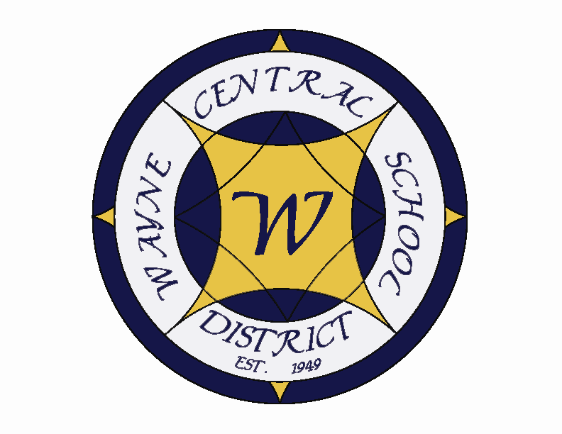
Letter to the Board

Michael Havens
Superintendent of Schools
Phone: 315-524-1001 Fax: 315-524-1049 mhavens@wayne.k12.ny.us

March 6, 2009

“Hope is a Waking Dream.” Aristotle, Greek Philosopher

Board Agenda

- Executive Session: There will be an executive session to discuss the results of the Hackett investigation. My report will be dropped off at your house ahead of time so that you will have an opportunity to review it thoroughly. If you have any specific questions that you would like answered before the board meeting, please do not hesitate to contact me.

- State Wrestling Champions: Mr. Blankenberg has invited the wrestlers who participated in the NYS Championship to be recognized for their accomplishments. The Coaches are Ron Gross and Ted Hargarther. Our exceptional student athletes are as follows: Vincent DiGravio – NYS Division I 130 lb State Champion, Bobby Dierna – NYS Division I 112 lb 3rd place finisher, Alec Dierna – NYS Division I 96 lb State Qualifier, Chris Marvin – NYS Division I 160 lb State Qualifier.

- Academic Report: Mrs. Cox will present the mid-year academic report through a powerpoint presentation.

- Adminstrative Budget: Mr. Atseff will be presenting the proposed administrative portion of the budget for board review and discussion. This represents the final piece of the budget. The budget is up .2% this year. This is the smallest increase in the past 10 years. At our second march meeting Mr. Atseff will present revenues and tie the entire budget together.

- Financial Report: Mr. Atseff will provide his monthly financial report.

- Student Representative: The student representative for this meeting is senior Terrah DeVito. Terrah is active is Student Council, is the treasurer of National Honor Society, plays varsity soccer, basketball and track, is a member of Rotary Interact Club.

Board Letter

- HS vs. MS Faculty Basketball Game: Trash talk reigned this week as the HS faculty vs. MS faculty basketball game geared up… however, the HS reigned superior, and is gaining redemption after several years of suffering at the hands of the MS.

- March 6 Conference Day: We had a very successful staff training day today. Several presenters worked with different areas to continue our efforts to be New York State’s finest school. Mrs. Cox did a great job in our opening session presenting our student achievement rates, which we are very proud of. It is always good to remind staff of what they are accomplishing, because it is easy to lose sight of it in the day to day work.

- HS Musical: Don’t forget the HS musical next weekend. It is sure to be a great show.

- Constellation Meeting: I told you last week I had a meeting with Ed Stoltz from Constellation. This Friday we had a conference call on the town, county and district’s position on the direction of the Ginna negotiations. The town and school both agreed that a non-court settlement would benefit all parties. Pending the county’s agreement, we plan to put an offer on the table where our current assessment of 5.1 million additional assessment for the new improvements on the Ginna property would be added to the 260 million dollar pilot agreement. This assessment would stand for the life of the pilot agreement (2013 or 2014 – there was question on the exact date) regardless of any changes made at the Ginna properties. Supervisor Kelsch will discuss this with the plant manager, John Calvin who will propose this to Ed Stoltz at headquarters in Maryland. If all goes well, a meeting with the attorneys and our officials will occur to hash out the details of the amendment to the pilot. I truly believe this is a win-win for the school, town and county. Legal battles can rage on for tremendously long periods of time, cost many thousands of dollars, and I very much believe, that this is a situation where the opinions can truly vary on worth and what is and is not part of the original pilot agreement.

- Parent/Teacher Conference Days: We have been asked a few times if the April Conference Days are for grades K-8 or K-12. So, for clarification, they are district wide (grades K-12).

- Student Injury: On Tuesday afternoon, a HS senior was watching a movie in class which had some scenes that had some blood. This (male) student has a very low tolerance to this, and excused himself to the bathroom. Unknown to the teacher and his classmates, he was feeling faint from the scene, and he passed out in the bathroom. On the way down, he hit a bathroom structure and received a serious contusion. An ambulance was called and he was taken to the hospital. He was kept overnight due to the injury and complications from it. He is home now being monitored.

- Assemblyman Oaks Visit: Thursday evening Assemblyman Oaks visited our school to discuss the state budget situation. We had a good turnout, although there was nothing new to report.

- Donkey Basketball: I think many of our board members attended the Donkey basketball game last Saturday evening. I realize that it is rather unique to Wayne Central, but I see that it is a community favorite. The auditorium was packed, and tickets were sold out, and there were about 100 kids that participated in riding the donkeys. That is saying quite a lot, considering the senior class is around 230. It is always more comedy than athletics, and provides great school spirit.

- Upcoming Events:
3/8 – Daylight Savings Time – turn clocks ahead one hour
3/9 – HS Parent Group Meeting – HS Faculty Room – 7:00 p.m.
3/10 – TCA Friends of Music Meeting – MS Conference Room – 6:30 p.m.
3/10 & 12 – Driver Improvement Class – HS Room 13D – 6:00 p.m.
3/10 – OP/OE PTA Meeting @ OE Cafeteria – 3:45 p.m.
3/10 & 11 – NYS Grades 6-6 Math Exams
3/11 – HS Musical “Thoroughly Modern Milly” Senior Citizens Matinee & Dinner – 4:00 p.m.
3/12 – MS Foreign Language Dessert Night @ MS Cafteria – 7:00 p.m.
3/12 – Board of Education meeting @ DO – 6:00 p.m.
3/13 – HS Musical “Thoroughly Modern Milly” @ PAC – 7:00 p.m.
3/14 – HS Musical “Thoroughly Modern Milly” @ PAC – 2:00 & 7:00 p.m.

- Attachments:

a) Policy Committee Meeting Minutes – 2/24

POLICY COMMITTEE MINUTES

DATE: Tuesday, February 24, 2009 TIME: 4:00 p.m. PLACE: District Office

COMMITTEE MEMBERS: Mrs. Newman, Mr. Paz, Mr. Havens, Mr. Atseff, Mr. Switzer

PRIOR MEETING MINUTES: Minutes of the meeting of February 3, 2009 were filed as presented.

OLD BUSINESS:

- Annual Review – 50% of Handbook - Section 7000 (Students): Mr. Paz presented the remaining portions of this section for review by the committee to complete the discussion from the prior committee meeting. No major revisions were cited.

- Review of Required Annual Review of Existing Policies: Tabled

1410 Annual Review of Policy Handbook (Mr. Triou)
3410 Code of Public Conduct on School Property (Policy and Regulations) (Mr. Triou)

- Review of Required Annual Review of Existing Regulations: Tabled

3410 Public Conduct on School Property (Mr. Triou)
3420 Sexual Harassment & Discrimination (Mr. Triou)
NEW BUSINESS:

- Referral from Safety Committee – Use of Personal Appliances in Classrooms & School Facilities – New Policy 5673: Committee members reviewed a draft of a proposed new policy 5673 to address this topic referred from discussion at the Board of Education meeting of February 12th. The proposed text was approved for first reading by the Board of Education on March 12th.

- Proposed Revisions – Existing Exhibits - Affidavits for Residency: Committee members reviewed proposed revisions of Exhibits 7120-E-1, E-2 & E-3 to include a disclaimer statement on submission of false information related to residency and guardianship and approved updated of these documents on an administrative basis. (copies filed in committee minute book for this meeting)

- Review of Proposed Items for the Board of Education meeting of March 12th: Committee members reviewed the policy items submitted for first reading on February 12th, cited below, and noted there were no revisions. The items were approved for second reading by the Board of Education on March 12th.

1313 Policy Annual Re-Organizational Meeting of the Board of Education (Re: Mileage Reimbursement)
1350 Bylaws Appointment & Duties – Internal Claims Auditor
1500 Policy Notice & Agenda for Board of Education Meetings (Re: Protocol)
5511 Policy Audit Committee – Charter
5760 Policy Operation & Use of School Busses
6160 Policy Use of Alcohol, Drugs & Substances in the Workplace

- 50% Handbook Review – Section 8000 (Instruction): Mr. Havens will present this chapter on March 24th.

NEXT MEETINGS: District Office @ 4:00 p.m. on Tuesdays, March 10th & 24th

ADJOURNMENT: 5:00 p.m. Recorded By Jim Switzer
JES/jes:wp
NEXT & FUTURE MEETING AGENDA ITEMS: DO NEW
• Follow-Up: Second Reading – Revisions - Section 5000 - Non-Instructional/Business Operations
● Follow-Up: Second Reading – Revisions - Bylaws – 1350 - Appointment & Duties – Internal Claims Auditor
● Follow-Up: Second Reading – Revisions - Policy 5511 – Audit Committee - Charter
● Follow-Up: Second Reading – Revisions - Policy 1500 – Meeting Agenda & Format (Protocol)
● Follow-Up: Second Reading – Revisions - Policy 1313 - Annual Reorganizational Meeting (IRS Mileage Rates)
● Follow-Up: Second Reading – Revisions - Policy 5760 – Qualifications of Bus Drivers/Operation & Use of School Busses
● Follow-Up: First Reading – New Policy 5673 - Use of Personal Appliances in Classrooms & School Facilities
● Review of: Tabled Items, Noted Above

