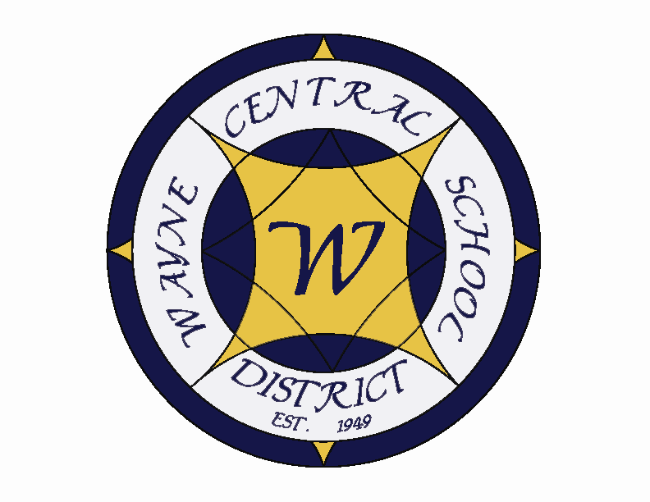
Letter to the Board

Michael Havens
Superintendent of Schools
Phone: 315-524-1001 Fax: 315-524-1049 mhavens@wayne.k12.ny.us

February 13, 2009

- Board Goal: I’ve listed below a draft charge to me (from you) on the Board goal of developing a plan for implementing elementary foreign language. Please review it and suggest any modifications. We will discuss it at our next Board meeting.

Board Elementary Foreign Language Goal

Develop a plan for the successful implementation of an elementary foreign language program. The plan will contain at least the following components;

- Program organization: Present at least two structures for delivering the program. Develop each structure in sufficient detail to make decisions about the other listed components.
- Research: Include published research as well as visits to benchmarking districts. Answers to questions in each of the other components may be at least partially answered through this research.
- Timeline: Begin with the acceptance of the plan and extend through the first classes’ high school career.
- Costs: Set up, implementation and sustaining expenses should be outlined. Include any savings that may be realized in other programs.
- Implications: Every change has positive and negative consequences. Apparent and unintended financial, educational and political consequences should be explored.
- Staffing: Discuss how much will be needed and how the staff will be organized over time. Also include the probable effect on other staff.
- Long term instructional changes: Consider what happens when these students reach middle school and high school. Include changes that will be necessary and possible in order for students to continue their studies.

The plan will be presented to the Board of Education for their review at their June 2009 meeting.

- March 21 Legislative Breakfast: Last night Joyce encouraged you to attend this breakfast. If you call Lori (524-1001) she can register you. It would be nice to have a good turn out for this event.

- Eduspeak: Last night, at the Board meeting, I heard the following terms; differentiated instruction, ELA, performance benchmarks, GAPP, Pedagogy, learning stations, co-teach, ESL (pronounced ess.il), reading camp, Powerschool, RTI, Bridge program, electronic management system, unencumbered and accrued. Some terms may be quite familiar to you. Others are probably a puzzle. I even get confused with some. I’ve decided to put together a little dictionary of these terms, some of which are Wayne specific, to help with presentations. If you hear a strange term during one of the next few meetings, send me an email and I’ll include it.

- Ginna Drill: We held our annual Ginna drill this morning. Evacuation times for each building are listed below. We measure evacuation times from when I say to Lori, “this is a Ginna drill”, through notifying buildings, calling bus drivers in, and loading buses to the time we receive a call from the building that it is all clear. We believe these were our best times ever district wide, and one of our smoothest overall.
High School: 49 minutes
Middle School: 47 minutes
Freewill: 50 minutes
OE: 41 minutes
OP: 31 minutes

5. Second Quarter: We have the second quarter numbers for the honor roll. Just under 50% (49.94 %) of our students made the honor roll (high honor, honor or merit). Of that, 6.39% made the high honor roll, 23.34% made honor roll and 20.21% made the merit roll. I am attaching the breakdowns. As you heard last night our Freshman class is our highest achieving class, which I think we can attribute to the value of the Freshman Academy structure.

- Next week’s Letter: I will be away next week, visiting the Carolinas so there will not be a Board letter. I will have my cell phone with me in case you need to get a hold of me.

- NYSSBA Annual Convention: I have received the notification on the Annual Convention. It is again being held in NYC. The date is October 16-17, 2009. I am sharing the date early in case anyone wishes to plan ahead

- Daytona 500: A former Wayne Central student and United States Marine Corp. member Derrick Ciani will again this year be holding the American flag on the in-field for the pre-race ceremonies at the Daytona 500 representing the United States Marine Corp. We are not sure if he will appear on TV, but for those interested, if you are watching I thought you could keep an eye out for him. He is currently stationed in Georgia, and will soon be deployed overseas.

- Upcoming Events:
2/16 – President’s Day – Schools Closed
2/16 – 2/20 – Winter Recess
2/25 – National Junior Honor Society Induction @ PAC – 7:00 p.m.
2/27 – Elementary All County @ Gananda
2/28 – Donkey Basketball Game @ HS Gym – 7:00 p.m.

Athletic Events:
2/13 – Boys V Section V Wrestling Championship @ Wayne – 4:00 p.m.
2/14- Boys V Section V Wrestling Championship @ Wayne – 10:00 a.m.
2/17 – Girls JV Basketball vs. Pal-Mac – 11:00 a.m.
Sectional Play - TBD

- Attachments:
a) Merit Roll List

