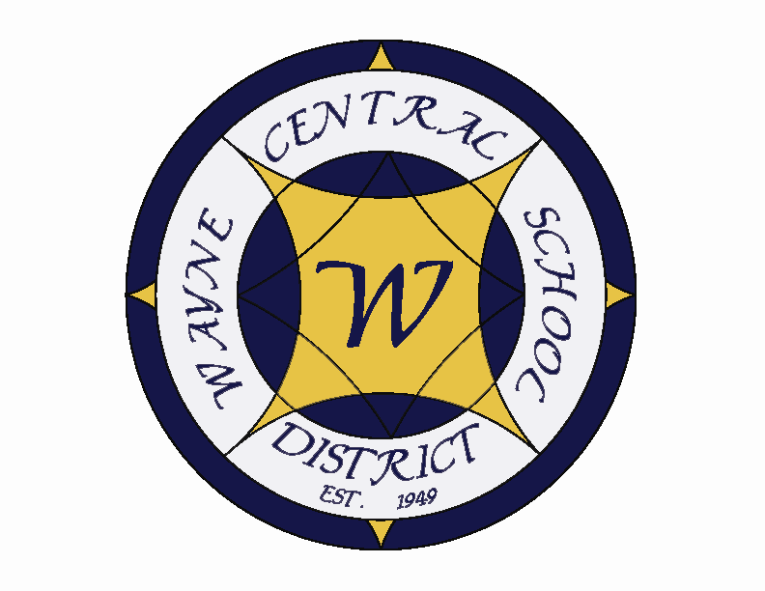
Letter to the Board

Michael Havens
Superintendent of Schools
Phone: 315-524-1001 Fax: 315-524-1049 mhavens@wayne.k12.ny.us

January 16, 2009

Board Agenda

- Tour of Middle School: Mr. Armocida will be leading the middle school tour at 6:30 p.m. starting from the media center.

- Budget Presentation: Mr. Atseff will be presenting the capital portion of the proposed budget. This is the

- Board Goal: The Board will decide on which of the goals it wishes to choose, base on the + and – charts from December.

- CSEA Contract Discussion: Mark Callahan, Greg Atseff and I were approached by the CSEA Labor Management team regarding a contract extension. They are pleased with the terms of the current contract, and believed the union members were as well. They asked if the district would be agreeable to a 2 year contract extension and allowing the CSEA to vote. This occurred on Thursday, 1/15. The vote passed XX to XX. I am asking the board to ratify the contract extension in the consensus portion of this meeting.

- Financial Report: Mr. Atseff will provide his monthly financial update to the board.

- Student Representative: Dom Maimone is a ….

- Board Action: We will have a short personnel action and CPSE action. Business items include accepting the November treasurers report, adopting the new IRS mileage rate (which is a reduction from last year), accept a gift to the district of $500 from the stop DWI program, award BOCES bid for electric supply participation and the surplus bus bid, approve a resolution for 403B plan participation, and approve budget transfers as listed. Also included for board approval is the formal acceptance of both audit reports that you reviewed at the December meeting. The last item is the CSEA contract which will be discussed under Superintendent’s Reports. I believe this contract extension is the right decision for both our support staff and our board, which reflects the level of confidence each has with the other. It also avoids the whole time consuming process of negotiations, which, I believe, benefits both organizations. I recommend approval of these requests.

- Policy: Several policies are presented for first and single readings of the board.

Board Letter

1. State Budget Update:

2. Facilities Update:

3. NYSSBA Trainings: There are several audit training sessions coming up if anyone is interested. I am attaching the brochure. If you wish to attend, please let Lori know as she can complete the registration.

3. XXX:

- Upcoming Events:
1/19 – Martin Luther King, Jr. Holiday – Schools Closed
1/21 & 23 – NYS ELA Testing – Grades 6-8
1/22 – Board of Education Meeting @ District Office – 7:00 p.m.
1/23 – Freewill Family Night
1/29 – Four County Meeting – President’s/Vice pres. @ WFL Boces
2/6 – Ontario Parks & Recreation “Comics On The Rocks” – Carey Lake – 7:00 p.m.
2/7 – Ontario Parks & Recreation “WinterFest” @ Casey Park – Noon – 4:00 p.m.
2/7 – Ontario Parks & Recreation Chicken BBQ – 3:30 p.m.

Athletic Events:
1/20 – Boys Freshman BB vs. Geneva – 4:15 p.m.
1/21 – Girls JV & V BB vs. Geneva – 6:00 & 7:30 p.m.
1/22 – Boys JV & V Wrestling vs. Newark – 6:00 & 7:00 p.m.
1/23 – Boys Freshman BB vs. Penn Yan – 4:15 p.m.
1/23 – Girls JV & V BB vs. Penn Yan – 6:00 & 7:30 p.m.
1/24 – SAT Exams

5. Attachments:
  - NYSSBA Audit Workshop

