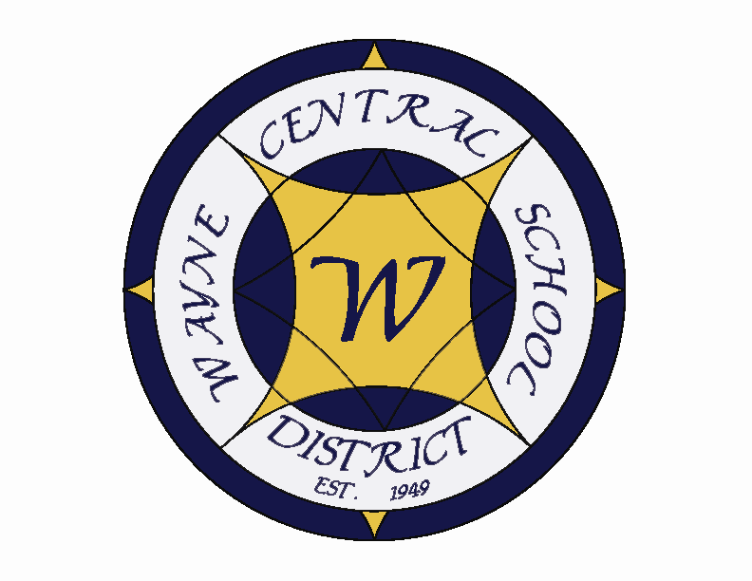
Letter to the Board

Michael Havens
Superintendent of Schools
Phone: 315-524-1001 Fax: 315-524-1049 mhavens@wayne.k12.ny.us

December 5, 2008

"We are rich only through what we give, and poor only through what we refuse."

--Anne-Sophie Swetchine,Russian-French writer

Board Agenda

1. Tour of High School: This month it is the high school's turn to be toured. We will meet in the Board room for a tour of the facilities at 6:00 p.m. Mr. Siracuse has arranged to have National Honor Society students lead the tour.

2. Executive Session: We have three things to discuss in executive session at 6:30. First, I would like to discuss extending the CSEA contract for two additional years. The current contract would then be good through June 30, 2012. If the Board is agreeable the CSEA leadership would bring the idea to their membership for consideration. The salary increase would continue at .65 per hour or 3.5%. The teachers’ increases are 4.25 and 4.0% as is the distractive unit. I think extending the CSEA contract would be a good thing for us to do. It keeps the good relationship we have established going. There won't be any of the tension that comes with negotiating a contract. It puts their negotiation on hold until after the teachers' contract comes due. Lastly, it protects them from the pressures to make concessions that they would certainly face if we began our negotiations with them. I know this sounds like a backwards position for me to take. The economic situation in the state and the country makes it an excellent time to squeeze concessions out of this group. The truth is that I believe this group needs protection rather than to be squeezed. They are our lowest paid group. We still have custodians leave the school district to go work for the Town for more money. In the last negotiations this group agreed to reduce their insurance to Blue Point II with a $20 co-pay. This was a great concession for them to make, which has really helped us. If there are further concessions to be made, I rather we begin with the higher paid teachers or administrators. Our CSEA are hard working people who live in this community and appeared very excited to think we would consider doing this. I'd like to talk to you about this and see whether you would like to proceed down this path.

The second item is the current economic situation and how we plan to address it. While the mid-year cuts are dead, it does not look as if the next two-three years will be healthy. I want to share how your administrative team has been preparing to meet this challenge. Because some of this preparation involves specific personnel, we need to address it in executive session.

Lastly, you will be voting on Mr. Siracuse's tenure. I have given you annual updates on how he is doing and I am recommending him for tenure. I am very proud how your high school has become under his leadership. This will be another opportunity for you to express any thoughts or concerns prior to public consideration.

3. Liquid Propane Bus Purchase: As a first move in our transportation department, we are looking to purchase two LPG buses in next year's budget. These are ultra low emissions meeting even the 2012 emissions without use of a catalytic converter. Propane vehicles are the largest alternative fuel powered vehicles in the world. Mr. Prince also estimates they will be 14 cents cheaper per mile to operate. Mr. Prince will present information to you about these vehicles.

4. High School Improvement Plan: You have already heard from the elementary, middle school and facilities about their annual goals. You will hear from our final group, the high school where they will discuss their plans.

5. Board Goals: This is a continuation of the Board summer and fall meetings. During the fall meeting the Board asked us to developed a list of positives and negatives for areas you were considering as your goal. We were to bring that information to the December meeting so that you could select the goal for consideration of inclusion in the annual district goals. Information on the three areas, Develop a long term website strategy, Implement elementary foreign language, or Implement a homework help line, are attached. I asked that you read through the positives and negatives of each. We will highlight them at the meeting and have a Board discussion about selecting the final one.

6. Budget Calendar: It is time for Mr. Atseff to discuss the dates for development of next year's budget. That tentative calendar is attached for your consideration

7. Audit update: The auditors have been here for three weeks. On Thursday they completed their overall audit. Tammy, the lead auditor, came in and told me that we get a gold star and that if the next step goes as well she will be making an apple pie for us. This next step will be to pick one of the areas they did a general audit of, and complete a more in depth study. That area is generally the one that appeared to provide the greatest risk based on the general audit. Hopefully things will continue to go well.

8. Financial Report: Mr. Atseff will present our monthly financial update.

9. Board Action: We have personnel action and the October Treasurer’s report. Please note that we are voting on Mr. Siracuse's tenure. There are 3 audit reports from Ray Wager: the single audit report, extra-classroom and general fund with the management letter. Please let Lori know if you have difficultly accessing these documents. We will have the hard copies for you at the Board meeting for your convenience. We also have a budget transfer from the reserve account, the budget calendar as discussed earlier and the declaration of surplus busses. One last item is the request to pass two resolutions to participate in applying for a grant which would study the feasibility of developing regional high schools for Wayne County. I recommend approval of all items as submitted.

Board Letter

1. Fire Alarm at HS: the fire department responded to a fire alarm at the high school which was inadvertently set off in a gym class by a student with a ball that hit the alarm and triggered it. (even though it was protected in one of those cages). Fortunately, the response was quite quick and students were not outside too long on a chilly day.

- County Superintendents: I hosted a meeting with a few of our county superintendents in order to prepare a position paper for our legislature on mandate relief. I will send you a copy when we finish it.

3. YAP Visit: This week I visited the Auburn prison with 8 students as part of the YAP program. You will recall that Trooper Chapman presented this program to you a few months ago. I believe everyone found it to be a worthwhile and enlightening visit. Our SRO will begin following up with the students and forming a YAP group.

4. NHS Induction: We had a very nice NHS induction ceremony this past Tuesday. Congratulations to Scott and Jeff, both of whom had their daughters inducted. Many thanks to the Julie Schwartz and Kelly Gallup for serving as Advisors to the club.

5. Upcoming Events:
12/6 – “Spirit of the Season” Holiday Community Benefit show at PAC – 7:00 p.m.
12/8 – TCA Friends of Music Meeting @ MS Conference Room – 7:00 p.m.
12/9 – FE Band & Chorus Concert @ PAC – 7:00 p.m.
12/10 – MS Chorus Concert @ PAC – 7:00 p.m.
12/11 – Board of Education Meeting @ DO – 7:00 p.m.
12/15 – HS Band & Chorus Concert @ PAC – 7:00 p.m.
12/16 – OE Band & Chorus Concert @ PAC – 7:00 p.m.
12/17 – MS Band & Chorus Concert @ PAC – 7:00 p.m.

Athletic Events:
12/9 – Boys JV & V BB vs. Geneva – 6:00 & 7:30
12/12 – Boys Freshman BB vs. Mynderse - 4:15
12/12 – Girls JV & V BB vs. Mynderse – 6:00 & 7:30
12/16 – Boys JV & V BB vs. Canandaigua – 6:00 & 7:30
12/19 – Boys Freshman BB vs. Newark - 4:15
12/19 – Girls JV & V BB vs. Newark – 6:00 & 7:30

