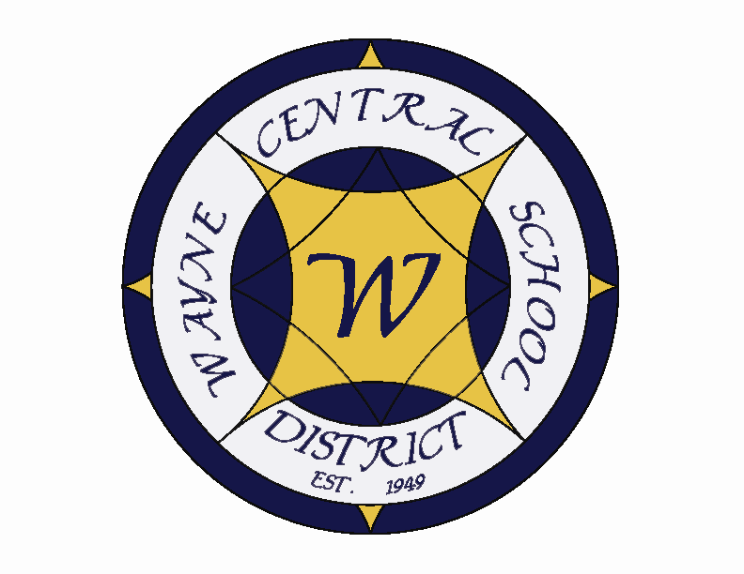
Letter to the Board

Michael Havens
Superintendent of Schools
Phone: 315-524-1001 Fax: 315-524-1049 mhavens@wayne.k12.ny.us

November 7, 2008

"Enthusiasm moves the world." --Arthur James Balfour,former British prime minister

Board Agenda:

- Tour: Mrs. Wright will lead the tour starting at 6:30. You should plan to meet in the Freewill Library where the board meeting will be held (I actually am not certain if this is where the board meeting is being held or in the cafetorium)

- Executive Session: do you need one?

- Musical Presentation: Freewill band director, Mr. Walker??? Has asked for an opportunity to allow his students to perform for the board again this year. (Mrs. Wright has asked your pleasure – would you like them to perform for a brief time at the beginning of the board meeting or would you rather have them perform exclusively for the board during the tour, in the band room?)…. If you want them in the band room, you will need to correct the agenda

- NYS Comptroller’s Audit: The auditors arrived on Thursday. We are making them as comfortable as possible in our conference room since they plan to be here for the next 1-2 months. ????

- Budget Planning: Don’t know what to say here.

- Facilities/Financial Improvement Plan: We will be presenting a powerpoint for this, but felt it would be better to not attempt to send this one out in advance…..?

- Financial Report: Mr. Atseff will provide his monthly financial reports.

- Student Representative: per schedule sent to me by HS, no student rep is designated for this meeting.

- Board Action: We have our typical personnel and CSE/CPSE, both of which are very light. We also have the September Treasurer’s Report, a budget transfer and 2 bids regarding fuel matters for action. I recommend approval of all items as presented.

Board Letter

- Retired Board members: As you will recall, the board wanted to recognize our past board members for their contributions over the years. This Saturday evening all past board members have been invited to come tour the high school and attend an evening of entertainment at the HS drama club’s Cabaret. Amy has made certificates and has little goody bags to go along with them. Unfortunately, I will be in Pennsylvania visiting my daughter so I will be unable to attend.

- CDEP memo: ??? (I received this memo from Kim with a note saying it was for the board letter…. )

- January Regents Dates: We have found an error in our school calendar. We show the regents dates running from January 26th through January 29, and NYS Regents dates are actually January 27th through January 30 (one day later to start and one day later to end).

- XXX

- Veteran’s Day Holiday: Just a reminder that the schools and the offices will be closed next Tuesday to honor the veteran’s day holiday.

- XXX

- XXX

- Upcoming Dates:

11/7 & 8 – Jr. High Area All State @ Pittsford Sutherland
11/10 – Dollars for Scholars Phone –A-Thon
11/10 – County/School Tax Discussion
11/10 – HS PTSA Mtg @ Faculty Room – 7:00 p.m.
11/11 – School’s Closed – Veteran’s Day
11/12 & 13– Grade 5 NYS Social Studies Exam
11/13 – Board of Education Meeting
11/14 – FE Family Night
11/14 – Parent Teacher Conferences – Grades K-12
11/15 – HS Drama Club “Cabaret” @ PAC – 7:00 p.m.

13. Attachments:
A) CDEP memo
Tot Spot Email
Safety Committee Meeting Minutes – 10/28
Four County Meeting Notice – November 24
WFL BOCES Newsletter “Board to Board”- October

Wayne Central School District
Office of the Superintendent of Schools

Memorandum

TO: Board of Education
FROM: Kim Cox
RE: The Comprehensive District Education Plan
DATE: 11/7/08

The Comprehensive District Education Plan (CDEP) team met on 8/21/08 and made two minor revisions to the shared decision making structure and plan for the district. The team also approved minor adjustments to the Professional Development Plan. (PDP). 2009 will end our district CDEP plan and will call for resubmission of our instructional plans, including, Professional Development, English as a Second Language, Physical Education, Academic Intervention, Annual Professional Performance Review, along with our Annual School Improvement Plan. Each of these plans will be completed or revised through the 2008-2009 school year and will be presented to the board for approval during the 2008-2009 school year.

I recommend that you approve these revisions to the Wayne Central School District’s Comprehensive District Education plan.

Should you have any further questions, please feel free to contact me.

These changes are minor and outlined below;

 | Changes |  |  | Previously
Shared Decision Making | Team meetings were expanded to include members of the Professional development team and the Wayne Central teacher resource board. community. This allowed for a more comprehensive discussion of the data and the professional development needed to target areas of need. |  |  | CDEP met independently of the other two teams and sent recommendations for professional development.
Professional Development Plan | Made the focus for the 2008-2009 professional development days, “Differentiated instruction” and “Looking at Student work” |  |  | These activities were to be accomplished at the building level.



WCSD Employee's;

I would like to take a moment to extend a thank you to all of you from all of The Tot Spot employees.The teachers are so grateful for all your help during our fire drills and the children had a GREAT time attending the recent assembly. The weather could not have been any more perfect for the Halloween parade in which The Tot Spot was invited as well. The children were so excited to show off their costumes.

Speaking of great news and welcoming, The Tot Spot would like to extend openings to your friends and family members as well. Please feel free to pass on our phone number 315-524-1139 to schedule a tour.

Thank you,
Stacy Bills
The Tot Spot 1 Site Director
TO: Safety Committee Members:
Chris Shaffer - Committee Co-Chairperson (MS Asst. Principal)
Fred Prince - Transportation
Maureen Doyle – MS PE
Tom Lucieer – OE Maintenance
Mark Callahan - DO Administration
Lori Sensenbach – OP SCRIP
Pamela Buddendeck– FE Instructional
Rob Chapman – SRO
Jacquie Brunner - School Board Rep.
Pat Griswold – OE Nurse
Riley Wheaton – HS Science

FROM: Bob Miller – Committee Co-Chairperson (Dir. of Facilities)
RE: Meeting Minutes
DATE: October 28, 2008

Old Business

Bob LaRuche has submitted a request to have a camera system installed, along with the doorbell, to monitor the handicapped entrance at the south end of Ontario Primary School.

The structural inspection was performed on October 21st. There were just a few minor items noted that will be repaired by the maintenance department.

New Business

There was a fire alarm pulled at OE by a Head Start student. The staff and students made an orderly evacuation to OP because of the rainy weather and after the fire department responded, the staff and students returned to OE.

I attended the October BOCES health and safety meeting. Some of the items that we discussed were:
- Asbestos in pour-in vermiculite insulation
- Bird Flu confirmed in Tyson chickens in Arkansas
- West Nile Virus confirmation in a hawk in Livingston County

We had a fire alarm in the PAC on October 21st at 1:00am. I discovered that a mechanical contractor who was working for the district had left the electronic valve open, causing the HVAC unit to overheat. The problem was corrected the following day.

There was some vandalism, using spray paint, around the high school track area. After an investigation, the persons responsible for the damage were identified. The maintenance staff was able to clean off most of the paint without leaving any permanent damage.

Next meeting will be held on Tuesday December 9th at 8:00am.

Four County School Boards Association
131 Drumlin Court
Newark, NY 14513
315/332-7294
315/332-7474 FAX
Email: 4countysba@edutech.org
Sharon A. Sweeney
Executive Director

GENERAL MEMBERSHIP MEETING

Monday, November 24, 2008
Club 86, Avenue E, Geneva, NY

5:30 – Registration/Conversation 5:45 - Board of Directors’ Meeting
6:30 – Dinner 7:30 – Program

“ARE YOU SMARTER THAN THE AVERAGE BOARD MEMBER?”
Facilitated by
Barry Entwistle
Director of Leadership Development, New York State School Boards Association
with use of
The Audience Response System
Courtesy of Reese Davis and Excellus Blue Cross/Blue Shield

Test your knowledge and experience against that of your Four County colleagues and the experts! We will explore the role and responsibilities of the board vs. those of the superintendent! Help us to identify the difference between oversight and accountability and micro management? Is it always clear or are there gray areas? Barry Entwistle, who is also a former board of education member, will pose the questions while audience members test their answers through the popular format of the audience response process. Thanks to Reese Davis, former Four County president and retired Director of Education for BCBS, for borrowing the system and his time to program and run it.

Join us for this interactive program - And for the Board of Directors’ Meeting at 5:45.

(This notice has been sent to all Four County board members, superintendents, board clerks and secretaries.)
Four County School Boards Association
General Membership Meeting
Monday, November 24, 2008
Please make your reservations no later than Thursday, November 20, 2008 by:
Ph: 315-332-7294 Fax: 315-332-7474 E-mail: 4countysba@edutech.org

Meal Choices are: New York Strip-$29.00 Baked Whitefish-$24.00 Pasta Primavera-$19.50

School District: ___________________________ Total Attending _____________

Name: __________________________________ __________________________________

__________________________________ __________________________________

__________________________________ __________________________________

24 hour cancellation notice required

