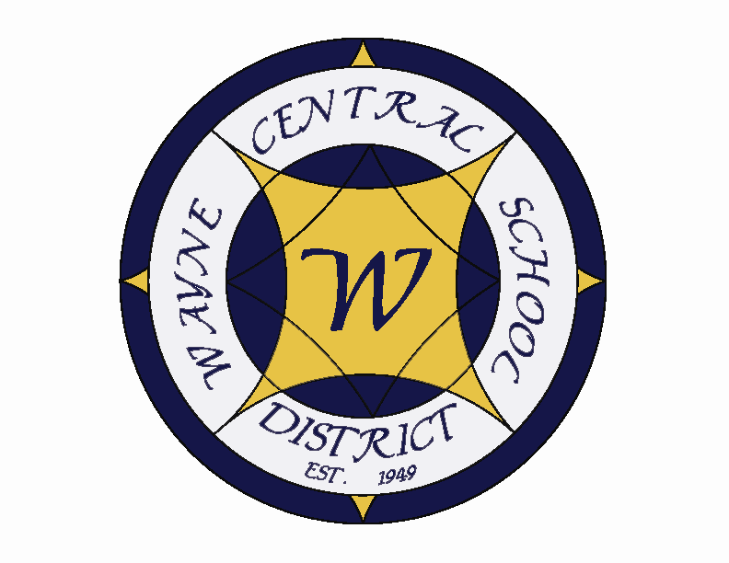
Letter to the Board

Michael Havens
Superintendent of Schools
Phone: 315-524-1001 Fax: 315-524-1049 mhavens@wayne.k12.ny.us

October 3, 2008

"We cannot always build the future for our youth, but we can build our youth for the future."
--Franklin D. Roosevelt,32nd U.S. president

Board Agenda:

- Building Tour: As you know, we are required to hold tours of our facilities and this evening’s special event is the Ontario Primary School with tour guide, Mr. Robert LaRuche.

- Retiree Reception: We will open the meeting with our retiree recognition reception. Mrs. Lyke has sent each of you a resolution to read. There will be a plaque to present to each retiree in attendance as well. We will take a short break following the presentation to allow us an opportunity to visit with our special guests and their families. We should plan to reconvene at appx. 7:30.

- Summer Exploration Program: Mrs. Cox will introduce, Susan Mack , Enrichment Coordinator, who will provide an overview of this program which was introduced this summer for students entering grades 3-8.

- International Baccalaureate Program: Mr. Siracuse will provide an update on the start up of the IB program at the HS.

- Financial Update: Mr. Atseff will provide his monthly financial update.

- Student Representative: Our student representative will be Junior Class Treasurer Stephen Palmer. Stephen has a 97% GPA, is a member of the basketball and baseball teams and does volunteer work at the Joy Community Church in Rochester as a media specialist.

- Board Action Items: We have personnel, CSE and CPSE action for your approval. Three Treasurer’s reports are attached for approval. As you may recall, there was a correction to the June Treasurer’s report. You opted to hold off on approving the July report until the June report was corrected. The August reports is new to you. We have a BOCES Cooperative bid for first aid supplies. There are budget transfers for elementary math consultant for the new math series, to correct a budget input error and one for summer school. The annual Red Ribbon resolution needs to be adopted. I recommend the approval of the fund balance transfers. These transfers are necessary to get us to the 4% state limit for unappropriated fund balance. We need to adopt a resolution to accept the settlement for the Monroe County sales tax litigation. See the attached letter from the lead attorney for the districts. I recommend approval of all items as presented.

- Four County Update: Mrs. Lyke will provide an update on Four County matters.

Board Letter

- Michael’s Daughter: Michael called today at 1:30 p.m. Jill’s surgery went very well. It was very long as you would expect. They found 2 additional holes in the heart and stitched all three. She was on a heart/lung machine during the surgery so she was under a very deep anesthesia. They were able to see her in recovery this afternoon around 2:00 p.m. However, due to the deep anesthesia they expect her to sleep all day today and into tomorrow. The doctors were pleased with the results and believe the procedure was successful. I will keep you posted as I hear more information.

- Vandalism at HS: We really have nothing new to report, other than the investigation is on-going and in the hands of the authorities.

- Transportation Letter: I am attaching a letter sent to an unhappy father who lives within our district. I forward this to you in case you hear from him. Mr. Prince spoke to him on a couple occasions before he called.

- Dennis Barrett Letter: Attached is a letter from the attorney for the school districts explaining the sales tax settlement agreement.

- Vandalism at MS: Earlier this week we had vandalism on our modified soccer field behind the middle school. A vehicle drove on the field and caused some damage. We are in the process of investigating the incident.

- Mrs. Johnson call: Just to keep you posted. We received another call from Mrs. Johnson. It was about a phone call she received from a teacher and she wondered why the teacher called her (she claimed the teacher hung up on her and was unprofessional). This was not the case. I just wanted to make you aware in case she decides to call any board members.

- Upcoming Dates:
10/6 TCA Friends of Music Meeting -@ DO – 6:30 p.m.
10/7 OP/OE PTA Meeting @ OP – 6:30
10/9 Board of Education Meeting @ OP – 6:15 p.m.
10/13 Columbus Day Holiday – Schools Closed
10/19 School Bus Safety Week
10/20 HS Band & Chorus Concert@ PAC – 7:00 p.m.

Athletics:
10/4 – Boys JV Football vs. East Rochester – 10:00 a.m.
10/6 – Boys JV & V Volleyball vs. Jefferson – 5:30 & 7:00 p.m.
10/7 – Boys JV & V Soccer vs. Pal-Mac – 4:30 & 6:30 p.m.
10/8 – Boys JV & V Volleyball vs Pavillion – 5:30 & 7:00 p.m.
10/9 – Boys JV & V Soccer vs. Waterloo – 4:30 & 6:30 p.m.
10/10 –Boys JV Football vs. Ithaca – 7:00 p.m.
10/10 – Boys JV & V Soccer vs. Pittsford Mendon – 4:30 & 6:30 p.m.

- Attachments:
A) Transportation letter
B) Dennis Barrett Letter
C) Safety meeting minutes – 9/23
Att. A)
Wayne Central School District
Office of the Superintendent of Schools

PO Box 155
6076 Ontario Center Road
Ontario Center, NY 14520
315-524-1001

October 2, 2008

Mr. Robert Thorpe
475 Bills Road
Macedon, NY 14520

Dear Mr. Thorpe:

Thank you for your phone call on Thursday, October 2nd. I reviewed the details of your situation with our transportation director and can understand the frustration of the matter you are faced with.

Mr. Prince has provided me with the background of what transpired in the past that allowed you to receive transportation while your children stayed with you (within the Wayne Central School District) on alternating weeks, although their “residency of record” is within the Pal-Mac Central School District. Our school district, as well as Pal-Mac and others, were operating under the belief that we were able to transport children under a “cooperative transportation agreement.” This would allow 2 districts to transport children, each on a part time basis, to a parochial school, so long as neither district was incurring undue additional expense. However, a local transportation director made an inquiry to the State Education Department and found that indeed, this was not a proper action and we were in fact told that this was an unauthorized action. In your situation, as the non-custodial parent, you fall under the child care guidelines for transportation under State Education Law.

Upon hearing of this clarification from the State Education Department, the Wayne Central School District ceased to transport students in this manner. Attached is a copy of the email citing the State Education Law.

We regret the inconvenience this has caused you and your family. We extend our best wishes to you in finding an acceptable resolution to this situation. Please feel free to contact me if I can assist you in any way.

Regards,

Gregory Atseff
Assistant Superintendent for Business

“Students First ~ Excellence For All”
Att. B)
Att. C)

TO: Safety Committee Members:
Chris Shaffer - Committee Co-Chairperson (MS Asst. Principal)
Fred Prince - Transportation
Maureen Doyle – MS PE
Tom Lucieer – OE Maintenance
Mark Callahan - DO Administration
Lori Sensenbach – OP SCRIP
Pamela Buddendeck– FE Instructional
Rob Chapman – SRO
Jacquie Brunner - School Board Rep.
Pat Griswold – OE Nurse
Riley Wheaton – HS Science

FROM: Bob Miller – Committee Co-Chairperson (Dir. of Facilities)
RE: Meeting Minutes
DATE: September 23, 2008

We welcomed new committee members Jacquie Brunner, BOE representative, and Riley Wheaton, HS Science.

Old Business

During the summer the wood platforms on the playground at OE were covered to prevent slivers.

New Business

Rob Chapman and I filled out the facilities assessment document, which is part of Project Save. It critiques the health and safety of each building in the district.

The fire inspection was conducted by the new inspector from BOCES Health and Safety, Marcie Steiner. We had one major violation, a blocked exit in the Eagle Ventures store front. New York Pizzeria had stored boxes in front of the door that exits Eagle Ventures. I spoke with Neil, the owner of the pizzeria, and he assured me that the area will be kept open. I also installed signage on the door and under the stairway as a reminder. The concession stand was also cited for the lack of a hood and Ansul extinguishing system over the existing grill. After requesting quotations I hired Monroe Extinguisher to install the hood system. It was completed in time for homecoming weekend.

I have scheduled the district’s structural inspection for October 15th. Tom Lucieer will be representing the safety committee during the inspection.

During dismissal time at the high school there has been a problem with cars exiting the north parking lot, using both the entry lanes and exit lanes. This causes the cars that are trying to enter the driveway to back up on to Route 350. We will be painting a double line to separate the two lanes and monitoring traffic during dismissal times.

There was a concern brought up about the handicapped entrance at the south end of OP. When the door is locked down during the day there is no way of telling if someone is trying to enter the building. I will speak to Bob LaRuche about installing a door bell for this entrance.

Jacquie Brunner presented some concerns regarding the PAC. This facility sees a lot of use and is very visible to the public. She would like the entire facility checked over, including water in the pit area and leaking due to the lack of proper flashing on the roof.

Jacquie also has a concern with the condition of the FE tennis courts. She suggested that the courts be removed.

Next meeting will be held on Tuesday October 25 at 8:00.

Robert Miller
Director of Facilities
Wayne Central School District
315-524-1045
Fax 315-524-1048

