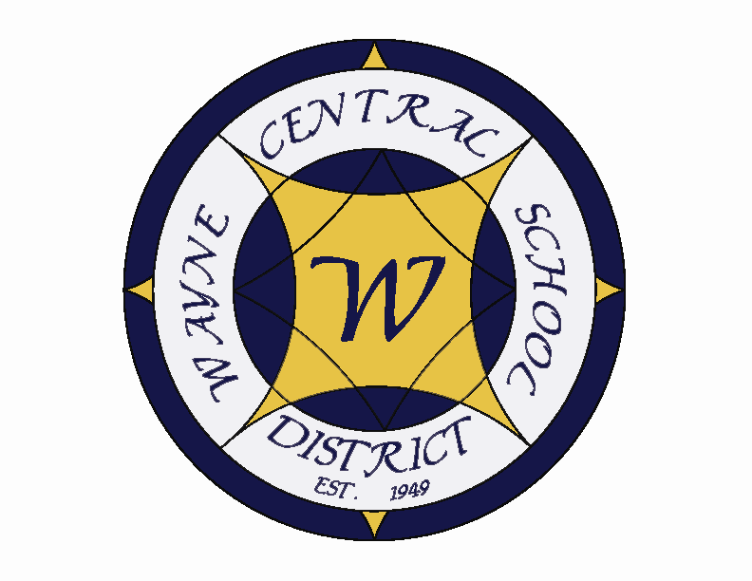
Letter to the Board

Michael Havens
Superintendent of Schools
Phone: 315-524-1001 Fax: 315-524-1049 mhavens@wayne.k12.ny.us

September 12, 2008

Ideals are like the stars: we never reach them,
but like the mariners of the sea, we chart our course by them.

- Carl Schurz

Greetings,
This will be short as we just met last night.

.
1. Bus Incident: Some high school boys were playing a “game” on the school bus. One person would whisper a word. The next person would say it a little louder and the next a little louder until they were yelling it. One of the words they chose was “nigger”. There were black children on the bus who were pretty upset. The mom of one has called us to talk about it. I think she was fairly reasonable given what happened. She said her daughter, who has known the boys since elementary school, has had her heart hurt. I think that is probably true. The boys have been suspended.

2. Staff Members Child: Last spring our IB coordinator and Social Studies department chair, Mark MacMillan, had a baby boy who was born with very serious birth defects. We just heard that they had to rush the baby to the hospital. No word on how he is but I will let you know if I here anything more.

3. Senior Project: As you are aware this is the first year of the Senior Project. Senior Project is a cornerstone piece of the Model Schools program. We have had a parent who objects to it, stating she believes it is a bunch of busy work that her daughter shouldn’t have to do. Dorothy Wayland, the parent, has sent a number of emails off to other parents in order to try to gain support. The high school has met with Dorothy but she remains unsatisfied. I have been forwarded a couple of the emails by parents who don’t agree with her and wanted me to know what she is doing. Dorothy can be tenacious so I wanted to give you a heads up in case anything came your way. You will be getting an update on senior project at an upcoming Board meeting.

4. Rebroadcast of Morning announcements: Morning announcements are rebroadcast each evening at 6:00 on channel six. It is a good way to keep abreast of things.

2. Sports Classification: At last night’s Board meeting we had a couple questions about sports classification. Classification is based on student population. Section V tries to keep about 17 teams in each class. Depending on how many schools field a team, we are class A in some sports and class B in others. This year Monroe County switched their volleyball season from winter to fall. This added a number of schools. When the split between A and B occurred we were in the Bs. All other fall sports have remained the same.

3. Building Project: Greg and I met this afternoon with the architects to review the draft work each of us had completed. We suggested some modifications which are assignments for the weekend. We are still on track to have our work in Carl Thurneau’s hand next Friday. I will let you know as soon as I hear anything.

4. Board Workshop: Attached is the agenda for the workshop next Thursday. We will meet at 6:00 with a light dinner provided. I anticipate getting you out of here by 7:30.

- Student Pictures: One of our sophomore girls was dating a boy from Webster. During the course of their relationship she sent him some nude pictures of herself. At some point later in the relationship they broke up. Allegedly, the exboyfriend told her that she had to send him more nude pictures or he would send the ones he had around to other people. The pictures are now on a number of boys’ cell phones including students here at Wayne. Our SRO has been investigating and had some removed. This week the item has appeared on the radio. I have been told it was also on TV and in the papers although I have found nothing. So far, she has been identified as a Wayne county teenager. I have been told, also unconfirmed, that some of the boys with the pictures have participated in the discussion on the radio. This afternoon I had a call from Ron Holdraker who was asking me questions about it. I told him I could not speak about it or even confirm if it was true. He delivers his paper on Sunday.

- Upcoming Events:
  - Homecoming: Activities Friday September 12 and Saturday September 13th
  - Powder Puff Game: Wednesday September 12
  - Fireworks: Friday, September 12th after the football game.

LO
WORKSHOP AGENDA
“Students First – Excellence For All”
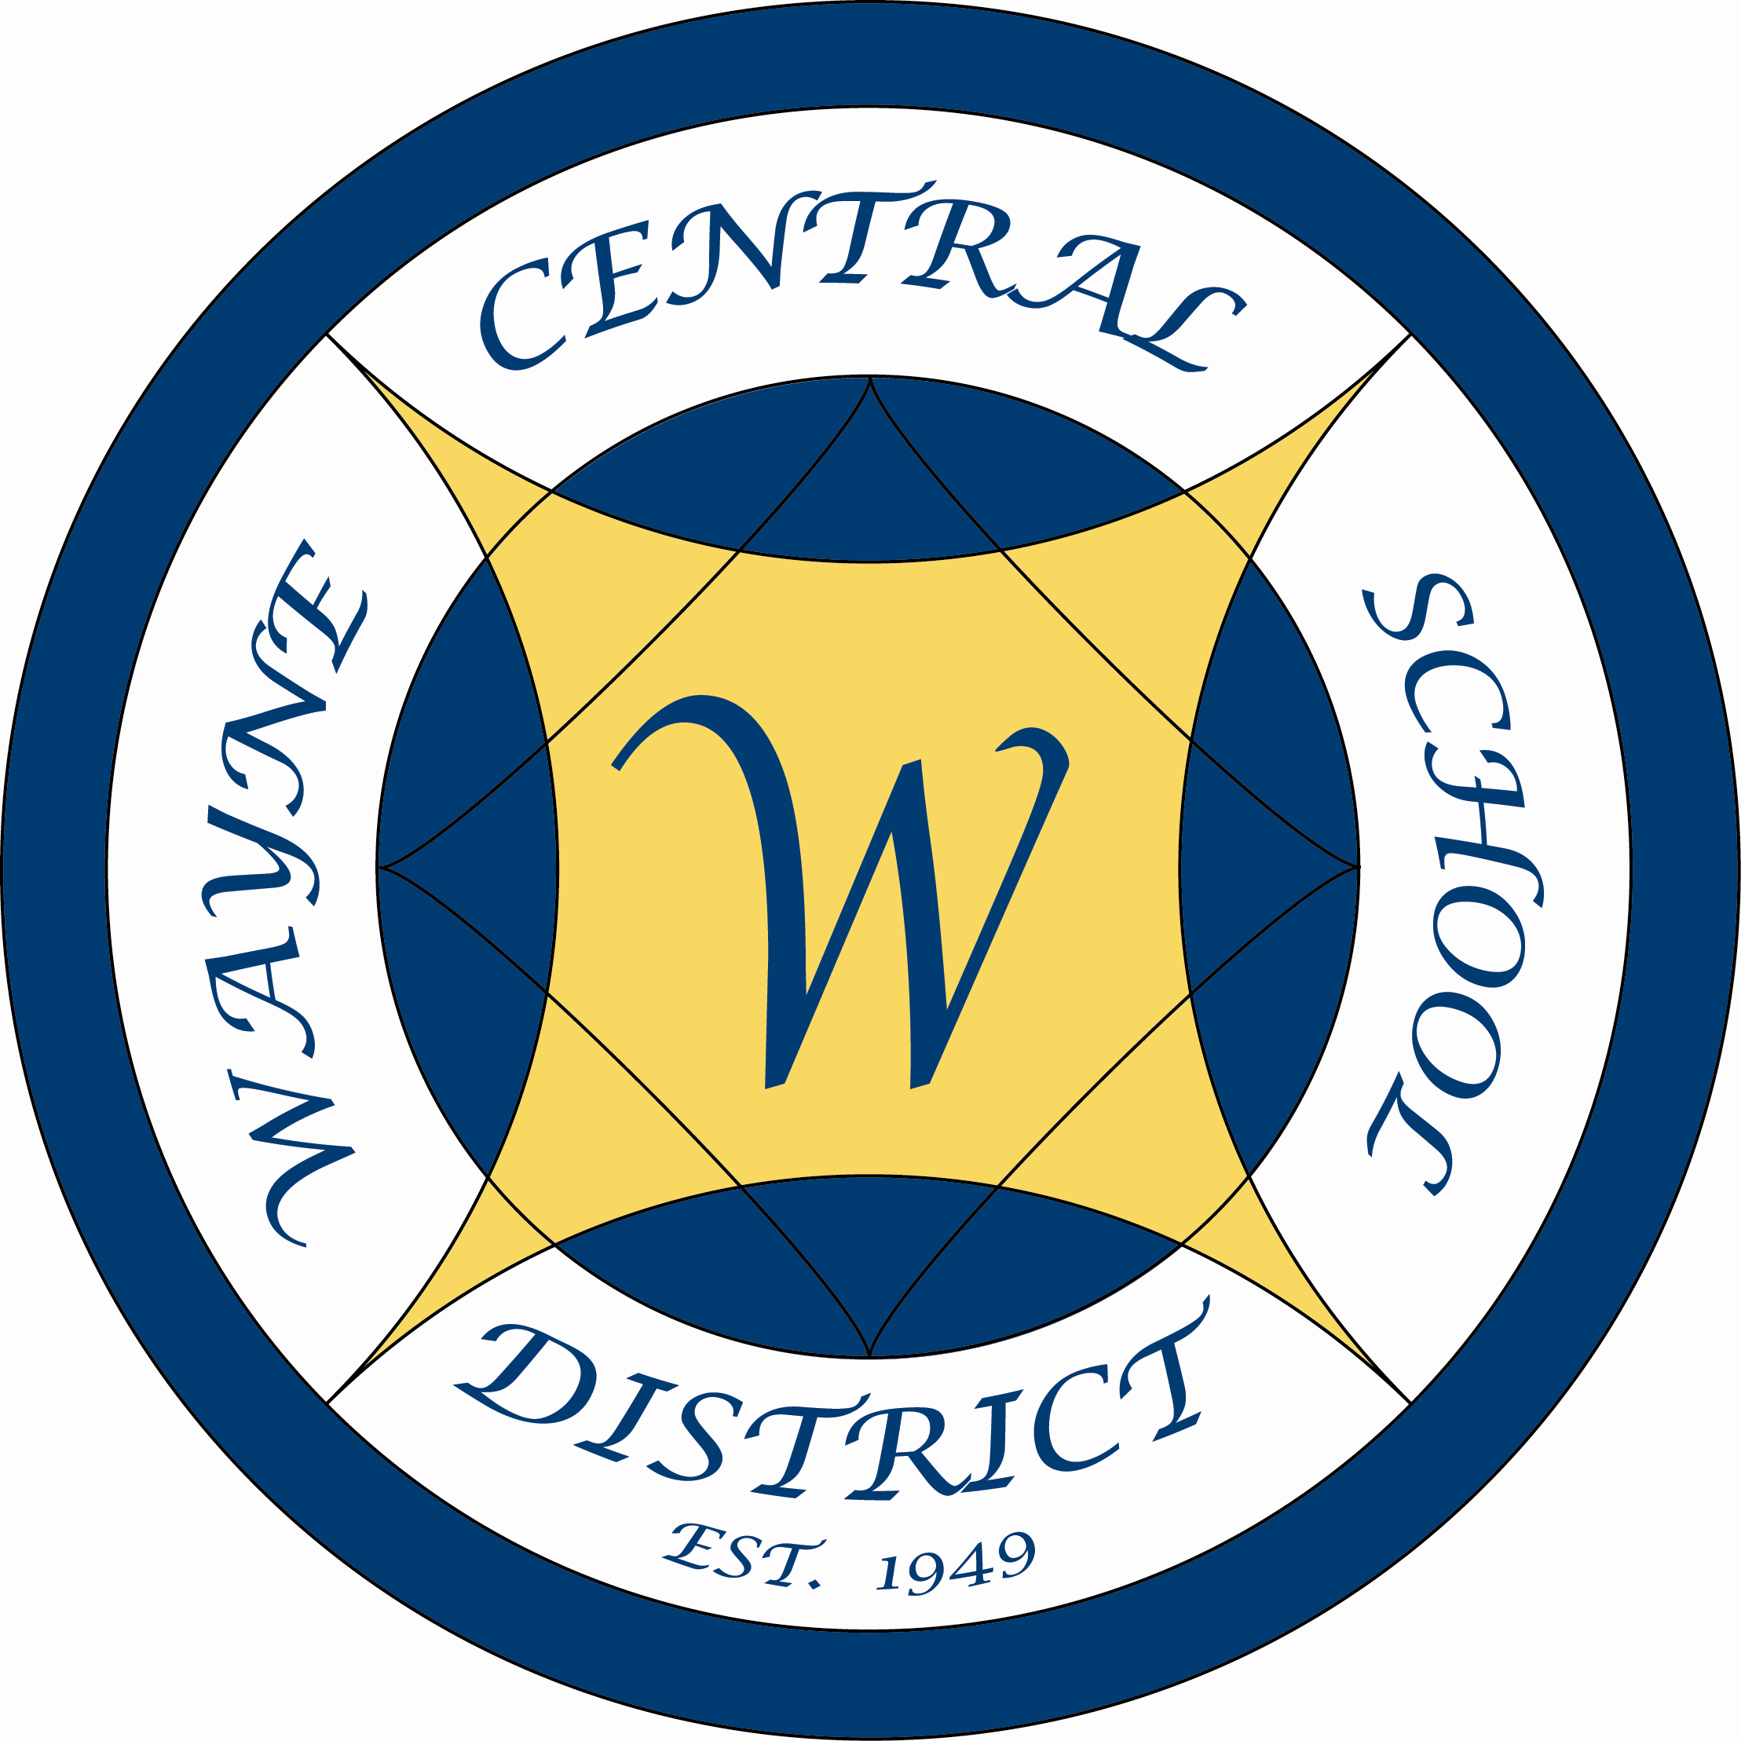

September 18, 2008
6:00 – 8:00
District Office Board Room

Time | Task |  | Comment
6:00 | Review process developed at last meeting |  | At our summer meeting the Board developed a “pre-retreat” process to use in preparation for the Board/Admin. Retreat. We agreed to try out the process this fall
6:15 | Review list of potential goals and make additions |  | The Board created a list of possible goals this summer. You will have the chance to add to them.
6:45 | Review and adjust criteria |  | Criteria for helping to choose goals was developed this summer.
7:00 | Use criteria to narrow list to three goals
7:30 | Refine three goals and charge administration with task of providing feedback |  | You will be giving us your top three choices to research and bring back the positives and negatives.
7:45 | Agree on next steps
8:00 | Adjourn

