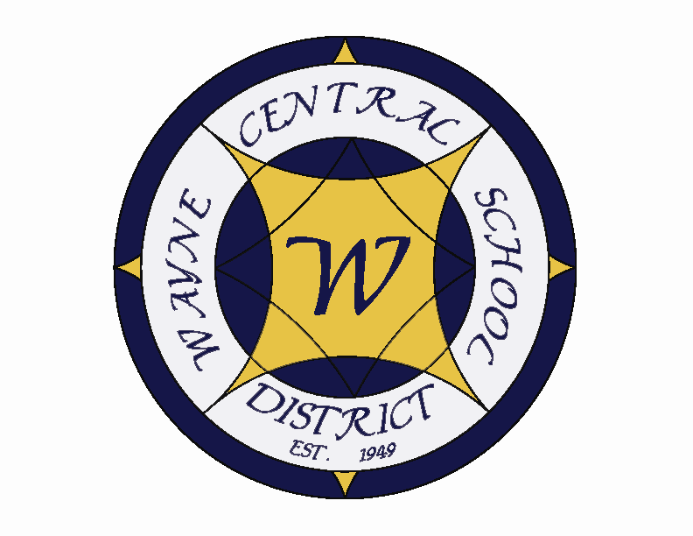
Letter to the Board

Michael Havens
Superintendent of Schools
Phone: 315-524-1001 Fax: 315-524-1049 mhavens@wayne.k12.ny.us

September 5, 2008

“Genuine beginnings begin within us, even when they are brought to our attention by external opportunities.”
--- William Throsby Bridges, Major General, Australian Army

Board Agenda:

- Executive Session: We had hoped to have an executive session with Kristen Benson but she is unable to be here. She said she will try to come in a few weeks to explain the next steps and to answer questions. Since there will be no executive session we will start at our regular 7:00 time.

- Moment of Silence: This meeting is on the 7th anniversary of the 9/11 attack on our nation. President Robusto will lead us in a moment of silence following the pledge in recognition of those innocent victims who lost their lives on that day.

- Opening Day: I will be giving a report on how the opening of school went this year including changes. I will tell you that it appears to have begun very smoothly. We did have some seniors write on the sidewalk the night before but it was in chalk and harmless. They even wrote “welcome freshman” and “freshman love seniors” which is a far cry from worries about freshman being pushed into lockers by seniors.

- Facilities Update: Greg and I travel to Albany on Wednesday with our architects. We will be discussing the aide issue with members of the facilities department of SED. As you are aware there is about $8 million dollars of unaided express as the project has been developed. We are going to see if there is any way more aid can be generated. Greg and I are both in agreement that we do not any project that will weaken our currently strong financial position. We are also seeking guidance from them on our windmill development. We want to size it correctly to maximize power generator and aid. In preparation of our meeting with SED, and Tuesday we are meeting with the engineer that designed the Harbec installation.

I am not sure what information I’ll have for you Thursday. It will probably have to be a fairly loose discussion. We will share what we learned, answer and questions and present some different options. I do not see it as a decision making night but rather an informational gathering session so that a decision can be made at a later meeting.

- Student Representative: Senior Samantha LaBarge will be our student representative. Sam spent this past summer as a Rotary Exchange student in Brazil and will be hosting her Brazilian sister this December for 6 weeks. Sam is the daughter of MS math teacher Brad LaBarge and FE Elementary teacher Tracy LaBarge. Sam has participated in Wayne soccer until recently, still plays Wayne Wings, is a Senior Class advisor, is in Rotary Interact Club, Yearbook Club, is a member of Student Senate. She has worked at Ton’s Original for 2 years. Sam plans on attending SUNY Brockport to pursue an education in psychology and business.

- Student Questions: This segment is on the agenda, however, I do not really anticipate any government class students attending a board meeting just yet….

- Board Action Items: Personnel and CSE/CPSE action items are presented as usual. The lion’s share of our personnel actions did occur over the summer and I am pleased to reiterate that we are meeting nearly all of our student’s special needs within the district. This is a tremendous benefit to our students in keeping them connected to their home district, but it also offers several cost savings opportunities as well. Under the Consent agenda we have two Treasurer’s reports (June and July), bid awards for a pump for the HS steam heating system, copy paper and cafeteria supplies, budget transfers, fire safety report and the corrective action plan for the general fund.

- Four County Update: Mrs. Lyke will provide an update on Four County matters.

Board Letter

- IB Breakfast: On Friday morning we had an informal breakfast for our 13 IB diploma candidates. It was the first time I had seen them all together. I found it to be an exciting moment to have real students to go with the program. They were each given t-shirts with the IB emblem. I was also presented with an IB flag. You will notice that it now flies to the right of the US flag in front of the school. Mr. Siracuse wants to try to have some sort of meeting with them each month to create that sense of team. They will begin the program second semester so this gives them a head start at being a group. Joe will be giving us an update in the near future.

- Tax Collection: We have been collecting taxes. So far it has gone smoothly. We collected $65,000 on the first day. Most people like to wait until the very last moment but some are afraid they will forget and so come at the first moment they can. We expect to collect 18.6 million dollars over the course of these two months.

- Overnight Athletic Trips: Attached is a list of overnight athletic trips. I have approved this list initial listing of trips. Please let me know if you have any questions.

- Upcoming Dates:
9/9 – MS PTO Mtg @ Media Center – 6:30 p.m.
9/10 – FE Curriculum Night – 7:00 p.m.
9/11 – FE Welcome Back Breakfast
9/15-20 – Homecoming Week – Various Activities
9/15 – HS Parent Group Mtg in HS Faculty Room – 7:00 p.m.
9/15 – TCA Friends of Music Mtg @ MS Conference Room – 6:30 p.m.
9/18 – MS Curriculum Night & Book Fair – 7:00 -9:00 p.m.
9/18 – FLCC Gemini Registrations @ HS -2:30 – 3:30
9/18 – Four County Board of Directors Mtg
9/19 – FE Back to School Bash
10/2 – Four County General Membership Mtg

Athletics:
9/5 – Boys JV & V Volleyball vs. Charlotte – 4:30 p.m. & 5:30 p.m.
9/5 – Girls V Tennis vs. Mynderse – 4:00 p.m.
9/5 – Boys JV & V Soccer vs. Canandaigua – 4:30 & 6:30 p.m.
9/6 – Boys JV Football vs. Brighton – 10:00 a.m.
9/9 – Girls V Tennis Team vs. Canandaigua – 4:00 p.m.
9/9 – Boys JV & V Soccer vs. Mynderse – 4:30 & 6:30 p.m.
9/11 – Girls JV & V Volleyball vs. Pal-Mac – 5:00 p.m. & 6:30 p.m.
9/11 – Girls JV Tennis vs. HAC – 4:00 p.m.
9/12 – Boys V Football vs. Geneva – 7:00 p.m.
9/12 – Girls JV & V Volleyball vs. Mercy High School – 5:00 p.m. & 6:30 p.m.

- Attachments:
a) Andy Templeman/Michael Havens E-mail
b) Athletic Department Overnight Trips
c) Four County News & Notes – August
d) Four County Fall Planning Mtg – 9/18
e) Albright Farm – Genesee Land Trust Invitation
f) Walworth Town Board Meeting Minutes – 8/21
g) Four County General Membership Mtg Information – 10/2
h) Four County Voting Delegates Mtg Information – 10/4

a)

Hello all,

It looks like this has been an excellent start. I know each one of you has been working extremely hard to make it go so smoothly. -thanks.

With Andy's permission, I am forwarding an email he sent to Mike this morning. Andy is a third grade teacher at Wayne. If you do not know Andy, he is a wonderful man and teacher. He raises an issue that has been discussed before. In fact we formed a committee a couple years ago to see if we should eliminate the cross district bus run. Andy is just so clear in what he is saying that I feel the need to raise the issue again. I know we may end up in exactly the same place, but I would like to once again have a discussion at council. If anyone still has the pros and cons developed from before please bring them.

Thanks.

Michael

From: Templeman, Andy
Sent: Thursday, September 04, 2008 4:32 PM
To: Pullen, Mike
Subject: 5,400 minutes lost
Mike,

5,400 minutes or 90 hours or 15 school days: That is the total amount of time a student misses when they take the Cross District bus each day. Guess who has a student leaving early each day? I would just like to reiterate my concerns as I have in the past about this issue. I know you understand this as well. I just do not understand how this is approved by the district so a child can go to a sitter’s home or daycare? And of course, this child is a Title 1 student who will miss some writing instruction at the end of the day.

Andy
b)
c)
d)
Four County School Boards Association
131 Drumlin Court
Newark, NY 14513
315/332-7294
315/332-7474 FAX
Email: 4countysba@edutech.org
Sharon A. Sweeney
Executive Director

FALL PLANNING MEETINGS

Thursday, September 18, 2008
6:00 p.m. Legislative Committee Meeting
7:00 p.m. Dinner
7:30 p.m. Board of Directors’ Meeting
Wayne-Finger Lakes BOCES Regional Support Center
Jack Loveless Conference Room
131 Drumlin Court, Newark, NY 14513

Four County School Boards Association
Legislative and Board of Directors’ Meetings
Thursday, September 18, 2008
Buffet dinner $12.00 per person

Please make your reservations no later than September 15, 2008 by:

Ph: 315-332-7294 Fax: 315-332-7474 E-mail: 4countysba@edutech.org

School District: ___________________________ Total Attending _____________

Name:
__________________________________ __________________________________

__________________________________ __________________________________

__________________________________ __________________________________

24 hour cancellation notice required

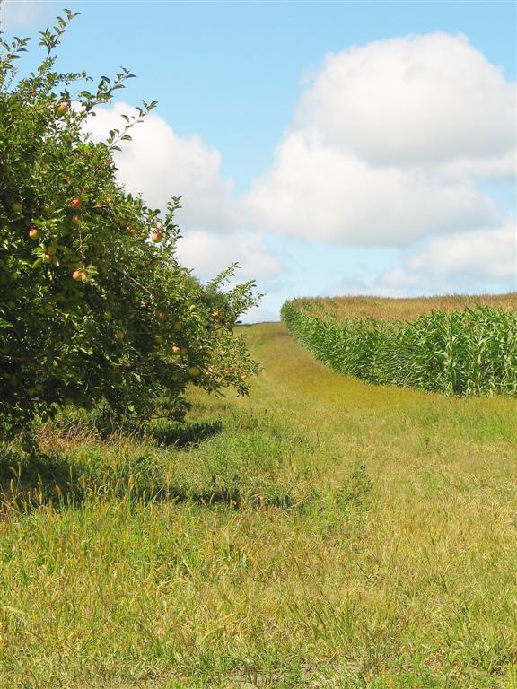
Albright Farm Open House:
Come enjoy a visit to the scenic 339-acre Albright Farm on Lake Road. Genesee Land Trust and the Town of Ontario have partnered to permanently protect this farm of fruit orchards, row crops and old growth woods with an agricultural conservation easement. Join an extended tour of the land at 10:30 a.m., or stop by anytime between 10 and Noon to take a short walk, look at maps and enjoy the views.

When:
Saturday, September 13, 10 a.m. to Noon

Where:
Lake Road in the Town of Ontario between Ontario Center and Knickerbocker Roads. Look for signs. Parking is along Lake Road.

 For information please call 585-256-2130



f)

WALWORTH TOWN BOARD – REGULAR MEETING

21 AUGUST 2008

Presiding Supervisor Plant called the regularly scheduled Town Board meeting, held at the Walworth Town Hall, 3600 Lorraine Drive, to order at 7:30 PM.

Present: Thomas Yale Councilman
Frank Maciuska Councilman
Patricia Marini Councilwoman
Suzi Hawkins-Mance Councilwoman
Susie C. Jacobs Town Clerk
Mike Frederes Highway Superintendent
Rob Burns Sewer Superintendent
Jacqueline Van Lare Recreation Director
Ed Parrone Engineer for the Town

MINUTES:
Motion by Councilwoman Hawkins-Mance to approve the minutes of August 7, 2008, Special Meeting as presented.
Seconded by Councilwoman Marini.
Adopted: Vote Ayes 5 Nays 0

Motion by Councilwoman Hawkins-Mance to approve the minutes of August 7, 2008,
as presented.
Seconded by Councilwoman Marini.
Adopted: Vote Ayes 5 Nays 0

CORRESPONDENCE:
Susie Jacobs, Town Clerk, had nothing to enter into record.

SUPERVISOR’S REPORT:
Motion by Councilwoman Marini to approve and file the Supervisor’s Monthly Report for July, 2008, as presented.
Seconded by Councilwoman Hawkins-Mance.

Discussion: Councilman Maciuska would like it noted that perhaps a quality check could be done on the copies verifying that all the information was legible.

Adopted: Vote Ayes 5 Nays 0

PUBLIC PARTICIPATION:
Paul Phillips, a member of the Walworth Fire Department, Chairman of the Walworth Ambulance Committee, and President of newly-formed Walworth Ambulance Incorporated was present to share some of the changes that have taken place with the Walworth Fire Department Ambulance Service in the last few months. In the Spring of 2008 the Walworth Fire Department convened a committee to look into stabilizing their budget for the ambulance for future years. The committee looked at several options and interviewed several local fire departments and found that a very successful route that a lot of departments were taking was to incorporate ambulance services and use third-party billing companies as a stable revenue source. At this time they have their Certificate of Need application filed with the State. The State is reviewing that information, and their hope is that by October 1, 2008, they should be declared as the new ambulance for the area. He assured everyone that with a new name they were still the same people, formed by the fire department members. The big difference is that NYS does not allow fire departments to bill for ambulance services, which makes fire departments’ ambulance services totally dependent on donations, town tax money and charitable sources such as United Way. With the exception of Town money, both of the other sources are extremely variable and they needed to find a way to stabilize their income in order to ensure there would be a

WALWORTH TOWN BOARD – REGULAR MEETING CONTINUED

21 AUGUST 2008

quality ambulance service for years to come. He introduced Eric Dodge with MedEx Billing who explained third-party billing. He stated that there would be a lot of questions and he would leave his number for anyone who needed to contact him. (Mr. Dodge spoke very quickly and the recording was not clear enough to make an accurate documentation of his statements.)

RESOLUTION 61-08 – AUDIT OF CLAIMS:
Councilman Maciuska offered the following Resolution 61-08 and moved its adoption. Seconded by Councilman Yale to wit:

WHEREAS, the following claims submitted at the scheduled Town Board Meeting of August 21, 2008, have been audited and approved by the appropriate Council Members.
BE IT RESOLVED that the claims be paid on Abstract #8, numbered 1,061 through 1,248, in the following amounts:

GENERAL FUND | $ 118,971.58
HIGHWAY FUND | $ 173,541.51
WALWORTH SEWER DISTRICT #1 | $ 23,491.27
BROOKSIDE LIGHT DISTRICT | $ 10.47
GANANDA LIGHT DISTRICT | $ 887.90
HARVEST HILL LIGHT DISTRICT | $ 647.43
ORCHARD VIEW LIGHT DISTRICT | $ 98.12
WALWORTH LIGHT DISTRICT  GANANDA SIDEWALK DISTRICT | $ 552.62  $ 23,488.14
WALWORTH CONSOLIDATED DRAINAGE | $ 893.00
PARK SPECIAL REVENUE FUND | $ 685.45
BE IT FURTHER RESOLVED that the claims be paid on Abstract #8, numbered 124 through 156, in the following amounts:

TRUST & AGENCY | $ 28,403.18

NOW THEREFORE BE IT RESOLVED that the Town Council of the Town of Walworth adopt resolution 61-08.

Adopted this 21st day of August, 2008, at the meeting of the Town Council.

Roll call vote: Councilman Maciuska Aye
Councilwoman Marini Aye
Councilwoman Hawkins-Mance Aye
Councilman Yale Aye
Supervisor Plant Aye
Resolution carried.

DEPARTMENT HEAD REPORTS:
HIGHWAY DEPARTMENT – BOYNTON ROAD PROJECT
Mike Frederes, Highway Superintendent, stated that the Boynton Road project was completed, except for the sweeping to be done.

HIGHWAY DEPARTMENT – CHIPS FUNDING
Mike Frederes stated that paperwork had been submitted for the CHIPS reimbursement; it should be here in September.

WALWORTH TOWN BOARD – REGULAR MEETING CONTINUED

21 AUGUST 2008

SEWER DEPARMENT – COMPLETED PROJECTS
Rob Burns, Sewer Superintendent, reported that the roof replacement at the Waste Water Treatment Plant was finished, the diffusers for the S.B.R. tank replacements had been completed, the sleeves were completed and the sludge tank patch work had been done.

RECREATION DEPARTMENT – GINEGAW PAVILION ROOF
Jacqueline VanLare, Recreation Director, reported that the roof replacement on the Ginegaw Pavilion was half-done.

ENGINEER FOR THE TOWN – DESIGN CRITERIA
Ed Parrone, Engineer for the Town, stated that this month he and Phil Williamson should finish the Design Criteria and present it to the Town Board.

TOWN CLERK – VAULT SHELVING TOWN CLERK OFFICE
Susie Jacobs, Town Clerk, reported that the new vault shelving was installed on Friday August 15, 2008, by ASR. The new 18 gauge interlock no-bolt/adjustable steel shelving has a total capacity of 210 cubic boxes. Each shelf can hold up to 480 pounds. This vault now meets NYS State Archives specifications. Susie thanked the Sewer Department for their help in removing the old shelving. The Sewer Department was most thankful to have them and will put them to good use.

COMMITTEE REPORTS:
LIBRARY COMMITTEE
Councilman Maciuska announced that Kitty Meier was the new President of the Friends of the Walworth-Seely Public Library. He also reported that the ice cream social was a huge success.

SEWER COMMITTEE – SEWER ENGINEER
Councilman Maciuska stated that the committee had completed all of the five (5) interviews for the Engineer for the Sewer Department and would like to present their first choice for consideration by the Town Board. The one that stood out, coming to the committee with recognition of what the problems were and proposing solutions with much more depth than what the others presented, that they would like to place a nomination for, was Parrone/Labella.

Motion by Councilman Maciuska to nominate Parrone/Labella for the Engineer for the Sewer Department.
Seconded by Councilwoman Marini.

Roll call vote: Councilman Maciuska Aye
Councilwoman Marini Aye
Councilwoman Hawkins-Mance Aye
Councilman Yale Aye
Supervisor Plant Aye
Motion carried.

Councilman Maciuska stated that the Sewer Department was entertaining the budget for sewer and would like to go on record as saying that for years they did their best to keep the rates low and went for years without a rate increase. Up until two years ago they held rates stable and at one point had a six percent decrease, which was something unusual in the municipal area. In hindsight that frugality was great at the time but had hurt us now, because the reserves are low. We have a lot of repairs and things to do. We are regretfully looking at the potential of having to implement a rate increase. We are looking to partner with Macedon for some things, which would probably keep the costs down. Running a sewer business is not a cheap business, but we have an obligation to protect the asset.

WALWORTH TOWN BOARD – REGULAR MEETING CONTINUED

21 AUGUST 2008

MORATORIUM – POWER GENERATION:
Councilman Yale reported that the Planning Board had an interesting work session proposal come before it on August 20, 2008, for a wind generator. Councilman Yale stated that he was not present but did some pre-work on it. In researching Town Law, he noted that we have very limited laws regarding wind generation of energy. Basically, all it addresses is making sure that it doesn’t fall on somebody else’s lot and has to do with the old concept of something being on a tower and falling over. This particular type of generation is not that type - it is actually a much smaller type - it’s conical and fits on a roof. It comes somewhere out of the Midwest; the resident had spoken with RG&E and stated that RG&E was happy with it. It was going to be interesting to see, Councilman Yale said, as these proliferate to some degree. Discussion ensued. Councilman Yale stated that it was wonderful that people were entering into this, however, the Town needed to be prepared to see if there was anything the Town would need to be concerned with. Councilman Maciuska stated that it might be prudent for right now to have a moratorium until we could get a law on the books; he gave an example of the temporary garages as a reason for this. Councilman Maciuska stated that a moratorium would give the Town six months to research the issue and time to get something on the books. It would be easier to do this than to go back and try to fix it later. Discussion ensued with the decision that the presentation was a concept at a work session. Ed Parrone advised the Town Board that it would be very smart to do this now.

Motion by Councilman Yale to move a moratorium on the establishment of residential and commercial power generation, not to include emergency stand-by generators – conventionally accepted, for a period not to exceed six months while the Town takes time to draft the appropriate legislature.
Seconded by Councilman Maciuska.

Discussion: Supervisor Plant questioned what alternative energy included, a fireplace or wood burning stove. Councilman Yale amended the motion with power generation. Supervisor Plant questioned stand-by generators. Motion amended with “not to include emergency stand-by generators - conventionally accepted.” Councilman Maciuska stated that it needed to be clear that the intent was not to stop it, the intent was to make sure that there would be clear guidance for people who want to do it.

Roll call vote: Councilman Maciuska Aye
Councilwoman Marini Aye
Councilwoman Hawkins-Mance Aye
Councilman Yale Aye
Supervisor Plant Nay
Motion carried.

TOWN COMPLEX STUDTY GROUP
Councilwoman Hawkins-Mance stated that the Town Complex Study Group would meet on September 24, 2008.

DOG CONTROL
Councilwoman Hawkins-Mance requested that a thank-you letter be sent to the Wayne County Sherriff’s Office, Mark Plyter, Wayne County Humane Society, and Gary Rose, Town of Palmyra, for their assistance with the dangerous dog situation on August 11, 2008.

Councilwoman Hawkins-Mance stated that she was working with Phil Williamson, Code Enforcement Officer, regarding penalty fees.

WALWORTH TOWN BOARD – REGULAR MEETING CONTINUED

21 AUGUST 2008

BINGO LAW:
Council members discussed preliminary information for the Bingo Law and decided that Sunday games would be permitted. The information would be compiled into legal form for the next Town Board meeting and then go to the County in order to be on the ballot in November, 2008.

MISSION STATEMENT:
To provide services to the Town residents for their health, safety and welfare which are not readily available from private sources and to do this in a way consistent with the needs of the residents as a whole.

Recognizing that we all serve at the pleasure of and for the benefit of the residents of the Town, we will strive to provide these services in a polite and friendly manner consistent with being public servants and recognizing that each person’s request, question or problem is very important to them and therefore to us.

Motion by Councilman Yale to accept this as the Town of Walworth Mission Statement.
Seconded by Councilwoman Hawkins-Mance.
Adopted: Vote Ayes 5 Nays 0

FINANCIAL TRANSACTIONS:
Councilwoman Marini offered the following Resolution 62-08 and moved its adoption. Seconded by Councilman Yale to wit:

BE IT RESOLVED that the Senior Account Clerk be authorized to modify budget as follows:
$3,657.90 from A1990.41 Contingent Account to cover current expenses:
$3,304.90 A1620.21R Computer Equipment
$65.50 A5410.21R Construction Hamlet Sidewalks
$67.50 A5410.41 Repair of Sidewalks
$220.00 A6989.41 Farm Land Preservation Grant

Roll call vote: Councilman Maciuska Aye
Councilwoman Marini Aye
Councilwoman Hawkins-Mance Aye
Councilman Yale Aye
Supervisor Plant Aye
Resolution carried.

JUSTICE COURT AUDIT:
Councilman Maciuska inquired if there had been a response from the Justice regarding the checkbook and presenting it for audit. Supervisor Plant replied that there was a response and that both Justices’ checkbooks would be present for audit at the September 4, 2008, meeting.

ADJOURNMENT:
Motion by Councilwoman Hawkins-Mance to adjourn. Seconded by Councilwoman Marini and unanimously carried.
Time: 8:14 PM.

RE-OPEN:
Supervisor Plant called Council members back to re-open the meeting to discuss an item. General public and media were still present, no objections to re-opening the meeting.
Time: 8:17 PM.

WALWORTH TOWN BOARD – REGULAR MEETING CONTINUED

21 AUGUST 2008

BURN PERMIT – 4300 CANANDAIGUA ROAD:
Motion by Councilman Yale to approve the burn permit for 4300 Canandaigua Road given that after contact with the school there were no objections and providing the resident followed the recommendations of the school as presented.
Seconded by Councilwoman Hawkins-Mance.
Adopted: Vote Ayes 5 Nays 0

ADJOURNMENT:
Motion by Councilwoman Hawkins-Mance to adjourn. Seconded by Councilwoman Marini and unanimously carried.
Time: 8:19 PM.

Respectfully submitted,

Susie C. Jacobs
Town Clerk

g)
Four County School Boards Association
Sharon A. Sweeney
Executive Director

GENERAL MEMBERSHIP MEETING
Thursday, October 2, 2008
Club 86, Avenue E, Geneva, NY
131 Drumlin Court
Newark, NY 14513
315/332-7294
315/332-7474 FAX
Email: 4countysba@edutech.org
5:30 – Registration/Conversation
6:30 – Dinner 7:30 – Program
Guest Speaker
ROBERT J. FREEMAN, Esq.
Executive Director, NYS Committee on Open Government
The Committee on Open Government is responsible for overseeing and advising with regard to the Freedom of Information (FOIL), Open Meetings and Personal Privacy Protection Laws (Public Officers Law, Articles 6, 7 and 6-A respectively). Specific responsibilities of the Committee under the Freedom of Information Law involve furnishing advisory opinions, both oral and written, to any person and promulgating rules and regulations relative to procedural aspects of the Law. The Open Meetings Law requires that the Committee provide advice to any person. Advisory opinions are also prepared concerning the Personal Privacy Protection Law at the request of persons who are subjects of records covered by the Law, as well as at the request of state agencies seeking to comply with that statute.
Bob Freeman has been the Committee’s Executive Director since 1976, having first served as its counsel. Bob has a law degree from New York University and a BS in Public Service from George Washington University. He is recognized across New York State and beyond as the expert on open government. An engaging speaker, Bob will discuss and answer questions about the “Sunshine” laws and their application to school boards and school board members, including how they apply to electronic communication, executive session, access to records etc., etc., etc.
Always a subject of interest to our members, the topic was also identified by our district clerks as an important topic for a joint event.
All Four County Board Members, Superintendents and Board Clerks are invited to join us!
______________________________________________________________________
(This notice has been sent to all Four County board members, superintendents, board clerks and secretaries.)
Four County School Boards Association
General Membership Meeting
Thursday, October 2, 2008
Please make your reservations no later than September 29, 2008 by:
Ph: 315-332-7294 Fax: 315-332-7474 E-mail: 4countysba@edutech.org Website: www.4csba.org/forms.cfm?myForm=3483
Meal Choices are:
New York Strip-$29.00 Pasta Primavera-$19.00 Broiled White Fish-$23.75
School District: ___________________________ Total Attending _____________
Name:
__________________________________ ______________________________________4 hour cancellation notice required
h)
Attention
NYSSBA Voting Delegates & Alternates

FOUR COUNTY SBA

GENESEE VALLEY SBA
MONROE COUNTY SBA

AREA 2

PROPOSED RESOLUTIONS DISCUSSION

SATURDAY, OCTOBER 4, 2008
9:00 a.m. – 11:30 a.m.

Canandaigua City School District
Canandaigua Academy
(See map on back)

Library
(second floor)

DISCUSSION LEADER
Barbara Clark, Gates-Chili BOE
Area 2 Representative - NYSSBA Resolutions Committee

Hosted by
Tom Nespeca, Area 2 Director

Reservations are appreciated but not required.

Contact:
Four County School Boards Association
131 Drumlin Court
Newark, NY 14513
E-mail: 4Countysba@edutech.org
Phone: (315) 332-7294

REFRESHMENTS PROVIDED
NO FEE charged for this event!

