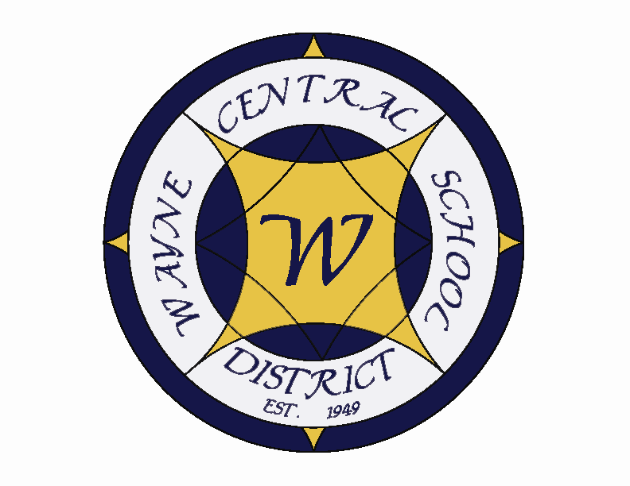
Letter to the Board

Michael Havens
Superintendent of Schools
Phone: 315-524-1001 Fax: 315-524-1049 mhavens@wayne.k12.ny.us

July 25, 2008

"A problem is a chance for you to do your best." --Duke Ellington, American Jazz Composer

Board Letter

.
1. Internal Audit: On July 31, Freed, Maxick, Battaglia will be performing the annual risk assessment, which fulfills our annual requirement for audit. Their findings will be reported to the Audit Committee this fall.

2. Staff Training: This past week we brought in Lance Gentile, a trainer who focuses on language and enhanced literacy skills in young children. Thirty-five elementary, speech and special education teachers from Ontario Primary, Ontario Elementary and Freewill participated in the training sessions.

3. Curriculum Writing: There was an extensive amount of curriculum writing done this summer, with 153 teachers completing 45 separate projects. This is important work for the district to relevant and rigorous programs. Teachers are just bringing this work to a close and Mrs. Cox is beginning thereview process.

4. District Vacancies: There were 21 probationary teaching openings to be filled for school opening and , to date, 20 have been hired. Additionally, we have three long term substitute teaching positions that we are currently interviewing for. Barring any last minute resignations, we are in an excellent position to start the new school fully staffed.

5. Exchange Students: We have three exchange students coming this year. We have a girl from Germany (Adrian Keller staying with OE Secretary Vita Barci), Spain (Laura Izquierdo staying with HS Aide Elaine O’Connor), Sweden (Ellen Maria Zetterberg staying initially with Susan Newman, Board member). We also have a girl coming in from Brazil for one month in December. Wayne student Sam LaBarge is currently spending the summer in Brazil with her.

6. Tax Cap: At this time it appears likely that the State will pass a tax cap bill. The senate leadership has come out in support of it due in part to their fear of losing the Republican majority. Patterson is pushing strongly for it. Some say he wants it to show he is a strong governor and head off Andrew Cuomo's plans to replace him in the next election. If passed, it would limit tax levy increases to the lesser of 4% or 120% of CPI. We should be okay with this as long as the state lives up to its funding promises and there aren't additional unfunded mandates.

7. Unfunded Mandates: SED has just issued new rules for home schooled children. We are now required to provide all special education services to home schooled children. We have never had to provide these services in the past. I am not sure what the financial impact will be but there will be some.

8. Summer cleaning: Summer cleaning of the classrooms is going well. The only problem appears to be the number of classrooms that are being used for summer programs. This year a larger than ever number are being used. We are getting all our other projects done now so that when the summer programs end in a couple of weeks we will be able to get those final rooms cleaned.

9. Vacation: I am on vacation next week. We are going to Newport Rhode Island. Greg will be looking after things while I am gone and Lori has my cell phone number in case there are any issues.

10. Upcoming Events:

July 26 – August 10 – Block Out Week – No meetings/activities scheduled
August 14 – Board of Education Meeting @ DO Conference Room – 7:00 p.m.

Summer Athletic Activities:
- Summer Conditioning Program open to all students grades 7-12: M/W/F 7-10am
averages about 40-50 students, T/TH 3-5pm averages about 20-30 students
- .Three Sessions of Bball Camp run by our coaches - (K-2 group) (3-5 group) (6-8 group)
25-50 students per session.
- Two Sessions of Soccer camps run by Tim Mattle - 30-40 students per session.
- 2 weeks of Lacrosse camp - 20-30 students.
- Girls/Boys JV/Varsity Basketball Camps & Summer League.
- Open Gyms for Girls Volleyball Mondays/Fridays 15-20 students per session.
- Multiple Football team camps (FL Camp, WCS Camp, 7 v 7 league.
- Volleyball camp grades K-5 - 15-20 students.
- Wrestling 2x per week open mats sessions and several summer tournaments, 15-20 students
- American Legion Baseball league - JV/Varsity Baseball players 15-20
- Softball Summer League - JV/Varsity Softball 14-20
- Cheerleading Workouts - Tuesdays 15-20 students
- Track workouts once per week – 10 students
- Cross-Country workouts once per week – 10-15 students

