
WAYNE CENTRAL SCHOOL DISTRICT
BOARD OF EDUCATION MEETING AGENDA

February 12, 2008 6:00 p.m. District Office Conference Room

6:00 Executive Session

7:00 Call to Order
Pledge of Allegiance

7:05 Approval of Agenda/Approval of Minutes Att. 1

7:10 Public Comment
7:15 Board Member Comments
7:20 Board President Comments

7:25 Superintendent’s Report
1. Proposed Budget – Program Portion Att. 2
2. Internship Proposal Att. 3
3. Financial Report
4. Student Representative
5. Student Questions

8:15 Board Action
1. Personnel Action Att. 4
2. CSE/CPSE Action Att. 5
3. Consent Agenda Items: Att. 6
1. Accept Treasurer’s Report
2. Approve Bus Purchase Recommendation
3. Approve Budget Transfers
4. Accept Gift to the District

8:25 Four County Report

8:30 Policy Report Att. 7

8:40 Public Comment

8:45 Board Member Comments

8:50 Adjournment

Next Meeting Date: March 12, 2008 District Office Conference Room 7:00 p.m.

District Mission Statement
Based on the belief that all students can learn, the staff of the Wayne Central School District accepts the responsibility to teach all students, regardless of differences, the fundamental skills. We further accept the responsibility to challenge all students to attain higher levels of achievement. Wayne Central will provide the opportunity, environment, and encouragement to meet this goal while developing the whole child, physically, socially, emotionally, and culturally.
Att. 1
WAYNE CENTRAL SCHOOL DISTRICT
Ontario Center, New York 14520

BOARD OF EDUCATION MINUTES UNOFFICIAL UNTIL APPROVED

DATE: Thursday, January 22, 2008 TIME: 7:00 p.m.
TYPE: Regular Business Meeting PLACE: Middle School Media-Center

PRESENT: Board Members Brunner, Griswold, Lyke, Newman, Paz, Robusto, Schultz & Triou;
District Clerk Switzer; Administrators Havens, Siracuse, Armocida, La Ruche, Schiek, Atseff,
Cox & Callahan

ABSENT: Mr. Nicholson

GUESTS: Visitor’s Roster filed in clerk’s agenda file, this meeting

I. CALL TO ORDER: 7 p.m. by Frank Robusto, Jr., School Board President

Prior to start of the business meeting, Board of Education members and school personnel conducted a tour of the middle school to fulfill the requirement of §1705 of the Education Law for annual building visits.

- PLEDGE OF ALLEGIANCE

- APPROVAL OF AGENDA & MINUTES (December 11, 2008)

Mrs. Newman offered a MOTION, seconded by Mrs. Brunner, to approve the agenda for this evening’s meeting and the minutes of the meeting of December 11, 2008, each as presented. 8 Ayes, 0 Nays, 1 Absent (Mr. Nicholson), Carried.

PUBLIC COMMENT

Mr. Robusto stated that the Board of Education values public comment and that, under NYS Open Meetings Law, school board meetings are open to the public, not public meetings. Two opportunities are provided for public comment and time limits are placed on each speaker. While immediate responses are not always possible, follow-up will occur if needed. He asked speakers to identify themselves, their address, any organization they may represent and to provide copies of any documentation to the school district clerk.

- Chris Murray, 1175 Plank Road, Ontario, introduced members of the junior varsity hockey club who were present and invited board members to attend their events at the Thomas Creek Ice Arena in Perinton. The events are fast-paced and the team members are anxious to create a lasting tradition.

- Kim Aumann, 2004 Bear Creek Drive, Ontario, spoke as president of CSEA Local Unit 859 and extended support for extension of the current collective bargaining agreement as proposed on this evening’s agenda.

V. BOARD MEMBER COMMENTS

- Mrs. Lyke noted that the Manchester-Shortsville Board of Education has adopted the paperless agenda which our board presented as a model at a recent meeting of the Four County School Boards Association and is very pleased with the results.

- Mrs. Newman extended thanks to Mr. Armocida and middle school students for their choral presentation and stated that she was impressed by the building tour prior to this evening’s meeting.

VI. BOARD PRESIDENT’S COMMENTS

- Mr. Robusto extended thanks to Mr. Armocida for the student presentations and building tour.

- REPORT ON ACTION ITEMS BY THE SUPERINTENDENT OF SCHOOLS – None

- REPORTS OF THE SUPERINTENDENT OF SCHOOLS

Mr. Havens complimented the middle school students on their presentations and tours.

Mr. Havens noted that middle school students have taken the statewide English-Language Arts exams this week and preliminary results look very good. He complimented Mr. Armocida and the middle school staff on their efforts.

- PROPOSED BUDGET ● 2009-2010 ● CAPITAL PORTION ● DRAFT #1

Mr. Havens presented the first draft of the capital portion of the proposed 2009-2010 school budget for review and consideration by the Board of Education. (copy filed in clerk’s agenda file, this meeting).

Mr. Gregory Atseff, assistant superintendent for business, reviewed projected expenses for operation, maintenance, employee benefits and debt service.

He noted the following highlights:

Operation
- Increase in custodial salaries reflects negotiated salary increases
- Increase in equipment reflects purchase of an auto floor scrubber machine for Ontario Primary School
- Increased cost for paper products and garbage bags

Maintenance
- Increase in maintenance salaries reflects negotiated salary increases
- Decrease in equipment & vehicle purchases; equipment addressed prior years; fleet in good shape
- Facilities Plan: decrease in contractual expenses; increase in supplies to address building needs

Employee Benefits
- 8.5% estimated rate increase in contributions to the NYS Teachers’ Retirement System (TRS)
- 8.0% estimated rate increase in contributions to the NYS Employee Retirement System (ERS)
- 4.0% estimated increase in health insurance costs

Debt Service
- Principal and interest payments for capital projects

Mr. Paz asked if there are floor scrubbers in other buildings; Mr. Atseff stated there are and they are on a replacement schedule; this unit has reached the end of its useful life.

Mrs. Brunner asked if the reduced allocation for Wayne-Finger Lakes B.O.C.E.S. indicates a diminished level of service. Mr. Atseff stated that final costs are still pending for a portion of our services and this allocation will change prior to final budget adoption. Until that information is available, he has used a 3% adjustment factor.

Mr. Atseff reviewed the proposed repairs and improvements to school buildings, by both district staff and outside vendors, in line with long-range plans for same. He noted that the proposed budget also reflects the increased cost for salt used by the town highway departments in their contracts for salting & sanding school driveways and parking lots.

Mr. Triou asked if the decrease in equipment expenses is due to having made necessary purchases in prior years; Mr. Atseff confirmed that was correct.

Mr. Paz complimented the staff of the excellent job in preparing these budgets.

Mrs. Brunner asked what is included in the proposed allocation for roof maintenance. Mr. Atseff stated that some roofs are reaching the end of their warranty. He added that preventive work on many of the roof surfaces has extended their life for another ten (10) years.

Mrs. Brunner asked if there is a long-range replacement plan for roofs; Mr. Atseff stated it is included in the long-range facilities’ plan. Mrs. Brunner asked about the status of the west wall of the performing arts center at the high school. Mr. Atseff stated that the issue there is the wall, not the roof.

Mrs. Brunner asked if the proposed allocation for architect’s fees is based on a contract or billable hours. Mr. Atseff stated that both capital project and non-project expenses are projected in that allocation.

Mr. Atseff reviewed contribution rates for employee retirement systems, social security and Medicare. Costs for worker’s compensation are projected to increase. Health insurance costs are projected to decrease based on a mid-year rate reduction in the health insurance consortium of forty-three (43) districts in which the district participates.
.
Mr. Atseff explained that two new budget codes are included to provide for the energy performance contract (2006/2007) and installment purchase debt. Debt service costs have decreased overall.

Mr. Schultz asked for clarification of use of reserve funds to reduce debt payments. Mr. Atseff explained that use of reserve funds as revenue for those payments decreases the impact on property tax or other local sources for those costs.

Mr. Griswold asked for clarification on the allocations for serial bond payments; Mr. Atseff provided details.

Mr. Havens thanked Mr. Atseff for his presentation and explanations.

- DISCUSSION OF BOARD OF EDUCATION GOALS FOR 2008-2009

Mr. Robusto asked the pleasure of board members on selection of a final Board of Education goal for the 2008-2009 school year.

Mrs. Brunner stated that she is not prepared to make a final decision at this time given the economic climate and the absence of final cost estimates for the three final goal areas.

Mr. Schultz asked Mr. Havens about long-range costs for the three possible areas: homework help line, long-range plan for the web site or addition of a foreign language at the elementary level. Mr. Havens shared some preliminary information.

Mr. Griswold recalled estimates from prior discussions that the cost for the first two areas was low compared to implementation of a foreign language in the elementary grades.

Mr. Robusto noted that some schools are using a no-cost self-help homework help line and others have staff members available.

Mrs. Newman stated that she views these areas differently in light of current financial concerns at the state and national level. Given those factors, she suggested that board members may wish to pursue more exploration and investigation of the topics and possibly postpone any new initiatives which require large expenditures until each of the three (3) components of the proposed 2009-2010 budget are presented.

Mr. Paz noted that these goal areas were established prior to the current state financial crisis. He added that his goal is not to burden taxpayers with any additional taxes and keep them the same level as this year. He concurs with the suggestion to take a neutral stance on board goals pending the outcome of the state’s budget and economic issues.

Mr. Schultz stated that he tends to concur with Mrs. Newman and Mr. Paz that now is not the time to add new costs or functions and noted that each of the goal areas are new initiatives.

Mr. Griswold stated he did not agree and suggested continuation of the process to explore the areas and develop cost estimates to consider as the budget development process evolves. He noted that a right time to pursue new initiatives may never occur and that the process used to determine goal areas will aid in future deliberations.

Mrs. Brunner suggested postponement of this effort until the proposed budget for next year is finalized; she is not prepared to make decisions without additional information.

Mrs. Lyke asked if there is any one of the three goal areas which board members favor over others.

Mr. Schultz suggested continuation of the process to determine a final goal area and then decide if, and when, to add cost to reach that goal.

Mr. Paz asked Mr. Havens if he needs a decision on goal area to finalize the proposed budget. Mr. Havens stated that funding options for a goal area could occur after the final goal is determined.

Mr. Robusto stated that he preferred to continue the process and select one of the three options for the superintendent of schools to explore and decide at a later date whether or not to include the goal in the proposed budget.

Mr. Triou stated he would favor continuation of the process. He asked if the final goal would also become one of the district-wide goals.

Mr. Havens stated that the final goal area would provide basis for discussion at the summer workshop on district-wide goals.

Mrs. Lyke stated that any program improvements should incorporate the final school board goal.

Mr. Griswold stated that he feels process is correct and that it is worthwhile to continue it.

Mr. Schultz favors moving forward with the process to select a final goal and deferring any budgetary decisions until later.

Mrs. Lyke noted that the goal selection process does not include any commitment of funds.

Mr. Havens stated that the goal selection process has been a great experience and he would be pleased to explore future implications and costs.

Mr. Robusto feels that the best goal is the one which is in the best interests of our students.

Mr. Paz stated that he feels strongly about the homework help line and that it provides an opportunity to include enhancements through the web site.

Mrs. Lyke, Mr. Griswold and Mr. Triou stated that they favor adding a foreign language at the elementary level.

Mr. Schultz asked if board members or school officials have received any feedback on any of the three goal areas from parents or staff members. He stated that he has received feedback on the web site and sees opportunities to review the function and format of the site to benefit parents, students and staff members.

Mrs. Newman stated that although it is not her top priority at this time, she believes that the web site is a great tool and would hate to see ideas for enhancements lost. She believes that a greater number of students would benefit from enhanced learning with addition of a foreign language at the elementary level.

Mrs. Lyke asked if there is a potential to combine the homework helpline and web site enhancement as a single goal area.

Mr. Schultz stated that he views them separately with the goal for the web site a long-range strategy which may or may not include the homework help line.

Mr. Robusto noted that a goal to add a foreign language at the elementary level would require consideration of where it would begin, where it would expand and the impact on program and costs over the long-term.

Mrs. Newman noted that there are varied initial options for addition of a foreign language at the elementary level such as a club format.

Mr. Griswold does not agree that selection of the end result is not the correct approach for selection of a final goal.

Mr. Robusto noted receipt of positive response to a homework help line from a local family with a child who is a freshman.

Mr. Paz offered a MOTION, seconded by Mr. Griswold, to pursue a school board goal of addition of a foreign language at the elementary level and to direct the superintendent of schools to explore the financial, personnel and operational impacts on both a short- and long-term basis.

Mrs. Newman commented that this approach is consistent with the district’s goal to expand opportunities for children such as the International Baccalaureate program.

Mr. Schultz stated that if the Board of Education does adopt addition of a foreign language at the elementary level is the final goal, he would like to see a specific goal which indicates what we are asking the superintendent of schools to explore.

Mr. Robusto stated that he sees many positive benefits for children in addition of a foreign language at the elementary level.

Mrs. Lyke suggested incorporating comments by Mr. Paz as criteria for exploring this goal.

Mr. Schultz stated that he supports selection of one goal area which is clearly stated in terms of what the Board of Education wishes the superintendent of schools and staff to do. He added that the information presently available is very open-ended and he feels the Board of Education needs to tighten it up.

Mr. Griswold asked if the effort to tighten the focus of the goal should occur now or at a future meeting.

Mrs. Newman stated that the superintendent of schools and staff have successful past experience in presenting documentation and research on program proposals which she believes is a good model to use for this process and for future exploration of goal areas.

Mr. Havens offered to present a draft of the goal for addition of a foreign language to the elementary grades to help determine a clear direction for further action.

Mrs. Brunner offered a MOTION, seconded by Mrs. Lyke, to call the question. 8 Ayes, 0 Nays, 1 Absent (Mr. Nicholson), Carried.

On the question, as originally stated, the vote was 8 Ayes, 0 Nays, 1 Absent (Mr. Nicholson), Carried.

- EXTENSION OF COLLECTIVE BARGAINING AGREEMENT ● CSEA Local Unit 859

Mr. Havens noted that the vote by the CSEA Local Unit 859 on the proposed extension of the current collective bargaining agreement was unanimous, a first in his years in school management. He noted that the proposed extension is included for consideration in the consensus agenda later this evening.

Mrs. Brunner extended congratulations to both parties on this effort.

- FINANCIAL AND BUDGET UPDATE

Mr. Havens introduced Mr. Atseff to present monthly financial reports for review and consideration by the Board of Education.

Mr. Atseff presented reports and information through December 31, 2008 .as follows: (copies filed in clerk’s agenda file, this meeting)

Revenue Status Report – General Fund: 70% of budgeted revenues have arrived.

Expense Status Report – General Fund: 35% of the budgeted expenses ….

Mr. Schultz asked about a negative revenue item on the report. Mr. Atseff stated he would share specific information with board members.

Mr. Atseff reviewed the expense for refund of taxes at the end of the school tax collection period.

Mr. Griswold asked about the increase in available funding from the financial reports from November to December. Mr. Atseff noted the timing issues which apply.

- STUDENT REPRESENTATIVE

Sophomore Domenic Maimone was student representative for the meeting and shared highlights of student academic, athletic and extra-curricular activities and achievements.

- STUDENT QUESTIONS

  - Megan Collins, 6812 Lakeside Road, Ontario, asked how the school board would select a foreign language if the goal to add one to the elementary levels were chosen. Mr. Havens reviewed the process that would occur.

  - Megan Collins, supra, noted the scheduling conflicts which prevented her from taking a foreign language in her senior year and suggested addition of teachers who can teach more than a single foreign language.

  - Tasha Jackson, 1711 Ridge Road, Ontario, asked why the high school does not have a senior study area. Mr. Havens stated that students need to present a proposal for such a project to the high school principal.

  - Tasha Jackson, supra, asked how much state aid the school district receives every day a student is present in school. Mr. Havens reviewed how state aid is paid to the school district.

  - Tasha Jackson, supra, asked if the Board of Education reduced any items during the current school year and asked if the school district would ever add boxing as an interscholastic sport. Mr. Havens reviewed the decisions to discontinue off-site travel for classroom units in physical education and the financial constraints to add new items such as boxing.

IX. RECESS: 8:15 p.m.

X. RECONVENE: 8:30 p.m.

XI. ITEMS FOR BOARD OF EDUCATION ACTION

- PERSONNEL CHANGES

Mr. Havens presented the following personnel changes for review and consideration by the Board of Education:

INSTRUCTIONAL STAFF

RESIGNATIONS

James Tiffin, math teacher, assigned to the high school, effective February 1, 2009 (personal reasons)

Lynda Young, math teacher, assigned to the middle school, effective July 1, 2009 (retirement after 24 years of service to Wayne Central School District)

APPOINTMENTS:

Zachary Hill, social studies teacher, NYS Control No. 251219081 (Initial certificate effective through 9/1/2013), assigned to the high school, a five (5) month temporary appointment effective February 2 through June 30, 2009 at $37,400 pro-rated (replacement for Joanna Johnson while on FMLA leave of absence)

Additional Coaching Appointments ● 2008-2009 ● Winter Season (11-3-08 to 3-6-09)

See Listing, Clerk’s Agenda File, This Meeting

Amend Extra-Duty Stipend Assignments • 2008-2009 School Year

Michael Walker, assistant principal, Freewill Elementary School, effective December 8, 2009 @ $2,042, pro-rated (replaces Pam Buddendeck who resigned this stipend position upon her transfer to teaching assignment at Ontario Primary School)

LEAVE OF ABSENCE:

Beau Watson, art teacher, assigned to the high school, a paid FMLA leave of absence effective October 24, 2008 through January 30 2009.

SUPPORTIVE STAFF:

APPOINTMENT:

Jacqueline Campbell, substitute bus driver, effective December 9, 2008 through June 30, 2009 at $10.80 per hour

Mrs. Brunner offered a MOTION, seconded by Mrs. Lyke, to approve the personnel changes as recommended by the superintendent of schools. 8 Ayes, 0 Nays, 1 Absent (Mr. Nicholson), Carried.

- PUPIL PLACEMENT RECOMMENDATIONS • COMMITTEE ON PRE-SCHOOL SPECIAL EDUCATION

Mr. Havens presented the pupil placement recommendations of the Committee on Pre-School Special Education for review and consideration by the Board of Education.

Mrs. Brunner offered a MOTION, seconded by Mrs. Newman, to adopt the following RESOLUTION for pupil placements by the CPSE, TO WIT:

RESOLUTION TO APPROVE RECOMMENDATIONS OF THE
COMMITTEE ON PRE-SCHOOL SPECIAL EDUCATION AND
AUTHORIZE ARRANGEMENT OF RECOMMENDED
SPECIAL PROGRAMS & SERVICES

RESOLVED, that the Board of Education approves the recommendations of the Committee on Pre-School Special Education and authorizes the Director of Student Services to arrange the recommended special programs and services.

On the question, the RESOLUTION was adopted by a vote of 8 Ayes, 0 Nays, 1 Absent (Mr. Nicholson), Carried.

AMEND 2008-2009 SCHEDULE OF THE BOARD OF EDUCATION MEETINGS

Mrs. Lyke offered a MOTION, seconded by Mrs. Newman, to amend the Board of Education meeting schedule for 2008-2009 to shift the meeting of May 28th to May 21st. 7 Ayes, 1 Nay (Mr. Griswold), 1 Absent (Mr. Nicholson), Carried.

CONSENSUS AGENDA

- Reports of the School District Treasurer (A/O 11/30/08)
- Amend Mileage Reimbursement Rate Effective January 1, 2009
- Accept Gift From Wayne County STOP DWI ● Donation to Rachel’s Challenge ● $500
- Award Bids for Sale of Surplus Bus Nos. 201, 202, 204, 206, 207, 208, 230 & 232
- Award Bid for Electric Supply Charges ● Voice Your Choice ● Cooperative Bid – W-FL B.O.C.E.S
- Resolution to Adopt 403 (b) Retirement Plan, Agreement & Selections
- Approve Budget Transfer Pursuant to Policy 5330
- Resolution to Adopt Audit Report of the General Fund, FY Ending June 30, 2008
- Resolution to Adopt Audit Report of the Special Aid Funds, FY Ending June 30, 2008
- Resolution to Adopt Audit Report of the Extra-Classroom Activities Funds, FY Ending June 30, 2008 (High School/Middle School)
- Resolution to Extend the Collective Bargaining Agreement with CSEA Local Unit 859 to 6/30/12

Mr. Havens presented the consensus agenda for review and consideration by the Board of Education.

Mrs. Brunner offered a MOTION, seconded by Mrs. Lyke, to approve/adopt the consensus agenda, as presented by the superintendent of schools, as follows:

- Receive & file reports of the school district treasurer for the period ending November 30, 2008 (copies attached to these minutes in the minute book)

- Adopt a RESOLUTION to amend the mileage reimbursement rate effective January 1, 2009, TO WIT:

RESOLUTION TO AMEND THE
MILEAGE REIMBURSEMENT RATE
(Effective January 1 to June 30, 2009)

RESOLVED that upon the recommendation of the superintendent of schools, the Board of Education hereby approves the mileage reimbursement rate of 55 cents per mile for the period of January 1 to June 30, 2009.

- Accept a cash donation of $500 from Wayne County STOP DWI Program as a gift to the district to apply toward the funding of the “Rachel’s Challenge” assembly

- Award bids for sale of surplus bus nos. 201, 202, 204, 206, 207, 208, 230 & 232 to the highest responsible bidders, multiple bid award (copy of bids in clerk’s files)

- Award the bid for electric supply charge under the “Voice Your Choice Program” for the period of January 1 through December 31, 2009 to RG&E (Energetix), the lowest responsible bidder in the cooperative bid with the schools in the Wayne-Finger Lakes BOCES area, with a price structure of SC-3 at a fixed price per KWH of $.07513 (copy filed in clerk’s files)

- Adopt a RESOLUTION to adopt the 403 (b) retirement plan, agreement & selections pursuant to new IRS guidelines relating to the ability to offer employee and employer contributions into Section 403(b) traditional and Roth tax sheltered annuities, TO WIT:

RESOLUTION TO ADOPT 403 (B) RETIREMENT PLAN,
ADOPTION AGREEMENT & SELECTIONS PURSUANT TO NEW GUIDELINES
OF THE INTERNAL REVENUE SERVICE TO OFFER
EMPLOYEE AND EMPLOYER CONTRIBUTIONS INTO SECTION 403(B)

BE IT RESOLVED, the Wayne Central School District acting through the superintendent of schools, or his/her designee, and pursuant to the authorization of its governing board, hereby adopts the Wayne Central School District 403(b) Retirement Plan, subject to its terms and, the terms of any other agreements as deemed appropriate, and made part hereof, and the adoption agreement and the selections made therein.

- Approve budget transfers pursuant to Policy 5330 (copy attached to these minutes in the minute book)

- Adopt a RESOLUTION to accept the accounts & financial statements and the management letter for the general fund for the fiscal year ending June 30, 2008, TO WIT:

RESOLUTION TO ACCEPT THE ANNUAL EXTERNAL
AUDIT REPORT & MANAGEMENT LETTER
(Fiscal Year Ending June 30, 2008)

RESOLVED, that the Board of Education does hereby accept the Report on Accounts & Financial Statements for the Fiscal Year Ended June 30, 2008 & the Management Letter for same, as prepared by Raymond P. Wager, CPA, P.C., independent auditors, as recommended by the audit committee, and authorize and direct the district clerk to forward certified copies and issue public notice as required by law (copy filed in clerk’s file)

- Adopt a RESOLUTION to accept the annual single audit (federal funds) for the fiscal year ending June 30, 2008, TO WIT:

RESOLUTION TO ACCEPT THE ANNUAL EXTERNAL
SINGLE AUDIT REPORT OF FEDERAL FUND EXPENDITURES
PURSUANT TO PL 84-502 (Single Audit Act of 1984)
(Fiscal Year Ending June 30, 2O08)

RESOLVED, that the Board of Education does hereby accept the single audit report for the fiscal year ended June 30, 2008 for expenditure of federal funds as prepared by Raymond P. Wager, CPA, P.C., independent external auditors, and does authorize and direct the district clerk to forward certified copies and issue public notice as required by law (copy filed in clerk’s file)

- Adopt a RESOLUTION to accept the annual external audit report of the extra-curricular activity funds, middle & high schools, for the fiscal year ending June 30, 2008, TO WIT:

RESOLUTION TO ACCEPT THE
ANNUAL EXTERNAL AUDIT REPORT
FOR EXTRA CLASSROOM ACTIVITY FUNDS
(Fiscal Year Ending June 30, 2008)

RESOLVED, that the Board of Education does hereby accept the Report on Accounts & Financial Statements of the Extra Classroom Activity Accounts for the Fiscal Year Ended June 30, 2008 as prepared by Raymond P. Wager, CPA, P.C., independent auditors, and authorize and direct the district clerk to forward certified copies and issue public notice as required by law. (copy filed in clerk’s file)

- Adopt a RESOLUTION to approve the tentative memorandum of agreement between the superintendent of schools and the CSEA Local Unit 859 to extend the terms of the agreement from July 1, 2005 to June 30, 2010 through June 30, 2012, TO WIT:

RESOLUTION TO APPROVE THE
TENTATIVE MEMORANDUM OF AGREEMENT TO EXTEND
THE TERMS OF THE COLLECTIVE BARGAINING AGREEMEMENT
BETWEEN THE SUPERINTENDENT OF SCHOOLS &
CSEA LOCAL UNIT 859 FROM EXPIRATION ON
JUNE 30, 2010 TO EXPIRATION ON JUNE 30, 2012

RESOLVED, that the Board of Education does hereby approve the tentative memorandum of agreement between the superintendent of schools and the CSEA Local Unit 859 to extend the terms of the agreement from July 1, 2005 to June 30, 2010 through June 30, 2012 (copy filed in clerk’s files)

Mrs. Lyke asked for clarifications on revenue entries on the reports from the district treasurer for tuition from other school districts, sales tax settlement and gifts. Mr. Atseff provided clarifications.

Mr. Atseff explained that the Internal Revenue Service (IRS) has issued a revised reimbursement rate of 55 cents per mile for business miles driven in response to gasoline prices.

Typically the Board of Education approves the mileage rate for the school year at the annual reorganization meeting in July. Since the rate is being lowered, the district needs to change the rate effective January 1, 2009 so the district is not reimbursing employees in excess of the IRS approved rate which would be construed as a gift of public funds.

Mrs. Lyke suggested that the policy committee consider amending policy to allow changes in mileage reimbursement rates to occur as dictated by the Internal Revenue Service rather than by specific school board action. Mr. Griswold shared his experience with rate amendments in the private sector.

By consensus, the matter was referred to the policy committee.

On the question, the consensus agenda was approved/adopted by a vote of 8 Ayes, 0 Nays, 1 Absent (Mr. Nicholson), Carried.

- LIAISON & COMMITTEE REPORTS

- FOUR COUNTY SCHOOL BOARDS ASSOCIATION

Mrs. Lyke reported on the recent program meeting on fiscal matters. A common theme was to always consider the long-term impact of decisions on expenses and facilities for positions or programs. The importance of the school board president or superintendent of schools as a common spokesperson was emphasized to insure a consistent message.

Mrs. Lyke noted that she is traveling to Albany in March to participate in meetings with state legislators and officials through the state legislative network. She shared recent reports that capital project funding for school districts may survive proposed state cutbacks because of their impact on jobs. Mr. Havens noted recent reports on possible federal funding for capital improvements which incorporate creation of jobs for the private sector.

Mrs. Lyke noted that many districts in our region are faced with more severe financial constraints that our district and the Four County School Boards Association is sponsoring a follow-up on February 5th as a following to the recent finance panel discussion.

Mrs. Lyke noted that the association will sponsor the fiscal oversight training for school board members in April.

- POLICY COMMITTEE

First Reading
1350 Bylaws Appointment & Duties – Internal Claims Auditor
5310 Policy Bonding of Employees & School Board Members
5500 Policy Disclosure of Wrongful Conduct and Protection From Reprisal
5560 Policy Application For & Use of Federal Funds
5640 Policy Smoking & Tobacco Use
5660 Policy Food Service Program – Free & Reduced Price Food Services

Single Reading
5321 Regulation Reimbursement for Travel & Conference
6100 Regulation School Board Officer & Employee Ethics
6100 Exhibit Conflict of Interest – Disclosure of Significant Financial Interests & Obligations

Mrs. Newman presented the policy, regulation and exhibit items, noted above, for review and consideration by the Board of Education.

Mrs. Newman offered a MOTION, seconded by Mr. Schultz, to approve first and single readings of policy, regulations and exhibits as presented by the policy committee.

Mr. Robusto asked for clarification on the proposed revisions to Bylaw 1350. Mr. Schultz noted that the internal claims auditor raised the issue with the audit committee and the committee suggested the amendment to the policy committee.

Mrs. Newman stated that there is some difference of opinion if school board protocol on multiple review of business items requires a written school board policy. She asked the pleasure of board members on the topic.

Mr. Robusto believes that protocol reflects the feeling of the school board currently in office and he feels that multiple review of non-policy items falls within protocol.

Mr. Paz asked if the issues which prompted this discussion on protocol were decided to consider and postpone for a second time.

Mrs. Newman stated she senses that the Board of Education is more comfortable if the multiple reviews of non-policy items is a protocol matter to allow modifications as they may occur.

Mr. Griswold feels that the policy committee should present a proposal for consideration by the Board of Education.

Mr. Triou suggested considering present practice on the matter.

Mr. Robusto stated that a benefit from protocol is the option for school boards to govern themselves.

Mr. Havens stated that established protocol would also help administrators to know when and what items require more than a single presentation or review.

Mrs. Brunner recalled her orientation and training by the late Helen Hightower as policy chairperson for the Board of Education that school board policy is a living document subject to revision, addition or deletion which is available for anyone to review. She added that while policy remains in place until modified or deleted, protocol may disappear by absence of documentation.

Mr. Schultz noted that absence of written policy or written protocol could lead to a public perception that the Board of Education is not following its own policy or protocol when choosing to conduct a single or multiple reviews on a matter. He cited the large amount of opinion, pro and con, on the math series as illustration of the need for an established policy or protocol.

Mrs. Brunner stated that if protocol is written, it is understood and can be saved and shared.

Mr. Robusto suggested that the policy committee present a proposal for consideration by the Board of Education.

On the question, the vote was 8 Ayes, 0 Nays, 1 Absent (Mr. Nicholson), Carried

- ADDITIONAL PUBLIC COMMENT

- ADDITIONAL BOARD MEMBER COMMENTS

- Mrs. Brunner noted that she had attended the recent meeting of the zoning board of appeals in the Town of Ontario to learn about issues (e.g. ice build-up, fall zone, tower height) related to a proposed wind turbine to support a zero-energy home at 304 Lake Road. She asked if school districts must comply with local zoning requirements and if the Board of Education has made a final commitment to a wind turbine project. She suggested that the firm engaged to study the matter present a report to the school board. Mr. Havens noted that the study by Sustainable Energy Development Company was approved by the Board of Education last fall (cf: Minutes of November 13, 2008).

- Mrs. Lyke asked if the study will take local zoning requirements into consideration. Mr. Havens stated that regulations of the NYS Education Department apply to school construction projects; town or county approval is not required.

- Mrs. Brunner asked if the study should address the additional issues raised at the local level. Mr. Havens stated that completion of the study is expected by end of June at which time the Board of Education will decide whether or not to move ahead on a wind turbine project.

- Mr. Schultz stated that the study by Sustainable Energy Development Company should answer many of the questions raised by Mrs. Brunner.

- Mrs. Newman noted upcoming workshops by the NYS School Boards Association on school district auditing and asked if board members not presently serving on the audit committee should consider attending to prepare to possibly serve on the audit committee in the future. The Rochester session is on February 27^{th.} Mr. Robusto stated that attendance by any board members is encouraged.

- Mrs. Newman stated she was pleased to see the recent district newsletter feature about the senior project by one of our students and suggested publishing profiles of additional senior project topics to provide parents and residents with insight into the interests and efforts of our students and how the senior project aligns with the district’s model school’s initiatives.

- Mr. Paz extended wishes for speedy recovery to the three seniors injured in a motor vehicle accident this past weekend.

- ADJOURNMENT

Mr. Triou offered a MOTION, seconded by Mrs. Newman, to adjourn the meeting at 9:08 p.m. 8 Ayes, 0 Nays, 1 Absent (Mr. Nicholson), Carried.

Respectfully submitted,

JAMES E. SWITZER
School District Clerk
APPROVAL OF MINUTES

The foregoing minutes of the Board of Education were submitted for review & (approved as presented)(corrected as noted) at the meeting of February 12, 2009

School District Clerk
JES/jes:wp
Att. 2
TO: Michael Havens
Superintendent of Schools
FROM: Gregory Atseff
Assistant Superintendent for Business
DATE: February 12, 2009
RE: 2009/2010 Budget

Attached is the first draft of the Program portion of the 2009/2010 proposed budget. The following are included:

- A three-part budget comparison, which shows the proposed Program budget in comparison to the existing Program budget.
- The complete breakdown of the budget, by budget code, for the Program portion of the budget.

Budget highlights for the Program portion include:

District wide

- 20% reduction in each conference category

Teaching Regular School

- Reduction of three (3) positions due to declining enrollment
- Reductions in student population produces a reduction of ($20,825) in the building budget formulas

Students with Special Needs

- Reduction of six (6) positions due to declining enrollment
- Reduction in BOCES services due to declining enrollment
- Reduction in supplies due to declining enrollment

Special Schools

- Reduction in salaries for ESL going from 1.0 to .5 and a $10,000 reduction for elementary summer school
- Increase in BOCES services to reflect High School Summer School Program

Computer Assisted Instruction

- Reduction in hardware purchases

Interscholastic Athletics

- Reduction in budget total now that the Modified Lacrosse program has been implemented

Transportation Services

- Reduction of (1) bus run due to declining enrollment

Employee Benefits

- 8.5% estimated rate for TRS
- 4% increase in health insurance costs

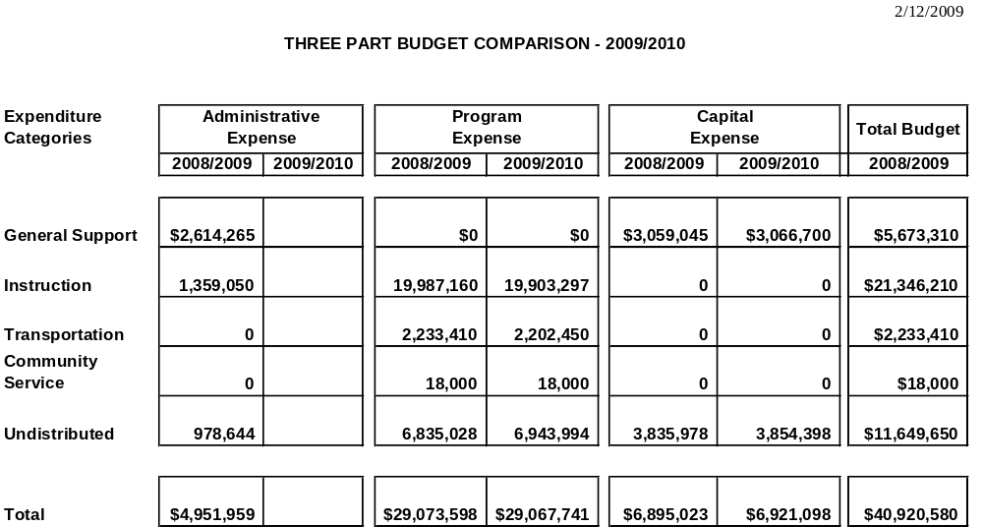
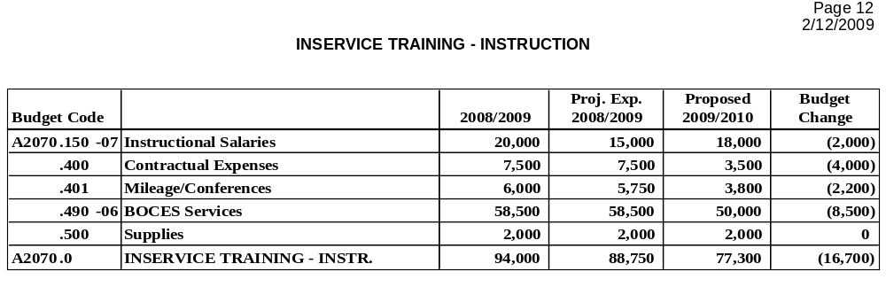

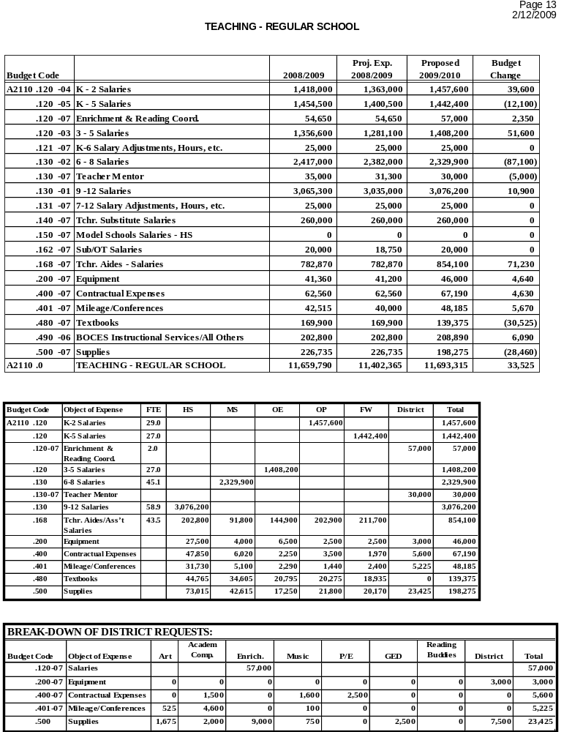

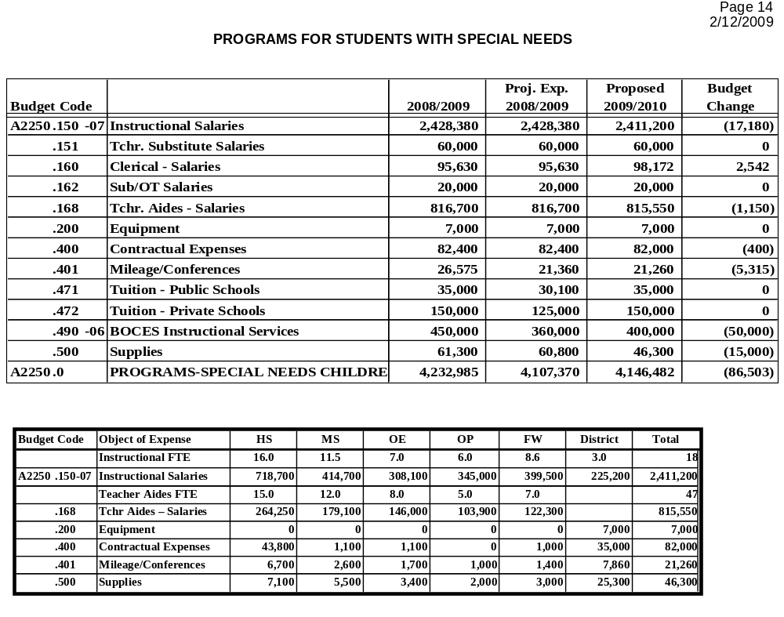

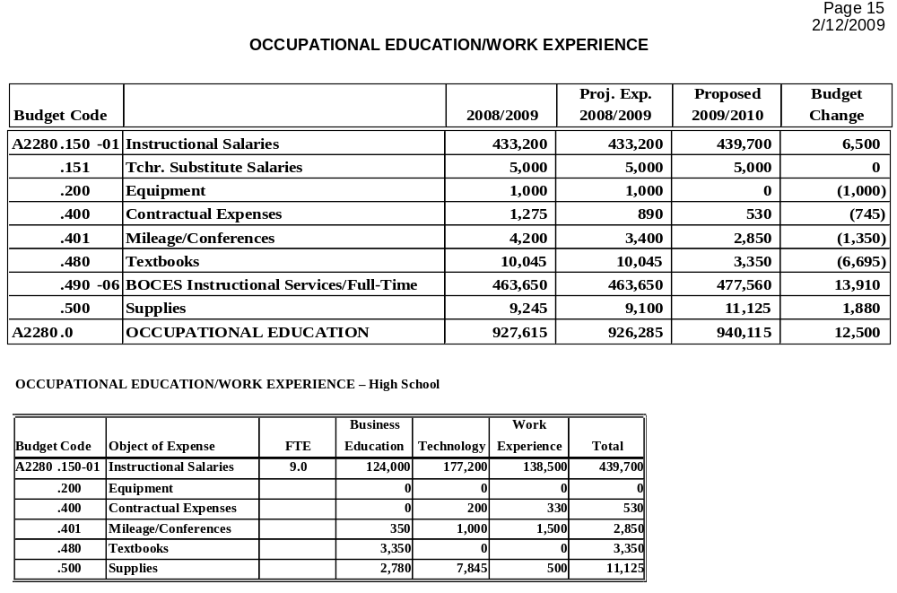

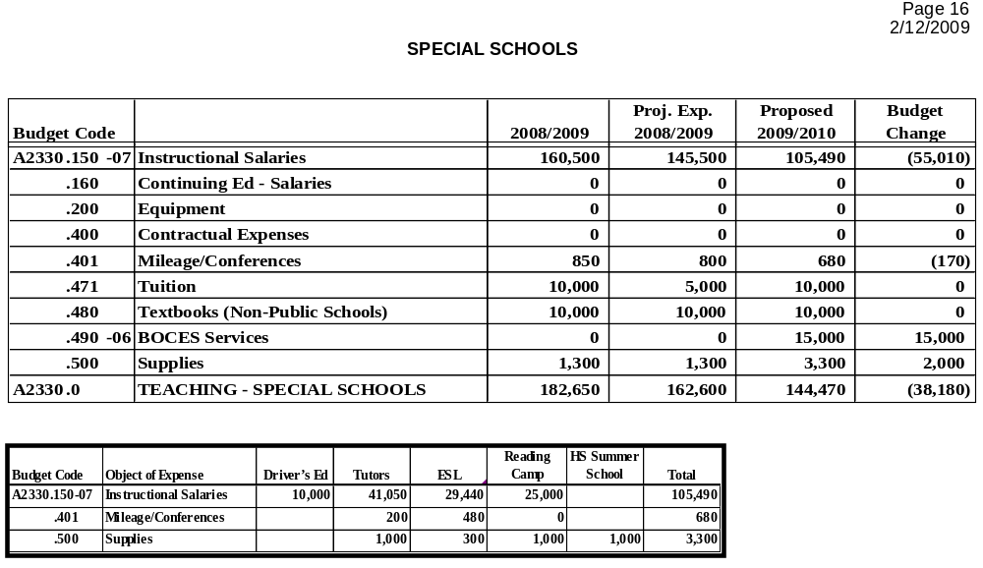

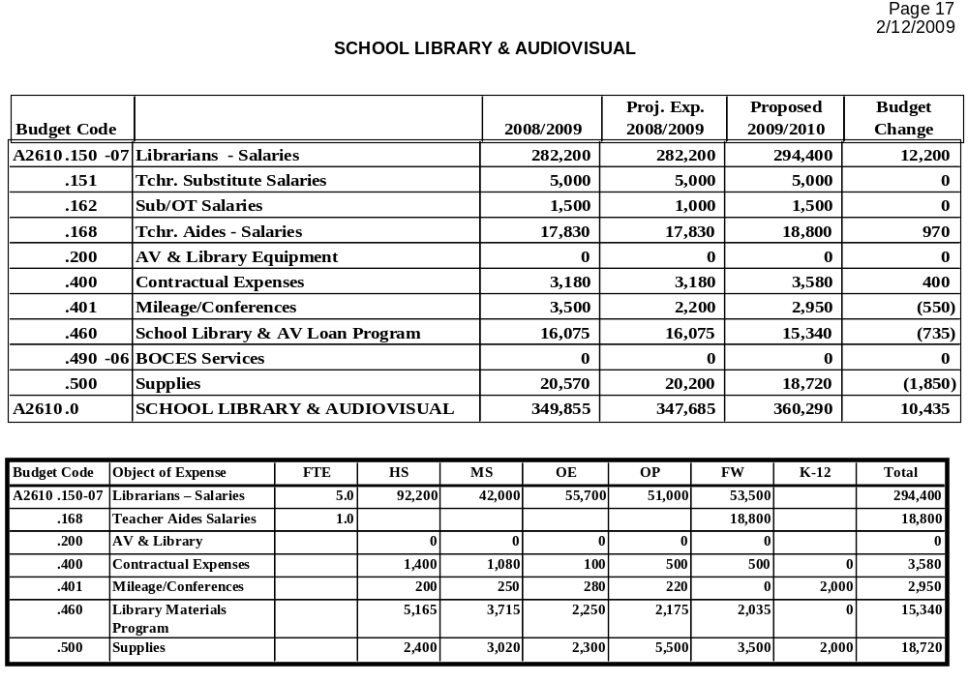

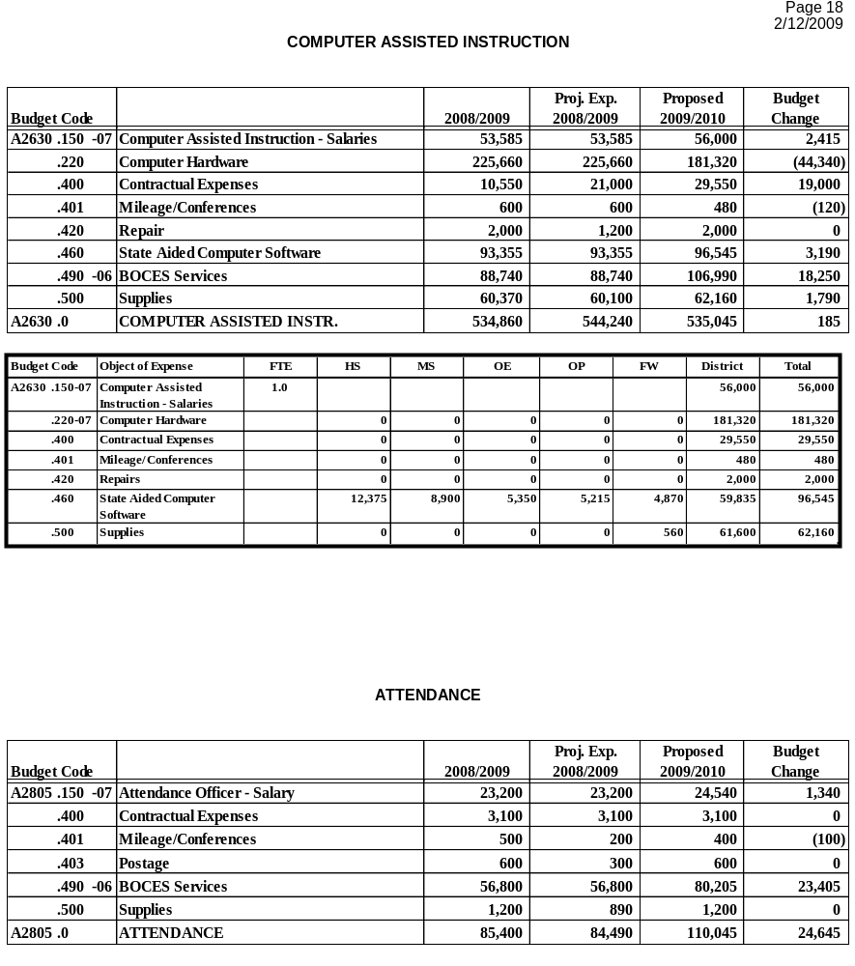

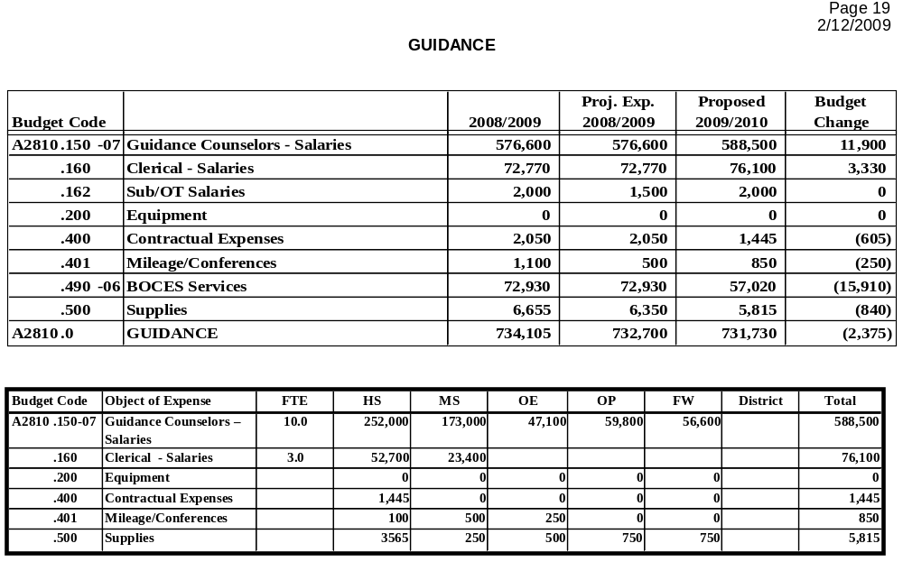

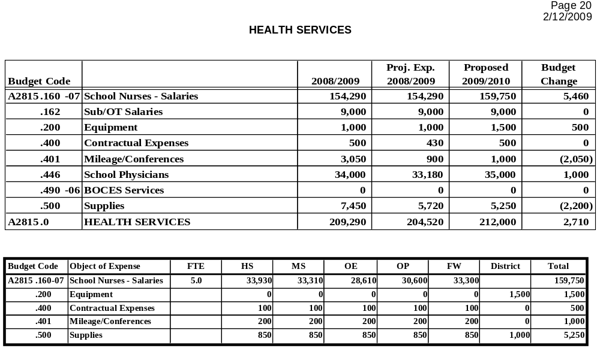

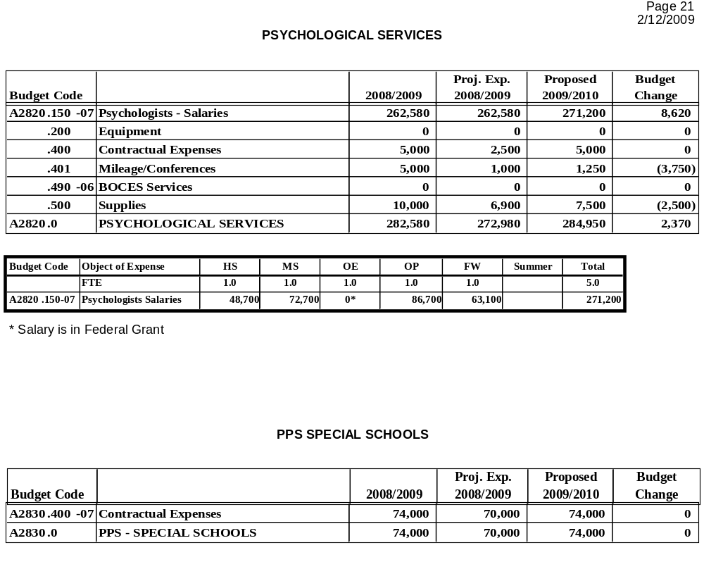

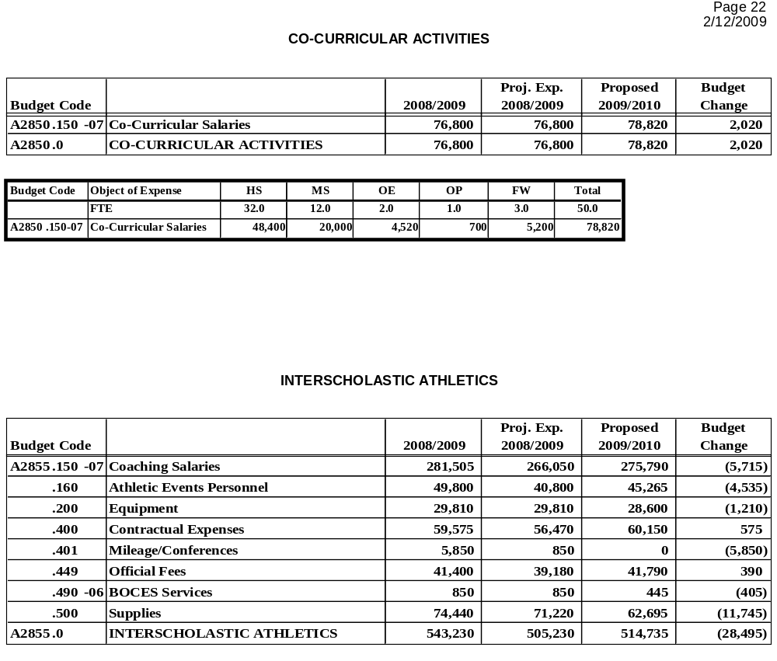

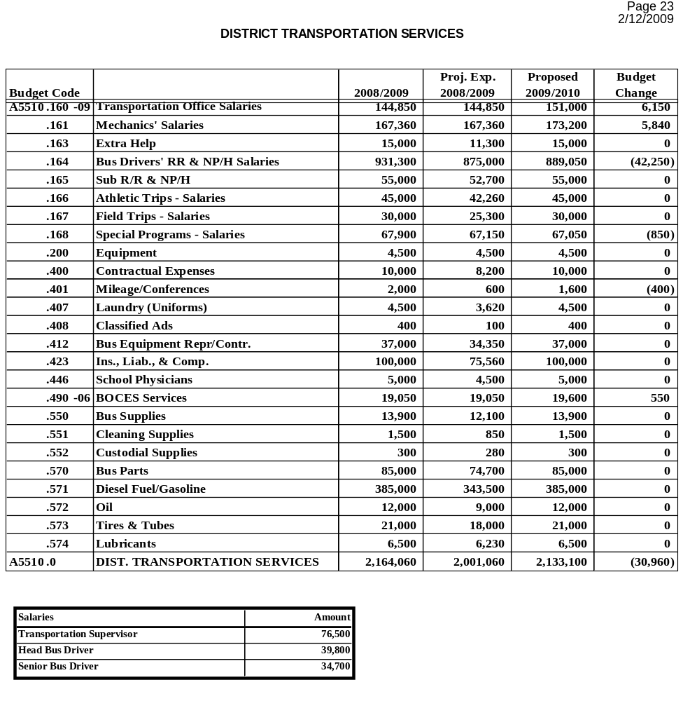

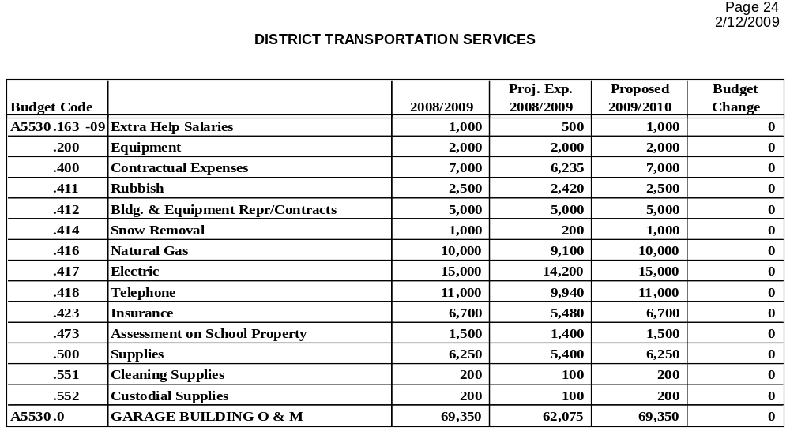

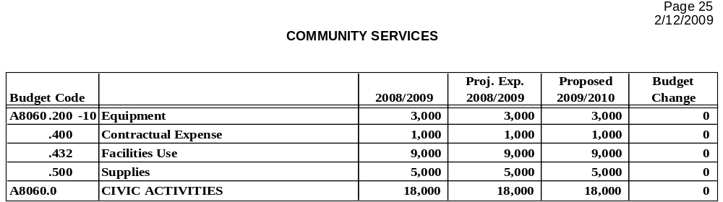

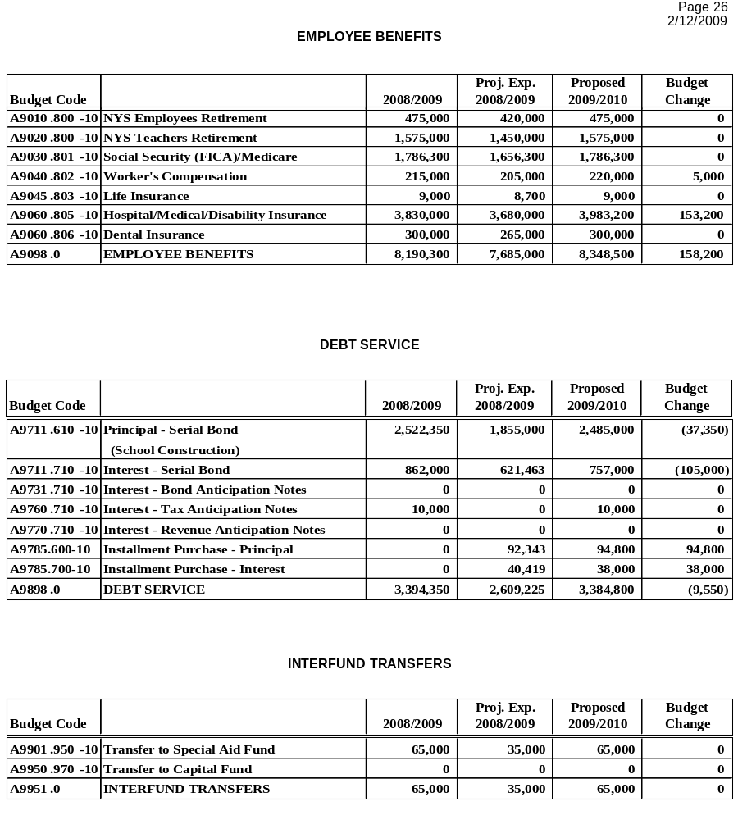

Att. 3

Jacqueline C. Senecal

Administrative Internship Plan
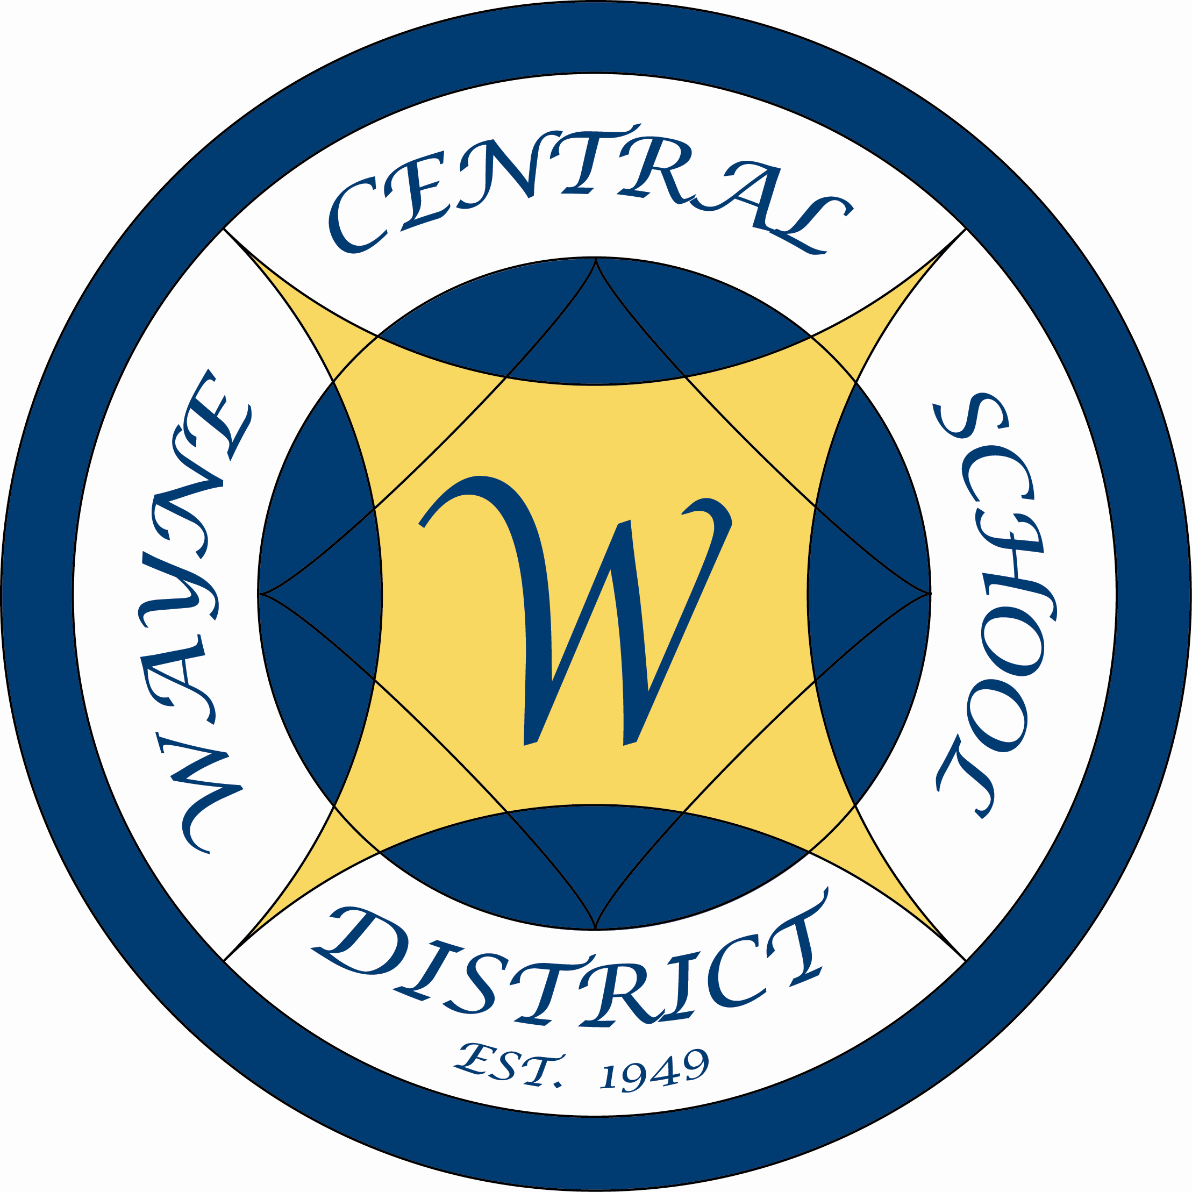

Wayne Central School District

2008-09 School Year

- Student Management

Mentor – Mrs. Holly Armitage
Objectives: | Performance Tasks | Assessment
- The administrator will be able to successfully interpret and administer High School discipline plan.  - The administrator will be able to effectively work with students to make good choices.  - The administrator will be able to gain support and assistance of parents in implementing discipline.  - The administrator will work with teachers to develop and maintain a positive but discipline learning environment. | •The intern will familiarize herself with the High School discipline plan and implementation strategy.  •The intern will supervise AIS discipline referrals  received by Mrs. Armitage.  •The intern will process AIS discipline referrals, investigating issues and assigning discipline as needed.  •The intern will communicate with parents and conduct parent meeting as needed. (Initially meetings will be conducted with the support of Mrs. Armitage until such point when the Intern can conduct parent meetings independently.)  •The intern will mentor two new teachers, who need classroom management assistance and work to improve their skills in that area. (Teachers to be selected by Mrs. Armitage.) | 1. A scoring rubric will be jointly developed by Mrs. Armitage and Mrs. Senecal measuring these objectives.  The rubric will be completed and discussed by both on a quarterly basis.  2. Mrs. Armitage will attest that Mrs. Senecal’s rubrics indicate he has mastered the objectives

- Program Organization

Mentor – Mr. Mark MacMillan and Mrs. Kim Cox
Objectives: | Performance Tasks | Assessment
- Develop the IB Wayne Website.  - Complete a IB Academic/event Calendar.  3. Identification of gaps within the Spanish curriculum based on NY state standards and assessment and on IBO standards and assessments.  - Create a plan for curriculum development to begin its implementation during the school year.  6. RtI – Response to Intervention | 1. Complete the IB Wayne Website to give the community and insight of the IBO Program at WCSD.  2. Create a schedule of internal and external assessments and assignments for all IB classes. Included would be student recognitions as well as upcoming meetings for both faculty and students. This schedule would be available in the IB website.  3. Analyze the results of determine needs and next steps to revamp the current MS/HS Foreign Language Curriculum.  - Work with Mrs. Cox to develop a plan for curriculum writing to make changes to the current Curriculum.  6. Team with Mrs. Jona Wright to develop and implement a new intervention program for at-risk students in the areas of literacy and behavior. Attend IST meetings as well as the brainstorming process of the program. | 1. Mr. MacMillan and Mrs. Armitage will review the finished website prior to attachment to the official WCSD website.  - The Student Academic Schedule will be completed and reviewed by Mr. MacMillan at the end of the first semester.  - Completion of the analysis by May 2009.  - Completed plan June 2009.  1. Manage a specific case study as per Mrs. Jona Wright. Learn aspects of case management through the collaboration with a case manager, including the process of the case study and preparation to the team.  2. Create a binder of intervention strategies for:  A. math  B. behavior  C. literacy

- Leadership: The Bridge Program (Summer School Program)

Mentor: Mr. Bob Armocida and Mr. Chris Shaffer
Objectives: | Performance Task | Assessment
- 1. Candidate will serve in assisting the middle school principal and assistant principal with their summer school program. | •Plan for the upcoming summer school program.  •Plan and provide for student supervision as directed.  •Provide instructional leadership to summer school staff under the direction of current middle school administration.  • Responsible for the overall school operation  •Create and manage the budget | Mr. Armocida and Mr. Shaffer will attest that all areas of preparation and implementation of the program have been mastered and competed.
2. The intern will select student candidates for summer school through the PST process, student assessment scores and teacher recommendations. | •Create a list of at risk students based on their grades on 5th, 6th and 7th grade state exams.  •Plan and create an information packet for parents and students about the program.  •Create a priority list of students invited to the program. | .
3. The intern will hire staff for the summer school program. | •Will develop and implement the criteria for hiring staff.  •Interview staff.  •Conduct staff meetings around goals.  •Create teacher handbook and student handbook.  •Assess staff.  •The intern will create a daily routine of visiting classrooms on a daily basis.
4. The administrator will be able to manage successfully student management issues | • Ensuring follow through of student management related issues including applying appropriate behavior consequences.  •Will process discipline referrals under  the direction of the assistant principal.  •Monitor and supervise students during arrival and dismissal via bus duty.  •Monitor student’s academics as well as behavior.

- Teacher Evaluation

Mentor: Mrs. Kim Cox
Objectives: | Performance Tasks | Assessment
1. The intern will successfully complete an observation of a fellow teacher providing meaningful feedback on how the teacher can grow in the profession. | •Meet with the ASI to review the district observation process  •Conduct a co-observation with an administrator from a building other than the High School.  •Review the write up of this first Observation.  •Conduct a minimum of 6 observations total. | •The intern will conduct at least three co-observations by March 2009.  •The intern will conduct at least three independent observations by June 2009.

Att. 4
WAYNE CENTRAL SCHOOL DISTRICT

To: Board of Education

From: Michael Havens, Superintendent of Schools
(Prepared by Mark D. Callahan, Director of Human Resources)

Re: Personnel Action

Date: February 12, 2009

The following is submitted for your review and approval.

INSTRUCTIONAL STAFF

TENURE RECOMMENDATIONS:

The following teacher and teaching assistant are being recommended by the Superintendent for appointment to tenure according to the tenure area and date listed:

Name Tenure Area Date

Heather Jeffrey English 2/28/09
Nancy Frederes Teaching Assistant 3/29/09

RESIGNATIONS:

Cheryl Fry, Elementary Teacher, assigned to the Freewill Elementary School, effective June 30, 2009. For the purpose of retirement.

LEAVE OF ABSENCE: None

APPOINTMENTS:

Denise Anderson, Art Teacher, NYS Control No. 521172041 (Initial certificate effective through 8/31/2009), assigned to James A. Beneway High School, a four month temporary appointment effective October 24, 2008 through February 27, 2009 at $37,400 pro-rated. Replacement for Beau Watson( FMLA)

SUPPORT STAFF

RESIGNATIONS: None

LEAVE OF ABSENCE:

Durwood Adams, School Bus Driver, assigned to the Transportation Department, effective December 22, 2008 through March 30, 2009. FMLA LOA

David Knorr, School Bus Driver, assigned to the Transportation Department, effective December 13, 2008 through February 12, 2009. FMLA LOA

APPOINTMENTS:

Christine LoDestro, 1:1 Teacher Aide assigned to Ontario Primary School, a temporary Civil Service appointment effective January 5, 2009 through June 30, 2009 at $8.89/hour. New position for new student.

Susan Brewer, Teacher Aide, assigned to Ontario Elementary School, having successfully completed a six month probationary review, a permanent Civil Service appointment effective February 28, 2009 at current hourly rate.

Patricia Gommenginger, Teacher Aide, assigned to James A. Beneway High School, having successfully completed a six month probationary review, a permanent Civil Service appointment effective February 28, 2009 at current hourly rate.

Lynne Howard, Teacher Aide, assigned to Thomas C. Armstrong Middle School, having successfully completed a six month probationary review, a permanent Civil Service appointment effective February 28, 2009 at current hourly rate.

Kim Hynes, Teacher Aide, assigned to Freewill Elementary School, having successfully completed a six month probationary review, a permanent Civil Service appointment effective February 28, 2009 at current hourly rate.

Amy Joram, Cook Manager, assigned to James A. Beneway High School, having successfully completed a six month probationary review, a permanent Civil Service appointment effective February 28, 2009 at current hourly rate.

George Kalweit, School Bus Driver, assigned to the Transportation Department, a three month temporary appointment effective January 5, 2009 through March 30, 2009 at $13.47 per hour. Replacement for Durwood Adams (FMLA LOA).

Jeanine Lubberts, Teacher Aide, assigned to James A. Beneway High School, having successfully completed a six month probationary review, a permanent Civil Service appointment effective February 28, 2009 at current hourly rate.

Kristine Murray, Teacher Aide, assigned to Freewill Elementary School, having successfully completed a six month probationary review, a permanent Civil Service appointment effective February 28, 2009 at current hourly rate.

Bonnie Ocke, Teacher Aide, assigned to Thomas C. Armstrong Middle School, having successfully completed a six month probationary review, a permanent Civil Service appointment effective February 28, 2009 at current hourly rate.

Lorraine Polzin, School Bus Driver, assigned to the Transportation Department, a three month temporary appointment effective December 12, 2008 through February 12, 2009 at $13.47 per hour. Replacement for David Knorr (FMLA LOA).

David Rick, School Monitor, assigned to Ontario Primary School, having successfully completed a six month probationary review, a permanent Civil Service appointment effective February 28, 2009 at current hourly rate.

Pamela Smith, Teacher Aide, assigned to Ontario Elementary School, having successfully completed a six month probationary review, a permanent Civil Service appointment effective February 28, 2009 at current hourly rate.

2008-09 SUBSTITUTE TEACHER APPOINTMENTS

Last Name | First Name
Dec | Gerard
Stitt | Lauren
Riggall | Charles
Pittinaro | Theodore
O'Donnell | Ryan

.

Att. 5

Committee On Special Education Recommendations (February 12, 2009)

Meeting | Alt. ID# | Age | Committee | Grade | Reason | Decision | Disability | Rec.  School | Rec.  Program
1/15/2009 | 101476 | 7.8 | CSE | 02 | Initial Eligibility Determination Mtg. | Classified | Learning Disability | Ontario Primary | Consultant Teacher  Consultant Teacher  Speech/Language Therapy

Committee On Pre-School Education Recommendations (February 12, 2009)

Meeting | Alt. ID# | Age | Committee | Grade | Reason | Decision | Disability | Rec.  School | Rec.  Program
01/14/2009 | 102213 | 5:0 | CPSE | Preschool | Initial Eligibility Determination Mtg. | Classified Preschool | Preschool Student with a Disability | Preschool Itinerant Services  Only | Speech/Language Therapy
01/14/2009 | 101452 | 4:10 | CPSE | Preschool | Initial Eligibility Determination Mtg. | Classified Preschool | Preschool Student with a Disability | Preschool Itinerant Services Only | Speech/Language Therapy

Att. 6

WAYNE CENTRAL SCHOOL DISTRICT
Consensus Agenda

TO: Board of Education

FROM: Michael Havens

RE: Consensus Agenda

DATE: February 12, 2009

The following items are being recommended for approval in a consensus agenda:

#1 Accept Treasurer’s Report – December

#2 Approve Bus Purchase Recommendation

#3 Approve Budget Transfers

#4 Accept Gifts to the District of $3,000 from Fastrac for the purchase of a Kiln at the HS

Consensus Agenda #1

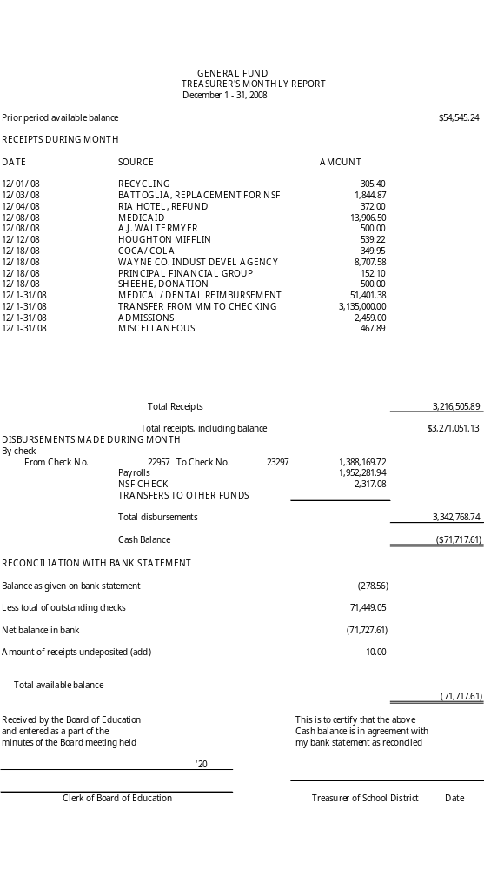
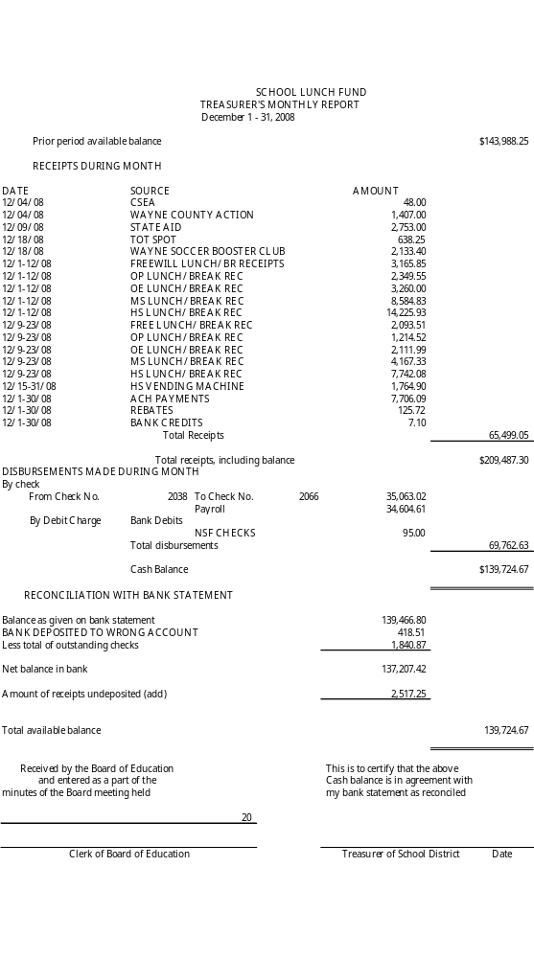
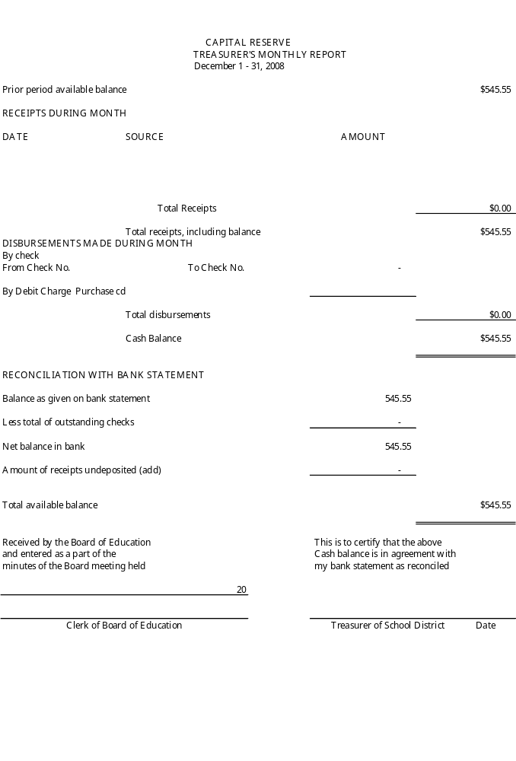
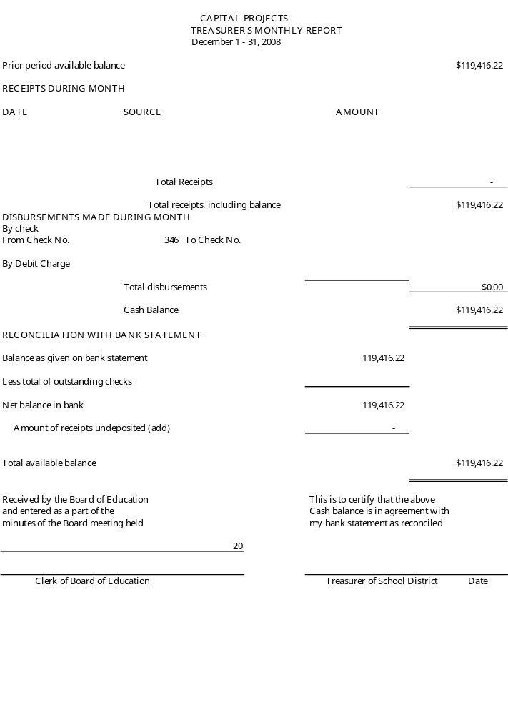

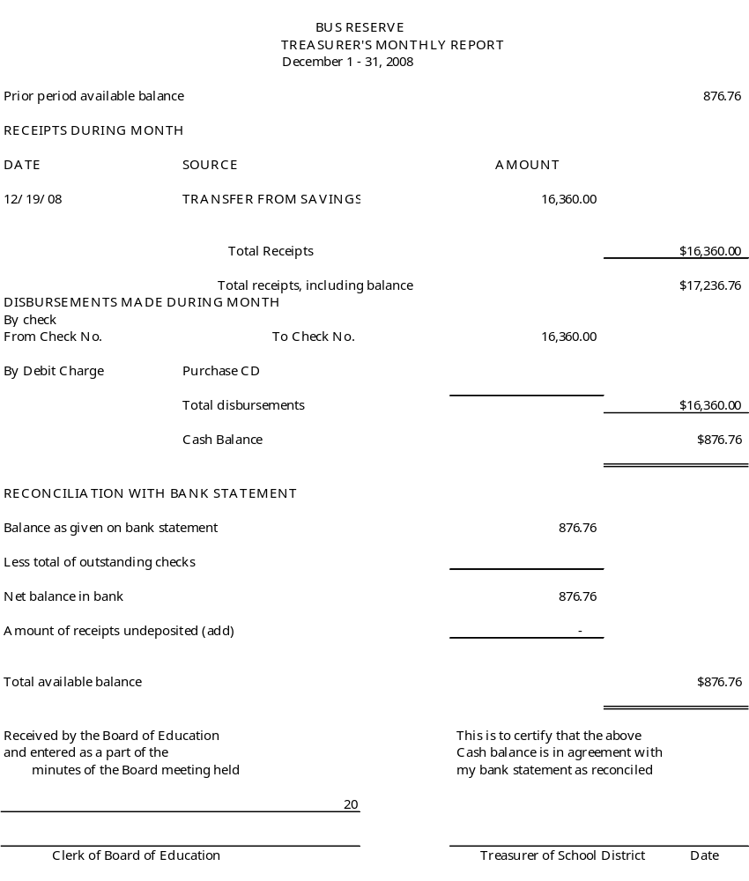

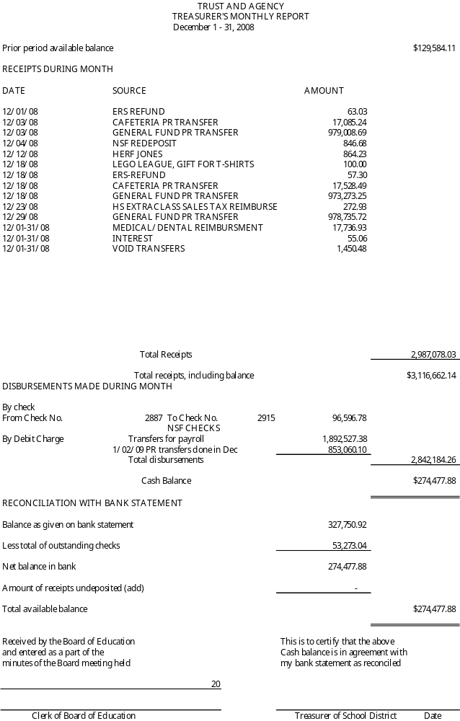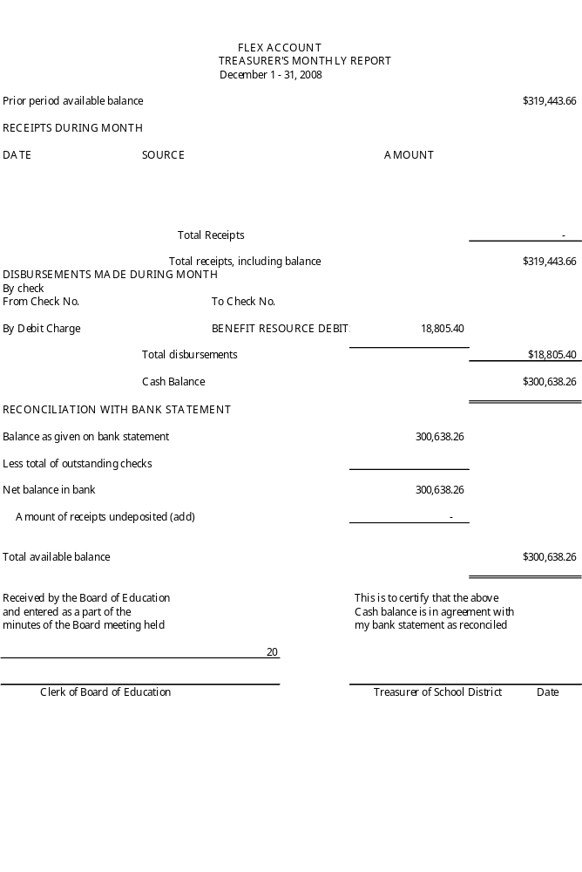
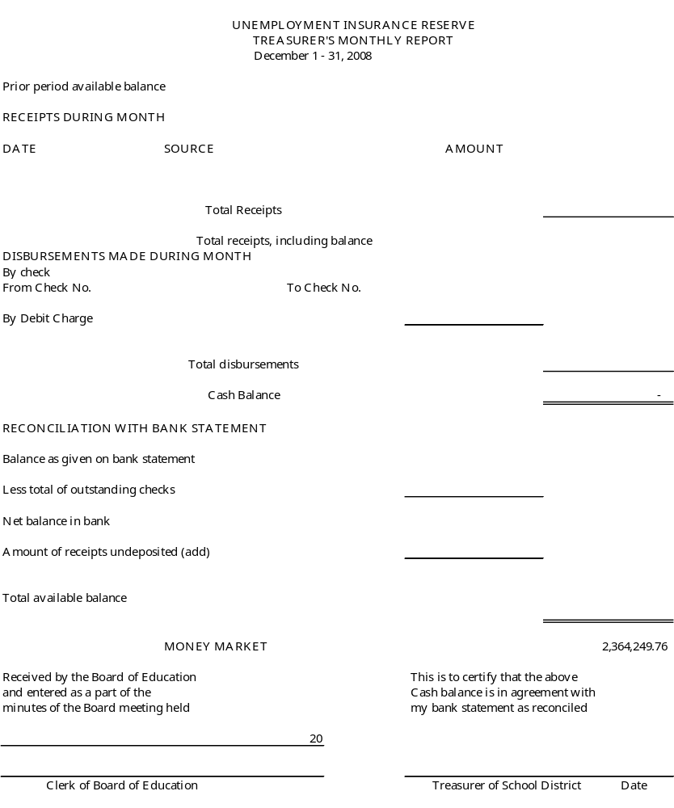
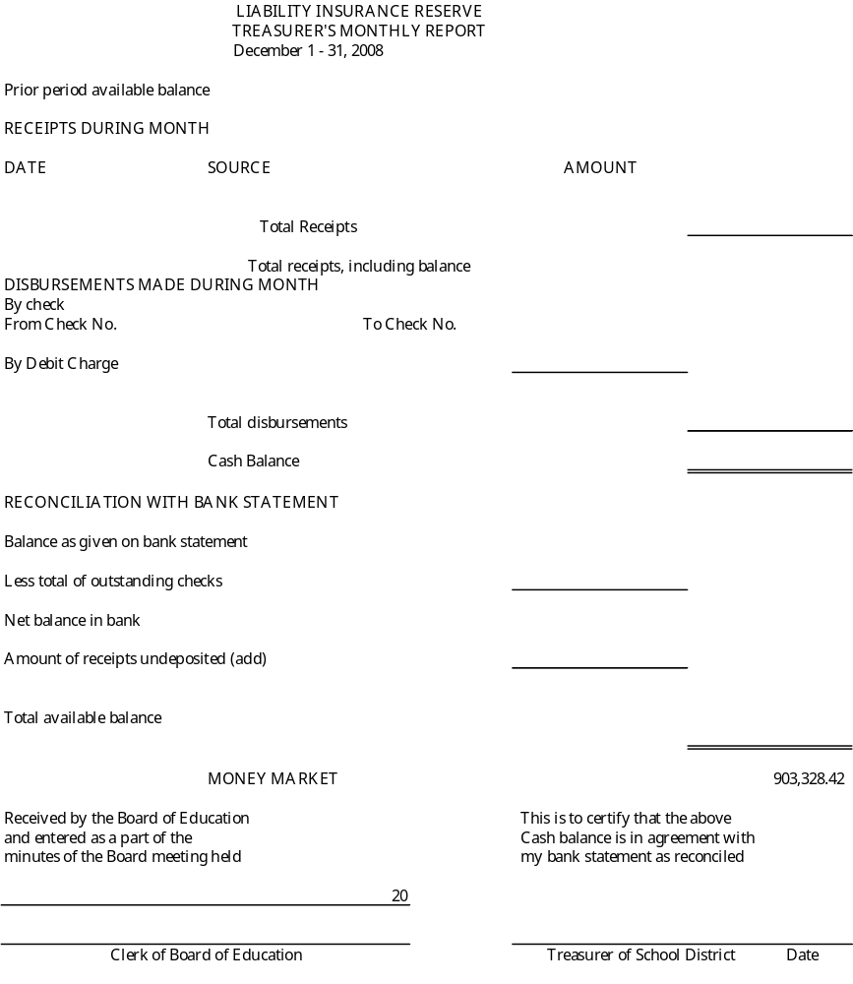

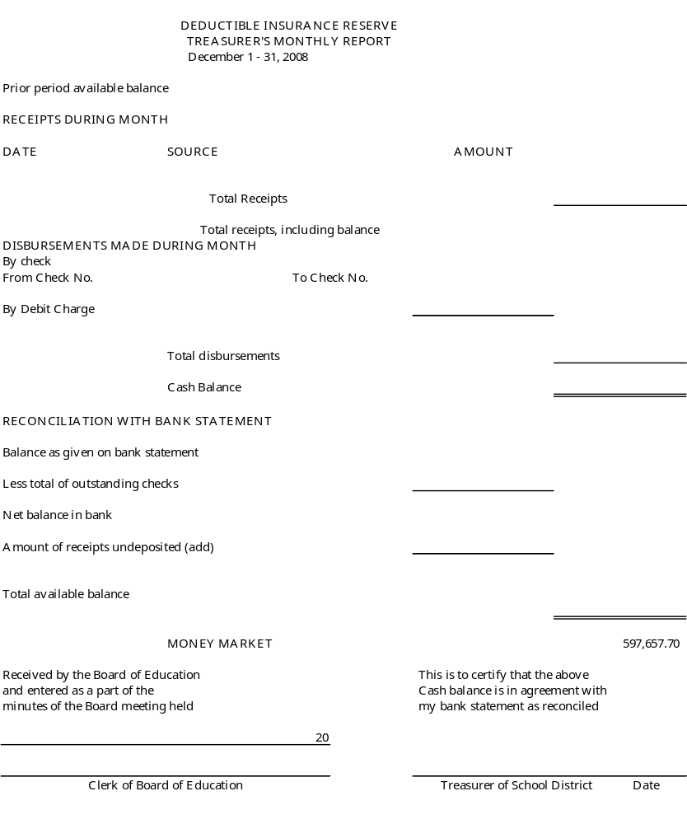

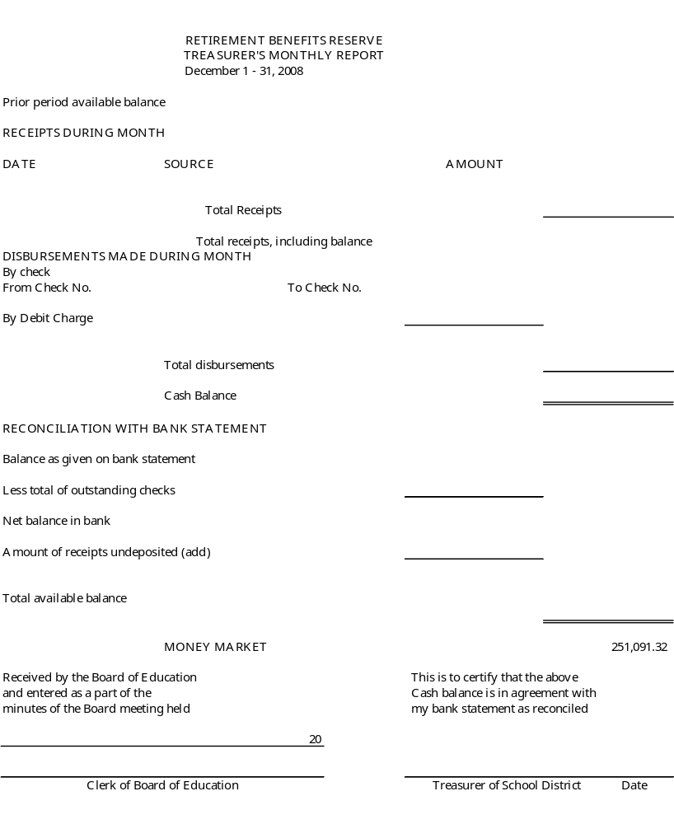`

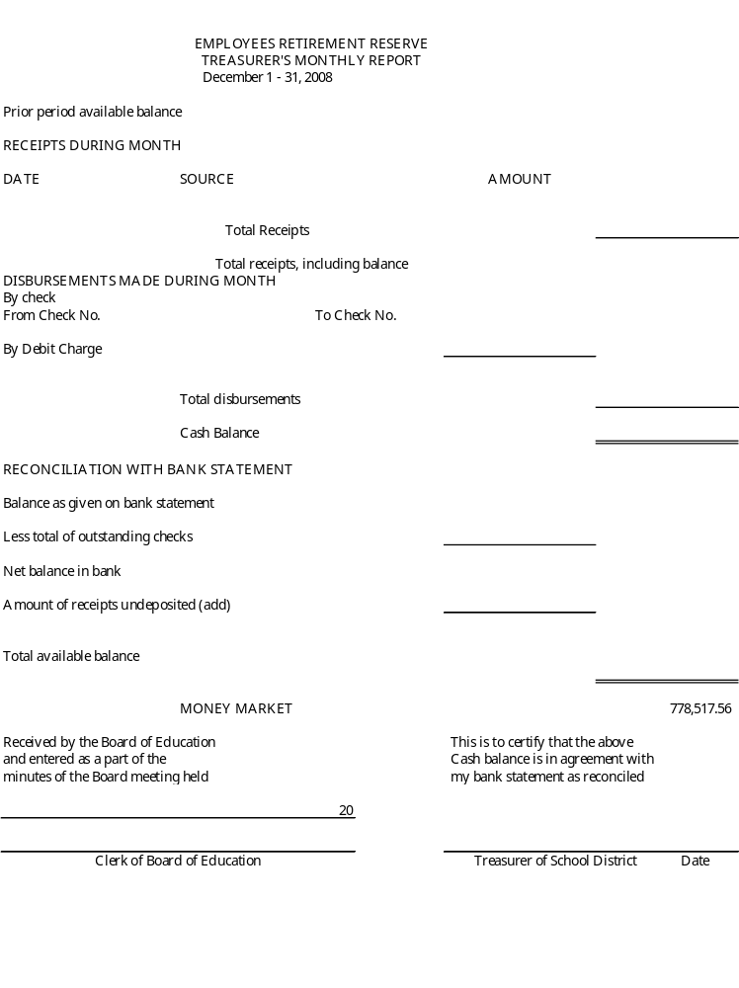

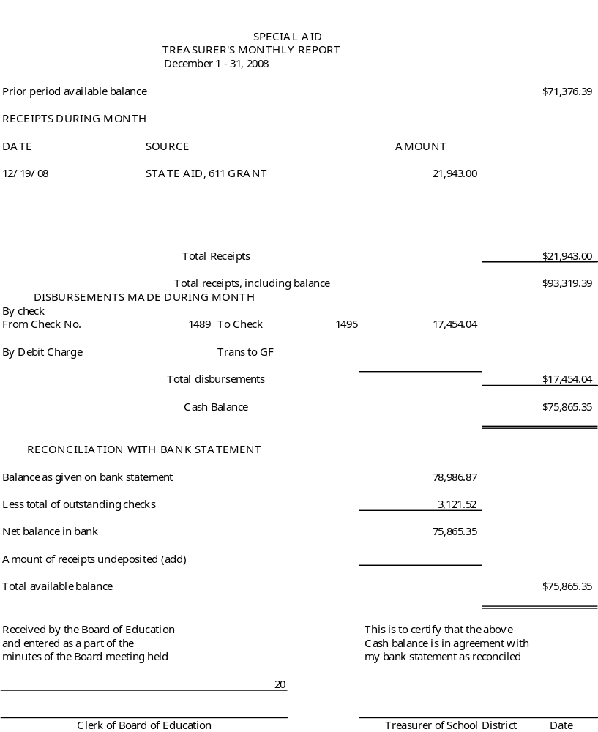

Consensus Agenda #2

To: Michael Havens, Superintendent of Schools

From: Gregory Atseff, Assistant Superintendent for Business

Date: February 5, 2009

Re: Bus Purchase Recommendation

The following is the bus purchase recommendation for the 2009/2010 school year:

Two (2) 65 passenger buses @ $102,994.86 = $205,989.72

Two (2) 65 passenger propane buses @ $115,188.76 = $230,377.52

Two (2) 30 passenger buses @ $49,566.08 = $99,132.16

One (1) wheelchair bus @ $62,493.39 = $62,493.39

TOTAL $597,992.79

The replacement schedule is based on large buses being replaced after ten (10) years, and the mini buses to be replaced after five (5) years. All the buses will be purchased from New York State contracts. We anticipate delivery to be at the beginning of the 2009/2010 school year. This allows the district to utilize the new buses for the entire school year. All bus purchases require voter approval (which will be presented to the voters at the annual school budget vote in May), and are paid for from the district’s Bus Purchase Reserve Fund.
Consensus Agenda #3

TO: Michael Havens
Superintendent of Schools
FROM: Gregory J. Atseff
Assistant Superintendent for Business
DATE: February 12, 2009
RE: Budget Transfers

In accordance with Policy #5330, please present the attached list of budget transfers to the Board of Education for their approval at their meeting on February 12, 2009.

GJA/db

c: Helen Jensen, Clerk

Attachment

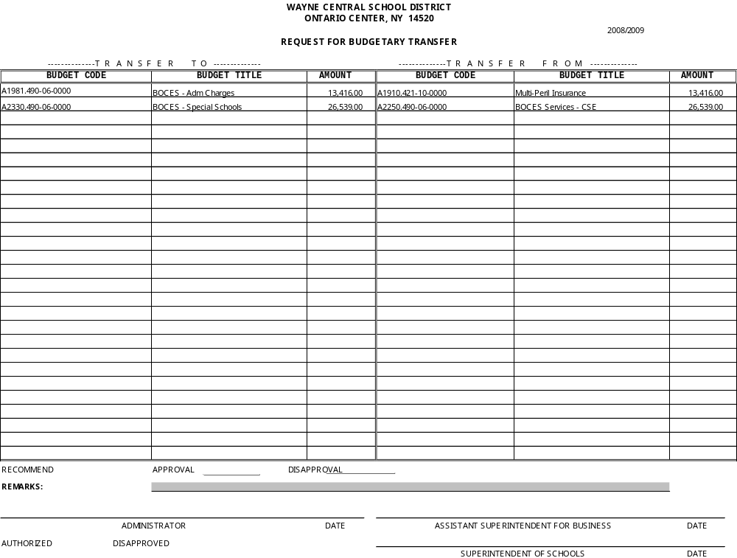

Consensus Agenda #4

TO: Michael Havens
Superintendent of Schools
FROM: Gregory J. Atseff
Assistant Superintendent for Business
DATE: February 12, 2009
RE: Gifts to the District

Wayne Central School District was one of 18 schools in New York State to receive a $3,000 grant from Fastrac Markets. The grant had one contingency; that the funds be used to purchase equipment or materials directly related to the education of the students. These funds will be used to purchase a ceramic firing kiln for the high school art classes.

Recommend that the Board of Education, at their regular meeting to be held on Thursday, February 12, 2009, accept this $3,000 gift from Fastrac Markets to purchase a ceramic kiln.

/db

c: Joseph Siracuse
Lee Stramonine
Helen Jensen

Att. 7

Policy Submitted for First Reading

1313 Annual Re-Organizational Meeting of the Board of Education
(re: Mileage Reimbursement)

1350 Appointment & Duties – Internal Claims Auditor (Re-Submitted)

1500 Notice & Agenda for Board of Education Meetings

5511 Audit Committee – Charter

5760 Qualifications of Bus Drivers/Operation & Use of School Busses

6160 Use of Alcohol, Drugs & Substances in the Workplace

Policy Submitted for Single Reading

5310 Bonding of Employees & School Board Members

5550 Disclosure of Wrongful Conduct and Protection From Reprisal

5560 Application For & Use of Federal Funds

5640 Smoking & Tobacco Use

5660 Food Service Program – Free & Reduced Price Food Services

7111

2/12/09 Board Meeting

Presented for First Reading by Board of Education on February 12, 2009 Revisions in Blue (Page 2-Mileage)
Proposed Revisions By Policy Committee; Response to Discussion by Board of Education on January 22, 2009

By-Laws 1313
Page 1 of 2

ANNUAL RE-ORGANIZATIONAL MEETING OF THE BOARD OF EDUCATION

As provided by NYS Education Law, the Board of Education must conduct a re-organizational meeting on the first Wednesday of July, or, if a legal holiday, on the following day. As an alternative, the Board of Education may adopt a resolution to establish the date for said re-organizational meeting during the first fifteen (15) days of July.

The purpose of the re-organizational meeting shall be to elect officers of the Board of Education and make the necessary appointments and designations of other district officers & officials for the proper management of the school district during the school year. The Board of Education shall also perform such annual functions as are designated by law.

The annual re-organizational meeting of the Board of Education shall be held before July 15th as previously established by resolution of the Board of Education.

The meeting shall be called to order by the previous school board president or his or her designee, who shall preside until the election of a new president. The order of business to be conducted at the re-organizational meeting shall include the following items required or implied by state law and/or regulation and local option:

Administration of Oath of Office

The school district clerk shall administer the oath of office to newly elected board members. Such oath shall conform to Article XIII-1 of the New York State Constitution, and §10 of the Public Officers Law. The school district clerk shall counter-sign the oath. No new board member shall be permitted to vote until he or she has filed the oath of office.

Election of Officers

The Board of Education shall elect a president and vice-president for the ensuing year and the school district clerk shall administer the oath of office to them. Such service shall be limited to three (3) consecutive terms. A majority of all members of the Board of Education shall be necessary for a valid election.

Appointment of Officers

The Board of Education shall appoint and establish the stipend (if any) for the following officers:

District Clerk District Treasurer School Tax Collector
Internal Claims Auditor Assistant District Treasurer
Records Management/Access Officer

ADOPTED: September 10, 2003 REVISED: February 7, 2008 REVISED: March …, 2009

Policy Handbook • Wayne Central School District • Ontario Center, New York 14520

Bylaws 1313
Page 2 of 2

ANNUAL RE-ORGANIZATIONAL MEETING OF THE BOARD OF EDUCATION (continued)

Additional Appointments

The Board of Education shall appoint and establish the stipend (if any) for the following positions:
School Physician School Attorney
Census Enumerator Attendance Officer
Purchasing Agent School Architect
External Auditor Internal Auditor
LEA Asbestos Compliance Designee Chemical Hygiene Officer
Civil Service Appointing Officer American Disabilities Act Coordinator
Liaison for Homeless Youth Section 504 Compliance/Hearing Officer
Title IX Compliance/Hearing Officer & Alternate Compliance/Hearing Officer
Central Treasurer(s), Extra-Classroom Activity Account (s)

Additional Designations

The Board of Education shall make additional designations, including the following:
Official Depositories
Official Newspaper(s)

Bonding of Personnel
Superintendent of Schools to Handle Student Residency Determinations
Board of Education Meeting Schedule
Signatory(s) of School District Checks & Authorization to Use Check-Signing Machine
Mileage Reimbursement Rate (As Defined by Latest Directive of the U.S. Internal Revenue Service)
Fees for Copies under the Freedom of Information Law
Fees for Use of School Facilities & Staff Compensation for Same (Custodial, Food Service)
Per Diem Rates for Substitute Teaching & Non-Teaching Personnel
Petty Cash Fund Amounts and Signatory(ies)
Additional Required Signatory(ies), Extra-Classroom Activity Funds
School Board Liaisons/Alternates to Four County School Boards Association
School Board Liaison/Alternate to Board of Education of Wayne-Finger Lakes BOCES

Committees of & Liaisons for the Board of Education
Standing Committees Ad Hoc Committee Liaisons to PTA/Parent Groups

Additional Authorizations:

The Board of Education shall approve additional authorizations, including the following
Authorization for the Chief School Officer to Make Budget Transfers
Authorization for the Chief School Officer to Make Invest Funds (e.g. General, School Lunch, Capital)
Authorization for the Chief School Officer to Borrow Funds within Limits Set By Board of Education
Authorization for the Chief School Officer to Approve Attendance at Conferences, Conventions, Workshops
Authorization for the Chief School Officer to Certify Payrolls
Designation of District-Wide and Building Level School Safety Teams
Adopt Continuing Resolutions for School Board Officers to Issuance Revenue/Tax Anticipation Notes
Adopt Continuing Resolutions for Joint Purchasing Programs

ADOPTED: September 10, 2003 REVISED: February 7, 2008 REVISED: March …, 2009

Policy Handbook • Wayne Central School District • Ontario Center, New York 14520

Deletions Underlined Italic; Revisions in Blue; First Reading by Board of Education on Feb 12 09
New Text Recommended By Audit Committee & Presented By Policy Committee
Re-Submitted for First Reading on February 12 (Items Omitted on January 22nd)

By-Laws 1350

APPOINTMENT AND DUTIES OF THE INTERNAL CLAIMS AUDITOR

Job Description

The Board of Education will designate and appoint a/an internal claims auditor (s) for the school district at the re-organizational meeting. The internal claims auditor(s) shall serve at the pleasure of the Board of Education and will report to the audit committee of the Board of Education. The internal claims auditor(s) is/are responsible for formally examining allowing or rejecting all accounts, charges, claims or demands against the school district.

The internal auditing process should determine that the:

- proposed payment is for a valid and legal purpose.
- obligation was incurred by an authorized school district official,
- items for which payment is claimed were in fact received or, in the case of services, were actually rendered,
- submitted claim voucher is in the proper form, mathematically correct, does not include previously paid charges, and is in agreement with the purchase order or contract upon which it is based
- submitted claims meet such other requirements as may be established by the Regulations of the Commissioner of Education and/or the Comptroller of the State of New York.

The internal claims auditor(s) shall have access to all documents regarding financial transactions to ensure that such documents are in compliance with the law, district policy and regulations. Questions or unresolved issues will be directed to the President of the Board of Education audit committee of the Board of Education .

Any claim originated by or relating to the internal claims auditor will be reviewed and approved by the audit committee.

The school district treasurer shall need the signature of approval of the internal claims auditor for payment of a warrant, invoice or payroll. It shall constitute the same authorization for payment as a resolution of the Board of Education.

No person shall be eligible for appointment to the office of internal claims auditor who shall be:

- A member of the Board of Education
- A member of the audit committee of the Board of Education
- The district clerk or district treasurer of the Board of Education
- The school district official responsible for business management
- The purchasing agent
- Clerical personnel directly involved in accounting and purchasing functions

Adopted: September 10, 2003 Revised: March .., 2009

Policy Handbook • Wayne Central School District • Ontario Center, New York 14520

Presented for First Reading by Board of Education on February 12, 2009
Proposed Revisions By Policy Committee; Discussion on Protocol vz Policy Revisions in Blue

By-Laws 1500

NOTICE OF & AGENDA FOR BOARD OF EDUCATION MEETINGS

In order to perform its duties in an open and public manner, and in accordance with state law, the Board of Education shall hold regular meetings at least once a month.

The time, dates and place of regular school board meetings shall be established at the annual re-organizational meeting. All regular meetings are open to the public and meeting facilities shall provide access to persons with disabilities.

In addition to the members of the Board of Education, the following individuals will regularly attend the business meetings of the Board of Education: the superintendent of schools, assistant superintendents, and other specified personnel as deemed necessary.

Notice of Meetings

The Board of Education believes that public notice of its activities is essential to ongoing, proactive cooperation between the Board of Education and the community it serves.

In accordance with state law, notice of meetings shall be provided to all members of the Board of Education, superintendent of schools and school district clerk by distribution of advance copies of meeting agenda and attachments.

In addition, the school district clerk shall issue public notice of school board meetings to the local news media, the public at large and other outlets as required by the NYS Open Meetings Law. Such notice shall occur not less than seventy-two (72) hours prior to the meeting. If a meeting is scheduled at least one (1) week in advance, public notice must be given by posting in one (1) or more designated public places. When a meeting is scheduled less than a week in advance, notice shall be made, to the extent possible, by posting conspicuously in one or more designated public locations.

Agenda Preparation, Content and Dissemination

The Board of Education agenda will be prepared and distributed by the superintendent of schools after consultation with school board officers. Any board member or staff member may request that certain items be included on the published agenda. Items from the staff must be submitted in writing to the superintendent of schools at least two (2) weeks in advance of the meeting. Supportive documentation may be requested.

All reports presented to the Board of Education must be scheduled by the superintendent of schools.

Unless determined by protocol guidelines of the Board of Education, business items which are located in the board action portion of the agenda are presented for consideration and action at the same business meeting. Items presented in the report of the superintendent of schools will be voted upon at the subsequent meeting. School board policy or regulations are subject to single or dual review as outlined by Bylaw 1410 (Adoption of Policy). By majority vote, the Board of Education by decided to shorten or lengthen the number of times items are considered.

Except for an emergency, the Board of Education agenda, which contains items needing school board action, will be in the hands of board members at least three (3) calendar days prior to the meeting.

Open Meetings Law, Public Officers Law §100 et seq. Education Law §§ 1606; 1708; 2504; 2563

ADOPTED: September 10, 2003 REVISED: February 7, 2008 REVISED: March …, 2009

Policy Handbook • Wayne Central School District • Ontario Center, New York 14520
Deletions Underlined Italic; Submitted for First Reading on February 12, 2009
(Initial First Reading Was Tabled on June 19, 2008; Re-Considered by 2008-2009 Policy Committee)
Text Revisions Recommended By Audit Committee & Presented By Policy Committee

Non-Instructional/Business Operations 5511
Page 1 of 4
AUDIT COMMITTEE - CHARTER

COMMITTEE AUTHORITY

Pursuant to resolution of the Board of Education, dated June 8, 2006, an audit committee was formed to assist the Board of Education of Education in the oversight of both the internal and external audit functions. The requirement to create an audit committee was established by Education Law §2116-c.

In accordance with Education Law §2116-c (4), the role of an audit committee shall be advisory and any recommendations it provides to the Board of Education shall not be substituted for any required review and acceptance by the Board of Education.

MISSION

The Board of Education has established an audit committee to provide independent advice, assistance, and recommendations to the Board of Education in the oversight of the internal and external audit functions of the district.

COMPOSITION AND REQUISITE SKILLS

The audit committee is comprised of a committee of three (3) members who collectively possess the knowledge in accounting, auditing, financial reporting and school district finances needed to understand and evaluate the school district’s financial statements, the external audit and the district’s internal audit activities.

Accordingly, the audit committee’s members, collectively, should:

● Possess the requisite knowledge necessary to understand technical and complex financial reporting issues.
● Have the ability to communicate with auditors, public finance officers and the school Board of Education.
● Be knowledgeable about internal controls, financial statement audits and management/operational audits.

To provide continuity for the changing nature and complexity of issues handled by the committee, at least one (1) committee member will continue to serve on the committee from year to year.

Adopted: January 11, 2007 Revised: March .., 2009

Policy Handbook • Wayne Central School District • Ontario Center, New York 14520

5511
Page 2 of 4
Non-Instructional/Business Operations

AUDIT COMMITTEE - CHARTER
Duties and Responsibilities

The duties and responsibilities of the audit committee include the following:

(1) External Audit Focus

● Make recommendations to the Board of Education regarding the appointment of the external auditor
● Meet with the external auditor prior to commencement of the audit to, among other things, review the engagement letter.
● Review and discuss with the external auditor any risk assessment of the district’s fiscal operations developed as part of the auditor’s responsibilities under governmental auditing standards for a financial statement audit and federal single audit standards, if applicable.
● Receive and review the draft annual audit report and accompanying draft management letter, including the external auditor’s assessment of the district’s system of internal controls, and, working directly with the external auditor, assist the Board of Education in interpreting such documents.
● Make a recommendation to the Board of Education on accepting the annual audit report.
● Review every corrective action plan developed by the school district and assist the Board of Education in the implementation of such plans.

(2) Internal Claims Audit Focus

● Make recommendations to the Board of Education regarding the annual appointment of the internal claims auditor.
● Meet with the internal claims auditor on not less than a quarterly basis to review and discuss any concerns or findings of his or her review of all claims presented for payment by the school district
● Meet with the internal claims auditor on not less than a quarterly basis for a risk assessment of the district’s fiscal operations or recommendations for modifications or improvement of the process for internal claims

(3) Internal Audit Focus

● Make recommendations to the Board of Education regarding the appointment of the internal auditor
● Assist in the oversight of the internal audit function, including reviewing the annual internal audit plan to ensure that high risk areas and key control activities are periodically evaluated and tested, and reviewing the results of internal audit activities.
● Review significant recommendations and findings of the internal auditor.
● Monitor implementation by management of the recommendations of the internal auditor
● Participate in the evaluation of the performance of the internal audit function.

Adopted: January 11, 2007 Revised: March .., 2009

Policy Handbook • Wayne Central School District • Ontario Center, New York 14520

Non-Instructional/Business Operations 5511
Page 3 of 4
AUDIT COMMITTEE - CHARTER
Performance of Duties

The duties of the audit committee include the following:

Good Faith

Committee members shall perform their duties in good faith in a manner they reasonably believe to be in the best interests of the committee and the school district with such care as a generally prudent person in a similar position would use under similar circumstances.

Independence

An individual, other than members of the Board of Education, may not serve on an audit committee constituted as an advisory committee if he or she:

● Is employed by the district.
● Currently provides, or within the prior two years, has provided, goods or services to the school district.
● Is an immediate family member (spouse, spouse equivalent or dependent, whether or not related) or close family member (parent, sibling or non-dependent child) of an individual who is an employee, officer or contractor providing services to the district.
● Is the owner of or has a direct and material interest in a company providing goods or services to the district.

Confidentiality

During the exercise of duties and responsibilities, the committee members may have access to confidential information. The committee shall have an obligation to maintain the confidentiality of such information.

MEETINGS AND NOTIFICATION

The audit committee shall meet on not less than a quarterly basis. An agenda of each meeting should be clearly determined in advance and the audit committee should receive supporting documents in advance, for reasonable review and consideration.

The number of persons present at such committee meetings shall not create or exceed a quorum of the Board of Education.

The audit committee shall give notice and prepare minutes of each meeting. At a minimum, the minutes will include the following:

● The meeting agenda
● Date, attendance and location of the meeting
● Except as otherwise provided by law in connection with executive sessions, summaries of the topics discussed, and all motions, proposals, resolutions and any other matter formally voted upon and the vote thereon, including recommendations agreed to by the committee.
● As appropriate, copies of materials discussed or presented at the meeting.

Adopted: January 11, 2007 Revised: March ….. 2009

Policy Handbook • Wayne Central School District • Ontario Center, New York 14520

Non-Instructional/Business Operations 5511
Page 4 of 4
AUDIT COMMITTEE - CHARTER

DECISION-MAKING PROCESS

All decisions shall be reached by vote of a simple majority of the total membership of the committee. A quorum constitutes a simple majority of the total membership and meetings will not be conducted unless a quorum is present.

REPORTING REQUIREMENTS

The audit committee has the duty and responsibility to report its activities to the Board of Education as needed, but not less than annually. Periodic written reports of audit committee activities are an important communication link between the committee and the Board of Education on key decisions and responsibilities.

The audit committee’s reporting requirements are to:

● Report on the scope and breadth of committee activities so that the Board of Education is kept informed of its work.
● Provide minutes or a summary of minutes of meetings which clearly record the actions and recommendations of the committee.
● Report on their review of the school district’s draft annual audit report and accompanying management letter and their review of significant findings.
● Report on suspected fraud, waste or abuse, or significant internal control findings and activities of the internal control function.
● Report on indications of any material or significant non-compliances with laws or district policies and regulations.
● Report on any other matters that the committee believes should be disclosed to the Board of Education

REVIEW OF THIS CHARTER

The audit committee shall assess and report to the Board of Education on the adequacy of this charter no less than an annual basis or as necessary. Charter modifications, as recommended by the audit committee, should be presented to the Board of Education in writing for their review and consideration.

Adopted: January 11, 2007 Revised: March ...., 2009

Policy Handbook • Wayne Central School District • Ontario Center, New York 14520
Presented for First Reading by Board of Education on February 12, 2009 5760
Proposed Revisions By Policy Committee; Annual Review of 50% of Policy Handbook
Deletions Underlined Italic; Revisions in Blue

Non-Instructional/Business Operations

QUALIFICATIONS OF OPERATION & USE OF SCHOOL BUSSES DRIVERS

Qualification & Training of School Bus Drivers

Only employees who have the appropriate license for the vehicle operated and who have complied with the regulations of the Commissioners of Motor Vehicles, Transportation and Education may drive a school owned vehicle having a pupil capacity greater than 15 passengers. may drive students to and from home on regularly scheduled routes.

To ensure the adequate and effective training of bus drivers, no person shall be allowed to operate a school bus without first receiving all of his/her training approved by and under the direct supervision of a school bus driving instructor approved by the NYS Education Department. While a trainee engages in pre-service training, which takes place prior to a driver transporting children, no direct supervision is mandated. however, an instructor approved by the NYS Education Department must approve all training.

None other than the above-mentioned persons may drive a school owned vehicle having a pupil capacity greater than 15 passengers. Employees hired as bus drivers as well as instructional staff members certified by the NYS Education Department may drive school vehicles having capacities of fewer than fifteen (15) passengers. The latter, however, may not drive on regularly scheduled routes.

Instructional staff members certified by the NYS Education Department transporting students in school-owned vehicles must also comply with requirements of the Commissioners of Motor Vehicles, Transportation and Education.

Upon completion of the established training procedures, the school district shall verify compliance with the direct supervision requirement through the use of their record-keeping systems.

The Board of Education also recognizes the importance of the contact time and relationships between bus drivers and students. In-service programs for bus drivers shall be provided annually to include, but not be limited to, such topics as student behavior management, child abuse and neglect, and first aid and CPR.

Operation of School Busses & School-Owned Vehicles

All school bus drivers must possess the appropriate Commercial Driver’s License (CDL) pursuant to NYS Vehicle & Traffic Laws. Instructional staff members certified by the NYS Education Department may drive school vehicles having capacities of fewer than fifteen (15) passengers. Volunteer bus drivers who operate a bus designed to carry fourteen (14) or fewer passengers and drive less than thirty (30) days per year are exempt from this (CDL) requirement. Such drivers may not drive regularly scheduled routes.

Lease or Rental of School Busses

If the need arises to rent a school bus to meet district needs, the leasing agency, and driver, if provided, must qualify under existing state regulations and be approved by the director of transportation. If a request is made to rent or lease a district vehicle to another school district or agency, said other school district or agency is responsible to provide a duly licenses and approved driver.

In regard to buses that are being leased, the lessee must employ a duly licensed and trained bus driver, who must be approved by the school district. The bus driver will not be furnished as part of the lease. If the lessee is another school district, that school district must certify, in writing, to the transportation manager that the bus driver employed is an approved school bus driver.

Education Law §36248Commercial Motor Vehicle Safety Act (CMVSA),; 1986 Vehicle and Traffic Law, Article 19-A
NYCRR §156.3, as amended ; 15 NYCRR Part 3
Adopted: September 10, 2003 Revised: March …., 2009

Policy Handbook • Wayne Central School District • Ontario Center, New York 14520

Presented for First Reading by Board of Education on February 12, 2009
Proposed Revisions By Policy Committee; Annual Review of 50% Handbook
Deletions Underlined Italic; Revisions in Blue (None)

Personnel 6160

USE OF ALCOHOL, DRUGS AND OTHER SUBSTANCES IN THE WORKPLACE

The Board of Education will not permit the consumption, sharing and/or sale, use and/or possession of illegal drugs, counterfeit and designer drugs or alcoholic beverages in the workplace, or when the effects of such drugs or alcoholic beverages may impair an employee’s job performance. The inappropriate use of prescription and over-the-counter drugs shall also be disallowed.

If an employee is found to have violated the terms of this policy, He or she will be subject to a range of penalties up to and including dismissal. Information about any drug and alcohol counseling and/or rehabilitation programs shall be made available to employees by the superintendent of schools or his or her designee. An employee may be required to participate in a substance abuse rehabilitation program authorized by the school district.

Drug-Testing of Employees

Except for random testing of those employees who hold a commercial driver’s license (CDL) as a requirement of his or her employment, no employee shall be subjected to urinalysis or other form of drug testing without reasonable individualized suspicion that the employee has been using a(n) illegal drug(s). The school attorney shall be consulted before any implementation of such testing. Failure to submit to required drug testing based upon reasonable individualized suspicion that the employee has been using a(n) illegal drug(s) is grounds for disciplinary action up to and including dismissal.

Notification

In its effort to maintain a drug-free environment, the school district shall cooperate to the fullest extent possible with local, state and/or federal law enforcement agencies. A copy of this policy and any related regulations will be posted in school facilities and distributed to employees in printed or electronic format as needed.

Drug-Free Schools and Communities Act (20 USC §§ 3171 et seq.)
Civil Service Law §§75
Education Law §§3020-a
Patchogue-Medford Congress of Teachers v. Board of Education, 70 NY2d 57 (1987)

‘

Adopted: September 10, 2003 Revised: April 25, 2007 Revised: March …., 2009

Policy Handbook • Wayne Central School District • Ontario Center, New York 14520

Deletions Underlined Italic; Revisions in Blue;
Presented for Second Reading by Board of Education on February 12, 2009

5310
Non-Instructional/Business Operations

BONDING OF EMPLOYEES AND SCHOOL BOARD MEMBERS

In accordance with New York State Education Law and Regulations of the Commissioner of Education, the Board of Education directs that the school district treasurer, the tax collector, the internal claims auditor(s) and central treasurers of extra-classroom activity funds be bonded prior to assuming their duties. Such bonds shall be in the amounts as determined and approved by the Board of Education based on the recommendation of the superintendent of schools.

Other school personnel and members of the Board of Education authorized or required to handle school district revenues may be covered by a blanket undertaking provided by the district in such amounts as approved by the Board of Education based upon the recommendations of the superintendent of schools or his/her designee.

Copies of said surety bonds will be filed with the school district clerk.

Education Law §1709(20-a),1720, 2130(5), 2526, and 2527
Public Officers Law § 11(2) 8 New York Code of Rules and Regulations
(NYCRR) §170.2(d)

Adopted: September 10, 2003 Revised: February.., 2009

Policy Handbook • Wayne Central School District • Ontario Center, New York 14520

Deletions Underlined Italic; Revisions in Blue (Pages 2 & 3 of 4) 5500
Presented for Second Reading by Board of Education on February 12, 2009 Page 1 of 4

Non-Instructional/Business Operations
DISCLOSURE OF WRONGFUL CONDUCT AND PROTECTION FROM REPRISAL

The Board of Education has adopted this policy to provide direction to school board members, school board officers and school employees of their responsibilities to disclose wrongful conduct and to protect the good faith disclosure by said school board members, school board officers or school employees of alleged wrongful conduct in the school district to a designated officer of the Board of Education or public body or official.

The Board of Education encourages employees to disclose serious breaches of conduct covered by policies or regulations of the school district or violations of law such as theft or fraud. The Board of Education further protects employees from reprisal by adverse employment action as a result of disclosing wrongful conduct and will provide individuals who believe they are subject to any such reprisal with a fair process to seek relief from retaliatory acts.

STANDARDS OF CONDUCT & BEHAVIOR

The Board of Education has developed policies, regulations and procedures for standards of conduct and behavior. Members of the Board of Education, school board officers and school district employees are expected to abide by applicable state and federal laws.

A member of the Board of Education, school board officer or school district employee can not be compelled by a supervisor or school district official to violate a school district policy, regulation, public policy or applicable law.

In the interests of the school district, a member of the Board of Education, school board officer or school district employee who has particular knowledge of specific acts which he or she reasonably believes constitute wrongful conduct should disclose the conduct to the appropriate school district official or appointee as defined in this policy.

If an adverse employment action is taken against a school district employee in knowing retaliation for his or her good faith disclosure of information to a designated school board appointee concerning alleged wrongful conduct, as defined in this policy, and if the employee’s work performance or behavior did not warrant the adverse action, the school district shall take remedial action for the employee and corrective action against the supervisor.

HANDLING DISCLOSURES AND COMPLAINTS

The superintendent of schools, or his or her designee, shall develop regulations and administrative procedures for handling disclosures and for responding to complaints of reprisal or retaliation that conform with guidelines established in this policy. Each school district employee will receive a copy of this policy and related regulations at the time of their employment.

Each school district employee who has responsibilities for fiscal accounting and/or handling cash or school funds will receive a copy of this policy and related regulations on an annual basis at the time of their appointment to such positions. Additional notifications of this policy and related regulations will include employee handbooks, postings in employee lounges and workplaces and on electronic outlets such as the district web page.

Adopted: April 27, 2005 Revised: February .., 2009

Policy Handbook • Wayne Central School District • Ontario Center, New York 14520

Non-Instructional/Business Operations 5500
Page 2 of 4

DISCLOSURE OF WRONGFUL CONDUCT AND PROTECTION FROM REPRISAL

REVIEW OF POLICY & PROCEDURES

Within two (2) years of adoption of this policy, and not later than three (3) years after such adoption, the Board of Education shall convene a committee to review the effectiveness of the policy and procedures. The committee will include school board officers, school district officers and school district employees who are responsible for implementation of said policies and procedures. They will make recommendations for revisions or additions to the Board of Education or a designated committee of same.

WRONGFUL CONDUCT

Wrongful conduct is defined in this policy is defined as:

- theft of school district funds, property, resources or authority, or fraud, or the use of school district money, property, resources, or authority for personal gain or other purposes non-related to school district operations except as provided under policies and regulations of the Board of Education.
- a serious violation of school district policy, regulation or procedures
- any violation of applicable state and federal laws

DISCLOSURE & INVESTIGATION OF WRONGFUL CONDUCT

The Board of Education has policies, regulations and procedures for maintaining standards of conduct and the steps to follow for disclosure of violations of those items that include, but are not limited to policies of the school district related to:

- the protection of money, resources and services of the school district, including extra-classroom activity funds,
- conflicts of commitment and interest
- academic integrity in research and publications
- prohibiting sexual harassment
- prohibiting discrimination

In matters relating to wrongful conduct as defined above, mismanagement of school district resources, or abuse or of authority, which is not covered by specific policies of the school district, the Board of Education shall appoint the school attorney, the independent auditor or the superintendent of schools, unless the disclosure is against the actions of those individuals, to receive such disclosures and to ensure that an investigation is conducted of the alleged disclosure of wrongful conduct (hereinafter referred to as a “disclosure investigation”)

Adopted: April 27, 2005 Revised: February .., 2009

Policy Handbook • Wayne Central School District • Ontario Center, New York 14520
Non-Instructional/Business Operations 5500
Page 3 of 4

DISCLOSURE OF WRONGFUL CONDUCT AND PROTECTION FROM REPRISAL

DISCLOSURE & INVESTIGATION OF WRONGFUL CONDUCT (continued)

The appointee of the Board of Education, as defined above, who received an alleged disclosure of wrongful conduct shall:

- keep the identity of the person(s) making the disclosure confidential
- maintain a written record of the allegation
- conduct an investigation or ensure that the appropriate law enforcement or other personnel investigates the disclosure
- notify the Board of Education and appropriate school board officers at a time considered appropriate by the appointee

In matters of disclosure, the appointee of the Board of Education will make all reasonable attempts to maintain the confidentiality of the identity of the employee making the disclosure as long as such confidentiality does not interfere with the conduct of any investigations of the specific allegations or taking corrective action. In the event that the identity of the employee making the disclosure is known, the appropriate designee will, at the conclusion of the investigation, provide written notification to the employee(s) who made the disclosure of the determination and retain a copy of same.,

Where an individual has knowledge that he or she is the subject of an investigation for wrongful conduct, that individual should be notified of the determination of the disclosure investigation at a time considered to be appropriate by the designee so that any notice would not compromise any further actions deemed appropriate by the investigating officer.

It should be noted a disclosure warranting a disclosure investigation is not the same as making a complaint of reprisal for disclosure. Such a complaint for reprisal of disclosure requires an adverse employment action as a result of the disclosure before it can be pursued as a complaint of reprisal.

COMPLAINTS OF REPRISAL

An employee who has been subjected to an adverse employment action based on his or her prior disclosure of an alleged or actual wrongful conduct may contest the action by filing a written complaint of reprisal with the President of the Board of Education. The school board president, or his or her designee, will review the compliant in a expeditious manner to determine whether:

- the complainant made a disclosure of alleged wrongful conduct before an adverse employment action was taken the responding party could reasonably have been construed to have any knowledge of the disclosure and the identity of the disclosing employee
- the complainant has, in fact, suffered an adverse employment action after having made the disclosure
- the complainant alleges that adverse employment action occurred as a result of the disclosure

If the designee determines that all of the above elements are present within thirty (30) days from the receipt of the complaint, the designee should appoint a review officer or panel to investigate the claim and make a recommendation to the school district officer to whom the designee reports.

In those situations where the impartiality of the review officer or panel is questioned, and sufficient factual basis exists to support external review, the designee should request a review by an external party. In this case, the costs are a charge incurred by the school district. The school district can define the standards for the review process.

Adopted: April 27, 2005 Revised: February .., 2009

Policy Handbook • Wayne Central School District • Ontario Center, New York 14520
Non-Instructional/Business Operations 5500
Page 4 of 4

DISCLOSURE OF WRONGFUL CONDUCT AND PROTECTION FROM REPRISAL

COMPLAINTS OF REPRISAL (continued)

At the time of the appointment of a review officer or panel, the designee should inform, in written form, the complaining and responding partiers of the:

- intent to proceed with an investigation
- specific allegations to be investigated
- appointment of the review officer or panel
- of their opportunity to support or respond to the allegations

Once the review officer or panel has conducted a review and considers the investigation as complete, the review officer or panel will notify the designee.

From the date of notice of completion, the review officer has thirty (30) day to report his or her findings and make any recommendations he or she deems appropriate to the designee.

The designee, in conference with the appropriate administrator, should issue a letter of findings to both the complainant and the respondent.

A decision at this stage is subject to appeal on procedural grounds only.

Nothing in this policy is intended to interfere with legitimate employment decisions.

Adopted: April 27, 2005 Revised: February .., 2009

Policy Handbook • Wayne Central School District • Ontario Center, New York 14520

Deletions Underlined Italic; Revisions in Blue;
Presented for Second Reading by Board of Education on February 12, 2009

5310
Non-Instructional/Business Operations

BONDING OF EMPLOYEES AND SCHOOL BOARD MEMBERS

In accordance with New York State Education Law and Regulations of the Commissioner of Education, the Board of Education directs that the school district treasurer, the tax collector, the internal claims auditor(s) and central treasurers of extra-classroom activity funds be bonded prior to assuming their duties. Such bonds shall be in the amounts as determined and approved by the Board of Education based on the recommendation of the superintendent of schools.

Other school personnel and members of the Board of Education authorized or required to handle school district revenues may be covered by a blanket undertaking provided by the district in such amounts as approved by the Board of Education based upon the recommendations of the superintendent of schools or his/her designee.

Copies of said surety bonds will be filed with the school district clerk.

Education Law §1709(20-a),1720, 2130(5), 2526, and 2527
Public Officers Law § 11(2) 8 New York Code of Rules and Regulations
(NYCRR) §170.2(d)

Adopted: September 10, 2003 Revised: February.., 2009

Policy Handbook • Wayne Central School District • Ontario Center, New York 14520

Deletions Underlined Italic; Revisions in Blue;
Presented for Second Reading by Board of Education on February 12, 2009
5560
Non-Instructional/Business Operations

APPLICATION FOR & USE OF FEDERAL FUNDS

The Board of Education shall consider whether to apply for any federal aid for which it is eligible Designates the superintendent of schools, or his or her designee, will to make application for federal funds when the purpose for such funds is within the educational goals of the school district.

Use of Federal Funds

These monies will be budgeted in special (federal) aid accounts. and approved by the Board of Education. The administrative staff has the responsibility to evaluate federally funded programs and make recommendations on their continual use. A separate federal aid fund shall be maintained to record all financial transactions in federally aided programs and projects. A separate checking account, distinct from all other district accounts, shall be maintained by the school district for federal funds by the school district treasurer.

Use Of Federal Funds For Political Expenditures

Federal funds may not be used for partisan political purposes of any kind by any person or group of persons involved in the administration of federally-assisted programs. Political purposes may include, but are not limited to, lobbying activities, publications, or materials intended for influencing legislation. Any cost associated with such activities which may be charged directly or indirectly to federally-assisted programs is prohibited.

8 New York Code of Rules and Regulations
(NYCRR) §§ 114, 167 and 200

Adopted: September 10, 2003 Revised: February……2009

Policy Handbook • Wayne Central School District • Ontario Center, New York 14520

Deletions Underlined Italic; Revisions in Blue;
Presented for Second Reading by the Board of Education February 12, 2009
5640 Page 1 of 2
Non-Instructional/Business Operations

SMOKING AND TOBACCO USE

Tobacco use shall not be permitted and no person shall use tobacco on school grounds at any time. For purposes of this policy, “school grounds” are defined as building, structure, and surrounding outdoor grounds contained within the school district’s pre-school, nursery school, elementary or secondary school’s legally defined property boundaries as registered in the county clerk’s office as well as any vehicles used to transport children or school personnel.

For purposes of this policy, “tobacco” is defined to include any lighted or unlighted cigarette, cigar, cigarillo, pipe, bidi, clobber cigarette and any other smoking product and spit tobacco (smokeless, dip, chew and/or snuff) in any form.

Posting & Notification of This Policy

In compliance with the NYS Clean Indoor Air Act, the school district clerk director of facilities will prominently post in school district facilities and other appropriate locations this smoking use policy and signage that indicates that all forms of tobacco products are prohibited on school grounds. Upon request, the school district will supply a copy of this policy with any current or prospective employee.

The superintendent of schools or his or her designee(s) will advise persons who smoke in a non-smoking area they are in violation of Article 13-E of the NYS Public Health Law, the federal Pro-Children Act of 1994, and school board policy.

The superintendent of schools or his or her designee shall also ensure that the provisions of this policy are communicated at least annually to staff, students, parents/guardians, volunteers and visitors, as deemed appropriate, in order to orient all persons to the district’s “no smoking” policy and environment. Announcement of this policy will also occur at events hosted in school facilities.

Prohibition of Advertising & Promotion of Tobacco

Promotional tobacco items such as brand names, logos and other identifiers are prohibited as follows:

- on school grounds
- in school vehicles
- at school-sponsored events
- in school publications
- on clothing, shoes, accessories, gear and school supplies
- in accordance with the school district’s Code of Conduct
- in accordance with applicable collective bargaining agreements

Adopted: September 10, 2003 Revised: February .., 2009

Policy Handbook • Wayne Central School District • Ontario Center, New York 14520

5640
Page 2 of 2
Non-Instructional/Business Operations

SMOKING/TOBACCO USE

Safe & Drug Free Schools & Communities Act, 20 United States Code (U.S.C.) §. 7101 et seq
Pro-Children Act of 2001 and 20 United States Code (U.S.C.) Sec. 7181-7184
As amended by the No Child Left Behind Act of 2001
Public Health Law Article 13-E
Education Law, §409 & 3020-a

Reference: Policies
3280 – Community Use of School Facilities
3410 – Code of Conduct on School Property
7310 – School Conduct and Discipline
7320 – Alcohol, Tobacco, Drugs & Other Substances (Students)
8211 – Prevention Instruction
District Code of Conduct on School Property

Adopted: September 10, 2003 Revised: February .., 2009

Policy Handbook • Wayne Central School District • Ontario Center, New York 14520

Deletions Underlined Italic; Revisions in Blue (See Page 2 of 2) 5660
Presented for Second Reading by the Board of Education on February 12, 2009 Page 1 of 2
Non-Instructional/Business Operations

SCHOOL FOOD SERVICE PROGRAM - FREE AND REDUCED PRICE FOOD SERVICES

The Board of Education recognizes that the nutrition of district students is an important factor in their educational progress. The Board of Education recognizes that the food service program is a part of the total school program and shall provide adequate facilities, resources and personnel for the provision of food services for all elementary and secondary students in district schools.

Food service management is the responsibility of the food service supervisor working under the supervision of the assistant superintendent for business. The school food service program shall be operated in the most economical, efficient method given the student’s needs and the district’s resources.

The Board of Education has entered into an agreement with the NYS Education Department to participate in the National School Lunch and Breakfast Programs and to receive commodities donated by the U.S. Department of Agriculture and to accept responsibility for providing free and reduced price meals to elementary and secondary students attending schools in the district.

The superintendent of schools or his or her designee shall have the responsibility to carry out the rules of the school lunch and breakfast programs. The determination of which students are eligible is the responsibility of the superintendent of schools or his or her designee. Appeals regarding eligibility should be submitted to the hearing officer designated by the Board of Education.

Procedures for the administration of the free and reduced price meal program are prescribed in current state and federal laws and regulations.

Eligibility Determination

The food service manager shall make final determinations as to which children are eligible to receive such services.

Standards of Eligibility

Any child who is a member of a family unit whose income is below the New York State Minimum Scale for family units of the same number shall be eligible to receive such services.

Adopted: September 10, 2003 Revised: February .., 2009

Policy Handbook • Wayne Central School District • Ontario Center, New York 14520

5660 Page 2 of 2
Non-Instructional/Business Operations

SCHOOL FOOD SERVICE PROGRAM - FREE AND REDUCED PRICE FOOD SERVICES

Application Procedures

- Application forms will be distributed to all district families prior to the start of each school year and to all children who enroll in the district as soon as possible after the beginning of the school year. Further, a press release shall be issued in an effort to announce the program through the local news media.

- Completed forms must be submitted to the food service manager prior to any determination of eligibility.

- The adult responsible for the child will be informed of the food service manager’s determination within one (1) week of receiving a properly completed application.

Provision for Anonymity

The school district will make all reasonable efforts to protect the anonymity of the student in accordance with federal regulations governing such programs.

Provision for Appeal

A family whose application has been denied may appeal the decision to the to the hearing officer designated by the Board of Education in compliance with federal regulations governing the National School Lunch Program.

Charging Meals – Child Nutrition Program

Based on the school district’s participation in the Child Nutrition Program, the Board of Education approves creation of a system to allow a student to charge the purchase of a meal. The superintendent of schools shall develop rules and regulations that address:

- what can be charged
- the limit of the number of charges each student may incur, with a minimum of three (3) two (2) charges as provided by the Child Nutrition Program
- the system used for identifying and recording charged meals
- the system used for collection of re-payments
- communication of this policy to eligible students and parents/guardians
- meeting basic nutritional needs for children unable to make payment for meals

Restriction of Sweetened Foods In School

The sale of sweetened foods is prohibited from the start of the school day until the end of the last scheduled meal period. “Sweetened Foods” consist of sweetened soda water, chewing gum, candy, including hard candy, jellies, gum, marshmallow candies, fondant, licorice, spun candy, candy sweetened popcorn and water ices except those that contain fruit or fruit juices.

Education Law, § 915, 1604 (28), 1709 (22) and (23)
National School Lunch Act of 1946
Child Nutrition Act of 1966

Adopted: September 10, 2003 Revised: February .., 2009

Policy Handbook • Wayne Central School District • Ontario Center, New York 14520

