Subject Area: Art K-6 Grade Level: K

Mission Statement: It is the mission of the Elba Central School District to actualize the phrase “Elba Equals Educational Excellence for Everyone.” We are committed to providing both quality and equity. Every student will have the opportunity to develop to the best of his/her ability.

Elba Standards: In addition to the knowledge and basic skills they need in order to participate in society, graduates of Elba Central School will develop:
- Empowering skills: decision making, goal setting, creative thinking and problem solving abilities;
- Communication and social interaction skills;
- Technological literacy;
- Total wellness (social, physical, emotional health and self-esteem);
- The values necessary to participate in society.
As a result of achieving these outcomes, our students will embrace lifelong learning.

New York State Standards:1) Creating, performing and participating in the arts.
2) Knowing and using art materials and resources. 3) Responding to and analyzing works of art.

National Standards: 1) Understanding and applying media technique, and processes. 6) Making connections between visual arts and other disciplines.

Performance Indicators:
1A Experiment and create art works in a variety of mediums (drawing, painting, sculpture, ceramics, printmaking, video and computer graphics), based on a range of individual and collective experiences
1B Develop their own ideas and images through the exploration and creation of art works based on themes, symbols and events
1C Understand and use the elements and principles of art (line, color, texture, shape) in order to communicate their ideas
1E identify and use in individual and group experiences, some of the roles and means of designing, producing, and exhibiting art works
2A understand the characteristics of various mediums (two-dimensional, three-dimensional, electronic images in order to select those that are appropriate for their purpose and intent
2B develop skills with electronic media as a means of expressing visual ideas
2C know about some cultural institutions (museums and galleries) and community opportunities (art festivals) for looking at original art and talking to visiting artists to increase their understanding of art
2D give examples of adults who make their livings in the art professions
3B explain the visual and other sensory qualities (surfaces, colors, textures, shape, sizes, volumes) found in a variety of art works
3D explain how ideas, themes, or concepts in the visual arts are expressed in other disciplines (e.g., mathematics, science, literature, social studies, etc.)
4A look at and discuss a variety of art works and artifacts from world cultures to discover some important ideas, issues and events of those cultures

Assessment: | Acceptable Performance Level
Completed art projects, assessed w/Rubric | 2-3 or (4) on completed work
2 pieces of artwork in Art show/ May | 2-3 or (4) on Report cards20/40 weeks

Scope: Kindergarten art students will build an awareness of art tools/ media, proper use and handling of materials, a broad range of art experiences developing their knowledge of the elements and principles of art.

CONTENT SEQUENCE  *Skill appears in bold print | STANDARD AND PERFORMANCE INDICATORS OF TAUGHT CONTENT AREA | INTEGRATED CONTENT STANDARD AND P.I. | METHOD OF ASSESSMENT | ACHIEVED PERFORMANCE LEVELS
Intro. Elements of Art: Line Shape Color, Texture, Form, Value, Space | 1C |  | Rubric | Awareness
Line Design w/ glue and chalk | 1A, 1B, 1C |  | Rubric | Awareness
Pos. and Neg. Shape Design | 1A, 1B, 1C |  | Rubric | Awareness
Color Mixing “ Dippity Dye” (White Rabbit’s Color Book) Alan Baker | 1A, 1C, 3D | ELA  L&R  2.1A  E | Rubric | Awareness
Texture Rubbings/ Name Stamping with Texture | 1A, 1B, 1C, |  | Rubric | Awareness
3-D Pumpkins, Form | 1-B, 1C, 1E, 2A, |  | Rubric | Awareness
Family Portrait  Colored Pencil Drawings 2-D | 1A, 2A, 3D |  | Rubric | Awareness
Holiday Fine Arts Festival | 1E, 2C, 3C |  | Report Card Gr. | Awareness
Christmas Carolers Display Shape | 1E, 3B, |  | Rubric | Awareness
Christmas Poinsettia 3-D construction paper Form | 1A, 1C, 4A |  | Rubric | Awareness
Modeling Clay Pinch and coil methods 3-D concepts Form  Discuss those who create ceramic art | 1A, 1C | CDOS  2.1A  E | Rubric | Awareness
Winter Paintings with Tempera paint concept of Space | 1A, 1B, 1C, |  | Rubric | Awareness
Weaving with different color values Warp & Weft look at examples of weaving and discuss those who weave  *tactile weaving, *electronic weave | 1C, 2B, 2D,  3B | CDOS  2.1A  E | Rubric | Awareness
 | 1C, 2B, 2D,  3B | MST  5.3B  E | Rubric | Awareness
Texture Clown Faces using combined media in a collage *clown photos in room | 1A, 1B, 1C,  1D |  | Rubric | Awareness
Rhythm Eggs; Plaster and Paint Form -take finished work to music class to create make a Rhythmic composition | 2A, 3C | Arts  M  2.2B  E | Rubric | Awareness
Torn Paper Dinosaurs Texture | 1A, 1B, 1C |  | Rubric | Awareness
Color Rainbow Fish; Pfister Marcus Author/Illust. Study  *Group Mural | 1E, 2D, 3B | ELA  L&R  2.1A  A | Rubric | Awareness
Spring theme artwork Review of Elements | 1A, 1B, 1C,  3D |  | Rubric | Awareness
Spring Fine Arts Festival | 1E, 2C, 3C |  | Report Card Gr. | Awareness

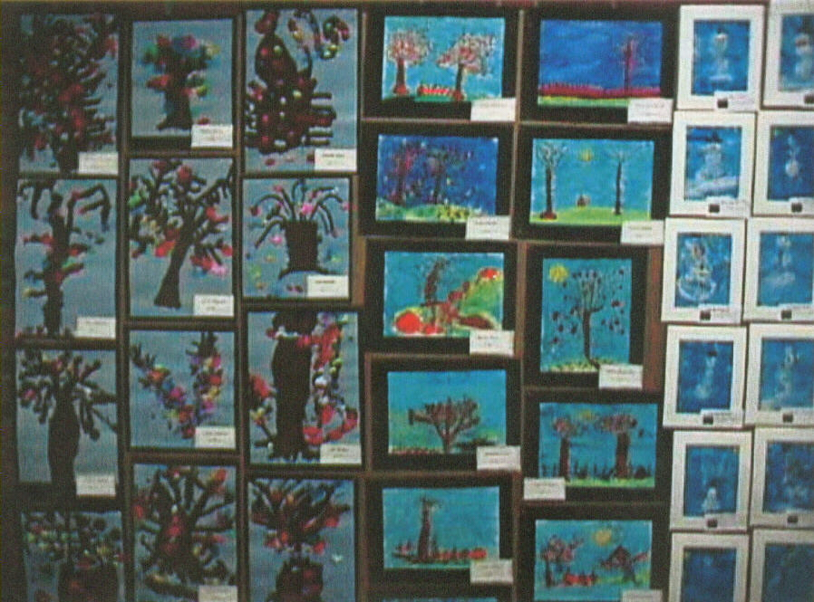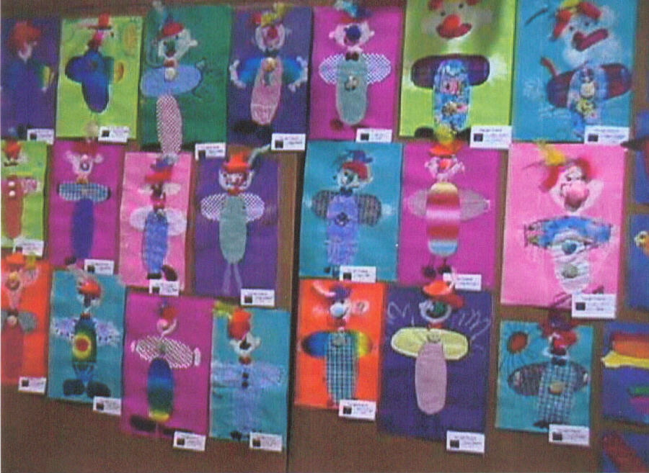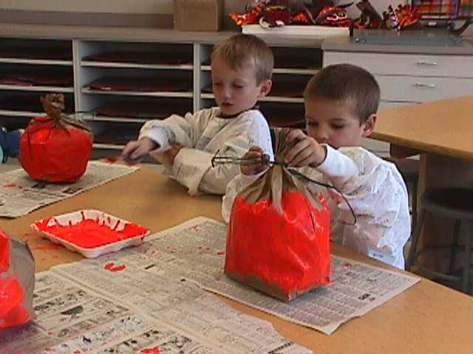
Painting P.I. 1A, 1C Texture Clown Collage P.I. 1A-D 3-D Pumpkins P.I. 2A

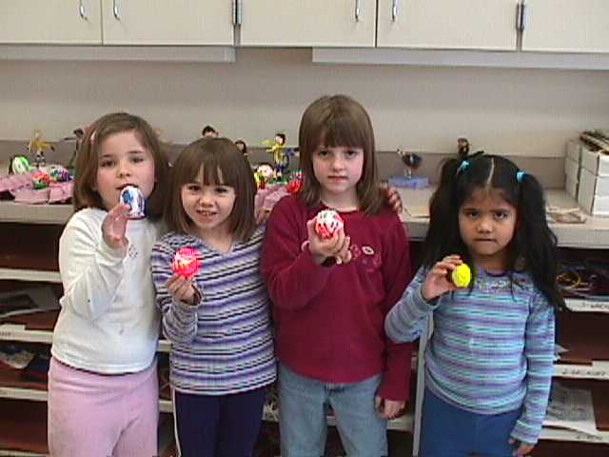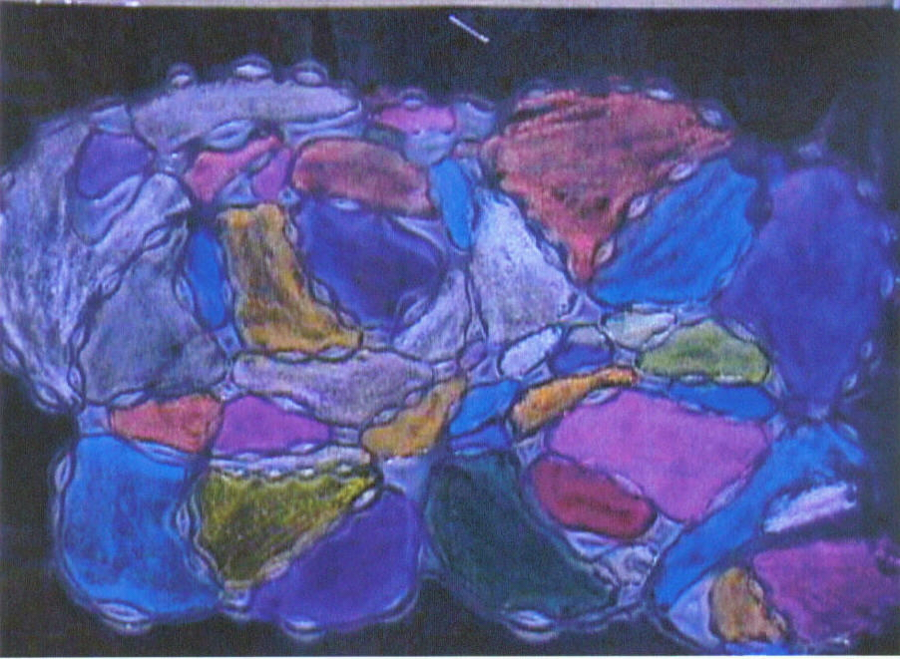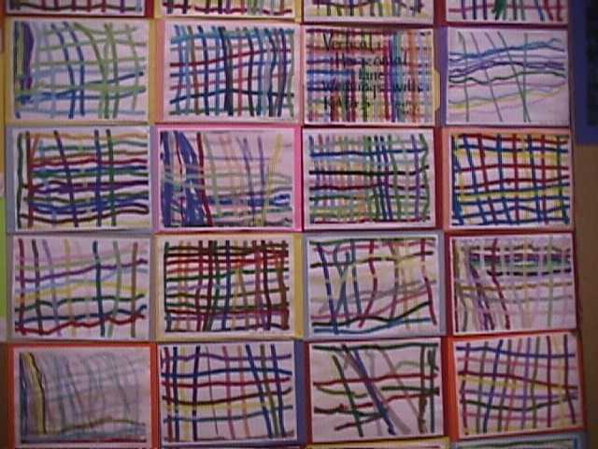
Rhythm Eggs P.I. 2A,3C Line/Shape Design with Electronic Weaving with line and color
Integration w/ Arts M 2.2B Glue and Chalk P.I.1A,B,C, P.I. 1C, 2B,D, 3B Integrated w/ MST 5.3B

Methodology: Hands on art activities and integration with Kindergarten units and themes when possible.

