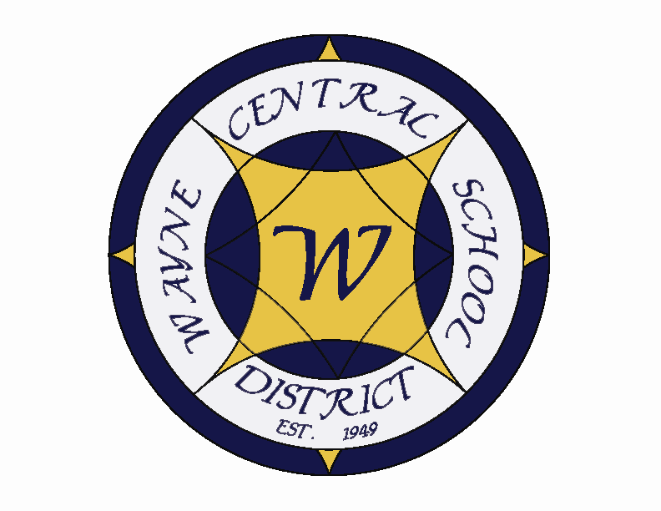
Letter to the Board

Michael Havens
Superintendent of Schools
Phone: 315-524-1001 Fax: 315-524-1049 mhavens@wayne.k12.ny.us

May 16, 2008

“Nobody can go back and start a new beginning, but anyone can start today and make a new ending.”
- - Maria Robinson
Board Agenda:

- Third Quarter Report: Mrs. Cox will be sharing the results of our State ELA scores and of third quarter report card results. Enclosed please find a copy of the report.

- Student Representative: The student representative for this meeting will be Jamie Wisner. Jamie is a Junior who has been on student senate all three high school years. He is a varsity football and baseball player. He is in select chorus and was in Brigadoon and Cinderella. He is also a member of the National Honor Society. Outside of school he plays with the Perinton Youth Hockey League. He also helps organize a youth program at Red Jacket Yacht Club. He is interested in pursuing a career in advertising and has completed an internship in the field. This is Jamie’s second time at the board meeting and he will be the student rep for the June 19th meeting as well.

- Board Workshop: As follow up to the discussion at our last Board meeting, this will be the first in a series of three workshops leading to deciding on annual goals for next year. During this first workshop the Board will focus on what is meant by “being the best school district” and then begin brainstorming ideas for what might be included as goals for next year to help us be the best school district. The second workshop, which will occur at one of our June Board meetings, will give us a chance to refine those goals. At our retreat, which is the third meeting, the Board will finalize the goals.

Board Letter:

1. Jill: I wanted to let you know that my daughter Jill is going to need to have heart surgery. We have known about the defect for a couple years but her doctor did not think treatment was necessary. A couple of weeks ago, the Monday after running a 13 mile half-marathon in Nashville, she learned that the hole had gotten worse and she would need surgery. She told me her left arm had started going numb after the first eight miles of the run but she didn’t think anything of it (children believe they are immortal).

I will be with her on June 11th and 12th , when she meets with the cardiologists at the University of Florida. They will be scheduling the surgery some time after that meeting. I am sure you understand that particularly with her being on her own and so far away I will need to be with her for a period of time. I have talked to Greg and Kim. They are prepared to carry things forward while I am gone. The surgery may not occur until school is out which would be easiest, but regardless of when it is I know they will do a fine job in my absence. President Frank and Vice President Joyce have agreed to provide whatever additional support they need. I will keep you abreast of any developments. I always thought that when they grew up you got to stop worrying about them.

2. Wayne Hockey?: We have been approached by a parent who is interested in having Wayne support a hockey team. She said there are 18 students currently playing club hockey who would like to be part of a Wayne team. There is a Monroe County JV Club League which has the following schools: Aquinas, Fairport, McQuaid , Pittsford, Webster, Brockport, Churchville Chili, HFL, Livingston, and Penfield. I am hesitant to entertain starting a new program when we are just beginning Lacrosse. That program will need our nurturing for the next few years. I thought you would want a heads up since they may be contacting you.

3. PAC Incident: Following the last performance of Willy Wonka, during tear down, there was an incident with the “unrigging” of the fly bars. This apparatus requires great care and attention and there was a breakdown in procedure and communication. It took a split second, when a bar was released without the brake applied and the weight properly adjusted. Although no one was hurt, some equipment was damaged. Our PAC director, Joe Stramonine, has investigated the incident and will be issuing a report . Joe will also be issuing recommendations for making sure this incident is not repeated. I have always worried about flying in our musicals. This is our first incident.

4. Board Gathering: Since Mark Wyse in unable to attend our June 19 Board meeting, would the board be able to all attend a social gathering for our outgoing board members on June 5 at Lori Smith’s house following the board meeting? I would like to get this date set so that we can finalize the arrangements. Please let Lori or I know as soon as possible. Thanks.

5. State Recognition: Two Wayne Central schools have again been named as “Gap Closing” schools by the state. Ontario Elementary and Wayne Middle School have earned this recognition based on academic achievement. Attached is an email that Kim Cox sent out to all staff congratulating them on this recognition. She attached a part of the state memo for reference.

6. Upcoming Events:
5/17 - Rotary’s “Mystery Dinner Theatre @ Ontario Fireman’s Field -
5/19 - FE Parent Group Budget presentation @ FE Media Center – 6:45 p.m.
5/20 – Budget Vote & Election @ HS Gymnasium – 9:00 a.m. – 9:00 p.m.
5/22 – Board of Education Meeting @ DO – 7:00 p.m.
5/26 – Memorial Day Commemoration at Bear Creek Harbor – 7:30 p.m.
5/27 – HS Student Achievement Awards @ PAC – 7:00 p.m.
5/29 - Four County Annual Meeting & Election of Officers – Belhurst Castle, Geneva

Athletics
5/17 - Girls & Boys JV & V Softball & Baseball Tournament - 11:00, 1:00 & 3:00
5/19 - Girls V Softball vs. Canandaigua – 7:00 p.m.
5/20 - Boys’ JV Baseball vs. Victor – 4:15 p.m.
5/20 - Coed V Track vs. Newark – 4:15 p.m.
5/20 - Girls JV Softball vs. Newark – 7:00 p.m.
5/21 – Co-Ed V Track vs. Newark (Raindate) – 4:15 p.m.
5/22 – Boys V Baseball vs. Canandaigua – 4:15 p.m.
5/23 – Co-Ed Track FL League Championship – 1:15 p.m.
5/23 – Boys V Baseball vs. Midlakes – 4:15 p.m.
5/23 – Girls V Softball vs. Midlakes – 7:00 p.m.

7. Attachments
A) Gap Closing School Email

Att. A)

Congratulations to Thomas C. Armstrong MS and Ontario Elementary School, for once again making the High Performing /Gap-Closing Schools List!

Congratulations to the entire staff, district-wide, that have contributed to the success of our students. The community of Wayne Central is fortunate to have you all working with their children!

Sincerely,
Wayne Central Administrative Team

State Memo:

“On May 15, 2008, we announced a list of 1,759 public schools, 19 charter schools, and 288 school districts that have been identified as “high performing/gap closing” based on their performance during the 2005-2006 and 2006-2007 school years. We will also announce a list of 373 schools, 10 charter schools and 62 districts that are “rapidly improving”. These actions are being taken in order to comply with the requirements of Section 100.2(p) of Commissioner’s Regulations as well as our No Child Left Behind accountability plan, which requires the State to recognize high performing and rapidly improving schools and districts.

Kim Cox
Assistant Superintendent for Instruction
Wayne Central School District
315-524-1004
kcox@wayne.k12.ny.us

