Saving and Printing Procedures for MS/Sr High Building

All teachers and students have their own home directory to save to.

To SAVE
Select Save as command or click on toolbar button

Navigate on Window save in box - to home directory.

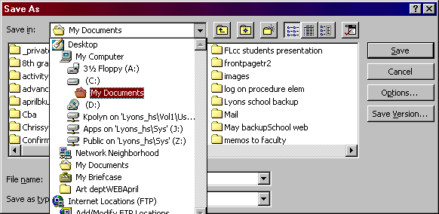
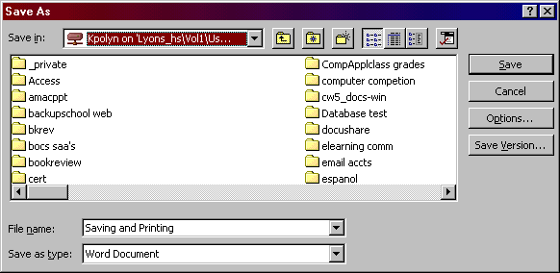
Navigate to Home directory

Save in home directory.

Printing
Each workstation has a default printer on the network.
Select print command and document will print to default printer.

