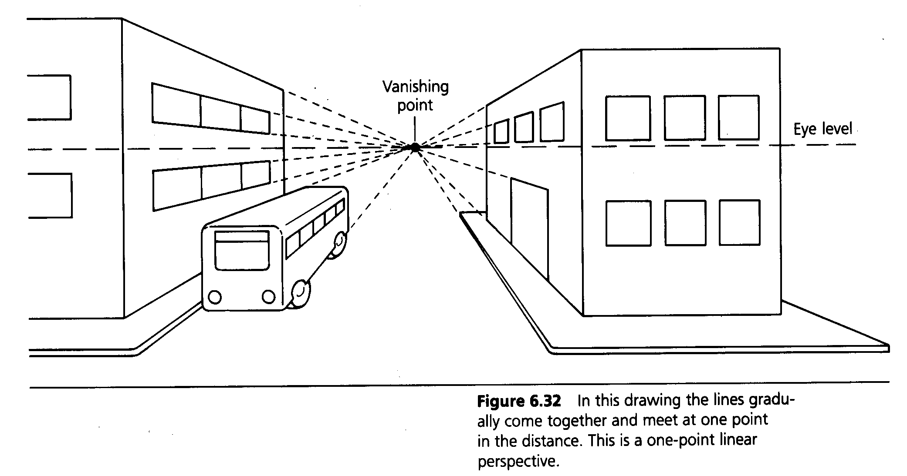
Studio Art Perspective-1 Point Rules

One Point Perspective – a system of drawing (with rules & steps) that helps you learn to draw as your eye sees and not as your mind knows.

Linear Perspective- A mathematical system for creating the illusion of space, using drawn lines to show depth on a flat surface.

Vocabulary
A. Eye Level – horizontal line that is always even with your eyes.
B. Horizon Line – the actual or imaginary line that shows where land and sky meet (eye level and horizon line always appears as the same line).
C. Vanishing point – a point on the eye level line where parallel lines seem to meet.
D. Vertical –lines that are straight up and down.
E. Vanishing point line- a line drawn from the top and bottom of any vertical to the vanishing point.
F. Depth – the illusion of three-dimensional space, the illusion of looking into a flat space and seeing forms and distance.
G. Horizontal- straight across, parallel to the eye level/horizon line.
H. Parallel- two lines equally distant from each other.

Rules-One Point Perspective

A. Start by drawing a square or rectangle using verticals and horizontals.
B. From the top and bottom of each vertical draw lines to the vanishing point.
C. Every part of the box is made up of four lines – two of each kind .
D All lines in your drawing are either:
1. Verticals
2. Horizontals
3. Vanishing point lines

