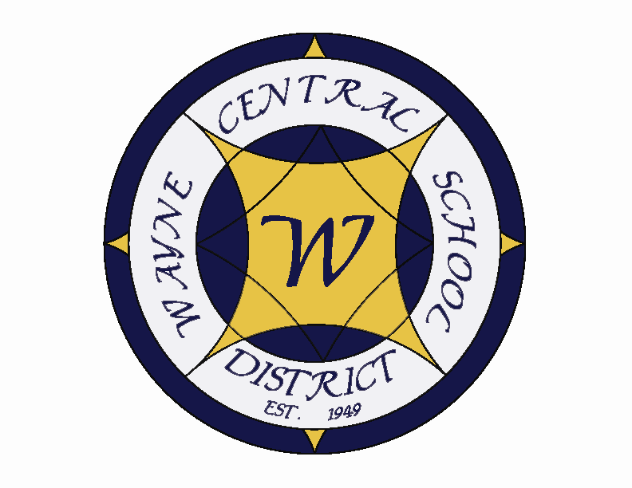
Letter to the Board

Michael Havens
Superintendent of Schools
Phone: 315-524-1001 Fax: 315-524-1049 mhavens@wayne.k12.ny.us

October 5, 2007

"One of the tests of leadership is the ability to recognize a problem before it becomes an emergency."
--Arnold H. Glasow, Author and humorist

Board Agenda:

1. Three Boards Meeting: This is one of our semi-annual “Three Boards Meetings” between the Wayne Central Board of Education, the Ontario Town Board and the Walworth Town Board. We have participated in these meetings for many, many years. Our agenda contains an update on the Walworth Town Hall study, a budget presentation from Ontario and an update on the landfill progress. I would like to review the status of the Ontario Elementary building.

2. New Staff Recognition and Reception: Each fall we host a new staff reception at one of our board meetings. This year, with the Three Boards meeting being hosted by Wayne Central, we thought we would try something new and blend our new staff introductions, with a new staff opportunity for the towns as well. We will see how it goes. This does offer an opportunity for the new assessor and library director in Ontario, and the new recreation director and assistance director in Walworth to become acquainted with staff and administration within the district, as well as our boards to meet staff. We will handle it in the same way with building administration introducing their staff. Town staff will introduce their new staff and then we will break for some refreshments. We will open the meeting with the staff introductions, break, and then reconvene for business.

3. Ontario Elementary Building: As you probably are aware I floated a trail balloon regarding Ontario Elementary in our last news letter. I wanted to see if I got any push back. So far there has been none. I thought I would take the next step with the two town Boards and ask them for feedback. I am curious about what Walworth has learned from their experience with the Walworth Academy and if their is any Ontario need for space that OE might help with.

Board Letter:

- MRSA (Super Staph infection) Information: I have attached some information that our nurses compiled and sent out to our staff. It provides data on a transferable germ called MRSA or “super staph” which has recently been in the news. It has specifically been in the news for its possible spread in schools. There has been much news coverage due to 2 student deaths due to its resistance to antibiotics. However, these were extremely rare cases. I am unaware of how they contracted it, however it has been noted that both students were athletes. The warnings are that it is spread through direct human contact, so student athletes are at higher risk than general population students. If you are interested in additional information, a good site is the national center for disease control at www.cdc.gov then select A-Z index; go to M’s – select “Methicillin” (MRSA) and from there, there are several subsections to chose from.

- Staff flu shots: Flu shots are being offered to staff again this year. If you are interested in receiving a flu shot, you are welcome to participate as well. These are covered under most insurance plans. The schedule is noted below. If you are interested in receiving a flu shot, please give Lori a call at 524-1001 or Patty Griswold at 524-1138 to check your insurance coverage. You may receive a shot anyway, but a fee may be charged.

High School……. . . . . . . Staff room (2:30-4:30pm 10/24/07))
Middle School…. . . . . . . Conference room (12:00-2:00pm 10/24/07))
Ontario Primary…. . . . . Conference room (12:00-2:00pm 10/23/07)
Ontario Elementary . . . . Conference room (2:30-4:30pm 10/23/07)
Freewill…………. . . . . . . Staff lounge. (2:30-4:30pm on 10/25/07)

- WFL BOCES Open House Invitation: Attached is the BOCES Open House invitation on Thursday, October 25 from 6:00 – 8:00 p.m. This conflicts with our Three Boards Meeting. However, if any board member feels they would like to attend this event instead, please let me know.

- Curves Donation: Curves of Ontario has once again made a donation of school supplies to the school for distribution to needy students. These donations come to the district office where Lori sorts them out and distributes them to each school building. In turn, each building is asked to distribute them to students identified by their staff as students in need.

- International Baccalaureate: The IB team has been visiting us for the past two days. This morning they met with Board members Frank Robusto, Joyce Lyke, Jeff Schultz and Susan Newman. Their recommendation to IB international will determine if we get certified. This afternoon we had a chance to hear feedback from them. They suggested we consider some changes including substituting IB German and IB French for level IV French and German currently offered. They also offered some suggestions in the area of mathematics. The team was very impressed with a number of areas. They thought the physical building was in wonderful shape. They loved the academic awards walls we have set up. They feel the school is very academically oriented. They loved the enthusiasm of our teachers and students towards the program. They had many kind words for Mr. Siracuse and what he has done at the high school. Leaving the best for last....They raved about our Board of Education. They were impressed how knowledgeable you were about IB, that three of you had gone to the Chicago conference, That having 50 students in IB would be considered wonderful not a burden and that you seemed willingly to do what ever it takes to make IB successful. You made me very proud today!

We won’t know our final determination until late winter or early spring, but I feel very optimistic that when school opens in the fall you will be Board members of an International Baccalaureate School.

- Upcoming Events:
10/22 – Hs Band & Chorus Concert @ PAC – 7:00 p.m.
10/23 – 30 - Red Ribbon Week
10/24 – Red Ribbon Family Show (Magician) @ PAC – 7:00 -8:30 p.m.
10/29 - Boys Modified Basketball begins
11/1 – Board of Education Meeting @ District Office – 7:00 p.m.
11/1 – Dollars for Scholars phone-a-thone
11/1 – Wrestling Spaghetti Dinner at Lincoln Fire Hall
11/2 – FE Family Night

Athletics ( Home Games Only):
10/27 – Girls V Soccer – Time TBD

7. Attachments
A) MRSA Information
B) Policy Committee Meeting Minutes
C) Curves Donation Letter
D) Wayne’s World
E) BOCES Open House

Att A)

From the Wayne Central Nurses

Have you heard the recent concerns about MRSA?
There have been reports of an increase of MRSA in the news lately. The reports have highlighted problems in Virginia, but there are concerns and cases in New York’s schools as well.

What is MRSA (Methicillin-Resistant Staphylococcus)?
MRSA is a type of bacteria that is resistant to many antibiotics.

Who gets MRSA?
Anyone can get MRSA.

What are the symptoms of MRSA infection?
Infection often results in redness, swelling and tenderness at the site of the infection.

How is MRSA transmitted?
The staph bacteria are generally spread through direct contact with the hands of a carrier or infected person.

How is MRSA diagnosed?
A doctor must take a culture from the infected area and send the culture to a laboratory for analysis.

What is the treatment for MRSA?
A MRSA infections must be treated with antibiotic therapy, using antibiotics that are not in the Methicillin family.

How can the spread of MRSA be controlled?
Careful hand washing is the single most effective way to control the spread of MRSA. In the event that you have an open sore or cut; wash it with soap and water and keep the injury covered with a band aide.

Please encourage you school aged children to practice good hygiene and frequent hand washing at school. Please also remind them that using hand sanitizers is a supplement not a replacement for hand washing!!!!!!!!!!

Winter reminder: Please dress your child appropriately for the weather, keeping in mind that they will be on the playground for 15-20 minutes during recess.

Att. B)

POLICY COMMITTEE MINUTES
DATE: Tuesday, October 16, 2007 TIME: 4:30 p.m. PLACE: District Office

COMMITTEE MEMBERS: Mrs. Newman, Mr. Johnson, Mr. Havens, Mr. Atseff, Mr. Switzer

NEW BUSINESS:

(1) Proposed Committee Charge: Committee members reviewed the proposed committee charge for 2007-2008 and approved it for presentation to the Board of Education at the next business meeting.

(2) Schedule of Annual Review – 50% of Policy Handbook: Mrs. Newman presented a proposed schedule for review of 50% of the policy handbook, as noted below, which was accepted by the committee.
Section 1000 (Bylaws of the BOE) – Mrs. Newman
Section 2000 (Administration) – Mr. Havens
Section 3000 ( Internal Operations) – Mr. Triou
Section 4000 ( Community Relations) – Mr. Johnson

(3) Schedule of Required Annual Review of Existing Policies: Mrs. Newman presented a proposed schedule for required annual review of existing policies, as noted below, which was accepted by the committee.

1410 Annual Review of Policy Handbook – Mrs. Newman
3410 Code of Public Conduct on School Property (Policy and Regulations) – Mrs. Newman
5220 Investment of District Funds (Policy and Regulation) – Mr. Atseff
5511 Audit Committee – Mr. Atseff
7580 Wellness & Nutrition – Mr. Atseff
7310 Code of Student Conduct & Athletic Eligibility – Mr. Atseff

(4) Schedule of Required Annual Review of Existing Regulation: Mrs. Newman presented a proposed schedule for required annual review of existing regulations, as noted below, which was accepted by the committee.

3410 Code of Public Conduct on School Property – Mrs. Newman
3420 Sexual Harassment & Discrimination – Mrs. Newman
5220 Investment of District Funds – Mr. Atseff
5400 Procedures for Purchasing Goods & Services – Mr. Atseff
5402 The Purchasing Process – Mr. Atseff
7111 K-5 Attendance – Mr. Johnson
7112 6-12 Attendance- Mr. Johnson
7113 9-12 Attendance – Mr. Johnson
8295 Guidelines - Use of Privately-Owned Computers by Staff Members (Regulation & Exhibit) – Mr. Atseff
9206 Guidelines - Use of Privately-Owned Computers by Students (Regulation & Exhibit) – Mr. Atseff

(5) Review of Section 1000 – Bylaws of Board of Education: Mrs. Newman presented suggested revisions and amendments from her review of this section. Mr. Switzer noted some technical revisions for consideration. Following discussion, the committee directed Mr. Switzer to prepare drafts of proposed revisions and amendments for review at the next committee meeting.

(6) Referral from Board of Education Discussion: Mrs. Newman presented items referred by the Board of Education at recent meeting on workshop/conference attendance (2320P) and reimbursement (5321R). Following discussion, the committee directed Mr. Switzer to prepare drafts of proposed revisions and amendments for review at the next committee meeting.

NEXT MEETINGS: Tuesdays @ District Office @ 4:30 p.m. – November 6 & 20, December 4 & 18

ADJOURNMENT: 5:30 p.m.
Recorded by Jim Switzer
NEXT & FUTURE MEETING AGENDA ITEMS:
• Follow-Up On: Annual Review – 50% Existing Policy Handbook – 2007-2008
• Follow-Up On: Drafts of Amended Policies – Section 1000 (Bylaws of the Board of Education)
• Presentation Of: Annual Review - Section 2000 (Mr. Havens)

JES/jes:wp

Att. C)
Wayne Central School District
Office of the Superintendent of Schools

PO Box 155
6076 Ontario Center Road
Ontario Center, NY 14520
315-524-1001

October 5, 2007

Curves
PO Box 492
2007 Route 104
Ontario, NY 14519

Dear Curves Members,

I would like to thank you, the patrons of Curves Ontario, for your most generous gift of school supplies to the students of Wayne Central.

We are very pleased to accept these gifts on behalf of our most deserving and needy children as identified by our school staff. These items mean a great deal to the daily education process, but more than that, they touch the lives of these children in a very special way. Your kindness and caring exemplifies the wonderful people of this community.

I extend once again my sincerest appreciation on behalf of all of the Wayne Central Schools and its students. Best wishes to each of you for continued health, friendship and good cheer.

Sincerely,

Michael Havens
Superintendent of Schools

/les

Students First ~ Excellence For All”
“
Att D)

A WTA Newsletter
Elizabeth Peters (FE), External VP Lisa Twitchell (HS), Treasurer Martha
Hanley (FE),
Secretary
Doug Casey & Bob Berkowitz (HS),
Retirement Delegates
President’s Message
In Celebration of National Education Week
Parents are cordially invited to participate in
“Bring Your Parents to School Week”
November 13-16th
For information call 315-589-2600

