
Letter to the Board

Michael Havens
Superintendent of Schools
Phone: 315-524-1001 Fax: 315-524-1049 mhavens@wayne.k12.ny.us

September 7, 2007

"Happy are those who dream dreams and are ready to pay the price to make them come true."
--Leon J. Suenes, writer

Board Letter:

- Conflict Waiver Letter: Attached is a new conflict release letter with the grammatical corrections to the first page. If you have already signed a letter we will send the letters to Kristen with a new first page. We will also send a copy of the letter with your signature back to each of you.

- Coaches Passes: Mr. Blankenberg has given me some coaches passes for you to use at athletic events. I will mail these to you via regular mail. Please enjoy.

- Enrollment figures: Our district enrollment continues to decline. On opening day in 2006, our enrollment was 2701. This year it was 2635. That is a decline of 66 students. All buildings have smaller populations this year with the exception of OP.

This is where it is getting interesting. The kindergarten population at OP is up 28 students. That is a huge increase. Luckily we had anticipated it might be up and had transferred a classroom to kindergarten. We didn’t anticipate quite so many new kindergarteners and so each of those classes are almost full. We will need to watch this for a couple years to see if this year is the beginning of the growth we have been anticipating or if it is just a one year anomaly.

- Nikki Miller Internship: Today I meet with Mr. Siracuse and Nikki Miller to discuss a possible internship. Nikki is one of our internal staff members we have been grooming for possible future administrative positions. She currently teaches health and oversees the implementation of the model schools program. If the meeting goes well I may be recommending her for an internship. This will not involve an additional cost to the district.

- Bus Driver: Murray Solomon, our BOCES labor relations specialist, has finished writing up the charges against the bus driver involved in last Friday’s incident. They will be formally presented to him and then, following civil service law, we will proceed with a dismissal hearing. Murray agrees that we have a very good chance to have this person dismissed. We are hopeful that when the driver see the charges he will resign. If he doesn’t, I will go the full measure on this one.

I will be asking you to appoint a hearing officer at our next meeting.

- Wayne Wrestling Newsletter: I have attached a Wayne Wrestling Newsletter with some upcoming events. They do a nice job promoting their events.

- Genesee Valley School Boards Institute: I have attached a membership form. Please let me know if you have any questions about continuing our participation. The annual cost is $170.00.

- School Resource Officer: We have been contact by Sgt McCormick of the NYS Police. First round interviews for the new SRO have been tentatively arranged for September 19th. Mr. Siracuse will be participating in those interviews on behalf of the district.

- Tot Spot Letter: We received a very nice letter from the Tot Spot regarding the facilities, the maintenance staff, and the staff at Ontario Elementary. I have attached it for you to read.

- Class of 1957: The Class of 1957 will be dedicating a tree this Sunday morning at 10:00 a.m. They planted the tree at the school for the 45th reunion. This year, for their 50th, they are placing a plaque. Mr. Dennis Kuhn is organizing this event and has extended an invitation to attend. He noted that there are appx. 40 classmates attending, which is remarkable since the graduating class was less than 70 people and several are no longer with us. He apologized for the late invite, but the letter was returned for an incorrect address while they were away.

- Breast Cancer Walk: The WTA is collectively supporting the “Making Strides against Breast Cancer Walk” for their membership. I believe our girls soccer team has been participating for years. The information is as follows: Sunday, September 30th at Frontier Field in Rochester, NY.

- Upcoming Events:
9/17 – FE Parent Group Meeting @ Media Center – 6:45 p.m.
9/17 – HS PTSO Meeting @ HS Faculty Room – 7:00 p.m.
9/20 – Middle School Open House – 7:00 – 9:00 p.m.
9/21 – FE Back to School Bash -
9/25 – High School Open House
9/26 – Powerschool Parent Informational Meeting @ PAC – 7:00 p.m.
9/27 – Board of Education Meeting (MT, Tran, Atletic Field Tour) @ DO – 6:00 p.m.

Athletics ( Home Games Only):
9/14 – Boys V Golf vs. Marcus-Whitman @ Brookwood CC – 4:15 p.m.
9/17 – Girls V Tennis vs. Geneva – 4:00 p.m
9/19 – Girls V. Tennis vs. Victor – 4:00 p.m.
9/21 – Boys V Football vs. Victor – 7:00 p.m.
9/21 – Girls V Tennis vs. Pal-Mac – 4:00 p.m.
9/21 – Boys JV & V Volleyball vs. Canandaigua – 5:30 & 7:00 p.m.
9/25 – Girls JV & V Volleyball vs. Newark – 5:00 & 6:30 p.m.
9/26 – Boys JV & V Soccer vs. Mynderse – 4:30 & 6:30 p.m.
9/26 – Girls JV Tennis vs. Pal-Mac – 4:00 p.m.
9/26 – Boys JV & V Volleyball vs. Victor – 5:30 & 7:00 p.m.
9/27 – Boys JV Football vs. Newark – 4:30 p.m.

13. Attachments
Att. A Conflict Waiver Form
Att. B Four County News (sorry for the quality on this attachment, my original is bad)
Att. C NYSSBA Special Ed Law Workshop
Att. D Athletic Overnight Trip Requests
Att. E GVSBI Membership Information
Att. F Wrestling Newsletter
Att. G Tot Spot Letter
Att. H Invitation

Att. A
Wayne Central School District
Office of the Superintendent of Schools

Memorandum

TO: Frank Robusto, Joyce Lyke, Scot t Griswold, Richard Johnson, John Triou,
Susan Newman, Jeff Schultz, Mark Wyse, Tom Nicholson, Sylvia Hungerford
Bob Armocida, Mark Callahan

FROM: Michael Havens

RE: Employment Conflict Letter

DATE: September 4, 2007

I have been asked by attorney for the district, Kristen Bensen, to have the named defendants sign waiver forms. Attached is a copy of the form that she has prepared.

Please sign the document and return to me as soon as possible. If you have any questions regarding it please let me know. I will collect them all and return them to Kristen when they have all been executed.

Disclosure and Conflict Letter to Clients
This concerns the request by Sylvia Hungerford, Wayne Central School District; Board of Education of the Wayne Central School District; Frank Robusto, Joyce Lyke, John Triou, Richard Johnson, Jeff Schultz, Scott Griswold, Mark Wyse, Susan Newman, Tom Nicholson, Robert Armocida, Michael Havens and Mark Callahan, that Smith, Sovik, Kendrick & Sugnet, P.C. represent their joint interests in the above proceeding. This letter confirms that this firm’s acceptance of the representation is based on your joint and informed consent after full disclosure, which is discussed further herein.
We confirm that Plaintiffs claim that Sylvia Hungerford made defamatory slanderous statements about plaintiffs to co-workers. We further understand that plaintiffs claim defendants Wayne Central School District; Board of Education of the Wayne Central School District; Frank Robusto, Joyce Lyke, John Triou, Richard Johnson, Jeff Schultz, Scott Griswold, Mark Wyse, Susan Newman, Tom Nicholson, Robert Armocida, Michael Havens and Mark Callahan (1) failed to properly investigate plaintiffs’ complaints; (2) discriminated against plaintiffs because of their gender and perceived sexual orientation and; (3) retaliated against plaintiffs for making complaints. This confirms that defendants deny any violation of laws, deny that the alleged statements constitute slander or defamation and that defendants’ administrative decisions did not constitute retaliation. We also understand that, to the extent that Sylvia Hungerford made the alleged statements, Sylvia Hungerford admits the statements were not made within the scope of her employment.
As discussed, there are many benefits to being jointly represented in this proceeding, including facilitating the coordination of efforts to defend the case, improving the ease of communications, and taking advantage of possible savings in defense costs. Further, this firm has substantial experience in connection with the particular claims and defenses at issue. The interests of all defendants appear to be aligned because of the common and joint duties under the circumstances involved in this dispute and the applicable laws and case law. Likewise, the defendants have common and joint defenses to the claims asserted in the above proceedings. While there are some differences in the available defenses, these differences do not create a conflict of interest based on the information that is presently available to us. For instance, the alleged statements off campus and alleged statements on school grounds were outside of the course and scope of Hungerford’s employment.
In the event any material dispute arises between the defendants, we understand that Smith, Sovik. Kendrick & Sugnet P.C. will not be able to continue with any representation. Based on the information presently available to us, the foregoing disclosures and our discussions with you and prior disclosures, it appears there is no actual or possible conflict of interest that precludes our law firm from undertaking this joint representation. Even so, separate representation may later become necessary in the event that any actual conflict(s) of interest may subsequently arise.
While differences of opinion may arise at times over the strategy and the defense of the case, these are generally matters over which multiple clients ultimately agree or arrive at a consensus. These circumstances typically do not give rise to a true conflict of interest that will interfere with or compromise our ability to furnish joint representation and fulfill our duties and responsibilities to both of you. If either of you become aware of circumstances that may create a conflict of interest, please let us know immediately.
Because we will be representing all defendants, we regard such representation as invoking and being subject to the joint defense privilege. This should prevent third parties such as the plaintiffs from discovering any confidential and privileged disclosures that are protected from disclosure by the attorney-client privilege, the work product immunity and any other privilege or protection.
Please bear in mind that any disclosures to this Firm as your counsel must be shared with all clients. While none of you are required to disclose or communicate confidential, privileged or protected information and documents to your attorneys, please bear in mind that in the event that information and documents that you choose to disclose must be shared with and disclosed to all clients. Again, such disclosures should be subject to the protections of the joint defense privilege described above.
Further, Smith, Sovik, Kendrick & Sugnet, P.C., discloses that AIG has agreed to pay the approved fees and costs for the work performed in your defense as dictated by your policy with AIG. This Firm does other work for AIG, which includes representations of insured companies and other insureds. AIG’s normal practice is to require periodic status updates as well as analysis and evaluation of liability, potential exposure and the risk of litigating the matter.
Smith, Sovik, Kendrick & Sugnet, P.C., has not been engaged to represent defendants on any coverage disputes that may now exist or may later arise with AIG. You will need to retain separate counsel for any representation on such matters. Please furnish us with any documents received from AIG regarding any reservation of rights or denial of coverage.
This letter confirms that each of you consent to Smith, Sovik, Kendrick & Sugnet, P.C., openly and without restriction sharing disclosures or discussions with one of you to the other client, and sharing any document furnished by one of you with the other client, subject to the joint defense privilege and to any other privilege protecting any such disclosures from communication or publication to other parties or persons.

If you have any questions, please contact me at (315) 474-2911 ext. 140. Your signature below means you have read the above and understand what is contained herein.

Dated: By:
Printed Name

Att. B

Att. C

Att. D
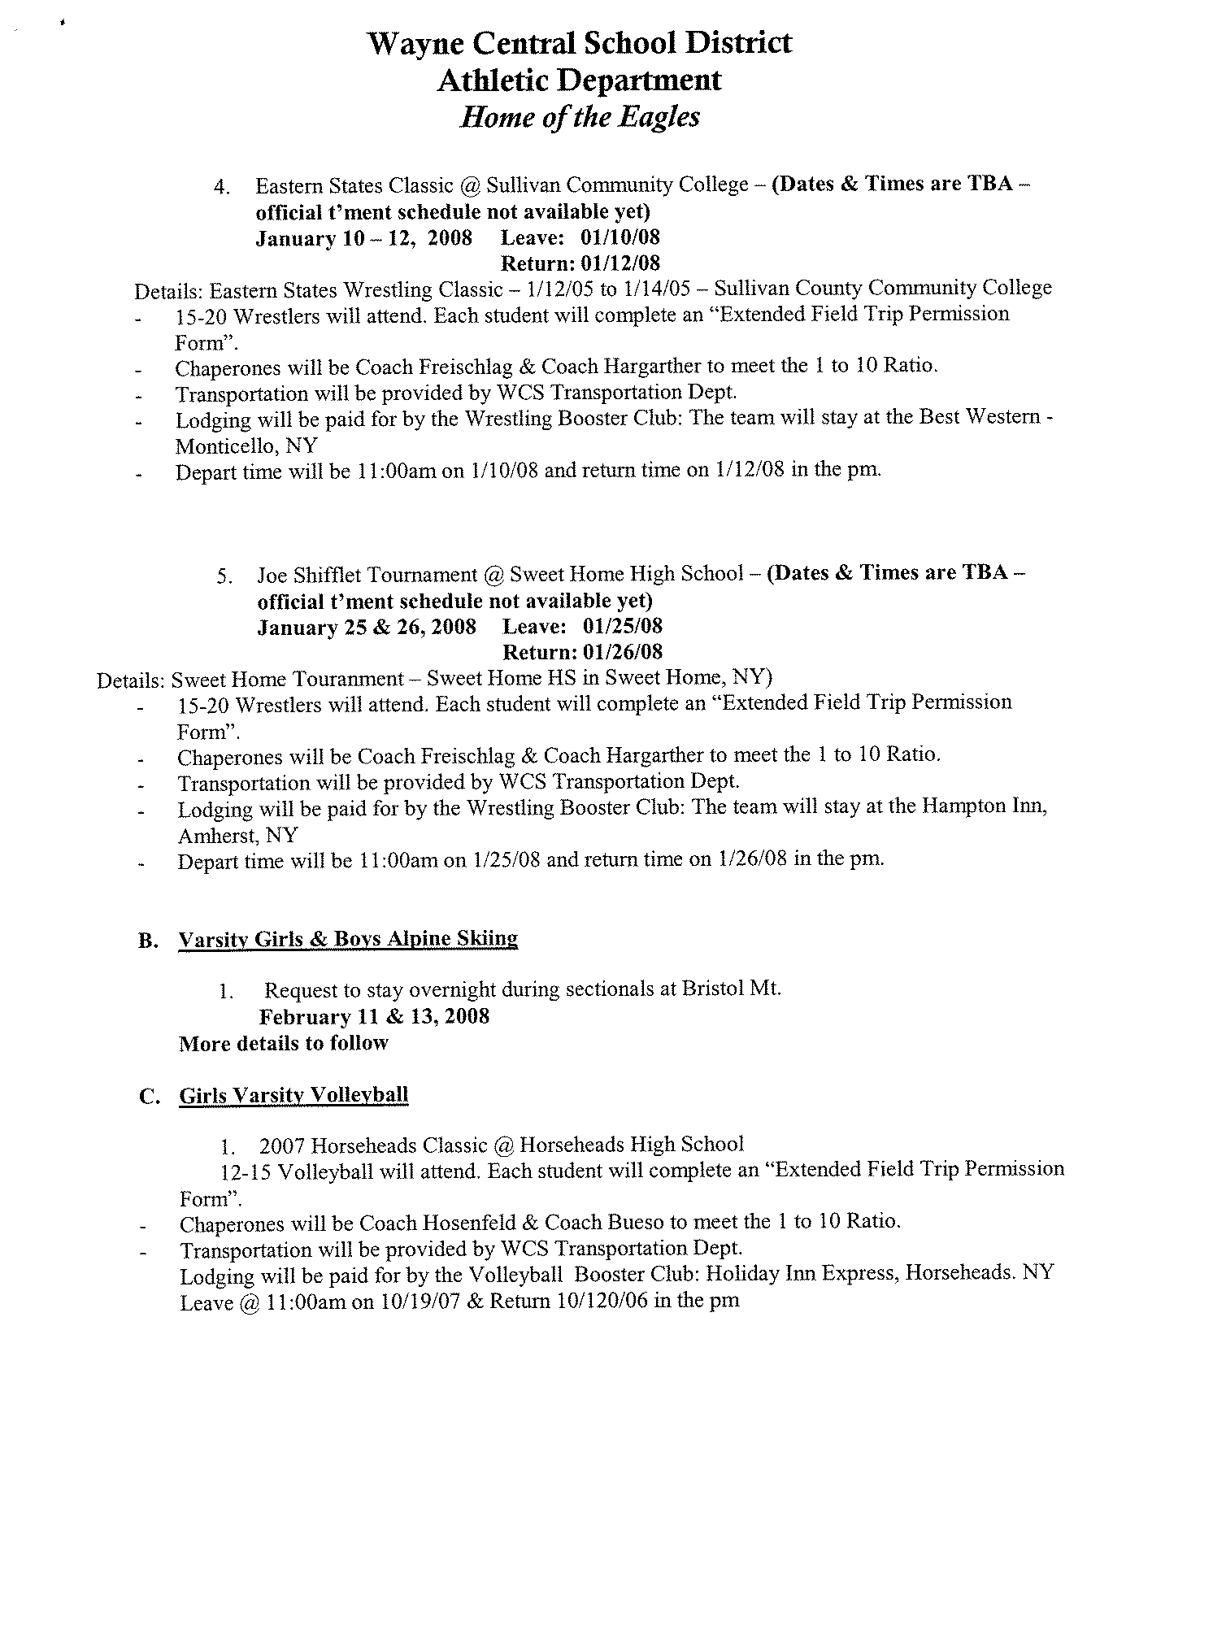
Att. E

Att. F


Att. G

Att. H

