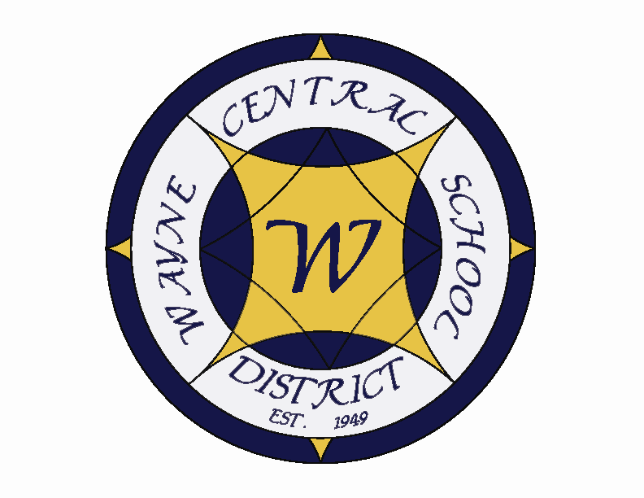
Letter to the Board

Michael Havens
Superintendent of Schools
Phone: 315-524-1001 Fax: 315-524-1049 mhavens@wayne.k12.ny.us

August 17, 2007

“Sometimes the questions are complicated and the answers are simple.”
- - Theodore Geisel, American Author & Illustrator, (Dr. Seuss)

Board Letter:

- District Calendar and Back to School Newsletter: Amy called the printer today. The calendar is being collated now. The back to school newsletter just finished being printed. Both will be mailed out next week. Residents should be receiving in their homes next week. If asked, you may let people know that both are on the Wayne web site.

- Staff Day Care Center: The maintenance staff has been working very hard to build the day care rooms at Ontario Elementary. They were given a tight timeline, and made it work despite other previously scheduled projects. I expect Tot Spot to begin setting up next week. The open house is scheduled for August 28. Enrollment is off to a slow start, which was expected, with the uncertainty of the program. However, I am confident that it will grow to full capacity in no time. I am planning on including a tour of the day care facility as part of the December 6 Ontario Elementary building tour, unless the board would like a separate tour scheduled earlier.

- Fall Sports: The fall season is underway. We have a request for an overnight trip for the boys’ soccer team to attend a tournament in the Syracuse area on Friday & Saturday, August 31 & September 1. I will be approving that trip. The sports schedules are all posted to the web page. I want to note that there are only 4 home football games for the season, so you may want to make note of a couple on your calendars. Also, homecoming is the weekend of October 5 & 6.

- Exchange Student: We have a new exchange student with us this year from Barcelona, Spain. He is Luis Miguel Roca Blanco and he is currently staying with board president Frank (& Jackie) Robusto. He is interested in becoming an architect and would like to improve his English and study architectural programs while here. I will arrange for a chance to bring him in to meet the board early in the school year with our Rotary Interact students.

- New Teacher Orientation: On Monday – Wednesday, August 20-22, 35 new teachers to the district will be participating in the new teacher orientation sessions. We will also have 30 teachers returning for 2nd & 3rd year training. Induction and orientation activities are planned for the three days. At 11:45 on Wednesday we will host our BBQ luncheon at the high school for all participants, administrators and presenters. You are cordially invited and welcome to attend. Please send Cathy Luke (cluke@wayne.k12.ny.us) or Lori a note if you plan to come for lunch.

- Upcoming Events:

8/20-22 – New Teacher Orientation
8/20 – Meet the Coaches Night @ PAC – 7:00 p.m.
8/23 – MS Ice Cream Social @ MS – 6:00 & 6:45 p.m.
9/4 – First day for Staff/Welcome Back Session
9/5 – First day for students

Athletics:
8/20 – Meet the Coaches Night @ PAC – 7:00 p.m.
8/25 – Boys V Football Scrimmage @ E. Rochester – 9:00 a.m.
8/28 – Boys V Volleyball Tournament @ Midlakes
8/31 & 9/1 – Girls JV & V Soccer Tournament – Cohocton
8/31 & 9/1 – Boys JV & V Soccer Tournament – Fayetteville
9/1 – Fall Modified Cross Country Season Begins
9/4 – Modified Volleyball Season begins
9/8 – Girls JV & V Volleyball Tournament – Baldwinsville

7. Attachment

A. Staff Welcome Back Letter

LO

Wayne Central School District

Office of the Superintendent of Schools

P.O. Box 155
6200 Ontario Center Road
Ontario Center, NY 14520
315/524-1001

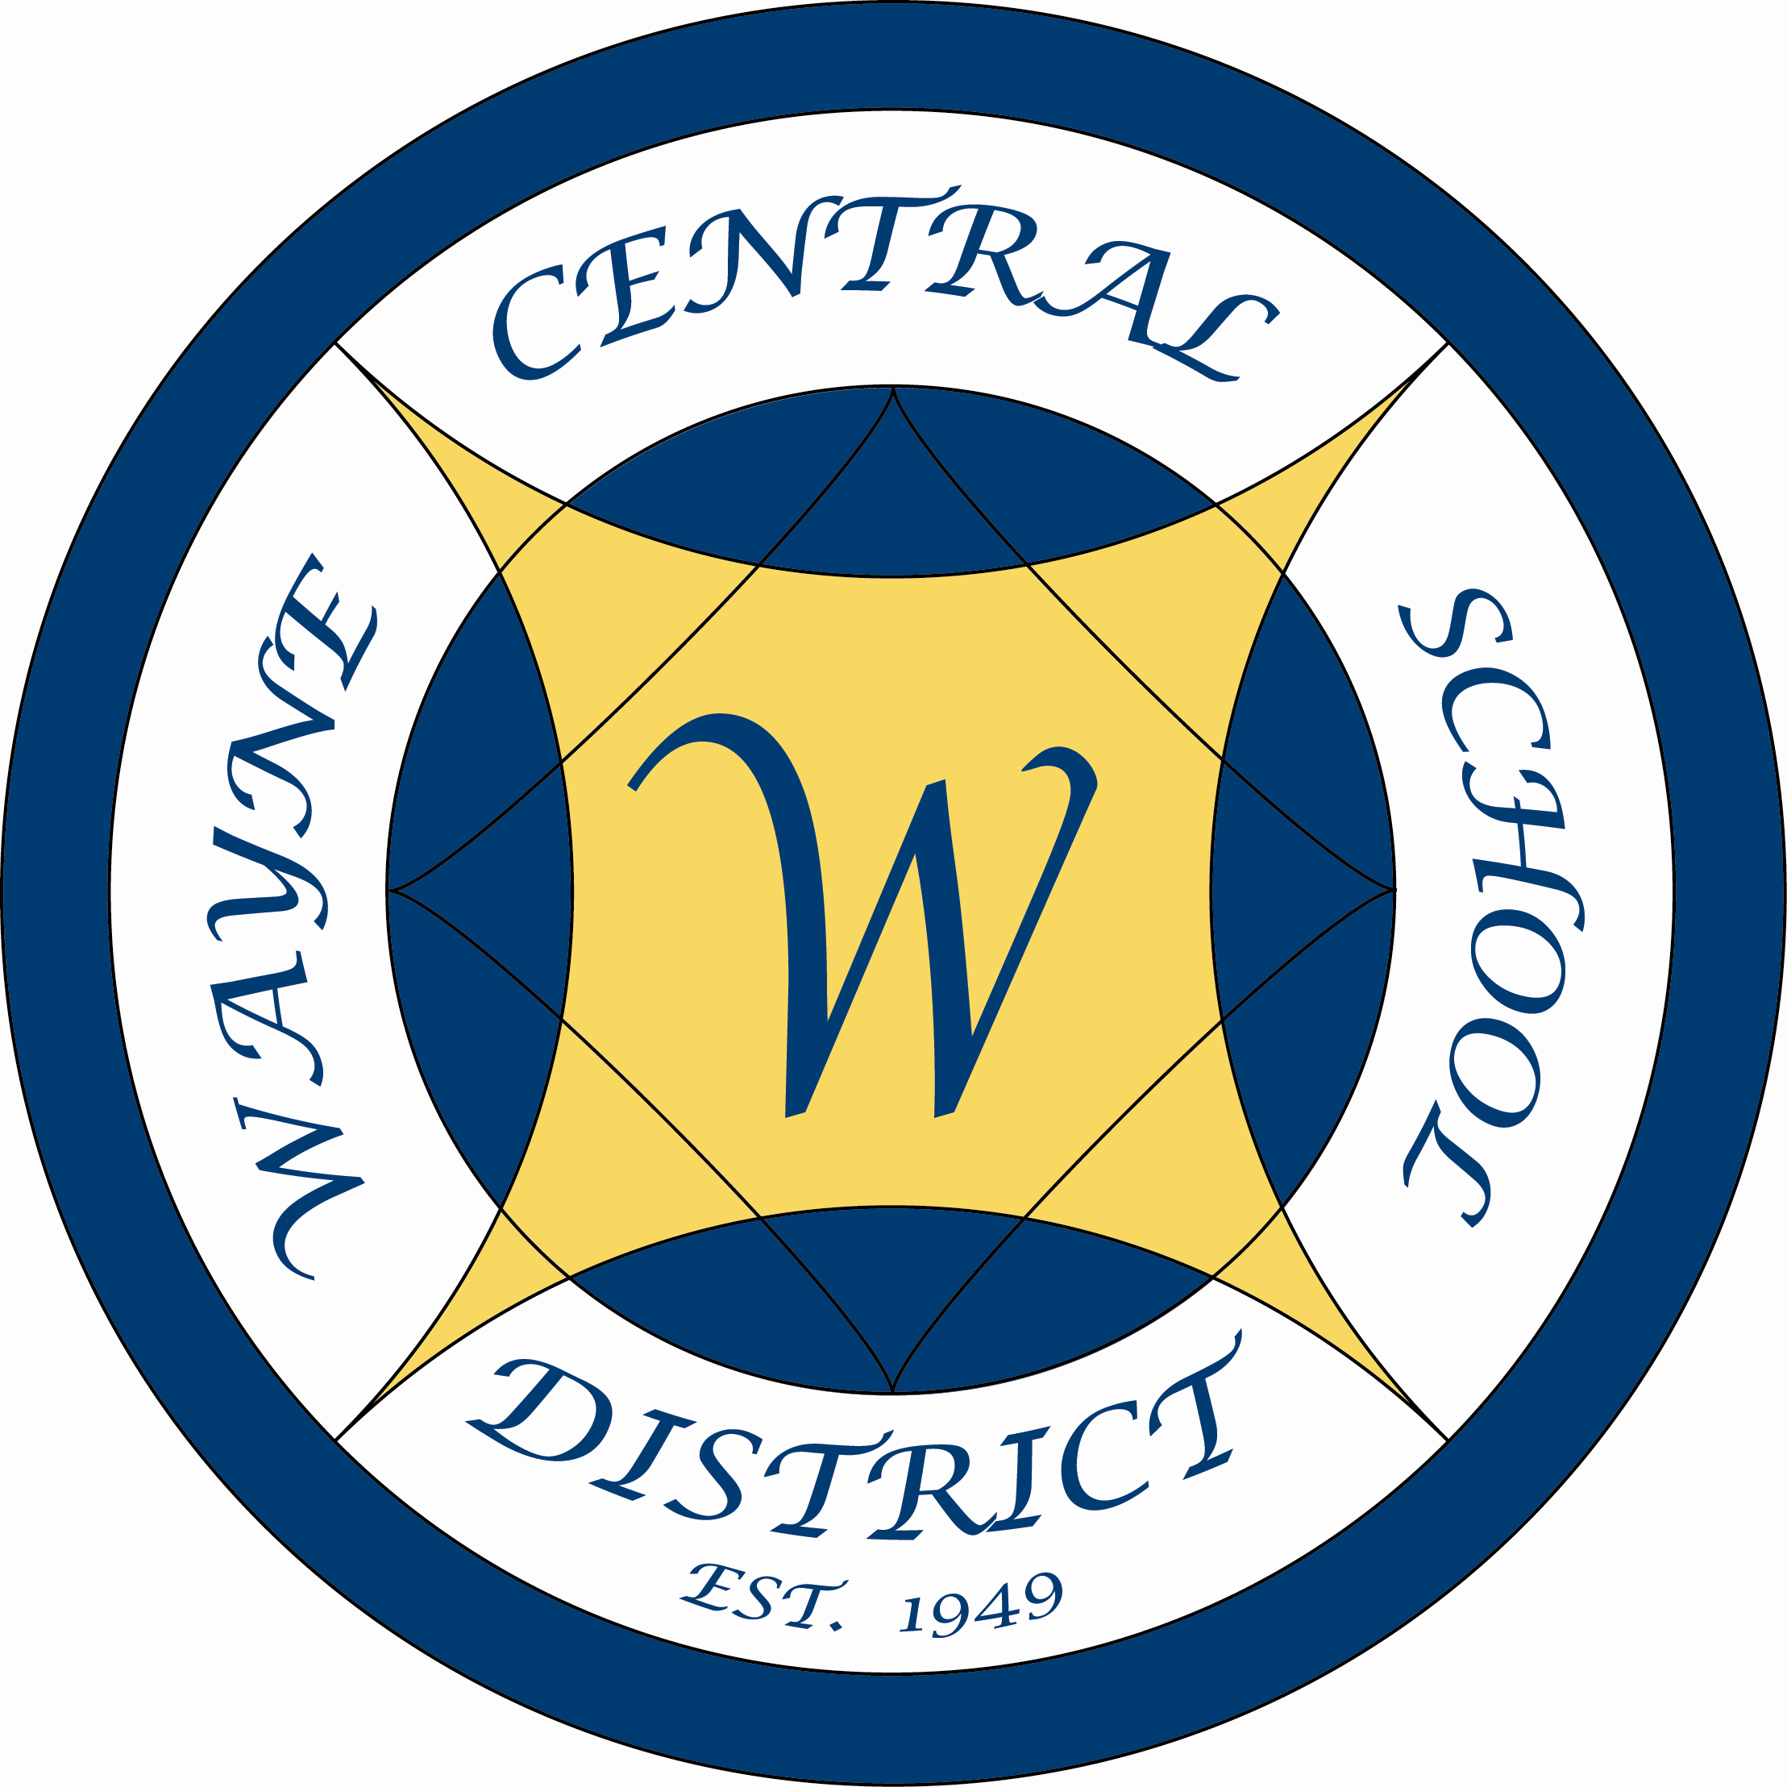

Dear Staff,

Greetings from Wayne Central. You may note that this year’s letter has arrived later than past ones. I know that many of you view this letter as the signal that summer is drawing to a close. While I don’t have the power to lengthen the seasons, I thought that perhaps delaying the letter would at least give some impression that summer was longer.

This has been a busy summer at school. Many of our staff taught elementary or middle summer school. Others wrote curriculum, while still others were part of the myriad of training programs offered. There was a time when summer was a relaxing period between school years. That seems to have disappeared as we work hard to prepare our students.

One of the changes for this year is that we have gone to an electronic card reader to gain access to buildings. This is part of our ongoing security updates. On opening day each of you will need to have your pictures taken for your proximity card reader. This card will gain you entrance to any one of the electronic entry doors in your building. It should actually make access easier for you while at the same time providing greater security.

Opening day for this school year will be September 4th. Please note the agenda on the back of this letter. We begin taking pictures at 7:00 in the high school gymnasium. Refreshments will be served at 7:30 in the cafeteria, with the program beginning in the Performing Arts Center at 8:00.

“Develop the unique quality of making each new day fresh and full of opportunity for teaching new things to your students, and learning something new yourself.” I look forward to working with you as you fill the 2007-08 school year with fresh and exciting opportunities for all.

Sincerely,

Michael Havens

Michael Havens
Superintendent of Schools

MH/les
Att.
“Students First – Excellence For All”

Opening Day Agenda

September 4, 2007
7:30 a.m. – 3:00 p.m.

7:00 | Staff ID Pictures Taken  (pictures will be available throughout the morning beginning at 7:00) | HS Small  Gymnasium
7:30 – 8:00 | Coffee, Bagels & Conversation | HS Cafeteria
8:00 – 9:30 | Welcoming Remarks:  Michael Havens, Superintendent  Jason Carter, WTA President  Kim Aumann, CSEA President | Performing Arts Center
9:30 - Noon | Break into K-5, 6-8, 9-12 Groups:
9:30 - Noon | Elementary Staff | Performing Arts Center
9:30 - Noon | Middle School Staff | Middle School  Cafeteria
9:30 - Noon | High School Staff | High School Cafeteria
Noon | Lunch (on your own)
PM | Time in individual buildings/rooms | Buildings

