Subject Area: Art K-6 Grade Level: 2

Mission Statement: It is the mission of the Elba Central School District to actualize the phrase “Elba Equals Educational Excellence for Everyone.” We are committed to providing both quality and equity. Every student will have the opportunity to develop to the best of his/her ability.

Elba Standards: In addition to the knowledge and basic skills they need in order to participate in society, graduates of Elba Central School will develop:
- Empowering skills: decision making, goal setting, creative thinking and problem solving abilities;
- Communication and social interaction skills;
- Technological literacy;
- Total wellness (social, physical, emotional health and self-esteem);
- The values necessary to participate in society.
As a result of achieving these outcomes, our students will embrace lifelong learning.

New York State Standards: 1) Creating Performing and participating in the arts.
2) Knowing and using art materials and resources. 3) Responding to and analyzing works of art.

National Standards: 3) Choosing and evaluating a range of subject matter, symbols and ideas. 6) Making connections between visual arts and other disciplines.

Performance Indicators:
1-A experiment and create art works, in a variety of mediums (drawing, painting, sculpture, ceramics, print-making, video and computer graphics) based on a range of individual and collective experiences.
1-B develop their own ideas and images through exploration and creation of art works based on themes symbols and events.
1-C understand and use the elements and principles of art (line, color texture, shape) in order to communicate their ideas.
1-D reveal through their own art work understanding of how art mediums and techniques influence their creative decisions.
1-E identify and use, in individual and group experiences, some of the roles and means for designing, producing, and exhibiting art works.
2-A understand the characteristics of various mediums (two-dimensional, three-dimensional, electronic images in order to select those that are appropriate for their purpose and intent.
2-B develop skills with electronic media as a means of expressing visual ideas.
2-C Know about some cultural institutions (museums and galleries) and community opportunities (art festival) for looking at original art and talking to visiting artists, to increase their understanding of art.
2-D give examples of adults who make their livings in the arts professions.
3-A explain their reflections about the meanings, purposes, and sources of works of art; describe their responses to the works and the reasons for those responses
3-B explain the visual and sensory qualities (surfaces, colors, textures, shape, sizes, volumes) found in a wide variety of art works.
3-D explain how ideas and themes, or concepts in the visual arts are expressed in other disciplines (e.g.; mathematics, science, literature, social studies, etc.)

Assessment: | Acceptable Performance Level
Completed projects, assessed w/ V.A.Rubric | 3-4 on completed work
2 pieces of art work in art each art show Dec.& May | 3-4 on Report Cards 20/40 weeks

Scope: Second Grade art students will experiment and explore the elements and principals of art and apply knowledge and understanding of the elements and principals to their own work. Students will create a body of work based on Realism through studies of landscapes. Reflect on selected projects through written description of finished work. Projects incorporating units collaborated with classroom studies.

CONTENT SEQUENCE  *Skill appears in bold print | STANDARD AND  PERFORMANCE  INDICATORS OF TAUGHT CONTENT AREA |  | INTEGRATED CONTENT STANDARD/  P.I. |  | METHOD OF ASSESSMENT |  | ACHIEVED PERFORMANCE LEVELS
Realism: concepts of Background, Middle-ground and Foreground in Landscapes in a variety of art media and techniques | 1A, 1C, 1D |  |  |  | Rubric |  | Developing
Concepts of Landscape (Photography) w/ digital cameras (Fall trip to Godfrey’s Pond.) |  | 2A-D  3A |  | MST  T  5.2A  E |  | Rubric |  | Developing  Awareness
CDOS
2.1A

E
Written Response to photographs  Focusing on “Ideas and “Organization” | 3A |  | 6+1 Traits of Writing I, O |  | 6Traits scoring Rubric |  | Awareness
Silhouetted Landscape:  Rainbow roll technique of Printing; India Ink painted silhouettes cont. concepts Background, Middle ground and Foreground | 1A, 1C, 3B |  |  |  | Rubric |  | Developing
Torn Paper Seascapes w/ watercolors “If you Sailed on the Mayflower in 1620” Ann McGovern | 1A, 1C |  | ELA  L&R  2.1A  E |  | Rubric |  | Developing

Holiday Fine Arts Festival | 1E, 2C, 3C |  |  |  | Report Card Gr. | Developing
Polar Express  Chris Van Allsburg; (an illustrator’s techniques)  Land scape chalk drawings |  | 1A,1C, 2C, 2D, 3B  3A | ELA  L&R  2.1A  E |  |  | Developing  Awareness
 |  | 1A,1C, 2C, 2D, 3B  3A | CDOS  2.1A  E |  |  | Developing  Awareness
“Stopping By woods on a Snowy Evening” Robert Frost Drawing |  | 1A,1C, 2C, 2D, 3B  3A | ELA  L&R  2.1A  E |  | Rubric | Developing  Awareness
Tempera landscape Painting “Owl Moon” Jane Yolan |  | 1A-C, 2D, 3B,  3D | ELA  L&R  2.1A  E |  | Rubric | Developing
Look at examples of Rhythm instruments from various cultures, create Bead Drums to be used in Music class to create Rhythm |  | 3C, 4A,4C | Arts  M  2.2B  E  Perform @ Assembly |  | Rubric | Developing
Landscapes w/ Kid Pix Technology |  | 2B, 3B | MST  5.3B |  | Rubric | Developing
Impressionism Spring Landscape Painting Monet |  | 1C, 2C, 2D, 3B |  |  | Rubric | Developing
Fossils with Clay  Use of Media |  | 2A, 3C |  |  | Rubric | Developing
Lots of Layers Collage  Organic vs. Geometric |  | 1A, 1C, 3D | MST  M  3.7H  E |  | Rubric | Developing
Aquarium Life Dioramas, underwater projects in a variety of media choices (2nd gr. Aquarium Field Trip) |  | 2A, 3C |  |  | Rubric | Developing
Spring Fine Arts Festival |  | 1E, 2C, 3C |  |  | Report Card Gr. | Developing

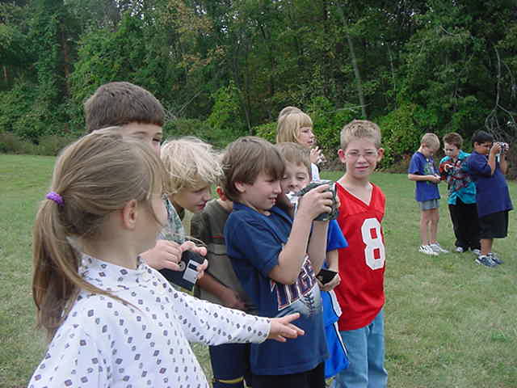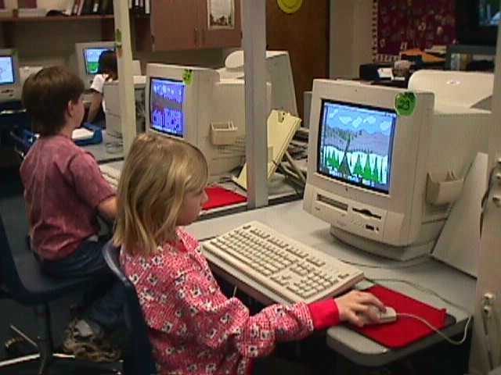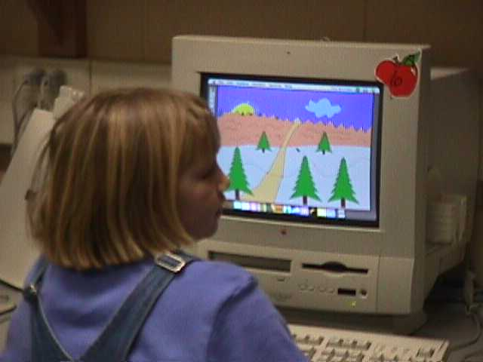
Digital Photography P.I. 2A,B Landscapes w/ Kid Pix P.I.2B,3B Integrated w/ MST5.3B

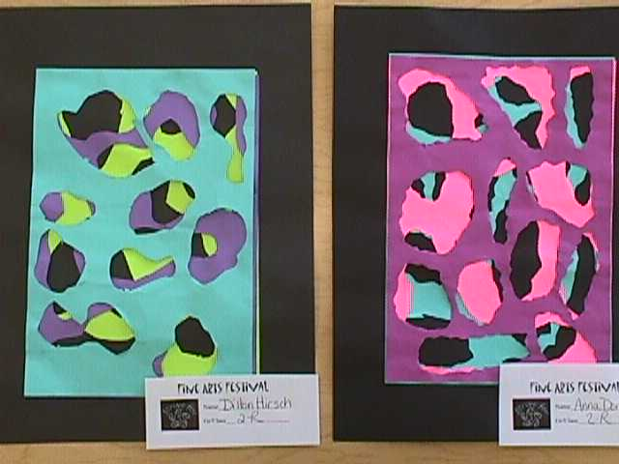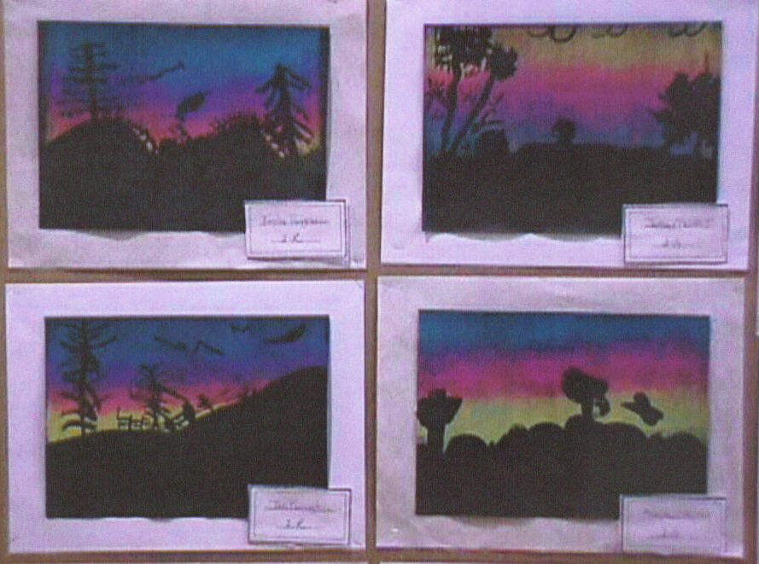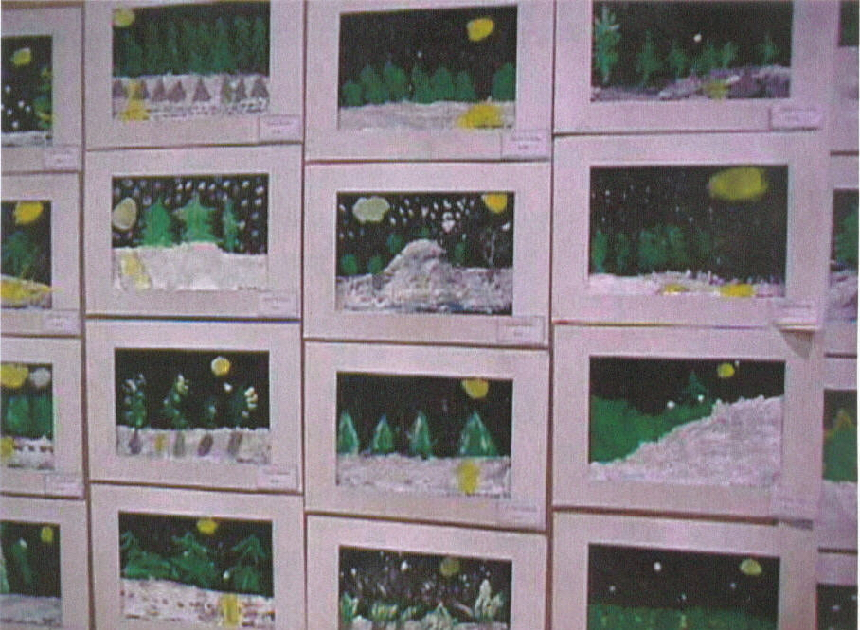
Lots of Layers Collage Silhouetted Landscapes P.I 1A,B,C Tempera Landscape “ Owl Moon”
P.I.1A,C, 3D Jane Yolan Integrated w/ ELA L&R 2.1A E

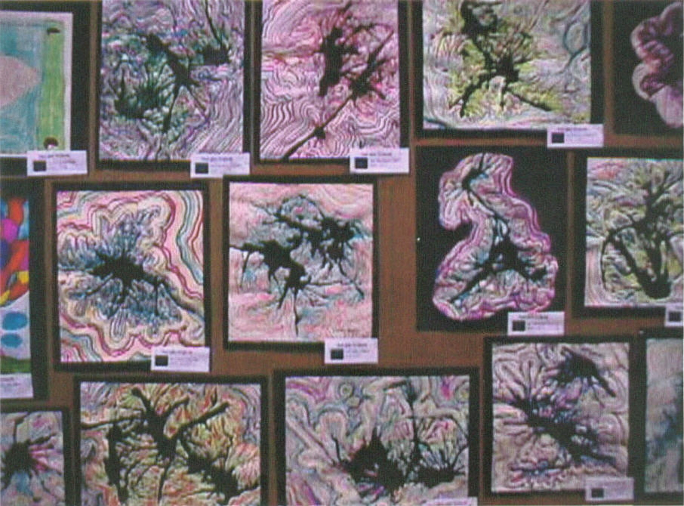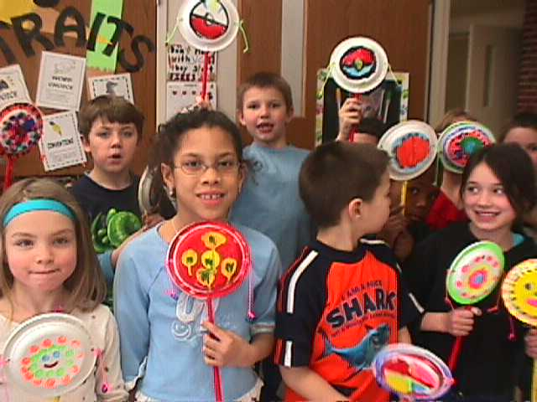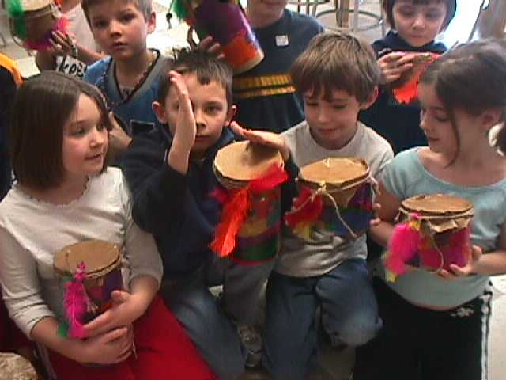
Non-Objective Designs Rhythm Instruments P.I. 3C,4A,C Integrated w/ Arts M2.2B E
P.I. 1A,C,D

Methodology: Kid Pix Deluxe 3, 6 Traits Writing “Ideas and Organization”, Digital Photography, integration with Second Grade units and themes when possible

